WEEK-7:
step-by-step procedure for setting up an AWS Lambda function to trigger whenever an object is uploaded to an S3 bucket and update a DynamoDB table:

STEP-1: Create the S3 Bucket
-Search for S3 bucket in amazon console
-Click on the create bucket in the S3 bucket console
-Select general purpose
-Name the bucket as you needed
-Enable Versioning
-Click on the create bucket
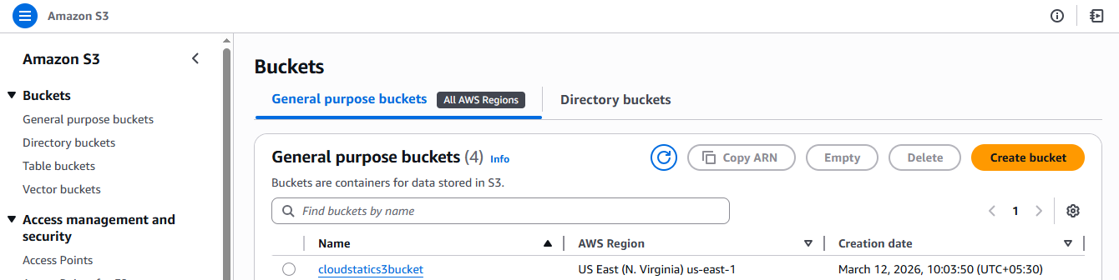

STEP-2: Create a AWS DynamoDB service table

-Search for dynamodb in the search bar of amazon console
-Click on the create table
-GIve any name to the table
Eg. newtable
-Name the row as unique with type string
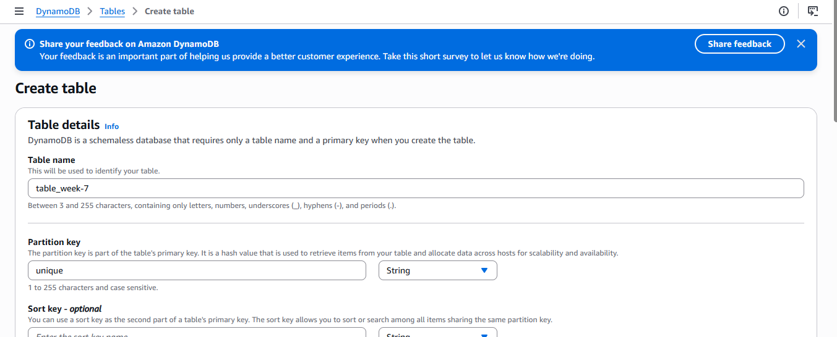
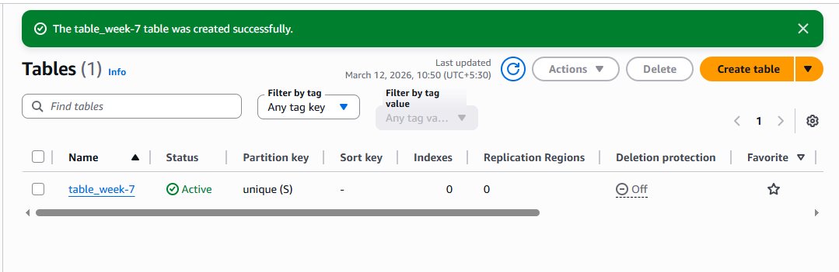

STEP-3: Creating the lambda function

-Search for aws lambda
-Click on the create function
-Choose Author from scratch
-Type any name in the function name input
-Choose a runtime
Eg.Python
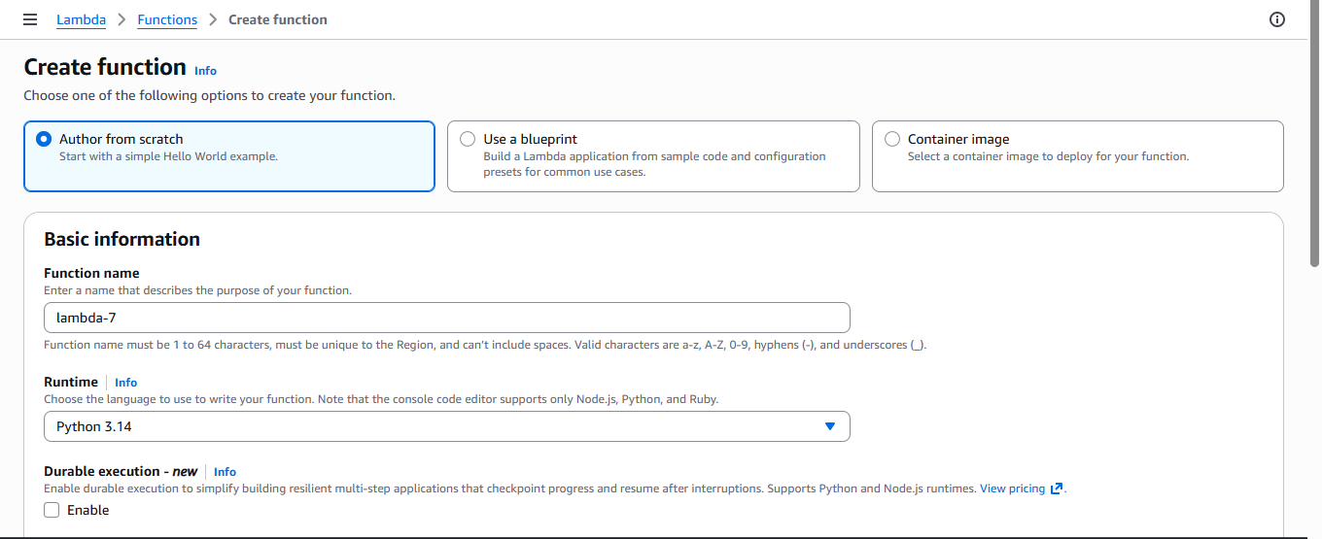

-In permissions choose the role type
If available labrole in the existing roles
Or
Create a new role with basic lambda permissions
-click on the create function
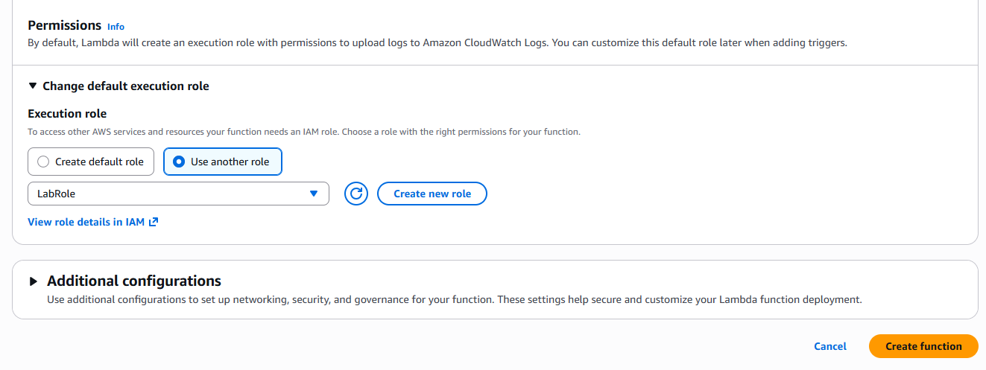

STEP-4: Adding trigger to connect the S3 bucket and DynamoDB

-Click on the Add trigger in the created function
-Search for S3 bucket in the trigger configuration
-Select the S3 bucket
-Choose the bucket which you want to apply the trigger
-Select All object create event in the event type, Acknoledge
-click on the add
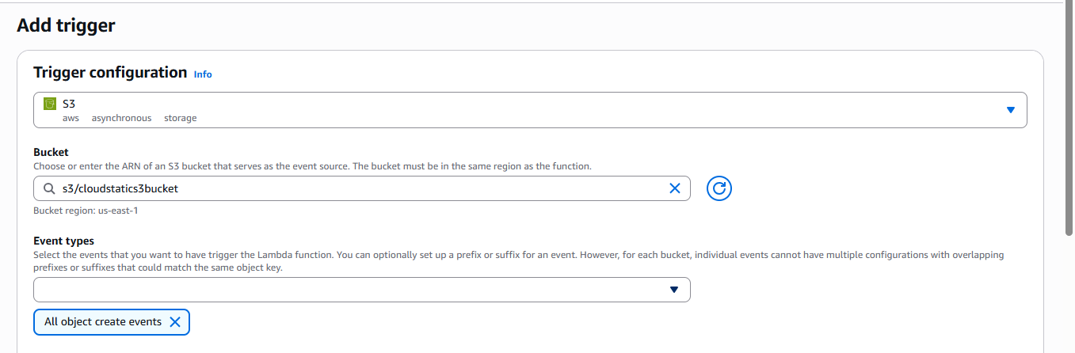

STEP: 5 Creating the deplyoment code and monitoring

-Add the code for triggering when object is uploaded
Eg
import boto3
from uuid import uuid4
deflambda_handler(event, context):
s3 = boto3.client("s3")
dynamodb = boto3.resource('dynamodb')
# Check if the 'Records' key is present in the event
if'Records'in event:
# Iterate over each record in the event
for record in event['Records']:
bucket_name = record['s3']['bucket']['name']
object_key = record['s3']['object']['key']
size = record['s3']['object'].get('size', -1)
event_name = record.get('eventName', 'Unknown') # Use get() method to handle missing keys
event_time = record.get('eventTime', 'Unknown') # Use get() method to handle missing keys
dynamoTable = dynamodb.Table('newtable')
dynamoTable.put_item(
Item={'unique': str(uuid4()), 'Bucket': bucket_name, 'Object': object_key,'Size': size, 'Event': event_name, 'EventTime': event_time})
else:
# Log a message indicating that the 'Records' key is missing from the event
print("No 'Records' key found in the event.")

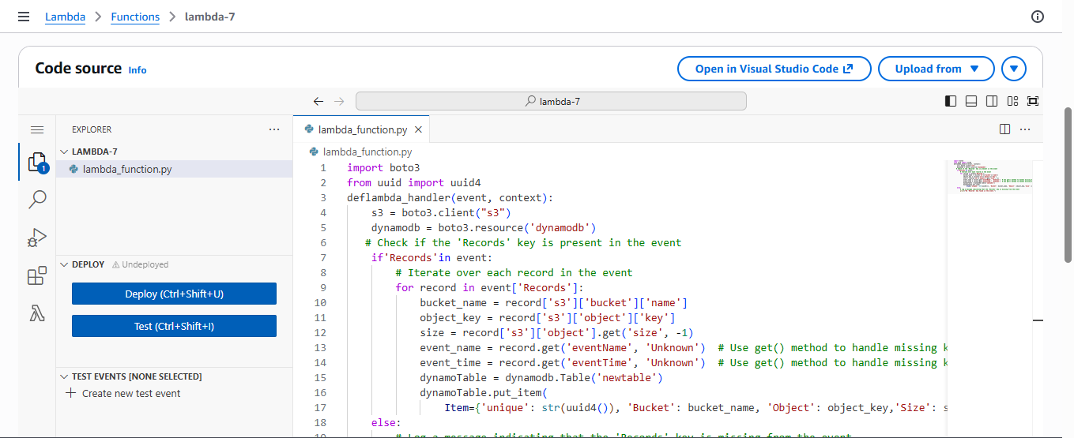

Create a policy if you are getting the Iam role problem Otherwise skip this

-Search for IAM console in AWS console
-Go to roles
-Select the Lamda function name like you gave in the labmda creation
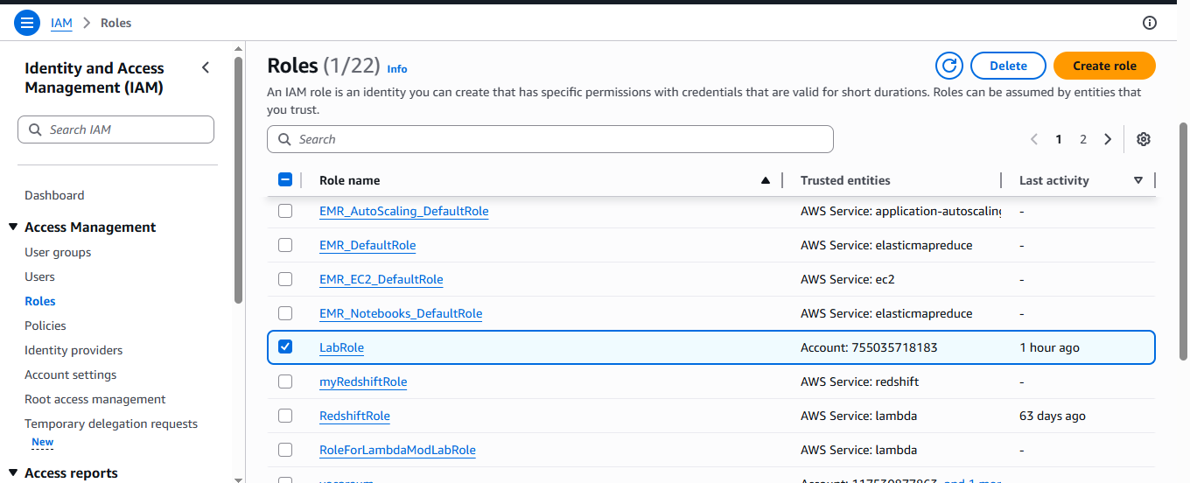
-In permission policies click on add permissions
-Select create inline policy

-Click on the JSON in the policy editor
Write this policy code in that editor

{
"Version": "2012-10-17",
"Statement": [
{
"Effect": "Allow", "Action": "dynamodb:PutItem",
"Resource": "arn:aws:dynamodb:us-west-2:669420739378:table/newtable"
}
]
}

-Click on the next
-Give any policy name
Eg.lambda-dynamo-policy
-Click on the create policy

STEP-6 : Upload any file(s) in the S3 bucket it will triggers and shows in both S3 bucket and the DynamoDB

-Click on the explore items in the DynamoDB
-click on the run

You’ll able to see the objects in the dynamodb which is uploaded in the S3 bucket
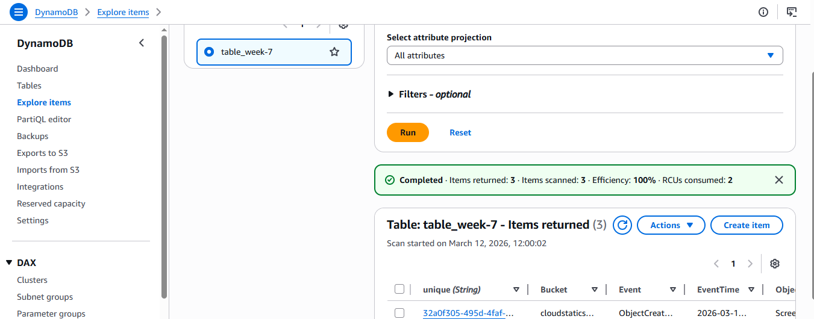

STEP-7: Monitoring using cloud watch

-Click on the Monitor tab in the lambda function
-Click on the view cloudwatch logs
-Click on the time lines and check the logs
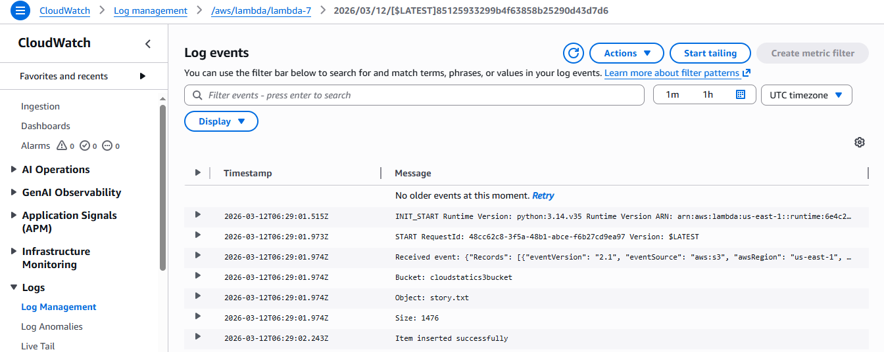

SBQ’s

1. A company wants to automatically process images whenever they are uploaded to an S3 bucket. The system should resize the images and store them in another bucket. Which AWS service can be used to automatically run the code when the image is uploaded?
Ans: The company can use AWS Lambda triggered by Amazon S3 event notifications so that the function automatically runs whenever an image is uploaded to the bucket.
2. A developer created a Lambda function to store uploaded file details into a DynamoDB table, but the function fails with a permission denied error when writing to the database. What could be the reason and how can it be fixed?
Ans: The Lambda execution role may not have permission to write to Amazon DynamoDB. This can be fixed by adding the required dynamodb:PutItem permission to the Lambda role using AWS Identity and Access Management.
3. An application needs to run a piece of code every time a new file is uploaded to an S3 bucket to extract metadata and store it in a database. How would you design this using AWS Lambda?
Ans: Configure Amazon S3 to trigger AWS Lambda whenever a file is uploaded. The Lambda function processes the file, extracts metadata, and stores the data in Amazon DynamoDB or another database.
4. A Lambda function is configured with an S3 trigger, but it is not executing when files are uploaded. What possible configuration issues might cause this problem?
Ans: Possible issues include incorrect event type configuration, prefix or suffix filters blocking the event, bucket and Lambda being in different regions, or missing permissions for Amazon S3 to invoke AWS Lambda.
5. A company wants to process only .jpg image files uploaded to an S3 bucket using Lambda. How can the trigger be configured so that the function runs only for those files?
Ans: In the Amazon S3 event notification configuration, set a suffix filter .jpg so that AWS Lambda is triggered only when .jpg files are uploaded.
6. A Lambda function works correctly for a few uploads but fails when hundreds of files are uploaded simultaneously. What AWS feature helps Lambda handle large numbers of events?
Ans: AWS Lambda automatic scaling and concurrency allows multiple instances of the function to run in parallel to handle large numbers of events efficiently.
7. A developer wants to store the table name and bucket name separately from the code so that they can easily change them later. Which Lambda feature can be used to achieve this?
Ans: The developer can use environment variables in AWS Lambda to store configuration values like bucket name and table name outside the code.
8. A Lambda function executes but does not show any output in the console, making debugging difficult. Which AWS service can be used to view logs and troubleshoot the issue?
Ans: Logs and execution details can be viewed in Amazon CloudWatch, which automatically records logs from AWS Lambda functions.
9. An organization wants a function to run every day at 10 PM to clean temporary files stored in S3. How can Lambda be triggered automatically at a scheduled time?
Ans: Create a scheduled rule using Amazon EventBridge with a cron expression that triggers AWS Lambda at 10 PM daily.
10. A Lambda function processes uploaded files and stores metadata in DynamoDB, but duplicate records appear in the table when the same file is uploaded again. How can this issue be prevented?
Ans: Use a unique primary key such as the file name or object key in Amazon DynamoDB, or implement conditional writes to prevent duplicate records.
11. A Lambda function processes files uploaded to S3, but the processing sometimes takes more than 10 minutes. What limitation of Lambda must be considered here?
Ans: AWS Lambda has a maximum execution timeout of 15 minutes, so tasks exceeding this time may require other services like batch processing.
12. A developer wants to allow a Lambda function to read files from S3 and write records into DynamoDB. What type of AWS security configuration must be created?
Ans: An IAM execution role must be created in AWS Identity and Access Management with permissions for Amazon S3 and Amazon DynamoDB.
13. A company wants to automatically send a notification email whenever a file is uploaded to S3 using Lambda. Which AWS services can be integrated to achieve this?
Ans: Use AWS Lambda triggered by Amazon S3, and send the notification email through Amazon Simple Notification Service.
14. A Lambda function is triggered by S3 uploads, but the function keeps running multiple times for the same file. What could be the possible cause?
Ans: This can happen if multiple S3 event notification rules exist or if the same file upload generates multiple events in Amazon S3, causing AWS Lambda to run more than once.
15. An organization wants to build a fully serverless application where uploaded files are processed automatically without managing servers. Which AWS services can be combined with Lambda to achieve this architecture?
Ans: A serverless architecture can combine Amazon S3 for file storage, AWS Lambda for processing, Amazon DynamoDB for data storage, and optionally Amazon API Gateway or Amazon Simple Notification Service for APIs and notifications.

