WEEK-11—Amazon LEX

Step 1: Open Amazon Lex
- Login to AWS Console
- Search Amazon Lex
- Click Create bot

Step 2: Create Bot
- Choose:
  - Create a blank bot
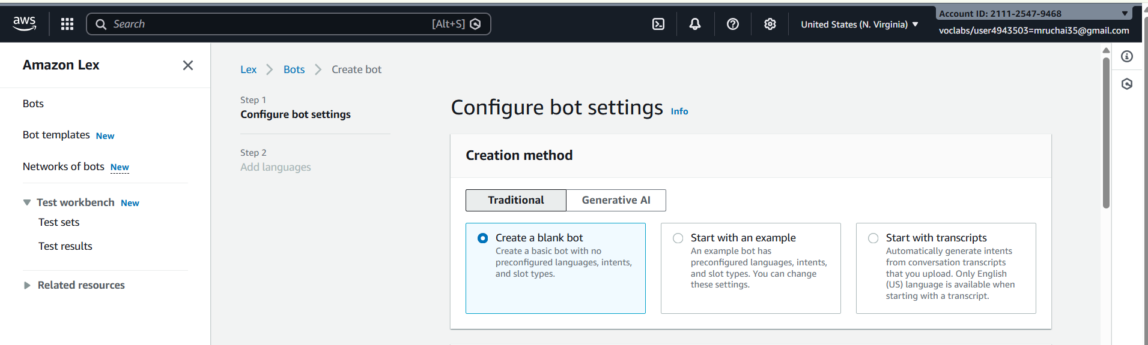
- Enter:
  - Bot name: HotelBookingBot
- IAM role → Create new role
- Remaining defaultnext
- Language: English
- Voice (optional)
- Click Done
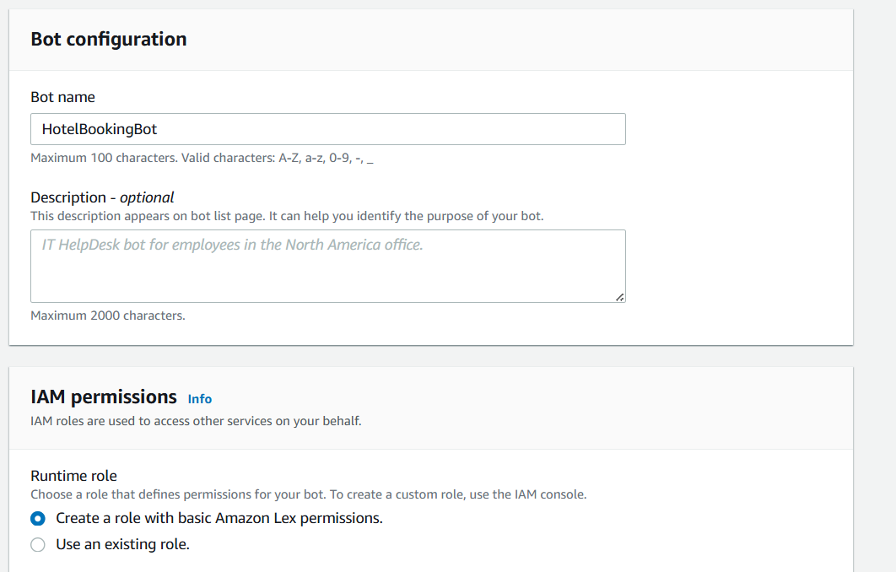

Step 3: Create Intent
- Go to Intents
- Name: BookHotel
- Click Create
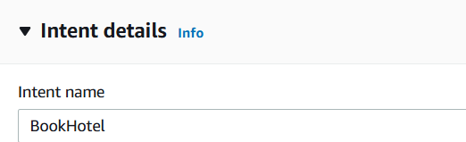

Step 4: Add Sample Utterances
Add user sentences (how user talks):
I want to book a hotel
Book a room
Reserve hotel
I need a room
These are Utterances
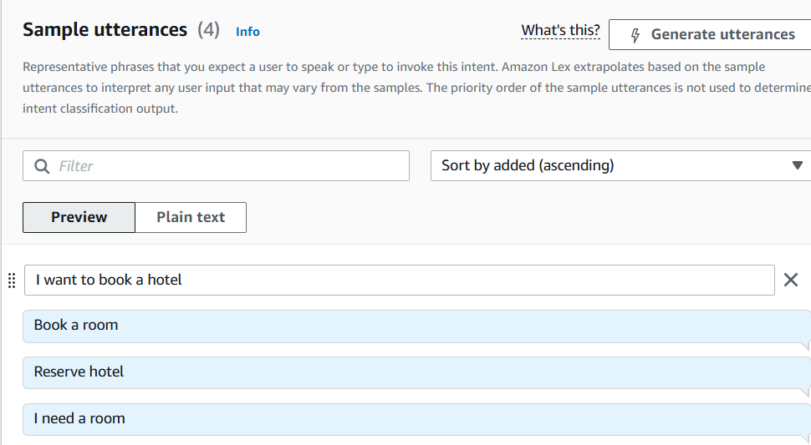

Step 5: Create Slots (User Inputs)
Slots collect user information.
Add Slot
- Click Add slot
- Fill:
  - Slot name: age
  - Slot type: AMAZON.Number
  - Prompt: Which city do you want?
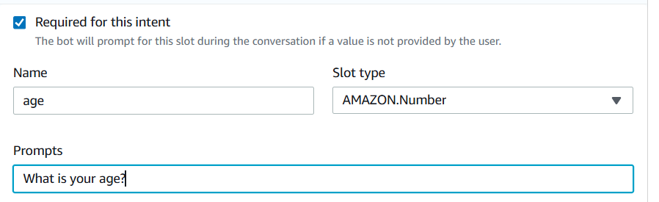
Mark as Required
Add IF Conditions (Conditional Logic)
Used to control flow based on slot values
Example Condition:
If {age} < 18
Steps:
- Go to Intent → Slots -> under Advance options
- Scroll to Slot capture: success response ->Conditional branching
- Click Add condition
Example:
Condition:
If {age} < 18
Response:
Your not eligible for hoot booking?

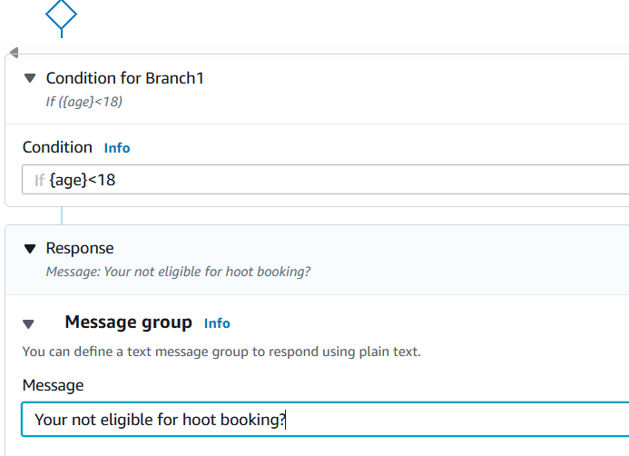

Step 6: Create Slots (User Inputs)
Slots collect user information.
Add Slot
- Click Add slot
- Fill:
  - Slot name: location
  - Slot type: AMAZON.City
  - Prompt: Which city do you want?
- Mark as Required
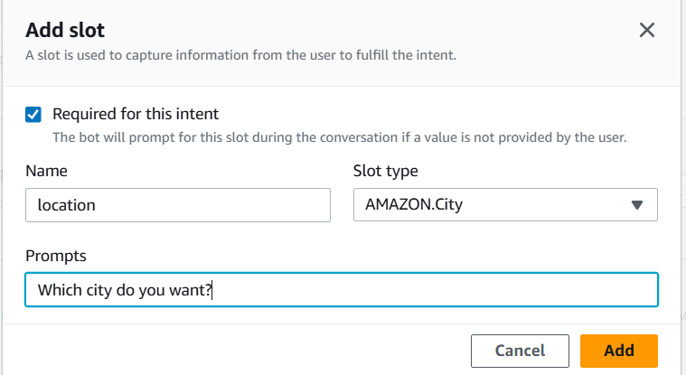

Repeat for other slots.
- Click Add slot
- Fill details:
  - Slot name: checkin
  - Slot type: AMAZON.Date
  - Prompt:
"What is your check-in date?"
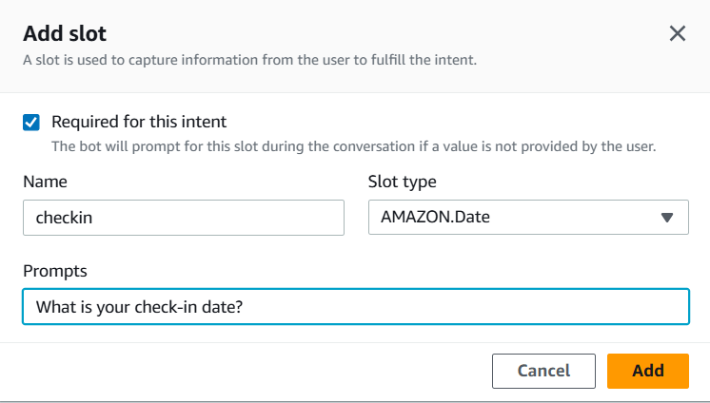
- Mark as Required
(Optional but recommended)
  - Add Retry prompt:
"Please provide a valid date (e.g., 2026-03-25)"
- Click Save

Slot 7: Number of Nights (nights)
Steps:
- Click Add slot again
- Fill details:
  - Slot name: nights
  - Slot type: AMAZON.Number
  - Prompt:
"How many nights will you stay?"
- Mark as Required
- Click Save
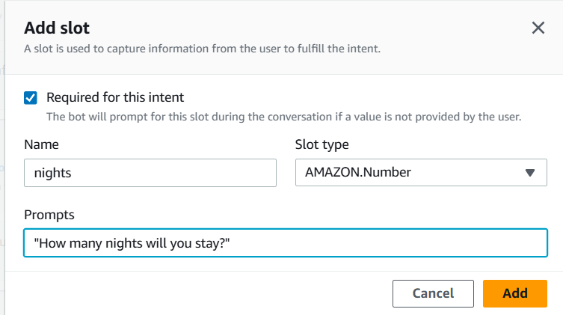

Step 7: Create Custom Slot Type

Save intent

Click on Back to intents
If you want custom values:
- Go to Slot Types
- Click Add slot type ->add blank slot type
- Name: RoomType
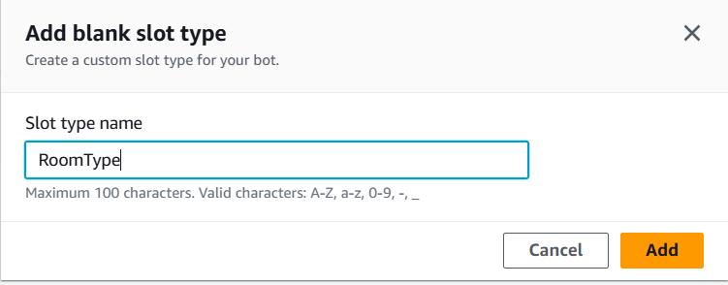
Add values:
Single
Double
Suite
Save slot type
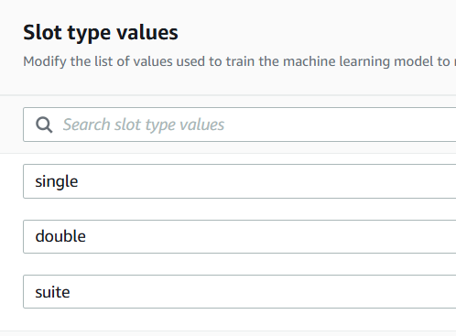
Now use this in slot: go back to intent
- Slot name: RoomType
- Slot type: RoomType
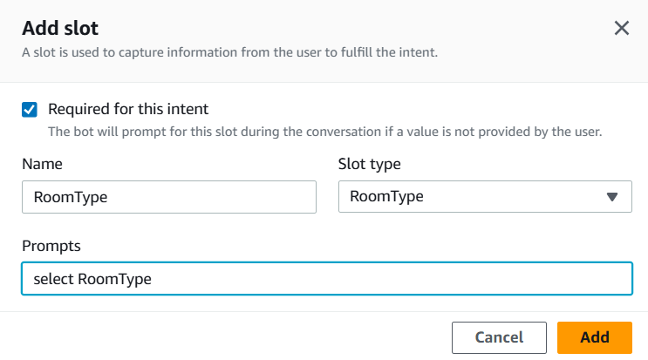

Step 9: Add Response Cards (Card Groups)
Used for buttons (quick replies)
Steps:
- Go to slot prompts -> more prompt options
- Click Add -> add card groups
Example:
Card Title: Select Room Type
click on add Buttons:
- Single → "Single"
- Double → "Double"
- Suite → "Suite"
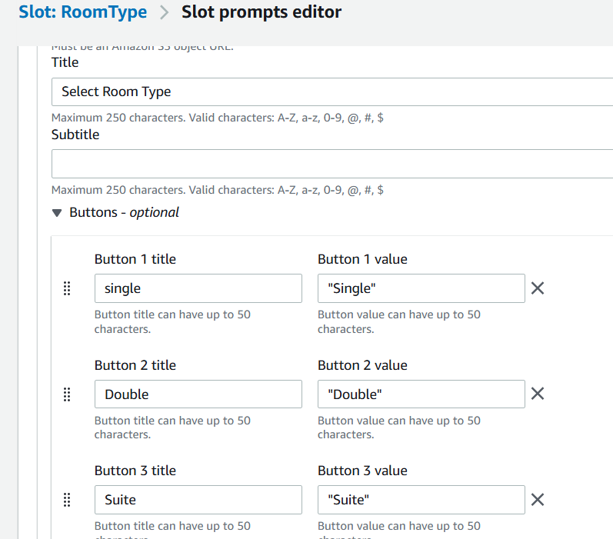

Step 10: Configure Responses
Initial Response:
Welcome to Hotel Booking! What is your name?
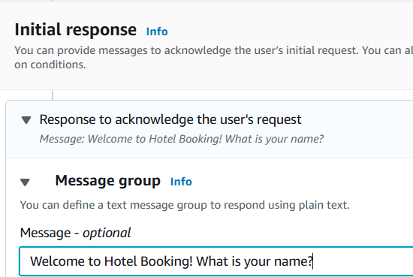
Confirmation:
Do you want to confirm booking in {location} for {nights} nights?
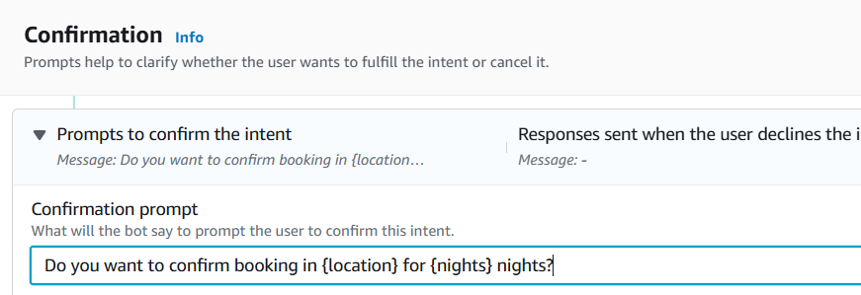

Step 11: Build & Test
- Click Build
- Use Test chatbot panel
- Try:
Book a hotel

Sample output
User: Book a hotel
Bot: What is your age?
User: 25
Bot: Which city do you want?
User: Hyderabad
Bot: Check-in date?
User: Tomorrow
Bot: Number of nights?
User: 2
Bot: Select room type
User: Double
Bot: Do you want to confirm booking in Hyderabad for 2 nights?
User: Yes
Bot: Booking confirmed.
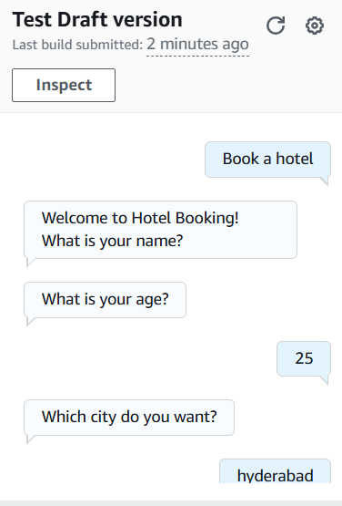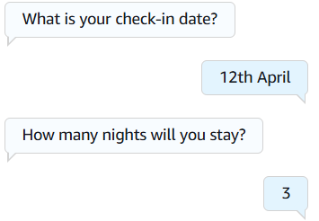
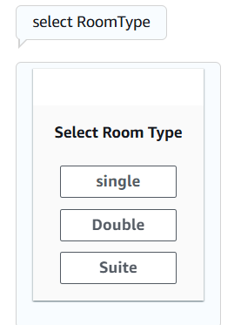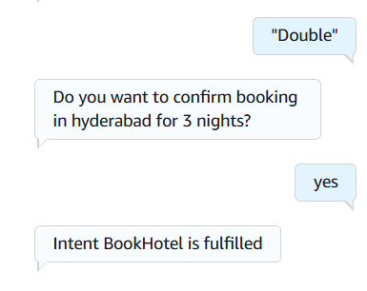

SCENARIO BASED QUESTIONS
Scenario 1: Bot Not Responding
You created a chatbot, but when you test it, the bot does not respond to user input.
• What could be the possible reason for no response?
Ans:- Possible reasons include the bot not being built, errors in configuration, missing intents, or incorrect input settings.
• Did you build and publish the bot correctly?
Ans:- The bot must be built and published; otherwise, it will not respond to user inputs.
• How would you troubleshoot this issue?
Ans:- Check build status, verify intents and slots, review logs, and ensure the bot is deployed correctly.
Scenario 2: Incorrect Intent Matching
A user types a valid query, but the chatbot responds with the wrong intent.
• What could cause incorrect intent recognition?
Ans:- Incorrect training data, limited utterances, or overlapping intent definitions can cause wrong intent recognition.
• How do utterances affect intent matching?
Ans:- Utterances train the model, so fewer or unclear utterances reduce the accuracy of intent matching.
• How can you improve accuracy?
Ans:- Add diverse sample utterances, refine intent definitions, and retrain the bot.
Scenario 3: Missing Slot Values
The chatbot asks for user input, but fails to capture required slot values.
• What is a slot in Amazon Lex?
Ans:- A slot is a variable used to capture specific user information such as age, date, or location.
• Why might slot values not be captured properly?
Ans:- Incorrect slot type, improper prompts, or slot not marked as required can cause failure in capturing values.
• How would you fix slot configuration issues?
Ans:- Ensure correct slot types, enable required option, and provide clear prompts.
Scenario 4: Fulfillment Not Working
The bot collects all user inputs but does not perform the expected action.
• What is fulfillment in Amazon Lex?
Ans:- Fulfillment is the process of executing backend logic after collecting all required slot values.
• Could Lambda integration be misconfigured?
Ans:- Yes, incorrect Lambda configuration or missing permissions can prevent fulfillment from working.
• How would you verify the backend processing?
Ans:- Check Lambda logs in CloudWatch and test the function separately.
Scenario 5: Bot Not Accessible
You created the bot successfully, but users are unable to access it.
• Did you deploy or publish the bot?
Ans:- The bot must be published with an alias to make it accessible to users.
• Could permissions or channel integration be missing?
Ans:- Yes, missing IAM permissions or integration setup can block access.
• How would you make the bot accessible to users?
Ans:- Publish the bot, configure permissions, and integrate it with required channels or applications.
Scenario 6: Wrong Language Understanding
The chatbot fails to understand user queries written in slightly different formats.
• How does Amazon Lex process natural language?
Ans:- Amazon Lex uses NLP and machine learning to interpret user input based on trained utterances.
• Why is training with multiple utterances important?
Ans:- Multiple utterances improve model accuracy by covering different ways users express the same intent.
• How can you improve NLP performance?
Ans:- Add diverse training phrases, refine intents, and continuously test and update the model.
Scenario 7: Versioning Issue
You updated the bot, but users still experience the old behavior.
• Did you create a new version of the bot?
Ans:- Changes require creating a new version; otherwise, updates will not be reflected.
• Why is alias configuration important?
Ans:- Alias determines which version users interact with, so incorrect alias leads to old behavior.
• How do you ensure users access the latest version?
Ans:- Update the alias to point to the latest version and redeploy the bot.
Scenario 8: Lambda Permission Error
The chatbot is connected to a Lambda function, but it fails during execution.
• What type of permission error might occur?
Ans:- Access denied errors occur when Lex does not have permission to invoke Lambda.
• How are IAM roles used in this integration?
Ans:- IAM roles grant necessary permissions for Lex to invoke Lambda functions securely.
• How would you fix the permission issue?
Ans:- Attach correct IAM policies and allow Lex service to invoke the Lambda function.
Scenario 9: Bot Gives Default Response
The chatbot always gives a fallback/default response instead of proper answers.
• What is a fallback intent?
Ans:- Fallback intent is triggered when user input does not match any defined intent.
• Why does the bot fail to match user input?
Ans:- Lack of proper utterances or unclear intent definitions can cause matching failure.
• How can you improve intent recognition?
Ans:- Add more training utterances and refine intent structure.
Scenario 10: Multi-turn Conversation Issue
The chatbot fails to continue conversation properly after asking follow-up questions.
• What is dialog management in Amazon Lex?
Ans:- Dialog management controls the flow of conversation between the user and the chatbot.
• How are slots used in multi-turn conversations?
Ans:- Slots store user inputs and help continue the conversation across multiple turns.
• How can conversation flow be improved?
Ans:- Configure proper slot prompts, use conditional logic, and manage dialog states effectively.
Scenario 11: Integration with Web Application
A company wants to integrate the chatbot into their website.
• How can Amazon Lex be integrated with web applications?
Ans:- Amazon Lex can be integrated using AWS SDKs or APIs in web applications.
• What services or APIs are required?
Ans:- Services include API Gateway, Lambda, and AWS SDK for communication.
• What challenges might occur during integration?
Ans:- Issues may include authentication, latency, and improper API configuration.
Scenario 12: Performance Issue
The chatbot responds slowly when many users interact simultaneously.
• What could cause performance delays?
Ans:- High traffic, slow backend processing, or inefficient Lambda functions can cause delays.
• How can scalability be handled in Amazon Lex?
Ans:- Use Auto Scaling, optimize backend services, and distribute load efficiently.
• What AWS services can support high traffic handling?
Ans:- Services like Auto Scaling, Elastic Load Balancer, and Lambda help manage high traffic.

