**Full Stack Development with MERN**

**Project Documentation Format**

|  |  |
| --- | --- |
| Date | 25-06-2025 |
| Team ID | LTVIP2025TMID59305 |
| Project Name | Resolve now: Platform for Online Complaint App using Mern |
| Maximum Marks | 10 Marks |

**Project Title: Resolve now: Platform for Online Complaints using Mern**

Date: 25-06-2025

Prepared by: Gummadi Karthik

 Doppalapudi Jyothika

Dhulipalla Mrudula

Dungala Lova Raju

**INTRODUCTION**

**Resolve Now** is a MERN stack-based web application that allows users to file and track online complaints seamlessly. It provides a transparent and efficient platform for grievance redressal between users and concerned authorities.

**DESCRIPTION**

**Resolve Now** is a user-friendly online complaint management web application developed using the MERN stack. It allows users to easily lodge complaints, track their status, and receive timely resolutions. The platform connects users with the responsible authorities in a streamlined digital environment, ensuring transparency, accountability, and faster grievance redressal. Whether it’s a civic issue, institutional complaint, or customer service problem, **Resolve Now** empowers users to raise their voice and get action taken effectively..

**1. App Purpose**

**Resolve Now** is designed to simplify the process of lodging and managing complaints online. It provides users with a platform to report issues and track their resolution in a transparent and systematic manner.

**2. User Roles**

* **User:** Can register, log in, and submit complaints with relevant details and categories.
* **Admin:** Can view, manage, and update complaint statuses. Responsible for resolving user issues.

**3. Core Features**

* **Complaint Submission:** Users can file complaints by selecting categories, uploading images, and providing descriptions.
* **Real-Time Tracking:** Users can view the live status of their complaints (Pending, In Progress, Resolved).
* **Admin Dashboard:** Admins get a centralized dashboard to manage all complaints efficiently.
* **Authentication System:** Secure login/signup using JWT for protected access.
* **Notification System:** Alerts for status changes or admin responses.

**4. Technical Overview**

* **Frontend:** Built using **React.js** for dynamic and responsive UI.
* **Backend:** Powered by **Node.js** and **Express.js**, ensuring scalable API services.
* **Database:** Uses **MongoDB** to store user and complaint data.
* **Security:** Implements secure authentication and role-based access.

**5. Real-World Application**

The app can be used by:

* Government departments to handle public grievances
* Educational institutions for student feedback and issue reporting
* Private companies for customer service complaints

user

**TECHNICAL ARCHITECTURE**

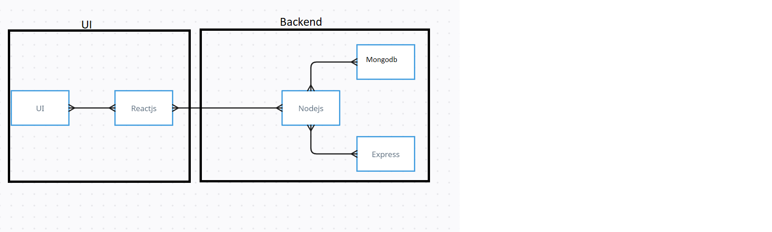

The technical architecture of our House rent app follows a client-server model, where the frontend serves as the client and the backend acts as the server. The frontend encompasses not only the user interface and presentation but also incorporates the axios library to connect with backend easily by using RESTful Apis.

The frontend utilizes the bootstrap and material UI library to establish real-time and better UI experience for any user whether it is admin, doctor and ordinary user working on it.

On the backend side, we employ Express.js frameworks to handle the server-side logic and communication.

For data storage and retrieval, our backend relies on MongoDB. MongoDB allows for efficient and scalable storage of user data, including user profiles, for booking room, and adding room, etc. It ensures reliable and quick access to the necessary information.

Together, the frontend and backend components, along with moment, Express.js, and MongoDB, form a comprehensive technical architecture for our House rent app. This architecture enables real-time communication, efficient data exchange, and seamless integration, ensuring a smooth and immersive booking an appointment and many more experience for all users.

**ER DIAGRAM**

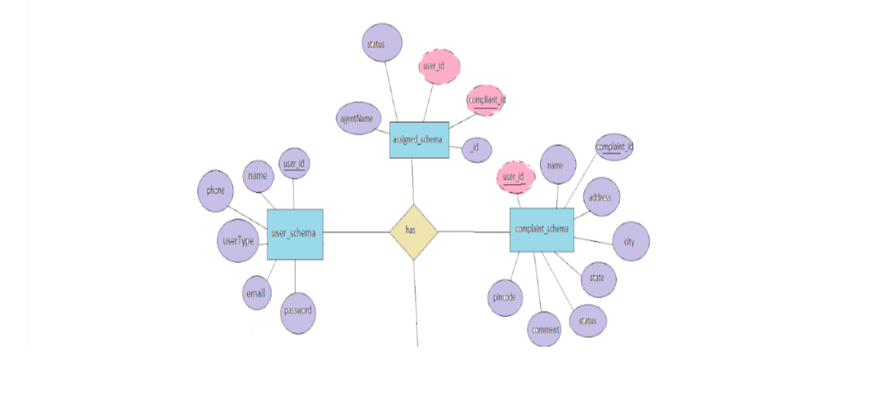

**PREREQUISITE:**

Here are the key prerequisites for developing a full-stack application using Node.js, Express.js, MongoDB, React.js:

✔**Node.js and npm:**

Node.js is a powerful JavaScript runtime environment that allows you to run JavaScript code on the server-side. It provides a scalable and efficient platform for building network applications.

Install Node.js and npm on your development machine, as they are required to run JavaScript on the server-side.

Download: https://nodejs.org/en/download/

Installation instructions: <https://nodejs.org/en/download/package-manager/>

**npm init**

✔**Express.js:**

Express.js is a fast and minimalist web application framework for Node.js. It simplifies the process of creating robust APIs and web applications, offering features like routing, middleware support, and modular architecture.

Install Express.js, a web application framework for Node.js, which handles server-side routing, middleware, and API development.

Installation: Open your command prompt or terminal and run the following command:

**npm install express**

✔**MongoDB:**

MongoDB is a flexible and scalable NoSQL database that stores data in a JSON-like format. It provides high performance, horizontal scalability, and seamless integration with Node.js, making it ideal for handling large amounts of structured and unstructured data.

Set up a MongoDB database to store your application's data.

Download: https://www.mongodb.com/try/download/community

Installation instructions: https://docs.mongodb.com/manual/installation/

✔**Moment.js:**

Moment Js is a JavaScript package that makes it simple to parse, validate, manipulate, and display date/time in JavaScript. Moment. js allows you to display dates in a human-readable format based on your location. Install React.js, a JavaScript library for building user interfaces.

Follow the installation guide: [https://momentjs.com/](https://momentjs.com/%20)

✔**React.js:**

React.js is a popular JavaScript library for building user interfaces. It enables developers to create interactive and reusable UI components, making it easier to build dynamic and responsive web applications.

Install React.js, a JavaScript library for building user interfaces.

Follow the installation guide: <https://reactjs.org/docs/create-a-new-react-app.html>

✔**Antd:**

Ant Design is a React. js UI library that contains easy-to-use components that are useful for building interactive user interfaces. It is very easy to use as well as integrate. It is one of the smart options to design web applications using react.

Follow the installation guide: <https://ant.design/docs/react/introduce>

✔**HTML, CSS, and JavaScript**: Basic knowledge of HTML for creating the structure of your app, CSS for styling, and JavaScript for client-side interactivity is essential.

✔**Database Connectivity**: Use a MongoDB driver or an Object-Document Mapping (ODM) library like Mongoose to connect your Node.js server with the MongoDB database and perform CRUD (Create, Read, Update, Delete) operations. To Connect the Database with Node JS go through the below provided link:

https://www.section.io/engineering-education/nodejs- mongoosejs-mongodb/

✔**Front-end Framework**: Utilize Reactjs to build the user-facing part of the application, including entering the booking room, status of the booking, and user interfaces for the admin dashboard.

For making better UI we have also used some libraries like material UI and bootstrap.

✔**Version Control**: Use Git for version control, enabling collaboration and tracking changes throughout the development process. Platforms like GitHub or Bitbucket can host your repository.

Git: Download and installation instructions can be found at: https://git-scm.com/downloads

✔**Development Environment**: Choose a code editor or Integrated Development Environment (IDE) that suits your preferences, such as Visual Studio Code, Sublime Text, or WebStorm.

• Visual Studio Code: Download from <https://code.visualstudio.com/download>

To run the existing Video Conference App project downloaded from GitHub:

Follow below steps:

Clone the Repository:

* Open your terminal or command prompt.
* Navigate to the directory where you want to store the e-commerce app.
* Execute the following command to clone the repository:

**git clone**: [**https://github.com/awdhesh-student/house-rent.git**](https://github.com/awdhesh-student/house-rent.git)

Install Dependencies:

• Navigate into the cloned repository directory:

cd house-rent

• Install the required dependencies by running the following commands:

cd frontend

npm install

cd ../backend

npm install

Start the Development Server:

• To start the development server, execute the following command:

npm start

• The house rent app will be accessible at <http://localhost:3000>

You have successfully installed and set up the online complaint registration and management app on your local machine. You can now proceed with further customization, development, and testing as needed.

**Roles and Responsibilities:**

The project has 2 types of users – Renter and Owner and the other will be Admin which takes care of all the users. The roles and responsibilities of these two types of users can be inferred from the API endpoints defined in the code. Here is a summary:

Renter/Tenant:

1. Create an account and log in to the system using their email and password.
2. They will be shown automatically all the properties in their dashboard.
3. After clicking on the Get Info, all the information of the property and owner will come and a small form will be generated in which the renter needs to send his\her details.
4. After that they can see their booking in the booking section where the status of booking will be showing “pending”. It will be changed by the owner of the property.

Admin:

1. He/she can approve the user as “owner” for the legit user to add properties in his app
2. He monitors the applicant of all doctors and approves them and then doctors are registered in the app.
3. Implement and enforce platform policies, terms of service, and privacy regulations.

Owner:

1. Gets the approval from the admin for his Owner account.
2. After approval, he/she can do all CRUD operation of the property in his/her account
3. He/she can change the status and availability of the property.

**PROJECT STRUCTURE**

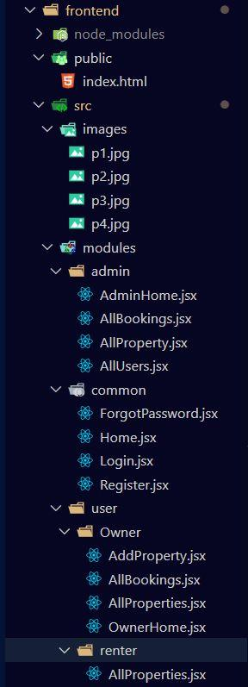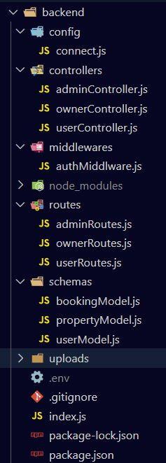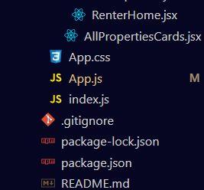

The first image is of frontend part which is showing all the files and folders that have been used in UI development

The second image is of Backend part which is showing all the files and folders that have been used in backend development

**Project Flow:**

Before starting to work on this project, let’s see the demo.

**Project demo:** [**https://drive.google.com/file/d/1enBJk-X3-ScODu_FMvZRJinwFIDdngb1/view?usp=drive_link**](https://drive.google.com/file/d/1enBJk-X3-ScODu_FMvZRJinwFIDdngb1/view?usp=drive_link)

Use the code in**:** [**https://github.com/awdhesh-student/house-rent.git**](https://github.com/awdhesh-student/house-rent.git)

or follow the videos below for better understanding.

**Milestone 1: Project setup and configuration.**

* **Folder setup:**

1. Create frontend and
2. Backend folders

* **Installation of required tools:**

1. Open the frontend folder to install necessary tools

For frontend, we use:

* + - React
    - Bootstrap
    - Material UI
    - Axios
    - Moment
    - Antd
    - mdb-react-ui-kit
    - react-bootstrap

2. Open the backend folder to install necessary tools

For backend, we use:

* + - cors
    - bcryptjs
    - express
    - dotenv
    - mongoose
    - Moment
    - Multer
    - Nodemon
    - jsonwebtoken

After the installation of all the libraries, the package.json files for the frontend looks like the one mentioned below.

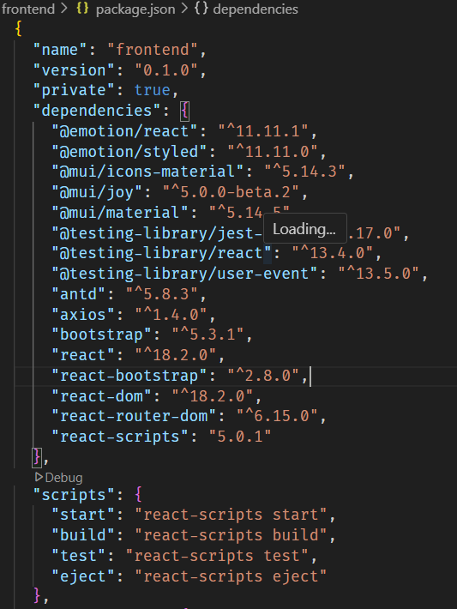

After the installation of all the libraries, the package.json files for the backend looks like the one mentioned below.

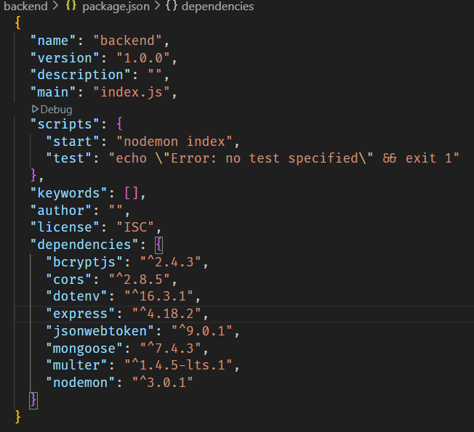

**Milestone 2: Backend Development**

* **Setup express server**

1. Create index.js file in the server (backend folder).
2. define port number, mongodb connection string and JWT key in env file to access it.
3. Configure the server by adding cors, body-parser.

* **Configure MongoDB**

1. Import mongoose.
2. Add database connection from config.js file present in config folder
3. Create a model folder to store all the DB schemas like renter, owner and booking, properties schemas.

* **Add authentication:** for this,

You need to make a middleware folder and in that make authMiddleware.js file for the authentication of the projects and can use it.

## **Milestone 3: Database Development:**

* Set up a MongoDB database either locally or using a cloud-based MongoDB service like MongoDB Atlas.
* Create a database and define the necessary collections for users, transactions, stocks and orders.
* Also let’s see the detailed description for the schemas used in the database.
* For the connection of database use the code given below
* 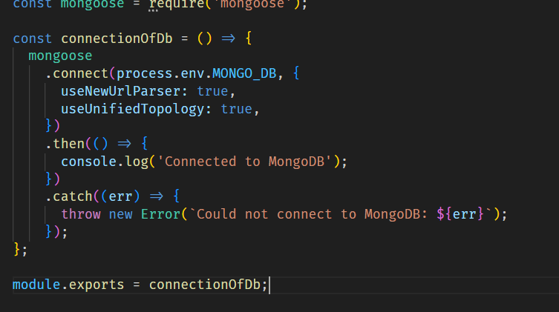

## **Milestone 4: Frontend Development:**

1. **Setup React Application:**

Bringing SB Stocks to life involves a three-step development process. First, a solid foundation is built using React.js. This includes creating the initial application structure, installing necessary libraries, and organizing the project files for efficient development. Next, the user interface (UI) comes to life. To start the development process for the frontend, follow the below steps.

* + Install required libraries.
  + Create the structure directories.

## **Design UI components:**

## Reusable components will be created for all the interactive elements you'll see on screen, from stock listings and charts to buttons and user profiles. Next, we'll implement a layout and styling scheme to define the overall look and feel of the application. This ensures a visually-appealing and intuitive interface. Finally, a navigation system will be integrated, allowing you to effortlessly explore different sections of SB Stocks, like viewing specific stocks or managing your virtual portfolio.

## **Implement frontend logic:**

## In the final leg of the frontend development, we'll bridge the gap between the visual interface and the underlying data. It involves the below stages.

* + Integration with API endpoints.
  + Implement data binding.

**5 . Project Implementation :**

**Register or Sign Up:**

**Login:**

**Properties:**

**Project demo: https://drive.google.com/drive/folders/1m_vXdKkujfkVq1x57h6bZ3Kj_07hdh4T**