CCN Project 1

Group members (Contributors):
- Arindrajit Seal (800960393)
- Mrudula Paturi (800913262)
Project Components:
Language Used: JAVA
CONTENTS:
Instructions to run the project
References................................................................................................7

Instructions to run the project:

- This part of project contains the following files (.java)
Client.java
Server.java
- Server needs to be compiled and run on the command line as:
javac Server.java
java Server <Port No.>

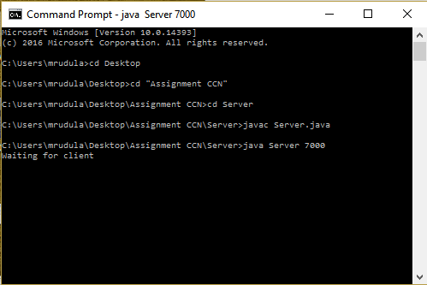

- Client needs to be compiled and run in following manner:
javac Client.java
java Client <localhost/Ip-Address_Of_Server> <Port No> <GET/PUT> <filename>
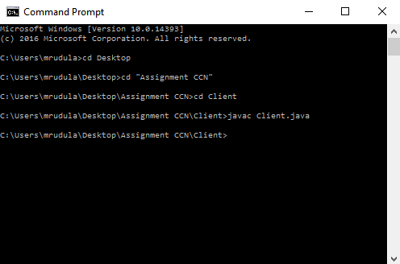

For GET Command:
- Client sends the file name to the server.
- The file can be a .txt file or a HTML file.
- Server searches for the filename and if the file is present, it sends a “200 OK” message followed by the message “Sending filename (no. of bytes)”
And “Done” once it sends.
- The file will be downloaded into the client and the file can be viewed either in command prompt or in browser depending upon the user input (1 or 2).
- If the file is not present on server, it sends a “404 File Not Found” error message.

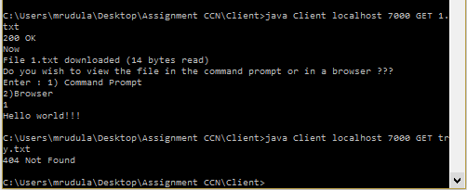
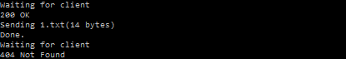

Another scenario arises when the file must be viewed in the browser . In that case the file downloaded must be an html file otherwise if its a .txt file and you want to view that in the browser , the prompt will inform you its not an html file . Enter your choice again.

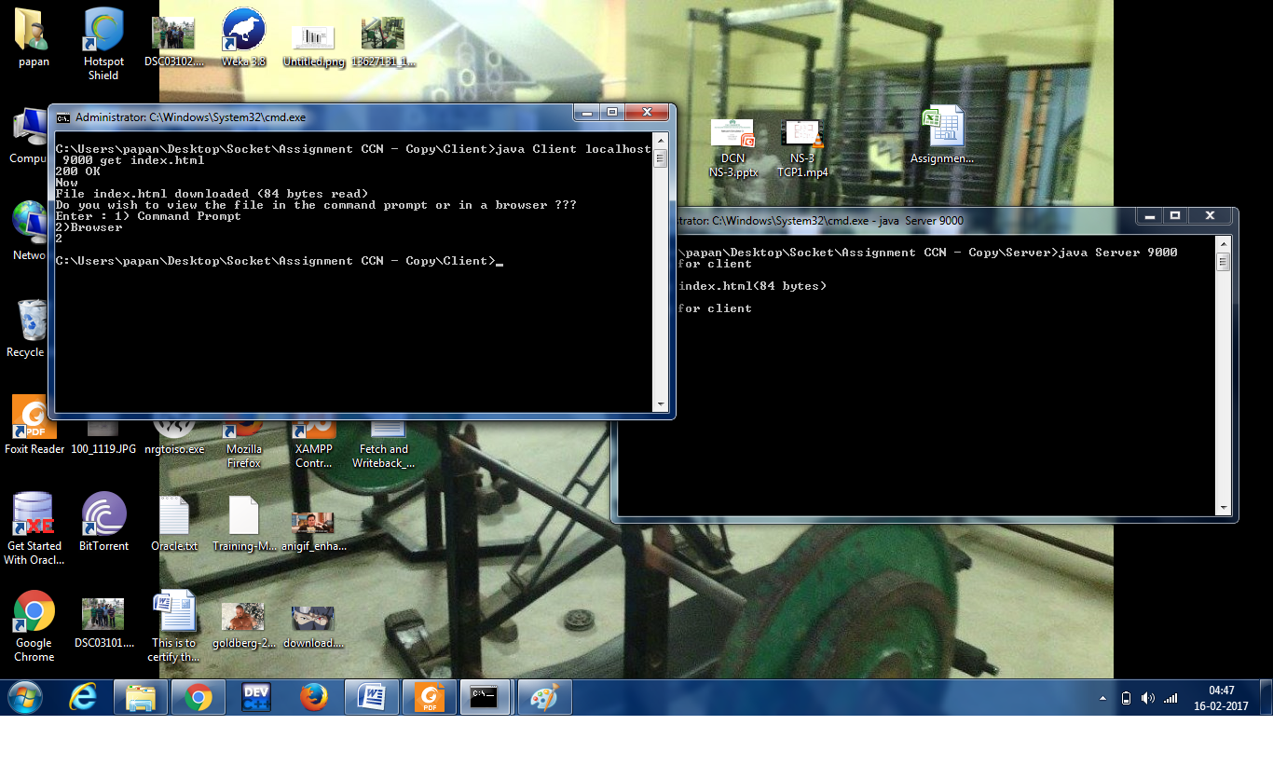
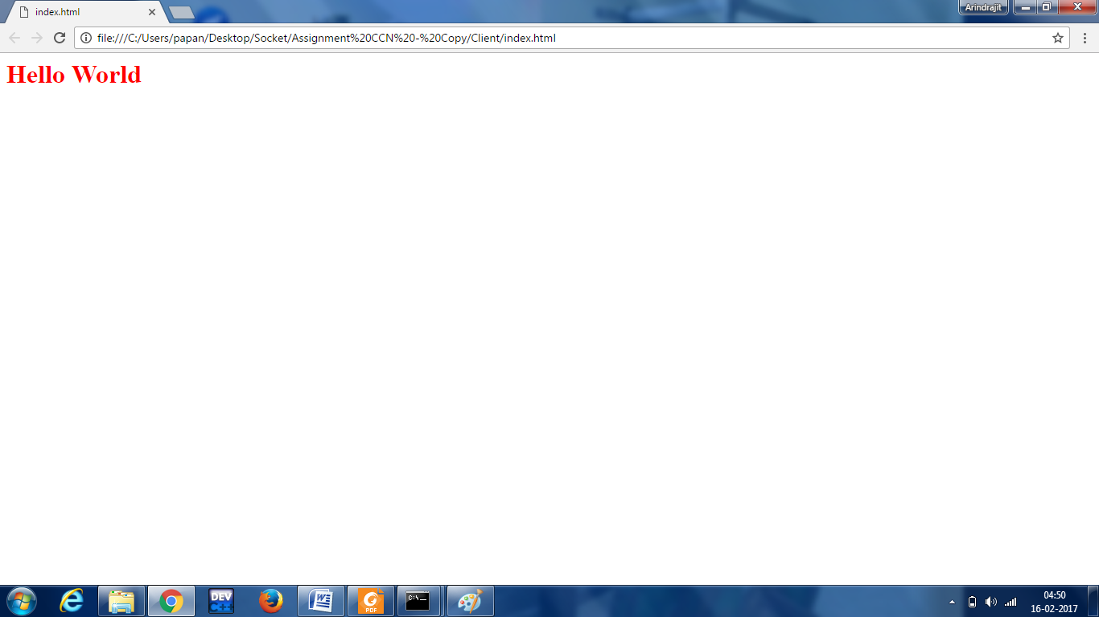
For PUT Command:
- Client can accept a file name as the fourth parameter.
- It then sends the filename and the file content along with the no. of bytes to the server
- The server sends “200 OK file created” message to the client after the file has been successfully copied to the server .
- The file is downloaded in the server.
- The file can be viewed in the server either in command prompt or in browser depending upon the user input (1 or 2).
- If the file is not present on client, it sends “No such files present” message.

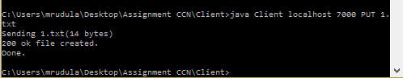

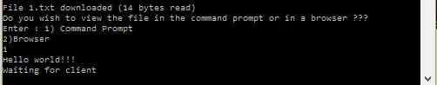

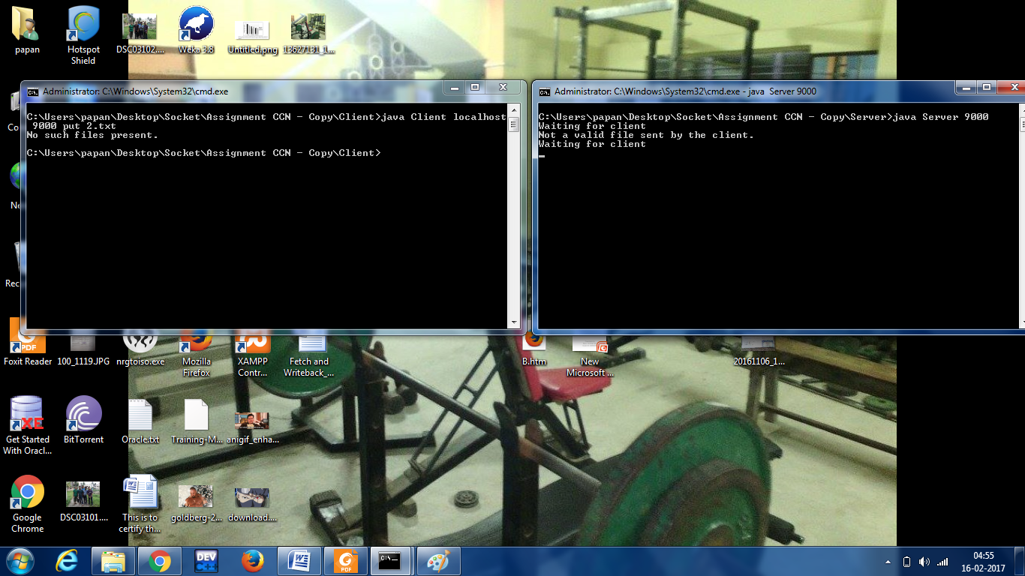

Since it is a multithreaded server it closes every client connection after it is served and it continues to loop to listen for the incoming connection

Another point worth mentioning is that we have devised the code in such a way that if by mistake the user wants to view a .txt file in the browser , the program won’t fail , rather it will prompt the user to enter his choice again. Follow this screenshot below. .Txt files should only be viewed in cmd prompt in our code.

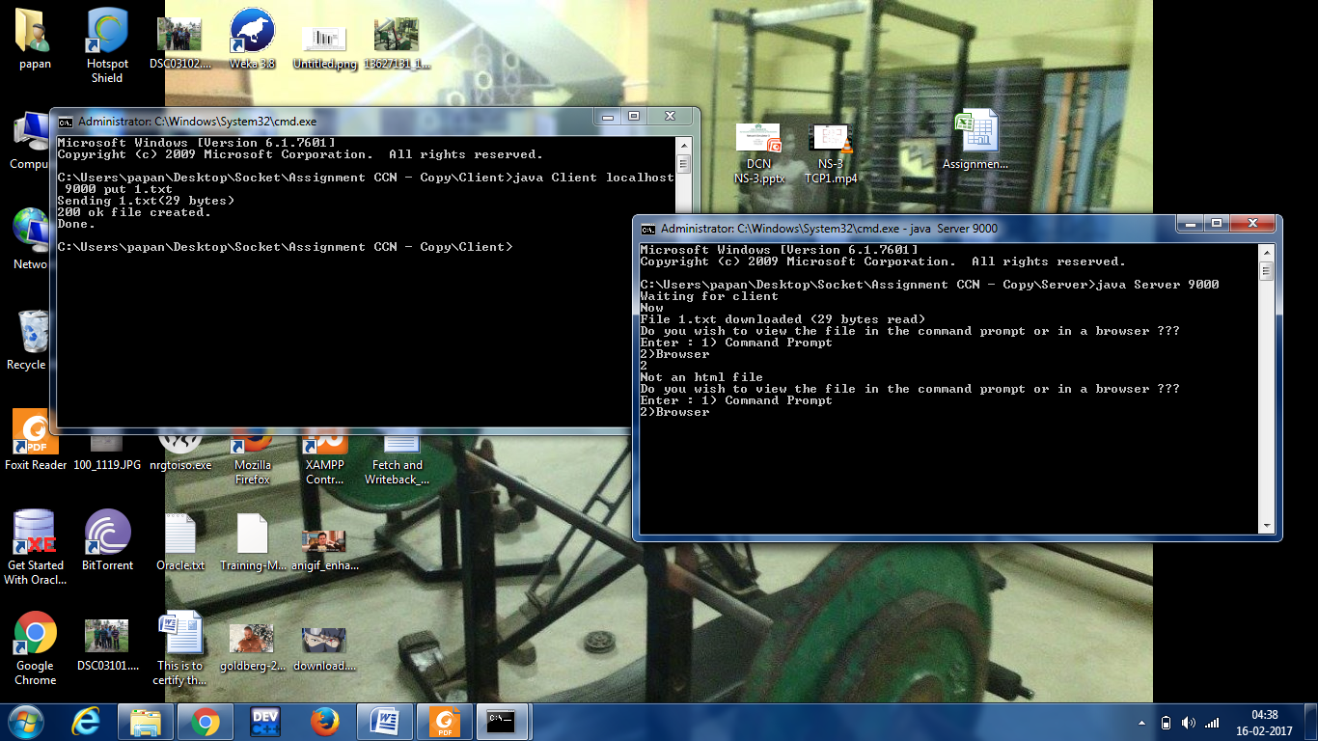

To shutdown server give the following command in the client
java Client <localhost/Ip-Address_Of_Server> <Port No> shutdown server

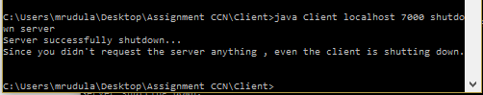

CONCEPT:

The Basic concept of this project is that a client opens up a socket which does a GET or PUT request by creating http header and sending at a port to which server listens too. The code construct http header and sends it via socket. While the socket opens server socket keeps on listening on it based on the request type PUT or GET the server constructs appropriate http response and send it on the port which the client sends the request to. The response of server can range from 404 or 300 or 200. The http request or get is for a file which can be done using file stream methods. The server is multithreaded so as soon as the request arrives it spawns a thread which executes the request and dies.

Improvement:
The improvements can be done by using a timeout too like if a client does not show activity for a while server should disconnect the client.

REFERENCES:
http://www.stackoverflow.com
http://www.javaworld.com/article/2077322/core-java/core-java-sockets-programming-in-java-a-tutorial.html

