Machine Learning Project
CSC 382
Mateusz Rudy

Project Overview
Background:
The genetic code has 64 different codons, composed of 3 nucleotide bases each. Each base has 4 possibilities of Adenine, Uracil, Cytosine, Guanine, thus 4 x 4 x 4 = 64. Sixty-one of these maps to amino acids, while the remaining three ‘UAA’, ‘UAG’, and ‘UGA’ are stop codons. Since there are only about 20 amino acids, the genetic code has redundancy whereby several codons link to the same amino acid. Leucine, Serine, and Arginine stand out with 6 different codons each. Thus, many species exhibit codon usage bias, where certain codons are preferred over others. These biases are valid classifiers of genomic features across the 3 Domains of Life and viruses.
What problem are you trying to solve?
In this study, we seek to build upon existing work by employing additional ML models to perform multi-class classification of organisms into their respective ‘Kingdom’ categories using codon frequencies exclusively. This work aims to compare metrics of previously unexplored models, optimizing their parameters with the goal of providing a net improvement. Additionally, we will use ML algorithms to identify the most significant codon features relevant for classification of organisms.
Why is this problem interesting or important?
Other than being a great entry-point to bioinformatics, this dataset is a ripe candidate for SVM with its high number of features. Improved performance metrics would encourage future genomic research to incorporate SVM. Decision Tree and Logistic Regression
models would likely perform worse but may serve as decent baselines with unique strengths such as optimal feature selection.
What type of machine learning task does it involve?
This task involves supervised, multi-class classification using tuned Support Vector Machines, Decision Trees, and Cross-Validation of the data. Logistic Regression will serve as baseline. If time permits, unsupervised PCA may be explored. Notably, PC1 and PC2 loadings may be compared against Decision Tree results to establish key features driving variance.

Problem Definition
Target variable: ‘Kingdom’ column
Problem Statement
This project aims to develop machine learning models capable of multi-class classification of organisms into their respective “Kingdom” categories using codon frequency data. In addition, the project seeks to identify which codons are most influential in distinguishing between kingdoms.
Objective
- Predict the Kingdom label of an organism using codon usage frequencies
- Compare the performance of multiple machine learning models
  - Logistic Regression, Decision Trees, & Support Vector Machines
- Identify the most important codon features for classification
Hypothesis:
We expect Support Vector Machines to outperform Decision Tree Classifier in Accuracy with scores of 90% to 80% respectively. However, we believe our best Accuracy will not exceed the best Accuracy of existing work by Khomtchouk et al. at 95.02%.
Since classes ‘bct’ and ‘vrl’ have the most entries, we believe their F-1 scores will be the highest.
We also expect codons encoding Leucine specifically to appear among the most important features due to their known variability across organisms.

Dataset Description
Source of the dataset:
Hallee, L. & Khomtchouk, B. (2020). Codon usage [Dataset]. UCI Machine Learning Repository. https://doi.org/10.24432/C5KP6B.
Number of samples: 13028 species within raw dataset codon_usage.csv
Label:
Column 1: Kingdom – The 3-letter suffix of organism as dictated by CUTG database from which dataset was curated. (ex. Sweet potato leaf curl virus [gbvrl] belongs to Kingdom ‘vrl’, a virus.)
Key: ‘bct’ = bacteria; ‘phg’ = bacteriophage; ‘pln’ = plant; ‘inv’ = invertebrate; ‘vrt’ = vertebrate; ‘mam’ = mammal; ‘rod’ = rodent; ‘pri = primate; ‘vrl’ = virus; ‘plm’ = plasmid; ‘arc’ = archaea. Classes ‘plm’ and ‘arc’ were added by researchers who provided this data, totaling 11 classes.
Features:
Column 2: DNAtype - A categorical variable denoted as an integer expressing the genomic composition. The key is as follows:
0:genomic, 1:mitochondrial, 2:chloroplast, 3:cyanelle, 4:plastid, 5:nucleomorph, 6:secondary_endosymbiont, 7:chromoplast, 8:leucoplast, 9:NA, 10:proplastid, 11:apicoplast, and 12:kinetoplast

Column 3: SpeciesID – An integer unique to each species obtained from CUTG database.
Column 4: Ncodons – The sum of all codons present in an organism entry in CUTG. It’s the denominator when calculating codon frequencies in columns 6-69.
Column 5: SpeciesName – The name of the species as a string, with ‘comma’ replaced by ‘space’.
Column 6-69: Unique Codons – 3 letter nucleotide bases (ex. AUG = methionine)
These floats represent codon frequencies for each organism, found by dividing number of occurrences of a codon by Ncodons, effectively normalizing them. Figures match CUTG data.
Description of key variables
Known challenges (missing data, imbalance, noise, etc.):
- Columns 5 and 6 contain non-numeric text, while they ought to be numerical proportions.
- The Kingdom class is imbalanced. For example, there are only 12 plasmid samples.
  - Remove plasmids and be sure to stratify data for training.
- The DNAtype feature is imbalanced. Nuclear DNA includes 9265 entries, Mitochondrial DNA makes up 2899, and Chloroplast DNA has 816. Remaining classes have under 32 samples. Also, it is currently a number that represents a categorical feature, thus implying a ranking. This needs to be addressed through one-hot encoding.
  - Limit the scope of this work to nuclear, mitochondrial, and chloroplast DNAtypes.
- Codon Count (Ncodon column) has exceptionally high variance between ‘Kingdom’ classes. For example, variance of Archaea is nearly 2x the variance of Bacteria.
  - This column may be dropped, as it is already being used in codon frequency calculations. Keeping ‘Ncodon’ may introduce noise, and detracts from the goal of using codon frequencies to classify organisms.

Planned Analysis
Describe how you plan to approach the problem.
The first steps involve pre-processing the dataset. Label encoding may be necessary for the target column ‘Kingdom’ if scikit-learn SVM implementation doesn’t do it automatically. Non-essential columns like ‘SpeciesID’ and ‘SpeciesName’ need to be dropped. A decision must be reached whether to drop columns ‘Ncodon’ and ‘DNAtype’ or retain them for training. Codon columns must be numerical without parsing issues. If retaining ‘DNAtype’, this feature must be One-Hot-Encoded before use with SVM as it is categorical. The 12 plasmids likely should be removed, as well as any DNAtypes not categorized as nuclear, mitochondrial, or chloroplast which limits the scope of this data but is necessary as sample sizes of those categories is small. Since SVM calculates distance between points, feature scaling using StandardScaler will be required for the codon column. If further imbalances exist, we will employ ‘class_weight=’balanced’ in the SVM and Logistic Regression parameters to ensure minority classes aren’t ignored. We will experiment with kernels and C values for SVM and utilize cross validation, likely using GridSearchCV. Exploratory graphs may be included, to highlight things like class imbalance or most relevant features.

Indicate task type:
- Multi-Class Classification will be performed using supervised ML models to assess the efficacy of codon frequencies as numerical proportions and one-hot-encoded categorical DNA types for purposes of ‘Kingdom’ classification.
List the models you plan to use (at least two)
- Support Vector Machines
- Decision Tree Classifier
Identify a simple baseline model
Logistic Regression will be used as a baseline model to verify if relationships between codon frequencies and non-taxonomic ‘Kingdoms’ are linearly separable before applying SVM. Its benefits are speed, and additional insight of relevant codons through the coefficients.
Briefly explain why these models are appropriate
SVM is known for its efficiency in high-dimensional spaces, and this dataset contains at minimum 64 features. Exploring kernel functions and hyperparameters like C provide flexibility which is useful for complex biological relationships to separate non-linear boundaries.
Decision Tree Classifier of scikit-learn will be implemented and assessed for accuracy, but its real purpose is to narrow down important features using the ‘feature_importances_’ attribute which uses the Gini Impurity calculation, thus providing a convenient list of codons to be analyzed in phylogenic research.
Describe how you plan to evaluate performance (metrics)
Overall accuracy will be compared, including weighted and macro where available using ‘accuracy_score’ method. For the highest score, training accuracy will be compared against testing accuracy to ensure the model did not ‘memorize’ data. Metrics like Precision, Recall, and F-1 will be found through ‘classification_report’ method, offering insight beyond Accuracy to identify which ‘Kingdoms’ the model struggled with most. This will be compared against the best models of existing work.

Feasibility and Timeline
Provide a brief plan for completing the project.
Last week: Exploratory Data Analysis – Understand data better (ex. imbalance) & make relevant plots.
This week: Data Prep & Baseline
I will clean the dataset, handle missing values, and implement Logistic Regression baseline. I need to decide whether to keep DNAtype column as a feature. Previous work dropped it. If I keep it, comparisons between accuracy scores may be like comparing apples to oranges.
Next week: SVM Development and Feature Importance
I will implement SVM and perform GridSearchCV to optimize C and gamma parameters across different kernels including linear, rbf, and poly. While doing this, I will jot down interesting observations to include in my final report. Then, I will train Decision Tree Classifier to extract the top 5-10 codons driving classification. A graph and short discussion may be useful.
Week 4: Evaluation and Comparison
I will generate classification reports, compare metrics with existing literature, and finalize the project report. Also, I will ensure the code is ready for submission.

Phase 2
Data Preprocessing
The original dataset contains 13,028 samples, each representing a species with associated codon usage frequencies and metadata.
- Target Variable: Kingdom (11 classes initially)
- Features:
  - 64 codon frequency columns (primary predictors)
  - DNAtype (categorical genomic classification)
  - Metadata (SpeciesID, SpeciesName, Ncodons)

Data Cleaning Steps:
1. Handling Missing & Invalid Data
- Columns such as UUU and UUC contained non-numeric values
- These were coerced into numeric format, with invalid entries converted to NaN
- Rows with missing values in these columns were removed
- Dataset was filtered for duplicates (but none were present)

2. Addressing Class Imbalance
- The ‘plm’ (plasmid) class had extremely low representation (18 samples)
  - This class was removed to prevent instability in model training
  - To compare, the 2nd smallest class was ‘arc’ (archaea) at 126 samples
- Rows with missing values in these columns were removed

3. Filtering DNAtype
- Only the three major categories were retained:
  - Nuclear (0), Mitochondrial (1), and Chloroplast (2)
- Rare DNAtype categories (3-12) were excluded due to insufficient sample sizes.

4. Preventing Data Leakage
- The DNAtype feature was found to be highly correlated with the target variable
  - We noticed Chloroplast DNA was a key indicator of class pln(plant)
- To avoid major leakage, the DNAtype feature was excluded from model training
  - While it is a meaningful feature, it undermined the goal of using codon frequencies.

5. Feature Selection
- Only the 64 codon frequency features were retained
- Metadata columns (SpeciesID, SpeciesName, Ncodons) were removed
  - Ncodons was excluded since codon frequencies are already normalized

6. Label Encoding
- The categorical target variable ‘Kingdom’ was encoded numerically using LabelEncoder.
  - While models used accept strings & convert internally, explicit encoding allows for greater insight such as loss function calculations.
7. Feature Scaling
- Standardization (Z-score normalization) was applied. This centers the data around a mean of 0 with a standard deviation of 1. This is essential for SVM & Logistic Regression, ensuring features contribute equally to distance-based calculations.
  - Otherwise, features with high variance or large scales may dominate the results.
  - PCA is variance-based thus also benefits from standardization. It’s required.
    - No bias toward large numbers, and improves algorithm performance

After pre-processing, the dataset included 12,962 samples and 64 features.
Target variable distributions:
‘bct’ = 2917 | ‘vrl’ = 2831 | ‘pln’ = 2490 | ‘vrt’ = 2077 | ‘inv’ = 1334
‘mam’ = 572 | ‘phg’ = 220 | ‘rod’ = 215 | ‘pri’ = 180 | ‘arc’ = 126

Model Development
1. Logistic Regression (Baseline)
- While our objective is not binary classification, this model can be adapted to multi-class problems to help determine whether our 10 classes are linearly separable.
- Hyperparameters were tuned to ensure a fair comparison with more complex models.
- Model coefficients may offer insight into feature importances.
Justification:
This model is a fast, interpretable baseline for comparisons.

2. Support Vector Machines
- This model is our primary focus, selected for its strong performance in high-dimensional spaces. Despite its slower training time, this model offers flexibility to explore kernel functions like RBF to capture non-linear relationships.

Justification:
SVM’s are effective for complex, nonlinear boundaries & high-dimensional data, making them suitable for this dataset. While requiring more computing time than Logistic Regression, the cleaned-up dataset consisting of just 12962 samples is quite modest, thus SVM training shouldn’t take too long.

3. Decision Tree Classifier
- We used this model for interpretability rather than performance.
- Feature importance stats were calculated using Gini Impurity metrics, allowing identification of the most influential codons driving class divides.
Justification:
Decision Trees offer transparency and feature importance insights, while being fast to compute.
Training and Validation
Train-Test Split:
- The data was split into 80% training & 20% testing sets.
- Stratification was also used to preserve class distribution.
Cross-Validation & Hyperparameter Tuning:
Logistic Regression:
- Although Logistic Regression serves as a baseline model, its hyperparameters (regularization strength and class weighting) were optimized using GridSearchCV with 5-fold cross-validation. This ensures that performance comparisons across models are fair and not biased by differences in tuning. The parameters involved included:
  - Regularization strength C
  - Class weighting (None, balanced)
  - 5-fold cross-validation
- The Macro F1-score was considered during optimization, to account for class imbalance.
Support Vector Machines:
- Hyperparameters were tuned using GridSearchCV with 5-fold cross-validation
- The parameter grid includes:
  - Regularization parameter C
    - Low C equates to large margin, at cost of some misclassification.
    - Low C thus encourages generalization & reduces risk of overfitting.
  - Kernel type (linear and RBF)
  - Gamma (for non-linear kernels specifically, such as RBF or Gaussian)
  - Class weighting (None, balanced)
- The Macro F1-score was also considered during optimization, to account for class imbalance.
Decision Tree:
- Hyperparameters were also tuned using GridSearchCV with 5-fold cross-validation
- The parameter grid includes:
  - criterion
  - max_depth
  - min_samples_split
  - class_weight
- The Macro F1-score was also considered during optimization, to account for class imbalance.

Evaluation
Model performance was evaluated using a combination of metrics to provide a comprehensive understanding of classification efficacy.
- Accuracy – This measures the ratio of correct predictions to the total number of samples, which can be misleading for imbalanced datasets like this one.
- Found within the classification_report are metrics like Precision, Recall, and F1-score, evaluated per class. Below we explain their significance:
- Precision – This focuses on the quality of positive guesses, thus is best suited for scenarios where the cost of false positives is high such as binary classifications (spam vs not spam). While insightful, precision doesn’t seem more meaningful than other metrics for our work.
- Recall – Known as ‘sensitivity’, this metric focuses on the ability to find all positives by incorporating false negatives in addition to true positives in the denominator. This metric is vital where the cost of a false negative is high, such as a medical diagnosis. Phages, a subcategory of viruses, had a low recall of 0.84 compared to virus recall of 0.99 indicating that some instances of phage were missed by the SVM model. Phage precision, meanwhile, remained high at 0.88. The lowest recall observed came from the Decision Tree regarding primates at 0.36. Unlike Logistic Regression and SVM, the Decision Tree had higher sensitivity to rodents than precision scores at 0.65 and 0.54, respectively. More rodents were caught, but the accuracy of positive predictions suffered.
- Macro F1-score:
  - Given the multiclass and imbalanced nature of this dataset, we believe the Macro F1 score to be the most representative metric of how well SVM performed for each specific group. It is the harmonic mean of precision and recall, meaning it penalizes extreme values within the prior metrics. Values range from 0 to 1, whereby 1 means all samples were classified correctly in accordance with the target.
  - Macro F1 assigns equal importance to all classes, making it more appropriate than accuracy for imbalanced datasets such as this.
Logistic Regression Performance
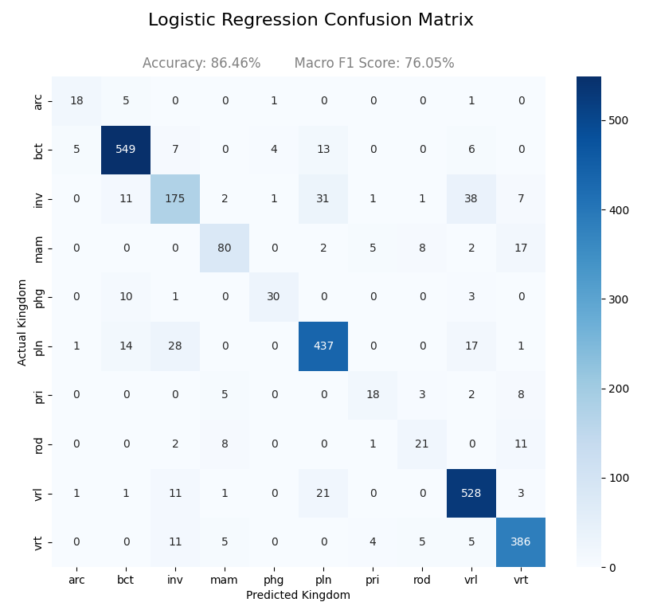
Our baseline Logistic Regression model was used to evaluate whether our classification problem is linearly separable.
While standard logistic regression uses the Sigmoid function to output a probability between 0 and 1, the application of logistic regression for 10 classes facilitates the use of a Softmax function that ensures the sum of probabilities across all classes equals 1. Optimal hyperparameters were found to be C = 1 and ‘class_weight’ set to ‘None’ despite the imbalance between classes.
The model achieved strong overall accuracy at 86%, indicating codon usage contains ample signal strength for classification. However, performance varied across classes, particularly for underrepresented groups like primates and rodents. At a reduced 76% macro F1-score, linear boundaries may be insufficient to fully separate all Kingdoms, especially sub-groups of eukaryotes.
The confusion matrix visualization shows that high-frequency classes such as bct (bacteria) and vrl (virus) were classified with high precision and recall. In contrast, lower-frequency classes such as pri (primate) and rod (rodent) exhibited more misclassification. The classification report further highlights this imbalance, with lower F1-scores observed for most minority classes. While a trend, it is not universal. Class vrt (vertebrate) had higher metrics than class pln (plant) despite there being more support for plants (498) than for class vertebrate (416). Likewise, mammals had higher F1-scores than invertebrates despite lower support at 114 to 267 samples, respectively.
Support Vector Machine Performance
The Support Vector Machine (SVM), tuned via GridSearchCV, achieved the best overall performance among the models tested. Optimal hyperparameters include C set to 10, RBF kernel, gamma at scale, and class weight set to none. As with baseline, this last parameter surprised us because we expected class weight to be balanced for best results. The increased C value reflects the SVM’s priority to classify all training points correctly rather than finding a smooth decision boundary. Overall, SVM demonstrated higher accuracy (95.30%) and macro F1-score (89.38%) compared to Logistic Regression. Manually setting the class_weight = ‘balanced’ in an attempt to prioritize minority classes saw a macro F1 increase and overall accuracy increase by less than 0.01 yet this change negatively impacted some minority classes. For example, phage precision fell from 0.88 to 0.83 resulting in a lower F1 score of 0.84, while rodent & mammal F1 scores stayed constant at 0.84 & 0.87, respectively.
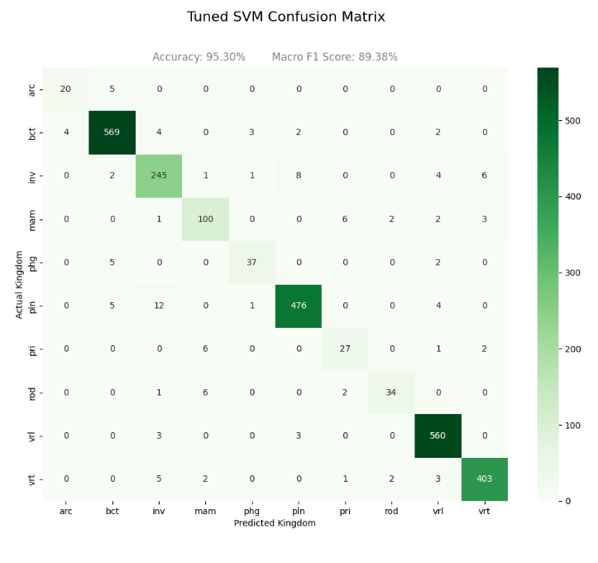

Improvements were especially noticeable in mid-sized classes like inv (invertebrates) and mam (mammals). Invertebrate F1-scores increased from 0.70 to 0.91 when using the SVM. This was amplified further in rare classes like rodents and primates. The most striking difference was in rodents, whose Logistic Regression F1-score increased from 0.52 to 0.75, marking a 44% improvement.
A close look at the confusion matrix reveals a stronger diagonal dominance compared to Logistic Regression, indicating improved classification across ‘Kingdoms’. In fact, more organisms were classified correctly by SVM than the baseline across each of our 10 classes, with the smallest improvement being arc (archaea) from 18 to 20 of the total 25 support samples. The classification report heatmap suggests a more balanced spread of F1-scores across all ‘Kingdoms’ and a noticeably reduced performance gap between the majority and minority classes.
Model Comparison
A direct comparison of per-class F1-scores between Logistic Regression and SVM shows the latter outperforming the former across all ‘Kingdoms’. As stated, classes with moderate representation like invertebrates and mammals saw the largest improvements. While primate and rodent classification improved greatly, these rare classes remain the weakest point for SVM. The metrics for strong-performing and abundant classes like bct (bacteria) and vrl (virus) remain high across both models.
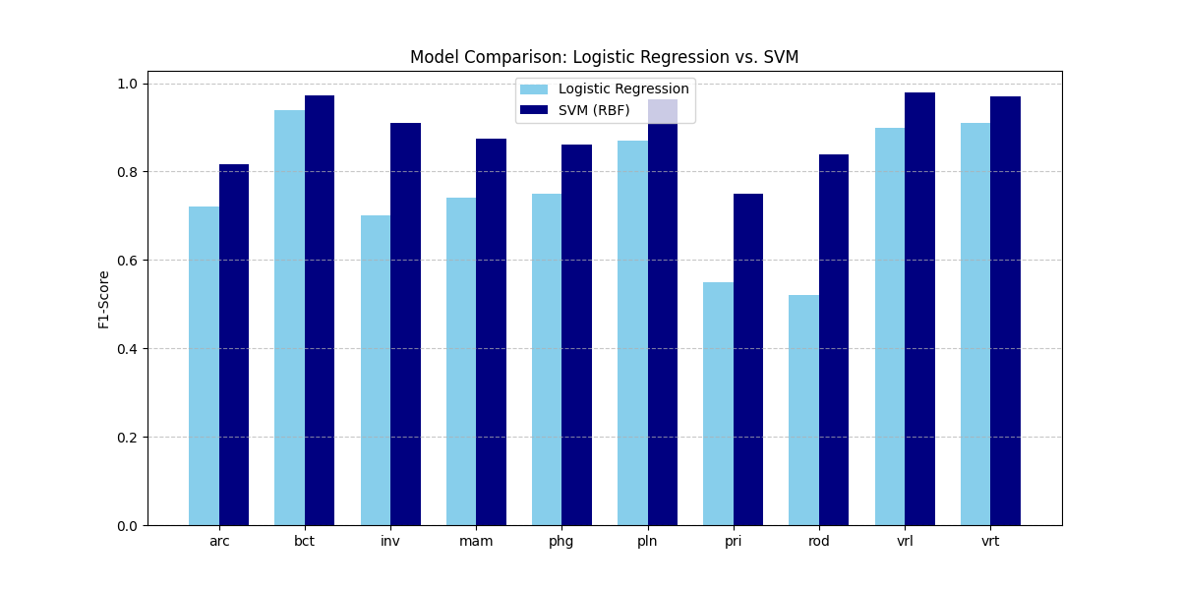
This comparison demonstrates that SVM is better able to capture non-linear relationships in codon usage patterns, particularly for organisms with recent evolutionary splits in terms of geologic time. SVM has captured the nuances of primate, rodent, and phage codon usage, relative to generic mammal and virus classes, much better than Logistic Regression.
Prior to SVM tuning, we experimented with a C value of 1, gamma set to ‘scale’, radial bias function as the kernel, & random_state set to 42. These initial parameters yielded SVM overall accuracy of 93.68% with primates’ and rodents’ F1-scores significantly improved over Logistic Regression at 0.62 and 0.72, respectively.
Therefore, we believe the RBF kernel of SVM is better suited to capture nonlinear relationships of overlapping classes, despite the signal being partially linearly separable.

In the classification reports below, we see the unoptimized SVM outperform the tuned baseline:
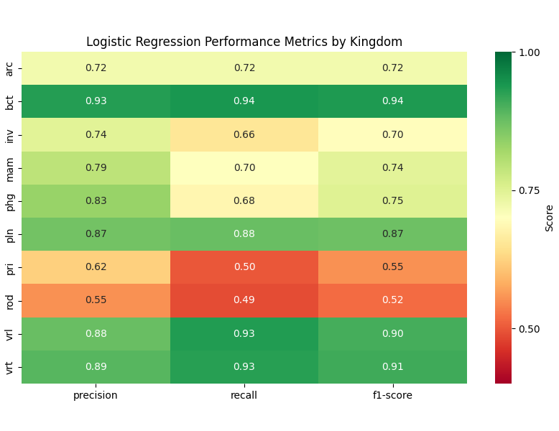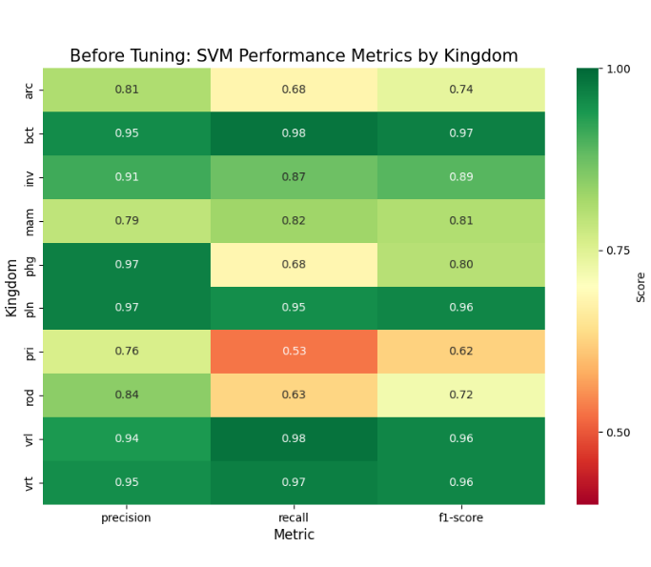
After tuning, overall accuracy improved further to 95.30%, while the macro average rose to 89% from 84%. The F1-scores of primates greatly improved from 0.62 to 0.75, while rodent F1-scores also jumped from 0.72 to 0.84. Considering the low sample count & close evolutionary relationships with the broader mammal category, this was a surprisingly good result. The higher C value with its heavy penalization for misclassifications led to a narrow margin & complex decision boundary which allowed the model to define these elusive kingdoms thus capturing their unique evolutionary fingerprint.
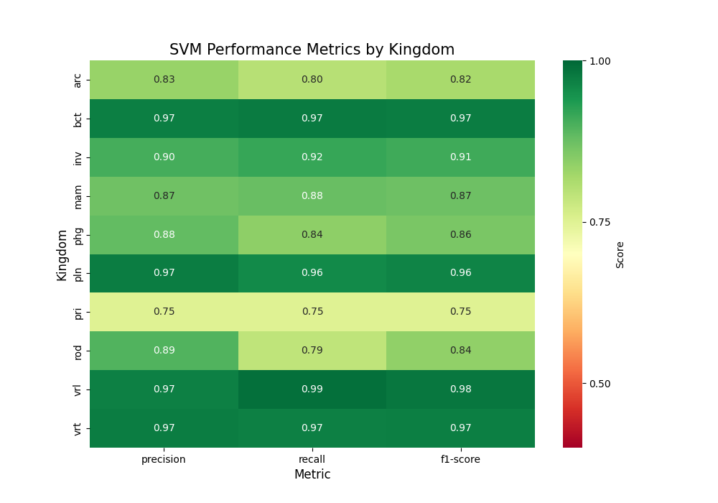
Decision Tree Performance
The Decision Tree model achieved lower test accuracy of 74.82% compared to SVM and Logistic Regression and a Macro F1 score of just 63.61%. Training accuracy was significantly higher than testing accuracy, indicative of overfitting. The gap between test and training accuracy was profound at 0.2518. For comparison, SVM had a gap of only 0.0426 thus suggesting strong generalization in comparison. To confirm, we graphed validation curves that saw training accuracy increase with tree depth but stagnate, or in some cases, decrease during cross-validation runs.
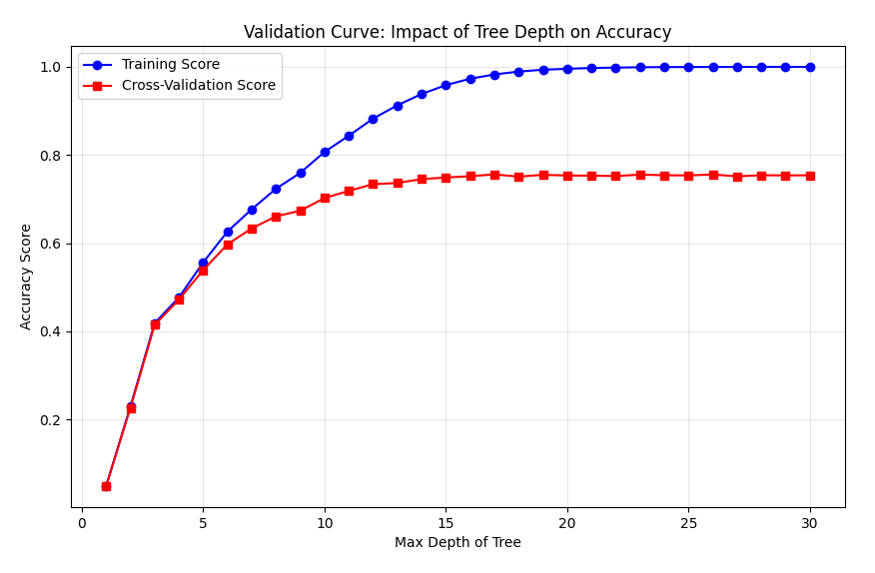
Our findings show Decision Trees to be highly prone to overfitting in high-dimensional spaces when allowed to grow excessively, memorizing noise in training data but generalizing poorly to new data.
Despite lower predictive performance, the Decision Tree provided valuable interpretability. While our SVM is a black box, Decision Trees are white box models that use simpler if-else statements.

Feature importance analysis identified the top 10 most influential codons. These codons contribute strongly to classification decisions and may reflect underlying biological differences between taxa.

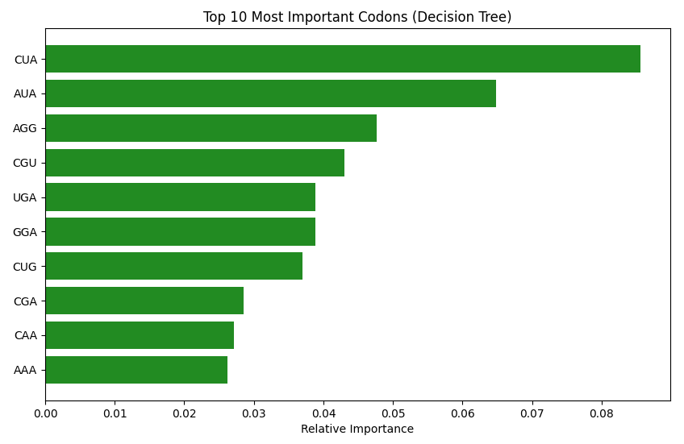

Overfitting Analysis
Of the three models, Decision Tree exhibited the largest accuracy gap between training and test data at 0.2518 as mentioned. With ‘max_depth’ tuned to None, this model is certainly overfitting. Logistic Regression had the lowest accuracy gap at just 0.0056 thus appears to be generalizing well to unseen data rather than memorizing it like the Decision Tree results. We checked the mean cross-validation macro F1 score for Logistic Regression and found it to be 0.7611. The lower F1 score highlights the prevalent class imbalance. In future work we may explore the change in macro F1 scores between training and validation, as the regularization parameter C changes. For now, we believe Logistic Regression has minimal overfitting. In contrast, the SVM shows a training-test gap of 0.0426, hinting at data memorization. The high C value is likely a primary factor here, as it favors a high-variance hyperplane that closely fits training outliers. Despite this, we believe SVM strikes the best balance between memorization and generalization as observed in the bar chart below.

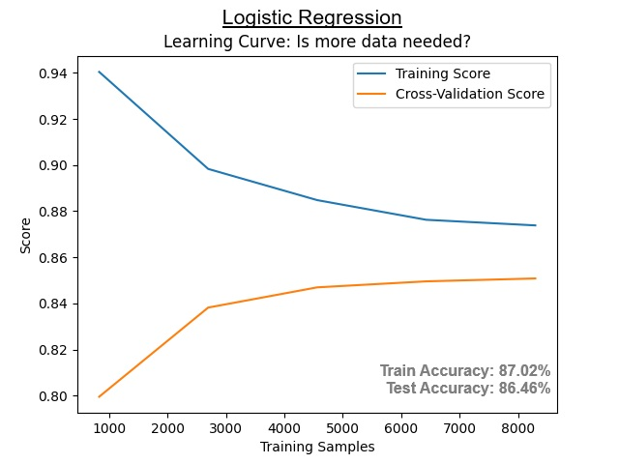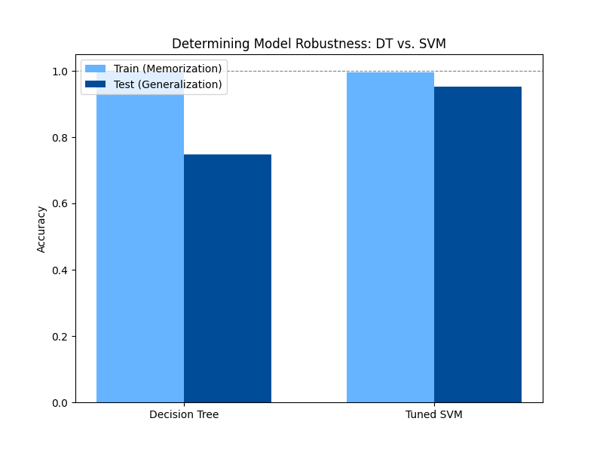

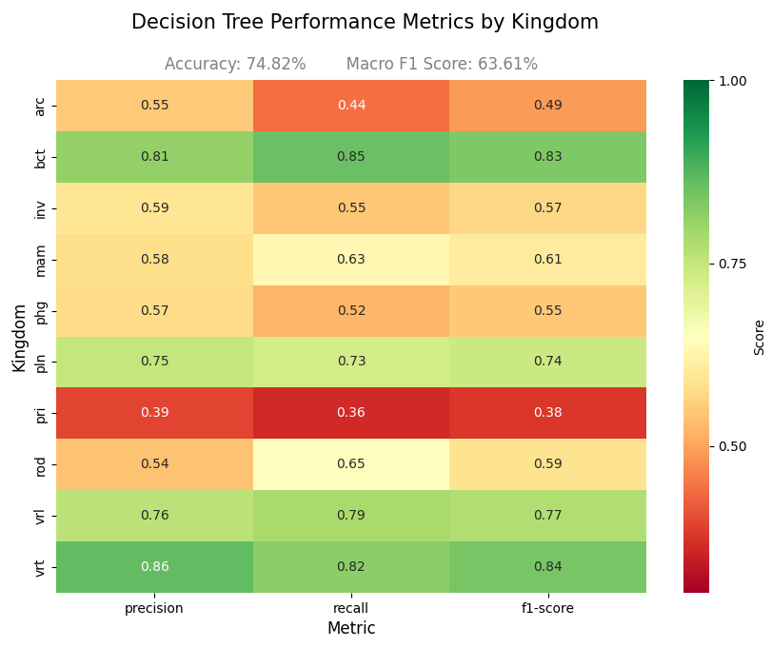
Decision Tree Discussion
The red bands of this classification report are, we believe, indicative of the class imbalance and overlapping feature distribution which plagued the Decision Tree particularly hard, leading to poor recall of class archaea, primate, and phage.
Additionally, we were pleased to find the top 10 features to include two codons encoding Leucine, as hypothesized in our proposal. In fact, the ‘CUA’ variant of Leucine ranked as the top feature of highest importance. The second of 6 possible Leucine codons, ‘CUG’ in this case, can be seen ranked as the 6th most important feature. Isoleucine (AUA) and Arginine (AGG) ranked 2nd and 3rd, but the fascinating highlight was the stop codon ‘UGA’ in 5th. We wish to explore PCA loadings in the future to verify the significance of this feature as a classification tool. In summary, our findings mostly align with current scientific consensus, as leucine and arginine codon preferences are known to vary across kingdoms.
SVM Discussion
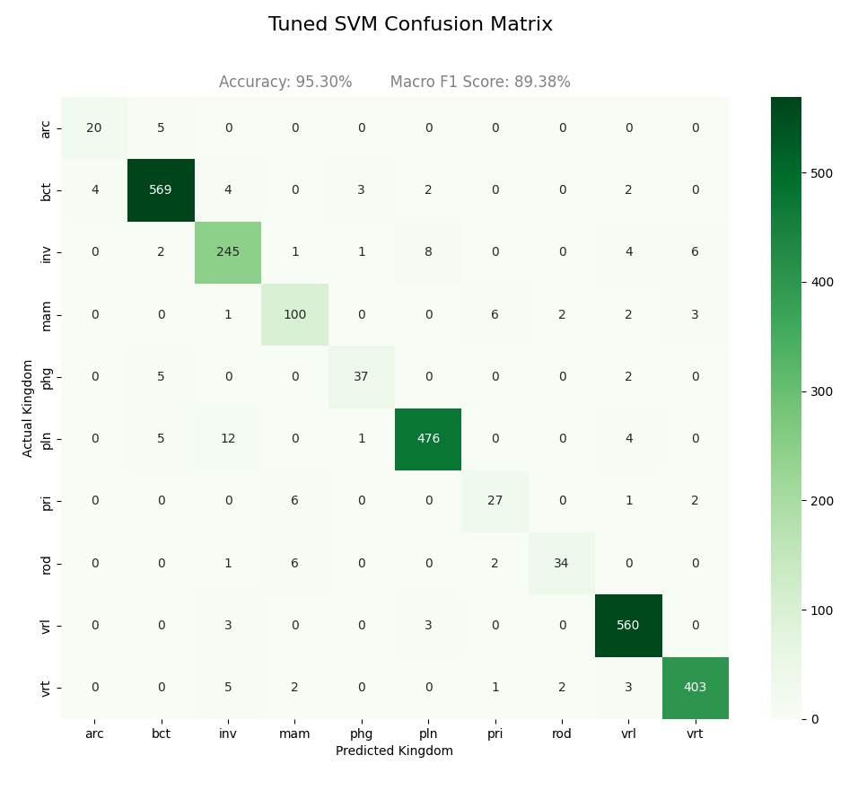
In the SVM Confusion Matrix it is apparent that viruses and bacteria have almost zero cross-contamination with eukaryotic organisms.

There were 8 instances of invertebrates misclassified as plants, and 12 cases of plants misclassified as invertebrates.

Interestingly, 6 primates and 6 rodents were misclassified as mammals despite technically being mammals.

As subcategories, their codon usage frequencies must be very similar which makes sense given their relatively recent evolutionary splits.

The majority of misclassifications affecting SVM accuracy are found within the ‘Kingdoms’ of mammals, vertebrates, primates, and rodents. We believe this demonstrates that mammalian codon usage is a gradient rather than a hard line.

The SVM classification report depicts viruses (vrl), bacteria (bct), plants (pln), and vertebrates (vrt) as dark green across all metrics, highlighting their distinctive signatures in terms of codon usage.
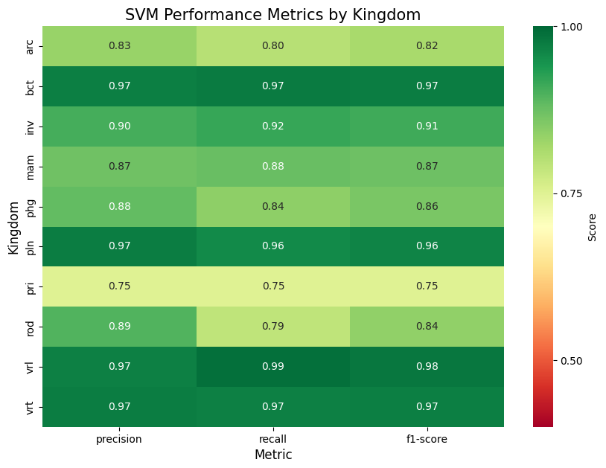
As expected, primates fared worst at 0.75 for all metrics while rodents showed 0.89 precision coupled with 0.79 recall with an F1 score of 0.84.

Archaea (arc) metrics were surprisingly poor at 0.82 for the F1 score, but given the context of merely 25 support samples it makes sense.

Phages, a subset of viruses, were misclassified more than viruses with F1 scores of 0.86 and 0.98 respectively.

Like before, this difference is likely magnified by the low number of phage samples (44), relative to the 566 viral samples.
The existence of sub-categories in this dataset also exacerbates the problem, as seen in the overlap within mammals and likewise with phages.
Additional Thoughts:
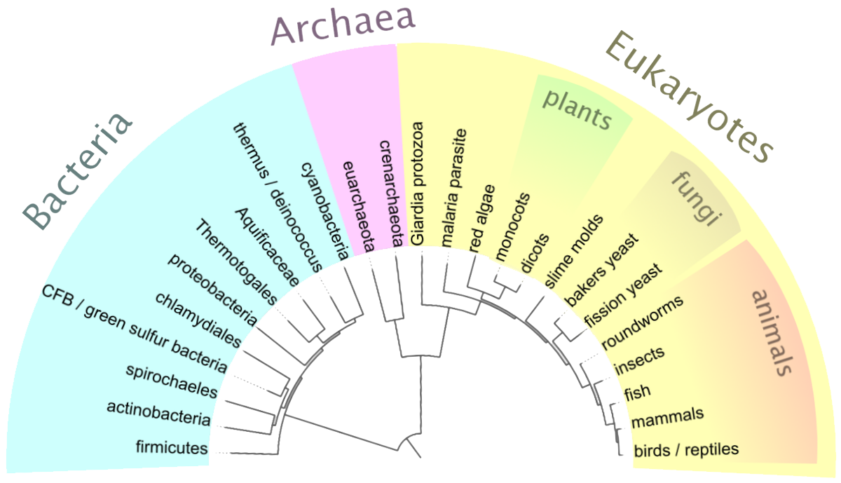
Source: Ramalho ’25 Bio 412

It was surprising to see the models struggle more with archaea than plants, given that archaea make up one of three domains of life, alongside bacteria and eukaryotes. Their evolutionary split is much more distant at an estimated 3.5 to 4 billion years ago. For comparison, the taxonomic Kingdom Plantae of Domain Eukarya is estimated to have diverged just 1.5 billion years ago.
We believed codon frequencies of Domain Archaea would stand out, but the testing data was limited to just 25 samples while plant samples were abundant at 498. We stand by the 80-20 train-test split for this dataset, but future work should include more samples of archaea and a broader attempt to balance the dataset.
Encountered Roadblocks:
At first, I one-hot encoded DNA_type appending them as features. After DecisionTree Classifier returned ‘Chloroplast’ as the 7th most important feature, I realized there was data leakage if the goal is to use codon frequencies alone in identifying biological ‘Kingdoms’. Since chloroplasts are specific to plants and algae, the model recognized this connection. To confirm the existence of this problem, the Chi-Square result between ‘Kingdom’ and DNA_2 was 3641 with p-value of 0 and 9 degrees of freedom. Therefore, Kingdom and DNA type are not independent. Cramer’s V value returned 0.5307 indicating a moderate to strong relationship between the chloroplast feature and plant kingdom samples. I expected the correlation to be a 1.0 perfect linear relationship, but plants have multiple DNA types. In addition to circular chloroplast DNA, they also contain nuclear DNA as members of Domain Eukarya.
While it made sense to limit the scope of this work to DNA of nuclear, mitochondrial, and chloroplast origin as these sample sizes were large, retaining this categorical information as features during initial training was a mistake. Fortunately, this was caught early on and resolved. Unfortunately, we had to eliminate our PCA analysis after seeing mitochondrial DNA in the top 5 features driving PCA2.
Conclusions
Our results demonstrate that codon usage frequencies are strong predictors of the respective ‘Kingdoms’ that biological organisms belong to. While the overfit Decision Tree performed worse than expected in our hypothesis at 74.82% overall accuracy, our SVM results performed the best. At 95.3%, not only did the model exceed our hypothesis of 90% but it also surpassed the results of prior work (95.02%) which used Extreme Gradient Boosting.
Our hypothesis regarding the best F1 scores obtained from majority classes like ‘bacteria’ and ‘virus’ was correct for SVM at 0.97 and 0.98 respectively, but vertebrates tied bacteria at 0.97 with plants trailing at 0.96. The hypothesis was not correct, by a slim 0.01 margin, for Logistic Regression which saw highest F1 scores in class vrt (vertebrate) and bct (bacteria). Likewise, the Decision Tree performed best with bacteria and vertebrates.

Ethical Considerations:
This project uses the codon usage dataset from UCI Machine Learning Repository which is publicly available. The dataset has no personally identifiable information or human subject data, thus does not raise privacy concerns. Despite high accuracy, these models’ predictions should not be interpreted as definitive biological classifications. A risk exists that results may be overgeneralized. Additionally, the dataset is imbalanced thus models tend to favor majority classes. To address this, stratified sampling was applied, macro F1-scores were prioritized, and class weighting was explored.

Future work:
Rather than looking at frequencies of 64 codons to aid classification, future work could examine codon usage bias more closely by engineering features for amino acids such as Leucine, whose codons were deemed influential by our Decision Tree results (and excluded PCA data). Since the ‘CUA’ variant of Leucine was the singular most important feature for Decision Tree results, and the ‘CUG’ variant of Leucine ranked 3rd in our dropped PC2, one could engineer a feature depicting the ratio of ‘CUA’ and ‘CUG’ within a sample organism. Streamlining dimensions in this way might eliminate excess noise and provide better results. From prior work, it appears the target macro F1-score to exceed is 0.966.
Acknowledgements:
Resources guiding our code implementation include lecture material covered in CSC 382, with particular emphasis on Homework 4 (hyperparameter tuning across models and overfitting), the Feature Engineering notebook showing pre-processing steps and PCA, and the Iris Classification lecture notebook covering metric interpretation. We'd also like to thank scikit-learn.org for providing ample documentation for tasks like plotting and analyzing specialty graphs like Validation Curves. Troubleshooting technical issues related to figure output and excessive warnings affecting legibility were resolved with Google. Biological insight and imagery like evolutionary timelines came from Bio 412 (Organic Evolution), the physical textbook Microbiology: An Evolving Science 6e by Slonczewski, and prior research which can be found at:
https://www.biorxiv.org/content/10.1101/2020.10.26.356295v1.full.pdf

To reproduce results, please check the README.md inside the project directory.

