Mruganshi Gohel

B20CS014

Lab-2

| import numpy as np from cvxopt import matrix, solvers import random from pandas.core.common import flatten |
| --- |

Question-1

* *Step -1: Function define*

| def f(x):  return (x[0] - 4)**2 + (x[1]- 4)**2 |
| --- |

| x0 = np.array([-0.5 * 4, 1.5 * 4]) f(x0) |
| --- |

* *Step 2: Find the Gradient and hessian of the given function*

| def grad_hess_f(x):  f0=f(x)  n=len(x)  h= 10**(-5)  b=np.zeros(n)  g=np.zeros(n)  H=np.zeros((n,n))  for i in range(0,n):  x1=x.copy()  x1[i]=x1[i]+h  b[i]=f(x1)  g[i]=(f(x1)-f0)/h  for i in range(0,n):  for j in range(0,n):  x2=x.copy()  x2[i]=x2[i]+h  x2[j]=x2[j]+h  H[i][j]=(f(x2)-b[i]-b[j]+f0)/h**2  return g,H |
| --- |

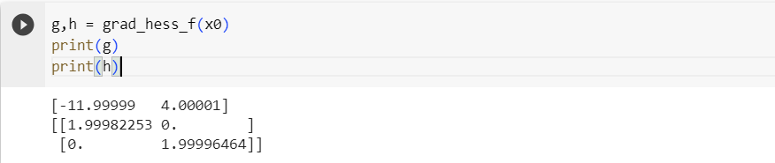

* *Step-3: Find Eigen values of hessian matrix*

| np.linalg.eig(h) |
| --- |

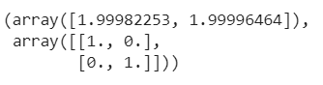

***Eigenvalues are positive and hence it is positive definite and the function is a convex function***

* *Step-4: if Hessian matrix is positive definite then find the optimal solution*

| A=np.vstack((-np.identity(2),np.identity(2))) lb=[-2*4,-2*4] ub=[2*4,2*4] b=np.append(x0-lb,ub-x0) |
| --- |

| soln= solvers.qp(matrix(h),matrix(g),matrix(A),matrix(b)) print(np.round_(soln['x'],decimals=5),soln['primal objective']) v1_11=np.round_(soln['x'],decimals=5) |
| --- |

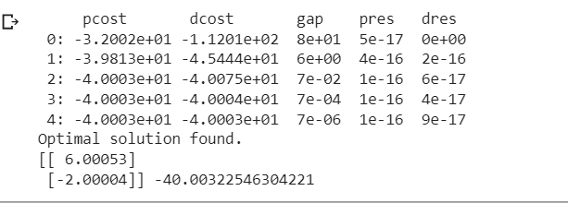

*Solution Correctness Check: if* ***dot product of gradient and optimal solution*** *is coming out* ***negative*** *then solution is correct (as said in the lab lecture by sir)*

| v1_11=list(flatten(v1_11)) v2_11=list(g) np.dot(v2_11,v1_11) |
| --- |



Question-2

* *Step-1: function defining as per question and taking dimension as 10 in input*

| import numpy as np  #function f1 def f1_1(x):  n = len(x)  I1 = [i for i in range(2, n+1) if i % 2 == 1]  denominator = len(I1)  result = x[0]  for i in I1:  result += ((x[i-1] - np.sin(6 * np.pi * x[0] + (i * np.pi / n)))**2 )*(2/(denominator))  return result  #function f2 def f2_1(x):  n = len(x)  I2 = [i for i in range(2, n+1) if i % 2 == 0]  denominator = len(I2)  result = 1 - np.sqrt(x[0])  for i in I2:  result += ((x[i-1] - np.sin(6 * np.pi * x[0] + (i * np.pi / n)))**2 )*(2/(denominator))  return result  # taking random 10 values for input in the range given in the question x1=[] x1.append(random.uniform(0.001, 1)) for i in range(9):  x1.append(random.uniform(-1, 1)) print("f1:", f1_1(x1)) print("f2:", f2_1(x1)) |
| --- |



**Optimal Solution Procedure for F1**

* *Step-2: gradient and hessian find for f1*

| def grad_hess_f1_1(x):  f0=f1_1(x)  n=len(x)  h= 10**(-5)  b=np.zeros(n)  g=np.zeros(n)  H=np.zeros((n,n))  for i in range(0,n):  x1=x.copy()  x1[i]=x1[i]+h  b[i]=f1_1(x1)  g[i]=(f1_1(x1)-f0)/h  for i in range(0,n):  for j in range(0,n):  x2=x.copy()  x2[i]=x2[i]+h  x2[j]=x2[j]+h  H[i][j]=(f1_1(x2)-b[i]-b[j]+f0)/h**2  # solver.qp()  return g,H |
| --- |

| g1_1,h1_1 = grad_hess_f1_1(x1) print(g1_1) print(h1_1) |
| --- |

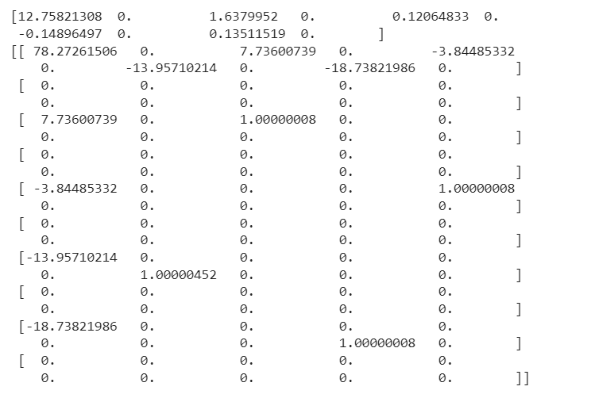

* *Step-3: Eigen value finding for hessian matrix of f1 and check if all are positive or not if positive find optimal solution else make hessian positive and find optimal solution*

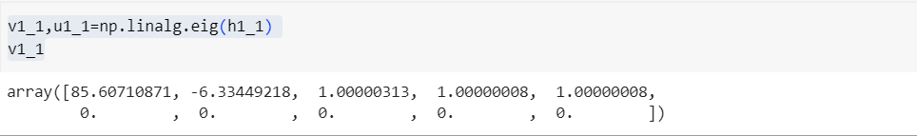

*Hessian is not positive definite and hence to find optimal solution we have to make it positive definite by following below formula.*

* *Step-4: New Heassian FInding*

| *newH1_1 = h1_1@h1_1 + (0.001-min(v1_1))*np.identity(10, dtype = float) np.linalg.eig(newH1_1)* |
| --- |

**

*As we can see above for new hessian matrix eigen values are coming out positive and hence we have positive definite hessian matrix and using this we will find optimal solution*

* *Step5: FInd Optimal Solution*

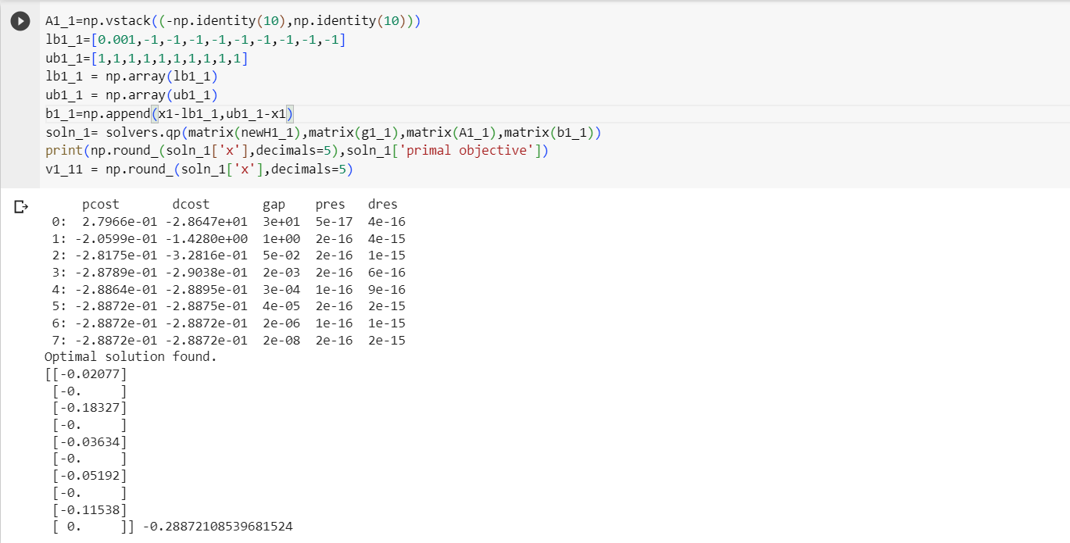

***Solution Correctness check***

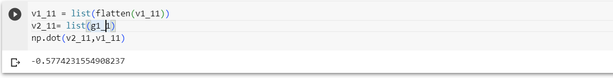

***Optimal Solution Procedure for F2***

* *Step-2: Gradient and Hessian finding*

| *def grad_hess_f2_1(x):  f0=f2_1(x)  n=len(x)  h= 10**(-5)  b=np.zeros(n)  g=np.zeros(n)  H=np.zeros((n,n))  for i in range(0,n):  x1=x.copy()  x1[i]=x1[i]+h  b[i]=f2_1(x1)  g[i]=(f2_1(x1)-f0)/h  for i in range(0,n):  for j in range(0,n):  x2=x.copy()  x2[i]=x2[i]+h  x2[j]=x2[j]+h  H[i][j]=(f2_1(x2)-b[i]-b[j]+f0)/h**2  # solver.qp()  return g,H* |
| --- |

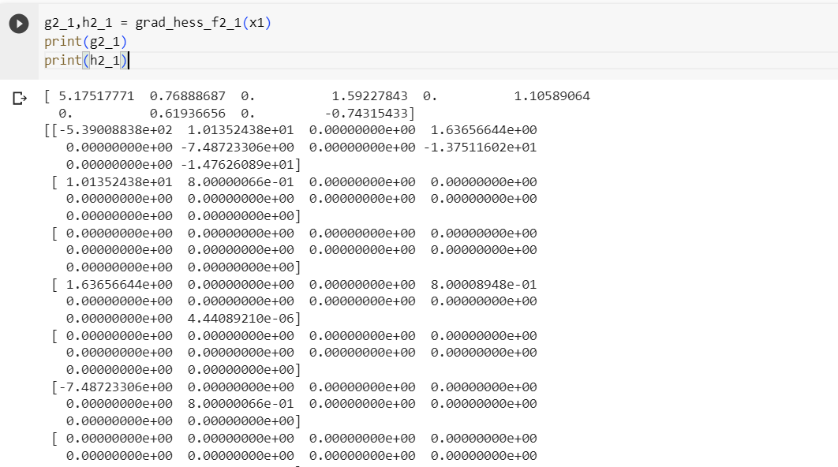

* *Step-3: Eigen values find*

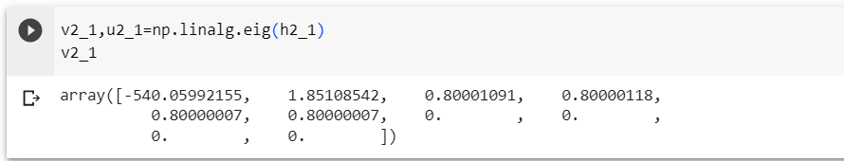

*not positive deifnite matrix*

* *Step-4: Find transformed hessian and its eigen values*

| *newH2_1 = h2_1@h2_1 + (0.001-min(v2_1))*np.identity(10, dtype = float) np.linalg.eig(newH2_1)* |
| --- |

*All eigen values are positive and so now we have positive definite hessian to find optimal solution*

* *Step-5: Optimal solution*

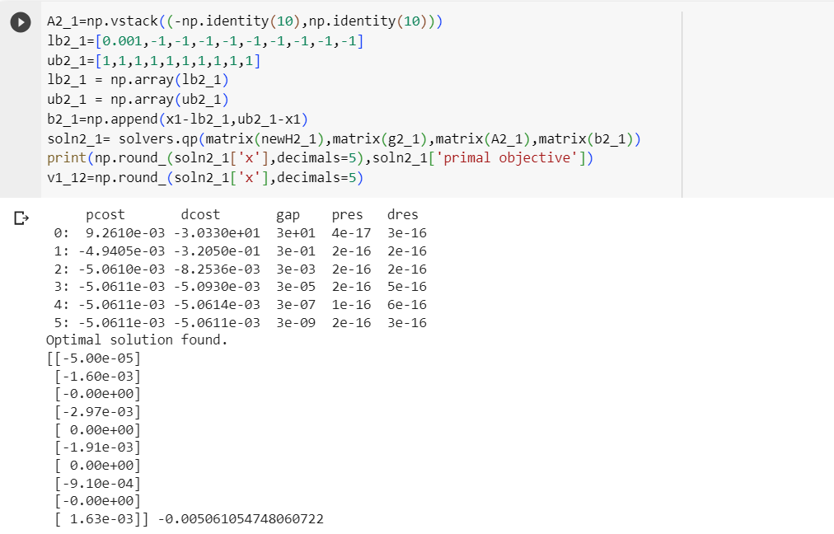

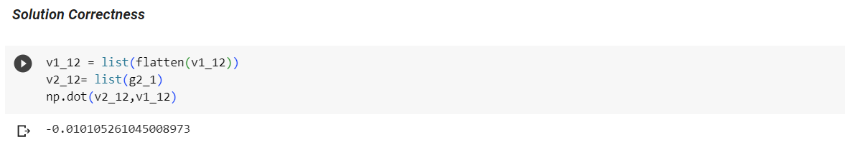

Question-3

* *Function Definition*

| def yi_3(i,x):  n=len(x)  if(i%2==1):  return x[i-1]-((0.3* ((x[0]**2)*np.cos((24 * np.pi * x[0])+(4*i*np.pi / n))) + 0.6*x[0])*(np.cos((6 * np.pi * x[0]) + (i* np.pi / n))))  else:  return x[i-1]-((0.3* ((x[0]**2)*np.cos((24 * np.pi * x[0])+(4*i*np.pi / n))) + 0.6*x[0])*(np.sin((6 * np.pi * x[0]) + (i* np.pi / n))))   def f1_3(x):  n = len(x)  I1 = [i for i in range(2, n+1) if i % 2 == 1]  denominator = len(I1)  result = x[0]  for i in I1:  result += (yi_3(i,x)**2)*(2/(denominator))  return result  def f2_3(x):  n = len(x)  I2 = [i for i in range(2, n+1) if i % 2 == 0]  denominator = len(I2)  result = 1 - np.sqrt(x[0])  for i in I2:  result += (yi_3(i,x)**2)*(2/(denominator))  return result   x3=[] x3.append(random.uniform(0.001, 1)) for i in range(9):  x3.append(random.uniform(-1, 1)) print("f1:", f1_3(x3)) print("f2:", f2_3(x3)) |
| --- |

***F1 Solution Finding***

* *Gradient and Hessian Finding*

| *def grad_hess_f1_3(x):  f0=f1_3(x)  n=len(x)  h= 10**(-5)  b=np.zeros(n)  g=np.zeros(n)  H=np.zeros((n,n))  for i in range(0,n):  x1=x.copy()  x1[i]=x1[i]+h  b[i]=f1_3(x1)  g[i]=(f1_3(x1)-f0)/h  for i in range(0,n):  for j in range(0,n):  x2=x.copy()  x2[i]=x2[i]+h  x2[j]=x2[j]+h  H[i][j]=(f1_3(x2)-b[i]-b[j]+f0)/h**2  # solver.qp()  return g,H* |
| --- |

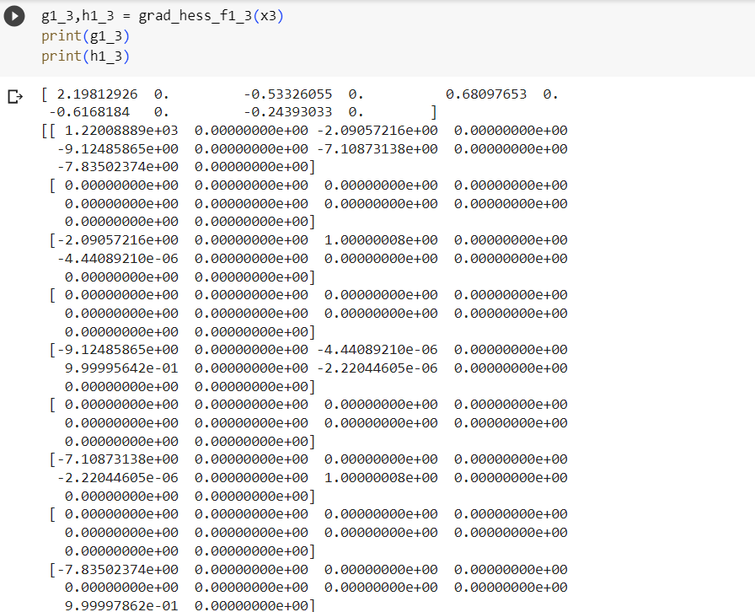

*Eigen values Finding*

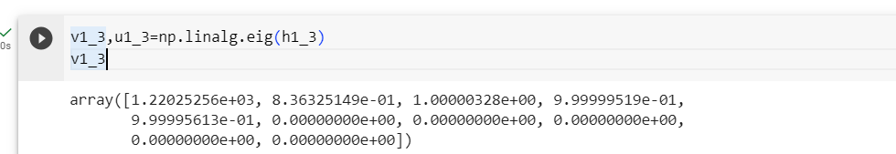

*not a positive deifinite matrix*

* *New Hessian*

| *newH1_3 = h1_3@h1_3 + (0.001-min(v1_3))*np.identity(10, dtype = float) np.linalg.eig(newH1_3)* |
| --- |

*All eigen values are positive*

* *Optimal Solution*

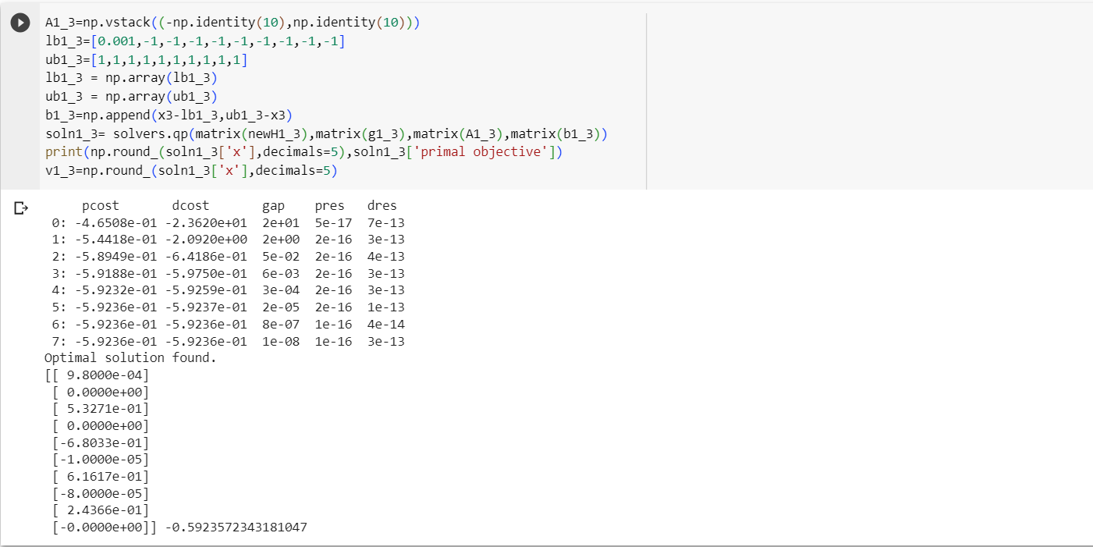

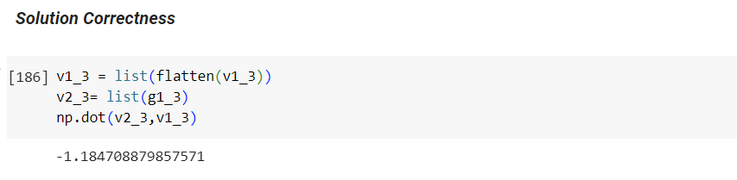

***F2 Solution Finding***

| **def grad_hess_f2_3(x):  f0=f2_3(x)  n=len(x)  h= 10**(-5)  b=np.zeros(n)  g=np.zeros(n)  H=np.zeros((n,n))  for i in range(0,n):  x1=x.copy()  x1[i]=x1[i]+h  b[i]=f2_3(x1)  g[i]=(f2_3(x1)-f0)/h  for i in range(0,n):  for j in range(0,n):  x2=x.copy()  x2[i]=x2[i]+h  x2[j]=x2[j]+h  H[i][j]=(f2_3(x2)-b[i]-b[j]+f0)/h**2  # solver.qp()  return g,H** |
| --- |

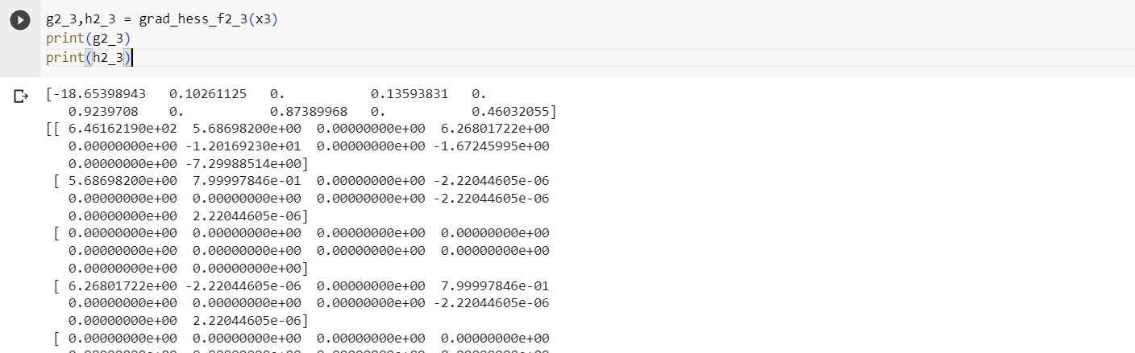

* *Eigen values Finding for f2*

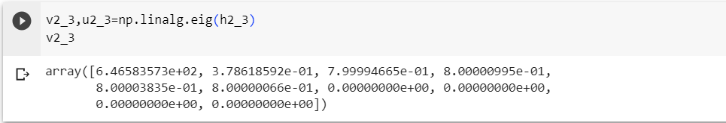

*not positive definite matrix*

* *New hessian calculation*

| newH2_3 = h2_3@h2_3 + (0.001-min(v2_3))*np.identity(10, dtype = float) np.linalg.eig(newH2_3) |
| --- |

*All eigen values are positive*

* *Optimal Solution Find*

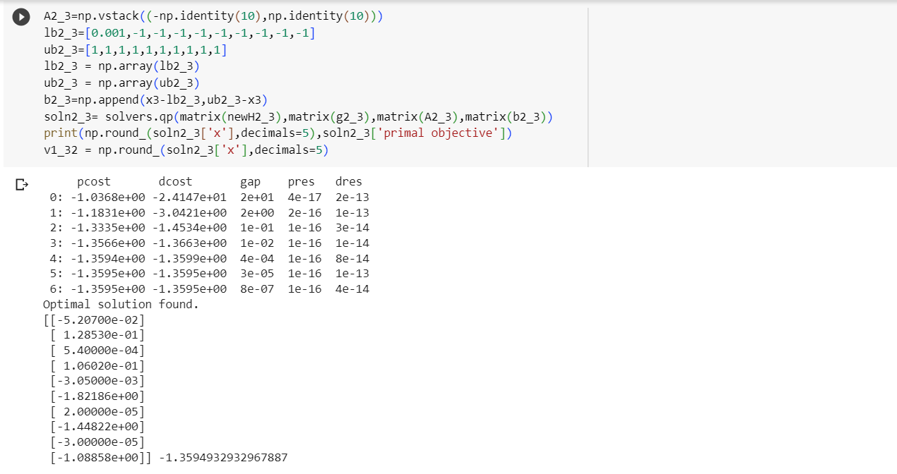

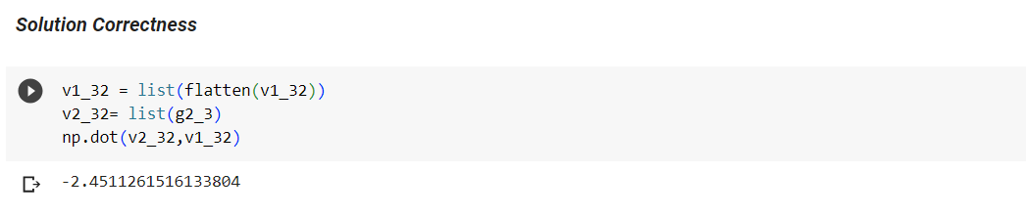

Question-4

* Function definition

| def yi_4(i,x):  n=len(x)  return x[i-1] - x[0]**(0.5*(1 + (3*((i-2)/(n-2)))))   def f1_4(x):  n = len(x)  I1 = [i for i in range(2, n+1) if i % 2 == 1]  denominator = len(I1)  result = x[0]  y_values = [yi_4(i, x) for i in I1]  sum_y_squared = sum([y ** 2 for y in y_values])  cos_multiplication=1  for i in I1:  cos_multiplication = cos_multiplication * np.cos((20 * yi_4(i,x) * np.pi)/ np.sqrt(i))  result = result + (2/denominator)*(4*sum_y_squared - 2*cos_multiplication + 2)  return result  def f2_4(x):  n = len(x)  I2 = [i for i in range(2, n+1) if i % 2 == 0]  denominator = len(I2)  result = 1 - np.sqrt(x[0])  y_values = [yi_4(i, x) for i in I2]  sum_y_squared = sum([y ** 2 for y in y_values])  cos_multiplication=1  for i in I2:  cos_multiplication = cos_multiplication * np.cos((20 * yi_4(i,x) * np.pi)/ np.sqrt(i))  result = result + (2/denominator)*(4*sum_y_squared - 2*cos_multiplication + 2)  return result  # Example usage x4=[] x4.append(random.uniform(0.001, 1)) for i in range(9):  x4.append(random.uniform(-1, 1)) print("f1:", f1_4(x4)) print("f2:", f2_4(x4)) |
| --- |

***F1 Solution***

* *Gradient and hessian*

| def grad_hess_f1_4(x):  f0=f1_4(x)  n=len(x)  h= 10**(-5)  b=np.zeros(n)  g=np.zeros(n)  H=np.zeros((n,n))  for i in range(0,n):  x1=x.copy()  x1[i]=x1[i]+h  b[i]=f1_4(x1)  g[i]=(f1_4(x1)-f0)/h  for i in range(0,n):  for j in range(0,n):  x2=x.copy()  x2[i]=x2[i]+h  x2[j]=x2[j]+h  H[i][j]=(f1_4(x2)-b[i]-b[j]+f0)/h**2  # solver.qp()  return g,H |
| --- |

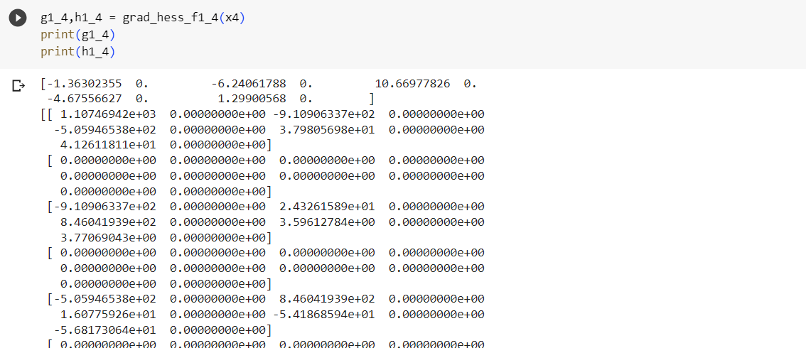

* *Eigen values*

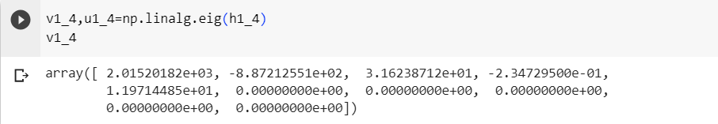

*not positive definite matrix*

* *New hessian*

| *newH1_4 = h1_4@h1_4 + (0.001-min(v1_4))*np.identity(10, dtype = float) np.linalg.eig(newH1_4)* |
| --- |

*All eigens are positive*

* *Optimal Solution*

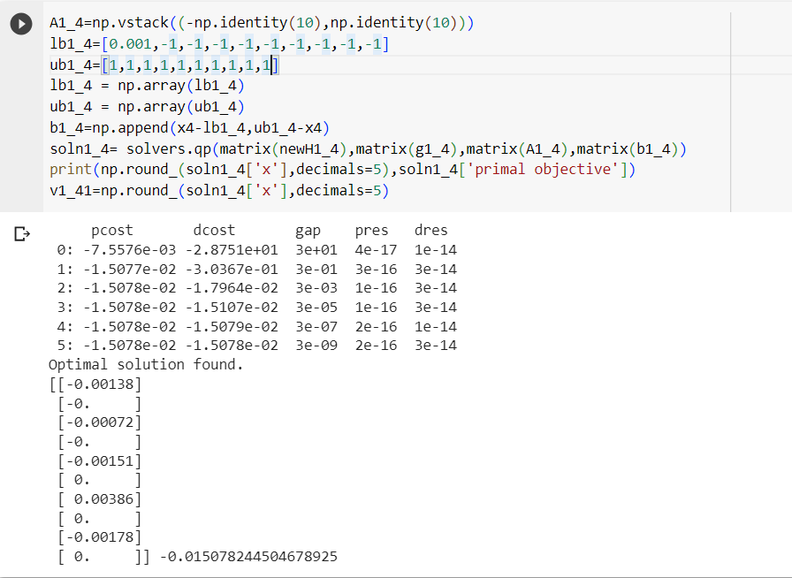

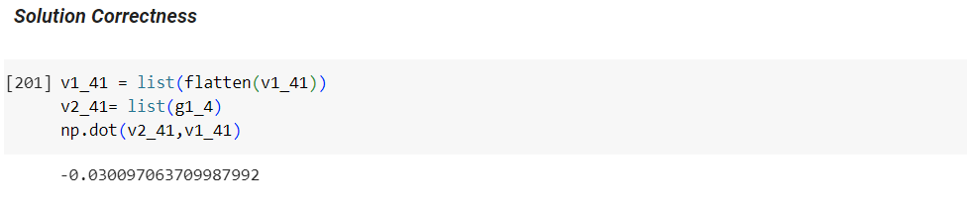

***F2 Solution***

* *Gradient and Hessian*

| *def grad_hess_f2_4(x):  f0=f2_4(x)  n=len(x)  h= 10**(-5)  b=np.zeros(n)  g=np.zeros(n)  H=np.zeros((n,n))  for i in range(0,n):  x1=x.copy()  x1[i]=x1[i]+h  b[i]=f2_4(x1)  g[i]=(f2_4(x1)-f0)/h  for i in range(0,n):  for j in range(0,n):  x2=x.copy()  x2[i]=x2[i]+h  x2[j]=x2[j]+h  H[i][j]=(f2_4(x2)-b[i]-b[j]+f0)/h**2  # solver.qp()  return g,H g2_4,h2_4 = grad_hess_f2_4(x4) print(g2_4) print(h2_4)* |
| --- |

* *Eigen values*

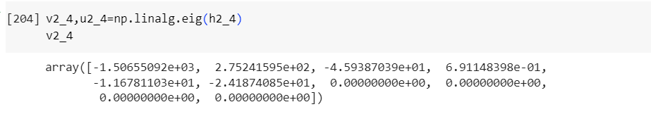

*Not positive definite*

* *FInd new hessian*

| *newH2_4 = h2_4@h2_4 + (0.001-min(v2_4))*np.identity(10, dtype = float) np.linalg.eig(newH2_4)* |
| --- |

*All eigen values are positive and hence find optimal solution*

* *Optimal Solution*

