Mruganshi Gohel

B20CS014

Lab-3

| import pandas as pd import numpy as np import matplotlib.pyplot as plt |
| --- |

Question-1

| data2= pd.read_excel('2_col.xlsx')  data2 |
| --- |

| dt2 = data2.values dt2 |
| --- |

| B=data2.values x,y=B[:,0],B[:,1] len(x) |
| --- |

| A=np.column_stack((x,np.ones((len(x),1),dtype=float))) beta=np.dot(np.linalg.inv(np.dot(A.T,A)),np.dot(A.T,y.T)) |
| --- |

| plt.figure(figsize = (12, 8)) plt.plot(x, y, 'b.') plt.plot(x, beta[0]*x + beta[1], 'r') plt.xlabel('Area') plt.ylabel('Price') plt.show() |
| --- |

| print("Slope(m) is: ", str(beta[0])) print("Intercept(c) is:", str(beta[1])) |
| --- |



| val = 4000; y = beta[0]*val + beta[1] print("The predicted value for R = 4000 is:", y) |
| --- |



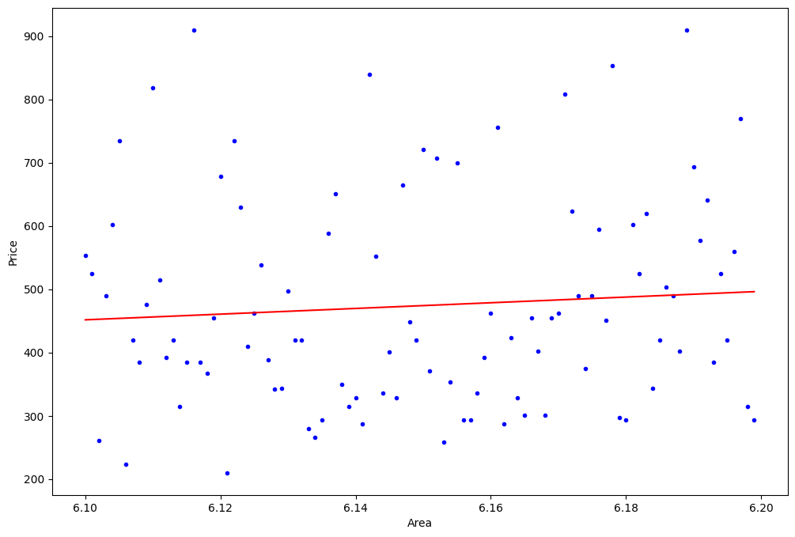

Question-2

Degree-2

| data2= pd.read_excel('2-col.xlsx') Data2  B=data2.values |
| --- |

| x2 = B[:,0] y2 = B[:,1] A = np.column_stack((x2**2, x2, np.ones((len(x2), 1), dtype = float))) beta = np.dot(np.linalg.inv(np.dot(A.T, A)), np.dot(A.T, y2))  plt.figure(figsize = (12, 8)) plt.plot(x2, y2, 'o', label = 'data') plt.plot(x2, beta[0]*x2**2 + beta[1]*x2 + beta[2], label = 'fit') plt.xlabel('x') plt.ylabel('y') plt.legend() plt.show()  val = 4000; y = beta[0]*val**2 + beta[1]*val + beta[2] print("The predicted value for R = 4000 with degree 2 is:", y) |
| --- |

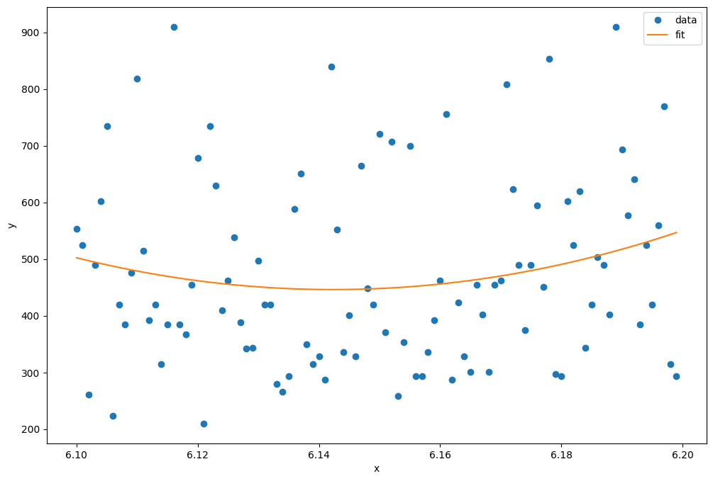



Degree-3

| x2=dt2[:,0] y2=dt2[:,1] A = np.column_stack((x2**3,x2**2, x2, np.ones((len(x2), 1), dtype = float))) beta = np.dot(np.linalg.inv(np.dot(A.T, A)), np.dot(A.T, y2))  plt.figure(figsize = (12, 8)) plt.plot(x2, y2, 'o', label = 'data') plt.plot(x2, beta[0]*(x2**3)+beta[1]*(x2**2) + beta[2]*x2 + beta[3], label = 'fit') plt.xlabel('x') plt.ylabel('y') plt.legend() plt.show()  val = 4000; y = beta[0]*val**3 + beta[1]*val**2 + beta[2]*val + beta[3] print("The predicted value for R = 4000 with degree 3 is:", y) |
| --- |

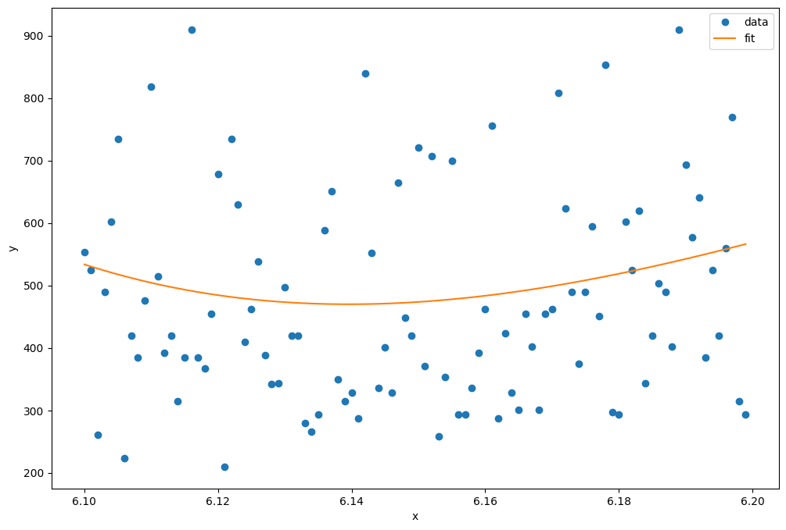



Degree-4

| x2=dt2[:,0] y2=dt2[:,1] A = np.column_stack((x2**4,x2**3,x2**2, x2, np.ones((len(x2), 1), dtype = float))) beta = np.dot(np.linalg.inv(np.dot(A.T, A)), np.dot(A.T, y2))  plt.figure(figsize = (12, 8)) plt.plot(x2, y2, 'o', label = 'data') plt.plot(x2, beta[0]*x2**4 + beta[1]*x2**3 + beta[2]*x2**2 + beta[3]*x2 + beta[4], label = 'fit') plt.xlabel('x') plt.ylabel('y') plt.legend() plt.show()  val = 4000; y = beta[0]*val**4 + beta[1]*val**3 + beta[2]*val**2 + beta[3]*val + beta[4] print("The predicted value for R = 4000 with degree 4 is:", y) |
| --- |

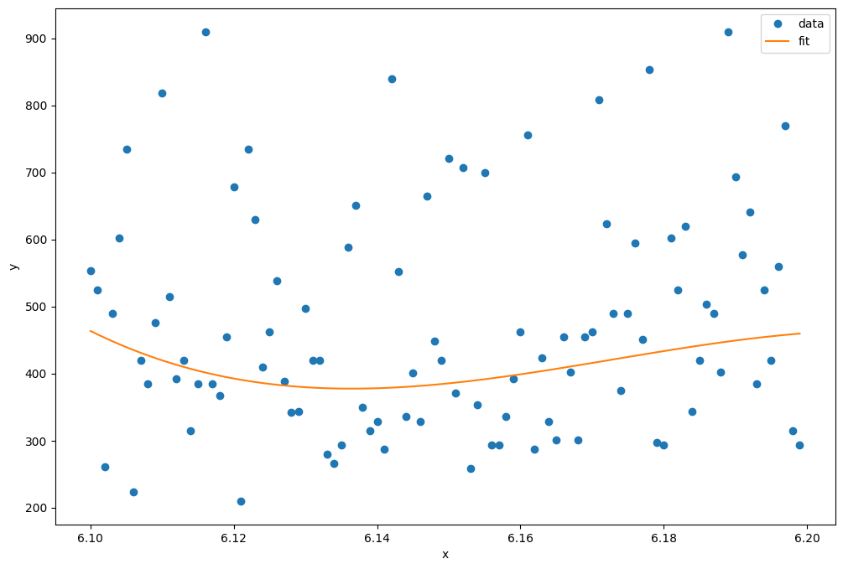



Degree-5

| x2=dt2[:,0] y2=dt2[:,1] A = np.column_stack((x2**5,x2**4,x2**3,x2**2, x2, np.ones((len(x2), 1), dtype = float))) beta = np.dot(np.linalg.inv(np.dot(A.T, A)), np.dot(A.T, y2))  plt.figure(figsize = (12, 8)) plt.plot(x2, y2, 'o', label = 'data') plt.plot(x2, beta[0]*x2**5+beta[1]*x2**4 + beta[2]*x2**3 + beta[3]*x2**2+ beta[4]*x2+beta[5], label = 'fit') plt.xlabel('x') plt.ylabel('y') plt.legend() plt.show()  val = 4000; y = beta[0]*val**5 + beta[1]*val**4 + beta[2]*val**3 + beta[3]*val**2 + beta[4]*val + beta[5] print("The predicted value for R = 4000 with degree 5 is:", y) |
| --- |

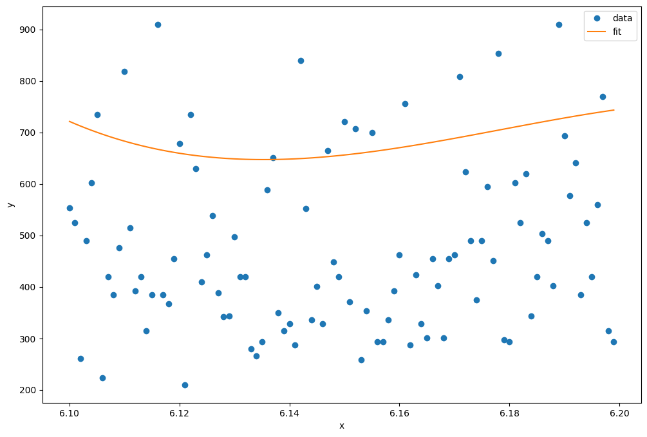



Degree-6

| x2=dt2[:,0] y2=dt2[:,1] A = np.column_stack((x2**6,x2**5,x2**4,x2**3,x2**2, x2, np.ones((len(x2), 1), dtype = float))) beta = np.dot(np.linalg.inv(np.dot(A.T, A)), np.dot(A.T, y2))  plt.figure(figsize = (12, 8)) plt.plot(x2, y2, 'o', label = 'data') plt.plot(x2, beta[0]*x2**6+beta[1]*x2**5 + beta[2]*x2**4 + beta[3]*x2**3+ beta[4]*x2**2+beta[5]*x2+beta[6], label = 'fit') plt.xlabel('x') plt.ylabel('y') plt.legend() plt.show()  val = 4000; y = beta[0]*val**6 + beta[1]*val**5 + beta[2]*val**4 + beta[3]*val**3 + beta[4]*val**2 + beta[5]*val + beta[6] print("The predicted value for R = 4000 with degree 6 is:", y) |
| --- |

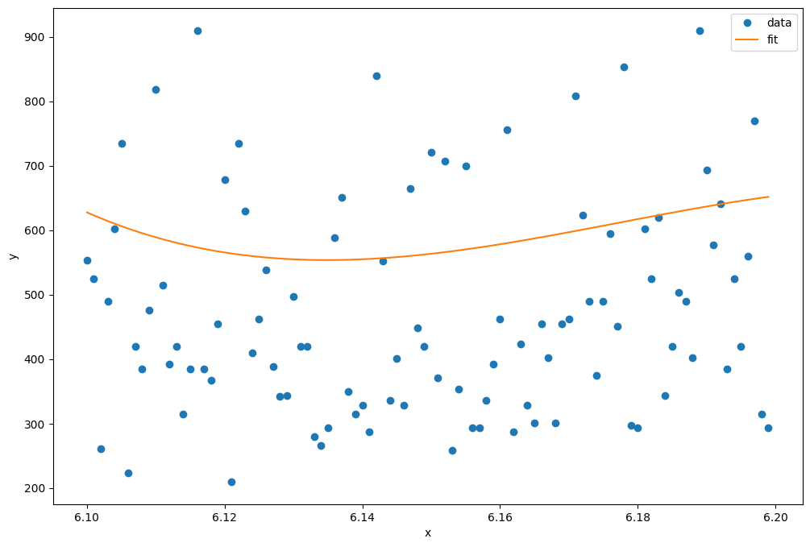



Degree-7

| x2=dt2[:,0] y2=dt2[:,1] A = np.column_stack((x2**7,x2**6,x2**5,x2**4,x2**3,x2**2, x2, np.ones((len(x2), 1), dtype = float))) beta = np.dot(np.linalg.inv(np.dot(A.T, A)), np.dot(A.T, y2))  plt.figure(figsize = (12, 8)) plt.plot(x2, y2, 'o', label = 'data') plt.plot(x2, beta[0]*x2**7+beta[1]*x2**6 + beta[2]*x2**5 + beta[3]*x2**4+ beta[4]*x2**3+beta[5]*x2**2+beta[6]*x2+beta[7], label = 'fit') plt.xlabel('x') plt.ylabel('y') plt.legend() plt.show()  val = 4000; y = beta[0]*val**7 + beta[1]*val**6 + beta[2]*val**5 + beta[3]*val**4 + beta[4]*val**3 + beta[5]*val**2 + beta[6]*val + beta[7] print("The predicted value for R = 4000 with degree 7 is:", y) |
| --- |

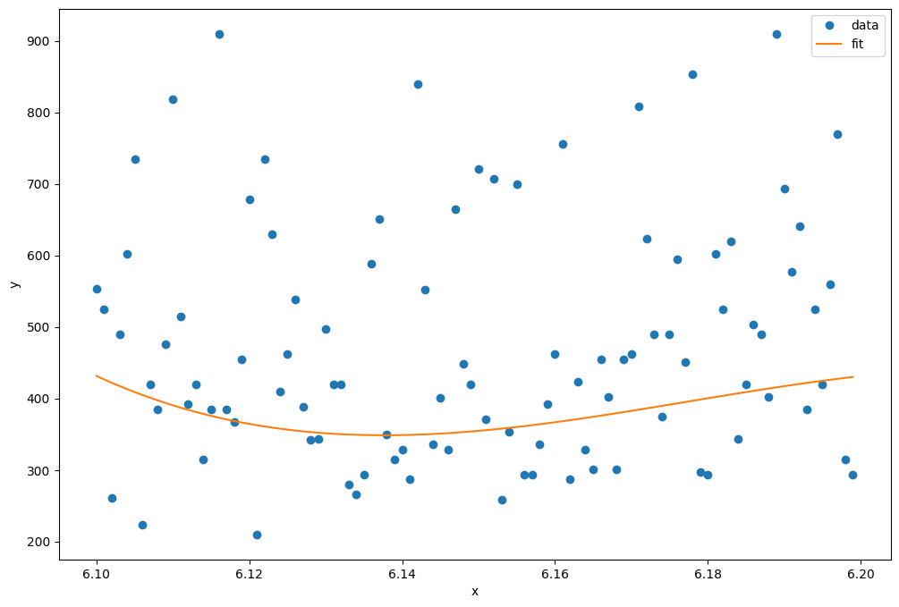



Question-3

| data4= pd.read_csv('6 columns - Copy.csv') data4 |
| --- |

| B=data4.values x,y,z=B[:,1],B[:,2],B[:,0] len(z) |
| --- |

| A = np.column_stack((x, y, np.ones((len(x), 1), dtype=float))) beta = np.dot(np.linalg.inv(np.dot(A.T, A)), np.dot(A.T, z)) house_area = 4000 house_bedrooms = 7  # Predict the house price using the fitted model predicted_price = beta[0] * house_area + beta[1] * house_bedrooms + beta[2] print("The predicted value for a house with", house_area, "square feet and", house_bedrooms, "bedrooms is:", predicted_price) |
| --- |

Question-4

| B=data4.values x,y,z=B[:,1],B[:,2],B[:,0] A = np.column_stack((x*x, x*y,y*y,x,y, np.ones((len(x), 1), dtype=float))) beta = np.dot(np.linalg.inv(np.dot(A.T, A)), np.dot(A.T, z)) print(beta) pred_area=4000 pred_bedrooms = 7 price= beta[0]*pred_area**2 + beta[1]*pred_area*pred_bedrooms + beta[2]*pred_bedrooms**2 + beta[3]*pred_area + beta[4]*pred_bedrooms + beta[5] print("Price with 4000 sq ft area and 7 bedrooms is: ", price) |
| --- |



Question-5

| B=data4.values x=data4.iloc[:,[1,2,3]] x=x.values y=B[:,0] A = np.column_stack((x, np.ones((len(x), 1), dtype=float))) coefficients = np.dot(np.dot(np.linalg.inv(np.dot(A.T, A)), A.T), y) pred_area = 4000 pred_bedrooms=7 pred_bathrooms=1 print(coefficients) predicted_price = np.dot(coefficients[:-1], [pred_area,pred_bedrooms,pred_bathrooms]) + coefficients[-1] print("The predicted value for a house with the 4000 sq ft area, 7 bedrooms and 1 bathroom (B20CS014) is:", predicted_price) |
| --- |



Question-6

5-Column

| B=data4.values x=data4.iloc[:,[1,2,3,4]] x=x.values y=B[:,0] A = np.column_stack((x, np.ones((len(x), 1), dtype=float))) coefficients = np.dot(np.dot(np.linalg.inv(np.dot(A.T, A)), A.T), y) pred_area = 4000 pred_bedrooms=7 pred_bathrooms=1 pred_stories=4 #assumed as not given what to take print(coefficients) predicted_price = np.dot(coefficients[:-1], [pred_area,pred_bedrooms,pred_bathrooms,pred_stories]) + coefficients[-1] print("The predicted value for a house with the 4000 sq ft area, 7 bedrooms and 1 bathroom and 4 stories (B20CS014) is:", predicted_price) |
| --- |



6-Columns

| B=data4.values x=data4.iloc[:,[1,2,3,4,5]] x=x.values y=B[:,0] A = np.column_stack((x, np.ones((len(x), 1), dtype=float))) coefficients = np.dot(np.dot(np.linalg.inv(np.dot(A.T, A)), A.T), y) pred_area = 4000 pred_bedrooms=7 pred_bathrooms=1 pred_stories=4 #assumed as not given what to take pred_airconditioning=1 #again assumed as not given print(coefficients) predicted_price = np.dot(coefficients[:-1], [pred_area,pred_bedrooms,pred_bathrooms,pred_stories,pred_airconditioning]) + coefficients[-1] print("The predicted value for a house with the 4000 sq ft area, 7 bedrooms and 1 bathroom, 4 stories and with airconditioner (B20CS014) is:", predicted_price) |
| --- |



Question-7

| data5= pd.read_csv('Census data (Chandigarh).csv') data5 |
| --- |

| B=data5.values x,y=B[:,0],B[:,1] z = np.log(y) A = np.column_stack((x, np.ones((len(x), 1), dtype=float))) coefficients = np.dot(np.linalg.inv(np.dot(A.T,A)),np.dot(A.T,z.T)) print(coefficients) pred_year=2021 m=coefficients[0] c=coefficients[1] pred_ln_population = m*pred_year + c pred_population = np.exp(pred_ln_population) print("Predicted Population for the year 2021: ", pred_population) |
| --- |

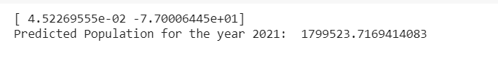

Question-8

| x,y=B[:,0],B[:,1] from sklearn.metrics import mean_absolute_error as mae  def polynomial_fitting_mplementation(x,y,p):  A=[]  i=p  while(i>-1):  A.append(pow(x.T,i))  i-=1  A=np.array(A)  A=A.T  beta=np.dot(np.linalg.inv(np.dot(A.T,A)),np.dot(A.T,y.T))  a=[]  i=p  while(i>-1):  a.append(pow(x,i))  i-=1  a=np.array(a)  ans=np.dot(beta,a)  return mae(y,ans) loss=[] for i in range(1,21):  loss.append(polynomial_fitting_mplementation(x,y,i)) plt.plot(loss) plt.show() print("Lowest average loss occurs at degree ", loss.index(min(loss)) , "polynomial and the avg loss is", min(loss)) |
| --- |

