Software Requirements Specification

Version 1.0

August 18, 2017

Money Lending Management System

Table of Contents

Table of Contents

Revision History

1. Introduction 3

1.1 Purpose 3

1.2 Product Scope 3

1.3 Intended Audience and Reading Suggestions 4

Glossary 4

1.4 References 4

1.5 Overview of Document 4

2. Overall Description 5

2.1 Product Perspective 5

2.2 Product Functions 5

2.3 User Classes and Characteristics 8

2.4 Operating Environment 9

2.5 Design and implementation Constraints 9

2.6 User Documentation 9

2.7 Assumption and Dependencies 9

3. System Features 11

3.1 System Feature 1 11

3.2 System Feature 2 (and so on) 12

4. Other Nonfunctional Requirements 19

* System Non-Functional Requirements 19
* Other Non-Functional Requirements 19

# 

# 1 Introduction

## 1.1. Purpose

The aim of this document is to specify complete description and understanding of money lending management system. It will explain the interface of system ,features of system, request and response of system, constraint under which it Operate and how the system will react to different users.This document is intended for both the stackholders and The developer of system.

## 1.2. Scope of Project

This software system will be a Money Lending Management System for Money Lenders who are doing business on individual or large scale through multiple branches in multiple cities. This system is designed to maximize Money Lenders productivity by efficient management of customer in digital way which reduce time and efforts.Which would otherwise have to record manually on hardcopy by maximizing Money Lender work efficiency and productivity system will meet Money Lender needs while remaining easy to understand and use.

Mainly system covers stock management for items taken as Mortgage and print formatted GST based Invoice. Software System is mainly designed for users interface. System manages customer record for each account transection and prepare date wise report for customer transection for managing of customer and mortgage items information. System also contain relational database.

## 

## 1.3 Intended Audience and Reading Suggestions

This document is to be read by the development team, the project managers, marketing staff, testers and documentation writers. Our stakeholders, company manufacturing associated hardware, company providing embedded operating system, Stack-holders and distributors who markets the finished product, may review the document to learn about the project and to understand the requirements. The SRS has been organized approximately in order of increasing specificity. The developers and project managers need to become intimately familiar with the SRS.

**Glossary:**

|  |  |
| --- | --- |
| User | Money lender who use  Software for their business |
| Customer | People who buys items from us and take a loan on their assets or valuables |
| Admin | Who manages whole system in digital form. |
| Intended audience | Money Lenders who wants to make their business robust and automated.0 |

## 1.4 References

*IEEE Standards 830-1998 IEEE Recommended Practice for Software Requirements Specifications.* IEEE Computer Society, 1998.Contact Money Lenders for Informationabout Real Time Requirements.

# 1.5 Overview of Document

In beginning section 1.0 version of document cover aim of this SRS document.it also covers scope of project, type’s people (stake-holders) who interact with system and reference follow for SRS of system.

The next chapter, the Overall Description section, of this document gives an overview of the functionality of the product. It describes the informal requirements and is used to establish a context for the technical requirements specification in the next chapter.

# 2 Overall Description

## 2.1 Product Perspective

Product is web based system implementing client-server model.

Money Lending Management System provide ease of customer management in digital way by reducing user’s efforts and time. This product is come with better idea of fulfill money Lenders requirements unlike other vendors in Money Lending Profession.

for more detail about other money lending management system provider

visit: http://www.manabh.com

## 2.2 Product Functions

Money Lending Management system contain following key functions.

* **Authenticate user through secure login feature.**
* **Description:**

System provide e-registration form on website. People in money lending profession who are interested to use Software should fill e-registration form which contain field to take general information form users. After submission of registration form by user it is verify by admin. After cross verification user is able to login or authenticated by provided username and password in registration form.

* **System mainly contain three functionalities for user interface:**

1) Create new customer account

2) Search old customer account

3) Manages customer account

* **System create new customer account for user.**

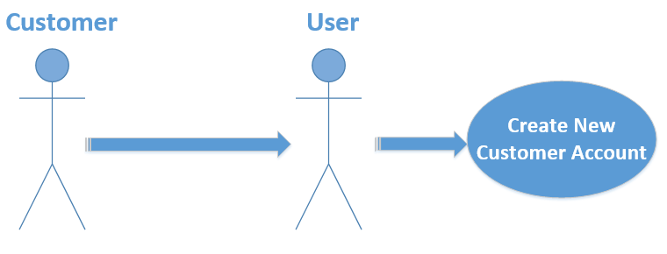

* System provide interface to add customer detail in customer account
* Description:

For adding new customer account system provide customer form to user so user fill it from customer detail which includes

Customer full name, address, city, mobile no, email id, etc. about customer later on it used in unique identification of customer. Submitted customer form add customer detail to

Customer account.

* System enable user to add mortgage items details taken from customer.
* Description:

After adding customer details user add mortgage items of Customer to mortgage item list in customer account. Final weight of mortgage items and equivalent mortgage amount on mortgage items are added to system.

* System manage customer ‘s mortgage items of account
* Reference Number is generated for added mortgage items of customer account.
  + - * Description:

After adding detail of mortgage items system generate reference Number for unique identification of each customer mortgage items. After generating reference number, it links to customer mortgage items inside database.

* User can verify detail of customer to their mortgage items.
* Description:

At last stage, After adding mortgage items of customer account system preview all detail of customer ‘s mortgage items so user verify it from customer. if any detail miss-match found then user can edit it before submission.

* System add customer’s account.
* Description:

After verification of customer details to their mortgage items user can add customer account to database.

* **User perform search to view past record of customer.**

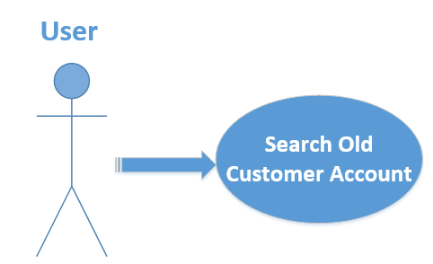

* + - * Description:

User input search for past customer account on basis of name, city or reference number of mortgage items. Search result display Report of date wise customer account transection.

* **System manage customer account Transection.**

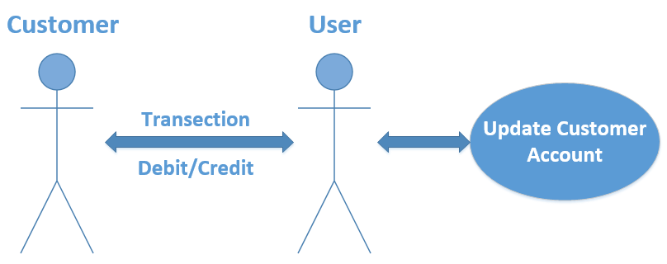

* + - * Description:

User can debit or credit amount as per Transection by customer and mortgage amount that to be return by customer is calculated with interest rate.

* System allow user to close customer account.
* Description:

User can clear customer account if user is fulfilled by mortgage amount return by customer on mortgageitems*.*

**2.3 User Classes and Characteristics**

**Money Lenders:**

Money Lending Management System is powerful, yet easy software to use so, all Money Lenders are easily deal with this Software. They have only basic knowledge about the computer. They are able to use it efficiently.

**Open source software developers and contributors:**

* **Application Developers:** People with very good knowledge of programming language project, in order to understand and be able to extend project’s source code.
* **Database Administrator:** A database administrator (DBA) maintains a successful [database](http://searchsqlserver.techtarget.com/definition/database) environment. Responsibilities include designing, implementing, [security](http://searchsecurity.techtarget.com/definition/security) and maintaining the database system.

**2.4 Operating Environment:**

Money Lending Management System should run on GUI based Operating System like Windows 2000, Windows Vista, Windows 7/8/8.1/10, Linux Based System and Mac also.

**2.5 Design and implementation Constraints**

Money Lending Management System is open source version. Everyone can use but who want to use the product firs they will fill registration form which will provide by admin. Money Lending Management System requires only basic browser and also requires internet connection. Users are comfortable with English language. Users not require much memory on hard drive. Everything stores in cloud. Users information is safe so don’t worry.

**2.6 User Documentation**

If user want to learn about use of web application, we also provide help section in application. User can easily refer from help section and user guide. We also provide tutorial of the use of application.

**2.7 Assumption and Dependencies**

It is assumed that the hardware designed will work correctly with the third-party operating system and the developed software. It is assumed that browser is supported ASP.NET platform.

On Functional requirements in section 3 we assume that customer credit

Amount is not more than Mortgage amount with interest rate in transection of

Account.

At any time based on user choice user allow to close customer account

If it is fulfilled by return back mortgage amount of customer.

## 3 System Features

**R1:** **System Authenticate users through Secure Login.**

**Description:** User provide system access after once user is authenticated through secure login feature.

**Precondition:** Before this use case can be initiated, the user (Money lender) has already accessed the online Money Lending Management System.

**R1.1:** System Provides e-Registration form for Money Lenders who are interested to use our Money Lending Management System as website (platform).

**R1.1.1:** Registration form contain field to take general information of user like full-name, address, city, contact number, email-id, etc.

**R1.1.2:** Registration form also contain custom customer's username and password field which is validated after authentication of valid user.

**R1.2:** System read register details of user.

**Input:** Enter register details by user. (As per R1.1)

**Output:** Read registration details.

**Description:** System read register details filled in registration form.

**R1.3:** System store register detail of user database.

**Input:** Read register detail

**Output:** Store to users-database

**Description:** System store register details of registration form.

**R1.4:** System verify user by admin.

**Input:** added user through registration.

**Output:** valid_user flag.

**Description:** System admin check added user in database and after cross-verification with user, admin authenticate user for login and set valid_user=true.

**R1.5:** System Authenticate user.

**Input:** Username and password (separately taken in e-registration form)

**Output:** Website access for authenticated user (authenticate_user flag)

**Description:** System check username and password in database if it is valid user then system access is given to user (authenticate_user flag=true).

**R2:** **System manages users**

**Description:** Admin creates users. He also updates user details, manage database. Here system can maintain all required details of users and admin can also manipulate them.

**Precondition:** Database administrator must have already access database login.

**R2.1:** System store record of each authenticated user based on registered information.

**Description:** Valid users by admin are authenticate to access system and their register information is store to database.

**R2.2:** System provide separate (database) connection to each user.

**Description:** System provide different database connection to manage different user's customer account.

**R3: System add new Account on basis of items taken as mortgage with its customer information and manage customer details.**

**Input:** customer details.

**Output:** Add customer detail for new customer's account.

**Description:** User create new account of customer by adding customer details.

**Precondition:** Authenticated user must have login to system and select for create new account.

**R3.1:** System provide Customer form (customer_info webpage) to add customer information for account.

**R3.1.1:** Customer form field include customer's full-name, address, city, mobile number, email id, aadhar number, etc. to unique identification of customer.

**R3.1.2:** System is available only for people of specific city and nearer villages.

**R3.2:** System read customer detail filled in form.

**Input:** Customer details in customer account form. (As per R3.1)

**Output:** Read customer details.

**Description:** System read customer information from filled in new customer account form.

**R3.3:** System check added customer detail in past-stored customer account record.

**Input:** Read customer details.

**Output:** customer_exist flag.

**Description:** System read customer information from filled customer account form and match with past stored customer accounts (in database) if match found then set customer_exist flag=true and it display "customer exist" message, else set customer_exist flag=false means match not found.

**R3.4:** System provide reset or edit facility for added customer details in customer's account.

**Description:** User can edit or reset filled customer details in customer form of customer's account.

**R3.5:** System store details of customer in customer account database.

**Input:** read customer details from new customer account form

**Output:** Store to database.

**Description:** System store new customer account detail to database.

**R4: System Provide interface to add mortgage items of customer to added customer account.**

**Input:** mortgage items of customer. (With added customer details)

**Output:** added mortgage items for customer account.

**Description:** Items taken as mortgage from customer are added to customer account.

**Precondition:** User must have already added customer detail in customer account.

**R4.1:** System can accept only Gold, Silver or Platinum metal jewellery to taken as mortgage from customer.

**R4.1.1:** System provide selection category for gold or silver or platinum for corresponding ornaments.

**R4.1.2:** System Display different jewellery items (ornaments) based on selection category (Gold or Silver or Platinum).

**R4.2:** System enables user to add multiple items of mortgage to customer account.

**Input:** Mortgage items of customer.

**Output:** Add items for mortgage.

**Description:** User can add one or more mortgage items to customer account.

**R4.3:** System enable user to remove multiple items of mortgage if they are previously added items.

**Input:** Mortgage items of customer.

**Output:** Remove items for mortgage.

**Description:** User can remove one or more mortgage items from customer account.

**R4.4:** System add mortgage item details.

**R4.4.1:** Read final weight and equivalent mortgage amount of customer mortgage items.

**Input:** Final weight and equivalent mortgage amount.

**Output:** Read final weight and equivalent mortgage amount.

**Description:** User input final weight and equivalent mortgage amount which describe mortgage items equivalent mortgage amount is final total amount that is provided to customer on mortgage items.

**R4.4.2:** System store weight and mortgage amount detail in database.

**Input:** Read weight and equivalent mortgage amount.

**Output:** Added weight and equivalent mortgage amount for mortgage items.

**Description:** User add customer mortgage item list with its total weight and equivalent mortgage amount.

**R5: System manages items of customer taken as mortgage.**

**Input:** Added customer mortgage items in customer account

**Output:** Organized customer mortgage items of customer's account.

Description: added mortgage items for customer account are manages (handle) by user.

**Description:** Added mortgage items for customer account are manages (handle) by user.

**Precondition:** User must have already added customer mortgage items details in customer account

**R5.1:** System generate unique 4-digit reference number for mortgage items of customer account.

**R5.1.1:** System link reference number to mortgage items of customer (internally).

**Description:** System generate 4-digit reference no for unique identification of different customer mortgage items.

**R5.2:** System Provide user to add reference place.

**Description:** user can add reference place which describe physical location of customer's mortgage items so user locate mortgage items.

**R5.3:** System enable user to verify mortgage items detail and customer details of customer account from customer.

**Input:** Added mortgage items in customer account.

**Output:** Verify_account flag.

**Description:** System review customer account before storing so that user conforms add account to database so if account verification is success then set verify account flag=true means now customer account is valid so user can add it.

**R5.4:** System debit amount from customer account.

**R5.4.1:** System read debited amount from customer account.

**Input:** Debit amount on mortgage items taken by customer.

**Output**: Read debit amount taken by customer.

**Description:** User add first time debit amount of customer to account.

**R5.5:** System Store reference detail of mortgage items and debit transection to its customer account.

**Input:** Added mortgage items with weight and mortgage amount.

**Output:** added reference and debit amount to customer account.

**Description:** System store reference no and reference place to mortgage items info in database and credit amount is stored as transection.

**R6: System search for past customer accounts record (to view transection record).**

**Input:** Search text.

**Output:** Search result.

**Description:** User perform search operation in previously added customer account and display search result as customer account if search found.

**Precondition:** User must have already login to system and select for search old customer account.

**R6.1:** System enable user to search customer account by name, reference number, city, mobile number etc.

**R6.2:** System read user input to search accordingly (refer R6.1).

**Input:** Search text.

**Output:** Search result.

**Description:** user enter search input is search in customer account database if match found then customer account displays.

**R7: System display past customer account transection from search result.**

**Description:** Search result for old customer account display customer account date-wise transection record in report format.

**Precondition:** User must already perform search to view transection of search customer account

**R7.1:** Search result format contain name, city and reference number.

**R7.2:** System prepare report of customer's account transection from searched account.

**R7.2.1:** Report includes date-wise record of customer account transection.

**R7.2.2:** System display customer's account transection.

**R7.2.2.1:** System display equivalent amount (in Rupees) for items taken mortgage from customer.

**R7.2.2.2:** System display total credit-debit money of customer account.

**Description:** Customer's account transection which show date-wise credit and debit transection of customer account with equivalent mortgage amount.

**R7.3:** System enable user to print customer's account transection report.

**R8: System manages transection of customer account.**

**Input:** Customer account transection report from search section.

**Output:** Updated customer account transection.

**Description:** User debit or credit amount as per Transection by customer and mortgage amount that to be return by customer is calculated on interest rate.

**Precondition:** User must have already view display result of customer account transection.

**R8.1:** System search customer account to update (refer R6).

**R8.2:** System display searched customer's account past transection (refer R7).

**R8.3:** System verify customer account from customer details.

**Description:** From search customer account user can view customer account detail with its transection so user can verify it from customer which validate customer.

**R8.4:** System update customer account transection.

**Input:** Credit or debit amount.

**Output:** Updated customer account transection.

**Description:** User update credit or debit amount transection of customer to account.

**R8.4.1:** System Read amount based on type of transection on customer account.

**Input:** Credit or debit amount for customer account.

**Output:** Read credit or debit amount.

**Description:** User credit or debit to customer account based on customer choice.

**R8.4.2:** System add debit amount to customer account.

**Description:** System debit amount to the customer account transection. If debit amount is less than mortgage equivalent amount.

**R8.4.2.1:** System check debit amount with equivalent mortgage amount.

**Input:** Debit amount of customer account

**Output:** Valid_debit_amount flag

**Description:** User credit to customer account if customer desire credit amount (by customer) is less than or equal to equivalent mortgage amount which set valid_debit_amout=true.

**R8.4.2.2:** System store debited money of customer account transection.

**Input:** Valid debit amount

**Output:** Store to customer account as debit transection.

**Description:** System store valid debit amount given to the customer by user in customer account transection in database.

**R8.4.3:** System add credit amount to customer account.

**Description:** System add credited amount transection to customer account on basis of interest rate calculation.

**R8.4.3.1:** System calculate interest rate on mortgage money.

**R8.4.3.1.1:** System calculate simple interest rate on mortgage items of customer if transection time is below 1 year from date item taken as mortgage

**R8.4.3.1.2:** System calculate compound interest rate on mortgage items of customer if transection time is above 1 year.

**Input:** Interest rate on mortgage amount.

**Output:** Final mortgage amount to be returned by customer

**Description:** Mortgage amount that customer will have to return on his mortgage items is calculated with interest rate based on time elapsed for specific mortgage items according to R8.4.3.1.1 and R8.4.3.1.2.

**R8.4.3.2:** System store credited money of customer to its account transection.

**Input:** Credit amount of customer

**Output:** Store credit amount to customer account as debit transection

**Description:** System store credit amount that customer paid to user in customer account transection in database.

**R8.5:** System allow user to close customer account.

Description: user can clear customer account if user is fulfilled by mortgage amount return by customer on mortgage items.

## 4 Non-Functional Requirements:

* **System Non-Functional Requirements:**
  + System provide web and mobile interface through which user can view his business. System is compatible with all kind of browsers.
  + System verify user by admin: -system admin check added user in database and after cross verification with user, admin authenticate user for login.
  + System is available only for people of specific city and nearer villages.
  + System can accept only gold, silver or platinum metal jewellery to taken as mortgage from customer.
  + System enable user to verify mortgage items detail and customer details of customer account from customer: -system review customer account before save customer account so that user conforms detail of customer account to customer.
* **Other Non-Functional Requirements:**
* The Money Lending Management will be on Server with high speed internet capability. Software developed here assume the use of visual studio MYSQL database Connection.