Screenshots

Final Revision Graph

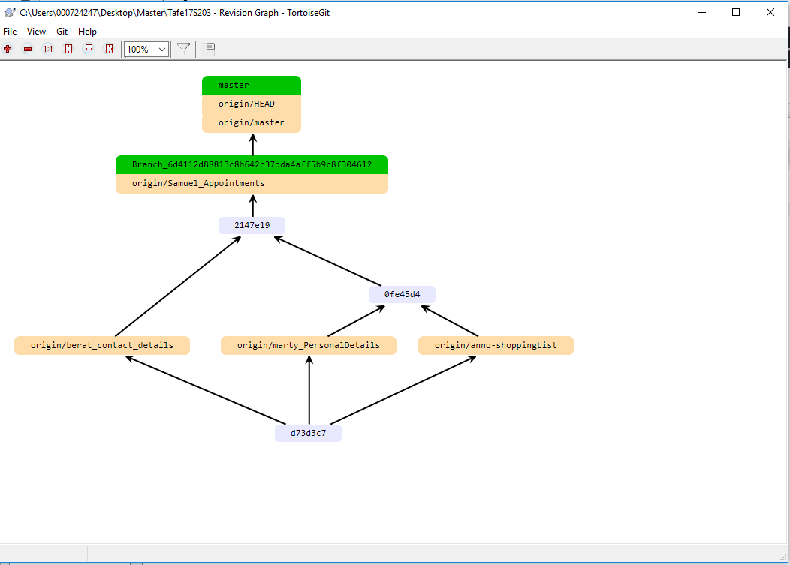

Screenshot showing hash indexs

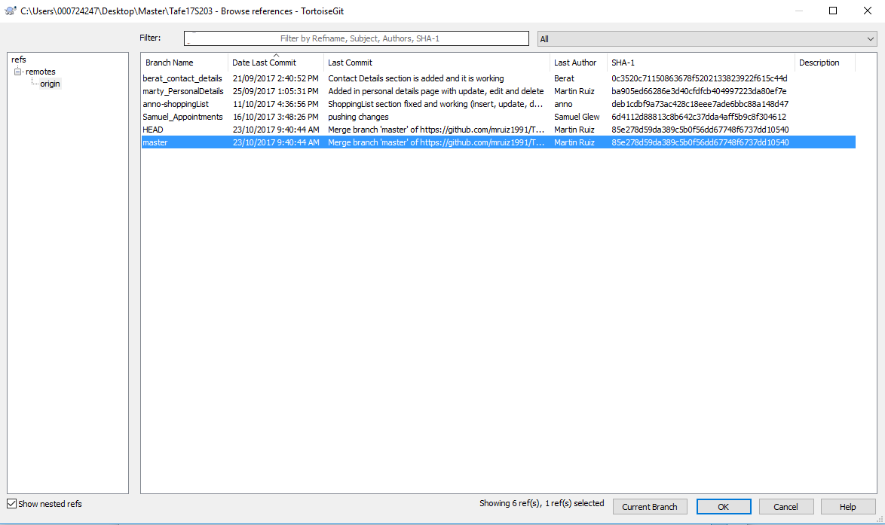

Screenshot of Patch

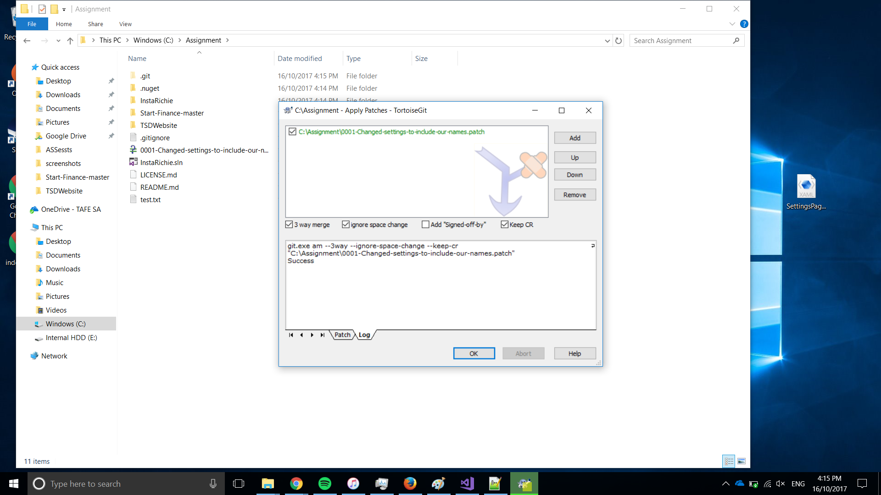

Communication via Github

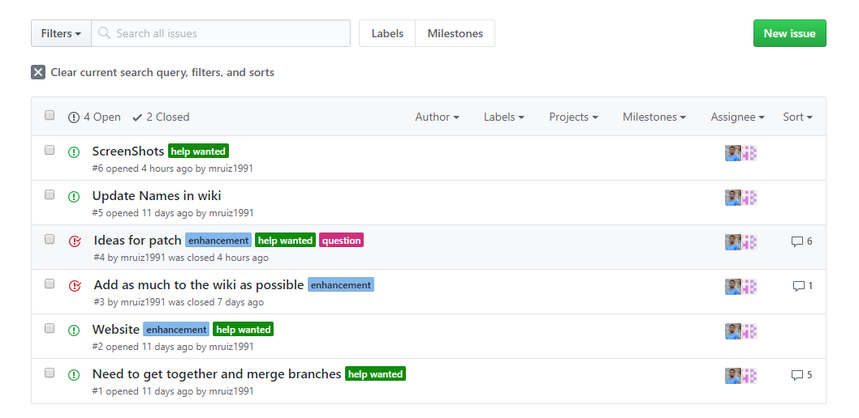

NOTES:

Website is located on the repository.