**ASSIGNMENT-13**

**Name:Aditya Parab**

**Roll No.: TCOD32**

**Title:Configure S/MIME Email security for outlook.**

**Objectives :** To learn how to configure email security using S/MIME protocol.

**PROBLEM STATEMENT:**

Illustrate the steps for implementation of S/MIME email security through Microsoft office outlook.

**THEORY:**

The steps for configuration are as below:

1.

**Download your certificate.**

Download a PKCS#12 file with your certificate from your SSL.com account by clicking the link supplied in your Certificate Activation Link email and following the on-screen instructions in your web browser. You will be prompted to create a password before downloading the file. (Keep this password secure – you will need it later.) **Make sure to keep track of where you saved your PKCS#12 file, and do not lose it.** If you lose your private key, you will be unable to read messages encrypted with your public key.

**Note:** when downloading your certificate it is possible to choose between the RSA and ECDSA algorithms via the **Algorithm** drop-down menu. However, ECDSA keys cannot be used for email encryption, so it’s best to leave this set to **RSA**.

2. **Open Outlook Options.**

In Outlook, select **File** from the main menu, then click **Options**.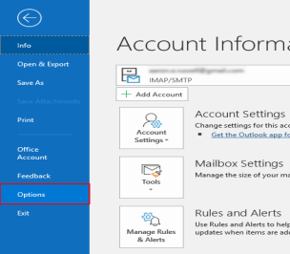

3. **Open Trust Center.**

Select **Trust Center** at the bottom of the menu on the left side of the **Outlook Options** window.

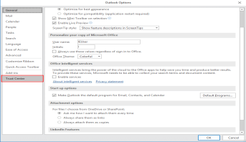

4. **Open Trust Center Settings.**

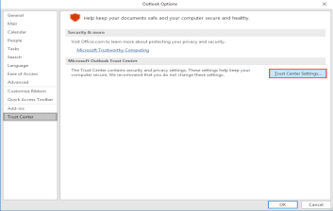Click the **Trust Center Settings** button.

5. **Select Email Security.**

Select **Email Security**

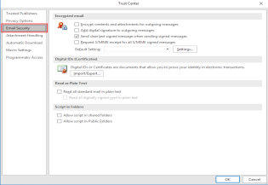

from the left-hand menu of the **Trust Center** window.

**Click Import/Export.**

Click the **Import/Export** button, under **Digital IDs (Certificates)**. 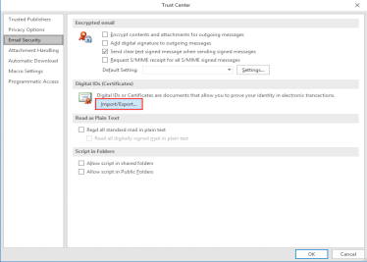

6. **Browse for file.**

Make sure **Import existing Digital ID from a file** is checked, then click **Browse…**

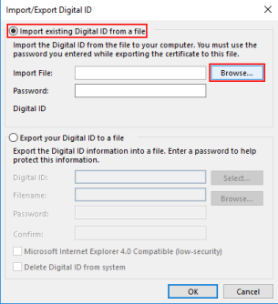7. **Open file.**

Navigate to the PKCS#12 file, then click **Open**. The filename extension should be .p12. 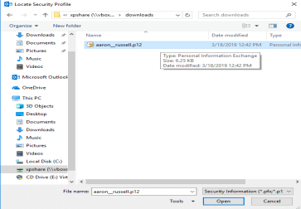8. **Enter PKCS#12 password.**

Enter the password you used when downloading the PKCS#12 file, then click **OK**.

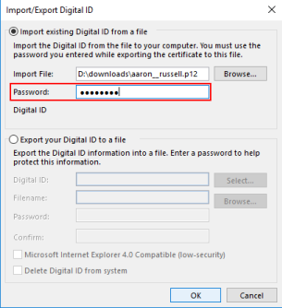

9. **Click OK.**

Click **OK** on the security dialog box that pops up.

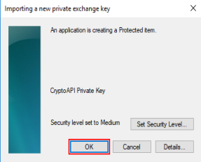

10. **Open encrypted email settings.**

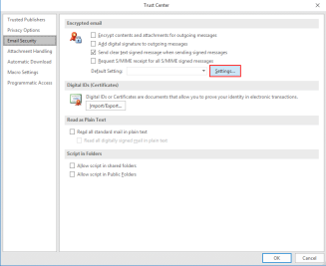Click the **Settings** button, under **Encrypted email**. 11.**Name security settings.**

Enter a name for your security settings.

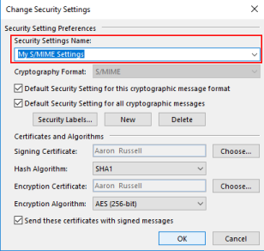

12. **Choose signing certificate.**

Click **Choose**, next to **Signing Certificate**.

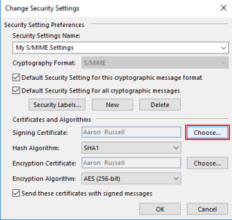13. **Confirm or select certificate.**

If you have only installed one certificate (as shown here), you can click **OK** on the **Confirm Certificate** dialog box that pops up. Otherwise, you will have to choose one from a list of installed certificates.

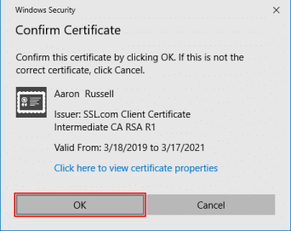14. **Set hash algorithm.**

Set the **Hash Algorithm** to **SHA256.**

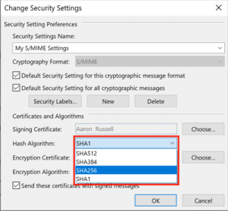

15. **Choose encryption certificate.**

Click **Choose**, next to **Encryption Certificate**, and click **OK** on the **Confirm Certificate** dialog box. Again, if you have more than one certificate, select the same one you chose for 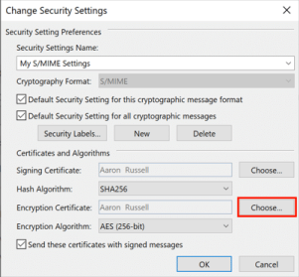

16. **Close window.**

Click **OK** to close the **Change Security Settings** window.

17. **Set S/MIME defaults.**

close the **Trust Center** Window.

18. **Set S/MIME options in a new message.**

Now that your S/MIME certificate is installed and configured, you can start sending signed and encrypted messages. Begin by creating a new email message in Outlook. Under **Options**, you can toggle the encryption and/or digital signature settings for the message

19. **Potential problem with encryption.**

Note that if you attempt to send encrypted email and do not have your recipient’s public key, you will get an error message giving the option to send the message unencrypted. You can solve this issue by having them send you a signed email message, then adding them as a contact in Outlook.

20. **Confirm signature.**

When your contact sends you a signed email, you should see a small ribbon icon in the upper right corner of the message. You can confirm the certificate’s details by clicking

the icon.

21. **Add contact (step 1).**

Right-click the sender’s

name and select **Add to Outlook Contacts**.

22. **Add contact (step 2).**

23. Click **Save and Close** to save your contact. You will now be able to send encrypted email to this recipient.

**Conclusion:**

In this way we have Configure S/MIME Email security for outlook