WEEK 2 ASSIGNMENT
Python for AI & Data Handling

Student Name | Mrunali G M
Course / Department | Computer Science and Engineering
College / Institution | East West Institute Of Technology
Internship Program | InternNova
Submission Date | 17 Oct 2026

Task 1: NumPy Fundamentals (20 Marks)
NumPy is a Python library for numerical computing. It provides multidimensional arrays and mathematical functions.
import numpy as np
one_d = np.array([10, 20, 30, 40, 50])
two_d = np.array([[1, 2, 3], [4, 5, 6]]) print(one_d[0]) # indexing print(one_d[1:4]) # slicing print(two_d.shape) # (2, 3)
print(two_d.ndim) # 2
print(one_d.mean(), one_d.max(), one_d.min(), one_d.sum())
A 1D array stores a sequence; a 2D array stores rows and columns. Indexing selects an item, slicing selects a range, shape gives axis sizes, and ndim gives the number of dimensions. For the example array, mean = 30, maximum = 50, minimum = 10, and sum = 150.

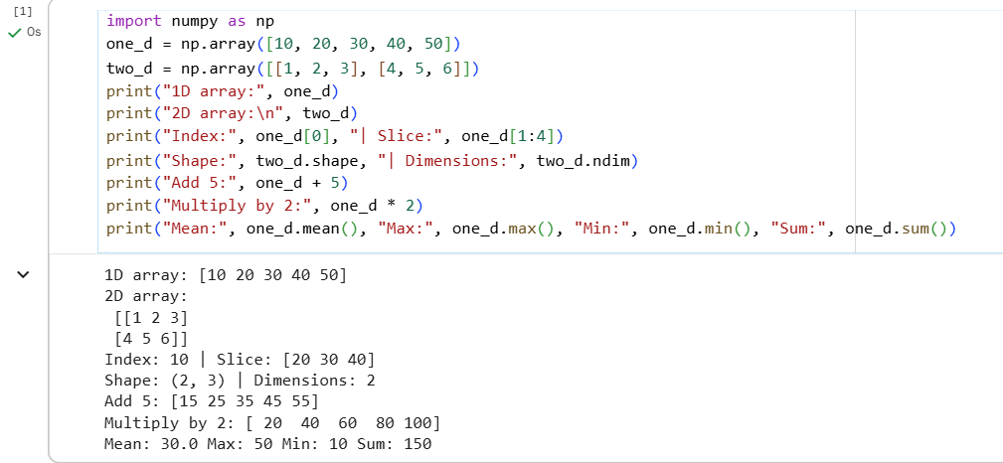

Task 2: Pandas & Dataset Handling (20 Marks)
Pandas provides DataFrames for tabular data. The CSV includes student IDs, names, class, subject marks, and attendance.
df = pd.read_csv("student_performance_raw.csv") display(df.head())
display(df.tail()) print(df.shape) print(df.dtypes)
display(df.describe(include="all")) display(df[["Name", "Maths"]])
display(df[pd.to_numeric(df["Maths"], errors="coerce") >= 80])
head() and tail() display first and last rows. shape reports row and column counts. dtypes shows types, describe() provides statistics, column selection chooses fields, and a Boolean condition filters rows.

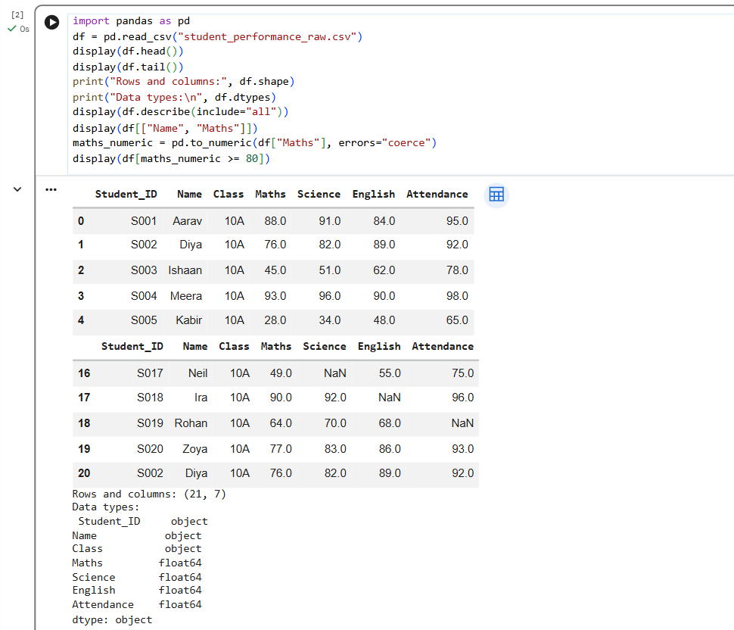

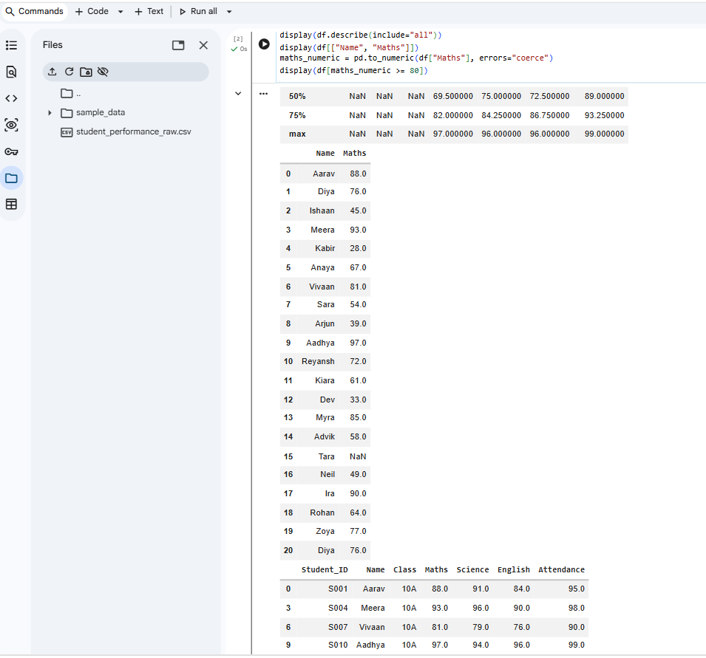

Task 3: Data Cleaning (20 Marks)
The raw dataset intentionally includes missing marks and attendance, a numeric value stored as text, and a duplicate record.
for col in ["Maths", "Science", "English", "Attendance"]: df[col] = pd.to_numeric(df[col], errors="coerce")
print(df.isna().sum())
print("Duplicates:", df.duplicated().sum()) df = df.drop_duplicates()
for col in ["Maths", "Science", "English"]: df[col] = df[col].fillna(df[col].mean())
df["Attendance"] = df["Attendance"].fillna(df["Attendance"].median())
The cleaning process converts numeric columns, counts missing and duplicate records, removes duplicates, fills subject scores with their column means, and fills attendance with its median. These are simple teaching choices; real projects should consider why values are missing.

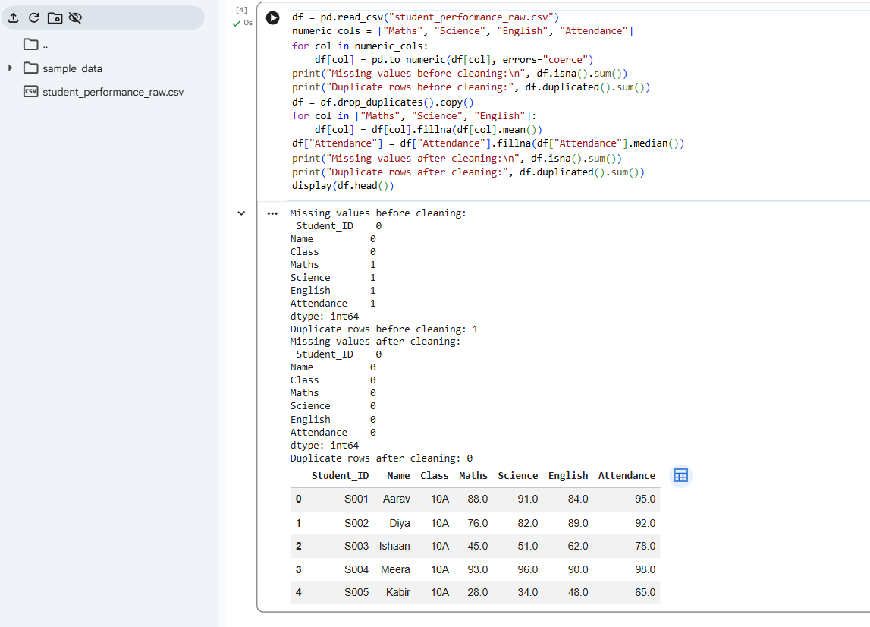

Task 4: Data Visualization (20 Marks)
Matplotlib creates charts that help communicate patterns in data.
- Bar chart: compares average marks for the first ten students.
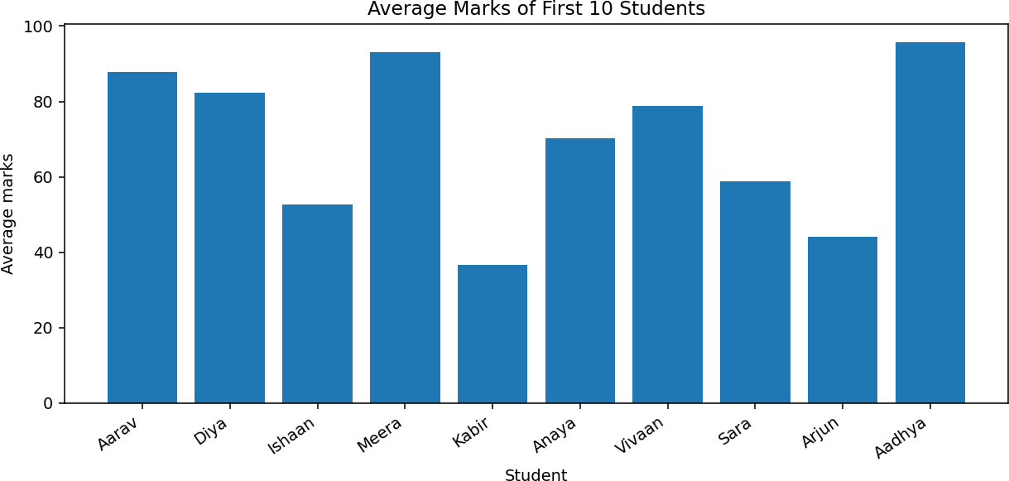

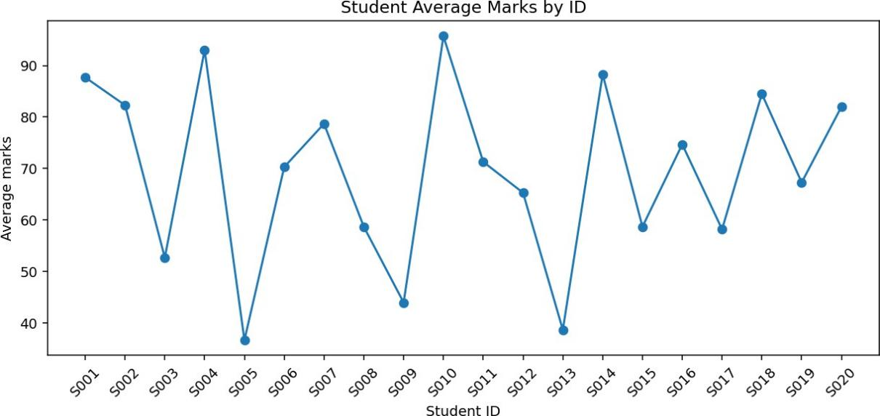
- Line chart: shows variation in average marks by student ID; it is not a time series.

Task 4: Data Visualization (continued)
- Histogram: shows how many students fall into different average-mark ranges.
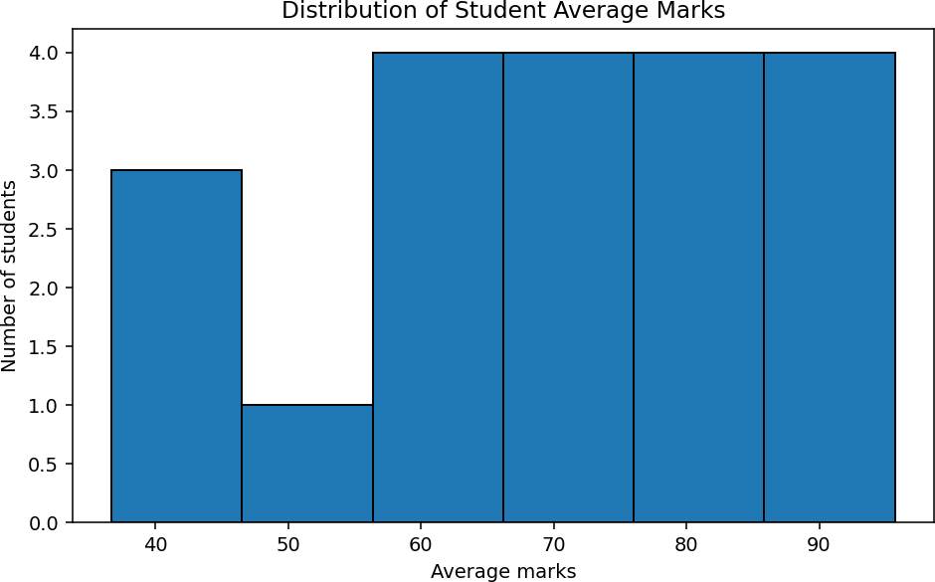

- Scatter plot: explores whether attendance and average marks appear associated; association does not prove causation.
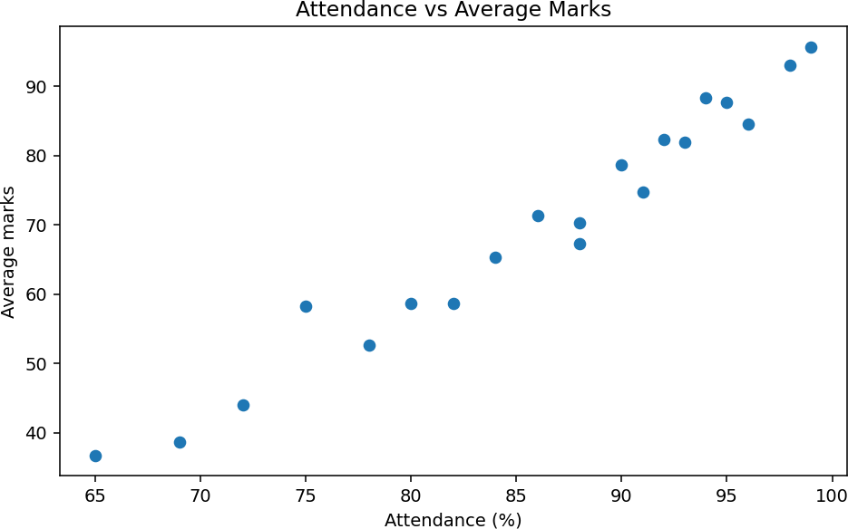

Task 5: Mini Project — Student Performance Data Analysis (20 Marks)
The mini project inspects the cleaned data, calculates average/highest/lowest marks, counts passes and failures, and creates three charts.
Pass/fail assumption: a student passes only if all three subject marks are at least 35. Change this rule if your institution uses a different policy.
subjects = ["Maths", "Science", "English"] df["Average_Marks"] = df[subjects].mean(axis=1)
df["Result"] = np.where(df[subjects].min(axis=1) >= 35, "Pass", "Fail") print("Average:", df[subjects].to_numpy().mean())
print("Highest:", df[subjects].max().max())
print("Lowest:", df[subjects].min().min())
print("Pass:", (df.Result == "Pass").sum())
print("Fail:", (df.Result == "Fail").sum())

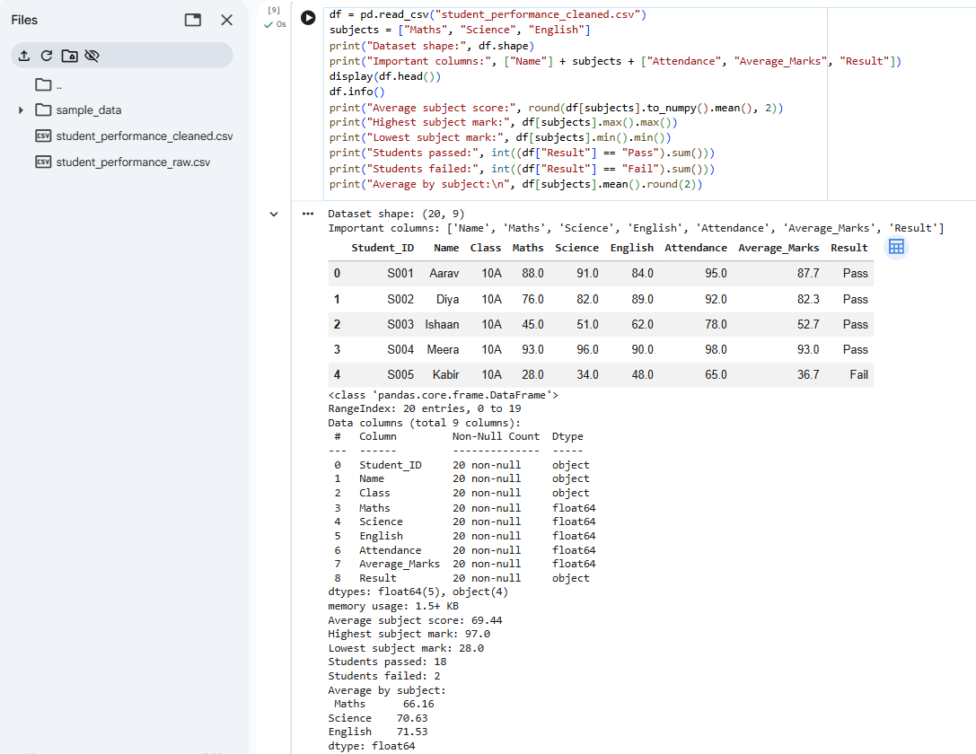

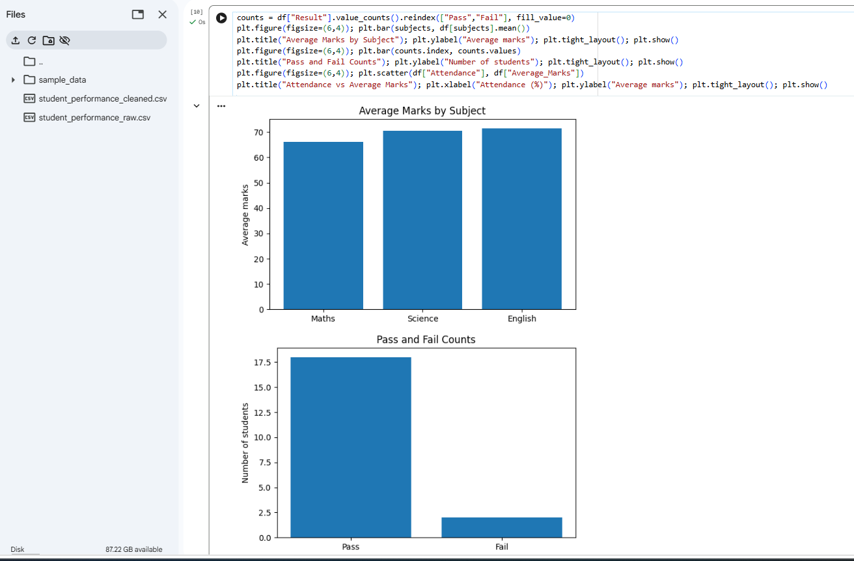

Conclusion :
This analysis uses a small synthetic dataset of 20 students to demonstrate an introductory data workflow. The original file contains missing subject marks, a missing attendance value, a numeric value stored as text, and a duplicated record. The cleaning process converts the score and attendance columns to numeric types, removes the duplicate, fills missing subject marks with each subject's mean, and fills missing attendance with the median. An average mark is then calculated for each student. A student is counted as passing only when every subject mark is at least 35; otherwise, the student is counted as failing. The subject-wise bar chart allows comparison of average performance across Maths, Science, and English. The pass/fail chart summarises outcomes, while the scatter plot helps explore whether attendance and average marks appear associated.Because the dataset is small and synthetic, these results should not be generalised to a real school. The exercise demonstrates how NumPy, Pandas, and Matplotlib can turn tabular data into readable summaries and visual evidence for further investigation.

