Deep Learning & Neural Networks
Week 5 Assignment - Complete Report Domain: Artificial Intelligence | 6-Week AI Internship

Task | Content | Marks
1 | Deep Learning Fundamentals | 20
2 | Build a Basic Neural Network (Breast Cancer, Keras) | 20
3 | Train & Visualize the Model | 20
4 | Model Evaluation & Prediction | 20
5 | Mini Project: Handwritten Digit Recognition | 20
 | Total | 100

Tools: Python, TensorFlow/Keras, scikit-learn, Matplotlib, Seaborn. Code is in the accompanying Jupyter notebooks.

Task 1 - Deep Learning & Neural Network Fundamentals

What is Deep Learning?
Deep Learning (DL) is a branch of Machine Learning that uses artificial neural networks with many layers to learn patterns directly from data. Instead of a programmer hand-crafting features, each layer learns a progressively more abstract representation: in an image model, early layers detect edges, middle layers detect shapes and the last layers detect objects. DL needs large datasets and computing power (GPUs), and powers image recognition, speech assistants, translation and medical diagnosis.

AI vs Machine Learning vs Deep Learning

 | Artificial Intelligence | Machine Learning | Deep Learning
Meaning | Any technique that makes machines act intelligently | Subset of AI: systems learn from data instead of fixed rules | Subset of ML: multi-layer neural networks
Features | Rules or learned | Often hand-crafted by humans | Learned automatically
Data needed | Varies | Small to medium | Large
Examples | Chess engines, expert systems | Linear regression, decision trees, SVM | CNNs, RNNs, Transformers
AI is the broad field, ML sits inside AI, and DL sits inside ML (AI > ML > DL).

What is an Artificial Neural Network (ANN)?
An ANN is a computing model loosely inspired by the brain. It consists of connected units called neurons arranged in layers. Each connection has a weight, and the network learns by adjusting these weights so that its predictions get closer to the correct answers.
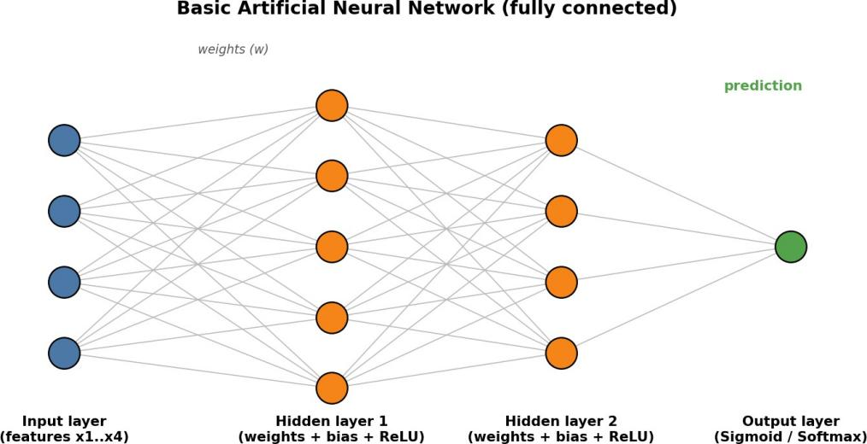

Figure 1: A basic neural network with an input layer, two hidden layers and an output layer.

What is a Neuron?
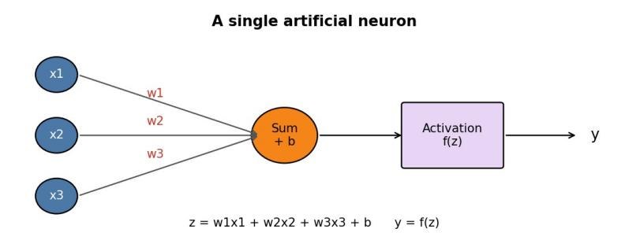
A neuron is the basic unit of a network. It multiplies each input by a weight, adds the results together with a bias, and passes the sum through an activation function: z = w x + w x + ... + b and output = f(z).1 1 2 2

Figure 2: Inside a single neuron.

Layers of a Neural Network

Layer | Role | Example (Breast Cancer model)
Input layer | Receives the raw features. One node per feature; no computation. | 30 nodes (30 tumour measurements)
Hidden layer(s) | Do the learning. Each neuron computes weighted sum + bias + activation. "Deep" means many hidden layers. | Dense(16, ReLU) and Dense(8, ReLU)
Output layer | Produces the final prediction. Size and activation depend on the task. | 1 node, Sigmoid = probability of benign

Weights and Bias
Weights control how strongly each input influences a neuron: a large positive weight amplifies an input, a negative weight suppresses it. Bias is an extra constant added to the sum that lets the neuron shift its output up or down, much like the intercept in a line equation. Weights and biases are the learnable parameters; training means finding good values for them. Our model has 641 of them.

Activation Functions
An activation function adds non-linearity. Without it, stacked layers collapse into a single linear equation and could not learn complex patterns.
Function | Formula | Output range | Typical use
ReLU | f(z) = max(0, z) | 0 to infinity | Hidden layers (fast, default choice)
Sigmoid | f(z) = 1 / (1 + e-z) | 0 to 1 | Binary classification output
Softmax | ezi / sum(ezj) | 0 to 1, sums to 1 | Multi-class output
Tanh | (ez - e-z) / (ez + e-z) | -1 to 1 | Hidden layers (older / RNNs)

Epoch, Loss and Optimizer
Epoch: one complete pass of the entire training dataset through the network. Training normally runs for many epochs (e.g., 50). The data are usually fed in small batches within each epoch.
Loss: a single number measuring how wrong the predictions are; lower is better. Examples: binary cross-entropy for two classes, categorical cross-entropy for many classes, and mean squared error for regression.
Optimizer: the algorithm that updates the weights and biases to reduce the loss. It uses gradients computed by backpropagation and a learning rate (step size). Common optimizers: SGD, RMSprop and Adam (used in our projects).

Basic Working Flow
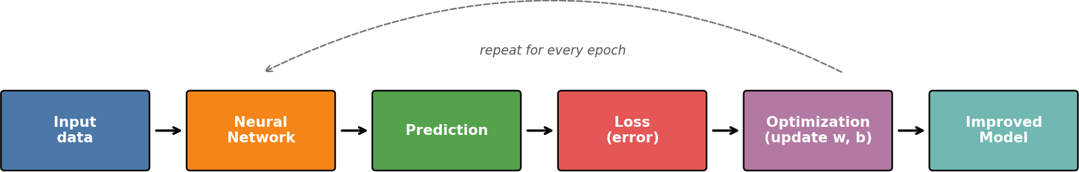

Figure 3: The training loop of a neural network.
Step by step: (1) The input data enter the input layer. (2) Forward pass: each layer computes weighted sums and activations until the output layer gives a prediction. (3) The loss function compares the prediction with the true label and gives an error value. (4) Backpropagation calculates how much each weight contributed to the error, and the optimizer nudges every weight and bias in the direction that reduces the loss. (5) The result is an improved model. This cycle repeats for every batch and every epoch until the loss stops improving, at which point the model is evaluated on unseen test data.

Task 2 - Build a Basic Neural Network
Dataset: Breast Cancer Wisconsin (scikit-learn): 569 samples, 30 numeric tumour measurements, target 0 = malignant (212) and 1 = benign (357). There are no missing values. Goal: predict whether a tumour is malignant or benign.

Steps performed

Step | What was done
1. Load dataset | load_breast_cancer() into a pandas DataFrame (569 x 31)
2. Features / target | X = 30 measurements, y = diagnosis label
3. Split | 80% train (455) / 20% test (114), stratified, random_state=42
4. Preprocess | StandardScaler fitted on training data only (avoids data leakage), then applied to test data
5. Build model | Sequential ANN with input, two hidden layers and output layer
6. Compile | Adam optimizer (lr 0.001), binary cross-entropy loss, accuracy metric
7. Train | 50 epochs, batch size 16, 20% of training data used as validation

Model architecture

Layer | Type | Units | Activation | Parameters
Input | Input | 30 | - | 0
Hidden 1 | Dense | 16 | ReLU | 496
Hidden 2 | Dense | 8 | ReLU | 136
Output | Dense | 1 | Sigmoid | 9
 | Total |  |  | 641

Core code
model = keras.Sequential([ layers.Input(shape=(30,)), layers.Dense(16, activation='relu'), layers.Dense(8, activation='relu'), layers.Dense(1, activation='sigmoid')])
model.compile(optimizer=keras.optimizers.Adam(0.001), loss='binary_crossentropy', metrics=['accuracy'])
history = model.fit(X_train, y_train, epochs=50, batch_size=16, validation_split=0.2)

Training output (from the notebook)

Epoch | Train accuracy | Val accuracy | Train loss | Val loss
1 | 0.673 | 0.791 | 0.630 | 0.528
50 | 0.992 | 1.000 | 0.023 | 0.021

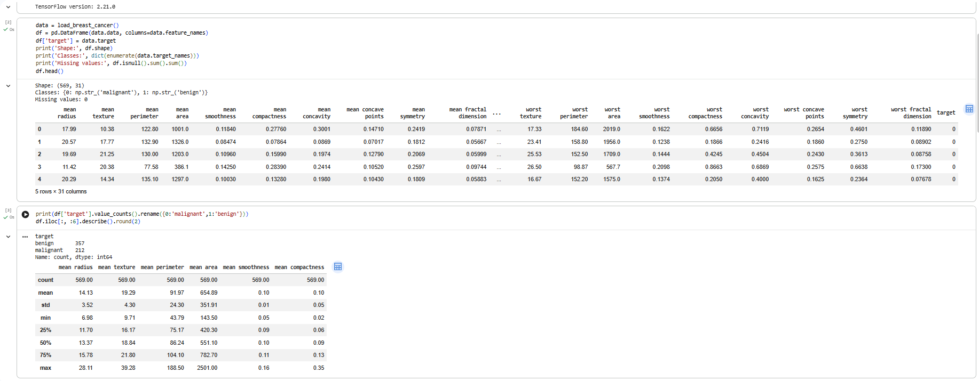

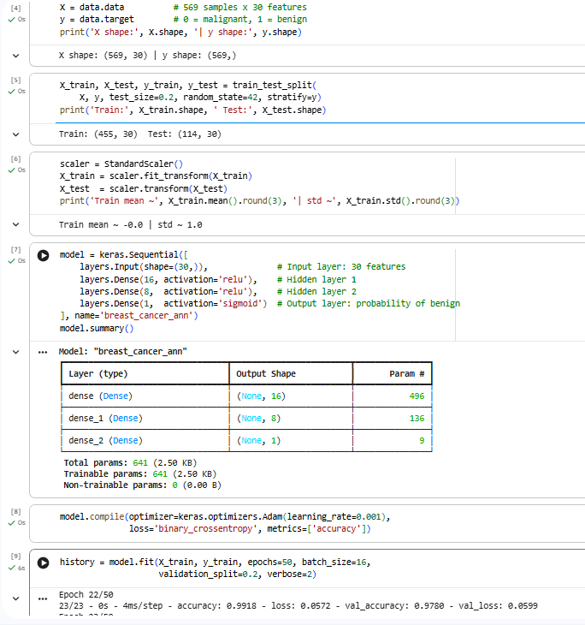

Task 3 - Train & Visualize the Model
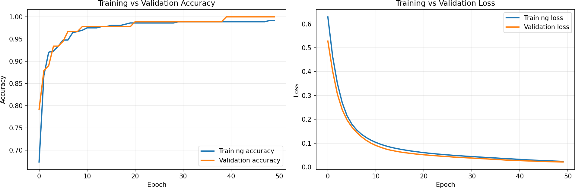
Figure 4: Training vs validation accuracy (left) and loss (right) over 50 epochs.

Explanation
During training, accuracy rose quickly. Training accuracy climbed from 67.3% in epoch 1 to 99.2% in epoch 50, while validation accuracy rose from 79.1% to 100%. Loss moved the opposite way: training loss fell from 0.630 to
0.023 and validation loss from 0.528 to 0.021, with the steepest drop in the first 10 to 15 epochs. The model is clearly improving, and the flattening curves show it is close to convergence. I see no strong sign of overfitting, because validation loss is still falling, tracks training loss closely, and validation accuracy is not below training accuracy. Overfitting would appear as training loss continuing to fall while validation loss rises and the accuracy gap widens. One caution: the validation set holds only 91 samples, so 100% validation accuracy is optimistic. The test accuracy of 95.6% is the more honest figure. EarlyStopping or Dropout would be sensible safeguards, and training for more epochs is unlikely to help much because the curves have already levelled off.

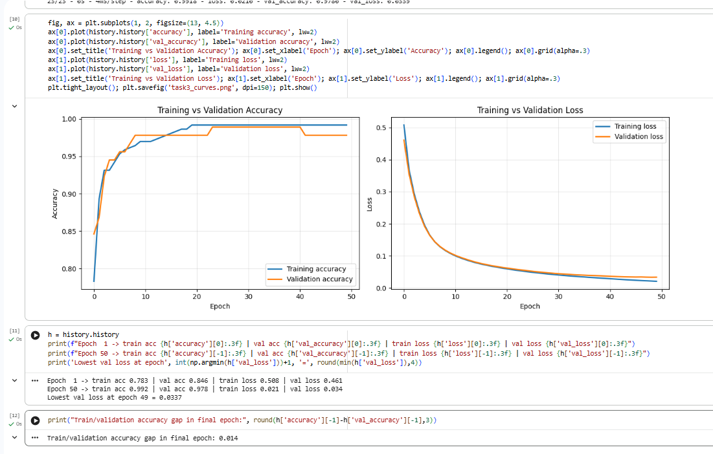

Task 4 - Model Evaluation & Prediction
Test accuracy: 95.61% (test loss 0.0987) on 114 unseen samples. Malignant: precision 0.91, recall 0.98. Benign:
precision 0.99, recall 0.94.

Actual vs predicted (first 10 test samples)

Actual | Predicted | P(Benign) | Correct?
Malignant | Malignant | 0.000 | Yes
Benign | Benign | 1.000 | Yes
Malignant | Malignant | 0.001 | Yes
Benign | Malignant | 0.381 | No
Malignant | Malignant | 0.000 | Yes
Benign | Benign | 0.998 | Yes
Benign | Benign | 1.000 | Yes
Malignant | Malignant | 0.000 | Yes
Malignant | Malignant | 0.000 | Yes
Malignant | Malignant | 0.000 | Yes
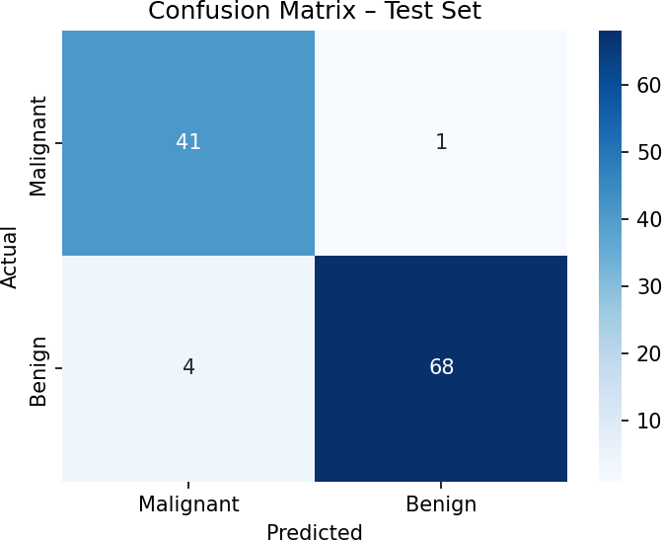

Figure 5: Confusion matrix for the test set.

Explanation of incorrect predictions
The model made 5 errors on 114 test samples (95.6% accuracy). Four were benign tumours predicted as malignant, with P(benign) between 0.29 and 0.49, so they were borderline cases near the decision threshold; these are false alarms that would lead to extra tests. One was a malignant tumour predicted as benign with high confidence (P(benign) = 0.986). This is the most serious type of error, because a real cancer would be missed. Such cases usually have measurements (radius, texture, concavity) that resemble benign tumours. Malignant recall is 0.98, which is good, but a real system should lower the threshold to reduce missed cancers and validate with
cross-validation and more data.

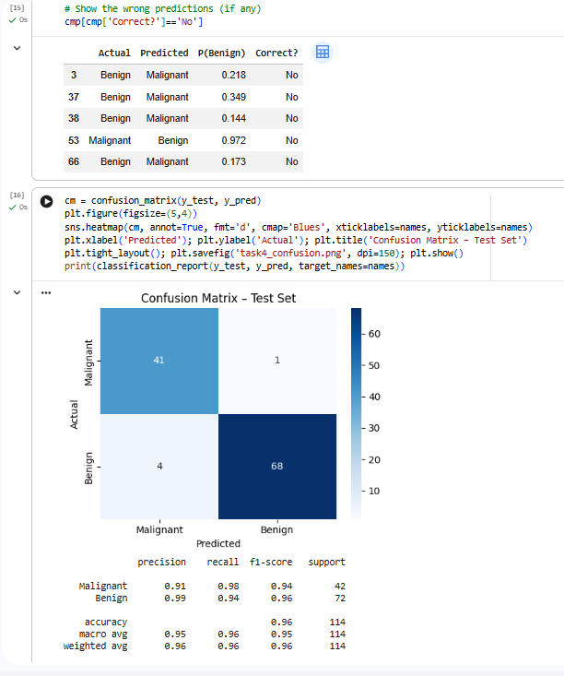

Task 5 - Mini Project: Handwritten Digit Recognition
Workflow: Dataset - Preprocessing - Train/Test split - Neural Network - Training - Prediction - Evaluation - Visualization - Conclusion
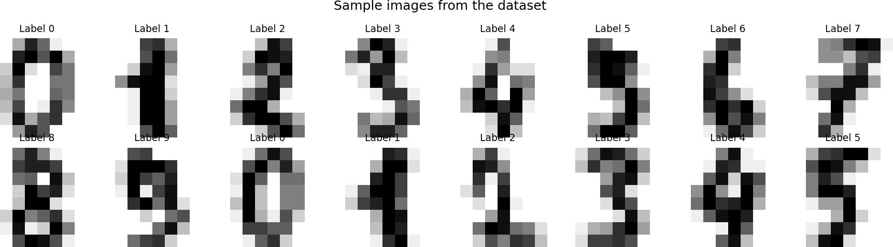
Figure 6: Sample images from the Digits dataset.
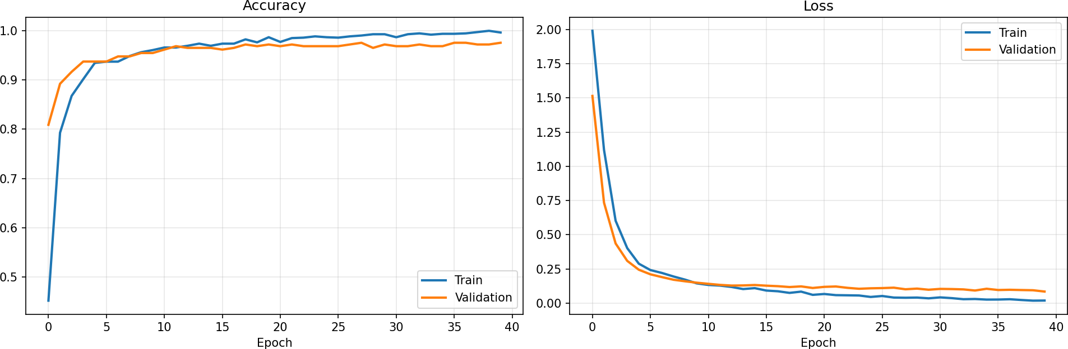
Figure 7: Accuracy and loss curves (40 epochs).
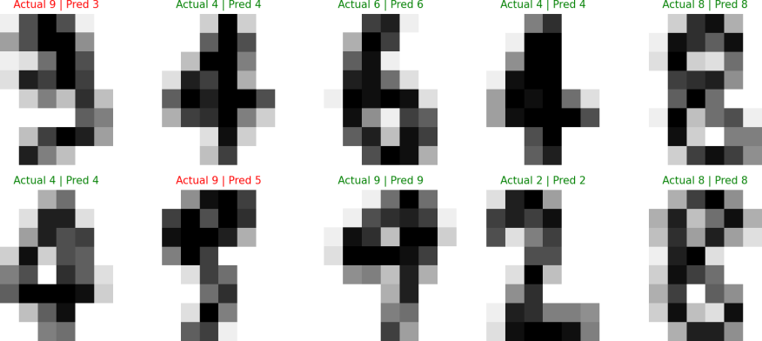

Figure 8: Ten test predictions (green = correct, red = wrong).
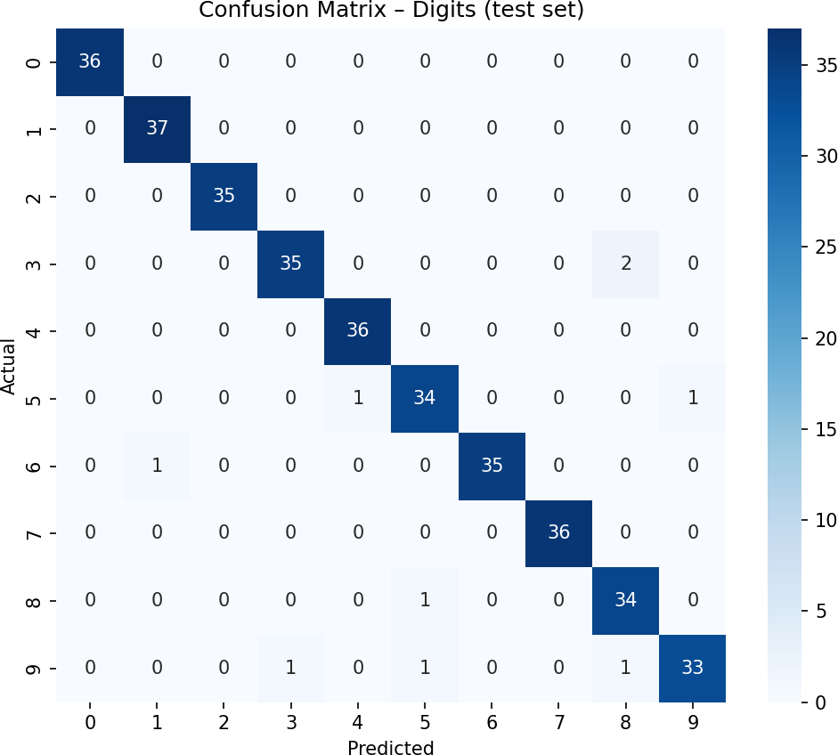
Figure 9: Confusion matrix (360 test images, 97.5% accuracy).

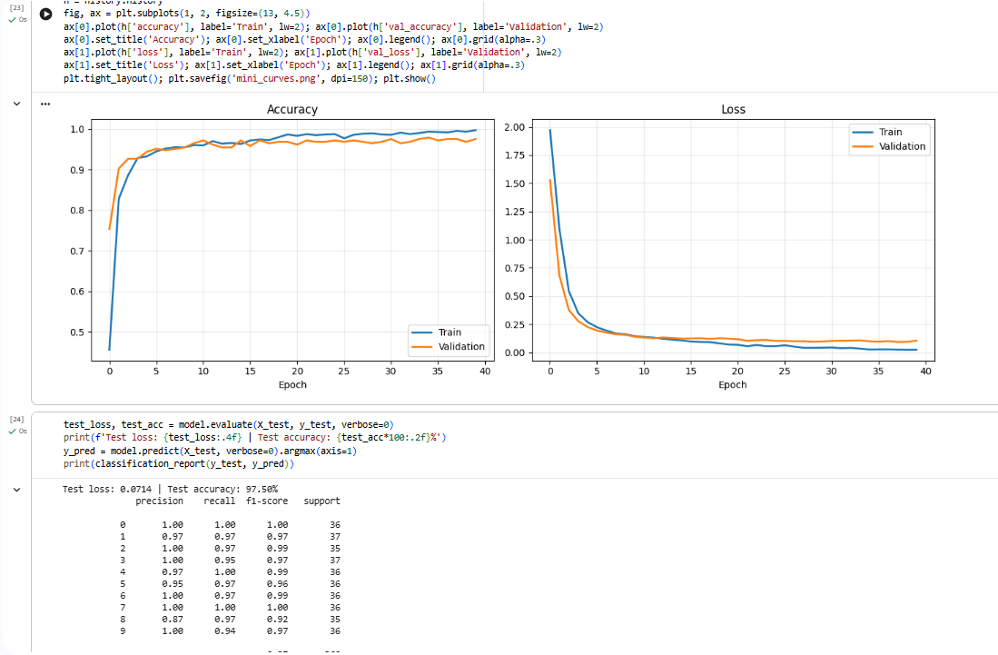

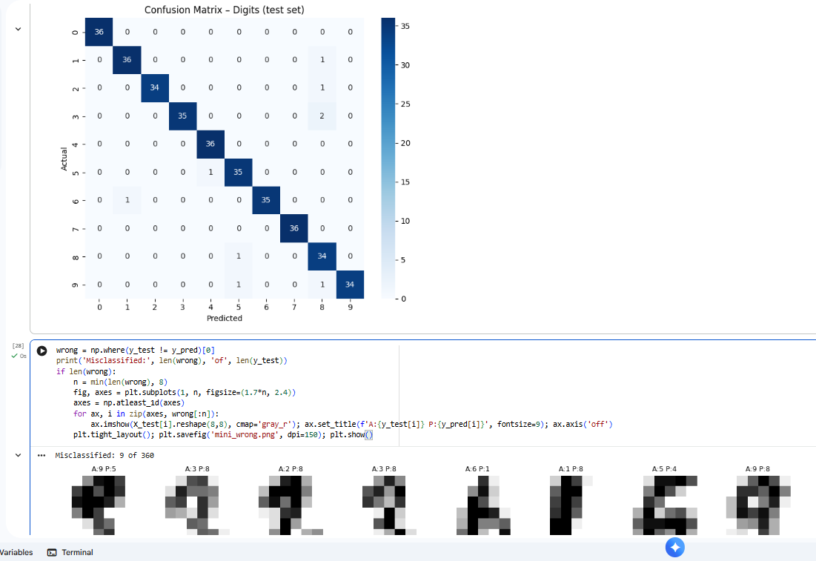

Project Report
Problem. Recognise handwritten digits (0-9) automatically, as used in postal-code reading and form digitisation.
Dataset. The scikit-learn Digits dataset has 1,797 grayscale 8x8 images (64 pixel features) in 10 balanced classes. Pixels were scaled to 0-1 and the data split 80/20 (1,437 train, 360 test, stratified).
Architecture. A fully connected network: 64 inputs, Dense(128, ReLU), Dropout(0.2), Dense(64, ReLU) and Dense(10, Softmax). It was compiled with Adam and sparse categorical cross-entropy.
Training. The model trained for 40 epochs with batch size 32 and 20% of the training data used for validation. Training accuracy rose from 45.2% to 99.7% and validation accuracy from 80.9% to 97.6%, while validation loss fell from 1.51 to 0.085. The two curves stayed close, so overfitting was mild; Dropout helped.
Results. Test accuracy was 97.5% (9 of 360 images misclassified). Most digit classes scored an F1 of 0.96 or higher; digit 8 was weakest, and errors involved visually similar digits such as 9, 3 and 5.
Limitations. The images are tiny (8x8) and clean, a dense network ignores the 2-D structure of images, and only one train/test split was used, so the estimate has some variance.
Future improvements. Use a Convolutional Neural Network on full-size MNIST, add data augmentation, tune hyperparameters, use cross-validation and EarlyStopping, and deploy the model in a small web app. Overall, the project shows that even a small neural network can learn useful patterns directly from raw pixels, and that careful preprocessing, validation curves and a confusion matrix are what make the results trustworthy. The same workflow can be reused for other classification problems such as medical or student-performance data.

