Task 1: Configure Git
1. Set your username and email in Git.
2. Verify the configuration.
$ git config --global user.name "Mrunalini"

$ git config --global user.email mrunalini184@gmail.com

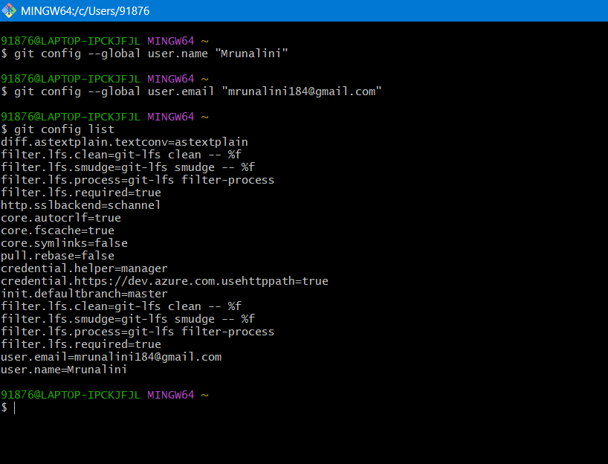

Task 2: Initialize a Local Repository
1. Create a new folder named git-hands-on.
2. Initialize it as a Git repository.
3. Check the repository status.
$ git status

$ git init

$ git status

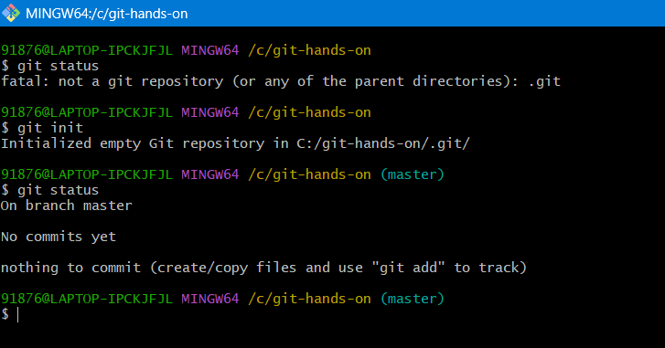
Task 3: Create and Track Files
1. Create a file named documentation.txt.
2. Add a short project description inside it.
3. Check file status.
4. Stage the file.
5. Commit the changes with an appropriate message.
$ git status

$ git add .

$ git status

$ git commit -m "comitted task 3"

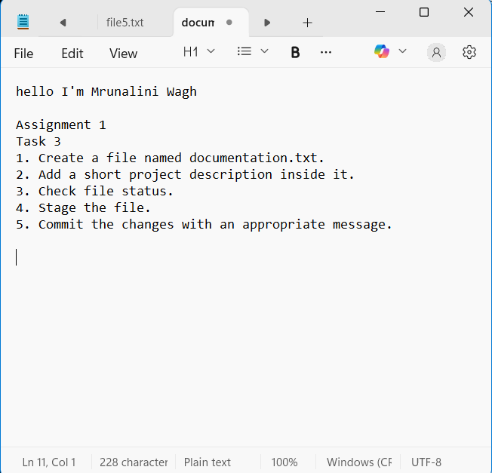
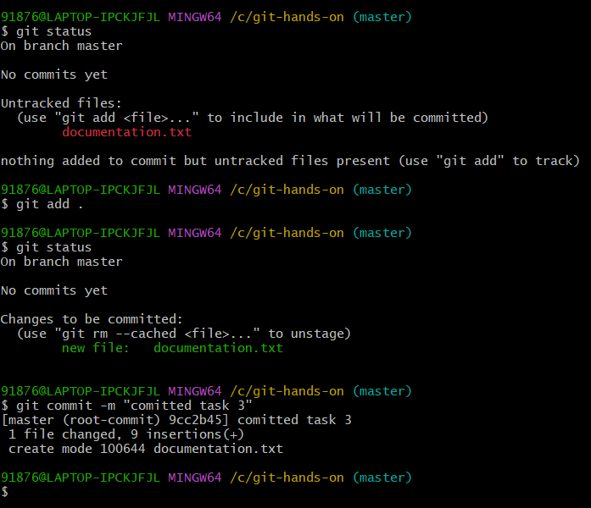

Task 4: Modify and Commit Changes
1. Edit documentation.txt and add one more line.
2. View the differences between working directory and staging area.
3. Stage and commit the changes.
$ git status

$ git diff

$ git add *

$ git status$ git commit -m "commited task 4"
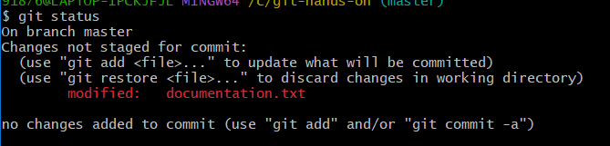
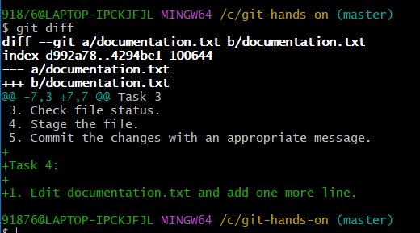

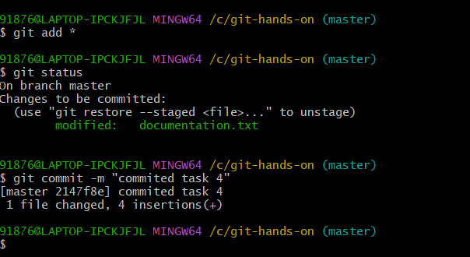
Task 5: View Commit History
1. View the complete commit history.
2. View commit history in one-line format.

$ git log

$ git log –pretty = oneline

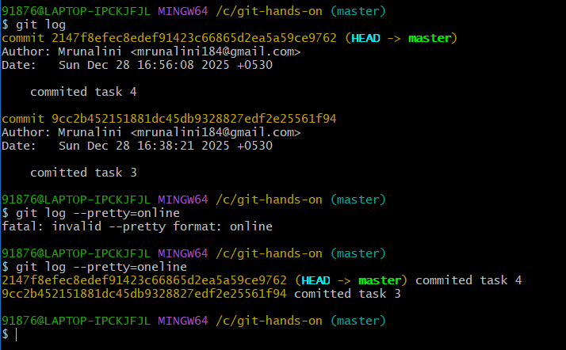

Task 6: Create and Work with Branches
1. Create a new branch named feature-1.
2. Switch to the new branch.
3. Create a new file feature.txt.
4. Commit the changes.
5. Switch back to the main branch.
$ git branch feature-1

$ git checkout feature-1

$ git status

$ git add .

$ git status

$ git commit -m “commited task 6”

$ git checkout master

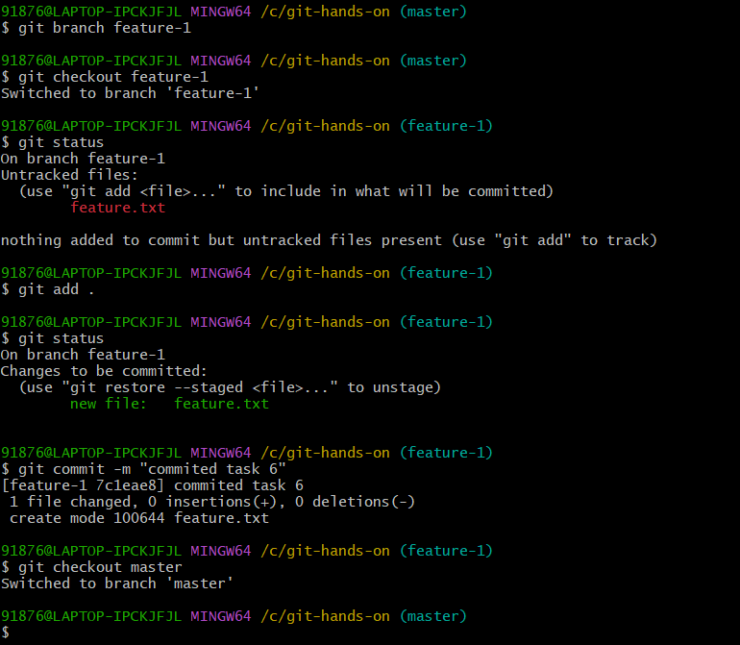

Task 7: Merge Branches
1. Merge feature-1 branch into main.
2. Verify the merge using commit history.
$ git merge feature-1

$ git log

Task 8: Connect to a Remote Repository
1. Create a new repository on GitHub.
2. Add the remote repository URL to your local repo.
3. Verify the remote connection.
$ git remote add origin https://github.com/mrunaliniOIBSIP/Assign_git.git

$ git remote -v

$ git push -u origin master

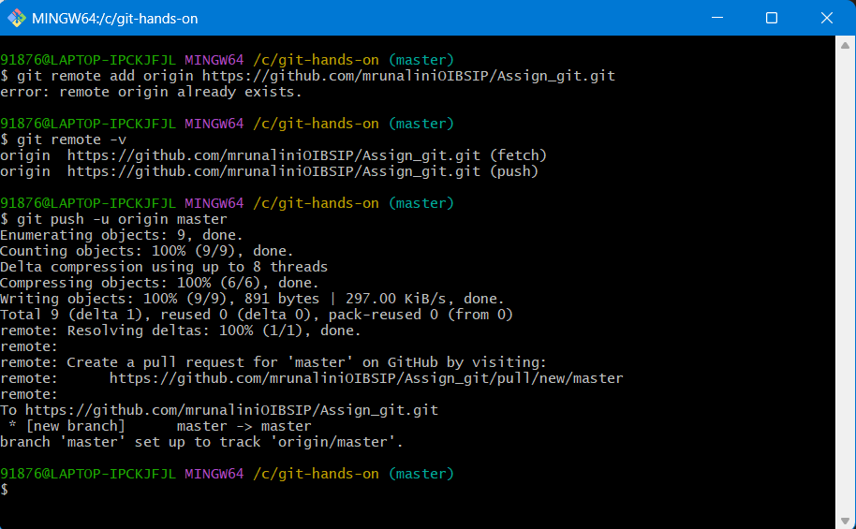

Task 9: Push Code to GitHub
1. Push the main branch to GitHub.
2. Verify files on GitHub.
$ git push -u origin master



Task 10: Clone a Repository
- Clone the same GitHub repository into a different folder.
- Verify the cloned content.

$ git clone https://github.com/mrunaliniOIBSIP/Assign_git.git

$ cd Assign_git

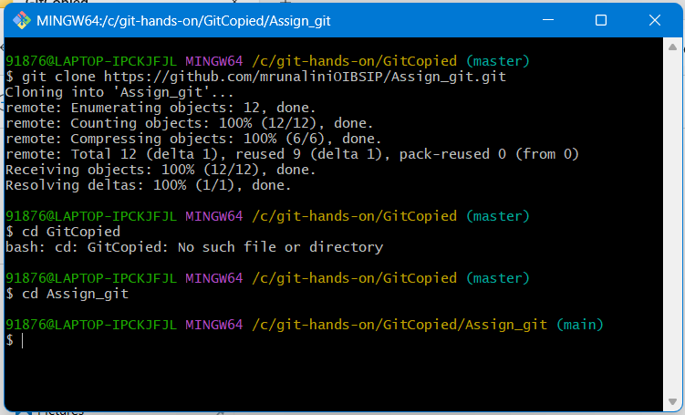

Task 11: Undo Changes
1. Make a change in documentation.txt but do not commit.
2. Discard the changes.
3. Verify the file status.
$ git status

$ git add -A

$ git status
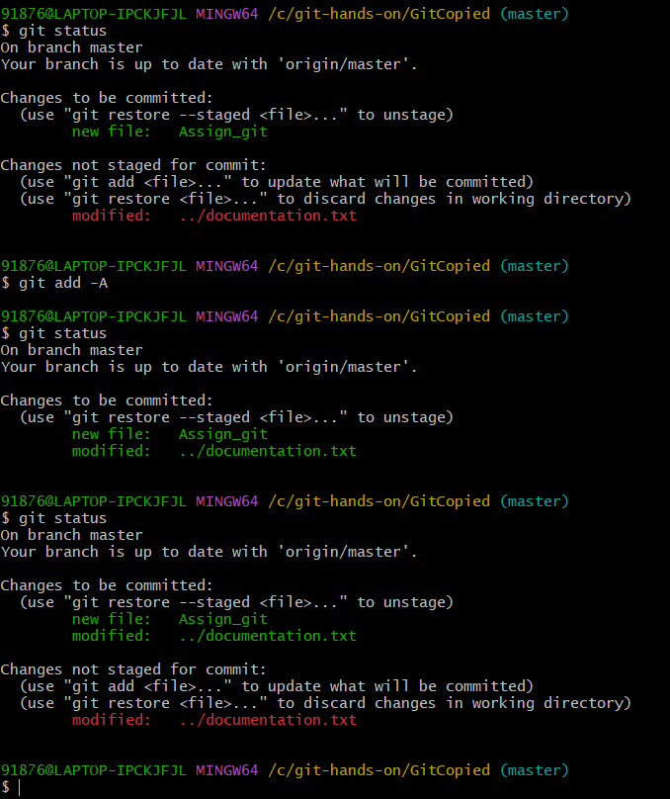

Task 12: Remove Files
- Delete feature.txt using Git.
$ cd ..

$ git rm feature.txt

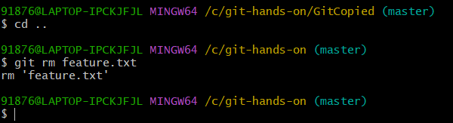

- Commit the deletion.
$ git commit -m "Last commit"

