1. Create a local git repository and move the entire code base to it

Amit@Amit-PC MINGW64 ~ (master)

$ cd c:/Edureka/Samplecode

Amit@Amit-PC MINGW64 /c/Edureka/Samplecode (master)

$ git init

Reinitialized existing Git repository in C:/Edureka/Samplecode/.git/

Amit@Amit-PC MINGW64 /c/Edureka/Samplecode (master)

$ git add .

warning: in the working copy of 'css/site.css', LF will be replaced by CRLF the next time Git touches it

warning: in the working copy of 'index.html', LF will be replaced by CRLF the next time Git touches it

Amit@Amit-PC MINGW64 /c/Edureka/Samplecode (master)

$ git commit -m "Move the entire code"

[master (root-commit) 5ec8746] Move the entire code

9 files changed, 198 insertions(+)

create mode 100644 css/site.css

create mode 100644 fonts/segoeuil.ttf

create mode 100644 img/cloneWhite.svg

create mode 100644 img/deployWhite.svg

create mode 100644 img/lightbulbWhite.svg

create mode 100644 img/stackWhite.svg

create mode 100644 img/successCloudNew.svg

create mode 100644 img/tweetThis.svg

create mode 100644 index.html

2. Create a new branch for a new feature you want to add to the application

Amit@Amit-PC MINGW64 /c/Edureka/Samplecode (master)

$ git status

On branch master

nothing to commit, working tree clean

Amit@Amit-PC MINGW64 /c/Edureka/Samplecode (master)

$ git checkout -b april20

Switched to a new branch 'april20'

Amit@Amit-PC MINGW64 /c/Edureka/Samplecode (april20)

3. Merge back the created branch with the master branch

Done changes in Html

Amit@Amit-PC MINGW64 /c/Edureka/Samplecode (april20)

$ vi index.html

Amit@Amit-PC MINGW64 /c/Edureka/Samplecode (april20)

$ git add .

warning: in the working copy of 'index.html', LF will be replaced by CRLF the next time Git touches it

Amit@Amit-PC MINGW64 /c/Edureka/Samplecode (april20)

$ git commit -m "Changes done in HTML"

[april20 91966c5] Changes done in HTML

1 file changed, 1 insertion(+), 1 deletion(-)

Amit@Amit-PC MINGW64 /c/Edureka/Samplecode (april20)

$ git status

On branch april20

nothing to commit, working tree clean

4. Create a remote repository

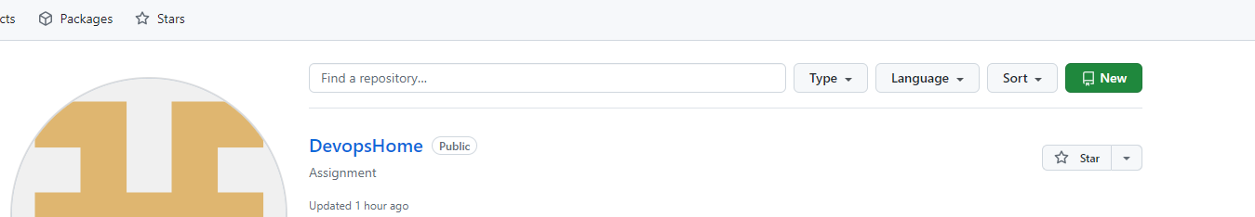

5. Push the local repository to company’s remote repository

$ git remote add origin <https://github.com/mrunaliwarehome/DevopsHome.git>

6. Push the local repository to company’s remote repository

Amit@Amit-PC MINGW64 /c/Edureka/Samplecode (april20)

$ git push -u origin april20

Enumerating objects: 17, done.

Counting objects: 100% (17/17), done.

Delta compression using up to 12 threads

Compressing objects: 100% (15/15), done.

Writing objects: 100% (17/17), 460.64 KiB | 10.24 MiB/s, done.

Total 17 (delta 2), reused 0 (delta 0), pack-reused 0 (from 0)

remote: Resolving deltas: 100% (2/2), done.

To https://github.com/mrunaliwarehome/DevopsHome.git

\* [new branch] april20 -> april20

branch 'april20' set up to track 'origin/april20'.