<https://www.jenkins.io/blog/2023/03/27/repository-signing-keys-changing/>

<https://github.com/htshshrm2/java-hello-world-with-maven> - Buiild pipeline . Compile- test- package

<https://github.com/htshshrm2/spring-petclinic> Compile- test- package

Jenkins installation doc

<https://docs.google.com/document/d/1Lnx2PFXbFmPpCPCN1nci0pI7-EWwuRE_/edit?pli=1>

sudo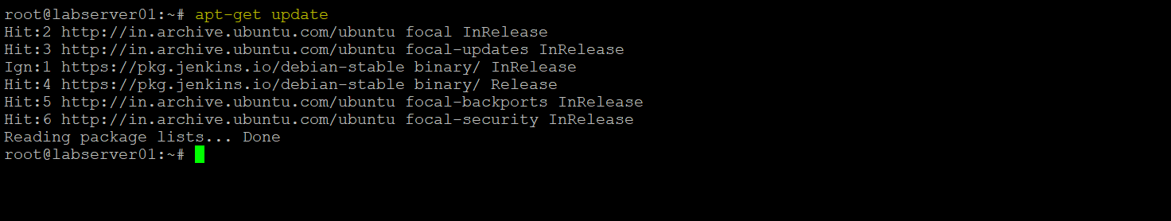

sudo apt install openjdk-11-jdk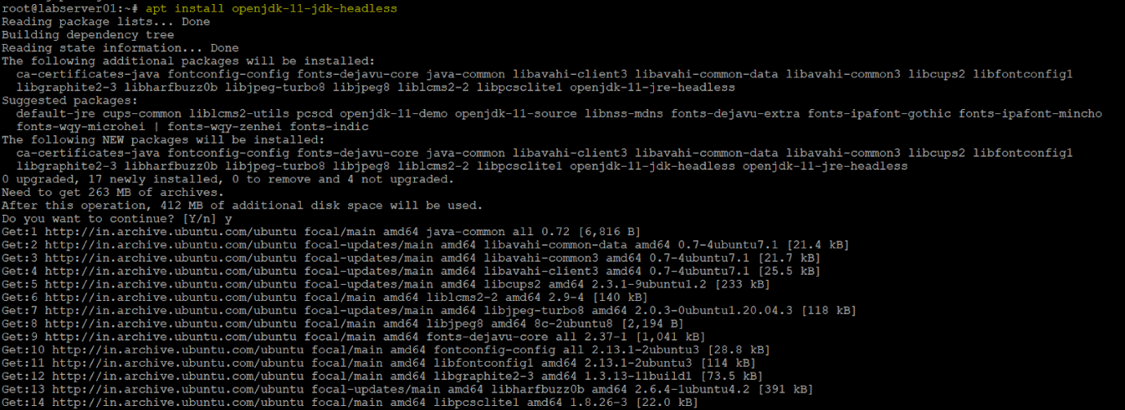

apt update && apt-get upgrade -y

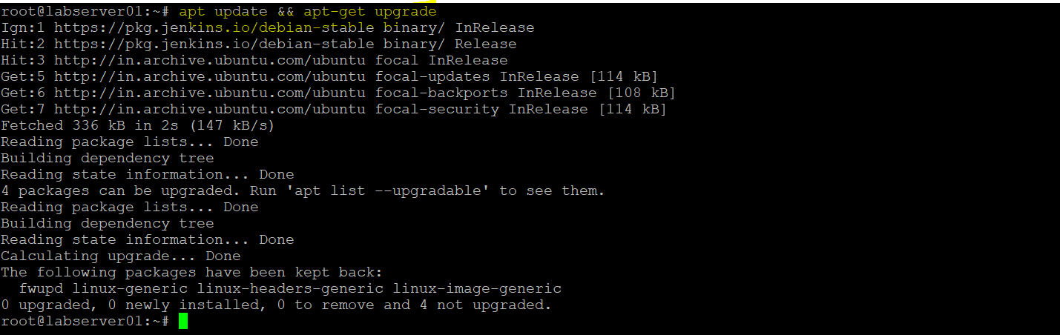

1.sudo wget -O /usr/share/keyrings/jenkins-keyring.asc <https://pkg.jenkins.io/debian-stable/jenkins.io-2023.key>

2.sudo apt-get update

3.sudo apt-get install jenkins

4. sudo systemctl start Jenkins

5.[hsudo systemctl npkg.jenkins.io/debian-stable/jenkins.io-2023.key](https://pkg.jenkins.io/debian-stable/jenkins.io-2023.key)

5.sudo systemctl enable Jenkins

6.then start on your browser using ipv4 :8080 or on vm browser <http://localhost:8080>

First time you have to enter password

7. sudo cat /var/lib/jenkins/secrets/initialAdminPassword - copy password and ligin to page

8.go with standard Jenkins plugins.

apt-get update

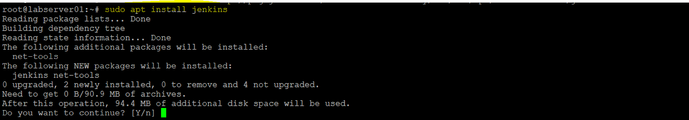

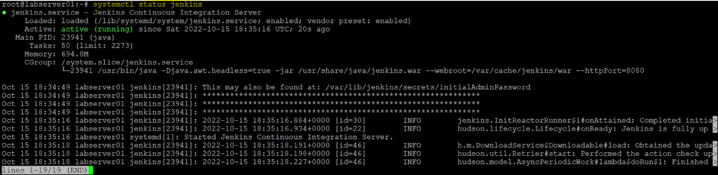



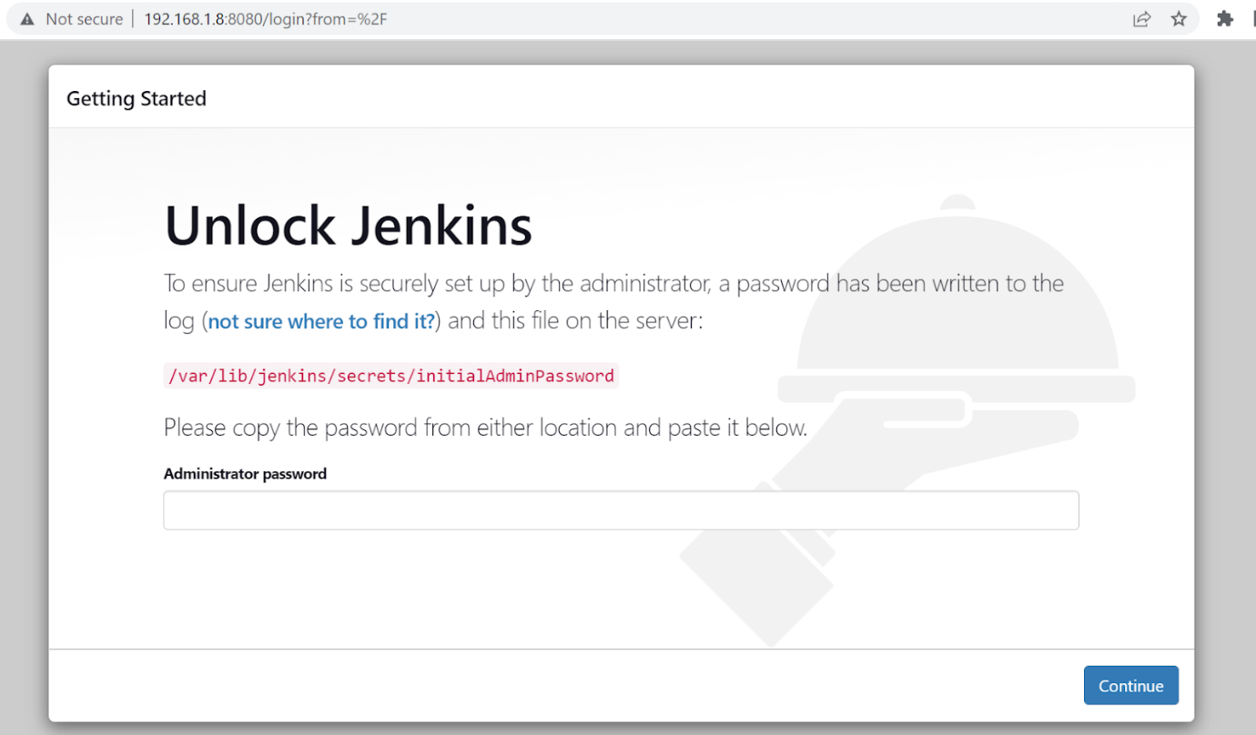

* Find out the IP address or hostname of your Oracle VM.

UbuntuDesktop

Vboxuser

Jenkin url: http://localhost:8080/