CAPSTONE PROJECT REPORT
on
PROJECT TITLE
Submitted by
Name of Student1 (PRN Number)
Name of Student2 (PRN Number)
Name of Student3 (PRN Number)
Under the Guidance of
(Internal Guide Name)
(Internal Co-Guide Name)
(Industry Guide Name)



Department of Electrical and Electronics Engineering
Dr. Vishwanath Karad MIT World Peace University, Pune
[2025-26]

CERTIFICATE

This is to certify that (Name of Student) _______________, PRN ______________ has successfully completed his/her Capstone Project entitled “Project Title_________________________” during the academic year 2025–26 towards the partial fulfilment of the degree of Bachelor of Technology in ___________________________________________________________________________________ as per the guidelines prescribed by Dr. Vishwanath Karad MIT World Peace University, Pune.

Dr. Parul Jadhav
(Project Guide) (Project Coordinator) (Program Director)

Certificate from Industry

DECLARATION

I/We hereby declare that the work carried out under Capstone Project entitled “_______________________” is my/our original work. Proper citations and references have been provided wherever other ideas or words have been included.
Date:
Place:
Details of the group members

Sr.  No. | Name of the students | PRN | Year, Class and Division | Name of the program | Sign
1
2
3
4

ACKNOWLEDGEMENT

We express our sincere gratitude to our project guide, Dr. Shweta Kukade, for her continuous guidance, her careful reviews of our progress and her constant encouragement to check every claim against data. We are equally grateful to our co-guide, Dr. Saket Yeolekar, whose earlier work on the Automated Drive Mode Switching and Recommendation Algorithm gave this project its starting point and who helped us understand how drive modes are handled in an electric two-wheeler.
We thank the Head of the Department and all faculty members and staff of the Department of Electrical and Electronics Engineering, Dr. Vishwanath Karad MIT World Peace University, Pune, for providing the laboratory facilities and the battery management development kit. We also thank the Center for Advanced Life Cycle Engineering (CALCE), University of Maryland, for making its LiFePO4 battery dataset publicly available. Finally, we thank our families and friends for their patience and support throughout the project.

TABLE OF CONTENTS
Content | Page No.
Abstract | 8
List Of Figures | 9
List Of Tables | 10
Abbreviations | 11
Chapter 1: Introduction | 12
1.1 Background & Motivation | 12
1.2 Problem Statement | 13
1.3 Objectives of the Project | 13
1.4 Scope & Limitations | 13
1.5 Organization of Report | 14
Chapter 2: Review Of Literature | 15
2.1 Literature Review | 15
2.2 Gap Identification | 18
Chapter 3: System Development & Methodology | 19
3.1 System Block Diagram / Architecture | 19
3.2 System Specifications (Hardware & Software) | 21
3.3 Flowchart / Algorithm | 22
3.4 Project Planning & Timeline | 24
3.5 Challenges and Complexities | 24
Chapter 4: System Implementation | 26
4.1 Hardware Design & Circuit Diagrams | 26
4.2 Component Selection and Justification | 28
4.3 PCB/Breadboard Implementation | 28
4.4 Simulation/Coding Results with Validation | 29
4.5 Mathematical Modelling | 31
Chapter 5: Results And Analysis | 34
5.1 Functional Demonstration Outcomes | 34
5.2 Test Results and Performance Evaluation | 36
5.3 Data Analysis (Graphs/Tables/Comparisons) | 39
5.4 Interpretation of Results | 42
Chapter 6: Discussion & Conclusion | 44
6.1 Key Achievements & Contributions | 44
6.2 Novelty and Technical Improvements | 44
6.3 Comparison with Existing Methods | 45
6.4 Limitations and Future Scope | 45
6.5 Conclusion | 46
References | 47
Appendices | 50
Appendix A: Codes | 50
Appendix B: Datasheets | 51
Appendix C: Extended Results | 52
Appendix D: Plagiarism Report | 52
Appendix E: Proof of Outcomes (Journal/Conference paper, Patent) | 52
Appendix F: Standards Used (IEEE/IEC/ISO/IPC) | 53
Appendix G: Bill of Material | 54
Appendix H: Safety Norms Followed | 54

ABSTRACT

Standard range estimators till date have typically scaled the state of charge (SOC) by a fixed consumption figure, assuming that the vehicle is driving in a perfect scenario, with no hilly roads and zero traffic. Traffic and terrain parameters are ignored by these estimators. To address this shortcoming, the proposed framework iBMS integrates data-driven battery-state tracking with external route physics and congestion for lithium iron phosphate (LiFePO4) two-wheelers.
The software stack comprises a long short-term memory (LSTM) network to portray complex cell dynamics directly from measured time-series vectors: terminal voltage, current and temperature. Simultaneously, the route-energy model combines elevation metrics, real-time traffic telematics and a road-load velocity parameter into mode-oriented distance-to-empty (DTE) values for ECO and SPORT profiles. Control decision is made via an Adaptive Mode Switching Algorithm (AMSA) that extends feasibility checking before a trip to actively enforce drive-mode overrides or mandate charging stops across safe, critical or infeasible predictions. A Next.js dashboard and a Node.js backend, both deployed in the cloud, integrate these functions.
On applying this on 8 route directions throughout India, a terrain-unaware range estimator overestimated the ECO range uphill by 53–60 % and endorsed a 60 km mountain route that AMSA discards even from a full charge. No initial SOC is required by the LSTM model. It achieves a mean absolute error of 0.20 % on held-out synthetic discharges and 3.17 % on unseen drive cycles of a public LiFePO4 dataset, where an extended Kalman filter with a measured open-circuit-voltage curve achieved 0.96 %. The int8 model occupies 67.6 KiB and runs in 0.41 ms on a laptop CPU, and SHAP shows a reliance on the recent terminal voltage for explainability. AMSA decides on a lower SOC bound, which cuts unsafe route acceptance from 0.71 % to 0.007 % at the cost of more refusals, going from 1.6 % to 8.2 %.
Keywords: adaptive drive-mode switching, distance-to-empty, electric two-wheelers, explainable artificial intelligence, LiFePO4 batteries, long short-term memory, state-of-charge estimation, uncertainty quantification.

LIST OF FIGURES
Fig. 3.1: Layered architecture of iBMS and data flow of a trip feasibility request (steps 1–5)
Fig. 3.2: Full-stack architecture of iBMS as implemented, with external services and technology stack
Fig. 3.3: Hardware–software integration of iBMS on the electric two-wheeler (dashed: planned)
Fig. 3.4: SOC estimation and uncertainty pipeline
Fig. 3.5: Flowchart of the route-level Adaptive Mode Switching Algorithm
Fig. 4.1: Connection diagram of the single-cell BMS bench prototype (red: power path
Fig. 4.2: Simulink model used for live monitoring of the single-cell prototype
Fig. 4.3: Assembled bench prototype: single-cell BMS development kit with resistor load
Fig. 4.4: LSTM estimate and reference SOC on a held-out synthetic discharge scenario
Fig. 4.5: Discharge current, synthesized speed and braking events in one session after the correction
Fig. 5.1: User view during the demonstration: Dehradun → Mussoorie at 80 % SOC, with route-aware distance-to-empty, ECO-Lock and charging recommendation
Fig. 5.2: SOC uncertainty card with the calibrated lower bound and the risk-aware AMSA decision
Fig. 5.3: SOC on the unseen FUDS cycle (CALCE A123 cell, 25 °C): reference, LSTM without initial SOC, EKF and Coulomb counting with a 10 % initial error
Fig. 5.4: DTE in ECO and SPORT modes versus initial SOC for four route directions, with the naive estimate, the route distance and the AMSA decision bands
Fig. 5.5: One-at-a-time sensitivity of the DTE (ECO, 80 % SOC, flat road, 60 km/h
Fig. 5.6: Share of SHAP attribution per input feature of the LSTM

LIST OF TABLES
Table 2.1: Summary of the literature survey
Table 3.1: System specifications
Table 3.2: Main REST endpoints
Table 3.3: Project phases and timeline
Table 4.1: Component and tool selection
Table 4.2: Hand calculation versus backend output (Dehradun → Mussoorie, ECO mode, 60 km/h, SOH 100 %)
Table 5.1: SOC estimation error (% SOC)
Table 5.2: AMSA decision thresholds on eight route directions (60 km/h, SOH = 100 %)
Table 5.3: Effect of the SOC used by AMSA on decision errors (eight routes, CALCE 25 °C test windows)
Table 6.1: Objectives and achieved evidence
Table 6.2: Comparison of AMSA [12] and iBMS
Table B.1: Battery pack of the electric two-wheeler
Table C.1: Federated learning on the field data (MAE, % SOC)
Table F.1: Standards considered in the design
Table G.1: Bill of material

ABBREVIATIONS
Abbreviations used in this report
Abbreviation | Meaning
ADC | Analogue-to-Digital Converter
AMSA | Automated / Adaptive Mode Switching Algorithm
API | Application Programming Interface
BMS | Battery Management System
CALCE | Center for Advanced Life Cycle Engineering (University of Maryland)
CAN | Controller Area Network
DST | Dynamic Stress Test
DTE | Distance-to-Empty
EKF | Extended Kalman Filter
EV | Electric Vehicle
FedAvg | Federated Averaging
FUDS | Federal Urban Driving Schedule
LiFePO4 / LFP | Lithium Iron Phosphate
LOSO | Leave-One-Session-Out
LSTM | Long Short-Term Memory
MAE | Mean Absolute Error
MIL | Model-in-the-Loop
NTC | Negative Temperature Coefficient (thermistor)
OCV | Open-Circuit Voltage
RC | Resistor–Capacitor
REST | Representational State Transfer
RMSE | Root-Mean-Square Error
RUL | Remaining Useful Life
SHAP | SHapley Additive exPlanations
SOC | State of Charge
SOH | State of Health
SRTM | Shuttle Radar Topography Mission
US06 | US06 Supplemental Federal Test Procedure (drive cycle)
VCU | Vehicle Control Unit

CHAPTER 1 INTRODUCTION

1.1 Background & Motivation
Even though electric two-wheelers offer low-cost urban mobility, their packs hold little energy reserve. The electric two-wheeler studied in this project carries a LiFePO4 pack of 63.5 V and an estimated 30.9 Ah, about 1.96 kWh. An error of a few hundred watt-hours in the planned trip energy of a pack of about 2 kWh decides whether the rider will arrive or is stuck somewhere.
Most of the range estimators calculate the distance-to-empty (DTE) by scaling the state of charge (SOC) with a fixed consumption value, as if every kilometre, and every two different routes with the same distance, will cost the same energy. References [1]–[2] state that route energy depends on topography, traffic and speed. Uphill routes require energy well above the flat-road values [3], [4], and downhills return part of it through regenerative braking [5], that is, motion is turned back into battery energy which is then stored. A flat-road DTE is hence optimistic on climbs, which is exactly where accuracy matters most.
Research regarding battery management systems (BMS) has been oriented so far to data-driven estimation of the SOC, the state of health (SOH) and the remaining useful life (RUL). LSTM networks model the time-series behaviour of cells [6], [7], explainability techniques make such models inspectable [8], [9], and edge and federated learning keep telemetry on the vehicle [10]–[11], ensuring privacy. These battery estimators do not see the trip in advance, and energy-aware routing barely uses the measured battery state. The Automated Drive Mode Switching and Recommendation Algorithm (AMSA) [12] connects the two by changing to ECO mode when the remaining distance of the trip exceeds the range left in the current mode. The range check of AMSA uses instantaneous consumption (power / speed) and cannot predict the cumulative climbs and congestion of a particular route.
The proposed software stack, iBMS, solves this problem for LiFePO4 two-wheelers. Before the trip begins, the route is returned with live traffic and its elevation profile; the cumulative grades, congestion and assumed cruising speed are then converted into ECO and SPORT DTE values scaled by the battery state. AMSA is extended from real-time mode selection to a route-level check. A leg is basically one section of a trip between two stops. A leg possible in SPORT mode stays under manual control, a leg possible only in ECO mode triggers an enforced ECO-Lock, and an impossible leg requires a charging stop.

1.2 Problem Statement
Conventional range estimation in electric two-wheelers ignores the terrain and traffic of the planned route and the health of the battery, so it can approve trips that strand the rider, especially on hill routes. Real-time mode switching reacts only once a climb has begun, and data-driven SOC estimators are rarely benchmarked fairly or connected to trip decisions. The problem addressed is to design and evaluate a framework that estimates the SOC of a LiFePO4 pack without an initial SOC, computes the energy of a planned route from its terrain, traffic and speed, checks the route leg by leg before departure using an uncertainty-aware SOC, and enforces ECO mode or a charging stop when needed.

1.3 Objectives of the Project
- Objective 1: a route-energy model that brings cumulative grades from a 30 m elevation model, a real-time traffic-jam ratio, a road-load speed factor and SOH-scaled pack energy into mode-specific DTE.
- Objective 2: a route-level AMSA that enforces ECO-Lock or a charging stop before the start of the trip, evaluated on eight real route directions against a terrain-unaware baseline estimator.
- Objective 3: a leak-free LSTM SOC estimator for a 63.5 V LiFePO4 pack that needs no initial SOC, compared with Coulomb counting, an extended Kalman filter (EKF) and a constant predictor.
- Objective 4: the estimator quantized to a 67.6 KiB int8 model, explained with SHAP and given a calibrated lower SOC bound for risk-aware decisions, as it makes unsafe trip acceptances much rarer.
- Objective 5: a web dashboard and REST backend, deployed in the cloud, that integrate these functions, and an IEEE conference paper describing the work.
The mid-term objective of federated learning was evaluated and replaced by uncertainty quantification: federated averaging reached 8.99 % MAE against 3.17 % for centralized training on CALCE, and its model updates needed more data transfer than the raw data (Appendix C).

1.4 Scope & Limitations
The project covers a software framework (data processing, estimation models, route-energy model, AMSA, dashboard and backend) with offline experiments, and a single-cell BMS bench prototype. ECO-Lock enforcement is at present a software command at the rider's interface. The field data come from stationary tests, so the route results are model-based evaluations on real routes with live traffic and measured terrain, not on-road validation. The main limitations are listed in Section 6.4.

1.5 Organization of Report
Chapter 2 reviews the literature and identifies the research gap. Chapter 3 describes the architecture, specifications, algorithms, project timeline and challenges. Chapter 4 covers the hardware, component selection, prototype, software validation and mathematical model. Chapter 5 presents the demonstration, test results, data analysis and interpretation, and Chapter 6 the contributions, novelty, comparison, limitations and conclusion.

CHAPTER 2 REVIEW OF LITERATURE

2.1 Literature Review
Trained battery models map voltage, current and temperature to internal states [7], LSTM networks predict the SOH [6], deep neural network models predict the remaining useful life [13], [14], and digital twins bring such models inside the BMS [15]. The opaque nature of these models is addressed by SHAP-attributed gradient boosting, making the system explainable [8], and by studies of the accuracy–transparency trade-off [9], while edge [10] and federated learning [16], [11], [17], [18] keep telemetry on board. Most of this work targets SOH on laboratory datasets. SOC estimators that are already trained are hardly ever compared with model-based ones under an uncertain initial SOC, and their output stays diagnostic rather than being informative about a trip decision.
Energy rather than distance is the binding constraint in electric-vehicle routing [2]. The trip energy depends on traffic [1], [19], topography [3], [4] and regeneration [5], and is handled by charging-aware routing [20] or by terrain-aware routing [21] for automated vehicles. Such methods plan the route or help in driving the vehicle, but they do not govern how a rider uses the drive modes. AMSA [12] switches modes in the vehicle control unit from the SOC, the instantaneous topographic gradient and the instantaneous power demand, and falls back to limp-home mode at low SOC. It was tested in model-in-the-loop simulation on a predefined urban drive cycle, and its range check reacts to a gradient only once the gradient occurs, without battery health, live traffic or the cumulative terrain ahead in the trip. As Table 2.1 shows, no surveyed work combines battery-state estimation with route terrain and live traffic into a pre-trip, leg-wise decision that enforces a drive mode or a charging stop.

2.1.1 Data-driven battery state estimation
Zhang et al. [7] review how sensing and artificial intelligence are converging into "smart batteries" and note that most learned battery models are trained and tested on laboratory cycling data rather than vehicle data. The LSTM network of Hochreiter and Schmidhuber [22], whose gated memory cell retains information over many time steps, is the recurrent architecture used in most learned battery estimators.
Xu, Xu and Zhu [6] estimate the SOH of lithium-ion cells with an LSTM extended by spatio-temporal attention. The model captures the temporal dependence of degradation but remains a black box and is not linked to vehicle operation. Liu et al. [13] predict remaining useful life from short discharging fragments with a hybrid deep-learning model; the prediction is diagnostic and not connected to trip planning. Li et al. [14] review neural networks for battery health and lifetime prediction and show that their accuracy depends on representative training data, which our own results confirm: an LSTM trained only on synthetic data performed poorly on the real pack until fine-tuned. Madani et al. [15] survey AI and digital-twin technologies for battery management systems, but do not address decisions about vehicle use.

2.1.2 Model-based SOC estimation and benchmark data
The Kalman filter [23] combines a model prediction with a measurement correction weighted by their uncertainties. Plett [24] applied the extended Kalman filter (EKF) to vehicle battery packs: Coulomb counting predicts the SOC and the terminal voltage corrects it through an open-circuit-voltage (OCV) curve and resistor–capacitor (RC) model. The EKF recovers from a wrong initial SOC but needs a characterized cell model. Xing et al. [25] estimated the SOC of LiFePO4 cells from the OCV at different temperatures, and He et al. [26] combined a neural network with an unscented Kalman filter. Both used the CALCE LiFePO4 dataset of the University of Maryland (DST, US06 and FUDS drive cycles at −10 to 50 °C), which is the public benchmark used in this project.

2.1.3 Explainable, edge and federated learning
SHAP [27] attributes a model's prediction to its inputs using Shapley values. Xiao et al. [8] explain an XGBoost SOH model with SHAP, and El Bahnasawi et al. [9] show that explainability is needed for operator trust; in both, the explanation is diagnostic and does not feed a control decision. A. R C et al. [10] run battery-health monitoring for electric scooters on an FPGA at the edge, without using the route or terrain. Federated learning keeps raw data on each vehicle and shares only model updates [16]; Abbaraju and Kundu [11], Wang et al. [18] and Bouchiha et al. [17] apply it to SOH estimation of connected EVs. None of these works acts on vehicle operation.

2.1.4 Uncertainty quantification
Gal and Ghahramani [28] showed that keeping dropout active at prediction time and repeating the prediction (Monte-Carlo dropout) approximates Bayesian uncertainty. Such estimates are often poorly calibrated; split-conformal prediction [29] uses a held-out calibration set to obtain intervals with guaranteed coverage. iBMS combines both to obtain a calibrated lower SOC bound.

2.1.5 Energy-aware routing and drive-mode adaptation
Zhu et al. [1] predict EV energy consumption from field data with machine learning, and Skuza et al. [19] model the effect of traffic parameters on consumption. Martin et al. [2] conclude that energy, not distance, is the binding constraint of EV routing. Lai et al. [3] include speed optimization and uneven topography in routing, Puma-Benavides et al. [4] report higher consumption on steep high-altitude urban roads, and Szumska [5] reviews regenerative braking and its limited recovery efficiency. Kirca and McGordon [30] report drag areas of about 0.50–0.59 m² for an upright electric-motorcycle rider, which supports the value used in our road-load model. Kapoor [20] routes EVs to charging stations with graph neural networks, and Ning et al. [21] plan energy-efficient trajectories on uneven terrain; these methods choose a route or control the vehicle fully but do not regulate a rider's drive modes.
The closest work is the AMSA of Pise, Yeolekar, Lokhande and Khan [12] from our department. It selects ECO, SPORT or limp-home mode in the vehicle control unit from the Coulomb-counted SOC, the instantaneous gradient and the power demand, prefers ECO below 40 % SOC and was evaluated in Simulink on a predefined 10 km Pune traffic profile. It reacts to a gradient only once it occurs and does not use battery health, live traffic or the terrain of the route ahead. Table 2.1 summarizes the literature.
Table 2.1: Summary of the literature survey
Authors (Year) | Methodology | Limitation / gap
Xu et al. (2024) [6] | LSTM with attention for SOH | Black box; not linked to vehicle operation
Liu et al. (2024) [13] | Hybrid deep learning for RUL | Diagnostic only
Li et al. (2025) [14] | Review of neural networks for battery health | Depends on representative data
Plett (2004) [24] | EKF with battery model | Needs OCV curve and model parameters
Xing et al.; He et al. (2014) [25], [26] | SOC of LiFePO4 cells on CALCE data | Laboratory cells; no vehicle decision
Xiao et al. (2024) [8] | XGBoost SOH explained with SHAP | Diagnostic explanation
El Bahnasawi et al. (2025) [9] | Explainable AI for battery health | No control decision
A. R C et al. (2025) [10] | FPGA edge monitoring for e-scooters | No route or terrain
Abbaraju and Kundu (2024) [11] | Federated SOH estimation | No intervention
Zhu et al. (2025) [1] | ML prediction of EV consumption | No battery-state decision
Lai et al. (2024) [3] | Routing with speed and topography | No battery state
Puma-Benavides et al. (2024) [4] | Consumption in high-altitude traffic | Analysis only
Kapoor (2025) [20] | GNN routing to charging stations | Does not regulate drive modes
Pise et al. (2026) [12] | AMSA: real-time mode switching | Instantaneous gradient; reacts while riding

2.2 Gap Identification
- Gap 1 – estimation and planning are separate: battery-state estimators [6], [8], [10], [11] do not know the trip ahead, and energy-aware routing [2], [3], [20] does not use the battery state, its health or its uncertainty.
- Gap 2 – no pre-trip, route-level drive-mode decision: no work combines battery state, route terrain and live traffic into a leg-wise decision that enforces a drive mode or a charging stop; AMSA [12] decides in real time from the instantaneous gradient.
- Gap 3 – weak evaluation and no uncertainty in the decision: learned SOC estimators are seldom compared with model-based and trivial baselines, and their uncertainty [28], [29] is not used in safety decisions.
iBMS addresses these gaps by checking the whole route before departure with a fairly benchmarked SOC estimate and deciding on its calibrated lower bound.

CHAPTER 3 SYSTEM DEVELOPMENT & METHODOLOGY

3.1 System Block Diagram / Architecture

3.1.1 Layered architecture
iBMS has five layers (Fig. 3.1). The first layer, the data layer, converts BMS readings of pack voltage V, current I, maximum cell temperature T, cell-voltage difference ΔV_cell and SOC into 1 Hz time series, and adds synthetic discharge scenarios to widen the SOC range for training. The second layer, the model layer, trains the SOC estimator in TensorFlow/Keras and exports it to TensorFlow Lite. A Node.js service layer, the third layer, hosts the route-energy model (Section 4.5.2) and AMSA (Section 3.3.2); it queries the TomTom Routing API for the route with live traffic and OpenTopoData for SRTM 30 m elevations. A Next.js layer, the API layer, which is the fourth layer, exposes these functions as REST endpoints for a web dashboard, the user interface (UI), which is the final layer.
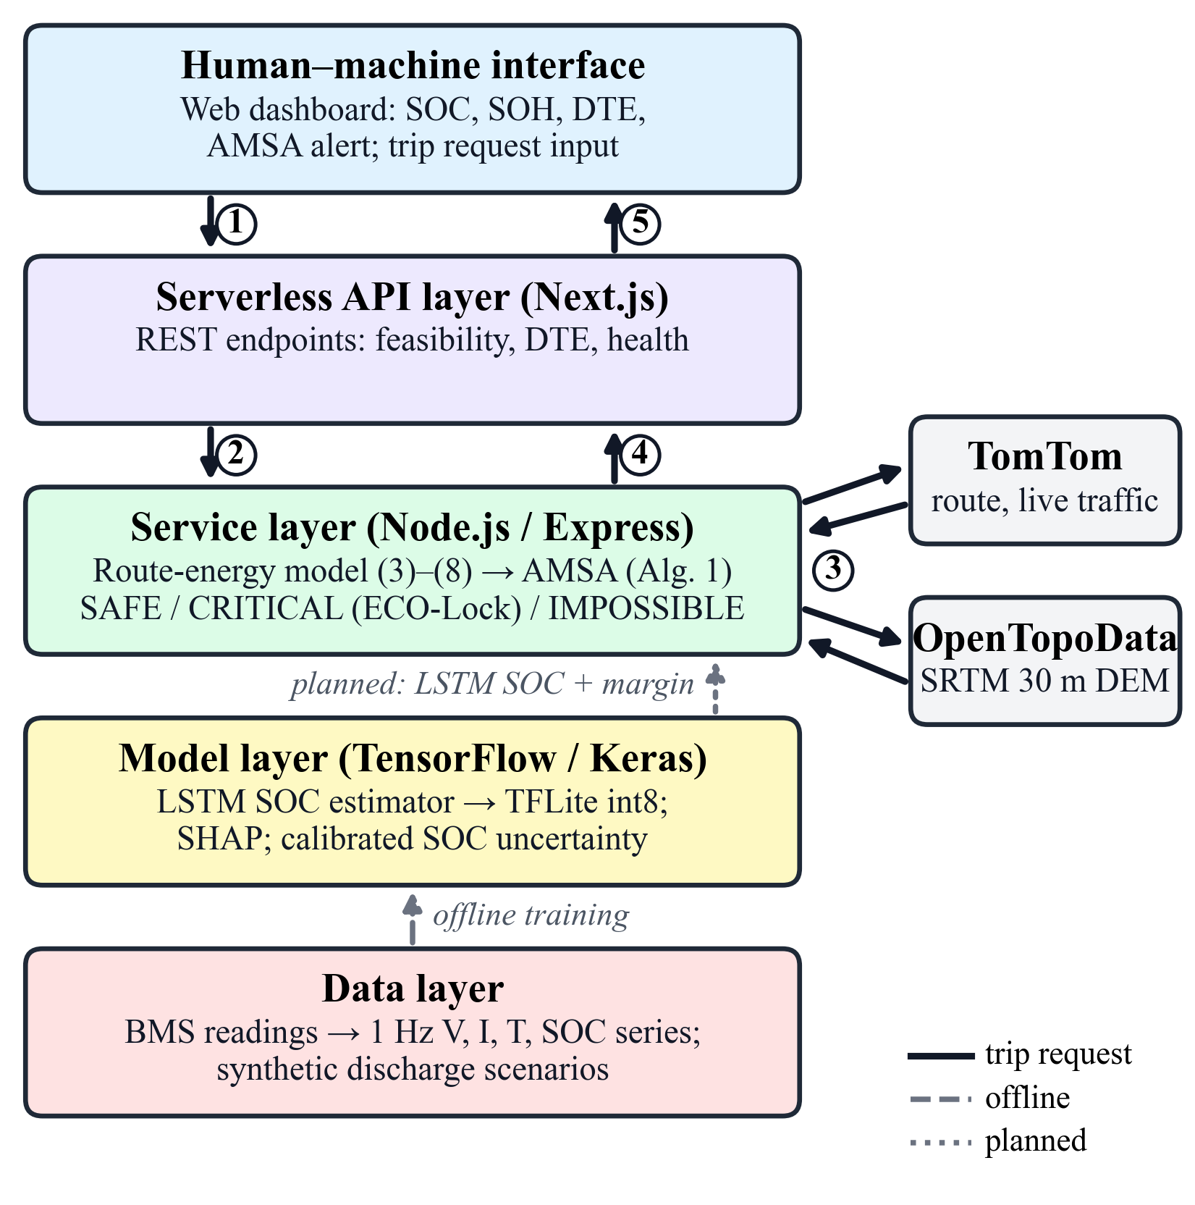
Fig. 3.1: Layered architecture of iBMS and data flow of a trip feasibility request (steps 1–5); dashed: offline training; dotted: planned online SOC feed
For a trip, when the rider enters the trip details, the dashboard sends the origin, destination, SOC, SOH and cruising speed to the feasibility endpoint, which returns the AMSA decision and its margins as a JSON response, which the dashboard displays. In the current prototype the SOC sent to AMSA is entered on the dashboard, because the LSTM is not yet connected to live BMS data from the vehicle. The stack is built in layers that are independent of each other, so each layer can be changed or moved without changing the others.

3.1.2 Full-stack implementation
Fig. 3.2 shows the system as implemented, with the components of each layer and the external services: data preparation (stand tests, synthetic discharges, CALCE data), learning and estimation, the route-energy model and AMSA in the backend, the Next.js API routes and the web dashboard.
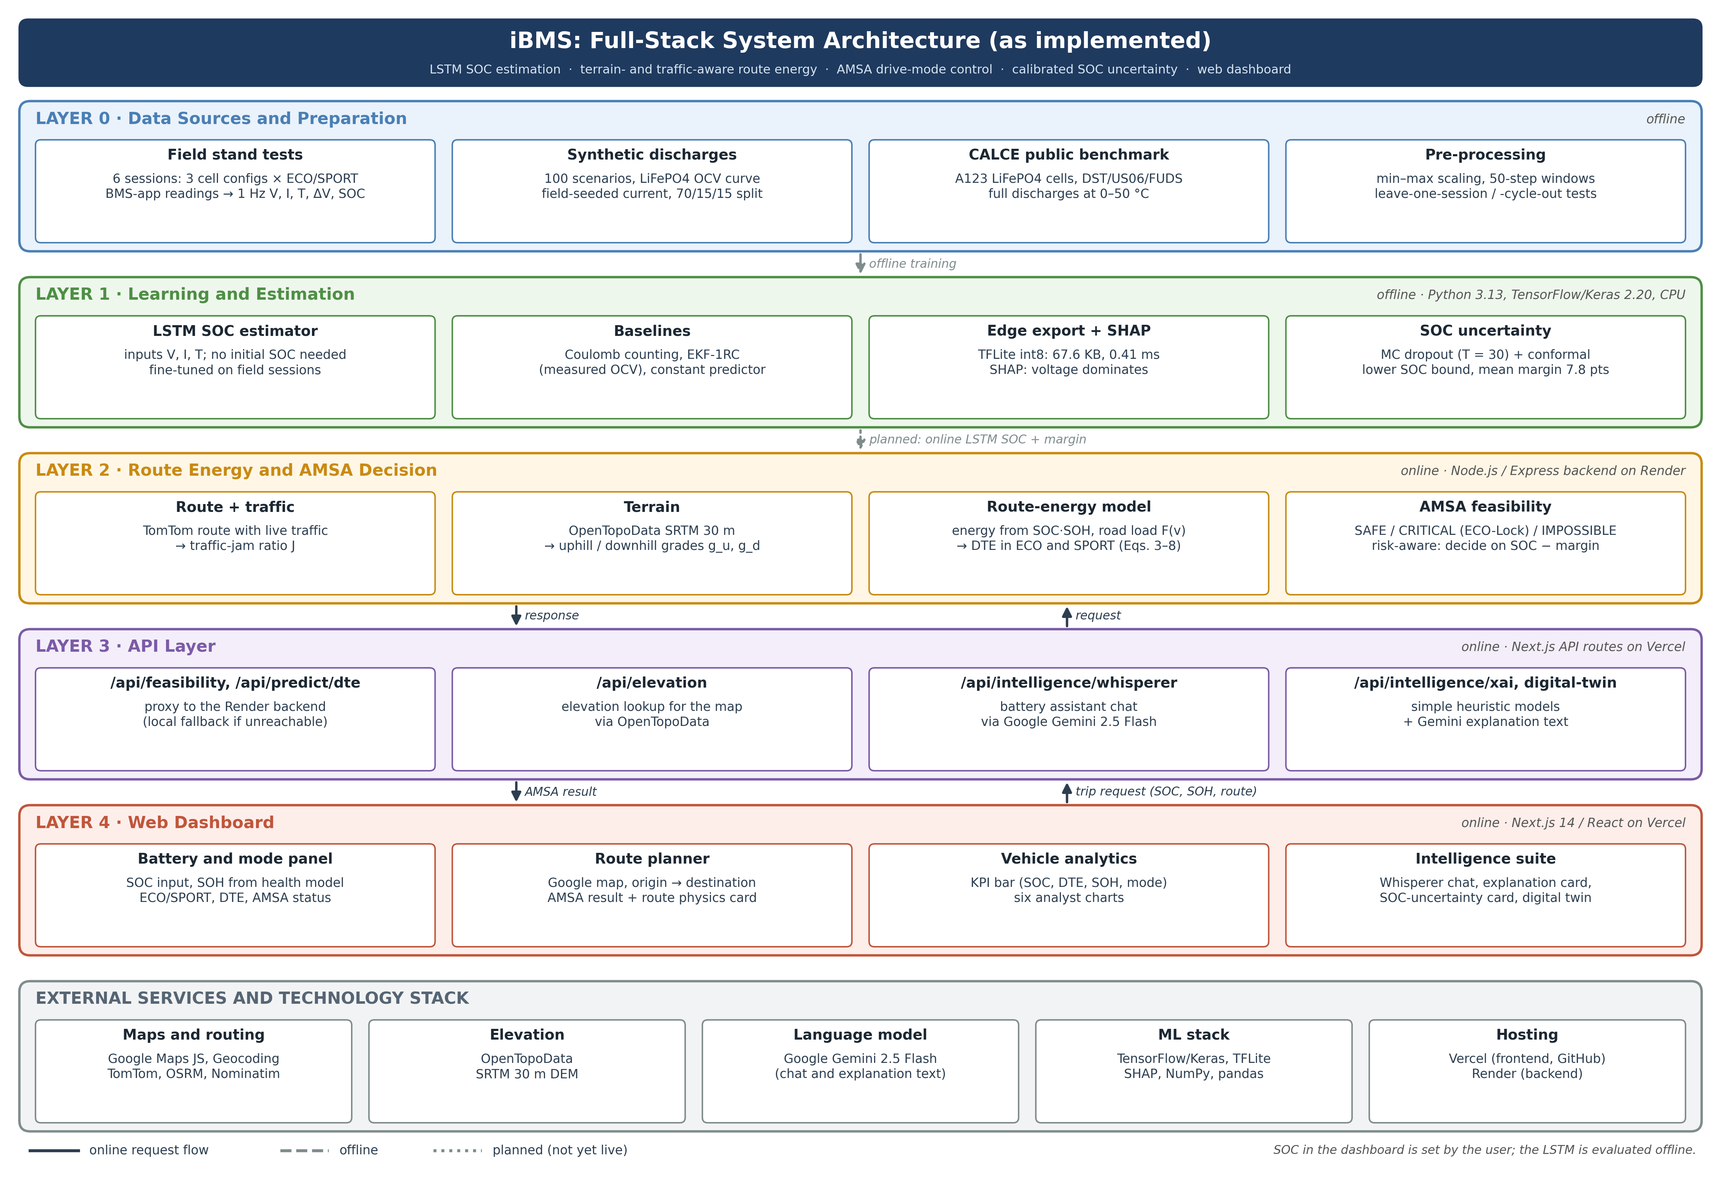
Fig. 3.2: Full-stack architecture of iBMS as implemented, with external services and technology stack

3.1.3 Hardware–software integration
Fig. 3.3 shows how the software connects to the vehicle. The pack is measured by the vehicle's own BMS, whose readings were acquired through its mobile app and converted to 1 Hz data for the models. The backend computes the decision and the dashboard disables SPORT mode when ECO-Lock is required. Sending the same command to the vehicle control unit (VCU) over CAN, so that the motor controller limits torque directly, is the planned next step.
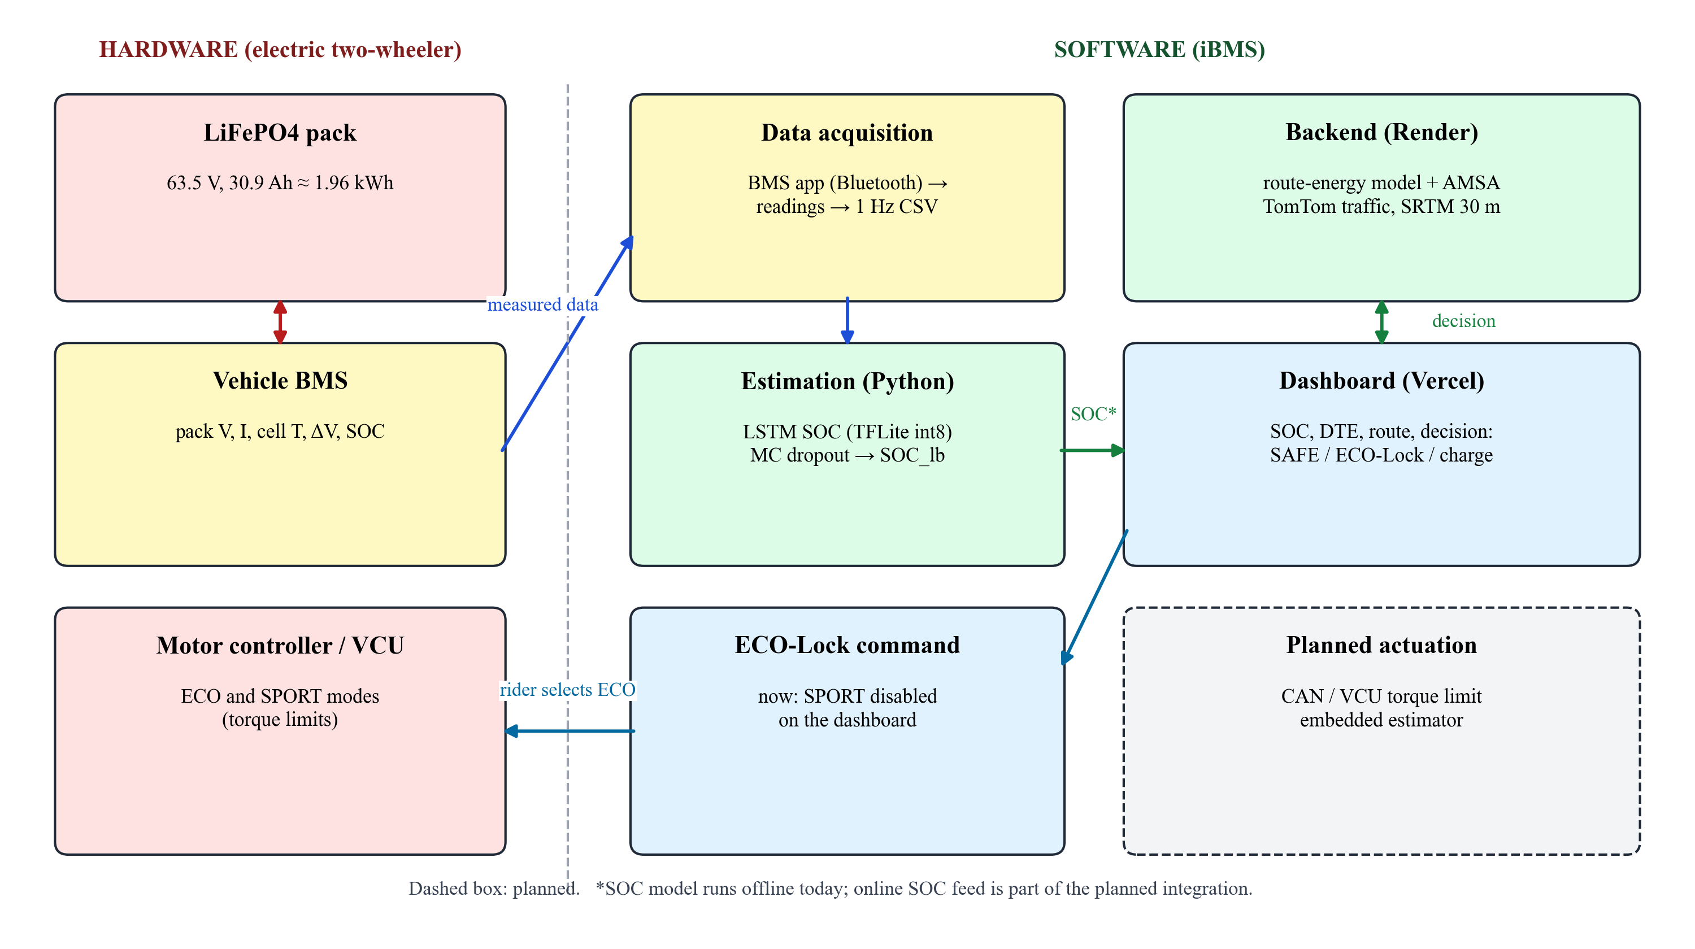
Fig. 3.3: Hardware–software integration of iBMS on the electric two-wheeler (dashed: planned)

3.2 System Specifications (Hardware & Software)

3.2.1 Vehicle and system specifications
Table 3.1: System specifications
Item | Specification
Vehicle | Electric two-wheeler with LiFePO4 pack and ECO and SPORT drive modes
Battery pack | 63.5 V nominal (63.8 V at full charge), 30.9 Ah (estimated by Coulomb counting), ≈ 1.96 kWh
Rated range (on-board display) | ≈ 76 km ECO, ≈ 62 km SPORT (25.8 / 31.6 Wh/km)
Data acquisition | Vehicle BMS mobile app; readings every ≈ 30 s, interpolated to 1 Hz
Bench prototype | Single-cell BMS development kit, resistor load, Arduino, MATLAB/Simulink
Training computer | Intel Core i5-12500H, 16 GB RAM, no GPU
SOC model | LSTM(64) → Dropout 0.2 → LSTM(32) → Dropout 0.2 → Dense(1); 29,857 parameters; input 50 × (V, I, T)
Edge model | TensorFlow Lite int8, 67.6 KiB, 0.41 ms per estimate
Road-load constants | m = 155 kg, C_rr = 0.012, ρ = 1.2 kg/m³, C_dA = 0.5 m², P_aux = 40 W, v_ref = 60 km/h
ML software | Python 3.13, TensorFlow/Keras 2.20, NumPy, pandas, scikit-learn, SHAP
Backend | Node.js with Express; deployed on Render
Frontend | Next.js 14, React 18, Recharts, Google Maps JavaScript API; deployed on Vercel
External services | TomTom Routing API, OpenTopoData SRTM 30 m, OSRM (fallback), Google Gemini (dashboard assistant)

3.2.2 Interfaces and endpoints
The dashboard and backend communicate through REST endpoints with JSON bodies (Table 3.2).
Table 3.2: Main REST endpoints
Endpoint | Layer | Function
POST /api/feasibility | Backend and Next.js proxy | Route, traffic, elevation, route physics, ECO/SPORT DTE and per-leg AMSA decision; optional SOC uncertainty margin
POST /api/predict/dte | Backend and Next.js proxy | DTE for a given SOC, mode and environment
POST /api/route/distance, /api/route/geometry | Backend | Route length and geometry
POST /api/elevation | Next.js | Elevation proxy to OpenTopoData
POST /api/intelligence/* | Next.js | Assistant, explanation, uncertainty and digital-twin panels
GET /health, /api/status | Backend | Health check and configuration status

3.2.3 Dashboard functions
The dashboard provides an SOC control with a battery-status card; ECO and SPORT mode selection with four driving-profile levels that scale the consumption; the route-aware DTE and a charging recommendation; route planning on a map with traffic colouring and alternative routes; a route-physics panel (climb, grade, traffic-jam ratio, regeneration); the AMSA status and ECO-Lock banner; the SOH gauge and RUL estimate; analytics charts; and an intelligence suite with a conversational assistant, an explanation panel, the SOC-uncertainty card and a digital-twin simulator. A role toggle switches between the User view and the Analyst view.

3.3 Flowchart / Algorithm

3.3.1 SOC estimation and uncertainty pipeline
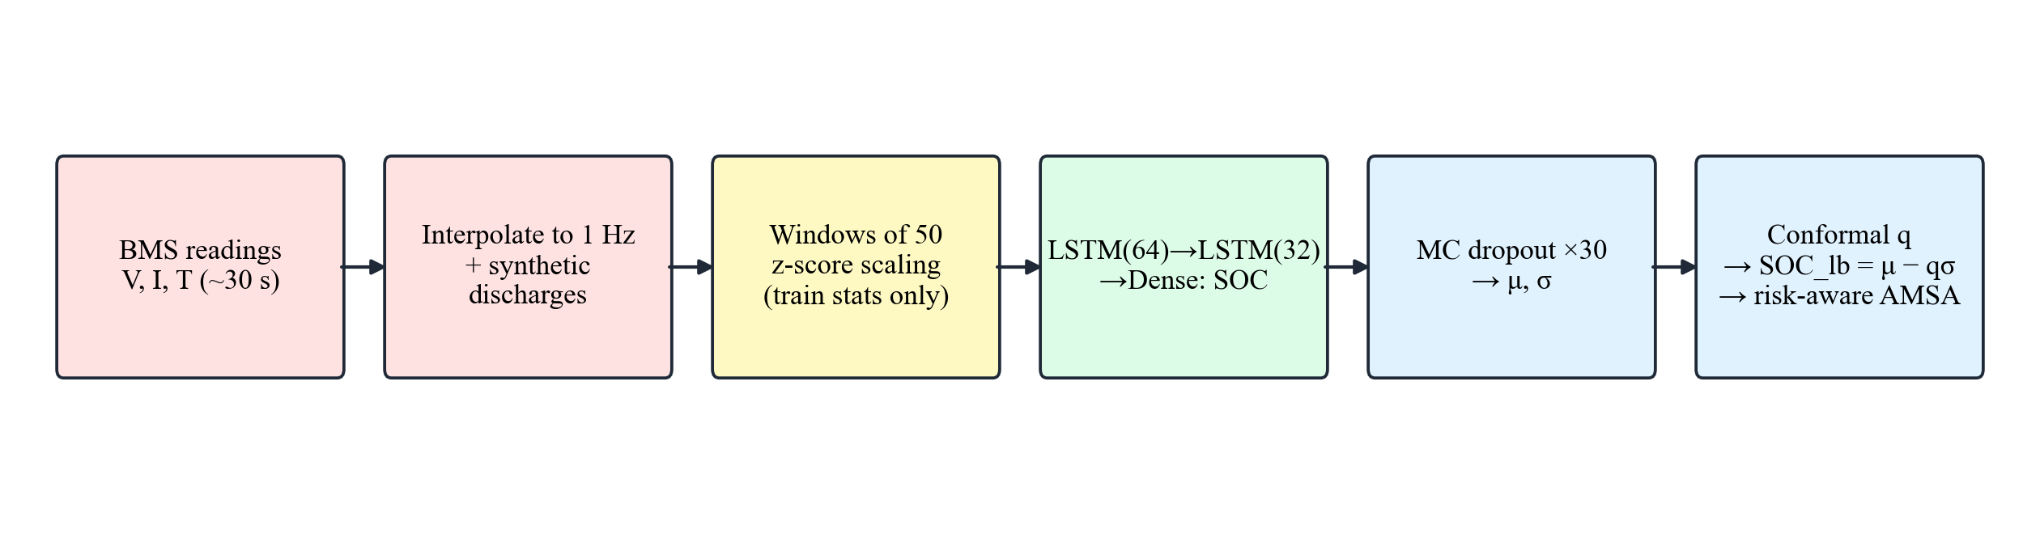
Fig. 3.4: SOC estimation and uncertainty pipeline
In the pipeline of Fig. 3.4, the BMS readings are interpolated to 1 Hz (synthetic full discharges are added for training) and cut into windows of 50 samples of voltage, current and temperature that never cross session boundaries. The inputs are scaled with training-data statistics only, and the LSTM outputs the SOC at the last step of the window; the SOC itself is never an input. For the risk-aware decision, the network is run 30 times with dropout active: the mean μ is the estimate, the standard deviation σ the uncertainty, and a conformal factor q gives the lower bound SOC_lb = μ − qσ, which the true SOC exceeds with 95 % confidence.

3.3.2 Route-level AMSA
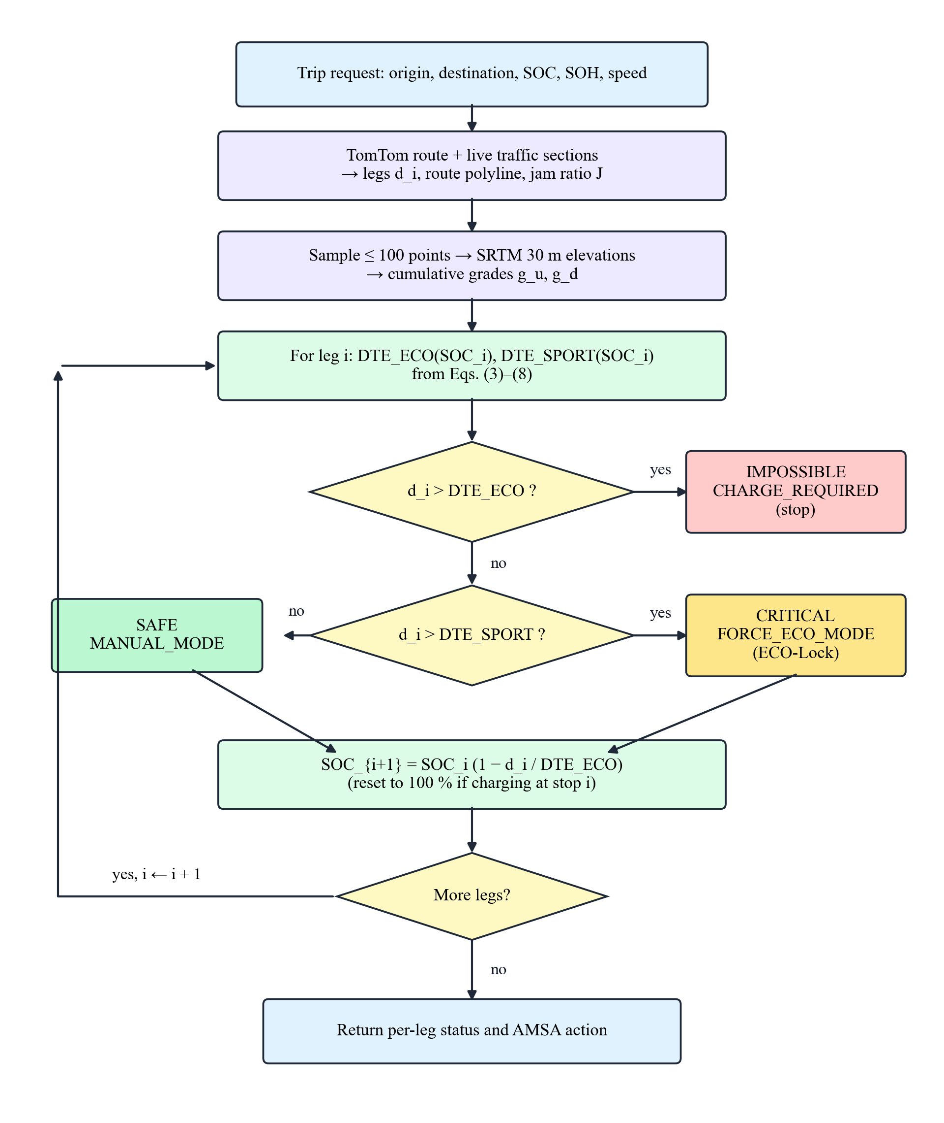
Fig. 3.5: Flowchart of the route-level Adaptive Mode Switching Algorithm
The AMSA of [12] switches modes while riding, using the instantaneous slope, but on a long slope this is already too late, because if the energy is not there beforehand, no switching on the way can save the trip. The modification done here is that AMSA (Fig. 3.5) turns the real-time mode selection of [12] into a pre-trip check per leg. Each leg length d_i is compared with the ECO and SPORT DTE at the SOC expected at the start of the leg. The leg is SAFE if reachable in SPORT mode (manual control), CRITICAL if reachable only in ECO mode (ECO-Lock enforced) and IMPOSSIBLE otherwise (charging stop required). The SOC at the start of the next leg follows Eq. (4.8) and is reset to 100 % after a charging stop.
- Input: legs $d_{1},…,d_{n}$; initial SOC (minus the uncertainty margin in risk-aware mode); SOH; speed; route features.
- For each leg $i$: compute $DTE_{ECO}(SOC_{i})$ and $DTE_{SPORT}(SOC_{i})$ with Eqs. (4.4)–(4.7).
- If $d_{i}>DTE_{ECO}$: IMPOSSIBLE, CHARGE_REQUIRED; stop.
- Else if $d_{i}>DTE_{SPORT}$: CRITICAL, FORCE_ECO_MODE (SPORT disabled).
- Else: SAFE, MANUAL_MODE.
- Update $SOC_{i+1}$ with Eq. (4.8), or set it to 100 % after a charging stop.
Since DTE is proportional to SOC, single-leg thresholds are analytic (Eq. (4.8)). In risk-aware mode, the model is evaluated at SOC_lb instead of the point estimate, so an overestimated SOC cannot turn an infeasible trip into an accepted one; the endpoint takes the margin μ − SOC_lb as an input. Following the 40 % threshold below which [12] prefers ECO mode, the dashboard also disables SPORT mode below 40 % SOC. ECO-Lock is issued as a software command at the rider interface; torque limiting through the vehicle control unit (VCU) is planned.

3.4 Project Planning & Timeline
Table 3.3: Project phases and timeline
Phase | Period | Main activities
1. Study and prototype | July 2026 | Literature review; LSTM and AMSA study; single-cell BMS kit with Arduino and Simulink; first prototype dashboard
2. Data collection | August 2026 | Six stand-test sessions; transcription and interpolation; synthetic data generator; first training pipeline
3. Software development | September – October 2026 | Next.js dashboard, Express backend, AMSA engine, route planning, intelligence features, Vercel deployment
Mid-term review | 15 September 2026 | Architecture and first results
4. Verification and experiments | 15–16 October 2026 | Code audit; leak-free LSTM with baselines; elevation fix; route study; sensitivity; edge and SHAP
5. Benchmark and uncertainty | 18 October 2026 | CALCE benchmark; EKF with RC model; uncertainty and risk-aware AMSA
6. Deployment and documentation | 19–21 October 2026 | Backend on Render connected to the dashboard; IEEE paper, report and presentation

3.5 Challenges and Complexities
- No road data: the vehicle could only be tested on a stand, and each session covers a small SOC range. Synthetic full discharges were added for training, the public CALCE data were used for a full-range test, and consumption was calibrated from the rated range.
- Sparse readings: the BMS app showed values only every ≈ 30 s, transcribed from screen recordings. They were interpolated to 1 Hz with small added noise.
- Data leakage: the first LSTM used the SOC as an input and an early comparison scored it against its own output. Both were discarded; the final model never sees the SOC and data are split by scenario and session.
- Choice of baselines: on the field data a constant predictor (1.22 %) matched the fine-tuned LSTM (1.24 %), so the field data cannot rank estimators and tracking was evaluated on CALCE.
- Flat LiFePO4 voltage curve: a simple EKF reached only 10.4 % on CALCE; an RC model with measured OCV (0.96 %) gave a fair baseline.
- Elevation bug: the backend requested an elevation dataset the public API does not offer, so every route was flat; it was switched to SRTM 30 m with at most 100 points per request.

CHAPTER 4 SYSTEM IMPLEMENTATION

4.1 Hardware Design & Circuit Diagrams
The hardware work served two purposes: learning BMS measurement and protection on a safe single-cell bench set-up, and acquiring data from the battery pack of the electric two-wheeler through its own BMS.

4.1.1 Bench prototype
Fig. 4.1 shows the connection diagram of the bench prototype. A single Li-ion test cell is connected to the B+ and B− terminals of a single-cell BMS development kit, which contains a MOSFET protection switch, a current-sense shunt, a voltage divider, an NTC temperature sensor and protection logic for over-voltage, under-voltage, over-current and over-temperature. A resistor load on the P+ and P− terminals discharges the cell, and the measured voltage, current and temperature are read by an Arduino and sent over USB to a computer.
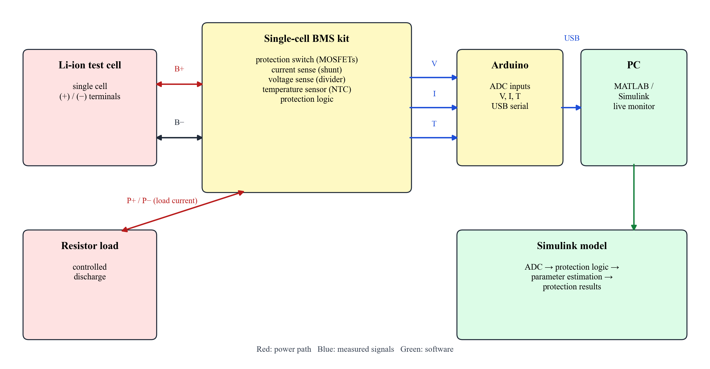
Fig. 4.1: Connection diagram of the single-cell BMS bench prototype (red: power path; blue: measured signals; green: software)
The computer runs a MATLAB/Simulink model (Fig. 4.2) that converts the ADC readings, applies the protection limits, estimates cell parameters and displays the results, so that charge, discharge and protection behaviour could be observed safely before working with the vehicle pack.
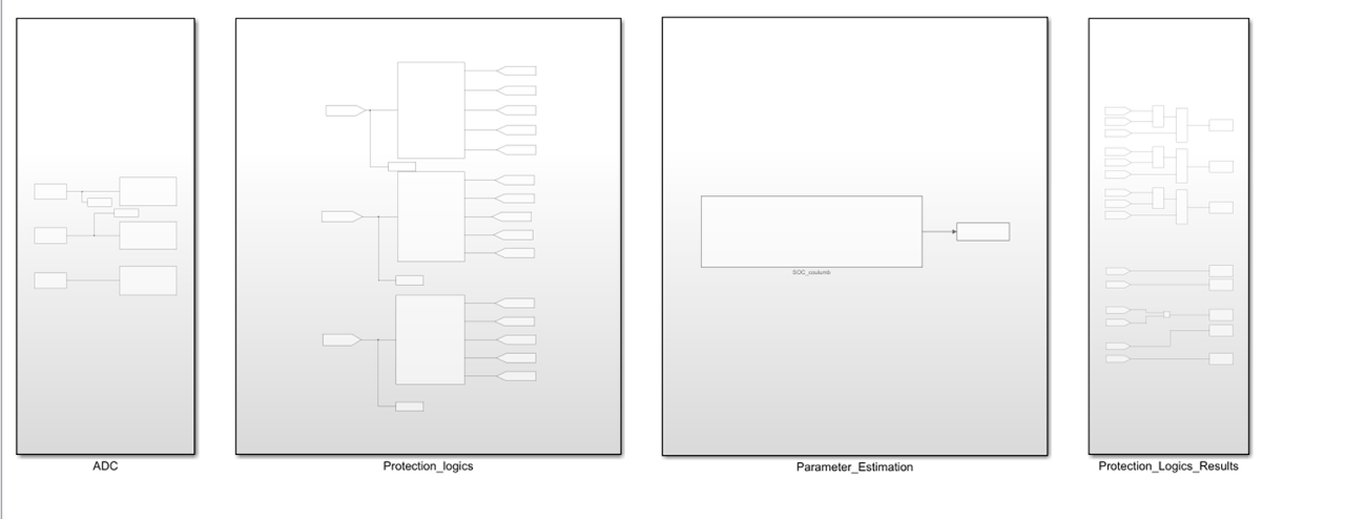
Fig. 4.2: Simulink model used for live monitoring of the single-cell prototype

4.1.2 Vehicle measurement chain and stand tests
Field data were recorded on a LiFePO4 electric two-wheeler (63.5 V pack) on a stand with the rear wheel lifted, so there was no rider and no road load. Six sessions of 266–285 s covered two modes, SPORT and ECO, as well as three cell configurations, series, parallel and single, using the throttle and brakes, making a combination of six sessions of about 4.5 minutes each. Voltage, current, maximum cell temperature, cell-voltage difference and BMS-reported SOC readings came from BMS-app screen recordings at about 30 s intervals, interpolated to 1 Hz and perturbed with Gaussian noise (σ_V = 0.02 V, σ_I = 0.10 A, σ_ΔV = 1 mV), giving 1,668 samples (62.4–63.8 V, up to 8.0 A, 30–31 °C). Each session covers only a tiny SOC change, so it cannot show tracking. That is why the CALCE data were used.
The pack capacity was estimated from these data by Coulomb counting (charge drawn divided by the reported SOC drop). The per-session estimates ranged from 20.7 to 40.5 Ah, with a pooled value of 28.9 Ah; the spread comes from the 0.1 % SOC resolution. The consistent value of 30.9 Ah was adopted, giving about 1,962 Wh at 63.5 V.

4.2 Component Selection and Justification
Table 4.1: Component and tool selection
Component / tool | Alternatives considered | Reason for selection
LiFePO4 battery pack | NMC, lead-acid | Pack of the test vehicle; high thermal safety and long cycle life
Single-cell BMS kit + Arduino | Custom PCB | Low cost and safe; all BMS blocks on one board
LSTM network | Feed-forward network, GRU | Learns temporal voltage–current–temperature patterns; needs no initial SOC, OCV curve or capacity
EKF with RC model | Coulomb counting, R-only EKF | Standard model-based estimator [24]; fair baseline
TomTom Routing API | Google Directions, OSRM | Route and live traffic sections in one request
OpenTopoData SRTM 30 m | SRTM 90 m | Free global 30 m elevation data
Node.js / Next.js | Python Flask | Lightweight backend and dashboard; free cloud deployment
TensorFlow Lite int8 | Full Keras model | 5.7× smaller model with sub-millisecond inference
Monte-Carlo dropout + conformal calibration | Deep ensembles | No retraining; calibrated coverage

4.3 PCB/Breadboard Implementation
No custom PCB was fabricated. The prototype was assembled from the ready-made BMS development kit (Fig. 4.3) with the test cell in its holder, the resistor load on the output terminals and an Arduino connected by jumper wires. Each measured signal was checked against a multimeter reading in Simulink, and controlled discharges were used to trigger the protection functions. On the vehicle, the existing BMS served as the measurement system.
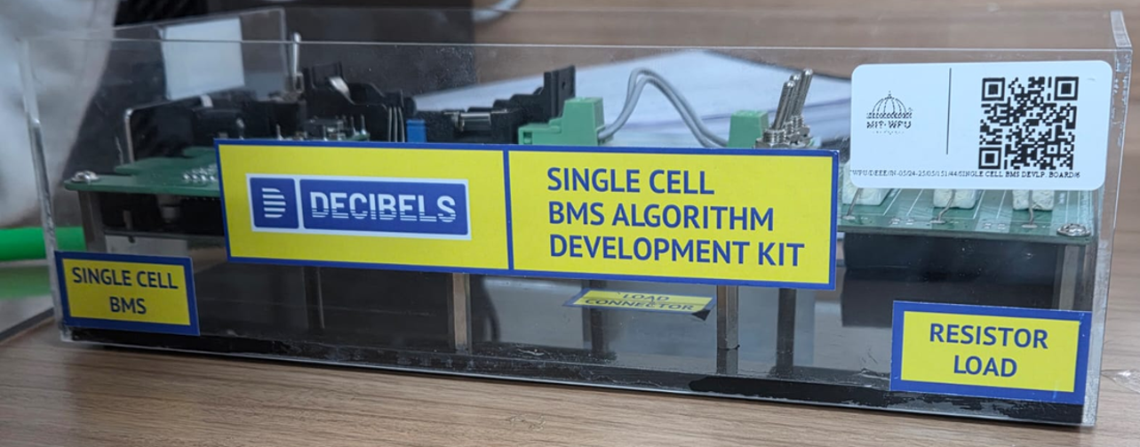
Fig. 4.3: Assembled bench prototype: single-cell BMS development kit with resistor load
For embedded use, the SOC model was converted to TensorFlow Lite with int8 quantization (67.6 KiB, 0.41 ms per estimate), which fits the memory of common 32-bit microcontrollers. Running it on a microcontroller next to the BMS and sending the AMSA command to the VCU is the next prototyping step.

4.4 Simulation/Coding Results with Validation

4.4.1 Datasets and LSTM training
Because the stand-test sessions cover a narrow SOC range, 100 synthetic discharge scenarios (300–800 steps, from 90–100 % down to 5–20 % SOC) were generated from a piecewise LiFePO4 voltage curve, field-seeded current profiles and an SOC-dependent heating model, giving 55,971 samples split 70/15/15 by scenario. For a full-range test on real cells, the public CALCE A123 LiFePO4 dataset [25], [26] was used: 1.1 Ah cells discharged from 100 % to 2.0 V under the DST, US06 and FUDS cycles at 0–50 °C (−10 °C was excluded because its records are incomplete). The LSTM was trained on two cycles at all temperatures and tested on the unseen third at 25 °C, against Coulomb counting and an EKF with a first-order RC model [24] whose OCV curve came from a C/20 test.
Training uses the Adam optimizer (learning rate 10⁻³, batch size 32) on the mean squared error, with early stopping after 5 epochs without validation improvement; it ended after 35 epochs (582 s on the laptop CPU). On held-out synthetic scenarios the LSTM reached 0.20 % MAE and R² = 0.9997 (Fig. 4.4). On the field data, the LSTM was tested zero-shot and with leave-one-session-out (LOSO) fine-tuning (Adam, learning rate 10⁻⁴, 10 epochs), and Coulomb counting and the EKF were run with the true SOC₀ and with a +2 % error.
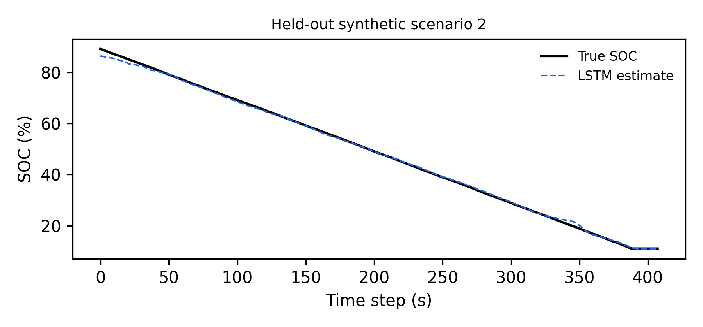
Fig. 4.4: LSTM estimate and reference SOC on a held-out synthetic discharge scenario

4.4.2 Kinematic synthesis
Because the vehicle was on a stand, a speed proxy was synthesized from the discharge current: a throttle proxy, a square-root speed map with v_max = 55 km/h and an exponential moving average with α = 0.15. Validation found a missing reset between sessions that caused an acceleration spike of 11.36 m/s²; after the fix the maximum acceleration is 0.80 m/s² and no sample exceeds plausible limits (Fig. 4.5).
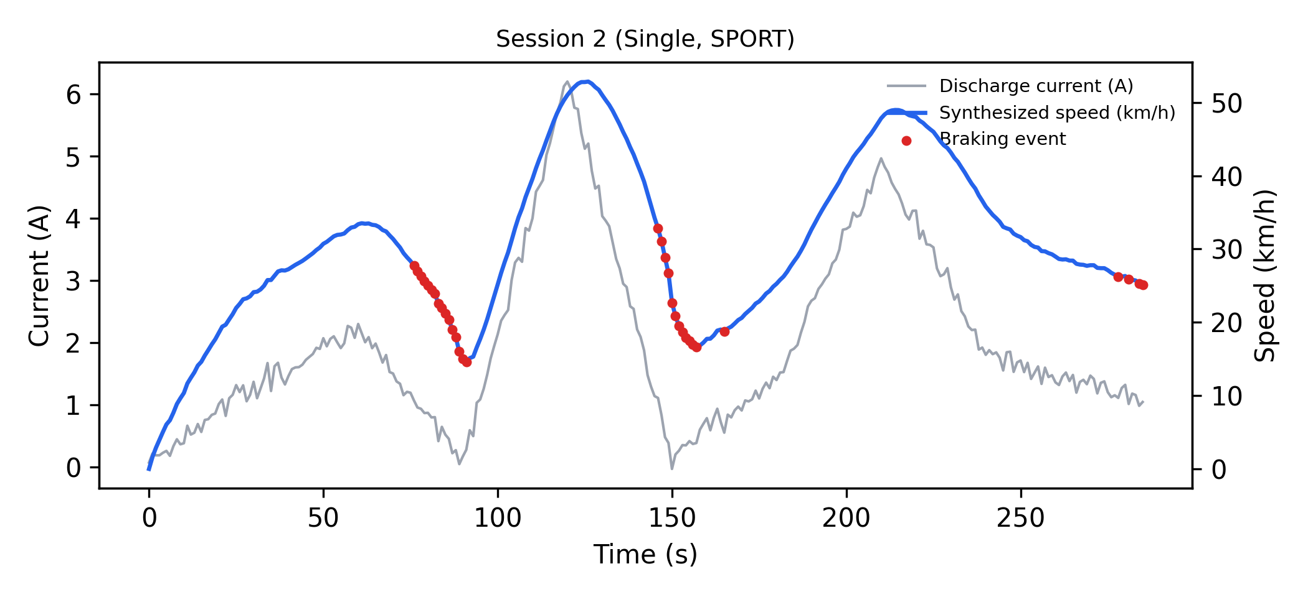
Fig. 4.5: Discharge current, synthesized speed and braking events in one session after the correction

4.4.3 Verification of the route-energy model
An independent Python implementation of the model reproduced the backend's DTE values within 0.08 km, and the endpoint returned CRITICAL with forced ECO mode at the midpoint of each ECO-Lock band. Table 4.2 compares a hand calculation with the backend for Dehradun → Mussoorie (33.3 km, climb 1,375 m, descent 42 m, jam ratio 0.014). A flat-road estimate would give 76.1 km and accept the trip from 43.7 % SOC.
Table 4.2: Hand calculation versus backend output (Dehradun → Mussoorie, ECO mode, 60 km/h, SOH 100 %)
Step | Hand calculation | Backend output
Uphill grade g_u | 1,375 / 33,300 × 100 = 4.13 % | 4.13 %
Climbing factor f_up | 1 + 0.15 × 4.13 = 1.62 | 1.62
ECO consumption | 25.8 × 0.989 × 1.004 × 1.62 × 0.994 ≈ 41.2 Wh/km | 41.2 Wh/km
Full-charge ECO range | 1,962 / 41.2 ≈ 47.6 km | 47.6 km
Minimum SOC for ECO | 33.3 / 47.6 ≈ 70 % | 69.9 %

At 80 % SOC on this route the endpoint returned FORCE_ECO_MODE (between the 69.9 % ECO and 85.6 % SAFE thresholds); with a 15-point uncertainty margin the decision SOC fell to 65 % and it returned CHARGE_REQUIRED, as intended.

4.5 Mathematical Modelling

4.5.1 State of charge
Coulomb counting: with the discharge current $I_{k}$ (A), recorded as negative by the BMS, taken as positive, the SOC (%) is updated as
$SOC_{k}=SOC_{k-1}-\frac{100 I_{k} Δt}{3600 C_{nom}}$ (4.1)
where Δt (s) is the sampling interval and $C_{nom}=30.9$ Ah is the total capacity of the pack, estimated from the field data. Coulomb counting only integrates the current and never checks it against the voltage, so any error in SOC₀ stays in the estimate. For example, if SOC is wrong by even 2 %, it will stay wrong by 2 % throughout.
EKF baseline: an EKF [23], [24] uses (4.1) for prediction and corrects it with the terminal-voltage residual
${\hat{x}}_{k}={\hat{x}}_{k}^{-}+K_{k}\left(V_{k}-OCV({\hat{x}}_{k}^{-})+R_{int}I_{k}\right)$ (4.2)
where ${\hat{x}}_{k}^{-}$ is the predicted SOC, $K_{k}$ the Kalman gain, $OCV(⋅)$ a piecewise-linear LiFePO4 open-circuit-voltage curve for a 63.5 V pack and $R_{int}$ (Ω) the internal resistance, fitted by least squares on the training sessions. It estimates SOC like Coulomb counting, then compares the measured voltage with what the battery model says the voltage should be at that SOC, and corrects the SOC to reduce the difference.
LSTM estimator: a two-layer LSTM [22] maps a window of 50 samples (50 s at 1 Hz) of V, I and T to the SOC at the last step. The stack is LSTM(64), dropout 0.2, LSTM(32), dropout 0.2 and a linear output, with 29,857 parameters. SOC is not an input, so the estimate does not depend on SOC₀, hence initial SOC is not required. A noticeable advantage is that no initial SOC, OCV curve or capacity value is required here for calculations. To prevent leakage, windows are built inside single discharge scenarios, the data are split by scenario, and the scalers are fitted on the training scenarios only. Each cell updates its memory $c_{t}$ and hidden state $h_{t}$ with the forget, input and output gates $f_{t}$, $i_{t}$, $o_{t}$:
$c_{t}=f_{t}⊙c_{t-1}+i_{t}⊙{\tilde{c}}_{t}, h_{t}=o_{t}⊙tanh(c_{t})$ (4.3)
SOH model: the SOH is derived from a parametric model that subtracts cycle fade, calendar fade and bounded temperature and imbalance penalties from an initial value; SOH shrinks the usable energy, as an aged pack at 100 % SOC holds less energy. With assumed ageing constants (850 equivalent cycles of a 5,000-cycle life, 3.5 years of age) it gives SOH ≈ 94.3 %. It is not learned or evaluated here; it only scales the pack energy in (4.4).

4.5.2 Route-energy model and DTE
The energy available for propulsion (Wh) is
$E_{av}=\frac{SOC}{100}⋅\frac{SOH}{100}⋅C_{nom}V_{nom}$ (4.4)
with $V_{nom}=63.5$ V, so $C_{nom}V_{nom}≈1962$ Wh. The TomTom route is down-sampled to at most 100 points, whose elevations are taken from the SRTM 30 m model. Every "up" step is summed into total climb and every "down" step into total descent. TomTom sections marked as jams or delayed by more than 20 s give the jam length $L_{jam}$ (about 50 m per route point). The cumulative uphill and downhill grades (%) and the traffic-jam ratio are
gu=100Lj​max(0,Δhj), gd=100Lj​max(0,-Δhj), J=min1,LjamL (4.5)
where $Δh_{j}$ (m) is the elevation change between samples and $L$ (m) the route length. Speed matters through air drag, as it makes up about 80 % of the road load at 60 km/h, which is why speed has the biggest effect. Congestion also lowers the effective speed to $v_{eff}=\overset{‾}{v}(1-0.5J)$, with an assumed cruising speed $\overset{‾}{v}$ = 60 km/h. Speed enters through the road-load force
$F(v)=mgC_{rr}+1/2ρC_{d}Av^{2}+\frac{P_{aux}}{v}$ (4.6)
with m = 155 kg, g = 9.81 m/s², $C_{rr}$ = 0.012, ρ = 1.2 kg/m³, $C_{d}A$ = 0.5 m² and $P_{aux}$ = 40 W. The drag area lies within wind-tunnel values for motorcycles with an upright rider (0.50–0.59 m² [30]), and $C_{rr}$ is close to the 0.01 used for an Indian electric two-wheeler in [12]; neither was measured on the test vehicle. The consumption (Wh/km) in mode m ∈ {ECO, SPORT} and the DTE (km) are
$c_{m}=c_{0,m} \frac{F(v_{eff})}{F(v_{ref})} f_{sg} f_{acc} f_{up} f_{dn} f_{T}, DTE_{m}=\frac{E_{av}}{c_{m}}$ (4.7)
where $c_{0,m}$ is the flat-road consumption at $v_{ref}$ = 60 km/h; $f_{sg}=1+J(0.3+0.4a)$ is the stop-and-go factor with acceleration aggressiveness a ∈ [0, 1]; $f_{acc}=1+0.15a$; $f_{up}=1+0.15g_{u}$; $f_{dn}=max(0.2,1-0.08g_{d}η_{r})$ with regeneration efficiency $η_{r}=0.6+0.2J$; and $f_{T}=1+0.005ΔT_{a}$ for an ambient-temperature deviation $ΔT_{a}$ ≥ 0 °C. The base values $c_{0,ECO}$ = 25.8 Wh/km and $c_{0,SPORT}$ = 31.6 Wh/km follow from dividing the pack energy by the approximate full-charge ranges shown on the vehicle display (76 km in ECO, 62 km in SPORT); they were not measured here. The correction factors in (4.7) are empirical and linear, so (4.7) is a calibratable structure rather than a fitted model. Its sensitivity to $c_{0}$ is reported in Section 5.3.

4.5.3 AMSA decision and uncertainty
The SOC carried to the next leg and the minimum SOC to complete a route of length $d$ in mode $m$ are
$SOC_{i+1}=SOC_{i}\left(1-\frac{d_{i}}{DTE_{ECO}(SOC_{i})}\right), SOC_{min,m}=100 \frac{d}{DTE_{m}(100 \%)}$ (4.8)
Uncertainty is estimated by Monte-Carlo dropout [28]: dropout stays active at inference, and 30 stochastic passes give a mean μ and a standard deviation σ per window. Raw dropout intervals are overconfident (too narrow), so they are calibrated by split-conformal prediction [29] on the validation windows. The 95 % quantile q of (μ − SOC)/σ gives the lower bound
$SOC_{lb}=μ-q σ$ (4.9)
and the score |μ − SOC|/σ gives a two-sided interval. Accuracy is measured by the mean absolute error and root-mean-square error over $N$ samples:
MAE=1Nk​|yk-yk|, RMSE=1Nk​(yk-yk)2 (4.10)

CHAPTER 5 RESULTS AND ANALYSIS

5.1 Functional Demonstration Outcomes
The complete system was demonstrated on the deployed website (https://ibmsdashboard.vercel.app), which calls the route-energy model and AMSA on the cloud backend; the backend queries TomTom for the route and traffic and OpenTopoData for the elevation. The demonstration uses the Dehradun → Mussoorie hill route, a 33 km climb of about 1,400 m.
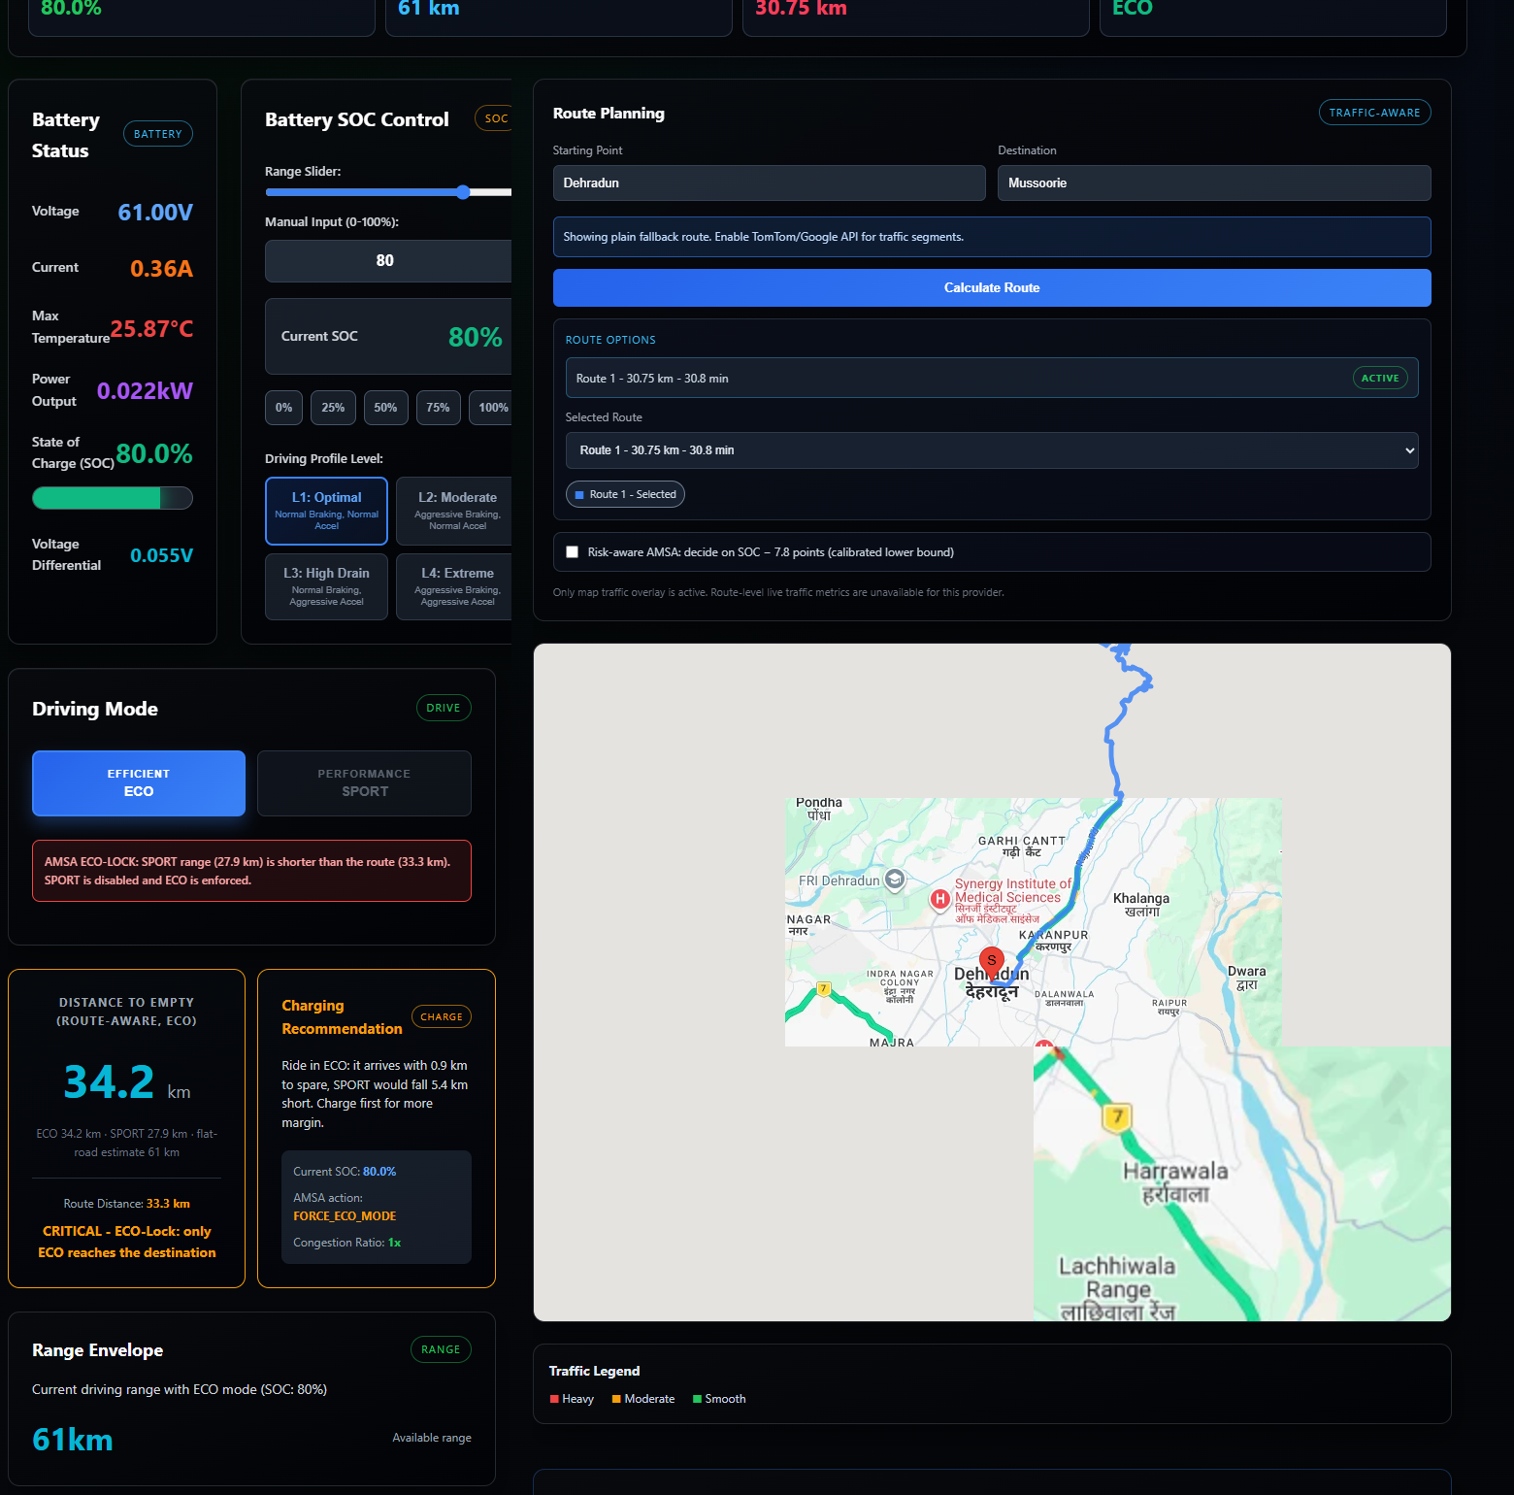
Fig. 5.1: User view during the demonstration: Dehradun → Mussoorie at 80 % SOC, with route-aware distance-to-empty, ECO-Lock and charging recommendation
In the User view (Fig. 5.1) the rider sets the SOC (80 %), enters origin and destination and calculates the route. The answer was CRITICAL: the route-aware range is 34.2 km in ECO but only 27.9 km in SPORT for a 33.3 km route, so the dashboard enforced ECO-Lock, disabled the SPORT button with an explanation and showed that ECO arrives with 0.9 km to spare. A flat-road estimate would have shown 61 km and allowed SPORT mode. The route-physics panel shows the values behind the decision: a cumulative climb of 1,385 m (grade 4.15 %), the traffic-jam ratio and the regenerative recovery.
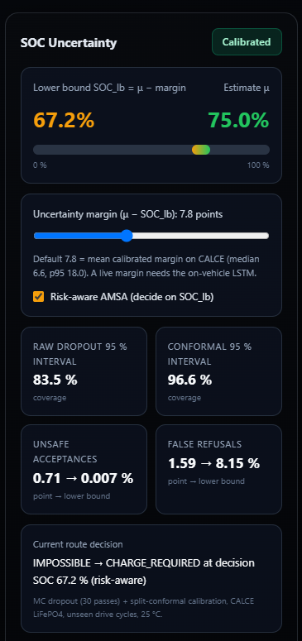
Fig. 5.2: SOC uncertainty card with the calibrated lower bound and the risk-aware AMSA decision
The Analyst view shows the state of health (94.3 %) and remaining useful life (11.7 years) with their contributing factors. The SOC uncertainty card (Fig. 5.2) shows the estimate and its calibrated lower bound. With risk-aware AMSA switched on at 75 % SOC, the decision SOC became 67.2 % (margin 7.8 points), below the 69.9 % needed, and the decision changed from ECO-Lock to a required charging stop.

5.2 Test Results and Performance Evaluation

5.2.1 SOC estimation
Table 5.1: SOC estimation error (% SOC)
Method | Test data | MAE | RMSE | Max error
LSTM | Synthetic held-out scenarios | 0.20 | 0.34 | 2.73
LSTM, zero-shot | Field (6 sessions) | 7.37 | 8.69 | 27.14
LSTM, leave-one-session-out fine-tuned | Field (6 sessions) | 1.24 | 1.87 | 8.33
Coulomb counting, true SOC₀ | Field | 0.07 | 0.09 | 0.28
Coulomb counting, SOC₀ + 2 % | Field | 2.06 | 2.06 | 2.28
EKF (true or +2 % SOC₀) | Field | 2.42 | 2.81 | 6.53
Constant (mean training SOC) | Field | 1.22 | 1.46 | 2.52
LSTM, no SOC₀ | CALCE, unseen cycle, 25 °C | 3.17 | 4.77 | 28.79
EKF-1RC, measured OCV, SOC₀ − 10 % | CALCE, unseen cycle, 25 °C | 0.96 | 1.36 | 4.25
Coulomb counting, SOC₀ − 10 % | CALCE, unseen cycle, 25 °C | 10.11 | 10.11 | 10.40
Constant (mean training SOC) | CALCE, unseen cycle, 25 °C | 24.65 | 28.50 | 49.86

On held-out synthetic scenarios the LSTM reached an MAE of 0.20 % (R² = 0.9997), which is the best case, because in synthetic data voltage almost directly gives SOC; the generator ties voltage to SOC almost deterministically. Zero-shot on the field data the MAE rose to 7.37 %, because the real battery's voltage curve differs from the synthetic one. LOSO fine-tuning on five sessions cut the error by 83 % to 1.24 % (0.49–1.40 % per session, and 3.39 % for the parallel-SPORT session, whose SOC lies at the edge of the training range).
Coulomb counting with the true SOC₀ gave 0.07 %, because each session lasts under 5 min; a +2 % initial error stayed in the estimate throughout (2.06 %). The EKF reached 2.42 % for either SOC₀. On the flat LiFePO4 voltage plateau, and with an OCV curve not measured on this pack, its voltage correction is weak and it settles on a biased estimate. A constant predictor of the mean training SOC reaches 1.22 %, on par with the fine-tuned LSTM, although it always outputs the same SOC. Each session moves only 0.2–0.4 % SOC, so the data cannot tell which method tracks better. The field data therefore show that fine-tuning removes the synthetic-to-real offset, but they cannot rank the estimators; SOC tracking is shown only on full discharges.
CALCE data matter because a full discharge is there, where the constant predictor fails (24.65 %). On CALCE, the LSTM tracked SOC on unseen cycles with 3.17 % at 25 °C and 2.4–4.1 % across 0–50 °C, using one model and no SOC₀, OCV curve or capacity (Fig. 5.3). Its largest errors are short spikes at abrupt load steps. The EKF with a measured OCV and an identified RC model was more accurate (0.96 %) and recovered from a 10 % initial error, but it needs pack-specific characterization that was not available for the test vehicle. This is the trade-off between the two approaches.

5.2.2 Route feasibility (AMSA)
AMSA was evaluated on four route pairs in both directions (New Delhi ↔ Noida, Dehradun ↔ Mussoorie, Shimla ↔ Kufri, Siliguri ↔ Darjeeling), queried from TomTom on 16 October 2026 with 60 km/h and SOH = 100 %, sweeping the initial SOC from 5 to 100 %. Different lengths (13–60 km) as well as hill climbs of about 700 m to 2.3 km gave mild and extreme cases. It was compared with a naive estimator using the same pack and consumption on a flat road, which models a conventional range display (Table 5.2).
Table 5.2: AMSA decision thresholds on eight route directions (60 km/h, SOH = 100 %)
Route | d (km) | Climb / descent (m) | J | DTE ECO / SPORT at 100 % (km) | SAFE at SOC ≥ (%) | ECO-Lock band (%) | Naive reachable at SOC ≥ (%)
New Delhi → Noida | 28.4 | 120 / 135 | 0.000 | 73.2 / 59.8 | 47.5 | 38.8–47.5 | 37.3
Noida → New Delhi | 27.1 | 132 / 118 | 0.055 | 74.4 / 60.8 | 44.6 | 36.4–44.6 | 35.6
Dehradun → Mussoorie | 33.3 | 1375 / 42 | 0.014 | 47.6 / 38.8 | 85.6 | 69.9–85.6 | 43.7
Mussoorie → Dehradun | 28.3 | 130 / 1472 | 0.004 | 95.0 / 77.6 | 36.5 | 29.8–36.5 | 37.3
Shimla → Kufri | 13.4 | 695 / 352 | 0.000 | 48.9 / 40.0 | 33.5 | 27.3–33.5 | 17.6
Kufri → Shimla | 13.4 | 351 / 688 | 0.000 | 72.5 / 59.2 | 22.6 | 18.5–22.6 | 17.6
Siliguri → Darjeeling | 60.4 | 2292 / 296 | 0.000 | 49.6 / 40.5 | — | Infeasible (needs 121.7 %) | 79.4
Darjeeling → Siliguri | 59.2 | 279 / 2277 | 0.000 | 87.1 / 71.2 | 83.2 | 68.0–83.2 | 77.9

Table 5.2 lists the SOC thresholds at which the AMSA decision changes, and Fig. 5.4 plots the DTE curves. On the three uphill routes, the cumulative climb cut the full-charge ECO range from the naive 76.1 km to 47.6–49.6 km, so the naive estimate overstates the range by 53–60 %. The required ECO energy was 1,371 Wh against a naive 858 Wh for Dehradun → Mussoorie: the display says 43.7 % SOC is enough, but actually a rider needs 69.9 % (+60 %). Similarly, Shimla → Kufri needs 536 Wh against 345 Wh (+55 %), and Siliguri → Darjeeling 2,388 Wh against 1,558 Wh (+53 %), which exceeds the 1,962 Wh pack, so it is infeasible even from a full charge. The minimum SOC to arrive in ECO mode rose by 9.7, 26.2 and 42.3 percentage points on these routes.
Over the SOC sweep, the naive estimator judged Dehradun → Mussoorie reachable at 26 SOC levels (43.7–69.9 %) at which AMSA returned IMPOSSIBLE. The counts were 21 for Siliguri → Darjeeling (79.4–100 %), 10 for Shimla → Kufri and one each for the two flat directions and Kufri → Shimla. A rider trusting the naive display would start each of these trips although the model predicts that it cannot be completed; AMSA instead requires a charging stop or, inside the ECO-Lock band, enforces ECO mode so that the trip stays feasible. On descents the naive estimate is conservative: Mussoorie → Dehradun needed 585 Wh against a naive 731 Wh (−20 %), as regeneration recovers part of the descent energy, which is opposite to the uphill scenario. The display is too cautious because regeneration gives energy back. On the flat pair the two estimates differed by at most 2 percentage points, so both the display and the model agree. Repeating the study on 18 and 21 October changed the hill-route ranges by at most 0.8 km and the thresholds by at most 1 point.

5.2.3 Edge deployment, explainability and uncertainty
Edge deployment: dynamic-range int8 quantization in TensorFlow Lite reduced the model from 385.7 KiB (Keras) to 67.6 KiB, which is 5.7× smaller, with the same accuracy, with a synthetic MAE of 0.199 % against 0.203 % before quantization. Median single-thread inference took 0.41 ms on the laptop CPU, against 3.05 ms for compiled and 124.5 ms for eager Keras. Full-integer conversion of this LSTM failed in the converter used, and microcontroller deployment is still to be tested.
Explainability: SHAP [27] attributions were computed on the LSTM with expected gradients and 200 background windows. Voltage carried 96.1 % of the attribution magnitude on synthetic data and 92.8 % on field data, current about 3 %, and temperature 0.9 % and 4.2 %. The last 10 of the 50 steps, that is mostly the last 10 seconds, held 64.6 % (synthetic) and 71.1 % (field) of the attribution, which also makes sense. The network thus reads SOC mainly from recent terminal voltage, using the voltage–SOC relationship it learned, which is physically plausible and explains the zero-shot gap in Table 5.1, because the voltage–SOC relation differs between the synthetic and the real pack.
Uncertainty and risk-aware AMSA: on CALCE (unseen cycles, 25 °C), the Monte-Carlo mean reached 3.24 %, close to the deterministic 3.17 %, showing that estimating uncertainty costs no accuracy. A nominal 95 % Gaussian dropout interval covered only 83.5 % of the reference SOC, showing that the model is overconfident and its raw intervals cannot be trusted. Conformal calibration made the intervals reliable: the two-sided interval covered 96.6 %, and the lower bound was violated in 2.1 % of windows (4.3 % over 0–50 °C and 7.6–10 % at 0–10 °C). The mean lower margin μ − SOC_lb was 7.8 points. To measure the effect on decisions, the ECO thresholds of the eight routes in Table 5.2 were applied to every test window (Table 5.3).
Table 5.3: Effect of the SOC used by AMSA on decision errors (eight routes, CALCE 25 °C test windows)
AMSA decides on | Unsafe acceptances (%) | False refusals (%)
Point estimate μ | 0.71 | 1.59
Calibrated lower bound SOC_lb | 0.007 | 8.15

Deciding on the point estimate accepted 0.71 % of the windows in which the trip was infeasible and refused 1.59 % of the feasible ones. Deciding on SOC_lb cut unsafe acceptances to 0.007 % and raised false refusals to 8.15 %: fewer accepted trips in exchange for two orders of magnitude fewer stranding decisions caused by SOC error. This trade-off is needed for safety, as being told to charge when it was not needed can be annoying sometimes, but it is a lot better than being stranded on hilly routes.

5.3 Data Analysis (Graphs/Tables/Comparisons)

5.3.1 SOC tracking
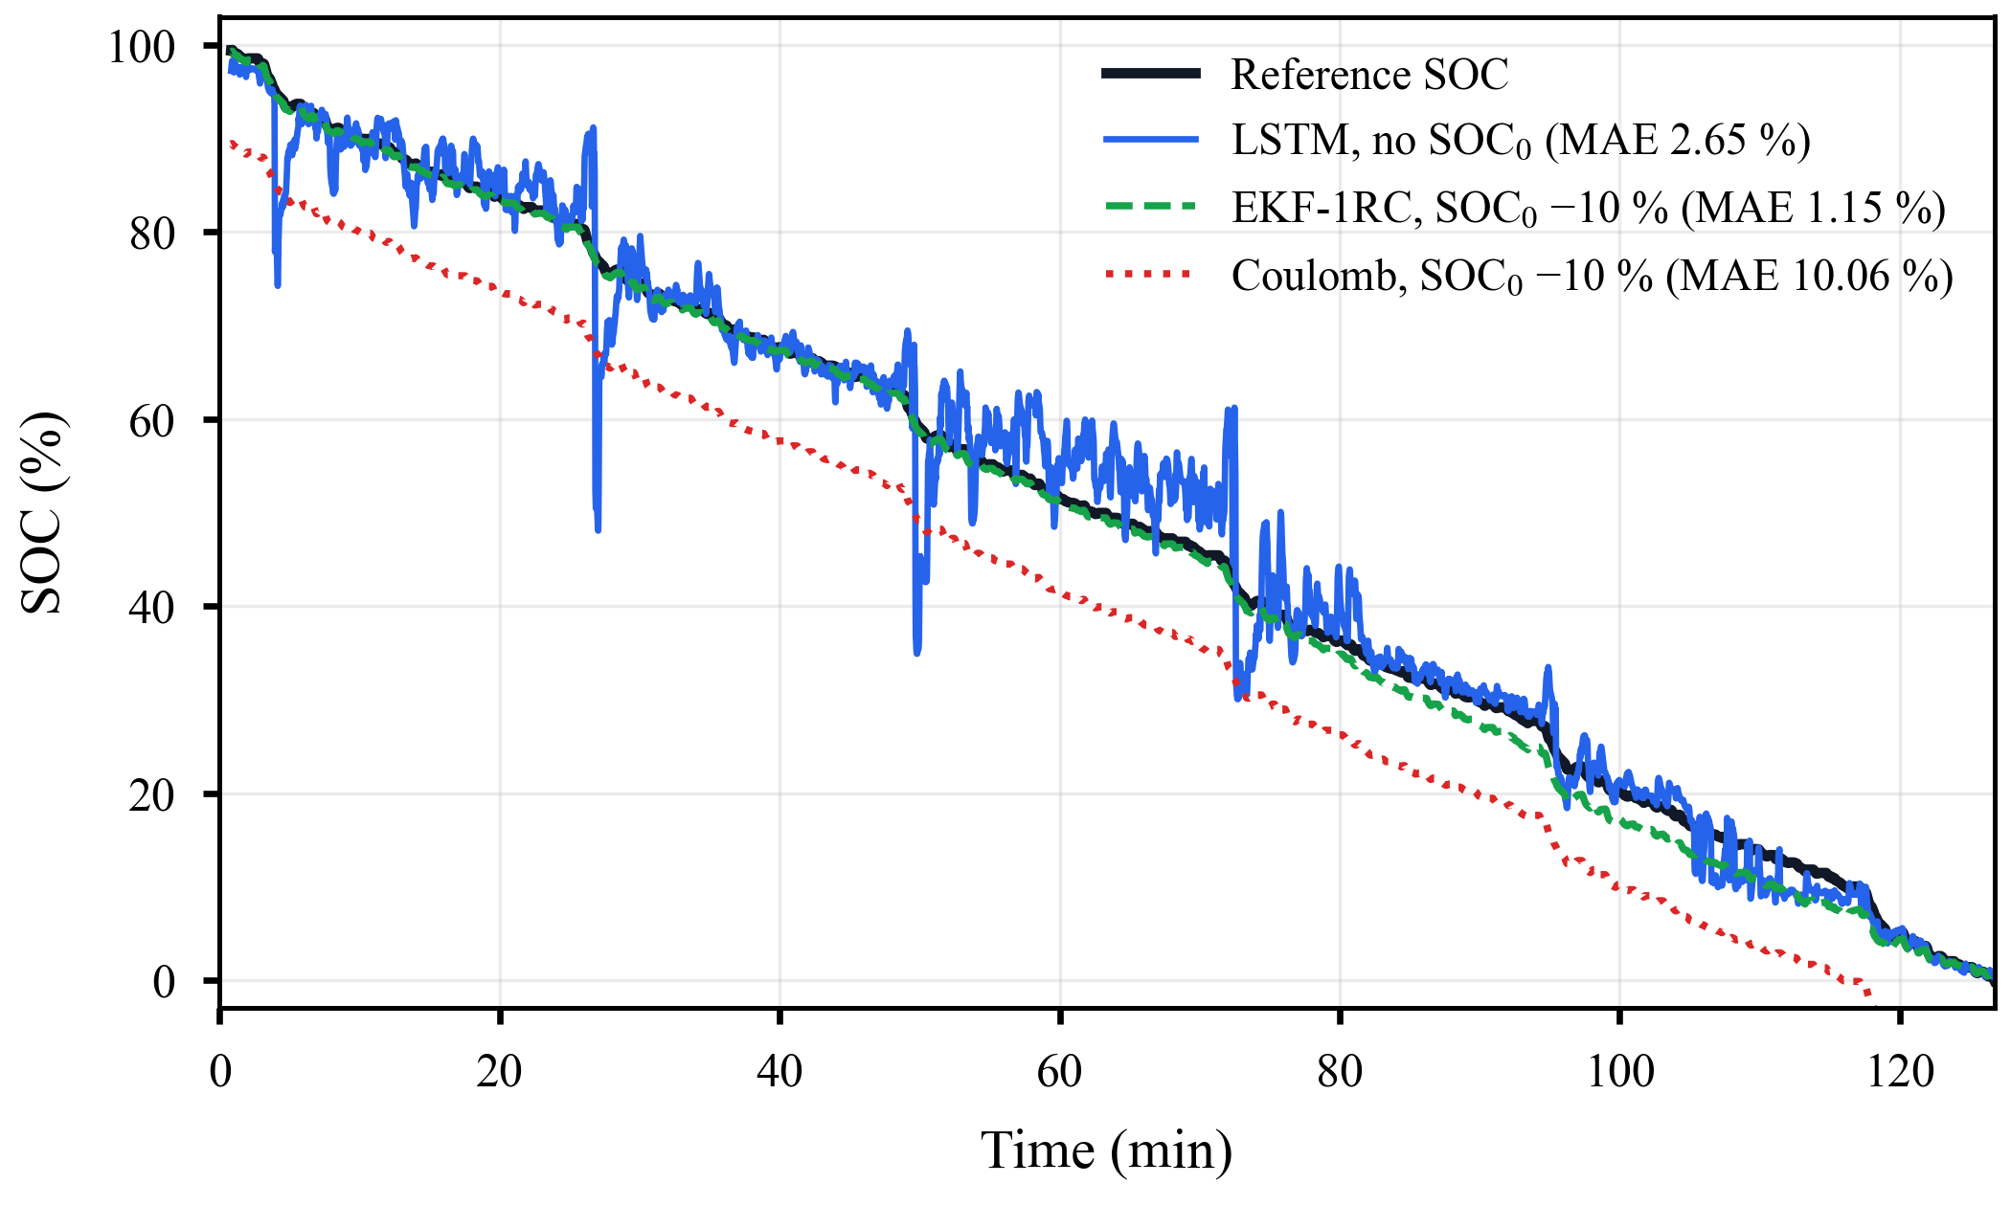
Fig. 5.3: SOC on the unseen FUDS cycle (CALCE A123 cell, 25 °C): reference, LSTM without initial SOC, EKF and Coulomb counting with a 10 % initial error
Fig. 5.3 shows an unseen FUDS cycle. The LSTM (2.65 % on this run) follows the reference without knowing the initial SOC, with short spikes at abrupt load steps. The EKF converges quickly from a 10 % initial error and then follows closely (1.15 %), while Coulomb counting keeps the 10 % error throughout (10.06 %).

5.3.2 Route study
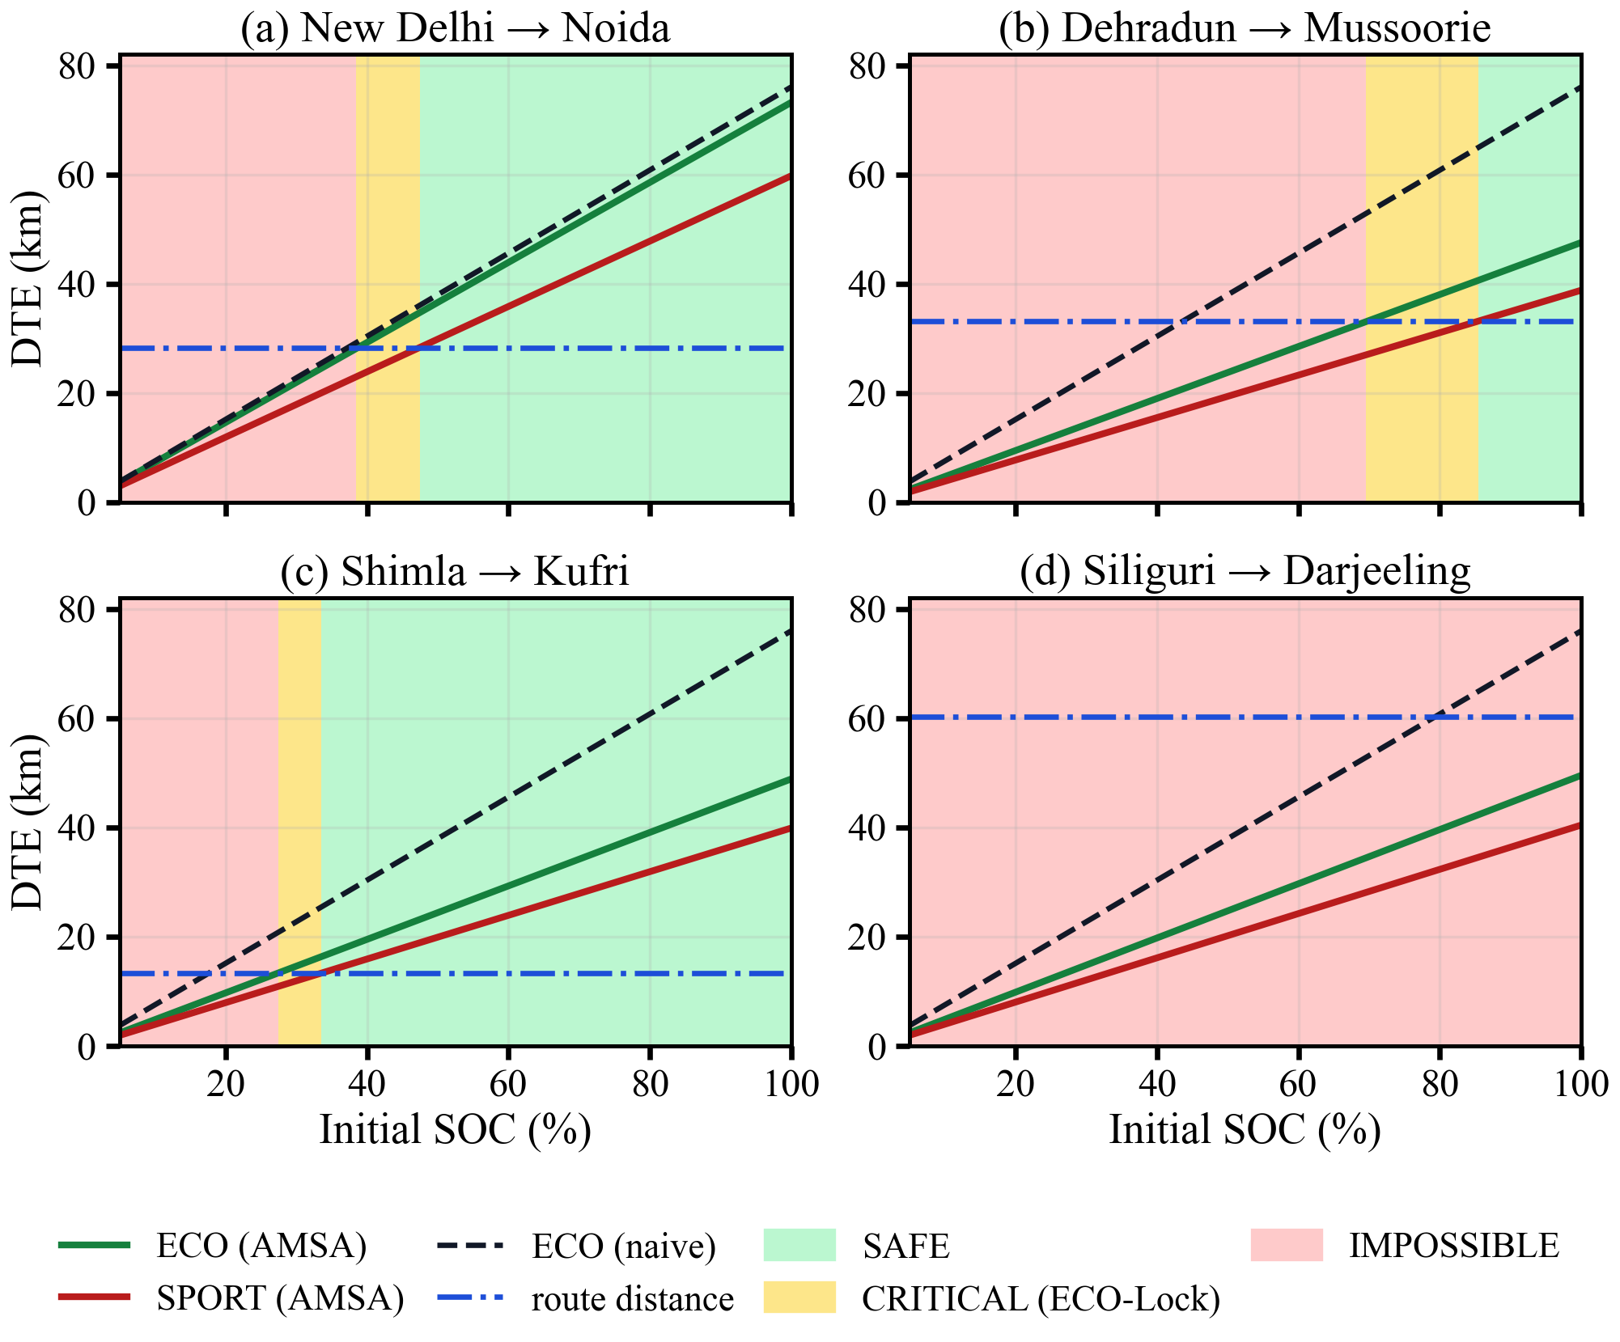
Fig. 5.4: DTE in ECO and SPORT modes versus initial SOC for four route directions, with the naive estimate, the route distance and the AMSA decision bands
In Fig. 5.4 the green band is SAFE, yellow ECO-Lock and red IMPOSSIBLE; the dashed line is the naive estimate and the dash-dotted line the route distance. On the hill climbs the naive line lies far above the route-aware ECO line, so it accepts the trip at a much lower SOC, while on Siliguri → Darjeeling the ECO line never reaches the route distance.

5.3.3 Sensitivity and explainability
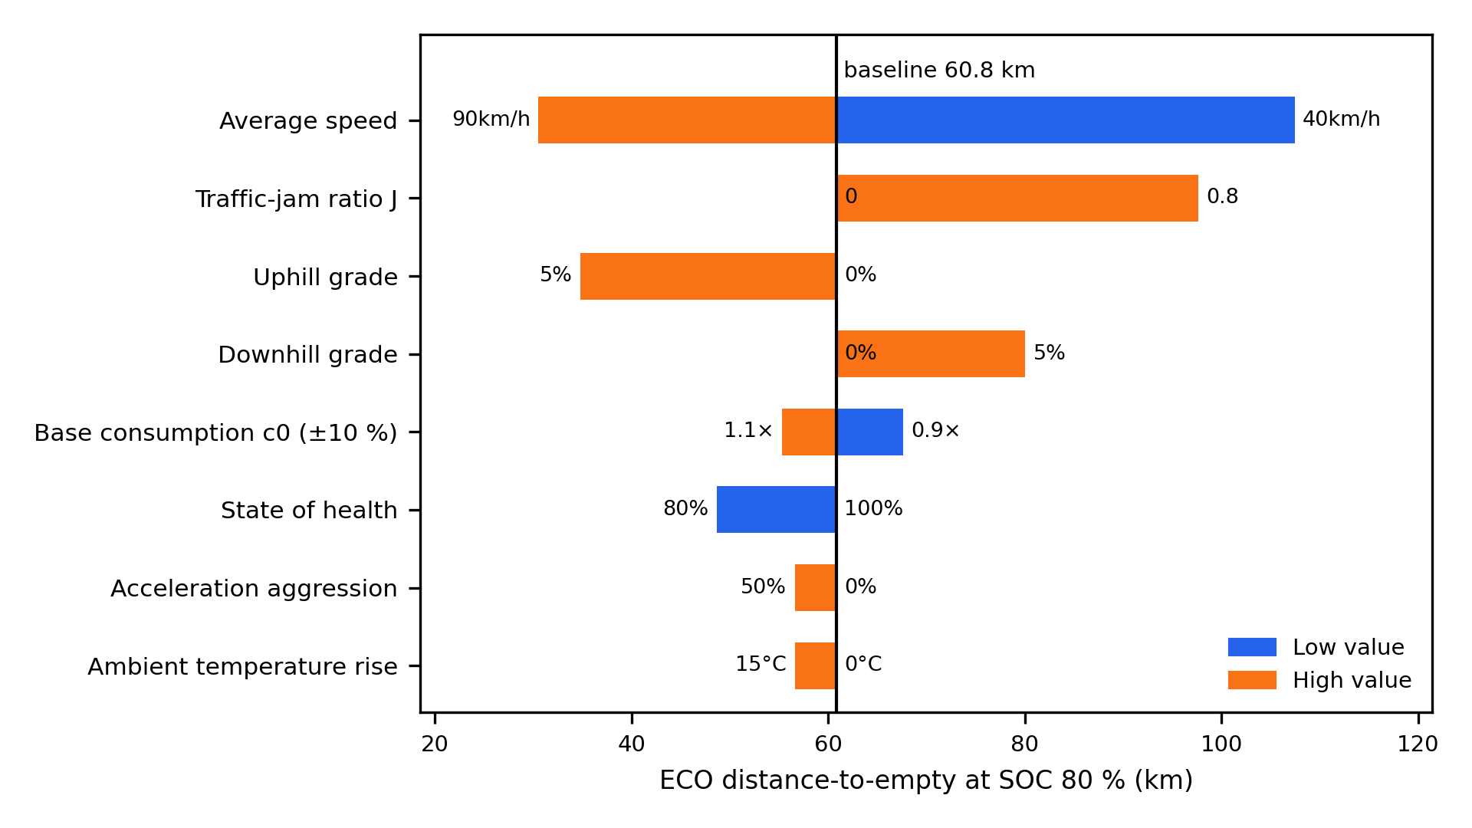
Fig. 5.5: One-at-a-time sensitivity of the DTE (ECO, 80 % SOC, flat road, 60 km/h; baseline 60.8 km)
A one-at-a-time sensitivity analysis of (4.7) was run around ECO mode, 80 % SOC, a flat road without traffic and 60 km/h, for which DTE = 60.8 km (Fig. 5.5). Speed matters the most because drag grows with speed squared: 40 km/h raised DTE by 76.6 % and 90 km/h lowered it by 49.9 %, since aerodynamic drag is about 80 % of the road load at 60 km/h. A 5 % uphill grade cut DTE by 42.9 %, and a 5 % downhill grade added 31.6 %. Ageing to 80 % SOH cut it by 20 %, and an acceleration aggressiveness of 50 % or a 15 °C ambient deviation each cut it by 7.0 %. A ±10 % change in $c_{0}$ moved DTE by +11.1 %/−9.1 %. The relative results, including the 53–60 % overestimation on climbs, do not depend on this calibration, while absolute DTE scales with 1/$c_{0}$. Siliguri → Darjeeling stays infeasible from a full charge for any flat-road ECO range below 92 km, above the 84.6 km upper end of the ±10 % band. Raising J from 0 to 0.8 increased DTE by 60.5 %; Section 5.4 discusses this result. Fig. 5.6 shows that the LSTM relies mainly on the terminal voltage.
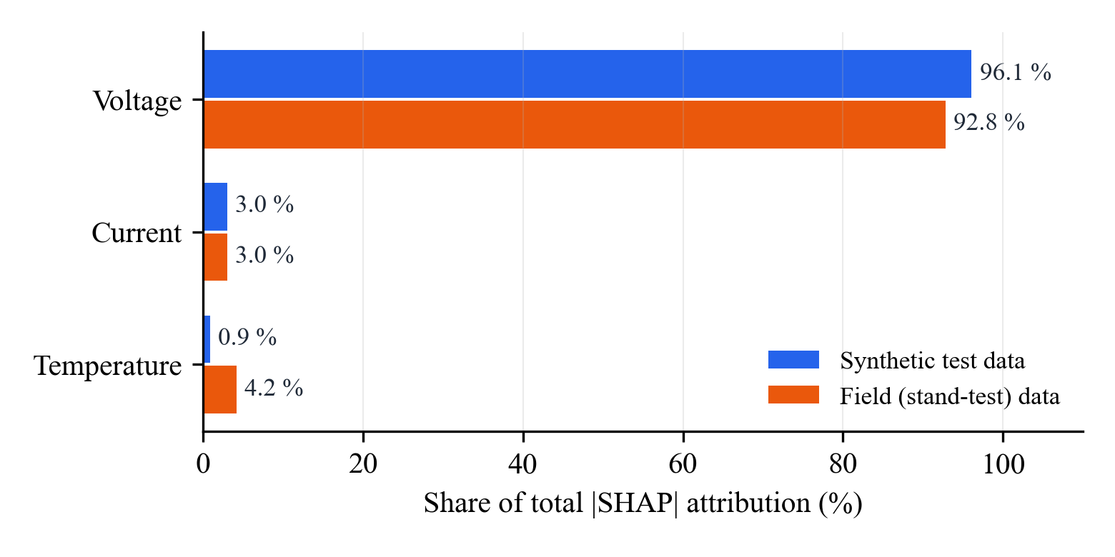
Fig. 5.6: Share of SHAP attribution per input feature of the LSTM

5.4 Interpretation of Results
Terrain decides trip feasibility as much as pack capacity does for a light two-wheeler. On flat urban routes an SOC-proportional estimate is adequate, but on mountain climbs it overestimates the ECO range by more than half and accepts trips that the model predicts will strand the rider, across SOC bands up to 26 percentage points wide. Live mode switching [12] cannot avoid this, because it reacts only once the climb has started. iBMS calculates the whole route before starting the trip, and either ECO-Lock is enforced from the start or a charging stop is required before the beginning of the trip. On descents the naive estimate is conservative, so SPORT mode can be released at a lower SOC. The cost is one routing request, one elevation request, a closed-form evaluation of (4.4)–(4.8) and a 0.41 ms SOC inference.
Traffic is one of the parameters that need attention. In the model, congestion lowers the speed, and since drag dominates at 60 km/h, the energy consumption per km falls. Electric vehicles in general are known to be more efficient at low speed. The losses of repeated starts are possibly underestimated by the stop-and-go factor in (4.7), so under heavy congestion the range gain is an upper bound.
On the SOC side, the field data show only offset removal, while CALCE shows real tracking; the EKF is more accurate when the cell is characterized, while the LSTM needs no initial SOC, OCV curve or capacity, so the choice is a trade-off. Conformal calibration restored the expected coverage, and deciding on the lower bound cut unsafe acceptances by two orders of magnitude at the cost of more refusals, the preferred trade-off for a safety function.

CHAPTER 6 DISCUSSION & CONCLUSION

6.1 Key Achievements & Contributions
All five objectives of Chapter 1 were achieved (Table 6.1).
Table 6.1: Objectives and achieved evidence
Objective | Status | Evidence
1. Leak-free LSTM SOC estimator with fair baselines | Achieved | 0.20 % MAE on synthetic data; 3.17 % on unseen CALCE cycles; Coulomb, EKF and constant baselines
2. Route-energy model | Achieved | SRTM 30 m terrain, live traffic, road-load model and SOH; verified by hand calculation and re-implementation
3. Route-level AMSA | Achieved | Eight real route directions; ECO-Lock bands; infeasible route detected
4. Edge-ready, explainable, uncertainty-aware estimator | Achieved | 67.6 KiB, 0.41 ms; SHAP on the LSTM; 96.6 % calibrated coverage; unsafe acceptances 0.71 → 0.007 %
5. Integrated system and publication | Achieved | Dashboard on Vercel, backend on Render; IEEE conference paper

The main contributions are a route-energy model with closed-form SOC thresholds for every route; a pre-trip, leg-wise extension of AMSA that enforces ECO-Lock or a charging stop; a leak-free LSTM SOC estimator benchmarked honestly on field and public data; an edge-ready, explainable and uncertainty-aware estimator that drives a risk-aware decision; and a deployed dashboard and backend.

6.2 Novelty and Technical Improvements
The novelty of iBMS lies in connecting three elements that earlier work treated separately. First, the decision is taken before the trip and per leg from the terrain and traffic of the whole route, rather than reacting to the current gradient, and the minimum SOC for each mode can be computed exactly. Second, the battery state enters the decision through an estimator that needs no initial SOC and whose uncertainty is calibrated, so the decision stays safe when the estimate is wrong. Third, the decision is enforced, not shown as a warning. The evaluation is also a contribution: the constant baseline exposes when field data are too narrow to rank estimators, and the route results are checked by hand calculation, re-implementation and repetition.
Since the mid-term review, the SOC model was rebuilt without data leakage and benchmarked fairly, the elevation service was repaired so that terrain actually enters the model, the heuristic speed factor was replaced by a physics-based road-load model, the dashboard was connected to the real AMSA in the backend, the simulated federated-learning panel was replaced by the SOC-uncertainty card, and the system was deployed publicly.

6.3 Comparison with Existing Methods
Table 6.2: Comparison of AMSA [12] and iBMS
Aspect | AMSA [12] | iBMS (this work)
SOC estimation | Coulomb counting | LSTM without initial SOC, with calibrated uncertainty
Gradient information | Instantaneous gradient while riding | Cumulative climb and descent of the whole route
Traffic | Predefined drive cycle | Live traffic from TomTom
Time of decision | During the ride | Before departure, for every leg
Battery health | Not used | Scales the available energy
Decision output | Automatic mode switching, limp mode | SAFE / ECO-Lock / charging stop
Evaluation | Simulink MIL on a 10 km Pune profile | Eight real route directions, deployed prototype

Compared with a conventional range display, iBMS avoided accepting infeasible hill trips across SOC bands of up to 26 percentage points. Compared with Coulomb counting, the LSTM does not depend on the initial SOC; compared with the EKF, it is less accurate (3.17 % vs 0.96 % on CALCE) but needs no OCV curve, cell parameters or initial SOC. Unlike the estimation and routing works of Chapter 2, iBMS uses its estimate in an enforced decision about how a given route can be ridden.

6.4 Limitations and Future Scope
The main limitations are:
- Data: 0.2–0.4 % SOC per session, so field SOC errors cannot rank estimators and tracking is shown only on synthetic and CALCE data; LOSO testing is across sessions of the same vehicle.
- Calibration: the base consumption $c_{0}$ comes from approximate display ranges, the coefficients in (4.6) and (4.7) are assumptions, and the route study uses a fixed speed of 60 km/h.
- Terrain and traffic: on flat roads, the climb is inflated by SRTM noise (about 4 m/km), sampling only 100 points along the route misses short grades, and the jam length is approximated from route-point counts.
- Baselines: the naive estimator models an SOC-proportional display, which is not the vehicle's own algorithm, and the field EKF uses an OCV curve not measured on the pack.
- Deployment: ECO-Lock only acts at the software level and does not intervene in the vehicle hardware. The SOC uncertainty was calibrated on laboratory cells, and its lower bound is less reliable in the cold (0–10 °C), so it must be re-tuned on the real pack. The system also depends on external routing and elevation services.
All route-level results are therefore model-based, and on-road validation is the next step.
Future scope includes on-road validation with GPS speed and measured trip energy, a force-based grade and stop-and-go model, a measured pack OCV curve, charging-station-aware routing, embedded deployment with ECO-Lock actuated through the VCU, and pack-level re-tuning of the SOC uncertainty.

6.5 Conclusion
iBMS integrates LSTM SOC estimation with a route-energy model using speed, traffic and topography for electric two-wheelers, and the stack extends AMSA from live mode selection to a pre-trip, leg-wise check that enforces ECO-Lock or a charging stop. A terrain-unaware estimator overestimated the range of ECO mode on climbs by 53–60 % and accepted a 60 km hilly route that AMSA rejects even from a full charge. The LSTM requires no initial SOC; it achieves 0.20 % MAE on synthetic discharge cycles and 3.17 % on unseen CALCE cycles, whereas 0.96 % is achieved by an EKF with a measured OCV. Fine-tuning on the stand tests reduced the error from 7.37 % to 1.24 %, but a complete-discharge field test is still required to rank the estimators. The int8 model occupies 67.6 KiB and inference requires 0.41 ms, its SHAP attributions show that the model relies mainly on recent terminal voltage, and deciding on its calibrated lower SOC bound reduces the chances of accepting unsafe routes by two orders of magnitude. The system is deployed and publicly accessible, and the work has been written up as an IEEE conference paper.

REFERENCES
[1] Q. Zhu, Y. Huang, C. F. Lee, P. Liu, J. Zhang, and T. Wik, "Predicting electric vehicle energy consumption from field data using machine learning," IEEE Trans. Transport. Electrific., vol. 11, pp. 2120–2132, 2025, doi: 10.1109/TTE.2024.3416532.
[2] X. A. Martin, M. Escoto, A. Guerrero, and A. A. Juan, "Battery management in electric vehicle routing problems: A review," Energies, vol. 17, no. 5, 1141, 2024, doi: 10.3390/en17051141.
[3] D. Lai, Y. Costa, E. Demir, A. M. Florio, and T. Van Woensel, "The pollution-routing problem with speed optimization and uneven topography," Comput. Oper. Res., vol. 164, 106557, 2024, doi: 10.1016/j.cor.2024.106557.
[4] D. S. Puma-Benavides et al., "Comparative analysis of energy consumption between electric vehicles and combustion engine vehicles in high-altitude urban traffic," World Electr. Veh. J., vol. 15, no. 8, 355, 2024, doi: 10.3390/wevj15080355.
[5] E. M. Szumska, "Regenerative braking systems in electric vehicles: A comprehensive review of design, control strategies, and efficiency challenges," Energies, vol. 18, no. 10, 2422, 2025, doi: 10.3390/en18102422.
[6] G. Xu, J. Xu, and Y. Zhu, "LSTM-based estimation of lithium-ion battery SOH using data characteristics and spatio-temporal attention," PLOS ONE, vol. 19, no. 12, e0312856, 2024, doi: 10.1371/journal.pone.0312856.
[7] N. Zhang, T. Hou, G. Han, Y. Yu, H. Xu, and Y. Huang, "Smart batteries: Materials, monitoring, and artificial intelligence," Chem. Soc. Rev., vol. 54, pp. 10006–10139, 2025, doi: 10.1039/D5CS00609K.
[8] Z. Xiao, B. Jiang, J. Zhu, X. Wei, and H. Dai, "State of health estimation for lithium-ion batteries using an explainable XGBoost model with parameter optimization," Batteries, vol. 10, no. 11, 394, 2024, doi: 10.3390/batteries10110394.
[9] M. El Bahnasawi, M. Abdellatif, M. Salem, P. Fasouli, M. Gebser, and K. Kyamakya, "Balancing performance and transparency: Explainable AI for battery health monitoring," in Designing the Conceptual Landscape for a XAIR Validation Infrastructure (Lecture Notes in Networks and Systems). Cham, Switzerland: Springer, 2025, pp. 102–121, doi: 10.1007/978-3-031-89274-5_8.
[10] A. R C, K. Athira, S. Verma, and S. Rajkumar, "FPGA based hardware accelerator with edge intelligence for electric scooter battery health monitoring," in Proc. Innov. Power Adv. Comput. Technol. (i-PACT), 2025, pp. 1–7, doi: 10.1109/i-pact65952.2025.11307954.
[11] P. Abbaraju and S. K. Kundu, "A novel federated & ensembled learning-based battery state-of-health estimation for connected electric vehicles," IEEE Open J. Intell. Transp. Syst., vol. 5, pp. 445–453, 2024, doi: 10.1109/OJITS.2024.3430843.
[12] S. N. Pise, S. Yeolekar, N. Lokhande, and F. Khan, "Automated drive mode switching & recommendation algorithm (AMSA): A modern approach to enhance electric vehicle energy efficiency and user experience," J. Electr. Eng. Technol., vol. 21, no. 3, pp. 3005–3019, 2026, doi: 10.1007/s42835-026-02582-6.
[13] Y. Liu, B. Hou, M. Ahmed, Z. Mao, J. Feng, and Z. Chen, "A hybrid deep learning approach for remaining useful life prediction of lithium-ion batteries based on discharging fragments," Appl. Energy, vol. 358, 122555, 2024, doi: 10.1016/j.apenergy.2023.122555.
[14] P. Li, X. Wu, R. Grosu, J. Hou, M. Ilolov, and S. Xiang, "Applying neural network to health estimation and lifetime prediction of lithium-ion batteries," IEEE Trans. Transport. Electrific., vol. 11, no. 1, pp. 4224–4248, 2025, doi: 10.1109/TTE.2024.3457621.
[15] S. S. Madani, Y. Shabeer, M. Fowler, S. Panchal, H. Chaoui, S. Mekhilef, S. X. Dou, and K. See, "Artificial intelligence and digital twin technologies for intelligent lithium-ion battery management systems," Batteries, vol. 11, no. 8, 298, 2025.
[16] V. P. Chellapandi, L. Yuan, C. G. Brinton, S. H. Żak, and Z. Wang, "Federated learning for connected and automated vehicles: A survey of existing approaches and challenges," IEEE Trans. Intell. Veh., vol. 9, no. 1, pp. 119–137, Jan. 2024.
[17] M. A. Bouchiha, A. Amara Korba, and Y. Ghamri-Doudane, "Automated Byzantine-resilient clustered decentralized federated learning for battery intelligence in connected EVs," arXiv:2605.21115, 2026.
[18] T. Wang, Z. Y. Dong, and H. Xiong, "Adaptive multipersonalized federated learning for state of health estimation of multiple batteries," IEEE Internet Things J., vol. 11, no. 24, pp. 39994–40008, Dec. 2024, doi: 10.1109/JIOT.2024.3448626.
[19] A. Skuza, E. M. Szumska, R. Jurecki, and A. Pawelec, "Modeling the impact of traffic parameters on electric vehicle energy consumption," Energies, vol. 17, no. 21, 5423, 2024.
[20] S. Kapoor, "Explainable and context-aware graph neural networks for dynamic electric vehicle route optimization to optimal charging station," Expert Syst. Appl., vol. 283, 127331, Jul. 2025, doi: 10.1016/j.eswa.2025.127331.
[21] C. Ning, C. Sun, X. Yang, Z. Huang, D. Wen, Z. Chen, and J. Leng, "UT-Planner: Energy-efficient trajectory planner for autonomous ground vehicles on uneven terrain," IEEE Internet Things J., vol. 13, no. 13, pp. 28505–28515, Jul. 2026, doi: 10.1109/JIOT.2026.3685118.
[22] S. Hochreiter and J. Schmidhuber, "Long short-term memory," Neural Comput., vol. 9, no. 8, pp. 1735–1780, 1997.
[23] R. E. Kalman, "A new approach to linear filtering and prediction problems," J. Basic Eng., vol. 82, no. 1, pp. 35–45, 1960.
[24] G. L. Plett, "Extended Kalman filtering for battery management systems of LiPB-based HEV battery packs: Part 3. State and parameter estimation," J. Power Sources, vol. 134, no. 2, pp. 277–292, 2004.
[25] Y. Xing, W. He, M. Pecht, and K. L. Tsui, "State of charge estimation of lithium-ion batteries using the open-circuit voltage at various ambient temperatures," Appl. Energy, vol. 113, pp. 106–115, 2014.
[26] W. He, N. Williard, C. Chen, and M. Pecht, "State of charge estimation for Li-ion batteries using neural network modeling and unscented Kalman filter-based error cancellation," Int. J. Electr. Power Energy Syst., vol. 62, pp. 783–791, 2014.
[27] S. M. Lundberg and S.-I. Lee, "A unified approach to interpreting model predictions," in Proc. Adv. Neural Inf. Process. Syst. (NeurIPS), 2017, pp. 4765–4774.
[28] Y. Gal and Z. Ghahramani, "Dropout as a Bayesian approximation: Representing model uncertainty in deep learning," in Proc. Int. Conf. Mach. Learn. (ICML), 2016, pp. 1050–1059.
[29] J. Lei, M. G'Sell, A. Rinaldo, R. J. Tibshirani, and L. Wasserman, "Distribution-free predictive inference for regression," J. Amer. Statist. Assoc., vol. 113, no. 523, pp. 1094–1111, 2018.
[30] M. C. Kirca and A. McGordon, "Effect of rider position on the energy consumption of an electric motorcycle," in Proc. IEEE Vehicle Power Propulsion Conf. (VPPC), 2023, pp. 1–3, doi: 10.1109/VPPC60535.2023.10403372.

APPENDICES

Appendix A: Codes

A.1 Repositories and experiment scripts
The source code is maintained in two Git repositories and a set of experiment scripts:
- Frontend (Next.js dashboard and serverless API routes): https://github.com/mrunaljadhor/iBMS_frontend
- Backend (Express route-energy model and AMSA): https://github.com/mrunaljadhor/bms_backend
- experiments/exp1_soc_lstm/run_exp1.py – leak-free LSTM, Coulomb counting, EKF and constant baselines on synthetic and field data
- experiments/exp2_calce_lfp/ – CALCE benchmark (LSTM, EKF-1RC, Coulomb, constant), uncertainty quantification (run_exp10_uq.py) and federated learning on CALCE
- experiments/exp3_amsa_routes/run_exp3.py – AMSA route study on eight route directions (calls the real backend)
- experiments/exp4_dte_sensitivity/run_exp4.py – one-at-a-time sensitivity of the DTE
- experiments/exp678_edge_shap_fl/run_exp678.py – TensorFlow Lite conversion, SHAP and federated learning on the field data
- kinematics_validation/validate_kinematics.py – validation of the kinematic synthesis
Listing A.1 is an excerpt of the AMSA decision in the backend.
Listing A.1: Three-tier feasibility check and leg-wise AMSA loop (backend/server.js, condensed)
function checkFeasibility(current_soc, route_distance_km, env = {}) {
const eco_dte = calculateDTE(current_soc, 'ECO', env);
const sport_dte = calculateDTE(current_soc, 'SPORT', env);
let status = 'SAFE';
if (route_distance_km > eco_dte) status = 'IMPOSSIBLE';
else if (route_distance_km > sport_dte) status = 'CRITICAL';
return { status, eco_dte, sport_dte,
safety_margin_eco: eco_dte - route_distance_km,
safety_margin_sport: sport_dte - route_distance_km };
}

// risk-aware AMSA: decide on the lower SOC bound
const decision_soc = Math.max(0, Number(current_soc) - socMargin);

for (let i = 0; i < legs.length; i++) {
const leg_dist = legs[i].distance.value / 1000;
const leg = checkFeasibility(simulated_soc, leg_dist, envParams);
if (leg.status === 'IMPOSSIBLE') {
overall_status = 'IMPOSSIBLE'; amsa_action = 'CHARGE_REQUIRED'; break;
} else if (leg.status === 'CRITICAL') {
overall_status = 'CRITICAL'; amsa_action = 'FORCE_ECO_MODE';
}
simulated_soc -= (leg_dist / leg.eco_dte) * simulated_soc; // Eq. (4.8)
if (chargeAtStops && i < legs.length - 1) simulated_soc = 100;
}

Appendix B: Datasheets
This appendix summarizes the specifications of the hardware used in the project, as obtained from the vehicle, the development kit and the measurements.
Table B.1: Battery pack of the electric two-wheeler
Parameter | Value | Source
Chemistry | Lithium iron phosphate (LiFePO4) | Vehicle
Nominal voltage | 63.5 V | Field data (mean under load)
Voltage at full charge | 63.8 V | Field data
Capacity | 30.9 Ah (pooled estimate 28.9 Ah) | Coulomb counting on the field data
Energy | ≈ 1.96 kWh | 30.9 Ah × 63.5 V
Rated range | ≈ 76 km ECO, ≈ 62 km SPORT | On-board range display at full charge
Measured temperature during tests | 30–31 °C | Vehicle BMS
Maximum discharge current during tests | 8.0 A | Vehicle BMS (stand test)

Appendix C: Extended Results

C.1 Federated learning on the field data
Table C.1 lists the leave-one-client-out results of federated learning with the six stand-test sessions as clients. All methods start from the synthetic-pretrained model; FedAvg uses 10 rounds of one local epoch.
Table C.1: Federated learning on the field data (MAE, % SOC)
Held-out client | Zero-shot | Local-only (mean) | Centralized | FedAvg
S1 Single-ECO | 5.06 | 1.94 | 0.67 | 0.95
S2 Single-SPORT | 10.57 | 1.82 | 1.63 | 1.15
S3 Series-ECO | 5.53 | 1.68 | 0.60 | 0.51
S4 Series-SPORT | 8.01 | 2.46 | 1.32 | 1.80
S5 Parallel-ECO | 4.68 | 1.40 | 0.62 | 0.62
S6 Parallel-SPORT | 10.10 | 4.24 | 3.34 | 4.90
Weighted mean | 7.37 | 2.27 | 1.38 | 1.67

The float32 model is 116.6 KB; ten rounds with five clients transfer 11.7 MB, against 21.7 KB for uploading the raw stand-test data. Federated learning would save bandwidth only when each vehicle logs more than about 4.1 hours of 1 Hz telemetry per round. On CALCE (14 cell × temperature clients), FedAvg reached 8.99 % MAE against 3.17 % for centralized and 16.39 % for local-only training, with 32–38 MB of model updates against about 3.1 MB of raw data.

C.2 Route-study repeatability
The route study was run three times: on 16 October 2026 at 11:49 IST (reported in Chapter 5), on 18 October 2026 at 18:37 IST and on 21 October 2026 at 08:54 IST. On the hill routes the ECO range differed by at most 0.8 km and the SOC thresholds by at most 1 percentage point between runs, and Siliguri → Darjeeling remained infeasible from a full charge in every run.

Appendix D: Plagiarism Report
The similarity report generated for this report is attached at the end of the report.

Appendix E: Proof of Outcomes (Journal/Conference paper, Patent)
The work has been written up as a conference paper in the IEEE two-column format:
- Title: iBMS: Explainable LSTM State Estimation and Terrain- and Traffic-Aware Supervisory Drive-Mode Control in Electric Two-Wheelers.
- Authors: Mrunal Jadhor, Ojal Dhuri, Dr. Shweta Kukade and Dr. Saket Yeolekar, Department of Electrical and Electronics Engineering, Dr. Vishwanath Karad MIT World Peace University, Pune.
- Content: 7 pages, 3 figures, 3 tables, 1 algorithm and 30 verified references.
- Target venue: IEEE International Conference on Intelligent Transportation Systems (ITSC); back-up venues IEEE ITEC-India, IEEE VPPC and IEEE INDICON.
The working system is publicly accessible at https://ibmsdashboard.vercel.app, with the backend at https://ibms-backend-k4rs.onrender.com.

Appendix F: Standards Used (IEEE/IEC/ISO/IPC)
Table F.1: Standards considered in the design
Standard | Scope | Relevance to iBMS
AIS-156 | Safety requirements for traction battery packs of L-category vehicles (India) | Pack safety limits and BMS functions
IEC 62660-1 / -2 | Secondary lithium-ion cells for EV propulsion: performance testing; reliability and abuse testing | Cell test conditions such as capacity and drive-cycle discharge
ISO 12405-4 | Test specification for lithium-ion traction battery packs and systems | Reference for pack-level testing in future work
ISO 26262 | Functional safety of road vehicles | Required before ECO-Lock is actuated through the VCU
UN 38.3 | Transport of lithium batteries | Handling and transport of cells and packs
IEEE editorial style | Referencing and paper format | Paper and report references

These standards were used as guidance for the design and the test procedures; no formal certification was carried out in this project.

Appendix G: Bill of Material
Table G.1: Bill of material
Item | Quantity | Purpose | Cost
Cloud services (Vercel, Render, TomTom, OpenTopoData, Google Maps, Gemini) | – | Free tiers used for hosting and APIs | 0

Appendix H: Safety Norms Followed
- The vehicle was tested only on a stand with the rear wheel lifted and the vehicle secured; no rider was on the vehicle during the tests.
- The pack temperature stayed between 30 and 31 °C, and no cell was charged or discharged outside the limits of its BMS.
- Bench tests on the single cell used the protection logic of the development kit and a fixed resistor load.
- API keys are stored in environment variables and are not committed to the code repositories.
- The backend does not keep a database of trips; route requests are answered and not stored.

