**ADS LA-4**

Name: Yash Gawande

PRN: 2018BTECS00113

**TY BTech(CSE)-II 4CS372 : Advanced Database System Lab. * LA4 (ESE) JUNE 2021 * Paper Code : ADS6L58 Using Neo4j Spatial**

Implement the following, for spatial data by creating relevant suitable schema: ∙ A schema to represent the geographic location of Shopping Mall along with features such as  the facilities available (Cashless, Doorstep delivery, returns accepted, etc.) at the Shopping  Mall and the level of expensiveness.

∙ A query to find moderately priced Shopping Mall that offer the fast checkouts and are within  5 miles of your house (assume any location from your home)

A query to find the distance of each Shopping Mall having the same facilities and with the same  level of expensiveness as that of the nearest Shopping Mall.

CREATE

(`0` :Mall {name:"Yash113",`Drag marker to required Latitude`:'20.7059393',Longitude:'77.0048819',Expensiveness:"moderate"}) ,

(`1` :Footware {name:"Hritik"}) ,

(`2` :`Jwellery shop` {name:"savji"}) ,

(`3` :Boutique {name:"Tavishi's boutique"}) ,

(`4` :Restaurants {name:"Shubham's res"}) ,

(`5` :`Gaming zone` {name:"bhange"}) ,

(`6` :Opticals {name:"Ruch-Prax"}) ,

(`7` :`Facilities Available` {Transaction:"cashless/cash",Eligibility:"Age below 15"}) ,

(`8` :`Facilities Available` {Transaction:"cashless/cash",Delivery:"Available"}) ,

(`9` :`Facilities Available` {Transaction:"cashless/cash",Delivery:"Available",Return:"48 hours"}) ,

(`10` :`Facilities Available` {Transaction:"cashless/cash",Delivery:"Available"}) ,

(`11` :`Facilities Available` {Transaction:"cashless/cash",Delivery:"Available",return:"7 days return"}) ,

(`12` :`Facilities Available` {Transaction:"cashless/cash",Delivery:"Available",Trial:"Free trial"}) ,

(`13` :Home {Latitude:'20.7133192',longitude:'77.0029122'}) ,

(`14` :Mallno2 {Latitude:'20.7227763',Longitude:'77.0052987',Expensiveness:"high"}) ,

(`15` :Mallno3 {Latitude:'20.7227763',Longitude:'77.0052993',Expensiveness:"high"}) ,

(`0`)-[:`Shops` ]->(`1`),

(`0`)-[:`Shops` ]->(`2`),

(`0`)-[:`Shops` ]->(`3`),

(`0`)-[:`Shops` ]->(`4`),

(`0`)-[:`Shops` ]->(`5`),

(`0`)-[:`Shops` ]->(`6`),

(`5`)-[:`RELATED_TO` ]->(`7`),

(`4`)-[:`RELATED_TO` ]->(`8`),

(`3`)-[:`RELATED_TO` ]->(`9`),

(`2`)-[:`RELATED_TO` ]->(`10`),

(`1`)-[:`RELATED_TO` ]->(`11`),

(`6`)-[:`RELATED_TO` ]->(`12`),

(`13`)-[:``Mall 1`` ]->(`0`),

(`13`)-[:`RELATED_TO` ]->(`14`),

(`13`)-[:`RELATED_TO` ]->(`15`)

Database screenshots:

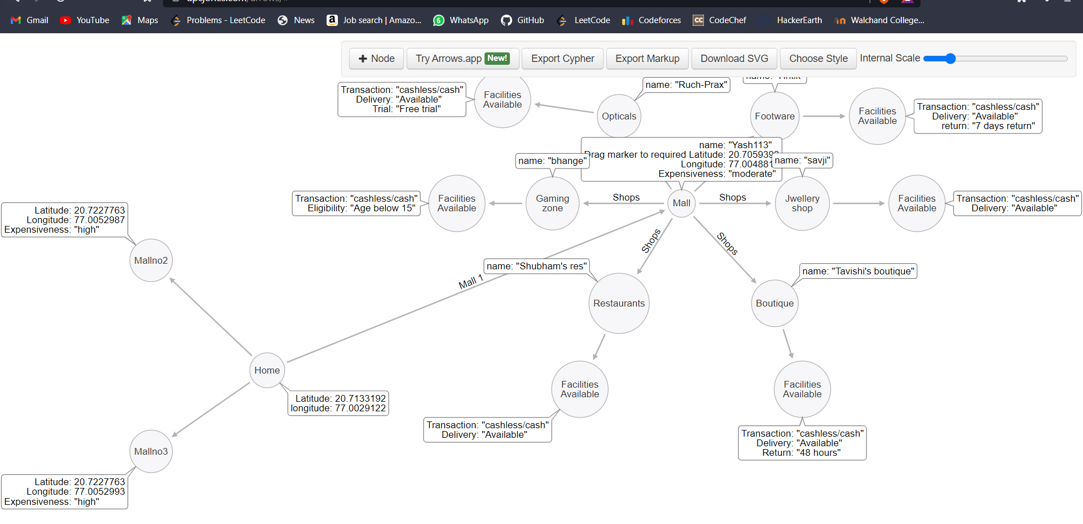

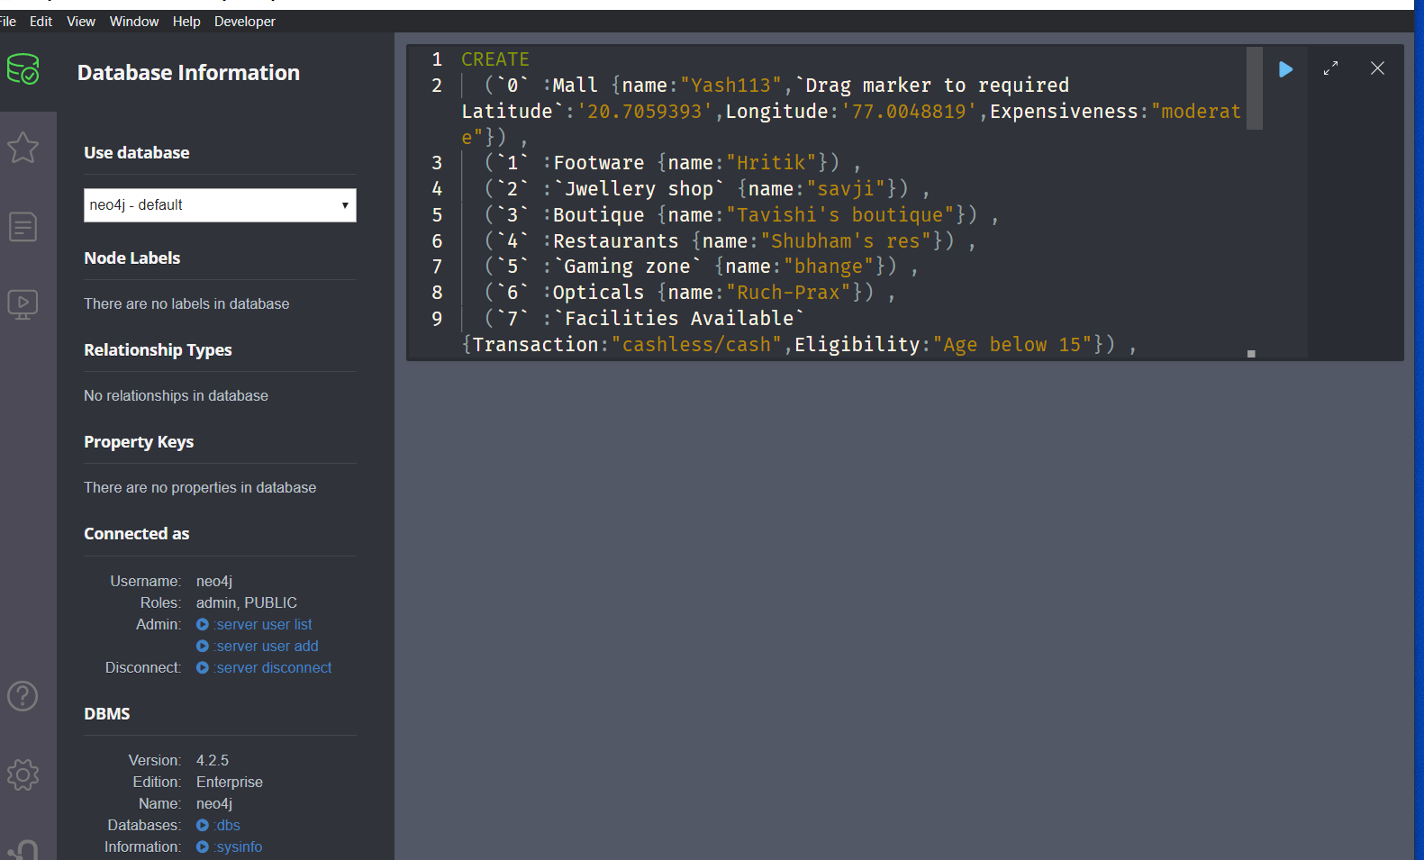

Ran successfully:

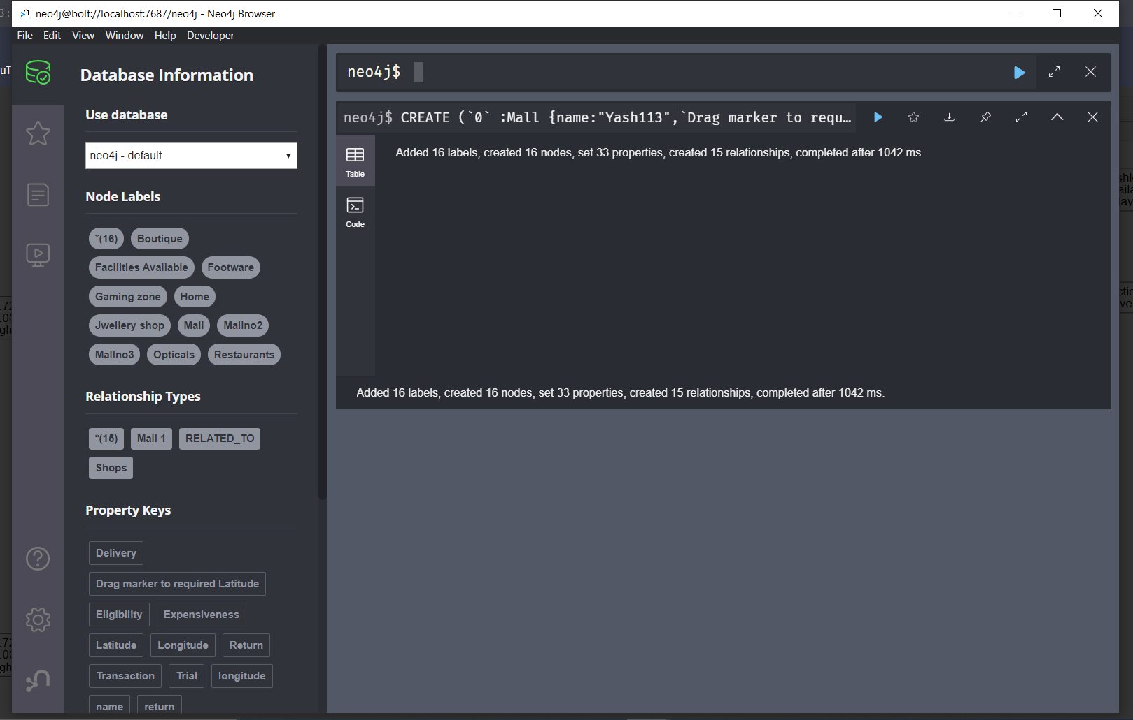

Query to find distance bet home and mall

MATCH (t:Mall)-[:Malltohome]->(o:Home)

WITH point({longitude: t.longitude, latitude: t.latitude}) AS homepoint, point({longitude: o.longitude, latitude: o.latitude}) AS mallpoint

RETURN round(distance(Mall, home)) AS distance

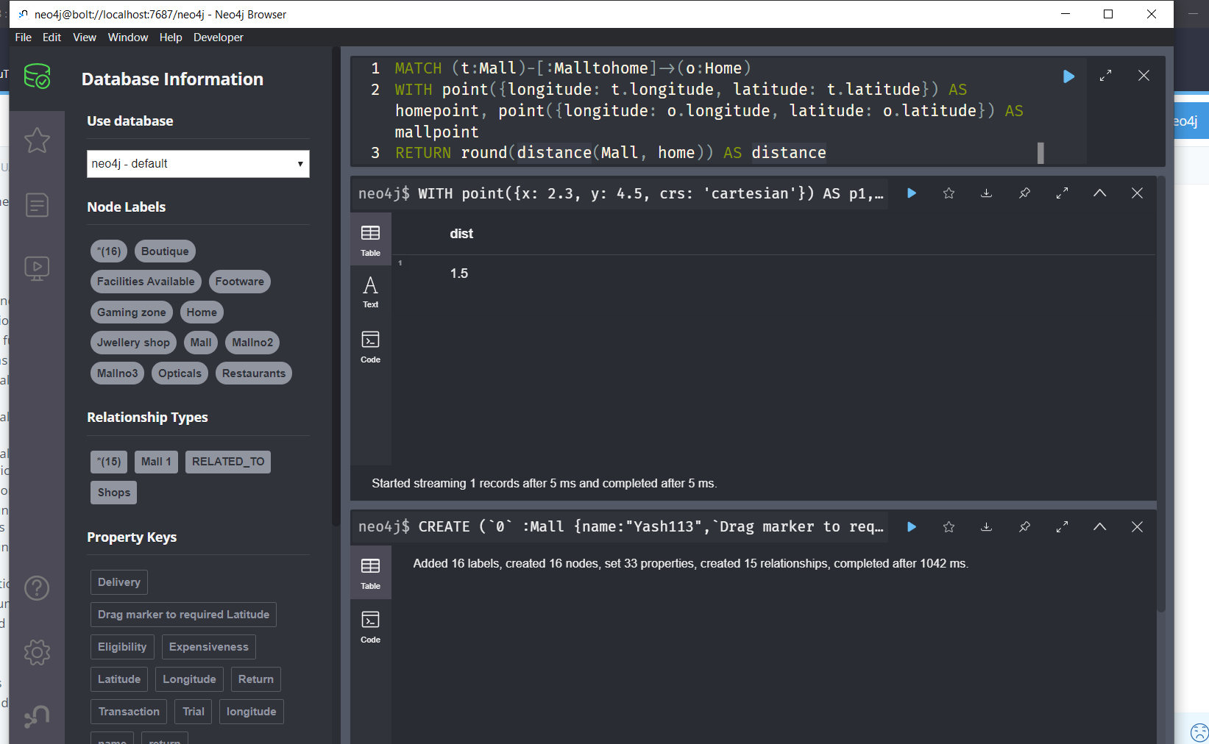

A query to find moderately priced Shopping Mall that offer the fast checkouts and are within  5 miles of your house (assume any location from your home)

MATCH (a:Mall {name:Yash113})

    WITH a

MATCH (b:home) WHERE id(b)<>id(a)

    WITH a, b, distance( point(a), point(b) ) as dist

        WHERE dist<=50000

RETURN

    a.title, b.title, dist

ORDER BY dist DESC

