1. Introduction
The Instant Ambulance Service System (IASS) is a android based application to allow the emergency response system. It maintains locations of ambulances and maintains a history of response results for analysis.The following subsections of the Software Requirements Specifications (SRS) document provide an overview of the entire SRS.

1.1 Purpose-
The Software Requirements Specification (SRS) will provide a detailed description of the requirements for the Instant Ambulance Service System (IASS). This SRS will allow for a complete understanding of what is to be expected of the IASS to be constructed. The clear understanding of the IASS and its’ functionality will allow for the correct application to be developed for the end user and will be used for the development of the future stages of the project. This SRS will provide the foundation for the project. From this SRS, the IASS can be designed, constructed, and finally tested.
The purpose of the IASS is to enhance the capabilities of ambulance dispatchers in the timely displacement of ambulance(s) to injury scenes in an efficient manner.

1.2 Scope-
The application to be produced is a Instant Ambulance Service System which will automate the major ambulance operations. The first subsystem is a Searching and Booking System to keep track of ambulance availability. The second subsystem is the Checking health parameter and Notify System. These two subsystems’ functionality will be described in detail in section 2-Overall Description. There are four end users for the IASS. The end users are the user(Request and book the ambulance),The ambulance driver(Confirm request and pick up),The technician (check health parameter and send to hospital) and the hospital administrative person(receive notification for further action).
The Instant Ambulance Service System’s objectives is to provide a system which do following-
- To locate the nearest ambulance facilities for the people requiring emergency medical treatment.
- To report about patient health condition to hospital for further services.

1.3 Definitions, Acronyms and Abbreviations.
Table 1: Acronyms and Abbreviations.
SRS | Software Requirements Specification
IASS | Instant Ambulance Service System
HAP | Hospital Administrative Person

1.4 Overview
The SRS is organized into two main sections. The first is The Overall Description and the second is the Specific Requirements. The Overall Description will describe the requirements of the IASS from a general high level perspective. The Specific Requirements section will describe in detail the requirements of the system.

2.The Overall Description(Abstract)
Describes the general factors that affect the application and its requirements. This section does not state specific requirements. Instead it provides a background for those requirements, which are defined in section 3, and makes them easier to understand.

2.1 Product Perspective
The IASS is an independent application. It is totally self contained.

2.1.1 Hardware Interfaces (Existing System)
The IASS will be placed on android device having inbuilt GPS functionality

2.1.2 Software Interfaces
All databases for the IASS will be configured using Firebase. These databases include user,ambulance and hospital information. These can be modified by the end users. The user database will include the name,password,email,mob_no. The ambulance driver database will contain all the information of driver such as name,password,location (captured by GPS),mob_no.The technician database will contains the name, email, password, mob_no.The HAP database contains name, mob_no,password.whether or not ambulance will be confirmed and expected health parameter is checked.

2.2 Product Functions (Informal approach)
Login
Login with username & password
Allows to register with details

Searching and Booking System
Search nearest ambulance
Send request for checking availability
If available then notify for confirmation else cancel
Pick up the patient

Checking health parameter & Notify System
The end user checks the health parameters such as ECG,Sugar,BP
Send these information to the hospital
Hospital Administrative persons will receive the information send by End User.
Hospital will able to take further action

2.3 User Characteristics
Knowledge about handling android app - Medium
Experience of IASS application – None
Educational knowledge(English) - Low

2.4 Apportioning of Requirements
First of all module needs to be register or login if already registered by using username as email/phone no and password as shown in fig 3.

2.4.1. User module:
After successful login user’s location is tracked by GPS and according to that nearest ambulance is displayed. User should select one and send request and receive response from ambulance driver.
2.4.2. Ambulance Driver :
The ambulance Driver receive the notification from user and send response to user and send the ambulance to pick up the user.
2.4.3. Medical Technician :
The Medical Technician check the current condition of the patient and then search for nearest hospital and notify the hospital about the patient for further action. If the ambulance has its own hospital then report to that hospital.
2.4.4. Hospital Administrative Person :
The hospital administrative person will receive the notification and according to that they should take the further action for patient’s safety.

2.5 Assumptions and Dependencies
- The System should have internet connection as well as GPS .
- Specific Requirements
This section contains all the application requirements at a level of detail, that when combined with the system DFD, UML,use cases and use case description is sufficient to enable designers to design a system to satisfy those requirements, and testers to test that the system satisfies those requirements.

External Interfaces
- The Instant Ambulance Service System will use the android device with GPS Functionality.

User Interfaces
The User Interface Screens are described in table 2.
Screen Name | Description
Login | Log into the system as a User,Technician,Driver,HAP
Registration | Fill the details as per the respective user
User | View nearest ambulance,choose free or paid , select it & send request, receive confirmation & Book the ambulance.
Driver | Receive request & call user for confirmation & pick up if confirmed.
Technician | Check health parameters & send to the hospital
HAP | Receive information for further action
Table 2: Instant Ambulance Service System User Interface Screens

Software Interfaces
The system developed by android studio and interface with Firebase database.

Hardware Interfaces
The system shall run on android device. System uses GPS for capturing location.

Communication Interfaces
The system shall notify to the user for the available ambulance then driver will call to user to confirm the requested ambulance.Technician notify health details to the Hospital Administrative person.

Functional Requirements
Functional requirements define the fundamental actions that system must perform.The functional requirements for the system are divided into four main categories Registration,Login,Booking ,Checking health parameters & Notify.

- Registration
  - The system shall record registration.
  - The system shall record the user’s name,password,Email,Mob_no.

- Login
  - The system shall select appropriate user.
  - The system shall login with username & password

- Booking
  - The system shall search for the nearest ambulance.
  - The system shall send request to the nearest ambulance.
  - The system shall check availability for the ambulance.
  - The system shall receive the user’s confirmation.
  - The system shall book ambulance.
  - The driver will ready for the pick up.

- Checking health parameters & Notify system
  - The system shall checks the health parameters such as ECG,Sugar,BP etc
  - The system shall send these information to the HAP
  - HAP will receive the information
  - HAP will able to take further action
3.3 Nonfunctional Requirements
Functional requirements define the needs in terms of performance, logical database requirements, design constraints, standards compliance, reliability, availability, security, maintainability, and portability.

3.3.1 Performance Requirements
Performance requirements define acceptable response times for system functionality.
- The load time for user interface screens shall take no longer time.
- The log in information shall be verified within few minutes.
- Queries shall return results in time.

3.3.2 Logical Database Requirements
The logical database requirements include the attention of the following data elements. This list is a complete list and is designed as a starting point for development.

Login System
- User’s name and password

Booking/Reservation System
- Type of user
- User Name , Mob_no,password
- User reenter password for confirmation
- User Email
- User Location

Checking Health & Notify System
- User Health Details like ECG,Sugar,BP
- Notify to HAP

3.3.3 Design Constraints
The IASS shall be running in a android device. The system shall be developed using android and an Access to the Firebase database.

3.3.4 Standards Compliance
There shall be consistency in variable names within the system. The graphical user interface shall have a consistent look and feel.

3.3.5 Reliability
Specify the factors required to establish the required reliability of the system at time of service.

3.3.6 Availability
The system shall be available 24 hours.

3.3.7 Security
User , Driver , HAP , Technician will be able to log in to IASS.User will have access to Searching & Booking System.Driver will have access to Pick up system. Technician will have access to Checking health & Notify system .

3.3.8 Maintainability
The IASS is being developed in android. Android is a mobile operating system.It is based on modified version of open source software.Android's default user interface is mainly based on direct manipulation, using touch inputs that loosely correspond to real-world actions, like swiping, tapping, pinching, and reverse pinching to manipulate on-screen objects, along with a virtual keyboard.

3.3.9 Portability
The IASS shall run in any android device that contains GPS functionality.

4 . System Design
4.1. System Architecture :
The implementation of this system is divided into server client architecture in order to make small size application and keep all the data available centrally as shown in fig 1. Thus client is nothing but a smart phone having the application and the server side used for handling user requests and respond by processing them.

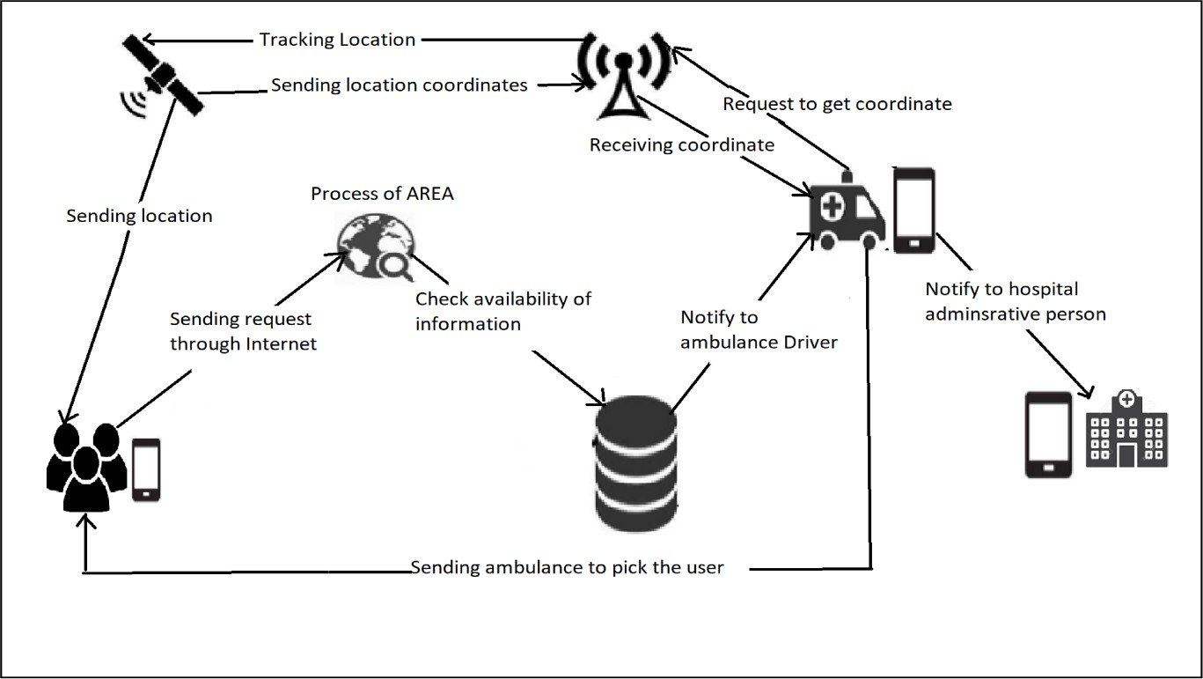
Fig1: Overall Architecture of Ambulance service system.

User application:
This application will initially be based on Android. First user need to register or login if already registered user. On launching the app first device will automatically detect the location of user using the GPS devices. Later depending on the user’s requirement, user will choose option of finding nearby ambulances. This query is sent in the form of request to the server. Server will process on it by sending it to ambulance driver and respond accordingly. Smart phone app will read the data from response and plot the information according to the user’s request. When server will receive a request from device, it will parse the data and extract result.
4.2. Data Flow Diagram :
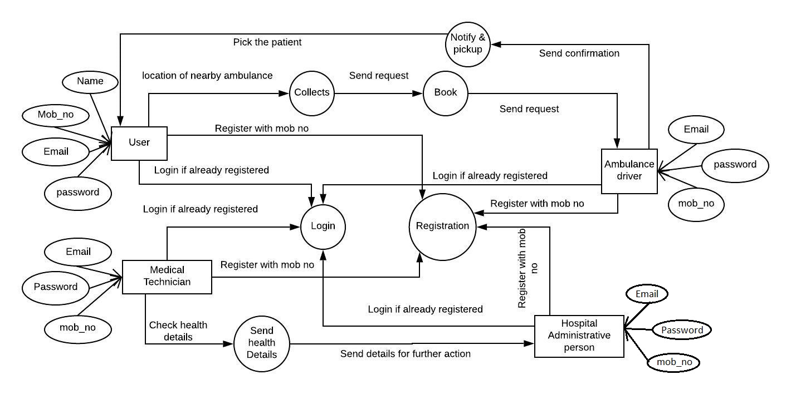
Fig 2: Data flow diagram for IASS
4.3. UML Diagrams

4.3.1. Use Case Diagram :
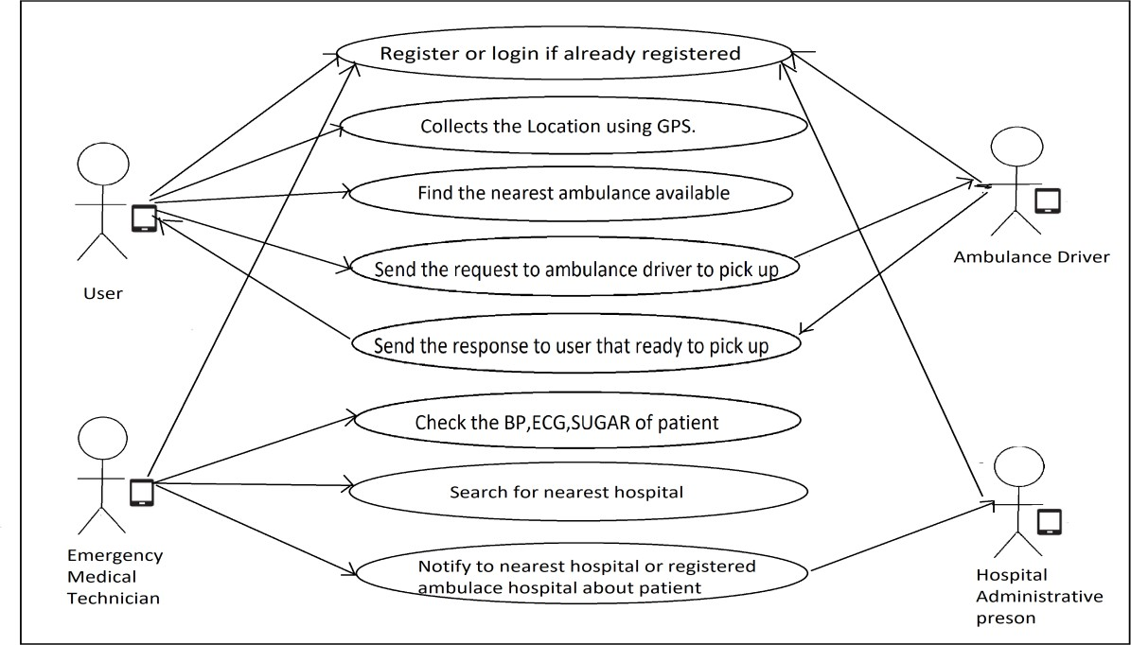
Fig 3. Use Case Diagram for IASS

4.3.2. Class Diagram :
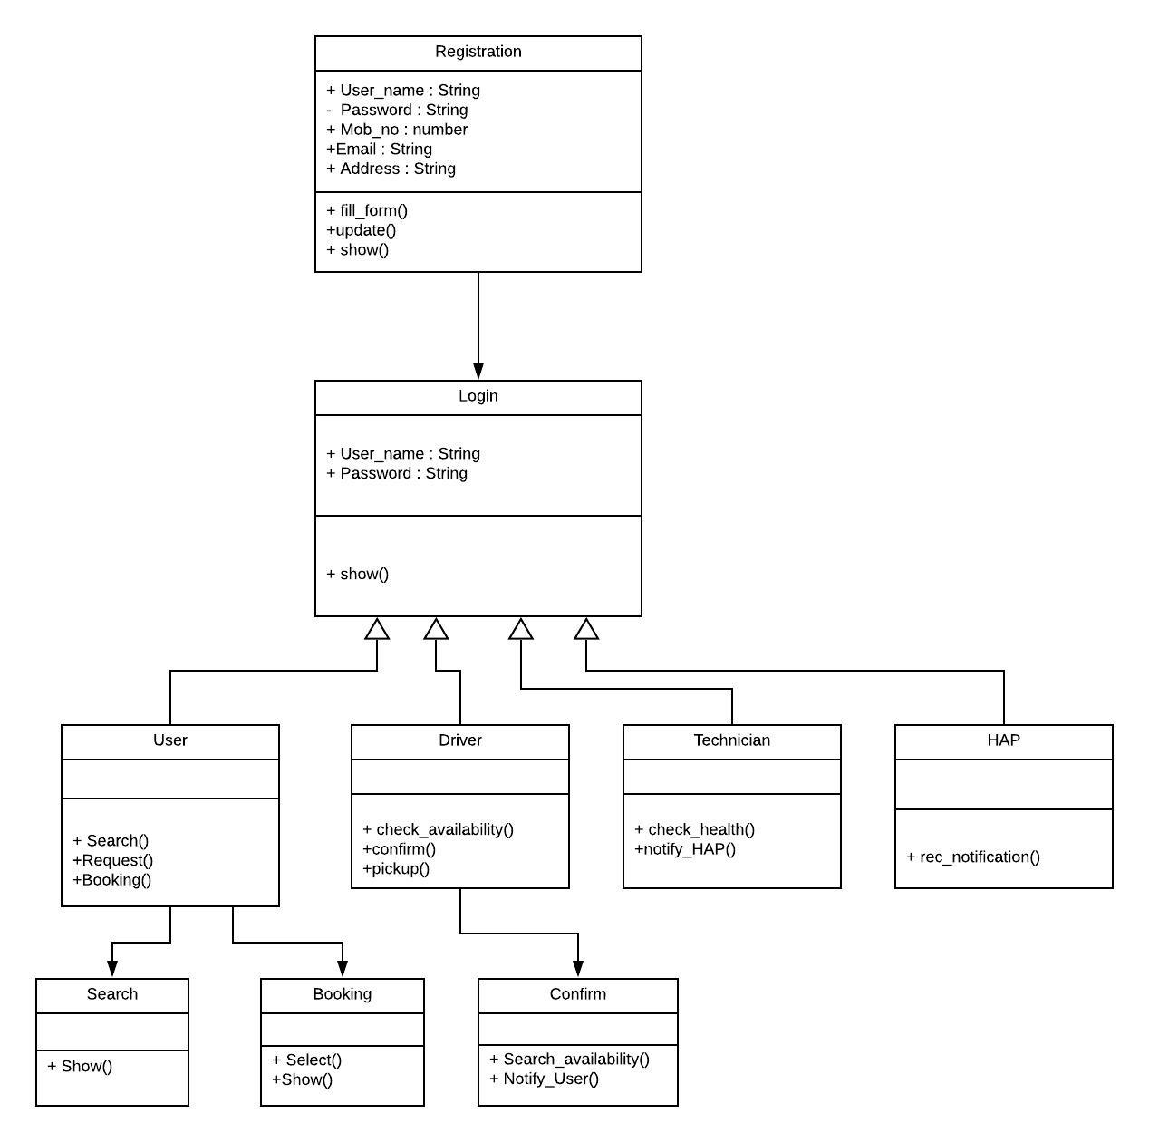
Fig 4. Class Diagram for IASS

4.3.3. Sequence Diagram :
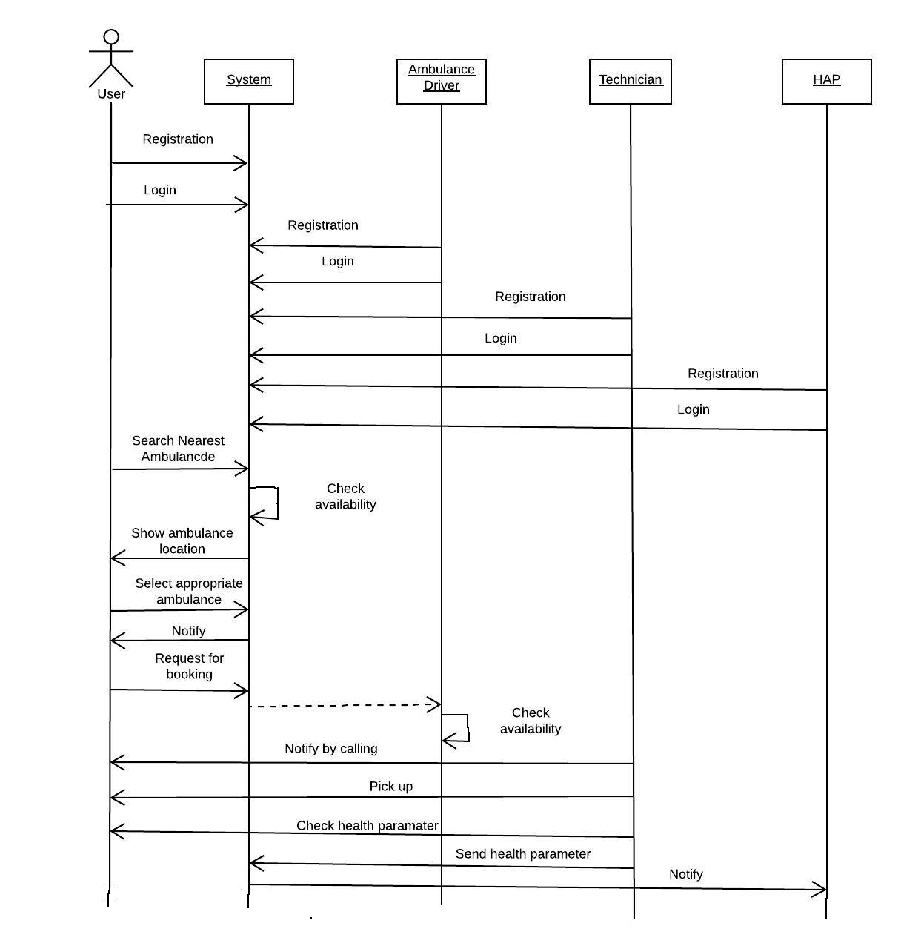
Fig 5. Sequence Diagram for IASS

4.3.4. Collaboration Diagram :

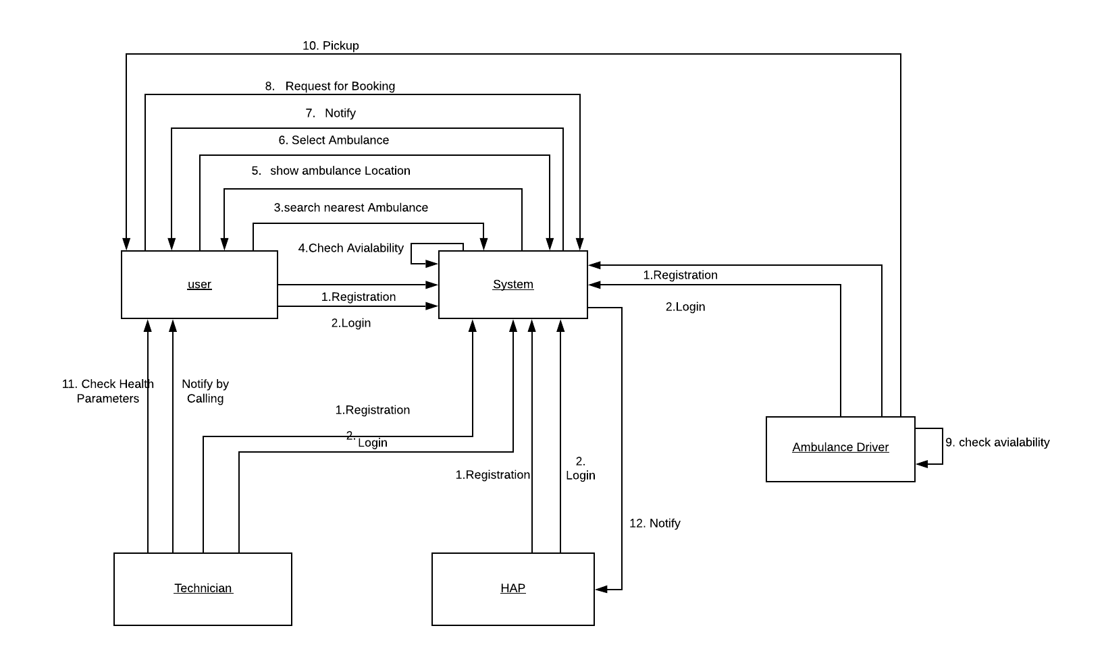
Fig 6. Collaboration Diagram for IASS

