1. **Introduction: -**

In today’s era, there are many cities which are working on transforming themselves into Smart Cities. If the city is going to be called as Smart City, then it should have all possible advancements in the sector of smart technology. Improving efficiency in health care sector if one of the difficult and most challenging jobs. That includes various aspects such as getting ambulance within minimum amount of time, providing proper treatment to the patient so that the chances of surviving increases in critical condition. Traffic congestion is one of the major problems in urban areas, which have caused much hitches for the ambulance. Moreover, road accidents in the city have been increased and to bar the loss of life due to the accidents is even more crucial. The APIs are designed in such a way that time complexity will be minimized extensively. This is achieved by exchanging only the required data with server in order to minimize the traffic and loss of data packets in the process of transaction. With the help of technology and keeping the goal in mind we’ve developed this application. It is also an attempt to participate actively in the process of transforming into smart city and make required services more accessible.

1. **Objectives: -**
2. To locate the nearest ambulance facilities for the people requiring emergency medical treatment.
3. To report about patient health condition to hospital for further services.
4. **Literature Survey:**

In the paper Smart Phone Based Enhancement in Health Services Using GPS [1], they proposed a system in which they are using GPS to track the location of the victim and GSM to send a message in case of an accident, so that the victim can be taken to hospital and treated as soon as possible.

In the article Emergency Traffic Management for Ambulance using Wireless Communication [2], they proposed a system in which in case of an accident the control room or the rescue team will receive a message using GPS and GSM technology to indicate about the accident.

In the paper Automatic Ambulance Rescue System Using Shortest Path Finding Algorithm [3], they proposed to create a system in which they will place a RF transmitter in the ambulance and RF receiver in the Traffic lights, using Bio sensor to detect the condition of patient while travelling and GPS to find out the location of the accident.

1. **Problem Statement: -**

Instant Ambulance Service management system.

1. **Problem Description: -**

Ambulance services are important for Health & Medical facilities. Traffic congestion is one of the major problems in urban areas, which have caused much hitches for the ambulance. Moreover road accidents in the city have been increased and to bar the loss of life. Patient rely on emergency ambulances and paramedics in their time of greatest need, but on too many occasions patients are not receiving the service as they deserve.In a life-threatening emergency, every second counts. The speed that treatment is received can literally make the difference between life and death, but unfortunately the Ambulance Service is now consistently failing to meet the response time targets set by the Government.

Emergency service providers are facing the various problem like how and where to locate vehicals in order to cover potential future demand effectively.Ambulance are suppose to be located at different locations such that in case of emergency the Ambulance can’t be reached in a time efficient manner.

Also if the patient health related details are known to the hospital,then it is helpful to hospital for further treatment in case of emergency.But this problem is faced by the patient and result in death of person.

1. **System Architecture:**

The implementation of this system is divided into server client architecture in order to make small size application and keep all the data available centrally. Thus client is nothing but a smart phone having the application and the server side used for handling user requests and respond by processing them.

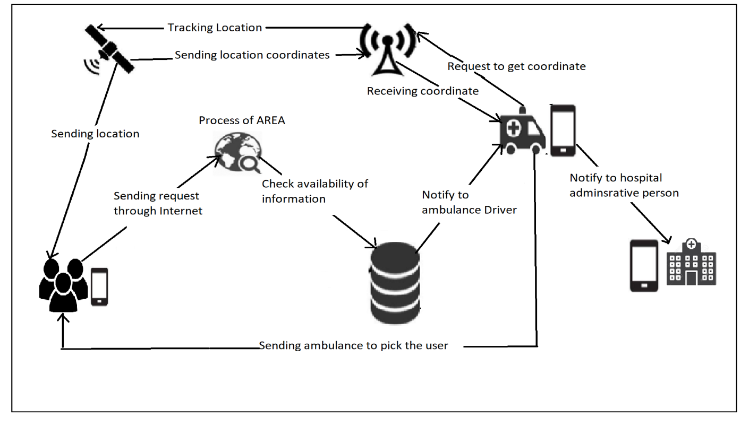

Fig1: Overall Architecture of Ambulance service system.

**User application:**

This application will initially be based on Android. First user need to register or login if already registered user. On launching the app first device will automatically detect the location of user using the GPS devices. Later depending on the user’s requirement, user will choose option of finding nearby ambulances. This query is sent in the form of request to the server. Server will process on it by sending it to ambulance driver and respond accordingly. Smart phone app will read the data from response and plot the information according to the user’s request.When server will receive a request from device, it will parse the data and extract result.

1. **Modules:**

First of all module needs to be register or login if already registered by using username as email/phone no and password.

**User module:**

After successful login user’s location is tracked by GPS and according to that nearest ambulance is displayed.User should select one and send request and receive response from ambulance driver.

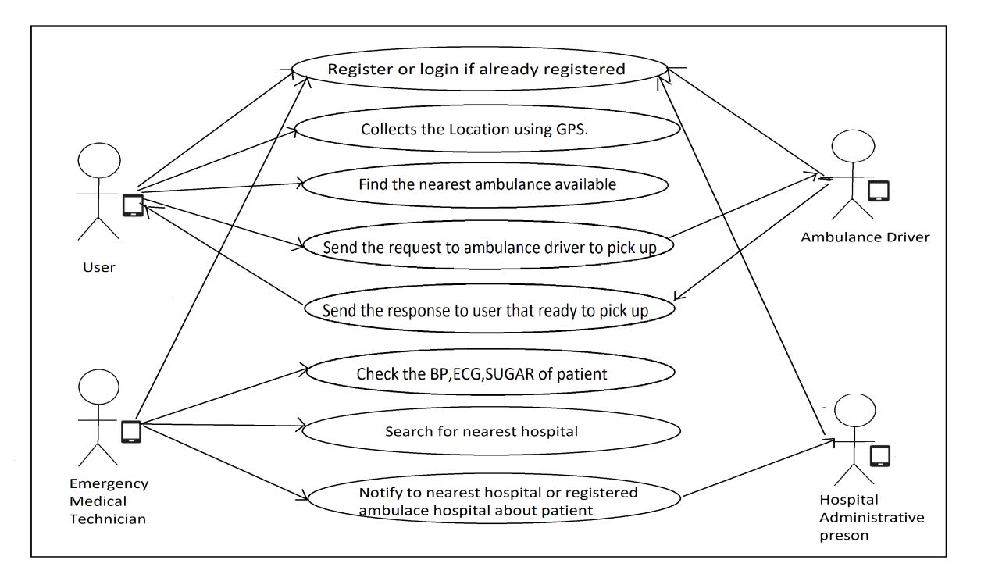

Fig 2: Module of Ambulance service system.

**Ambulance driver:**

The ambulance Driver receive the notification from user and send response to user and send the ambulance to pick up the user.

**Emergency Medical Technician:**

The Emergency Medical Technician check the current condition of the patient and then search for nearest hospital and notify the hospital about the patient for further action.If the ambulance is has its own hospital then report to that hospital.

**Hospital Administrative person:**

The hospital administrative person will receive the notification and according to that they should take the further action for patients safety.

1. **Application:**

* The tracking of ambulance as well as to understand the health parameter values of patient.
* To find out the position of ambulance carrying the injured person to the hospital.

1. **System requirements with justification:**

* **Front End Technology-**

Android Studio IDE(version3.3):- Android Studio is the official Integrated Development Environment (IDE) for Android app development, based on IntelliJ IDEA.On top of IntelliJ's powerful code editor and developer tools, Android Studio offers even more features that enhance your productivity when building Android apps.

Global Positing System (GPS):- GPS hardware and uses Google Map Application Programming Interface (API) to plot details of the ambulances on the Google Map Client of the Smart phone App.

Hardware Requirement:- Windows OS with RAM 8GB,Android Studio version 3.3,Android phone with GPS.

* **Back End Technology-**

Firebase - Firebase is Google's mobile platform that helps you quickly develop high-quality apps and grow your business.Firebase is a complete package of products that allows to build web and mobile apps, improve the app quality and help your clients grow their business.

1. **References:**
2. Smart Phone Based Enhancement in Health Services Using GPS Imperial Journal of Interdisciplinary Research (IJIR) Vol-2, Issue-3, 2016.
3. Emergency Traffic Management for Ambulance using Wireless Communication IPASJ International Journal of Electronics and Communication 2014.

[3] Automatic Ambulance Rescue System Using Shortest Path Finding Algorithm

International Journal of Science and Research (IJSR) 2012.