Inline JavaScript

<button onClick= ”alert(‘Hello’)”>Click Me</button>

Internal JavaScript

<script>console.log(‘hello,world!’);</script>

External JavaScript

<script src=”script.js”></script>

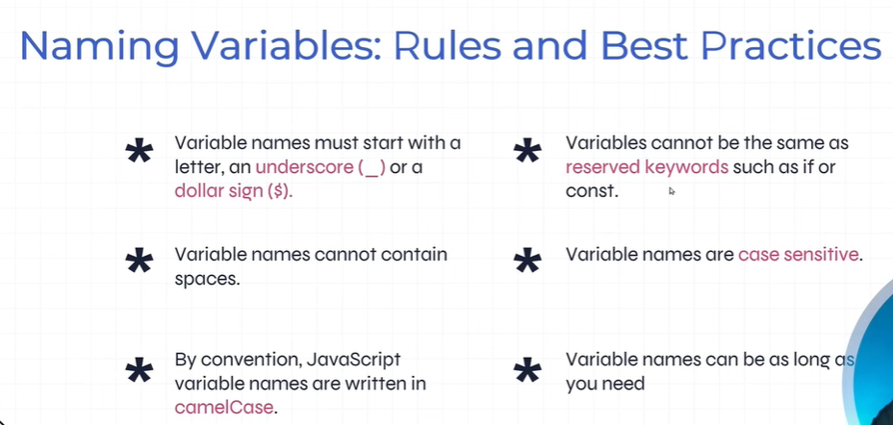

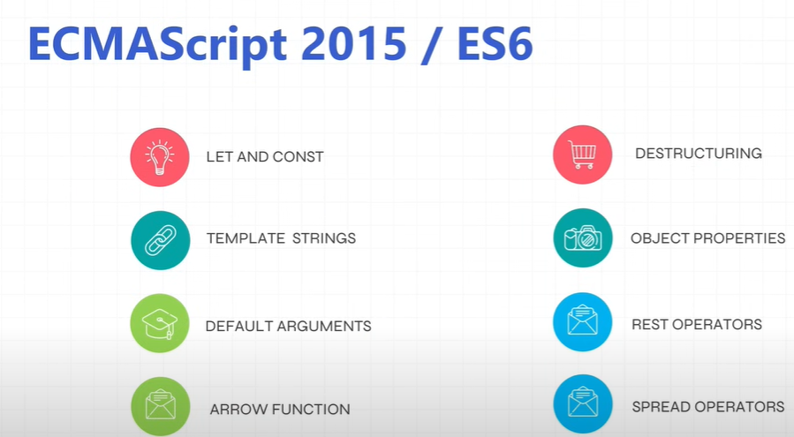

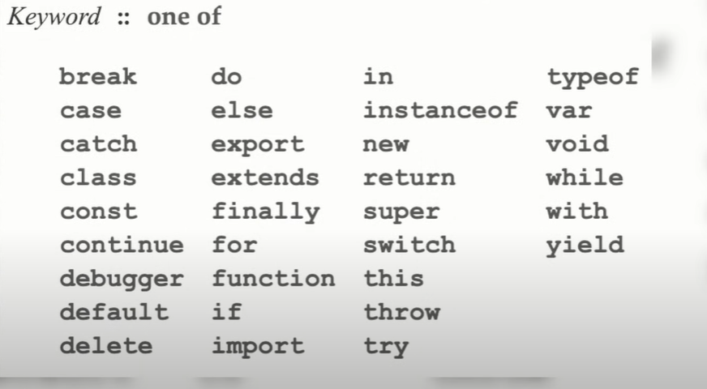

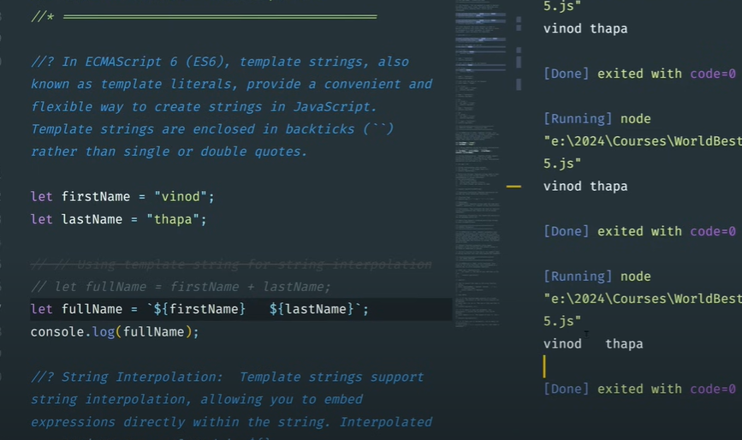

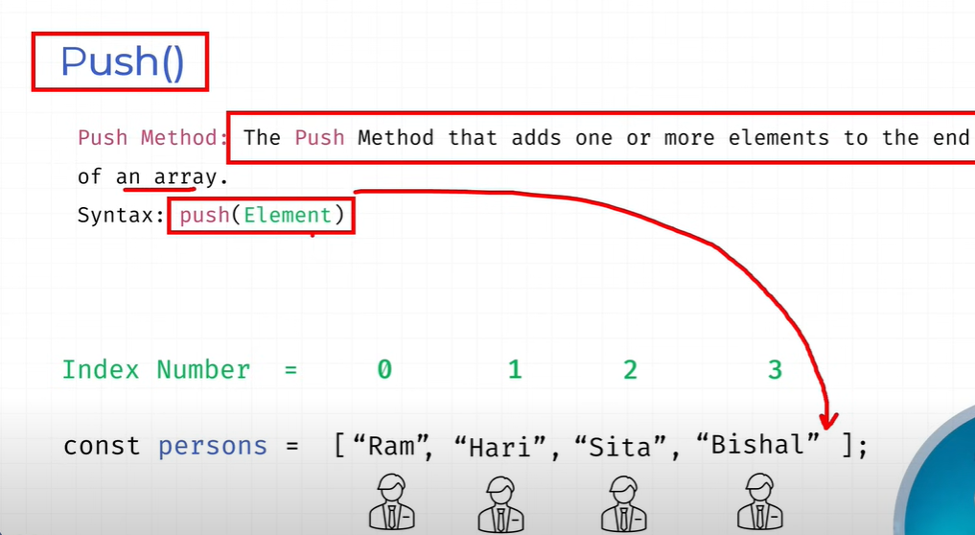

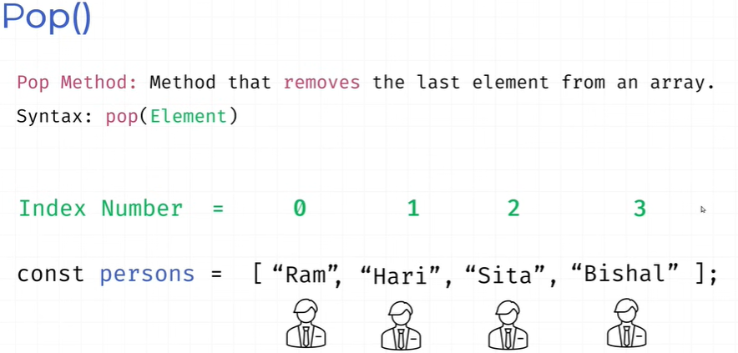

<!DOCTYPE html>

<html>

<body>

<h1>JavaScript Strings</h1>

<h2>The at() Method</h2>

<p>The at() method returns an indexed element from a string:</p>

<p id="demo"></p>

<script>

const name = "W3Schools";

let letter = name.at(2);

document.getElementById("demo").innerHTML = letter;

</script>

</body>

</html>

Output : S

The at() method returns the character at a specified index (position) in a string.

The at() method is supported in all modern browsers since March 2022:

The at() method is a new addition to JavaScript.

It allows the use of negative indexes while charAt() do not.

Now you can use myString.at(-2) instead of charAt(myString.length-2).

<!DOCTYPE html>

<html>

<body>

<h1>JavaScript Strings</h1>

<h2>The slice() Method</h2>

<p>The sliced (extracted) part of the string is:</p>

<p id="demo"></p>

<script>

let text = "Apple, Banana, Kiwi";

let part = text.slice(7,13);

document.getElementById("demo").innerHTML = part;

</script>

</body>

</html>

Output:

**JavaScript Strings**

**The slice() Method**

The sliced (extracted) part of the string is:

Banana