**File Share Application**

**Register Page :**

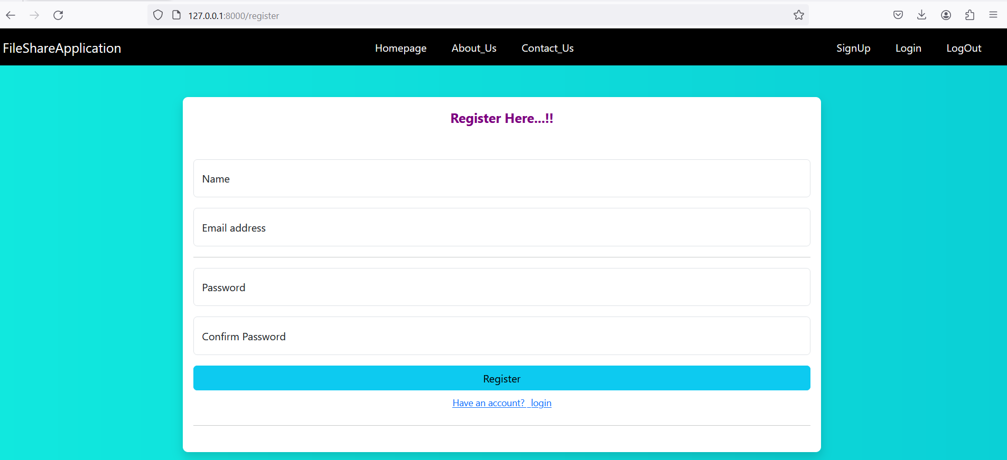

**Registration Mail functionality:**

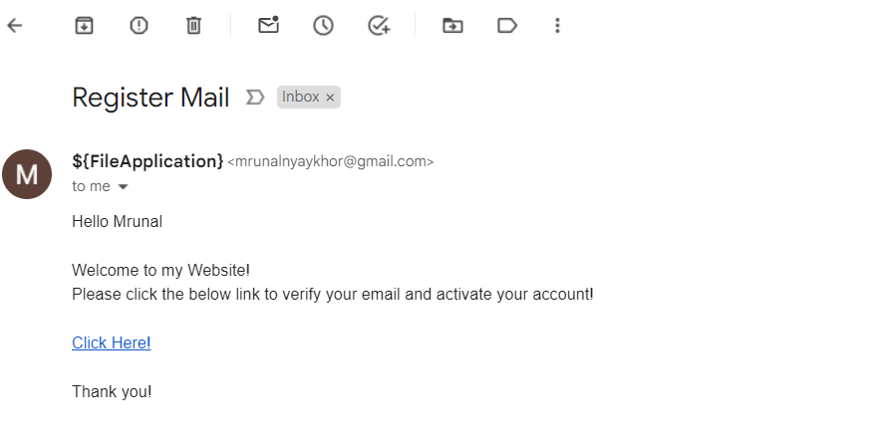

**Login Page :**

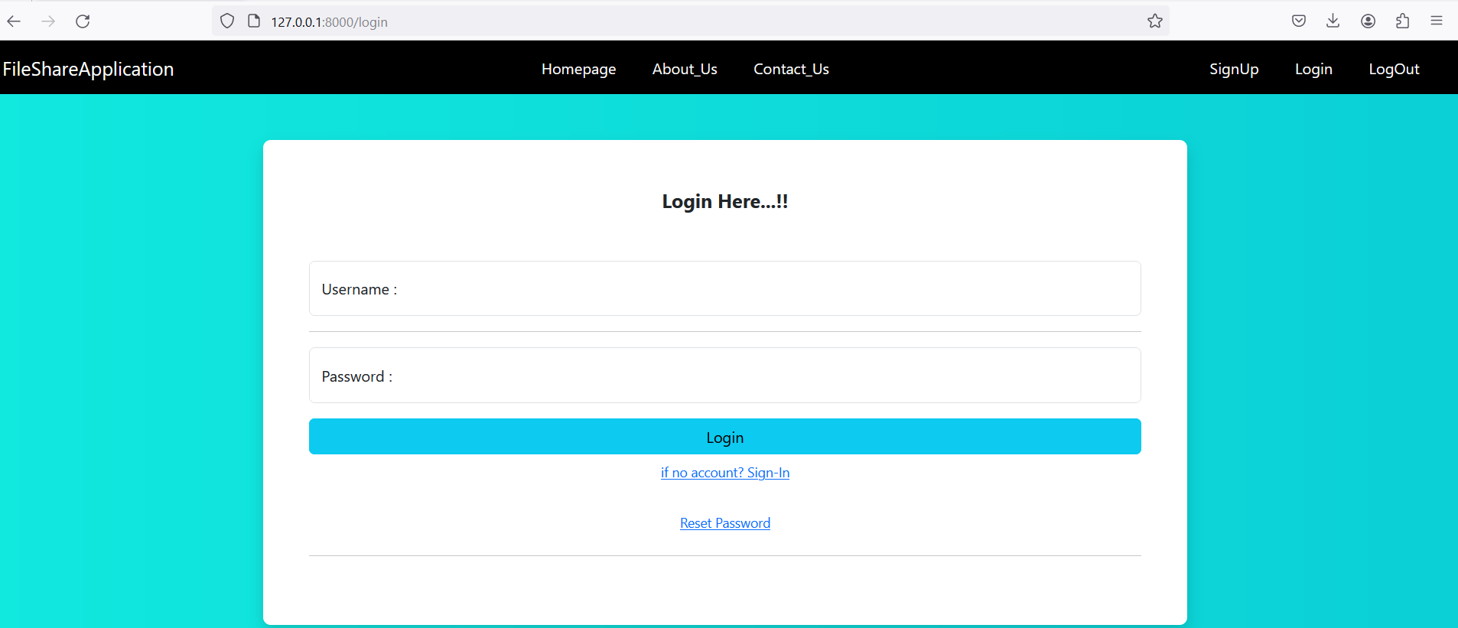

**UploadFile Page:**

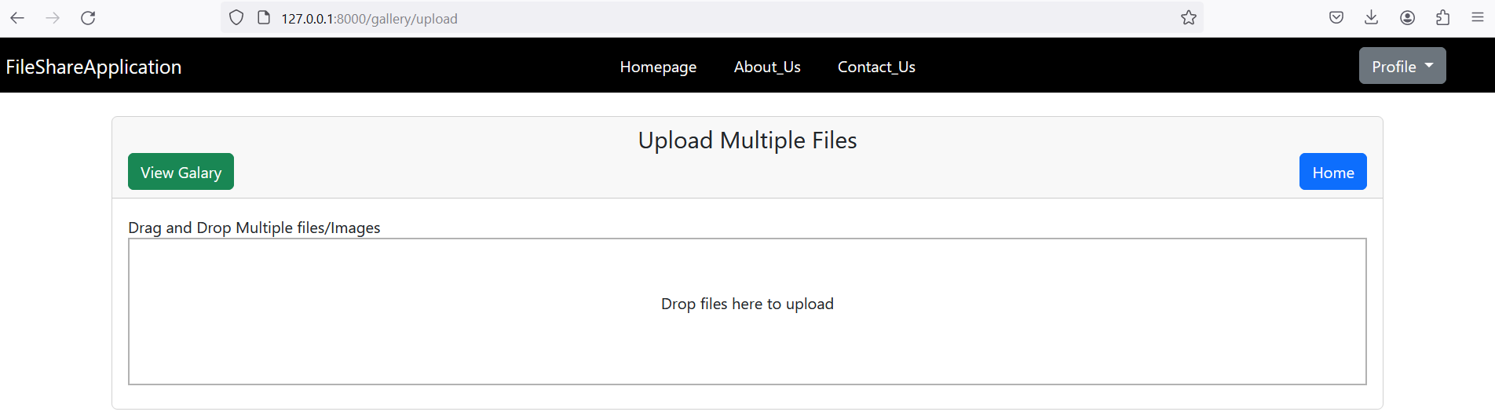

**Dashboard :**

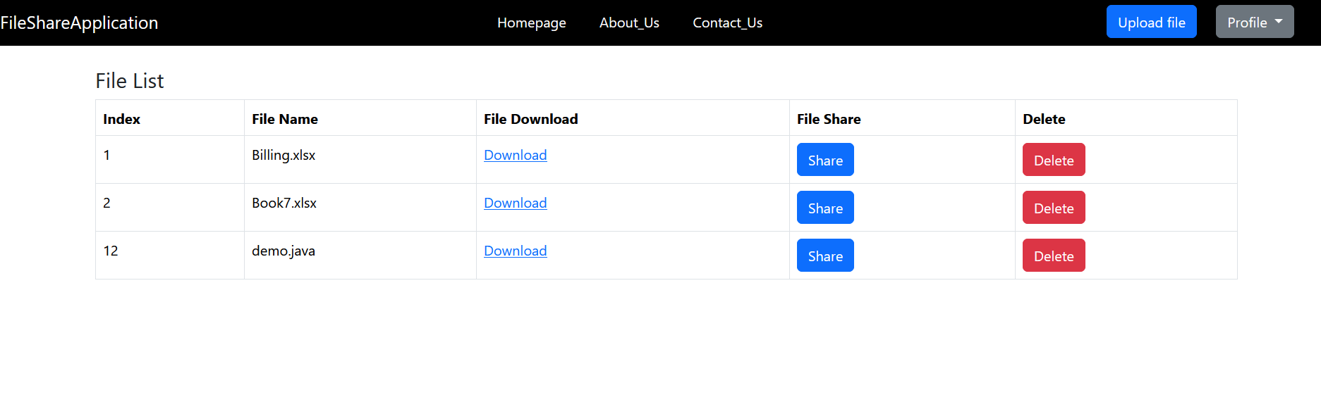

**User Table:**

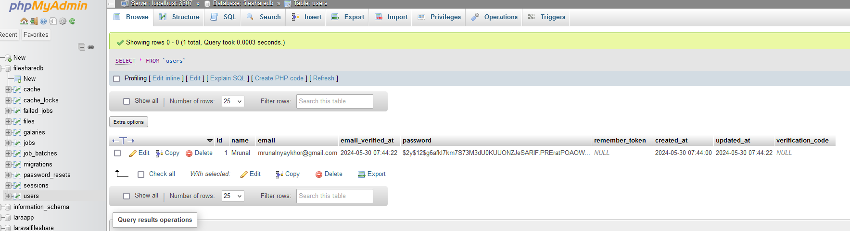

**File Metadata Table:**

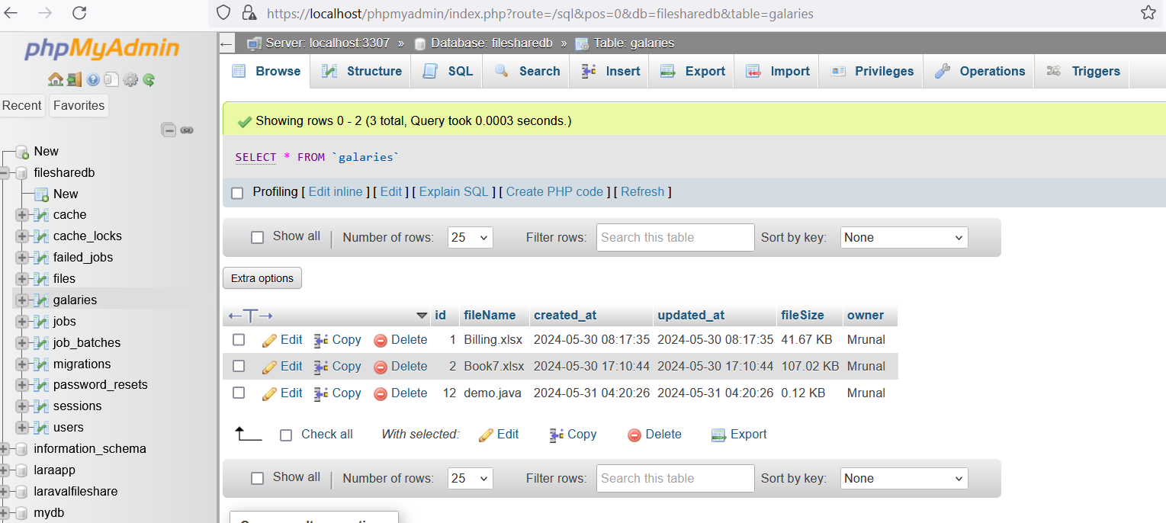

**Password Reset Functionality:**

