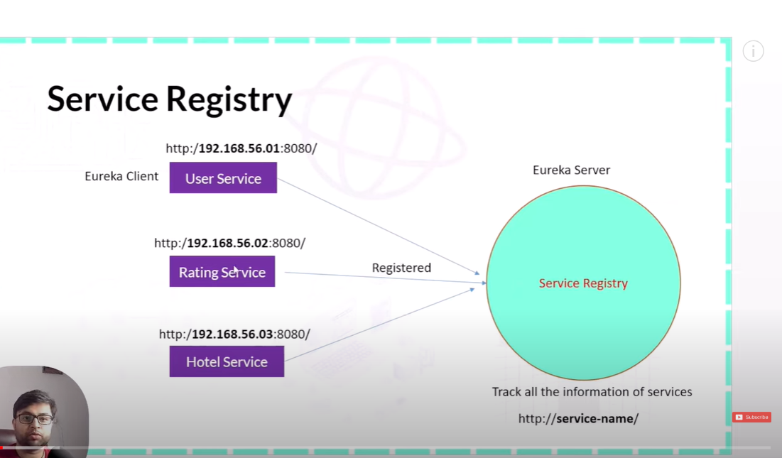

spring:

application:

name: eureka-server

server:

port: 8761

eureka:

client:

registerWithEureka: false

fetchRegistry: false

server:

waitTimeInMsWhenSyncEmpty: 0

logging:

level:

com.netflix: 'WARN'

org.springframework.cloud: 'WARN'

package com.tech;  
  
import org.springframework.boot.SpringApplication;  
import org.springframework.boot.autoconfigure.SpringBootApplication;  
import org.springframework.cloud.netflix.eureka.server.EnableEurekaServer;  
  
@SpringBootApplication  
@EnableEurekaServer  
public class ServiceRegistryApplication {  
  
 public static void main(String[] args) {  
 SpringApplication.*run*(ServiceRegistryApplication.class, args);  
 }  
  
}

<?xml version="1.0" encoding="UTF-8"?>  
<project xmlns="http://maven.apache.org/POM/4.0.0" xmlns:xsi="http://www.w3.org/2001/XMLSchema-instance"  
 xsi:schemaLocation="http://maven.apache.org/POM/4.0.0 https://maven.apache.org/xsd/maven-4.0.0.xsd">  
 <modelVersion>4.0.0</modelVersion>  
 <parent>  
 <groupId>org.springframework.boot</groupId>  
 <artifactId>spring-boot-starter-parent</artifactId>  
 <version>3.2.2</version>  
 <relativePath/> <!-- lookup parent from repository -->  
 </parent>  
 <groupId>com.tech</groupId>  
 <artifactId>Service_Registry</artifactId>  
 <version>0.0.1-SNAPSHOT</version>  
 <name>Service_Registry</name>  
 <description>Demo project for Spring Boot Service Registry</description>  
 <properties>  
 <java.version>17</java.version>  
 <spring-cloud.version>2023.0.0</spring-cloud.version>  
 </properties>  
 <dependencies>  
<!-- <dependency>-->  
<!-- <groupId>org.springframework.boot</groupId>-->  
<!-- <artifactId>spring-boot-starter-web</artifactId>-->  
<!-- </dependency>-->  
 <dependency>  
 <groupId>org.springframework.cloud</groupId>  
 <artifactId>spring-cloud-starter</artifactId>  
 </dependency>  
 <dependency>  
 <groupId>org.springframework.cloud</groupId>  
 <artifactId>spring-cloud-starter-netflix-eureka-server</artifactId>  
 </dependency>  
  
 <dependency>  
 <groupId>org.springframework.boot</groupId>  
 <artifactId>spring-boot-starter-test</artifactId>  
 <scope>test</scope>  
 </dependency>  
 </dependencies>  
 <dependencyManagement>  
 <dependencies>  
 <dependency>  
 <groupId>org.springframework.cloud</groupId>  
 <artifactId>spring-cloud-dependencies</artifactId>  
 <version>${spring-cloud.version}</version>  
 <type>pom</type>  
 <scope>import</scope>  
 </dependency>  
 </dependencies>  
 </dependencyManagement>  
  
 <build>  
 <plugins>  
 <plugin>  
 <groupId>org.springframework.boot</groupId>  
 <artifactId>spring-boot-maven-plugin</artifactId>  
 </plugin>  
 </plugins>  
 </build>  
  
</project>

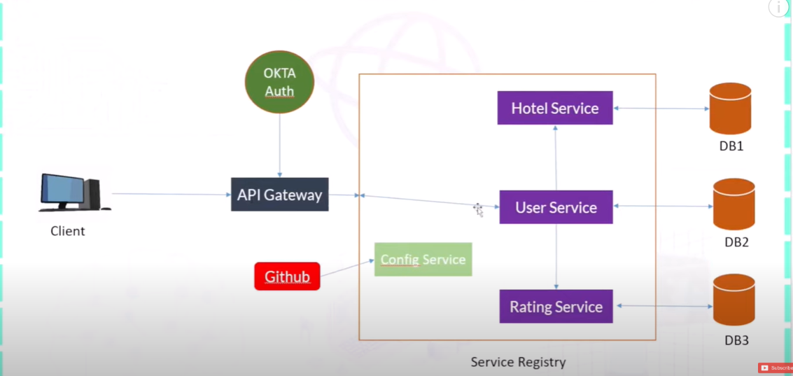

@Override  
public User findById(String userId) {  
  
 User user = userRepository.findById(userId).orElseThrow(()-> new ResourceNotFoundException("User not found"));  
 Rating[] ratingsOfUser = restTemplate.getForObject("http://localhost:8082/ratings/users/" + user.getUserId(), Rating[].class);  
 List<Rating>ratings = Arrays.*stream*(ratingsOfUser).toList();  
 List<Rating> ratingList= ratings.stream().map(rating ->{  
 ResponseEntity<Hotel>forEntity = restTemplate.getForEntity("http://localhost:8081/hotel/getHotel/"+ rating.getHotelId(), Hotel.class);  
 Hotel hotel = forEntity.getBody();  
 rating.setHotel(hotel);  
 return rating;  
 }).collect(Collectors.*toList*());  
 user.setRatings(ratingList);  
 *log*.info("get user");  
 return user;  
}

Get url = http://localhost:8080/users/getUserId/df136e57-a5c6-4f6f-b708-724f080d5743

{

    "userId": "df136e57-a5c6-4f6f-b708-724f080d5743",

    "name": "mrunal",

    "email": "mrunal@gmail.com",

    "about": "laptop",

    "ratings": [

        {

            "ratingId": "b8435e32-09a9-41df-9680-e35c161955b0",

            "userId": "df136e57-a5c6-4f6f-b708-724f080d5743",

            "hotelId": "de1a5d24-d1e0-4dd0-af78-7ce85f84e4ed",

            "rating": 4,

            "feedback": "This is not good products",

            "hotel": {

                "id": "de1a5d24-d1e0-4dd0-af78-7ce85f84e4ed",

                "name": "Yashoda Farsan",

                "location": "Nagpur",

                "about": "foods"

            }

        }

    ]

}

