**Docker** Created -Mrunal wagh

**Docker Desktop Installation process in your Local Machine**

1. Install Docker in your system go thorw google and write Docker for windows or you can click this site <https://docs.docker.com/desktop/install/windows-install/> download docker for desktop
2. Install docker and open with sign up/sign in with Gmail.
3. Do not close docker desktop until last step.
4. Go to vs code create new file name- “Dockerfile” in our project which project you want to generate docker image.
5. In this file write Docker script like- which version you have use in our project like -if your project based on python then you have check which python version is used then write in Dockerfile also write other dependances like requirments.txt or any other dependences which that have you use used in your project

Docker File Example.

# Use the official Python image as a base

FROM python:3.10

# Set the working directory in the container

WORKDIR /app

# Copy the current directory contents into the container at /app

COPY . /app

# Run the Python script when the container launches

CMD ["python", "main.py"]

1. Save this file and execute this cmd – “docker build -t myimage .”

In this command you have write different name instead myimage – you have write your image name that you want. Then Execute the command- below image is view, after execute the command

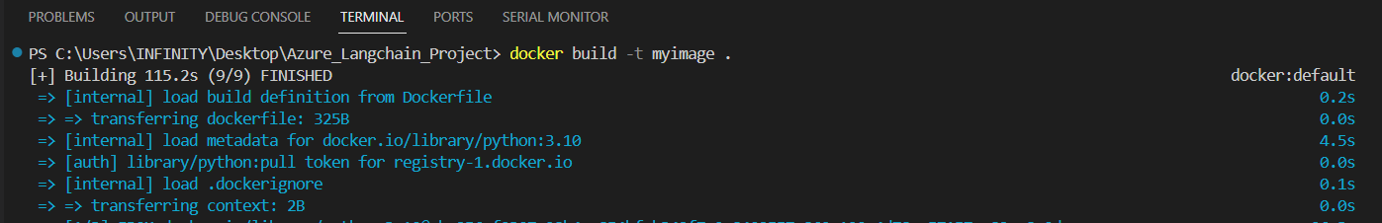

1. Docker image successfully created then you have check on Docker Desktop and see your image generated.
2. You can run docker image on Docker desktop you have got same console result on Docker console window.
3. Then if you want share this image to any person or Dev-Ops team members / deployment team.