

**Michael Adam E. Trinidad**



328



Purok 6 Bawa

, Gerona, Tarlac, Philippines



Mobile:



0



9156119134



; 09

502873167



E



-



mail:

madamt0001

@gmail.com

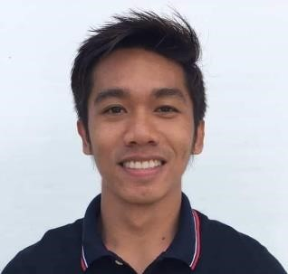

# TECHNICAL SKILLS

* Full Stack Web Development Using Laravel
* Firewall and VPN Technologies
* Active Directory Management & Windows Server 2019 Administration
* Google Cloud Technologies
* MySQL and MSSQL RDBMS
* WordPress Programming
* VM Ware EXSi Management
* CPanel Web Server Management
* ASANA Web Platform

# CORE COMPENTENCIES

Strong analytical thinking, problem solving and creativity. Interpersonal skill and team work ability. Time management and timeline prediction. Ability to work in dynamic environment and handle multiple task to meet deadlines.

# WORK EXPERIENCES

*Brookside Farms Corporation*

**IT Manager –** June 2022 to Present

*Duties:*

* Manages & Supervise IT Tech and Dev Personnel on their daily tasks and duties.
* Lead In-House Web Development Team in crafting Systems that is used all through out the company.
* Monitors regular network and server health check done by IT personnel.
* Manages Google Cloud Platform
* Manages VMware ESXi Servers
* Manages and Maintain Local Servers
* Maintain Information Security Policy

*Brookside Farms Corporation*

**IT Supervisor –** October 2019 to June 2022

*Duties:*

* Supervise IT personnel on their daily tasks and duties.
* Lead In-House Web Development Team in crafting Systems that is used all through out the company.
* Monitors regular network and server health check done by IT personnel.
* Manages Google Cloud Platform
* Manages VMware ESXi Servers
* Manages and Maintain Local Servers
* Maintain Information Security Policy

*Brookside Farms Corporation*

**IT Specialist –** October 2018 to October 2019

*Duties:*

* Lead Support and Supervise IT personnel on their daily tasks and duties.
* Lead In-House Web Development Team in crafting Systems that is used all through out the company.
* Manages and Maintain Local Servers
* Monitors regular network and server health check done by IT personnel.

*Advance Institute of E-Commerce*

**IT Instructor –** April2014 to May 2016

*Duties:*

* Teaches Information Technology Subjects on 1st and 2nd year level College Students.
* Creating Lesson Plans on each Subjects based on Curriculum.

*Freelance Web Developer* January 2013 to Present

*Duties:*

* Project/Client Based Web Development using Laravel

# EDUCATION

College BS Information Technology

2009-2014

Tarlac State University

Tarlac City, Tarlac