**Summary**

In this project we have analyzed the district-wide standardized test results. We have access to every student's math and reading scores, as well as various information on the schools they attend like type of school, grade budget, gender etc. We aggregated the data to showcase obvious trends in school performance.

**Conclusion**

1. From the given data we have analyzed that charter schools have higher overall passing percentage. Also top 5 school in district are charter schools. Whereas bottom 5 schools are district schools.

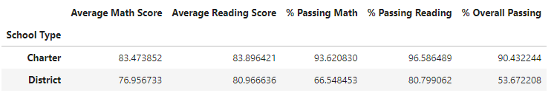

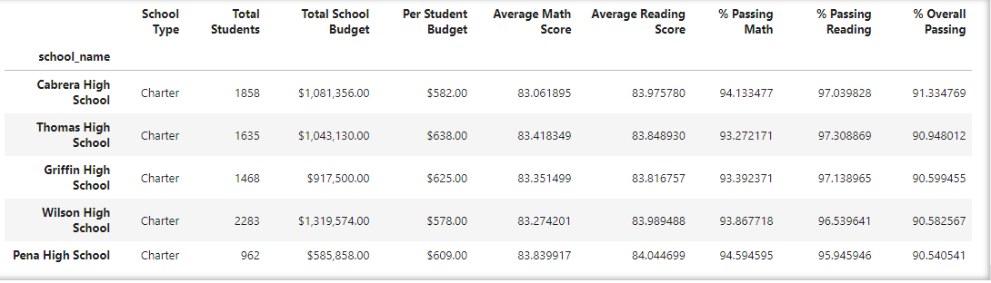

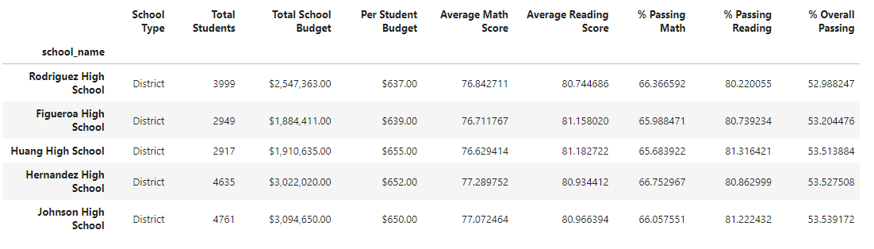

1. From picture given below we can see that when school size is large (2000-5000 students) there is a drop in average math score and average reading score. But in % passing math and % passing reading there is a huge drop. Due to that %overall passing of the large schools is drastically dropped.

