**PHASE 1 –**

STEP 1 : Client Hello

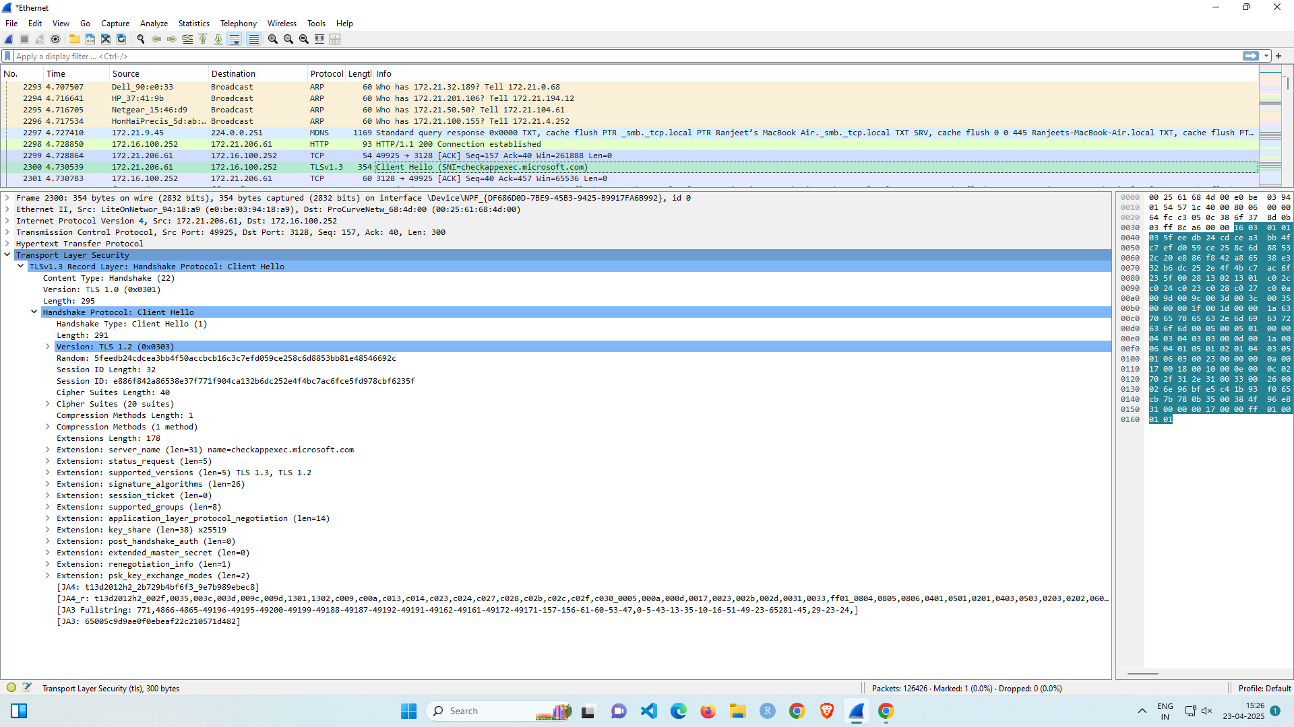

STEP 2 : Server Hello

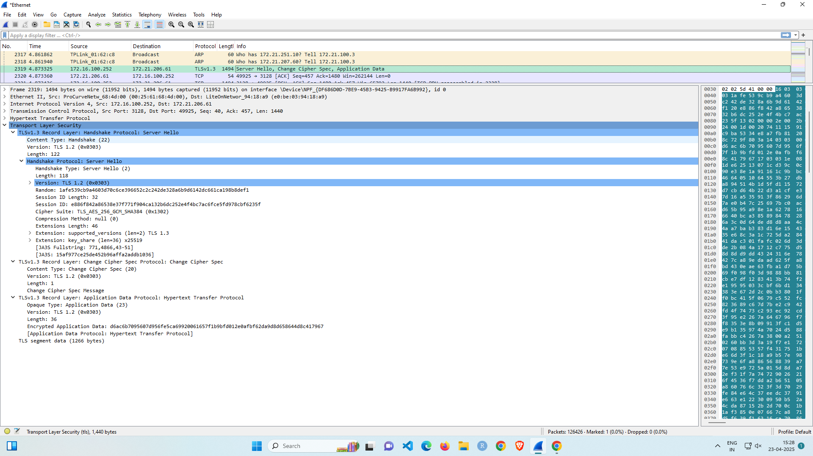

**PHASE 2 –**

STEP 1 - Certificate, Server Key Exchange, Server Hello Done

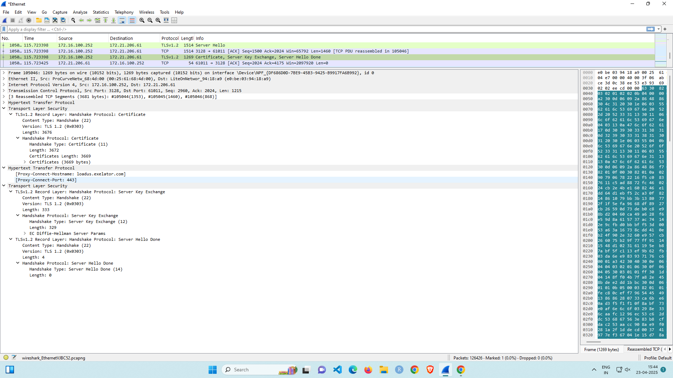

**PHASE 3 –**

STEP 1 : Client Key Exchange, Change Chiper Spec, Encrypted Handshake Message

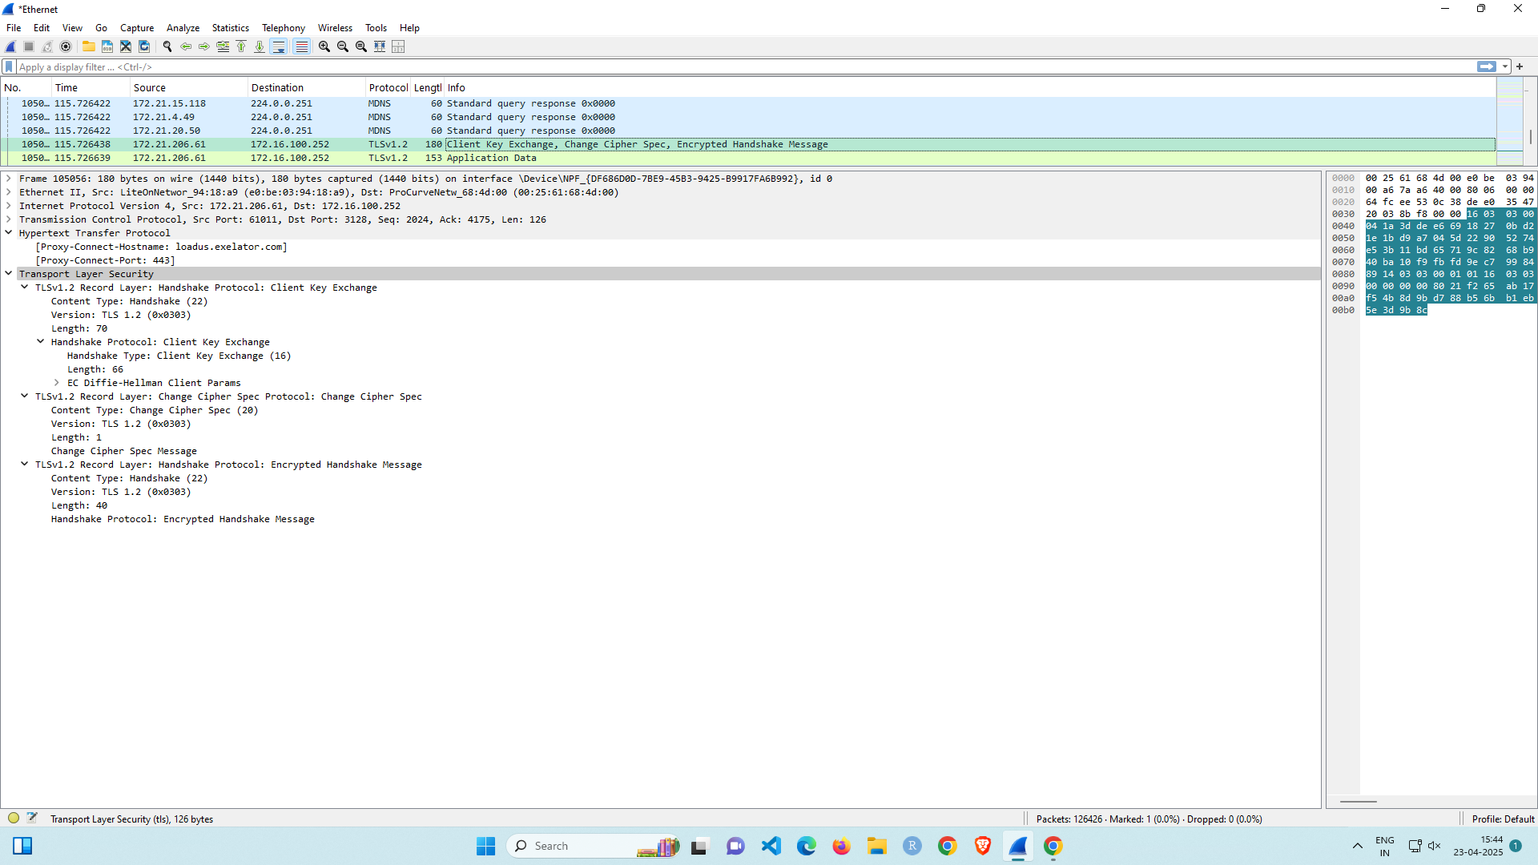

**PHASE 4 –**

STEP 1 - Change Cipher Spec, Encrypted Message Handshake

