Appendix A: System Testing Record
Operational model UX relies upon a total of five forms and a multitude of message handling and (external) service automations. These forms have input validation which limit the inputs, though incorrect inputs can still feasibly be made in some cases, and these in turn can lead to services or gateways triggering a loop in the system. As such, the strategy to test these exhaustively (since it is only a small system we can test fairly exhaustively) will revolve around making all correct entries, attempting incorrect entries and the outcomes of those entries, and finally, correct entries post-incorrect entry. This encapsulates the majority of edge cases and a largely complete set of possible scenarios within the automation. We also ensure that the processing is in line with our expectations, and the desired variables are recorded and accessed where they need to be.
Input validation for all forms confirmed desirable. Consistency of membership and its effects verifiable. 100% tests passing.
----------------------------------------------------------------------------------------------------------------------------------------------------------------------------------
Gather info about customer and vehicle needs [user form]
Incorrect MemberNumber Test
Form state - Existing member box checked: true, New member box checked: false
Membership number not found: 666555
Invalid membership number: 666555
MemberCheck result: false
RESULT: Desired result achieved. MemberCheck = false, Gateway loopback triggered, form re-entry req.
Test Passed
Correct MemberNumber Test
Form state - Existing member box checked: true, New member box checked: false
Membership number validated: 111111
Valid membership number confirmed: 111111
MemberCheck result: true
Activated 1 jobs for worker default and job type InitialCostCheck
RESULT: Desired result achieved. MemberCheck = true, business process progressed
Test Passed
NewMember box checked + MemberNumber ‘111111’ left in form field Test
Form state - Existing member box checked: false, New member box checked: true
MemberCheck result: true
Generated new membership number: 095208
Added new member: Enzo Joly with number: 095208
Successfully added new member: Enzo Joly with number: 095208
CSV FILE:
095208,Enzo Joly
RESULT: Desired result achieved. MemberCheck = true, new entry in members.csv, name can be duplicate
Test Passed
No boxes checked – Not a Member and Not wanting to be a Member Test
Form state - Existing member box checked: false, New member box checked: false
MemberCheck result: true
RESULT: Desired result achieved. MemberCheck = true, business process progressed
Test Passed
----------------------------------------------------------------------------------------------------------------------------------------------------------------------------------

----------------------------------------------------------------------------------------------------------------------------------------------------------------------------------Calculate initial payment (Deposit and membership fees) [service task] (form 1 service)
InitialCostCheck received variables: [InputVariable_1ndksl9, SignedUp, Breakdown, extraInfo, VehicleMake, CustomerName, VehicleModel, CustomerEmail, VehicleLocation, MembershipNumber, faultDescription] (tow selected)
TowRequest received variables: [SignedUp, isMember, Breakdown, SigningUp, extraInfo, MemberCheck, VehicleMake, CustomerName, VehicleModel, customerName, CustomerEmail, customerEmail, depositAmount, towRequestSent, towingPriority, vehicleDetails, VehicleLocation, MembershipNumber, faultDescription, paymentTimestamp, breakdownLocation, towInfoAdditional, DescriptionOfFault, processInstanceKey, estimatedTowArrival, initialCostNotified, initialCostReceived, towRequestProcessed, towRequestTimestamp, initialCostTimestamp]
Tow Test
Activated 1 jobs for worker default and job type InitialCostCheck
----------------------------------------------------------------------------------------------------------------------------------------------------------------------------------
InitialCostCheck received variables: [InputVariable_1ndksl9, SignedUp, isMember, Breakdown, SigningUp, extraInfo, MemberCheck, VehicleMake, CustomerName, VehicleModel, customerName, CustomerEmail, customerEmail, depositAmount, towRequestSent, towingPriority, vehicleDetails, VehicleLocation, MembershipNumber, faultDescription, paymentTimestamp, breakdownLocation, towInfoAdditional, DescriptionOfFault, processInstanceKey, estimatedTowArrival, initialCostNotified, initialCostReceived, towRequestProcessed, towRequestTimestamp, initialCostTimestamp]
----------------------------------------------------------------------------------------------------------------------------------------------------------------------------------
Form state - Existing member box checked: true, New member box checked: false
Membership number validated: 095208
Valid membership number confirmed: 095208
Calculated deposit: 150.00
MemberCheck result: true
Activated 1 jobs for worker default and job type inform-customer-init-cost
----------------------------------------------------------------------------------------------------------------------------------------------------------------------------------
inform-customer-init-cost received variables: [SignedUp, isMember, Breakdown, SigningUp, extraInfo, MemberCheck, VehicleMake, CustomerName, VehicleModel, customerName, CustomerEmail, customerEmail, depositAmount, towRequestSent, towingPriority, vehicleDetails, VehicleLocation, MembershipNumber, faultDescription, paymentTimestamp, breakdownLocation, towInfoAdditional, DescriptionOfFault, processInstanceKey, estimatedTowArrival, initialCostNotified, initialCostReceived, towRequestProcessed, towRequestTimestamp, initialCostTimestamp]
----------------------------------------------------------------------------------------------------------------------------------------------------------------------------------
Informing customer Enzo Joly of initial cost £150.00 for vehicle Honda Civic
Simulating payment receipt by sending message for process instance: 6755399457249505
Sending message 'ReceiveInitialCost' with correlation key '6755399457249505'
Message 'ReceiveInitialCost' sent successfully
----------------------------------------------------------------------------------------------------------------------------------------------------------------------------------TowRequest received variables: [SignedUp, isMember, Breakdown, SigningUp, extraInfo, MemberCheck, VehicleMake, CustomerName, VehicleModel, customerName, CustomerEmail, customerEmail, depositAmount, towRequestSent, towingPriority, vehicleDetails, VehicleLocation, MembershipNumber, faultDescription, paymentTimestamp, breakdownLocation, towInfoAdditional, DescriptionOfFault, processInstanceKey, estimatedTowArrival, initialCostNotified, initialCostReceived, towRequestProcessed, towRequestTimestamp, initialCostTimestamp]
---------------------------------------------------------------------------------------------------------------------------------------------------------------------------------- Sending tow request to towing service
Breakdown location: Bristol
Vehicle details: Honda Civic - Brake Failure
Additional info: Nil
Activated 1 jobs for worker default and job type TowRequest
Sending message 'TowingRequest' with correlation key '6755399457249505'
Activated 1 jobs for worker default and job type process-tow-request
Message 'TowingRequest' sent successfully
----------------------------------------------------------------------------------------------------------------------------------------------------------------------------------
Received variables: [SignedUp, isMember, Breakdown, SigningUp, extraInfo, MemberCheck, VehicleMake, CustomerName, VehicleModel, customerName, CustomerEmail, customerEmail, depositAmount, towRequestSent, towingPriority, vehicleDetails, VehicleLocation, MembershipNumber, faultDescription, paymentTimestamp, breakdownLocation, towInfoAdditional, DescriptionOfFault, processInstanceKey, estimatedTowArrival, initialCostNotified, initialCostReceived, towRequestProcessed, towRequestTimestamp, initialCostTimestamp]
----------------------------------------------------------------------------------------------------------------------------------------------------------------------------------
Processing tow request for Honda Civic
Vehicle location: Bristol
Fault description: Brake Failure
Additional info: Nil
Membership status - existing: true, new: false, final: true
Tow request processed with priority: High
Vehicle details: Honda Civic - Brake Failure
Breakdown location: Bristol
RESULT: Desired result
Test Passed
No Tow Test
Activated 1 jobs for worker default and job type InitialCostCheck
----------------------------------------------------------------------------------------------------------------------------------------------------------------------------------
InitialCostCheck received variables: [InputVariable_1ndksl9, SignedUp, isMember, Breakdown, SigningUp, extraInfo, MemberCheck, VehicleMake, CustomerName, VehicleModel, customerName, CustomerEmail, customerEmail, depositAmount, towRequestSent, towingPriority, vehicleDetails, VehicleLocation, MembershipNumber, faultDescription, paymentTimestamp, breakdownLocation, towInfoAdditional, DescriptionOfFault, processInstanceKey, estimatedTowArrival, initialCostNotified, initialCostReceived, towRequestProcessed, towRequestTimestamp, initialCostTimestamp]
----------------------------------------------------------------------------------------------------------------------------------------------------------------------------------
Form state - Existing member box checked: true, New member box checked: false
Membership number found in cache: 095208
Valid membership number confirmed: 095208
Calculated deposit: 150.00
MemberCheck result: true
Activated 1 jobs for worker default and job type inform-customer-init-cost
----------------------------------------------------------------------------------------------------------------------------------------------------------------------------------
inform-customer-init-cost received variables: [SignedUp, isMember, Breakdown, SigningUp, extraInfo, MemberCheck, VehicleMake, CustomerName, VehicleModel, customerName, CustomerEmail, customerEmail, depositAmount, towRequestSent, towingPriority, vehicleDetails, VehicleLocation, MembershipNumber, faultDescription, paymentTimestamp, breakdownLocation, towInfoAdditional, DescriptionOfFault, processInstanceKey, estimatedTowArrival, initialCostNotified, initialCostReceived, towRequestProcessed, towRequestTimestamp, initialCostTimestamp]
----------------------------------------------------------------------------------------------------------------------------------------------------------------------------------Informing customer Enzo Joly of initial cost £150.00 for vehicle Honda Civic
Simulating payment receipt by sending message for process instance: 6755399457249505
Sending message 'ReceiveInitialCost' with correlation key '6755399457249505'
Message 'ReceiveInitialCost' sent successfully
RESULT: Desired Result
Test Passed
----------------------------------------------------------------------------------------------------------------------------------------------------------------------------------
Receive initial costs [message receive task]
General Test (this part specifically)
Message 'TowingRequest' sent successfully
Received variables: [SignedUp, isMember, Breakdown, SigningUp, extraInfo, MemberCheck, VehicleMake, CustomerName, VehicleModel, customerName, CustomerEmail, customerEmail, depositAmount, towRequestSent, towingPriority, vehicleDetails, VehicleLocation, MembershipNumber, faultDescription, paymentTimestamp, breakdownLocation, towInfoAdditional, DescriptionOfFault, processInstanceKey, estimatedTowArrival, initialCostNotified, initialCostReceived, towRequestProcessed, towRequestTimestamp, initialCostTimestamp]
RESULT: Desired Result
Test Passed
----------------------------------------------------------------------------------------------------------------------------------------------------------------------------------
----------------------------------------------------------------------------------------------------------------------------------------------------------------------------------Calculate cost of repairs [user form] [msg send]
General Test (successful message sending, variable consistency, application of discount) MSG SEND
Activated 1 jobs for worker default and job type notify-reception-costing
Notifying reception of repair costs for Honda Civic: £333.00
Fault description: Brake Failure
----------------------------------------------------------------------------------------------------------------------------------------------------------------------------------
CalculateFinalPrice received variables: [SignedUp, isMember, Breakdown, SigningUp, extraInfo, repairCost, MemberCheck, RepairCosts, VehicleMake, CustomerName, VehicleModel, customerName, CustomerEmail, customerEmail, depositAmount, towRequestSent, towingPriority, vehicleDetails, VehicleLocation, MembershipNumber, costingTimestamp, faultDescription, paymentTimestamp, breakdownLocation, towInfoAdditional, DescriptionOfFault, processInstanceKey, estimatedTowArrival, initialCostNotified, initialCostReceived, towRequestProcessed, towRequestTimestamp, initialCostTimestamp, repairCostingNotified]
----------------------------------------------------------------------------------------------------------------------------------------------------------------------------------
Original cost: 333.00
Is member: true
Discount: 10.00%
Final price: 299.70
Activated 1 jobs for worker default and job type CalculateFinalPrice
Activated 1 jobs for worker default and job type FinalQuote
Sending final quote to customer: Enzo Joly
Customer email: business@enzojoly.dev
Vehicle: Honda Civic
Final price: £299.70
Sending message 'QuoteNotification' with correlation key '6755399457249505'
Message 'QuoteNotification' sent successfully
RESULT: Desired result
Test Passed
----------------------------------------------------------------------------------------------------------------------------------------------------------------------------------
Calculate membership discounts if applicable [service task]
Activated 1 jobs for worker default and job type CalculateFinalPrice
CalculateFinalPrice received variables: [SignedUp, isMember, Breakdown, SigningUp, extraInfo, quoteSent, TotalPrice, finalPrice, repairCost, MemberCheck, RepairCosts, VehicleMake, CustomerName, VehicleModel, customerName, CustomerEmail, QuoteApproved, customerEmail, depositAmount, quoteTimestamp, towRequestSent, towingPriority, vehicleDetails, VehicleLocation, discountApplied, MembershipNumber, costingTimestamp, faultDescription, paymentTimestamp, QuoteApprovalForm, breakdownLocation, towInfoAdditional, DescriptionOfFault, discountPercentage, processInstanceKey, estimatedTowArrival, formattedFinalPrice, initialCostNotified, initialCostReceived, towRequestProcessed, towRequestTimestamp, initialCostTimestamp, repairCostingNotified]
Is A Member Test
Original cost: 333.00
Is member: true
Discount: 10.00%
Final price: 299.70
Vehicle: Honda Civic
Final price: £299.70
Sending message 'QuoteNotification' with correlation key '6755399457249505’
Message 'QuoteNotification' sent successfully
RESULT: Desired result
Test Passed
Is Not A Member Test
Original cost: 333.00
Is member: false
Discount: 0.00%
Final price: 333.00
Activated 1 jobs for worker default and job type FinalQuote
Sending final quote to customer: Enzo Joly
Customer email: business@enzojoly.dev
Vehicle: Honda Civic
Final price: £333.00
Sending message 'QuoteNotification' with correlation key '6755399457249505'
Message 'QuoteNotification' sent successfully
RESULT: Desired result
---------------------------------------------------------------------------------------------------------------------------------------------------------------------------------Approve or deny the repair based on quote [user form]
Consent Given Test
Found QuoteApprovalForm with value: true
Processing customer approval: Approved
Sending message 'Approval' with correlation key '6755399457249505'
Message 'Approval' sent successfully
RESULT: Desired result
Test Passed
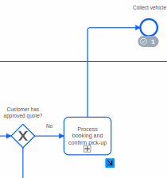
Consent NOT Given Test
Found QuoteApprovalForm with value: false
Processing customer approval: Denied
Sending message 'Approval' with correlation key '6755399457249505'
Activated 1 jobs for worker default and job type ArrangeCollection
Message 'Approval' sent successfully
RESULT: Desired result
Test Passed
----------------------------------------------------------------------------------------------------------------------------------------------------------------------------------
Process customer approval or denial [service task]
ABOVE Test (cont.)
RESULT: Desired result
Test Passed
----------------------------------------------------------------------------------------------------------------------------------------------------------------------------------
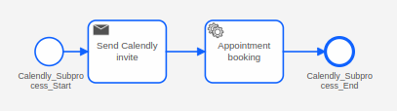
Process booking and confirm pick-up {SUB-PROCESS [service task] } working calendly link
We did not pay a premium Calendly subscription (outside the scope of the project) otherwise webhooks would be configured, instead we simulate a webhook. As such no “real” booking takes place but this functionality is assumed. Instead we chose Stripe API for our demonstration of external service integration.
Appointment Booking Test
Sending message 'Approval' with correlation key '6755399457249505'
Activated 1 jobs for worker default and job type ArrangeCollection
Message 'Approval' sent successfully
Creating booking link for Enzo Joly - Vehicle collection
Generated booking URL: https://calendly.com/business-enzojoly/30min
email=business@enzojoly.dev&name=Enzo%20Joly&custom=Honda%20Civic&reason=Vehicle%20collection
Created Calendly booking link: https://calendly.com/business-enzojoly/30min
email=business@enzojoly.dev&name=Enzo%20Joly&custom=Honda%20Civic&reason=Vehicle%20collection
In production, an email would be sent to: business@enzojoly.dev
Vehicle details: Honda Civic
Sending message 'CollectionArranged' with correlation key '6755399457249505'
Activated 1 jobs for worker default and job type process-booking
Message 'CollectionArranged' sent successfully
No webhook data found, simulating booking confirmation
Simulated booking for Enzo Joly at 2025-03-27T10:00:00Z
Processing booking for Enzo Joly at 2025-03-27T10:00:00Z for vehicle: Honda Civic
RESULT: Desired result
Test Passed
----------------------------------------------------------------------------------------------------------------------------------------------------------------------------------
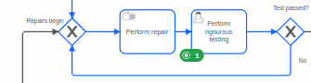
Perform rigorous testing [user form]
Tests NOT Passing Test
[No terminal output but BPMN looped]
RESULT: Desired result
Test Passed
Tests Confirmed Passing Test
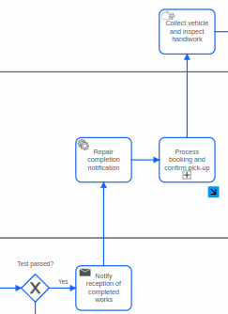
Activated 1 jobs for worker default and job type NotifyWorkComplete
Notifying reception that vehicle repairs are complete
Vehicle: Honda Civic
Sending message 'WorksComplete' with correlation key '6755399457249505'
Activated 1 jobs for worker default and job type repair-complete-notify
Message 'WorksComplete' sent successfully
Processing repair completion notification for the receptionist
Repair completion details being recorded for customer notification
Sending message 'WorksComplete' with correlation key '6755399457249505'
Message 'WorksComplete' sent successfully
Creating booking link for Enzo Joly - Vehicle collection
Generated booking URL: https://calendly.com/business-enzojoly/30min
email=business@enzojoly.dev&name=Enzo%20Joly&custom=Honda%20Civic&reason=Vehicle%20collection
Created Calendly booking link: https://calendly.com/business-enzojoly/30min
email=business@enzojoly.dev&name=Enzo%20Joly&custom=Honda%20Civic&reason=Vehicle%20collection
In production, an email would be sent to: business@enzojoly.dev
Vehicle details: Honda Civic
Activated 1 jobs for worker default and job type ArrangeCollection
Sending message 'CollectionArranged' with correlation key '6755399457249505'
Activated 1 jobs for worker default and job type process-booking
Message 'CollectionArranged' sent successfully
Using existing booking info from webhook
Processing booking for Enzo Joly at 2025-03-27T10:00:00Z for vehicle: Honda Civic
RESULT: Desired result. Sub-process triggered. BPMN progressed
Test Passed
----------------------------------------------------------------------------------------------------------------------------------------------------------------------------------
Repair completion notification [service task]
ABOVE Test
Activated 1 jobs for worker default and job type repair-complete-notify
Message 'WorksComplete' sent successfully
RESULT: Desired result. Message sent
Test Passed
----------------------------------------------------------------------------------------------------------------------------------------------------------------------------------
Verify customer satisfaction [user form]
Customer NOT Satisfied Test
Activated 1 jobs for worker default and job type process-satisfaction
Found CustomerSatisfactionForm with value: NotSatisfied
Customer satisfaction status determined as: Not Satisfied
Setting CustomerSatisfied to: false
RESULT: Desired result
Test Passed

Customer Satisfied Test
Activated 1 jobs for worker default and job type process-satisfaction
Found CustomerSatisfactionForm with value: Satisfied
Customer satisfaction status determined as: Satisfied
Setting CustomerSatisfied to: true
RESULT: Desired result. Stripe processing triggered
Test Passed
----------------------------------------------------------------------------------------------------------------------------------------------------------------------------------
Process customer satisfaction [service task]
Above Test
process-approval received variables: [SignedUp, isMember, Breakdown, SigningUp, extraInfo, quoteSent, TotalPrice, finalPrice, repairCost, MemberCheck, RepairCosts, TestsPassed, VehicleMake, bookingLink, CustomerName, VehicleModel, customerName, CustomerEmail, QuoteApproved, customerEmail, depositAmount, quoteTimestamp, towRequestSent, towingPriority, vehicleDetails, VehicleLocation, appointmentTime, discountApplied, MembershipNumber, bookingConfirmed, bookingReference, costingTimestamp, faultDescription, notificationSent, paymentTimestamp, textfield_cny2ct, CustomerSatisfied, QuoteApprovalForm, breakdownLocation, customerSatisfied, towInfoAdditional, DescriptionOfFault, appointmentEndTime, discountPercentage, processInstanceKey, completionTimestamp, estimatedTowArrival, formattedFinalPrice, initialCostNotified, initialCostReceived, towRequestProcessed, towRequestTimestamp, initialCostTimestamp, repairCostingNotified, CustomerSatisfactionForm, repairCompletionProcessed, repairCompletionTimestamp, workCompleteNotificationSent]
RESULT: Desired result

----------------------------------------------------------------------------------------------------------------------------------------------------------------------------------
Generate Stripe invoice [service task]
Invoice Generation and Sending Test
stripe-invoice worker received variables: [SignedUp, isMember, Breakdown, SigningUp, extraInfo, quoteSent, TotalPrice, finalPrice, repairCost, MemberCheck, RepairCosts, TestsPassed, VehicleMake, bookingLink, CustomerName, VehicleModel, customerName, CustomerEmail, QuoteApproved, customerEmail, depositAmount, quoteTimestamp, towRequestSent, towingPriority, vehicleDetails, VehicleLocation, appointmentTime, discountApplied, MembershipNumber, bookingConfirmed, bookingReference, costingTimestamp, faultDescription, notificationSent, paymentTimestamp, textfield_cny2ct, CustomerSatisfied, QuoteApprovalForm, breakdownLocation, customerSatisfied, towInfoAdditional, DescriptionOfFault, appointmentEndTime, discountPercentage, processInstanceKey, completionTimestamp, estimatedTowArrival, formattedFinalPrice, initialCostNotified, initialCostReceived, towRequestProcessed, towRequestTimestamp, initialCostTimestamp, repairCostingNotified, CustomerSatisfactionForm, repairCompletionProcessed, repairCompletionTimestamp, workCompleteNotificationSent]
Generating invoice for customer: Enzo Joly
Vehicle: Honda Civic
Amount: £333.00
Using Stripe in PRODUCTION mode
Generating Stripe invoice for customer: Enzo Joly
Invoice amount: £333.00
Using Stripe API in PRODUCTION mode
Creating/retrieving customer with email: business@enzojoly.dev, name: Enzo Joly
Activated 1 jobs for worker default and job type stripe-invoice
Calling Stripe API: /customers with data: email=business@enzojoly.dev, name=Enzo Joly,
Stripe API response status: 200
Stripe API response body: { . . . } [very extensive api call body omitted]
----------------------------------------------------------------------------------------------------------------------------------------------------------------------------------

Using customer with ID: cus_S3PHZ173ZOz8SC
Amount before conversion: 333.0
Amount after conversion to smallest unit: 33300
Invoice item data being sent to Stripe: {"customer":"cus_S3PHZ173ZOz8SC","description":"Auto Repair Services - Brake Failure - Honda Civic","amount":33300,"currency":"gbp"}
----------------------------------------------------------------------------------------------------------------------------------------------------------------------------------
Created invoice with ID: in_1R9IT9K76YVOCfmrHjm1qkPT
Invoice initial amount_due: 33300
Finalizing invoice with ID: in_1R9IT9K76YVOCfmrHjm1qkPT
Calling Stripe API: /invoices/in_1R9IT9K76YVOCfmrHjm1qkPT/finalize with data:
Stripe API response status: 200
Stripe API response body: { . . . }
----------------------------------------------------------------------------------------------------------------------------------------------------------------------------------
Invoice email sent successfully to customer
Successfully created Stripe invoice with ID: in_1R9IT9K76YVOCfmrHjm1qkPT
Sending message 'InvoiceGenerated' with correlation key '6755399457249505'
Message 'InvoiceGenerated' sent successfully
Invoice generation completed successfully. Invoice ID: in_1R9IT9K76YVOCfmrHjm1qkPT
RESULT: Desired result
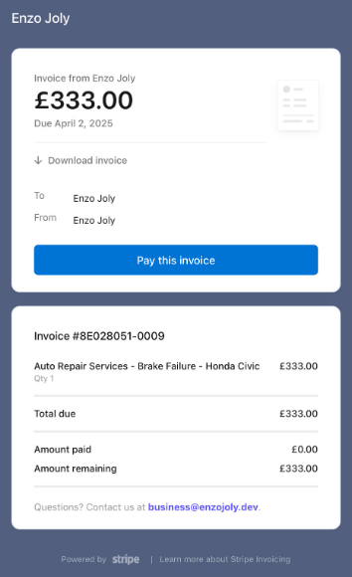
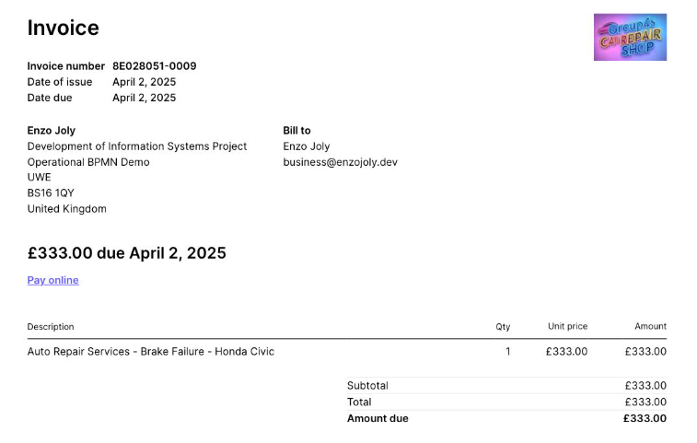

Test Passed

