**CS 2990 Project #1 (20 points)**

**Submission instruction:** Copy and paste the test run results to the end of program and comment it (Note: use ‘’’ block comments.) Submit the program file (must be a .py file) to blackboard.

1. In Lab2 we calculated BMI in USA/English system. Now we’d like the user to choose whether to use USA/English system or Metric system.

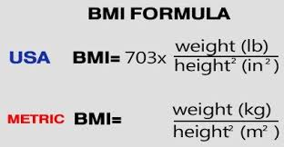

1. A BMI scale is in the attached file. Please provide the user some feedback based on the calculated BMI with regards to the information given in the BMI scale table. Provide test runs of various scenarios (i.e. normal BMI, overweight, obese, extreme obesity). Note: you may convert your BMI result to an integer.
2. Provide test runs for abnormal inputs (such as 0 for weight or height etc. – see Lab 2). Try your best to let your program report input errors instead of crashing the program.

Grading criteria:

1. Program quality (proper comments, meaningful variable names, nice output message, …) - 5 pts
2. Program correctness -- 10 pts
3. Testing (required test case runs attached) – 5 pts