Retail Customer Segmentation Using K-Means Clustering
Minor Project Report

1. Abstract
This project develops a retail customer segmentation system using K-Means clustering. Customer purchase behavior is analyzed using Python, standardized for machine learning, clustered into customer segments, and visualized using PCA. A Power BI dashboard communicates the resulting customer groups and business insights.

2. Introduction
Retail businesses serve customers with different purchasing behaviors. Treating all customers the same can reduce the effectiveness of marketing decisions. Customer segmentation groups similar customers so businesses can design more relevant offers and retention strategies.

3. Problem Statement
To develop a data-driven system that identifies groups of retail customers according to income, purchase frequency, order value, spending, recency, and discount usage.

4. Objectives
Clean and analyze retail customer data; identify useful customer behavior features; standardize selected features; apply K-Means clustering; evaluate cluster quality; use PCA for visualization; build a Power BI dashboard; and provide business recommendations.

5. Dataset Description
The project dataset contains 600 synthetic retail customer records. Fields include CustomerID, Age, Gender, AnnualIncome, PurchaseFrequency, AvgOrderValue, TotalSpend, RecencyDays, DiscountUsagePct, OnlinePurchases, StorePurchases, PreferredCategory, and City.

6. Methodology
Data loading → data inspection → EDA → feature selection → standardization → K-Means → silhouette evaluation → PCA → segment profiling → Power BI dashboard.

7. K-Means Clustering
K-Means was evaluated for K values from 2 to 6. The best K according to the silhouette score was 2, with a score of 0.5943.

8. PCA
PCA was used to reduce the standardized feature space to two components for visual interpretation of customer clusters.

9. Results
The model creates distinct customer segments with different spending, income, purchase-frequency, and recency patterns. The cluster summary CSV provides the average behavior of each segment.

10. Business Recommendations
High-value customers can receive loyalty rewards and premium offers. Regular customers can receive personalized bundles. Budget customers can be targeted with value packs. Occasional customers can receive re-engagement campaigns.

11. Tools and Technologies
Python, Pandas, NumPy, Matplotlib, Seaborn, Scikit-learn, K-Means, PCA, and Microsoft Power BI.

12. Conclusion
The project demonstrates how unsupervised machine learning can transform retail customer data into actionable customer segments. Combining K-Means with PCA and Power BI provides analytical results and an understandable business dashboard.

13. Sample Visualizations
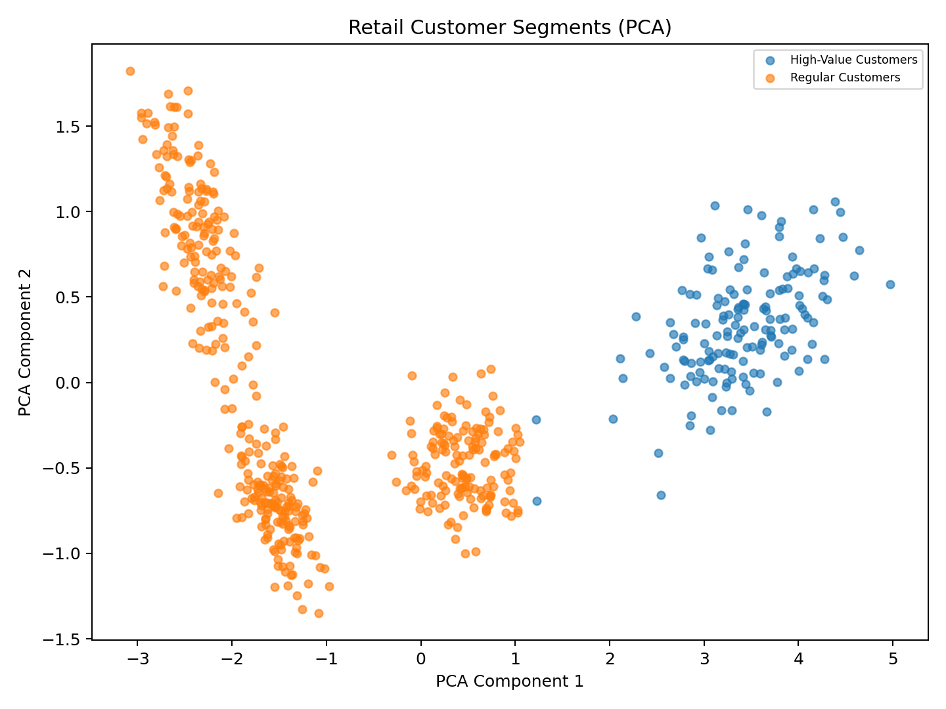
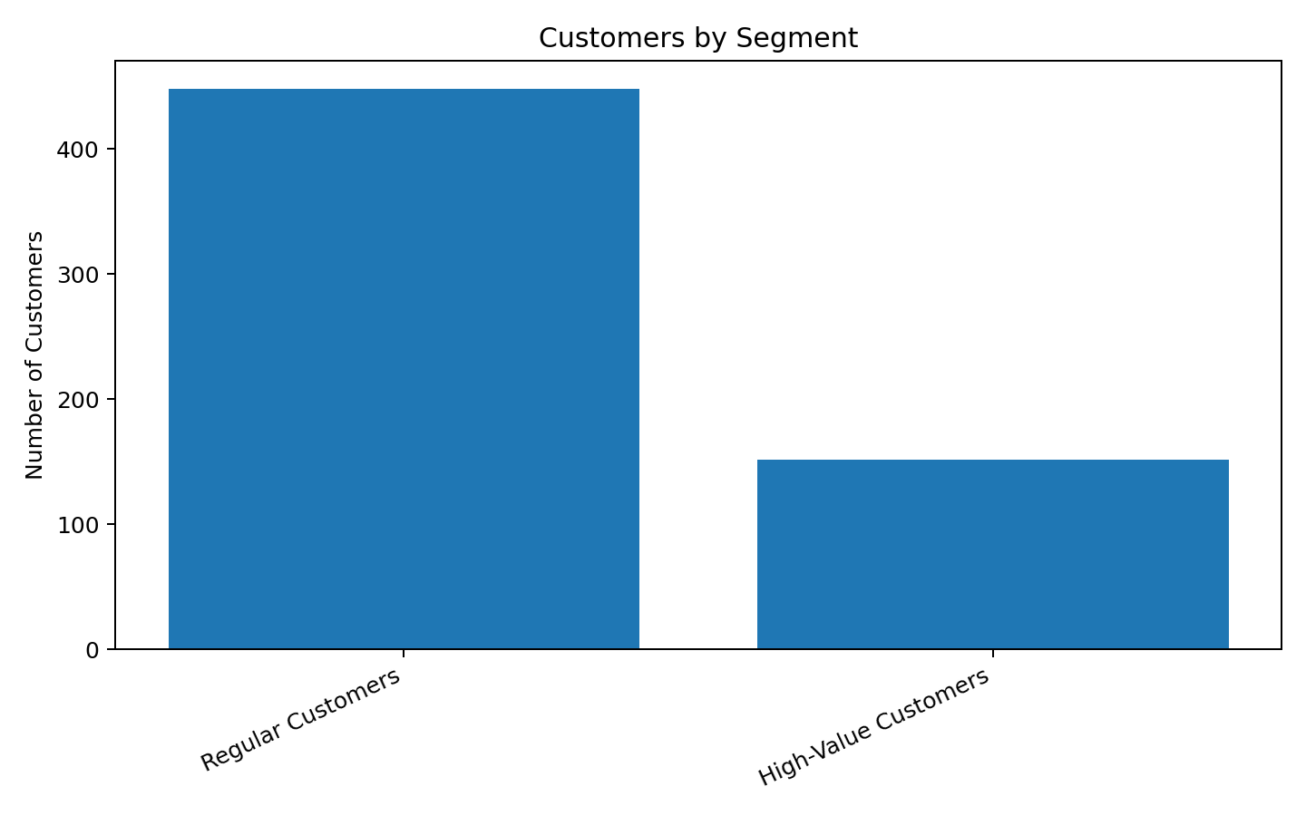

14. Project Files
- retail_customer_data.csv
- customer_segments.csv
- cluster_summary.csv
- customer_segmentation.py
- requirements.txt
- Power BI dashboard plan

