**GUJARAT TECHNOLOGICAL UNIVERSITY**



Chandkheda, Ahmedabad

Affiliated

**Government Engineering College, Rajkot**

A Report on

**“GECR”**

Under subject of

**Summer Internship (3170001)**

B.E. Semester – VII (Computer Engineering)

Submitted by

|  |  |  |
| --- | --- | --- |
| **Sr.** | **Name of Student** | **Enrolment Number** |
| 1 | Vasani Kishan d | 180200107118 |

|  |  |
| --- | --- |
| **Guided by**  (Prof. Rushi Trivedi) | **Head of the Department**  (Prof. Chirag S. Thaker) |

**Academic Year (2020-21)**

**INDEX**

|  |  |  |
| --- | --- | --- |
| **No.** | **Description** | **pages** |
| 1 | Candidate declaration | 3 |
| 2 | Certificate | 4 |
| 3 | Acknowledgement | 5 |
| 4 | Abstract | 6 |
| 5 | Introduction | 7 |
| 6 | Application | 8 |
| 7 | Aim of objective | 9 |
| 8 | Scope | 10 |
| 9 | Research and methodology | 11 |
| 10 | Benefit of proposed system | 12 |
| 11 | Process model | 13 |
| 12 | Diagram   * ER * Activity * Use case | 22 |
| 13 | Choice programming language | 28 |
| 14 | Screenshot | 29 |
| 15 | Requirement | 37 |
| 16 | Conclusion | 38 |
| 17 | Limitations | 39 |
| 18 | Reference | 40 |

# Candidate’s Declaration

We hereby declare that the work presented in this project entitled “GECR” submitted towards completion of project

“Summer Internship” B.E. (Computer Engineering) is an authentic record of my original out under the guidance of “Prof. Rushi Trivedi”.

We have not submitted the matter embodied in this project for the award of any other degree.

|  |  |
| --- | --- |
| Semester: 7th Place: Rajkot  Signatures: |  |
| Vasani kishan d. | (180200107118) |

#### GOVERNMENT ENGINEERING COLLEGE RAJKOT



CERTIFICATAE

Date: 2 June 2021

This is to certify that the **“GECR”** has been carried out by **VASANI KISHANKUMAR D** my guidance in fulfilment of the subject **Summer Internship** in COMPUTER ENGINEERING (7th Semester) of Gujarat Technological University, Ahmedabad during the academic year 2020-21.

Prof. Rushi Trivedi Prof. (Dr.) C. S. Thaker

Faculty Guide (Head of the Department*)*

ACKNOWLEDGEMENT

We have taken many efforts in this project. However, it would not have been possible without the kind support and help of many individuals and organizations. We would like to extend my sincere thanks to all of them.

We are highly indebted to “**Prof. Rushi Trivedi**” for their guidance and constant supervision as well as for providing necessary information regarding the Design Engineering Project Titled “**GECR**”. We would like to express my gratitude towards staff members of Computer Engineering Department, Government Engineering College - Rajkot for their kind co- operation and encouragement which helped us in completion of this project.

We even thank and appreciate to our colleague in developing the project and people who have willingly helped us out with their abilities.

**Vasani kishan d**

### ABSTRACT

Government Engineering College Rajkot (gecr) on of most essential tools that are mostly used in gecr student and faculty. It is mostly used to student view to all college activity like new-letter, admission, event, workshop details, labs details, faculty, staff, etc.

In this Project we tried to Web base Application based college website, our main mediation details to provide details in student.

### INTRODUCTION

The main aim of the project is the gecr to provide all kind activity to student. Government Engineering College Rajkot (gecr) on of most essential tools that are mostly used in gecr student and faculty. provide all college activity like new-letter, admission, event, workshop details, labs details, faculty, staff, etc.

### APPLICATION

This program can be used in government engineering college Rajkot student and faculty. It’s mostly for beginner’s student how to admission college, college faculty details, which is courses to provide college to solve the all problem in this website.

Also, this website provided all kind of details already government engineering college Rajkot students like some event organize gecr, then college provided all details in this website. Then all student view the event details this student not part of gecr.

### AIMS AND OBJECTIVES

The aim of this project is the develop a website for the government engineering college Rajkot student that will be able to achieve thefollowing objectives:

* The provide all kind information in government engineering college Rajkot.
* If there is any error occurred, we work in this error and solve this error very soon.
* Improving the efficiency of the system by ensuring effective monitoringof services and activates.
* To system that the user friendly.
* To be update the site within a specified period of time.

# SCOPE

* Scope of this project website is provided all information in college.
* Can be used to covid-19 situation in how to admission this college and view the term and condition.

### RESERCH AND METHEDOLOGY

The research method used to this project work given a description of how the gecr website.

Therefor the method used in the design and collation of information from various sources.

* Studying the present system details and the organization style.
* Knowing and understating the input and output processes of the existing system.

### BENIFITE OF PROPOSED SYSTEM

The proposed system would be designed to help make all gecr student as well as the other student and provide the all-kind information in government engineering college Rajkot. Some benefits provided onto below.

* The system would improve productivity.
* The system would enhance User/System interface.
* The system will not cost.
* The system would improve information quality and accessibility.

# PROCESS MODEL

#### Software Development Life Cycle

Software Development Life Cycle, SDLC for short, is a well- defined, structured sequence of stages in software engineering to develop the intended software product.

##### SDLC Activity

SDLC provides a series of steps to be followed to design and develop a software product efficiently. SDLC framework includes the following steps:

* + Communication
  + Requirement Gathering
  + Feasibility Study
  + System Analysis
  + Software Design
  + Coding
  + Testing
  + Integration
  + Implementation
  + Operation & Maintenance
  + Disposition

##### Communication:

This is the first step where the user initiates the request for a desired software product. He contacts the service provider and tries to negotiate the terms. He submits his request to the service providing organization in writing.

##### Requirement Gathering:

This step onwards, the software development team works to carry on the project. The team holds discussions with various stakeholders from problem domain and tries to bring out as much information as possible on their requirements. The requirements are contemplated and segregated into user requirements, system requirements and functional requirements. The requirements are collected using a number of practices as given –

Studying the existing or obsolete system and softwareConducting interviews of users and developers Referring to the database or Collecting answers from the questionnaires.

##### Feasibility Study:

A feasibility study is undertaken to determine the possibility or probability of either improving the existing system or developing a completely new system.

A feasibility study is defined as an evaluation or analysis of the potential impact of a proposed project. Feasibility study is conducted once the problem is clearly understood. Feasibility study is a high level capsule version of the entire system analysis and design process. The objective is to determine quickly at a minimum expense how to solve a problem. The purpose of feasibility is not to solve the problem but to determine if the problem is worth solving. Feasibility and risk analysis are related in many ways. If project risk is huge, the feasibility of producing quality software is reduced. During product engineering, however, we concentrate our attention on following primary areas of interest.

##### System Analysis:

At this step the developers decide a roadmap of their plan and try to bring up the best software model suitable for the project. System analysis includes understanding of software product limitations, learning system related problems or changes to be done in existing systems beforehand, identifying and addressing the impact of project on organization and personnel etc. The project team analyses the scope of the project and plans the schedule and resources accordingly.

##### Software Design:

Next step is to bring down whole knowledge of requirements and analysis on the desk and design the software product. The inputs from users and information gathered in requirement gathering phase are the inputs of this step. The output of this step comes in the form of two designs: logical design and physical design. Engineers produce meta-data and data dictionaries, logical diagrams, data-flow diagrams and in some cases pseudo codes.

##### Coding:

This step is also known as programming phase. The implementation of software design starts in terms of writing program code in the suitable programming language and developing error-free executable programs efficiently.

##### Testing:

An estimate says that 50% of whole software development process should be tested. Errors may ruin the software from critical level to its own removal. Software testing is done while coding by the developers and thorough testing is conducted by testing experts at various levels of code such as module testing, program testing, product testing, in-house testing and testing the product at user’s end. Early discovery of errors and their remedy is the key to reliable software.

##### Integration:

Software may need to be integrated with the libraries, databases and other program. This stage of SDLC is involved in the integration of software with outer world entities.

##### Implementation:

This means installing the software on user machines. At times, software needs post-installation configurations at user end. Software is tested for portability and adaptability and integration related issues are solved during implementation.

##### Operation & Maintenance:

This phase confirms the software operation in terms of more efficiency and less errors. If required, the users are trained on, or aided with the documentation on how to operate the software and how to keep the software operational. The software is maintained timely by updating the code according to the changes taking place in user end environment or technology. This phase may face challenges from hidden bugs and real- world unidentified problems.

##### Disposition:

As time elapses, the software may decline on the performance front. It may go completely obsolete or may need intense up gradation. Hence a pressing need to eliminate a major portion of the system arises. This phase includes archiving data and requires software components, closing down the system, planning disposition activity and terminating system at appropriate end-of-system time.

##### ITERATIVE MODEL

This model leads the software development process in iterations. It projects the process of development in cyclic manner repeating every step after every cycle of SDLC process.

The software is first developed on very small scale and all the steps are followed which are taken into consideration. Then, on every next iteration, more features and modules are designed, coded, tested and added to the software. Every cycle produces a software, which is complete in itself and has more features and capabilities than that of the previous one.

DELIVERY

CODING

DESIGNING

PLANNING

REQUIREMENT

After each iteration, the management team can do work on risk management and prepare for the next iteration. Because a cycle includes small portion of whole software process, it is easier to manage the development process but it consumes more resources.

##### Requirement analysis:-

The development team analyses the requirements and specifications document for completeness and feasibility. Once everyone agrees on the project specification, the next step is to analyses how to do it. The purpose of the analysis is to determine the scope of the effort.

##### Design:-

In Design phase, following activities are done by the designer**.**

##### Layout and Navigation Design

Laying out the navigation within the web site is key. The user should be directed logically through the web site so that they always know where they are going. The layout and navigation design process categorize the information and creates a flowchart, which outlines both, the organization of the web site, and the links, which will exist within the web site. The structure should naturally follow the content.

##### Current scenario:-

The flowcharts and block diagram providing a top-l Level view of the website are developed during this phase.

##### Human computer interface design:-

The first step to design the interface is to define what the user must accomplish. After defining the requirements, the next step is to determine the order a user would most likely use to accomplish the tasks. This requires understanding the target audience and how people want to do things. Once this is understood, the look and feel of the web site should be documented.

##### Implementing and unit testing:-

During this stage, the process of building the web according to its design is done. The detail of the operations are implemented. The integration of the new code with existing code, issued from previous iterations, is implemented gradually during the construction. Unit testing procedures are applied to the prototype. Unit testing involves verifying that each unit meets its specification

##### Current Scenario:

We have tested each module, function, page individually and finally sections as a whole. Thus the site has been thoroughly tested.

##### Integration and testing:-

The individual program units or programs are integrated and tested as a complete system to ensure that the web site requirements have been met. After testing, the web site is delivered to the customer.

##### Operation: -

Normally this is the longest life cycle phase. Before the software gets deployed to the world, it must be documented properly. The on-line help is created and checked against the distribution web site. Someone needs to use the system aided only with the on-line help and if a user can operate the systemjust from the on-line help, then it is ready for deployment.

# Diagram ER

*ER diagram is a structured analysis technique. And also description logical data items design that can converted easily into table structure. ERD is snapshot of data structure.*

*ER diagram enables a software engineering to identify data objects and their relationship using graphical notations. ERD is a details logical representation of any system. It has three main elements of data object entity attribute and their relationship.*

* *Entity:-*
  + *A data object is a real world entity or things.*
  + *It can be external entity, a thing, an organization, a place or an event.*
  + *Entity are represent using rectangle.*
* *Attribute:-*
  + *Attribute is a property or characteristics of an entity.*
  + *Attribute provide meaning to the object.*
  + *Represented using oval.*
* *Relationship:-*
  + *Entity are connected to each other via relational. Generally relational is binary.*
  + *Relationship illustrates how two entity share information in the data saturates.*
  + *Relationship is repented using diamond shape symbol with joined relationship.*

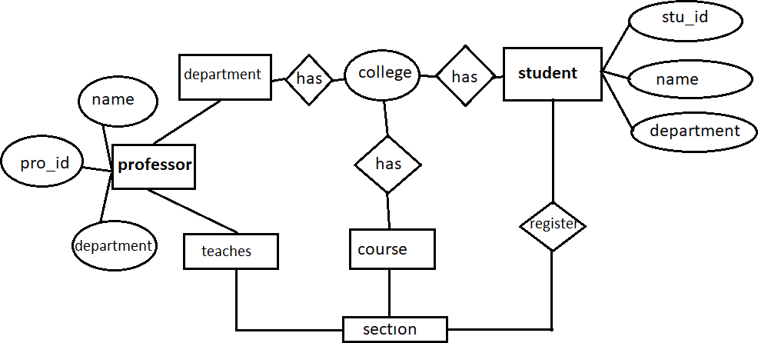

# ACTIVITY

Activity diagram consist of activity, state and transition between activity and state. It describes how the events in signal use case relate to one another.

Activity diagram represent workflow in a graphical way. Activity diagram are similar to procedural flow charts. The difference is that activity diagram support parallel actives.

* Activity:-
  + It represented a flow. Of control.
* Initial activity:-
  + Frist activity flow.
* Final activity:-
  + End activity flow.
* Flow:-
  + Represent arrow.
* Decision:-
  + Represent diamond for condition.

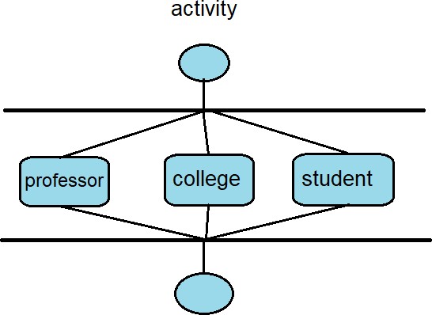

### USE-CASE

The use-case model for any system consisted of a set of “use cases”. Use cases represents the different ways in which a system can be used by the users.

The purpose of a use case is to define the logical behavior of the system without knowing the internal structure of it. UML description “who can do what in a system”.

A use cases typically represent a sequence of interactions between the user and the system.

* Use case:-
  + Each use case is represented by an below.
* Actor:-
  + An actor is anything outside the system that interact with it.
  + Actor in the use case diagram are represented by using the stick person icon.

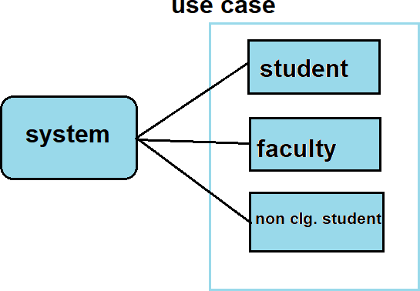

# CHOICE PROGRAMMING LANGUAGE

Choosing a programming language depend on your language experience and the scope of the application you are building while small application are often created using only one language it is not uncommon to develop large application using multiple language.

The purpose application to be is not a web based application that needs internet facility to function but a stand long application.

The choice of programming language to use for this programming is html, , JavaScript, php.

Net beans new and many improved features such as inheritance, interface and overloading that make it a powerful object oriented to programing language.

# Screen-Short

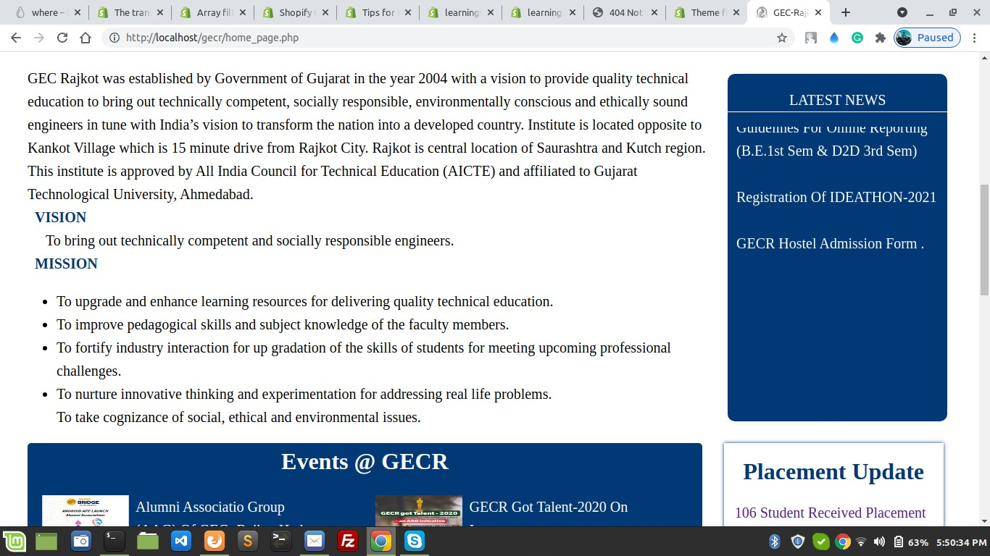

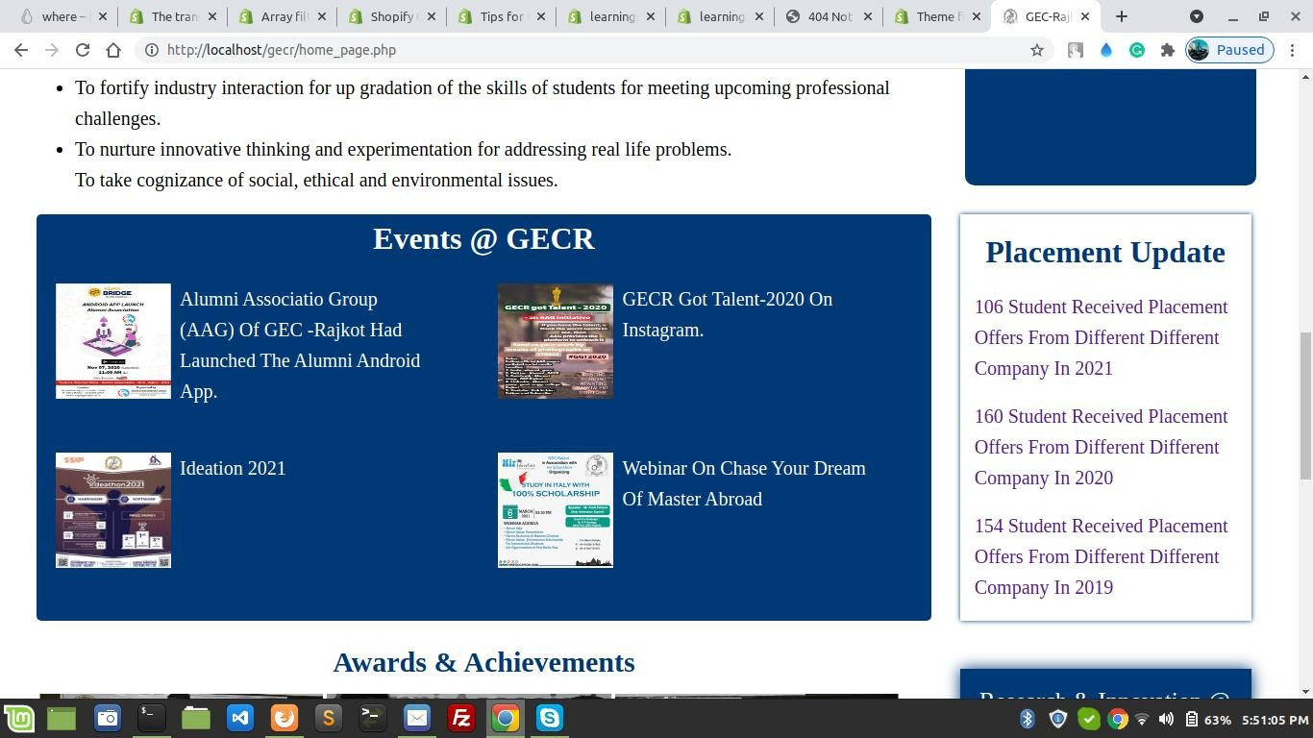

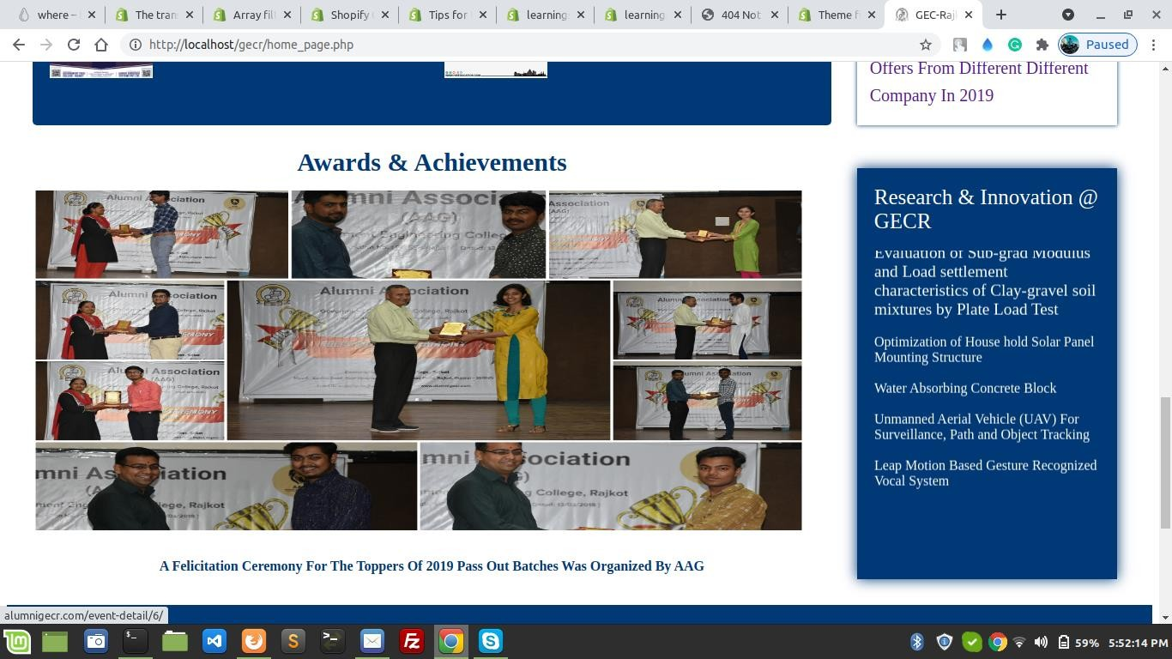

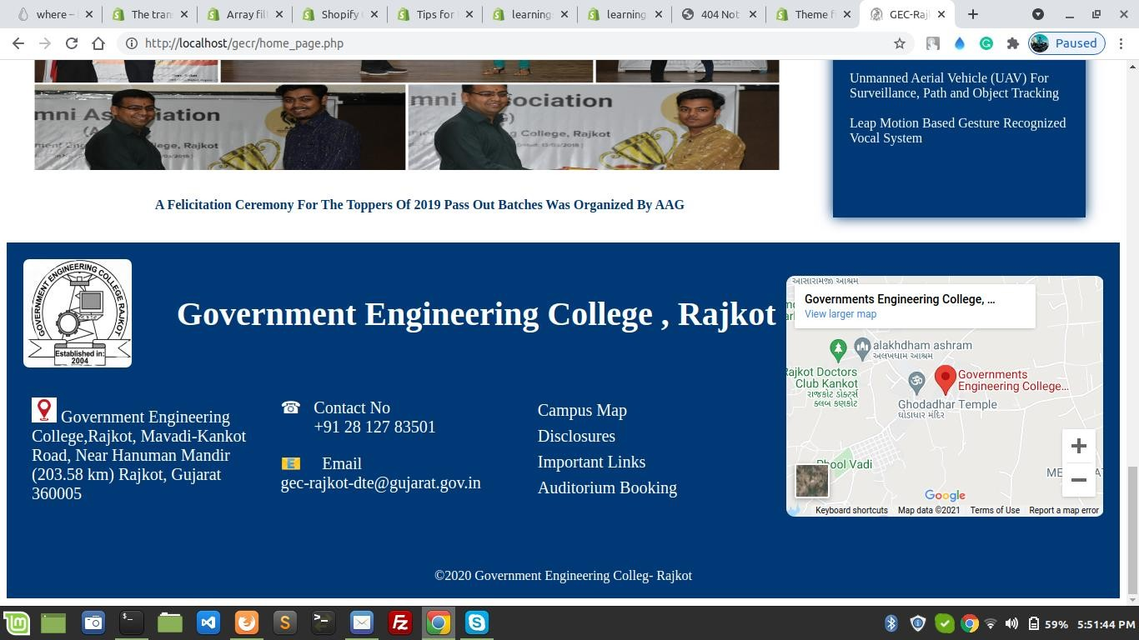

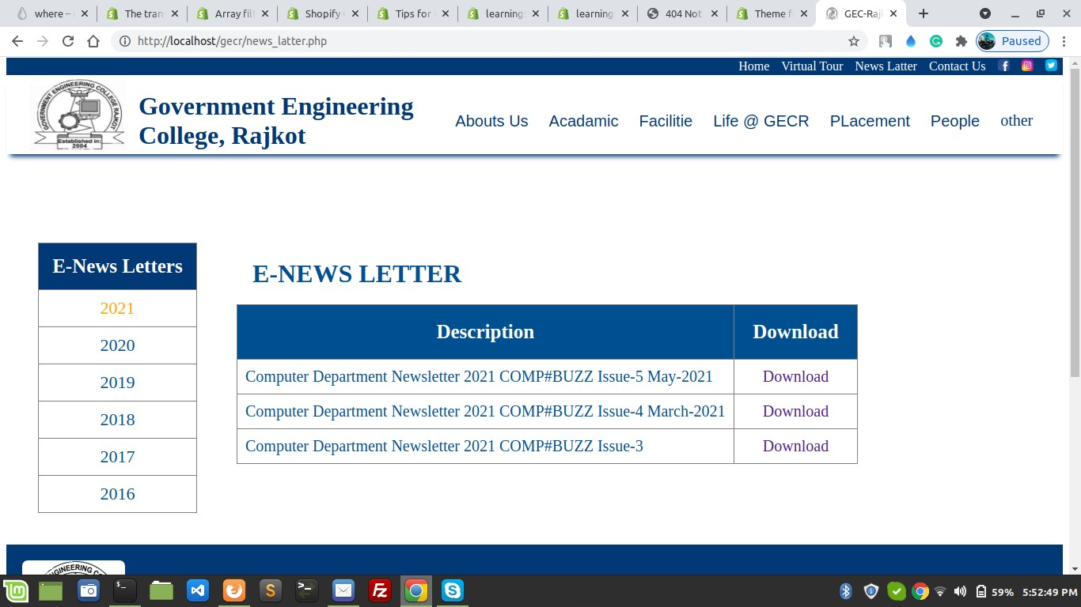

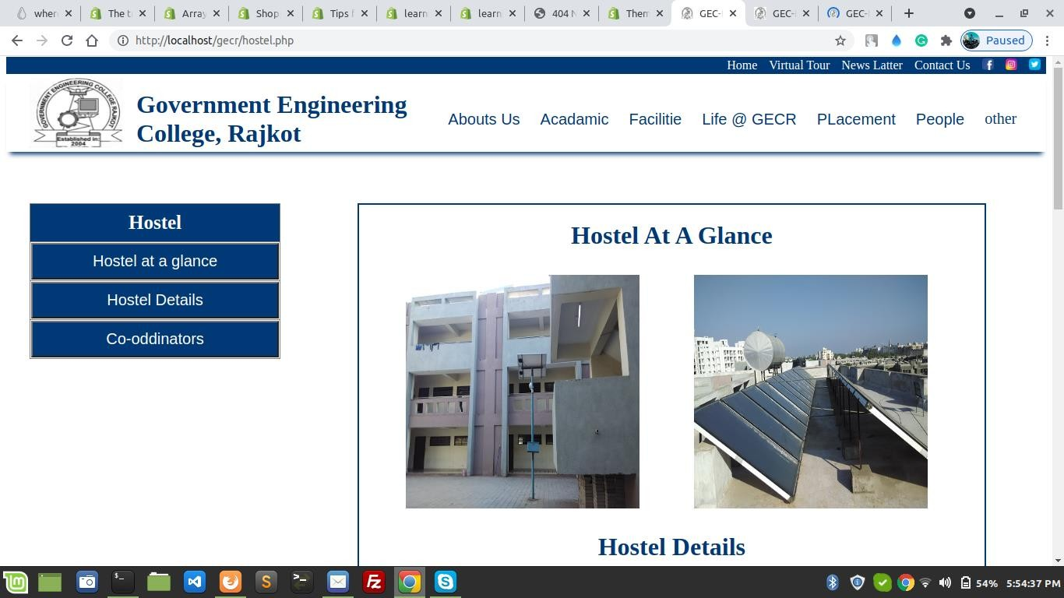

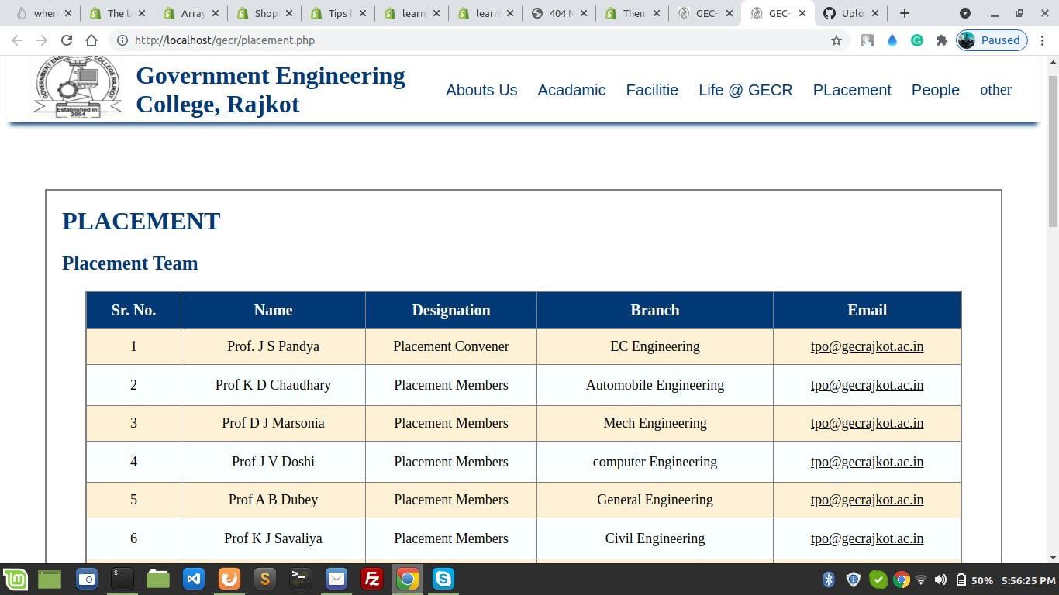

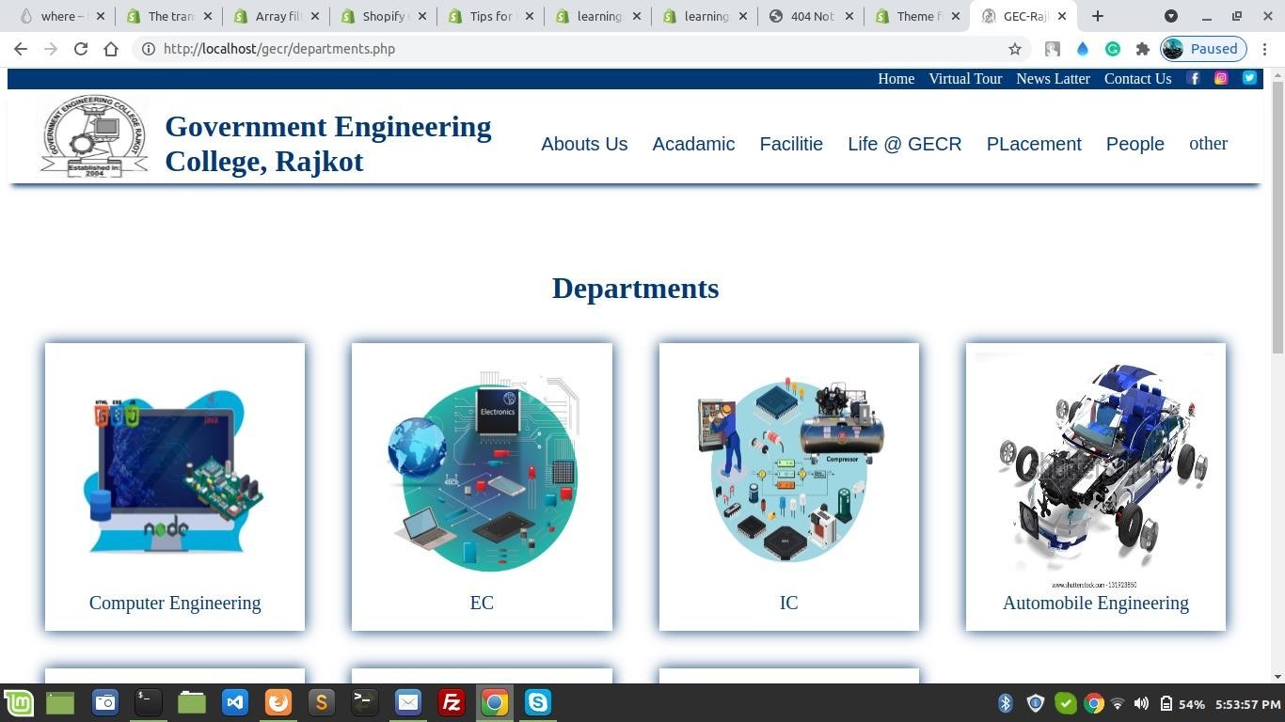

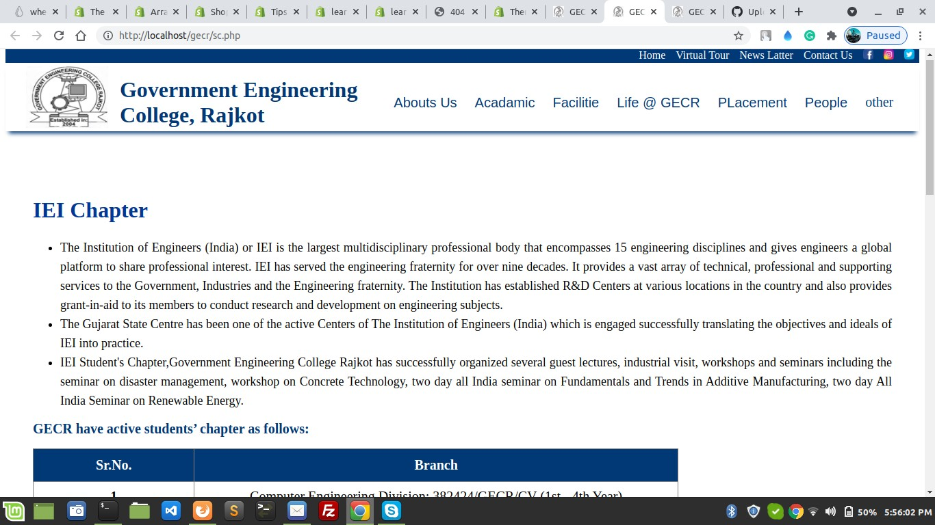

## REQURMENT

###### Hardware Requirement:-

* + *A minimum hard disk space of 20 GB.*
  + *RAM size 1 GB.*
  + *Pentium 4 dual processor CPU.*
  + *A VGA color monitor.*
  + *Mouse.*
  + *Keyboard.*

###### Software Requirement:-

* + *Any Browser*

# Conclusion

This website its very useful so every can use in any place and any where And any device, its very easy use we hope you like it.

This website also provided the student view the notifications, placement Circular, staff / faculty details, IEI chapter, like that.

Also, this website provided all kind of details already government engineering college Rajkot students like some event organize gecr, then college provided all details in this website. Then all student view the event details this student not part of gecr.

# Limitation

* this is web-based application so main required is a good internet and browser.
* We can not provided login / sign up.
* Any server side issue its main problems in website that not solved in small time.
* As soon as possible added the features in over website.

## Reference

[http://www.google.co.in](http://www.google.co.in/) [http://www.udemy.com](http://www.udemy.com/) https://stackoverflow.com https://w3schools.com