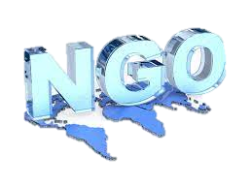

**NGO**

**AS A**

**SERVICE**

**SECTOR**

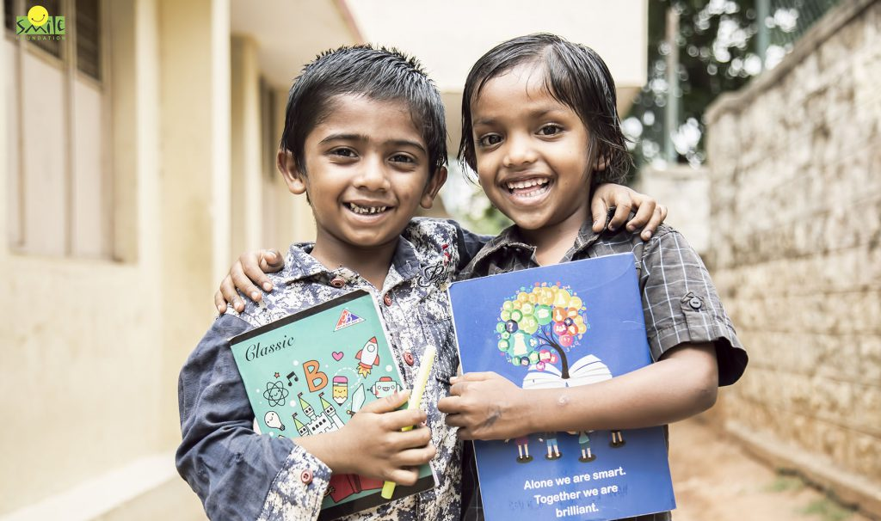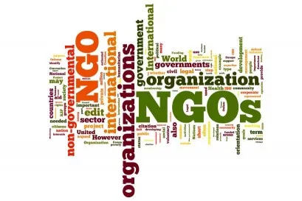

WHAT IS NGO ?

* Humanitarian assistance and disaster relief…
* Education and skill development …
* Healthcare and public activities…
* Environmental conservation
* Women empowerment…
* Gender equality…
* Poverty alleviation …
* Sustainable development…

A-non-governmental organization is an organization that generally is formed independent from government. They are typically nonprofit entities, and many of them are active in humanitarianism or the social sciences; they can also include clubs and associations that provide services to their members and others…

**Key activities of NGO ?**

**How to start NGO in India** ?



Step 1: Decide the cause and mission of your

NGO.

Step 2: Set up the board of directors/members.

Step 3: Decide the name of your NGO.

Step 4: Memorandum Articles of incorporation/

Articles of Association.

Step 5: Get your NGO registered.

Step 6: Start collecting funds…

**Role of NGO in Development ?**

The purpose of an NGO is to focus on all topics relating to human rights, social issues, environmental issues, and advocacy. They strive to develop and improve society’s social and political conditions on a large scale. The following are some of the NGO’s functions **:**

* **Poverty eradication**
* **Animal Rights**
* **Prevent Social Injustice**
* **Conservation of Environment**
* **Aged people care routine**
* **Empowerment of women**
* **Disease Control and others**
* **Health and Nutrition plans**
* **Conservation of Wildlife**
* **Hygiene and Sanitation conditions**
* **Humanitarian Relief**
* **Education plans and literacy**
* **Refugee Crisis**



# **List of non-governmental organisations: in India**

1. World Vision India
2. Akhil Bhartiya Vidyarthi Parishad
3. Akhil Bhartiya Vidyarthi Parishad
4. Centre For Public Interest Litigation
5. Child In Need Institute
6. Child Rights and You (Cry)
7. Save Life Foundation
8. Panjab Digital Library
9. Literacy India
10. Akanksha Foundation



**World NGO Day, 27 Feb**

