

LET’S SPEAK ENGLISH !

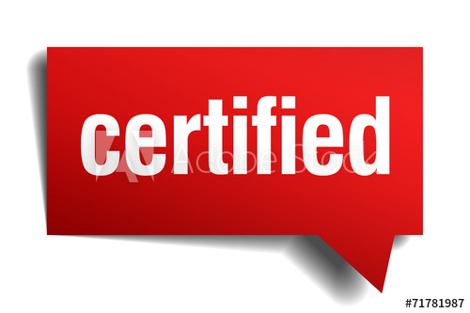

CAMBRIDGE TKT QUALIFIED NATIVE ENGLISH TEACHER.



LESSONS: ONE-TO-ONE COURSE.



LESSONS: PERSONALISED GROUP COURSE FOR UP TO 7 PEOPLE



CONTACT US: 966700727