Project Proposal
Project Title :
School Science Fair Project Evaluator
Introduction :
The School Science Fair Project Evaluator is a menu-driven C++ console application. It is created to help keep records of student projects that are entered into a school science fair. A user can add information, about a project look at all the projects that are saved and see how projects there are in total.

Problem Statement :
Keeping track of student science fair project details by hand can be messy and hard to manage. It’s easy to lose records or get confused when project IDs are repeated or information is missing. This project offers a computerized system to store and show a small number of project records. It also makes sure that key rules are followed when entering data.

Objectives :
- To create a record for a students science fair Project the program must store the Project details.
- To display all Project records that are stored during the program run.
- To display the number of Project that have been added.
- To validate that Project IDs are positive numbers.
- To prevent duplicate Project IDs from being entered.
- To ensure that required text fields, for the Project are not left empty.
- To demonstrate basic C++ object-oriented programming concepts.

Scope :
The application keeps track of up to five project records in an array while the program is running. It allows you to create projects and read them. It does not have features, for adding project marks, grading, changing information removing projects logging in or saving data permanently. All the project details stay in the computers memory. When the program ends all the project records disappear.

Main Features :
- Add New Project : takes project ID, title, student name, class and science category.
- View All Projects : shows all records that are saved now.
- View Total Projects : shows how many projects were added successfully.
- Input Validation : does not allow IDs that're not positive and also does not allow empty text fields.
- Duplicate Check : does not allow an ID that is already used by another project that is saved.
- Capacity Check : stops adding projects when there are already five projects.

Hardware and Software Requirements :
Type | Requirement
Hardware | Desktop or laptop computer, keyboard and monitor.
Operating System | Windows, Linux, or another OS supporting a C++ compiler.
Programming Language | C++
Compiler / IDE | GCC, MinGW, Code::Blocks, Visual Studio, or equivalent.
Header Files | iostream and string

Methodology :
A class called ScienceProject represents one science project. The main function creates an array of five ScienceProject objects. A menu lets the user add a project view all projects view the count or exit. Before storing a record the program checks the project capacity checks that the ID is positive checks, for duplicate ID and checks that required text fields are filled. A static class member keeps track of the number of successfully added projects.

Expected Outcome :
The program should add valid project records, reject invalid or duplicate IDs, reject empty project details, display stored project records, and show the total number of projects.

Project Limitations :
The current version keeps data in RAM. It can hold up to five records. When the program closes the records vanish. It does not let you update records, delete records, search records, by name add evaluation marks or calculate grading.

Data Dictionary
The data dictionary describes the important data members and variables used in the program.
Name | Data Type | Description | Rule / Use
projectID | int | Unique identifier of a science project. | Must be positive and unique.
projectTitle | string | Title of the science project. | Cannot be empty.
studentName | string | Name of the student submitting the project. | Cannot be empty.
studentClass | string | Class or grade of the student. | Cannot be empty.
scienceCategory | string | Science subject/category of the project. | Cannot be empty.
totalProjects | static int | Number of projects successfully added in the current run. | Incremented in setDetails().
projects | ScienceProject[5] | Array containing up to five project objects. | Maximum capacity is five.
ptr | ScienceProject* | Pointer used to refer to an object in the array. | Assigned the address of projects[i].
count | int | Number of project records currently stored. | Starts at zero and increases after a successful add.
choice | int | Menu option entered by the user. | 1 to 4 are valid menu options.
duplicate | bool | Indicates whether an entered ID already exists. | true if duplicate; otherwise false.
UML Diagram
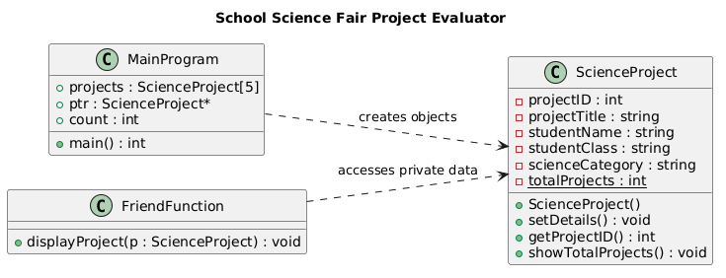
FlowChart
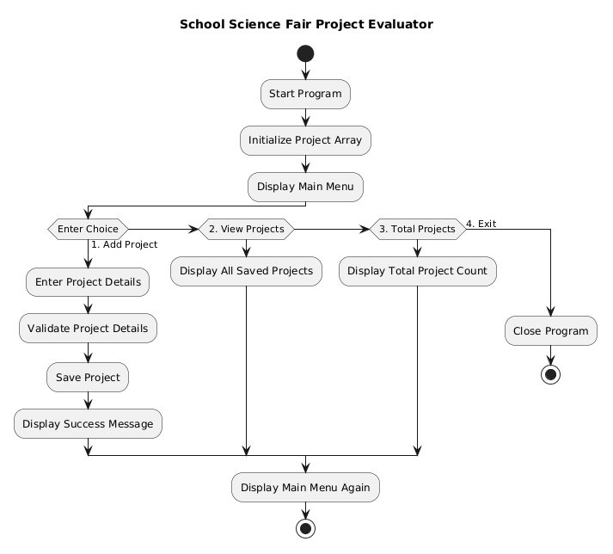
Source Code
https://github.com/mrvithubunge01/Cpp_Project-12620583-/tree/main

Conclusion
The School Science Fair Project Evaluator is a C++ console-based project developed to manage science fair project records. It allows users to add projects view all saved projects and check the total number of projects. This project helped me understand C++ concepts such, as classes and objects, constructors, static members, inline functions, friend functions arrays of objects and pointers. Overall this project improved my programming skills and helped me understand how basic C++ concepts can be used to develop a real-life application.

