DESIGN AND DEVELOPMENT OF FUNCTIONAL MODULES FOR A LEARNING MANAGEMENT SYSTEM
A project report submitted to the
DEPARTMENT OF COMPUTER APPLICATIONS
in partial fulfilment of the requirements for the
award of the degree of

MASTER OF SCIENCE
In
APPLIED DATA SCIENCE
By
JASTI KESAVA DATTA
REG. NO: RA2432014010026
Under the guidance of
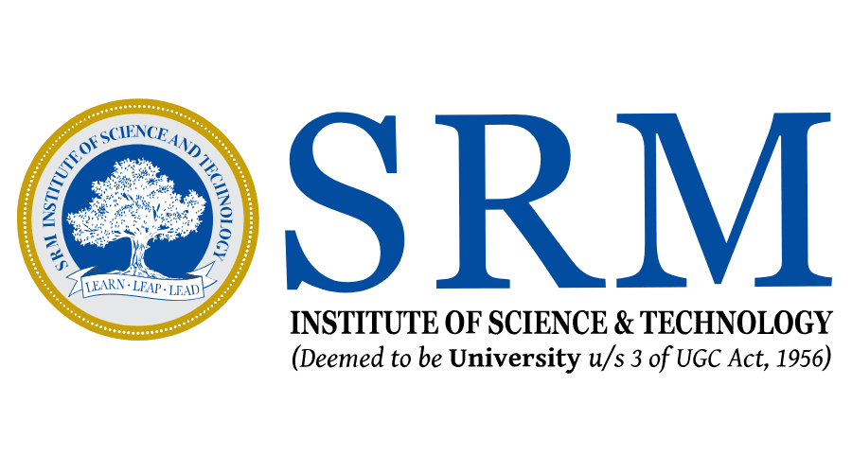
Dr. P. CHANTHINI M.Sc., M.Phil., Ph.D.,

SRM INSTITUTE OF SCIENCE AND TECHNOLOGY
Faculty Of Science and Humanities
Kattankulathur – 603 203
Chennai, Tamilnadu
APRIL – 2026

