DESIGN AND DEVELOPMENT OF FUNCTIONAL MODULES FOR A LEARNING MANAGEMENT SYSTEM
A project report submitted to the
DEPARTMENT OF COMPUTER APPLICATIONS
in partial fulfilment of the requirements for the
award of the degree of

MASTER OF SCIENCE
In
APPLIED DATA SCIENCE
By
JASTI KESAVA DATTA
REG. NO: RA2432014010026
Under the guidance of

Dr. P. CHANTHINI M.Sc., M.Phil., Ph.D.,

SRM INSTITUTE OF SCIENCE AND TECHNOLOGY
Faculty Of Science and Humanities
Kattankulathur – 603 203
Chennai, Tamilnadu
APRIL – 2026

BONAFIDE CERTIFICATE
This is to certify that the project report titled “DESIGN AND DEVELOPMENT OF FUNCTIONAL MODULES FOR A LEARNING MANAGEMENT SYSTEM” is a bonafide record of work done by JASTI KESAVA DATTA (Register Number: RA2432014010026) during the academic year 2025–2026 in partial fulfillment of the requirements for the award of the degree of M.Sc. Applied Data Science from SRM Institute of Science and Technology, Kattankulathur.

Dr. P. CHANTHINI  Assistant Professor  Department of Computer Applications,  SRM Institute of Science and Technology | Dr. P. J. ARUL LEENA ROSE  Head of the Department  Department of Computer Applications,  SRM Institute of Science and Technology

Internal Examiner | External Examiner

DECLARATION OF ASSOCIATION OF RESEARCH PROJECT WITH SUSTAINABLE DEVELOPMENT GOALS

This is to certify that the research project entitled "Design and Development of Functional Modules for a Learning Management System" carried out by Mr. Jasti. Kesava Datta under the supervision of Dr. P. Chanthini in partial fulfilment of the requirement for the award of Post-Graduation program has been significantly or potentially associated with:
- SDG Goal No 04 (FOUR) titled QUALITY EDUCATION — The project develops functional modules for a Learning Management System that automates exam administration, generates performance analytics for students and mentors, and distributes progress reports to parents — directly contributing to improved quality of education through technology-driven academic management and stakeholder engagement.
- SDG Goal No 09 (NINE) titled INDUSTRY, INNOVATION AND INFRASTRUCTURE — The project demonstrates innovation in software architecture through the migration of monolithic systems to scalable microservices using modern design patterns (CQRS, Strangler Fig, Repository Pattern), cloud infrastructure (AWS S3, Elastic Beanstalk), and asynchronous processing frameworks (Celery, Redis).
This study has clearly shown the extent to which its goals and objectives have been met in terms of filling the research gaps, identifying needs, resolving problems, and developing innovative solutions locally for achieving the above-mentioned SDGs on a National and/or on an international level.

SIGNATURE OF THE STUDENT SIGNATURE OF THE GUIDE

HEAD OF THE DEPARTMENT
ACKNOWLEDGEMENT
With profound gratitude to the ALMIGHTY, I take this opportunity to thank all those who supported and guided me in completing this project successfully.
I would like to express my sincere gratitude to Dr. T. R. Paarivendhar, Chancellor, SRM Institute of Science and Technology, for providing the platform and opportunities for academic growth.
I am thankful to Prof. A. Vinay Kumar, Pro Vice-Chancellor (SBL), and Dr. A. Duraisamy, Dean, Faculty of Science and Humanities, SRM Institute of Science and Technology, for their continuous support and encouragement.
I extend my sincere thanks to Dr. S. Albert Antony Raj, Professor and Deputy Dean, Faculty of Science and Humanities, for providing a motivating academic environment.
I express my heartfelt gratitude to Dr. P. J. Arul Leena Rose, Professor and Head, Department of Computer Applications, for her guidance and for providing the necessary facilities to carry out this project.
I am deeply grateful to my project guide Dr. P. Chanthini, Assistant Professor, Department of Computer Applications, for her constant support, encouragement, and valuable suggestions throughout the development of this project.
I would also like to thank Codegnan IT Solutions Pvt. Ltd., where I worked as a Software Developer (Project Trainee) and gained practical exposure to enterprise software development.
I extend my sincere thanks to all the faculty members of the Department of Computer Applications for their support and encouragement.
Finally, I thank my parents, family, and friends for their constant motivation and support.
Jasti Kesava Datta

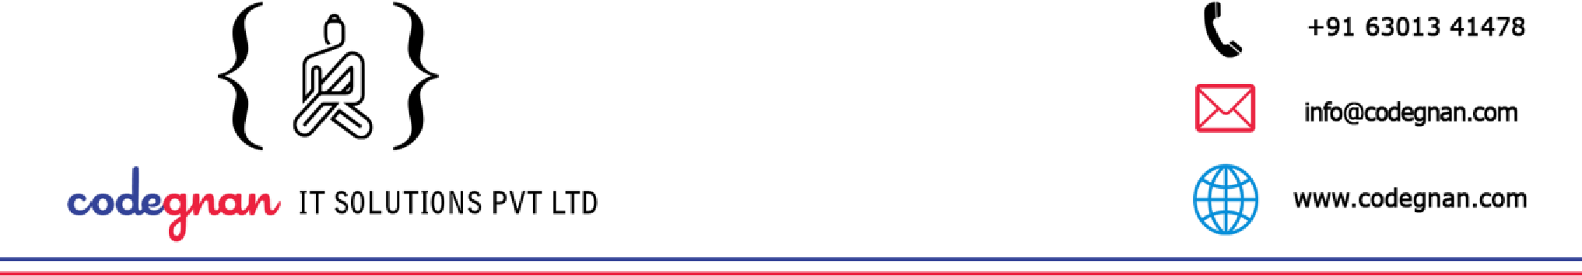Date: 1st December 2025

To Whomsoever It May Concern

This is to certify that Mr. Jasti Kesava Datta, bearing Register Number: RA2432014010026, is a student of II Year, M.Sc. Applied Data Science, Faculty of Science and Humanities, SRM Institute of Science and Technology (SRMIST), Kattankulathur.
The student is currently working with our organization as a Software Developer (Project Trainee) and is involved in an in-house software development project titled:
“Design and Development of Functional Modules for a Learning Management System.”
As part of the Project Work prescribed by the university, the student is contributing to the design, development, and enhancement of functional LMS modules, following standard software development practices.
The project work is carried out during the period from December 2025 to March 2026, under the guidance of experienced professionals in the organization.
This confirmation is issued upon the request of the student for academic purposes, in accordance with the project requirements of SRM Institute of Science and Technology. Yours sincerely,

Authorized Signatory
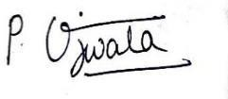
Ujwala Podisetti

HR Executive


Codegnan IT Solution Pvt Ltd
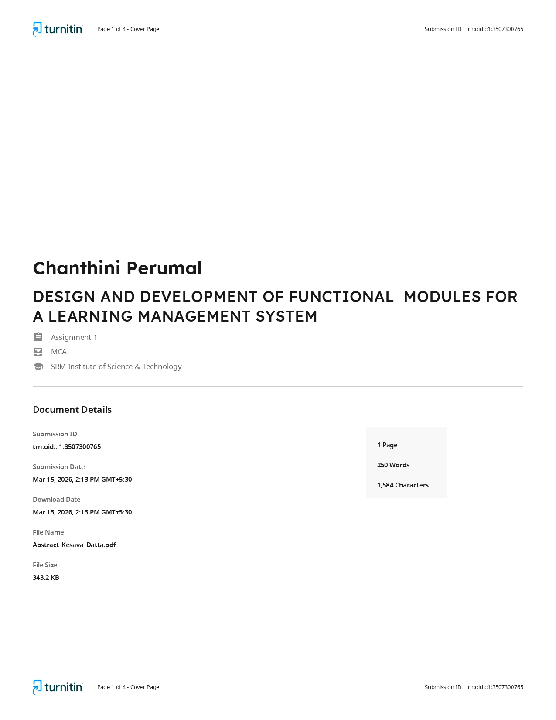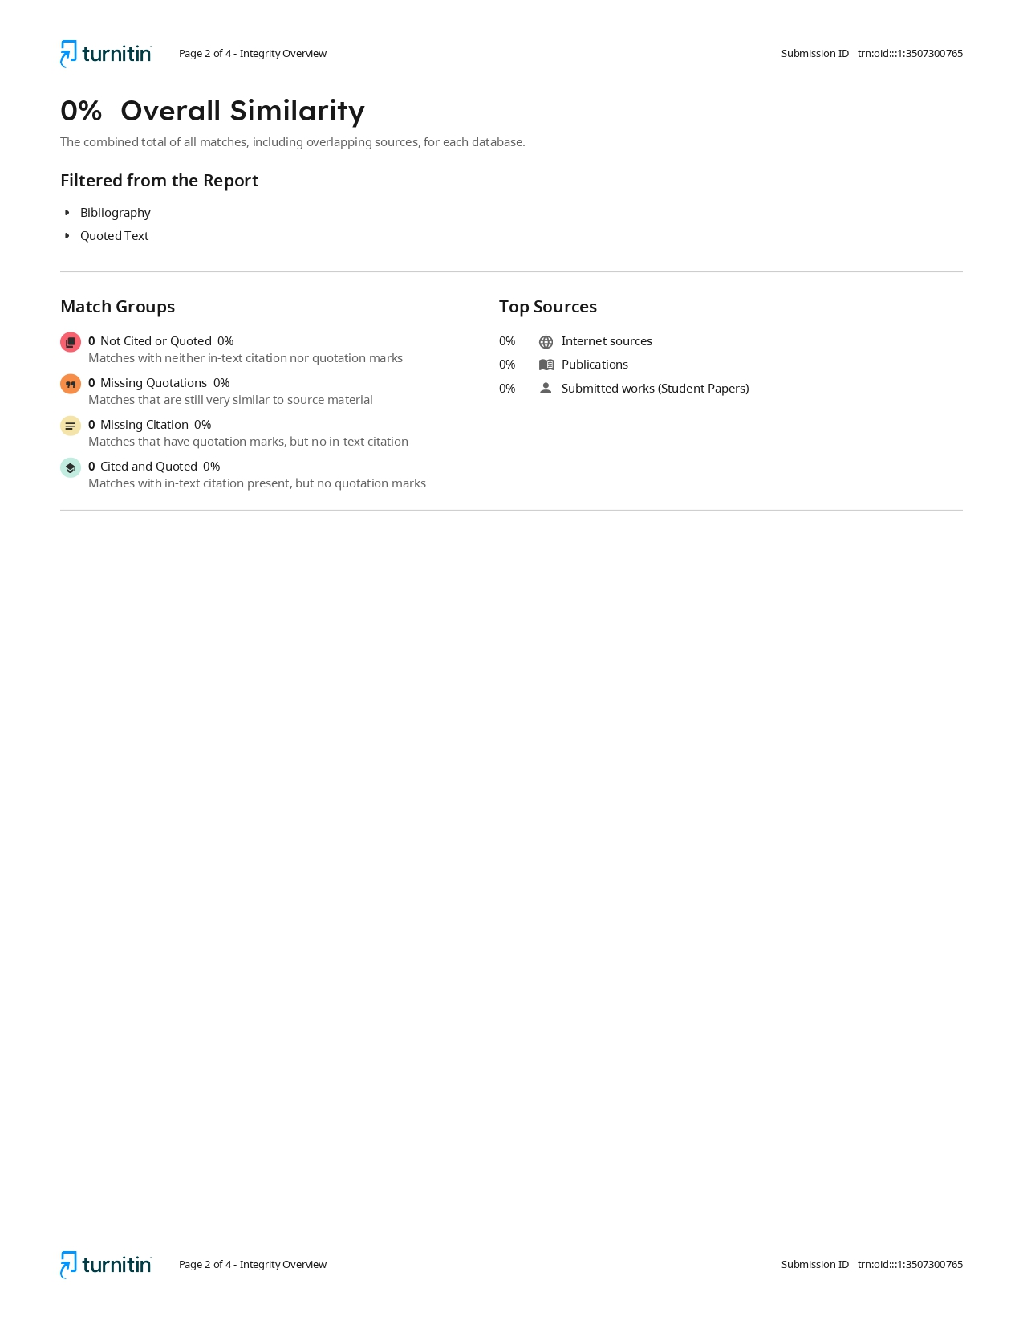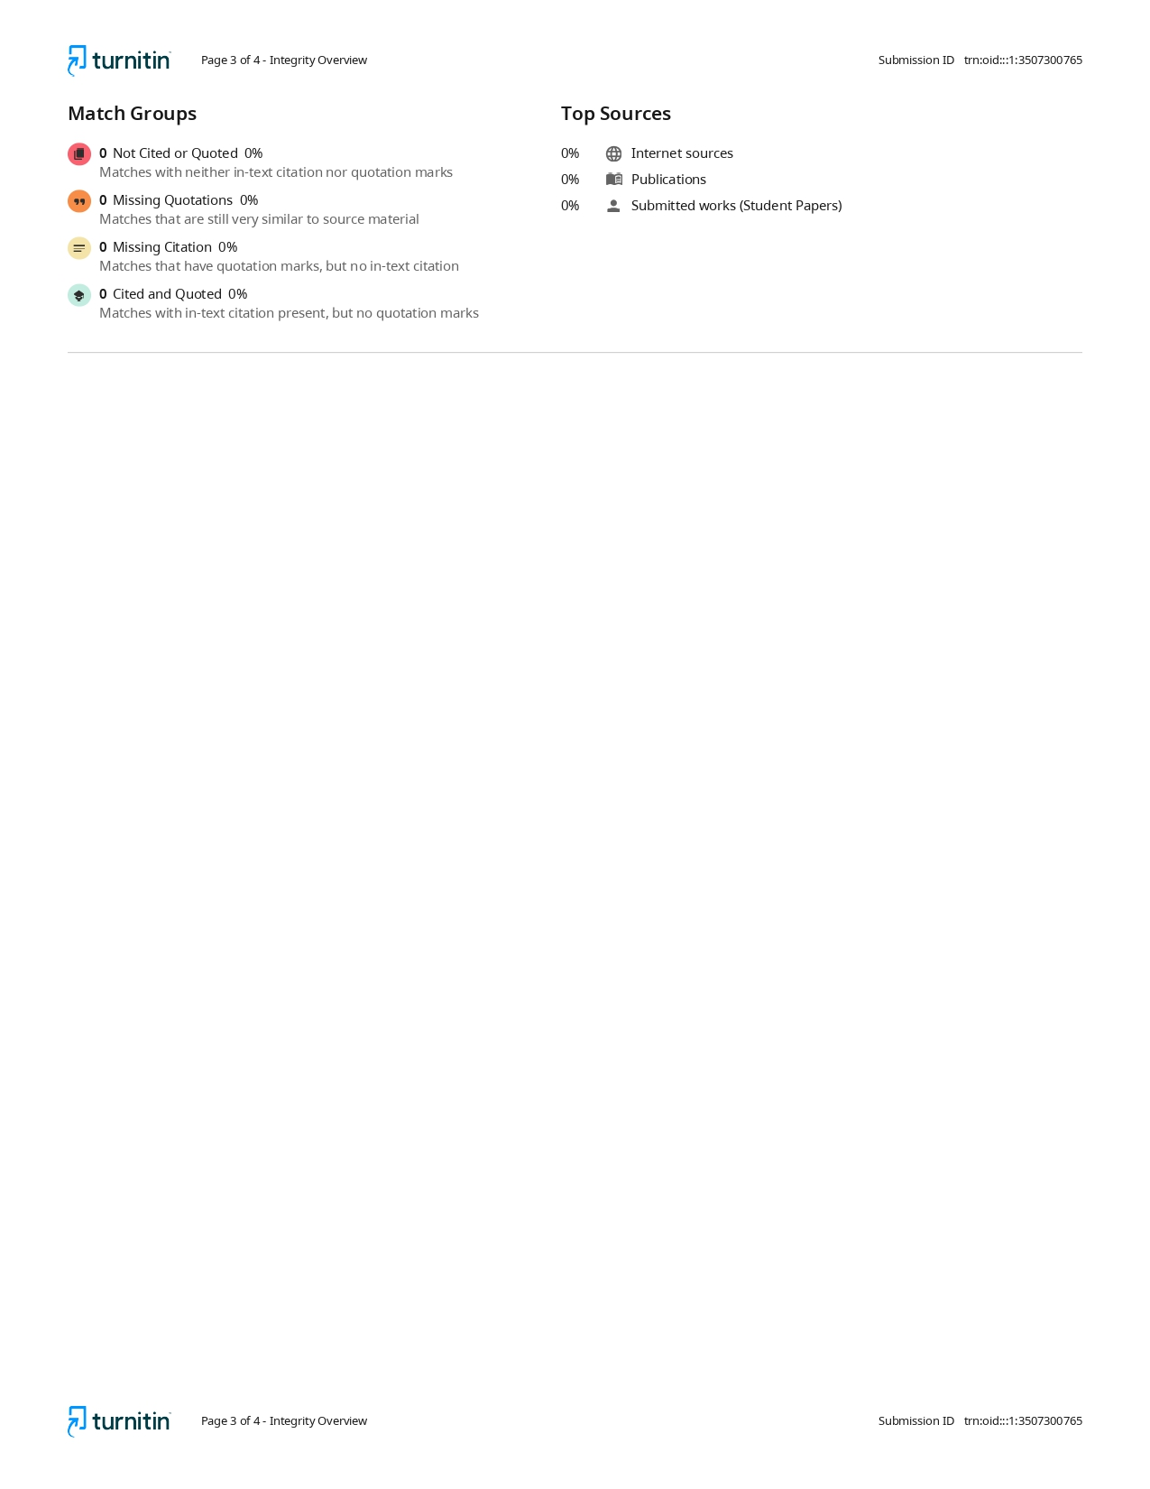
Table of Contents
ABSTRACT 12
LIST OF TABLES 13
LIST OF FIGURES 14
CHAPTER 1: INTRODUCTION 15
1.1 Background of the Study 15
1.2 Statement of Objectives 16
1.3 Scope of the Project 17
CHAPTER 2: LITERATURE SURVEY 19
2.1 Microservices Architecture 19
2.2 Monolith to Microservices Migration 21
2.3 Related Work 22
CHAPTER 3: SOFTWARE REQUIREMENT ANALYSIS 24
3.1 Hardware Specification 24
3.2 Software Specification 24
3.3 About the Software and its Features 25
3.3.1 Exam Examiner Service 25
3.3.2 Exam Reports Service 26
3.3.3 Parent Reports Service 27
CHAPTER 4: SYSTEM ANALYSIS 28
4.1 Requirement Specification 28
4.1.1 Functional Requirements — Exam Examiner Service 28
4.1.2 Functional Requirements — Exam Reports Service 29
4.1.3 Functional Requirements — Parent Reports Service 30
4.1.4 Non-Functional Requirements 31
4.2 Characteristics of Existing System 31
4.3 Feasibility Study 32
4.4 Software Requirement Specification 33
4.4.1 Exam Examiner Service 33
4.4.2 Exam Reports Service 33
4.4.3 Parent Reports Service 33
CHAPTER 5: SYSTEM DESIGN 34
5.1 System Architecture 34
5.1.1 Overall Architecture 34
5.1.2 Exam Examiner Service — Layered Architecture 35
5.1.3 Exam Reports Service — CQRS Architecture 37
5.1.4 Parent Reports Service — Domain-Driven Architecture 38
5.2 Context Diagram 40
5.3 Use Case Diagram 40
5.3.1 Exam Examiner Service — Use Cases 40
5.3.2 Exam Reports Service — Use Cases 41
5.3.3 Parent Reports Service — Use Cases 42
5.4 Activity Diagram 43
5.4.1 Exam Generation Flow 43
5.4.2 Parent Report Generation and Distribution Flow 44
5.5 Data Flow Diagram 45
5.5.1 Level 0 DFD — LMS Functional Modules 45
5.5.2 Level 1 DFD — Exam Examiner Service 45
5.5.3 Level 1 DFD — Parent Reports Service 46
5.6 Database Design 46
5.6.1 MongoDB Collections — Exam Examiner Service 46
5.6.2 MongoDB Collections — Exam Reports Service 48
5.6.3 MongoDB Collections — Parent Reports Service 48
5.7 User Interface Design 50
5.7.1 API Endpoints — Exam Examiner Service 50
5.7.2 API Endpoints — Exam Reports Service 50
5.7.3 API Endpoints — Parent Reports Service 51
CHAPTER 6: SYSTEM IMPLEMENTATION 52
6.1 Modules Description 52
6.1.1 Module 1: Exam Examiner Service 52
6.1.2 Module 2: Exam Reports Service 54
6.1.3 Module 3: Parent Reports Service 56
6.2 Validation Checks 59
6.2.1 Exam Examiner Service — 5-Layer Validation 59
6.2.2 Exam Reports Service — 2-Layer Validation 59
6.2.3 Parent Reports Service — 2-Layer Validation 60
6.2.4 Common Validation Patterns 60
CHAPTER 7: TESTING 61
7.1 Test Cases 61
7.1.1 Test Cases — Exam Examiner Service 61
7.1.2 Test Cases — Exam Reports Service 62
7.1.3 Test Cases — Parent Reports Service 63
7.2 Unit Testing 63
7.3 Integration Testing 64
CHAPTER 8: RESULT AND CONCLUSION 65
8.1 Results 65
8.1.1 Exam Examiner Service — Results 65
8.1.2 Exam Reports Service — Results 65
8.1.3 Parent Reports Service — Results 66
8.1.4 Overall Project Outcomes 66
8.2 Future Enhancements 68
CHAPTER 9: APPENDICES 69
Appendix-1: Plagiarism Certificate 69
Appendix-2: Screenshots 69
A2.1 Exam Examiner Service 69
A2.2 Exam Reports Service 70
A2.3 Parent Reports Service 73
Appendix-3: Sample Coding 76
A3.1 Exam Generation Service (Exam Examiner Service) 76
A3.2 CQRS Query Repository (Exam Reports Service) 77
A3.3 PDF Report Builder (Parent Reports Service) 78
A3.4 WhatsApp Async Sender (Exam Examiner Service) 78
Appendix-4: User Documentation 79
Installation Instructions 79
README: How to Interact with the System 80
Appendix-5: Glossary 81
CHAPTER 10: BIBLIOGRAPHY 82

ABSTRACT

Learning Management Systems (LMS) are essential platforms in educational institutions for managing academic operations including attendance tracking, examination administration, and stakeholder communication. As these systems grow in complexity, monolithic architectures become bottlenecks in scalability and maintainability. This project focuses on improving selected modules of an existing LMS used at Codegnan IT Solutions Pvt Ltd. Instead of maintaining the earlier tightly connected backend, the chosen modules were redesigned to function as separate services. The work includes redevelopment and enhancement of three main modules: an exam management module, an exam reporting module, and a parent reporting module. The exam module supports question handling, batch-level exam tracking, and student notifications. The reporting module provides exam-related summaries and performance information. The parent reporting module generates student performance reports, prepares PDF files, and shares them through WhatsApp. Report generation is handled separately so that it does not interrupt other LMS activities. The modules were developed using Python and MongoDB and organized in a way that allows them to operate independently. This approach reduces strong dependencies between components and simplifies future updates. During the transition from the earlier backend structure, unnecessary elements were removed to keep the system simpler and easier to manage. The project was carried out between December 2025 and March 2026 as part of the LMS redevelopment process at Codegnan IT Solutions Pvt Ltd.

Keywords: Learning Management System, Microservices, Flask, MongoDB, REST API, CQRS, WhatsApp Integration, PDF Generation, AWS, Celery, Redis

LIST OF TABLES

Table No. | Title | Page No.
3.1 | Hardware Specification | 24
3.2 | Software Specification | 24
3.3 | Technology Stack — Exam Examiner Service | 25
3.4 | Technology Stack — Exam Reports Service | 26
3.5 | Technology Stack — Parent Reports Service | 27
4.1 | Functional Requirements — Exam Examiner Service | 28
4.2 | Functional Requirements — Exam Reports Service | 29
4.3 | Functional Requirements — Parent Reports Service | 30
4.4 | Non-Functional Requirements | 31
5.1 | MongoDB Collections — Exam Examiner Service | 46
5.2 | MongoDB Collections — Exam Reports Service | 48
5.3 | MongoDB Collections — Parent Reports Service | 48
5.4 | API Endpoints — Exam Examiner Service | 50
5.5 | API Endpoints — Exam Reports Service | 50
5.6 | API Endpoints — Parent Reports Service | 51
6.1 | Validation Layers — Exam Examiner Service | 59
7.1 | Test Cases — Exam Examiner Service | 61
7.2 | Test Cases — Exam Reports Service | 62
7.3 | Test Cases — Parent Reports Service | 63

LIST OF FIGURES

Figure No. | Title | Page No.
5.1 | Overall System Architecture | 34
5.2 | Exam Examiner Service — Layered Architecture | 35
5.3 | Exam Reports Service — CQRS Architecture | 37
5.4 | Parent Reports Service — Domain - Driven Architecture | 38
5.5 | Context Diagram — LMS Functional Modules | 40
5.6 | Use Case Diagram — Exam Examiner Service | 40
5.7 | Use Case Diagram — Exam Reports Service | 41
5.8 | Use Case Diagram — Parent Reports Service | 42
5.9 | Activity Diagram — Exam Generation Flow | 43
5.1 | Activity Diagram — Report Generation and Distribution | 44
5.11 | Level 0 DFD — LMS Functional Modules | 45
5.12 | Level 1 DFD — Exam Examiner Service | 45
5.13 | Level 1 DFD — Parent Reports Service | 46
5.14 | MongoDB Document Schema — Exam Document | 47
5.15 | MongoDB Document Schema — Parent Report Document | 48

CHAPTER 1: INTRODUCTION

1.1 Background of the Study
The education technology sector has witnessed rapid growth in the adoption of Learning Management Systems (LMS) as centralized platforms for managing academic and administrative operations. These systems handle diverse functionalities including student enrollment, attendance tracking, curriculum management, examination administration, placement coordination, and stakeholder communication.
Codegnan IT Solutions Pvt Ltd operates a production-grade LMS platform that serves as the backbone for managing the complete lifecycle of students enrolled in various technical training programs. The platform supports multiple user roles — Administrators, Managers, Mentors, Students, Business Development Executives (BDEs), and Testers — across multiple geographical locations.
The existing LMS was built as a monolithic application using Python Flask framework with MongoDB as the primary data store, deployed on AWS Elastic Beanstalk. Over time, the system grew to encompass over 15 functional modules with more than 80 REST API endpoints. While functionally comprehensive, the monolithic architecture presented challenges in terms of independent scalability, deployment agility, and fault isolation for compute-intensive modules.
As part of the internship at Codegnan IT Solutions, the student was tasked with designing and developing three critical functional modules as independent microservices. These modules were identified as high-impact, computationally intensive components that would benefit most from independent deployment and scaling:
- Exam Examiner Service — Handles exam creation, paper generation with subject-specific question types, exam status management, and automated WhatsApp notifications to students. This module requires independent scaling during examination periods when 500+ students need to be notified simultaneously.
- Exam Reports Service — Provides comprehensive exam analytics and reporting for students, examiners (managers), mentors, and administrators. It implements the CQRS (Command Query Responsibility Segregation) pattern for optimized read-only operations with Redis caching for performance.
- Parent Reports Service — Automates the generation of personalized PDF performance reports (attendance, exam scores, placement data) and their distribution to parents via WhatsApp. This module involves heavy I/O operations including PDF generation, AWS S3 uploads, and WhatsApp API calls, making it a prime candidate for independent deployment with async processing.

The development methodology followed industry-standard practices including clean layered architecture, domain-driven design, Pydantic-based input validation, JWT authentication with role-based access control, and containerized deployment using Docker. Each service was designed with its own codebase, dependency management, and deployment pipeline, enabling independent development and deployment cycles.
The project was carried out during the period from December 2025 to March 2026 at Codegnan IT Solutions Pvt Ltd, under the guidance of experienced professionals in the organization.

1.2 Statement of Objectives
The primary objectives of this project are:
- To design and develop the Exam Examiner Service as an independent microservice that enables examiners to create exams, generate exam papers with subject-specific question types (MCQ, Code, Query), check exam status across batches, and automatically notify students via WhatsApp with delivery tracking.
- To design and develop the Exam Reports Service as a CQRS-based microservice that provides paginated exam summaries for students, detailed exam analysis with question-by-question review, examiner batch reports with search and filtering capabilities, mentor cross-location exam lists, and admin-level statistics with automated scheduling.
- To design and develop the Parent Reports Service as an async-processing microservice that aggregates student performance data from multiple sources (attendance, exams, placements), generates personalized PDF reports, uploads them to AWS S3, and distributes them to parents via WhatsApp with real-time delivery tracking.
- To implement clean layered architecture with strict separation of concerns across all three services — API layer, Service layer, Repository layer, and Integration layer.
- To implement comprehensive input validation using Pydantic v2 schemas and business logic validation to ensure data integrity across all API endpoints.
- To implement JWT-based authentication with role-based access control (RBAC) supporting multiple user roles — Student, Manager (Examiner), Mentor, and Admin.
- To deploy each service independently with its own configuration, dependency management, and health monitoring endpoints.

1.3 Scope of the Project

In Scope
Exam Examiner Service: - Exam status checking with pagination (GET API) - Exam data retrieval for specific batch, date, and subjects (POST API) - Exam paper generation with subject-specific question types and scoring (POST API) - Automated WhatsApp notifications to students via ChatRace API with rate limiting - WhatsApp webhook integration for delivery status tracking - 5-layer validation system (Pydantic, Middleware, Business Logic, MongoDB Schema, Custom Validators) - Database-driven enum system for subjects, locations, and modes - Notification tracking with per-student success/failure logging

Exam Reports Service: - Student exam summary with pagination and exam type filtering (GET API) - Student exam detail with subject breakdown analysis (GET API) - Question-by-question review with subject filtering and correct solutions (GET API) - Examiner exam day list with statistics per location (GET API) - Examiner batch reports with search, filter, and sort capabilities (GET API) - Examiner, Mentor, and Admin statistics endpoints (GET APIs) - Unified notification logs endpoint with role-based filtering (GET API) - CQRS pattern implementation for optimized read-only operations - Redis caching for enum mappings with local fallback - Automated stats scheduling using APScheduler

Parent Reports Service: - PDF report generation for weekly and monthly periods - Data aggregation from attendance, exam, and placement collections - PDF generation using ReportLab with student info, attendance tables, exam results - AWS S3 upload for generated PDF reports - WhatsApp distribution via ChatRace API with phone validation - Celery-based async processing with Redis as message broker - Real-time status tracking at document, location, batch, and student levels - Webhook processing for WhatsApp delivery confirmations - Three processing scenarios: specific batch, location-wide, all locations

Out of Scope
- Frontend application development
- Development of other LMS modules (admin, attendance, BDE, certificates, code playground)
- API Gateway or service mesh implementation
- Database-per-service migration
- CI/CD pipeline automation
- Load testing at production scale
- Mobile application development

CHAPTER 2: LITERATURE SURVEY

2.1 Microservices Architecture
Microservices architecture is an architectural style that structures an application as a collection of small, autonomous services, each running in its own process and communicating through lightweight mechanisms, typically HTTP/REST APIs. Each service is built around a specific business capability and can be independently developed, deployed, and scaled.
The foundational principles of microservices, as articulated by Fowler and Lewis [10], include:
- Single Responsibility: Each service handles one specific business domain or capability.
- Autonomy: Services are independently deployable without coordination with other services.
- Decentralized Data Management: Each service manages its own data access patterns.
- Design for Failure: Services handle failures gracefully with proper error handling and fallback mechanisms.
- Infrastructure Automation: Deployment and scaling are automated through containerization and cloud platforms.

In the context of this project, each of the three functional modules — Exam Examiner Service, Exam Reports Service, and Parent Reports Service — was designed as an independent microservice with its own Flask application, dependency management (requirements.txt), database access layer, and deployment configuration.

Advantages Relevant to This Project
- Independent Deployment: Each service can be deployed without affecting the other two services or the main LMS monolith.
- Targeted Scalability: The Parent Reports Service, which involves heavy PDF generation and WhatsApp API calls, can be scaled independently during report distribution periods.
- Fault Isolation: A failure in the WhatsApp notification system of the Examiner Service does not affect the Reports Service or the Parent Reports Service.
- Technology Flexibility: The Parent Reports Service uses Celery with Redis for async processing, while the Reports Service uses APScheduler — each service chooses the best tool for its specific needs.

Design Patterns Used
Several established design patterns were applied across the three services:
CQRS (Command Query Responsibility Segregation): Applied in the Exam Reports Service, where all operations are read-only queries against exam data. This pattern separates read operations from write operations, enabling optimized query paths with MongoDB aggregation pipelines.
Strategy Pattern: Applied in the Exam Examiner Service for handling different exam types (Daily-Exam, Weekly-Exam). The strategy pattern allows configuration-driven exam type handling without modifying core logic.

Repository Pattern: Applied across all three services to abstract data access logic behind clean interfaces. Each service has dedicated repository classes for each MongoDB collection it accesses.

Factory Pattern: Applied in the Exam Reports Service (RepositoryFactory) and Exam Examiner Service (DocumentFactory) for dynamic creation of repository and document instances based on exam type.

Layered Architecture: All three services follow strict layering — API Layer, Service Layer, Repository Layer, and Integration Layer — with clear responsibilities and no cross-layer violations.

2.2 Monolith to Microservices Migration
The Strangler Fig pattern, introduced by Fowler [9], is the most widely adopted strategy for incremental monolith decomposition. Named after the strangler fig tree that gradually envelops its host tree, this pattern involves:

- Identify: Select a module or functionality to extract from the monolith.
- Implement: Build the new microservice that replicates the identified functionality.
- Redirect: Route incoming requests to the new microservice instead of the monolith.
- Remove: Once the microservice is stable, remove the corresponding code from the monolith.

This pattern was followed in this project. The original LMS monolith contained exam management, exam reporting, and parent report functionality as tightly coupled modules within a single Flask application. These modules were identified as extraction candidates based on:

- High computational intensity: PDF generation, WhatsApp API calls, and complex MongoDB aggregations consume significant resources.
- Independent business domains: Each module serves a distinct business capability with minimal cross-module dependencies.
- Different scaling requirements: Exam generation peaks during exam periods, report distribution peaks weekly/monthly, while exam reports are accessed continuously.

After the three microservices were developed and deployed, the corresponding routes in the monolith’s app.py were commented out, completing the Strangler Fig migration for these modules.

Newman [13] documented practical patterns for decomposition, emphasizing the importance of starting with modules that have the highest change frequency and maintaining data consistency during migration. Balalaie et al. [3] presented a case study of migrating a cloud-based educational platform, reporting 60% reduction in deployment time and 45% improvement in resource utilization.

2.3 Related Work
Dragoni et al. [6] provided a comprehensive overview of microservices evolution and identified educational platforms as a growing adoption domain due to their periodic load patterns and diverse functional requirements.

Al-Debagy and Martinek [1] proposed a decomposition approach for e-learning platforms based on functional cohesion analysis, achieving a 35% reduction in deployment time and 50% improvement in fault isolation. Their approach of identifying high-cohesion, low-coupling modules aligns with the methodology adopted in this project.

Villamizar et al. [17] evaluated monolithic and microservice architecture patterns, demonstrating that microservices improved scalability by 40-60% for compute-intensive operations like exam processing and report generation.

Grinberg [11] demonstrated Flask’s suitability for microservices due to its minimal overhead and extensible architecture. The Flask-RESTful extension’s resource-based routing maps naturally to microservice API design.

Banker et al. [4] highlighted MongoDB’s aggregation pipeline as particularly valuable for reporting microservices, enabling complex analytics without requiring a separate data warehouse. This is directly applicable to the Exam Reports Service which relies heavily on MongoDB aggregation pipelines for exam statistics.

The CQRS pattern, as described by Young [18], separates read and write operations to optimize each independently. This pattern was applied in the Exam Reports Service where all endpoints are read-only, enabling optimized query paths and caching strategies without the complexity of write-side concerns.

Evans [7] introduced Domain-Driven Design principles including bounded contexts and aggregates, which guided the service boundary identification in this project. Richardson [16] provided practical microservices patterns with implementation examples that informed the design of inter-service communication and data management strategies.

CHAPTER 3: SOFTWARE REQUIREMENT ANALYSIS

3.1 Hardware Specification
Table 3.1: Hardware Specification
Component | Specification
Processor | Intel Core i5 / AMD Ryzen 5 or higher
RAM | 8 GB minimum (16 GB recommended)
Storage | 256 GB SSD minimum
Network | Stable internet connection for MongoDB Atlas, AWS S3, and WhatsApp API
Server (Production) | AWS Elastic Beanstalk instances with auto-scaling

3.2 Software Specification
Table 3.2: Software Specification
Software | Version | Purpose
Python | 3.11+ | Primary programming language
Flask | 3.1.1 / 2.3.3 | Web framework
Flask-RESTful | 0.3.10 | REST API extension
MongoDB | 5.0+ (Atlas) | Primary database
Redis | 6.0+ | Message broker, caching
Docker | 24.0+ | Containerization
Git | 2.40+ | Version control
Gunicorn | 21.2 – 23.0 | Production WSGI server
VS Code / Kiro | Latest | Development IDE
Postman | Latest | API testing
Operating System | Windows 11 / Linux | Development and deployment

3.3 About the Software and its Features

3.3.1 Exam Examiner Service
Table 3.3: Technology Stack — Exam Examiner Service
Technology | Version | Purpose
Flask | 3.1.1 | Web framework
Flask-RESTful | 0.3.10 | REST API resource routing
Flask-JWT-Extended | 4.7.1 | JWT authentication
Flask-CORS | 6.0.0 | Cross-origin resource sharing
PyMongo | 4.13.0 | MongoDB driver
Pydantic | 2.10.4 | Input validation schemas
Requests | 2.32.3 | HTTP client for WhatsApp API
Gunicorn | 23.0.0 | Production WSGI server
python-dotenv | 1.1.1 | Environment configuration

Key Features: - Exam paper generation with subject-specific question types (MCQ, Code, Query) - 5-layer validation system (Pydantic → Middleware → Business Logic → MongoDB Schema → Custom Validators) - Async WhatsApp notifications to 500+ students with ThreadPoolExecutor - Rate limiting for WhatsApp API calls (configurable delay between requests) - Webhook integration for real-time delivery status updates - Database-driven enum system for subjects, locations, and modes - Notification tracking with per-student success/failure logging - TTL-based caching for enum data optimization

3.3.2 Exam Reports Service
Table 3.4: Technology Stack — Exam Reports Service
Technology | Version | Purpose
Flask | 3.1.1 | Web framework
Flask-RESTful | 0.3.10 | REST API resource routing
Flask-JWT-Extended | 4.7.1 | JWT authentication
Flask-CORS | 6.0.0 | Cross-origin resource sharing
PyMongo | 4.13.0 | MongoDB driver
Pydantic | 2.10.4 | Input validation schemas
Redis | 5.0.1 | Enum caching
APScheduler | 3.10.4 | Automated stats scheduling
Schedule | 1.2.0 | Task scheduling
Gunicorn | 23.0.0 | Production WSGI server

Key Features: - CQRS pattern with read-only operations for optimized performance - 10 API endpoints serving 4 user roles (Student, Examiner, Mentor, Admin) - Redis caching for enum mappings with 1-hour TTL and local fallback - Paginated responses with configurable page size - Search, filter, and sort capabilities for batch reports - Auto-submit detection for cron-submitted exams - Correct source code display for incorrect answers - IST timezone formatting for timestamps - Automated stats scheduling with APScheduler

3.3.3 Parent Reports Service
Table 3.5: Technology Stack — Parent Reports Service
Technology | Version | Purpose
Flask | 2.3.3 | Web framework
Flask-RESTful | 0.3.10 | REST API resource routing
PyMongo | 4.6.0 | MongoDB driver
Pydantic | 2.5.0 | Input validation schemas
Celery | 5.3.4 | Distributed task queue
Redis | 5.0.1 | Message broker and result backend
Boto3 | 1.28.0 | AWS SDK for S3 uploads
ReportLab | 4.0.4 | PDF generation
PyPDF2 | 3.0.1 | PDF manipulation and merging
phonenumbers | 8.13.0 | Phone number validation
PyJWT | 2.8.0 | JWT authentication
Gunicorn | 21.2.0 | Production WSGI server

Key Features: - Automated PDF report generation (weekly and monthly) - Data aggregation from attendance, exam, and placement collections - PDF components: student info, attendance tables, exam results, manager contacts - AWS S3 upload with public URL generation - WhatsApp distribution via ChatRace API with rate limiting - Celery-based async processing for long-running operations - Three processing scenarios: specific batch, location-wide, all locations - Real-time status tracking at document, location, batch, and student levels - Webhook processing for delivery confirmations with deduplication - Phone number validation and E164 format conversion

CHAPTER 4: SYSTEM ANALYSIS

4.1 Requirement Specification

4.1.1 Functional Requirements — Exam Examiner Service

Table 4.1: Functional Requirements — Exam Examiner Service
ID | Requirement | Priority
FR-EE-01 | The system shall allow examiners to check exam status for a given date and exam type with pagination | High
FR-EE-02 | The system shall retrieve exam data for a specific batch, date, and subjects | High
FR-EE-03 | The system shall generate exam papers with subject-specific question types (MCQ for aptitude, Query for SQL, MCQ + Code for programming) | High
FR-EE-04 | The system shall automatically send WhatsApp notifications to all eligible students upon exam generation | High
FR-EE-05 | The system shall track notification delivery status via webhook callbacks | Medium
FR-EE-06 | The system shall validate all inputs through a 5-layer validation system | High
FR-EE-07 | The system shall use database-driven enums for subjects, locations, and modes | Medium
FR-EE-08 | The system shall extract examiner location and ID from JWT claims | High

4.1.2 Functional Requirements — Exam Reports Service
Table 4.2: Functional Requirements — Exam Reports Service
ID | Requirement | Priority
FR-ER-01 | The system shall provide paginated exam summaries for students with exam type filtering | High
FR-ER-02 | The system shall provide detailed exam analysis with subject breakdown for students | High
FR-ER-03 | The system shall provide question-by-question review with optional subject filtering | High
FR-ER-04 | The system shall provide exam day lists with statistics for examiners (location-specific) | High
FR-ER-05 | The system shall provide batch reports with search, filter, and sort for examiners | High
FR-ER-06 | The system shall provide cross-location exam lists for mentors | Medium
FR-ER-07 | The system shall provide statistics endpoints for examiners, mentors, and admins | Medium
FR-ER-08 | The system shall provide unified notification logs with role-based filtering | Medium
FR-ER-09 | The system shall cache enum mappings in Redis with local fallback | Medium
FR-ER-10 | The system shall display correct source code for incorrect code/query answers | High

4.1.3 Functional Requirements — Parent Reports Service
Table 4.3: Functional Requirements — Parent Reports Service
ID | Requirement | Priority
FR-PR-01 | The system shall generate personalized PDF reports for students (weekly and monthly) | High
FR-PR-02 | The system shall aggregate data from attendance, exam, and placement collections | High
FR-PR-03 | The system shall upload generated PDFs to AWS S3 and store public URLs | High
FR-PR-04 | The system shall distribute reports via WhatsApp with phone validation | High
FR-PR-05 | The system shall support async processing via Celery for large batch operations | High
FR-PR-06 | The system shall track status at document, location, batch, and student levels | High
FR-PR-07 | The system shall process webhooks for WhatsApp delivery confirmations | Medium
FR-PR-08 | The system shall support three scenarios: specific batch, location, all locations | High
FR-PR-09 | The system shall prevent duplicate processing with in-progress detection | Medium
FR-PR-10 | The system shall provide status and list query endpoints for monitoring | Medium

4.1.4 Non-Functional Requirements
Table 4.4: Non-Functional Requirements
ID | Requirement | Category
NFR-01 | API response time shall be less than 100ms for report queries | Performance
NFR-02 | The system shall handle 500+ concurrent WhatsApp notifications | Scalability
NFR-03 | Each service shall be independently deployable | Deployability
NFR-04 | All endpoints shall require JWT authentication with role-based access | Security
NFR-05 | Input validation shall prevent NoSQL injection and XSS attacks | Security
NFR-06 | Services shall return standardized error responses with proper HTTP status codes | Reliability
NFR-07 | MongoDB connection pooling shall be configured (50 max, 10 min) | Performance
NFR-08 | Services shall include health check endpoints for monitoring | Availability

4.2 Characteristics of Existing System
The existing LMS monolith is a single Flask application (app.py) that imports and registers all 80+ API endpoints at startup. The relevant characteristics that motivated the extraction of these three modules are:

Single Deployment Unit: The monolith’s app.py imports all modules including exam management, reporting, parent reports, admin, attendance, BDE, certificates, and more. Any change to the exam generation logic requires redeploying the entire application, including unrelated modules like certificate generation or job postings.

Shared Resource Pool: The MongoDB connection pool (maxPoolSize=50) is shared across all modules. During exam generation when WhatsApp notifications are being sent to 500+ students, the connection pool can be exhausted, causing timeouts for unrelated operations like student profile updates.

No Fault Isolation: An unhandled exception in the WhatsApp notification pipeline can crash the entire Flask application, taking down all 80+ API endpoints simultaneously. There is no fault boundary between the exam system and other modules.

Monolithic Dependencies: The requirements.txt contains 90+ packages. The exam modules only need Flask, PyMongo, Pydantic, and Requests, but every deployment installs all dependencies including ReportLab (certificates), Google Generative AI (ATS checks), and Pandas (data export).

Commented-Out Routes: The monolith’s app.py shows the migration evidence — exam APIs, parent report APIs, and exam statistics APIs are all commented out, indicating they were previously part of the monolith and have been migrated to independent services.

4.3 Feasibility Study

Technical Feasibility
The project is technically feasible as it uses well-established technologies — Python Flask for web services, MongoDB for data storage, Redis for caching and message brokering, and AWS for cloud infrastructure. The development team has existing expertise in these technologies from maintaining the monolith.

Operational Feasibility
The three microservices maintain the same API contracts and authentication mechanisms (JWT) as the original monolith endpoints, ensuring seamless integration with existing frontend clients. The migration follows the Strangler Fig pattern, allowing gradual transition without service disruption.

Economic Feasibility
The microservices architecture enables cost optimization through independent scaling. The Parent Reports Service, which runs heavy PDF generation only during weekly/monthly report periods, can be scaled down during idle periods. The Exam Examiner Service can be scaled up during examination periods. This targeted scaling reduces overall infrastructure costs compared to scaling the entire monolith.

4.4 Software Requirement Specification

4.4.1 Exam Examiner Service
- Input: Exam type, date, batch, subjects with question configurations, JWT token
- Processing: Validate inputs through 5 layers, fetch questions from subject-specific collections, generate exam document, store in MongoDB, send WhatsApp notifications asynchronously
- Output: Exam document ID, notification tracking statistics

4.4.2 Exam Reports Service
- Input: Student ID (from JWT), exam type, exam document ID, pagination parameters, search/filter/sort parameters
- Processing: Validate inputs via Pydantic, fetch exam data from MongoDB with aggregation pipelines, convert enum IDs to readable names via Redis cache, format responses with pagination metadata
- Output: Paginated exam summaries, detailed analysis, question reviews, batch reports, statistics

4.4.3 Parent Reports Service
- Input: Report type (weekly/monthly), location, batch, date range, processing mode (sync/async)
- Processing: Aggregate student data from multiple collections, generate PDF reports using ReportLab, upload to AWS S3, send WhatsApp messages via ChatRace API, track delivery status
- Output: PDF reports on S3, WhatsApp delivery status, processing statistics at all hierarchy levels

CHAPTER 5: SYSTEM DESIGN

5.1 System Architecture

5.1.1 Overall Architecture
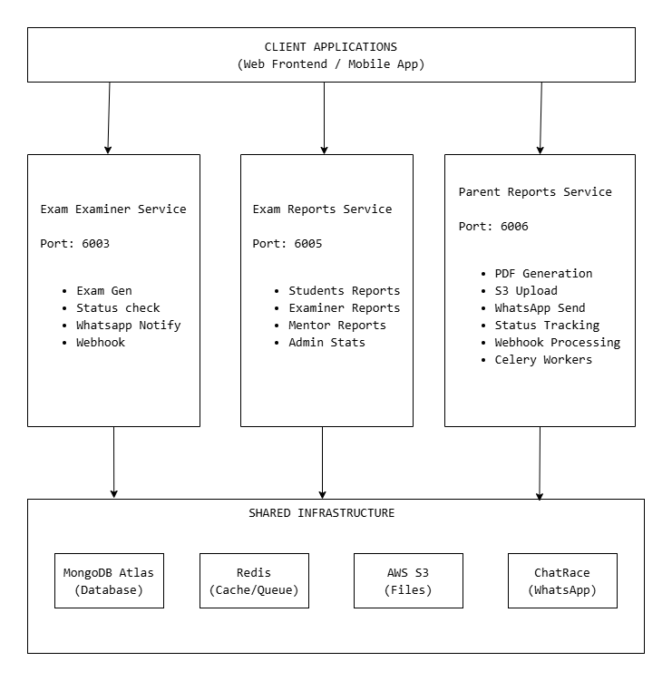
The three functional modules are designed as independent microservices, each with its own Flask application, database access layer, and deployment configuration. They share the MongoDB Atlas cluster but access only their relevant collections.

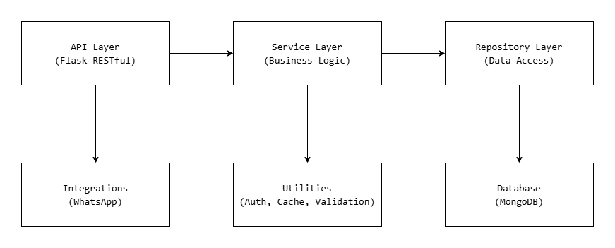
5.1.2 Exam Examiner Service — Layered Architecture

Project Structure:
exam-examiner-service/
├── app.py # Flask application entry point
├── src/
│ ├── api/
│ │ ├── examiner_api.py # ExamStatusAPI, ExamDataAPI, ExamGenerationAPI
│ │ └── webhook_api.py # WhatsAppWebhookAPI
│ ├── config/
│ │ └── settings.py # Service configuration
│ ├── exceptions/
│ │ ├── custom_exceptions.py # ValidationError, NotFoundError, etc.
│ │ └── error_handler.py # Centralized error handling
│ ├── integrations/
│ │ ├── whatsapp_client.py # ChatRace API client
│ │ ├── whatsapp_payloads.py # Message payload builders
│ │ └── whatsapp_sender.py # Async notification sender
│ ├── middleware/
│ │ └── validation_middleware.py # @validate_json_schema, @validate_query_schema
│ ├── repositories/
│ │ ├── batch.py # Batch data access
│ │ ├── curriculum.py # Curriculum data access
│ │ ├── exam.py # Exam CRUD operations
│ │ ├── factory.py # Repository factory
│ │ ├── manager.py # Manager data access
│ │ ├── notification_repository.py # Notification tracking
│ │ ├── question.py # Question data access
│ │ ├── student.py # Student data access
│ │ └── window.py # Exam window configs
│ ├── schemas/
│ │ ├── exam_schemas.py # Pydantic validation schemas
│ │ ├── mongodb_exam_schema.py # MongoDB document validation
│ │ └── webhook_schemas.py # Webhook validation schemas
│ ├── services/
│ │ ├── strategies/ # Strategy pattern for exam types
│ │ ├── curriculum_service.py # Curriculum business logic
│ │ ├── document_factory.py # Exam document creation
│ │ ├── generation_service.py # Exam paper generation
│ │ ├── status_service.py # Exam status checking
│ │ ├── validation_service.py # Business logic validation
│ │ ├── webhook_processing_service.py # Webhook processing
│ │ └── window_service.py # Exam window management
│ └── utils/
│ ├── cache/ # TTL-based enum caching
│ ├── database/ # MongoDB connection management
│ ├── formatting/ # Data formatting utilities
│ ├── pagination/ # Paginated response builder
│ ├── queue/ # Webhook queue management
│ ├── response/ # Standardized API responses
│ ├── security/ # JWT auth middleware
│ ├── time/ # Time utilities
│ ├── validation/ # Input validation utilities
│ └── webhook/ # Webhook processing utilities
├── requirements.txt
├── Dockerfile
└── .ebextensions/
└── 01_flask.config

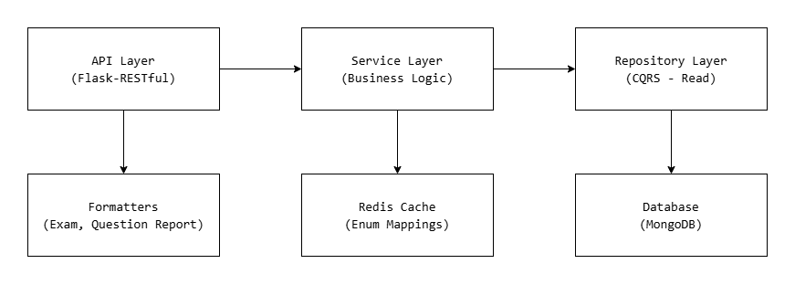
5.1.3 Exam Reports Service — CQRS Architecture

Service Hierarchy:
BaseExamService (DRY - common exam fetching logic)
├── Student Services
│ ├── ExamSummaryService — Paginated exam list with scores
│ ├── ExamDetailService — Detailed exam analysis
│ └── ExamReviewService — Question-by-question review
├── Examiner Services
│ ├── ExamDayListService — Exam schedule with statistics
│ └── BatchReportsService — Student-wise batch reports
├── Mentor Services
│ └── MentorExamListService — Cross-location exam list
├── Stats Services
│ └── StatsScheduler — Automated statistics calculation
└── Admin Services
└── AdminStatsService — System-wide statistics

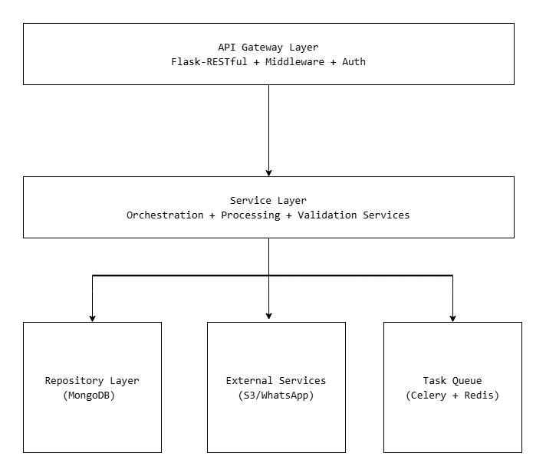
5.1.4 Parent Reports Service — Domain-Driven Architecture

Domain Organization:
parent-reports-service/
├── app.py # Flask entry point (6 endpoints)
├── webhook_worker.py # Webhook processing worker
├── src/
│ ├── api/ # HTTP handling
│ │ ├── middleware/ # Request validation
│ │ ├── reports/ # ReportProcessor, ReportStatus, ReportList
│ │ ├── status/ # Status query endpoints
│ │ └── whatsapp/ # WhatsAppProcessor, WhatsAppStatus, Webhook
│ ├── common/ # Shared kernel
│ │ ├── auth/ # JWT authentication
│ │ ├── config/ # AppConfig, DatabaseConfig, S3Config, RedisConfig
│ │ ├── constants/ # Application constants
│ │ ├── database/ # MongoDB connection
│ │ ├── exceptions/ # Custom exceptions
│ │ ├── external/ # S3 client, WhatsApp client
│ │ ├── repositories/ # Shared data access
│ │ ├── services/ # Cross-domain services (Tracking, Stats, Completion)
│ │ ├── tasks/ # Celery configuration
│ │ └── utils/ # Logger, formatters
│ ├── reports/ # Reports bounded context
│ │ ├── pdf/ # PDF generation (ReportLab components)
│ │ ├── repositories/ # Report data aggregation
│ │ ├── schemas/ # Pydantic validation
│ │ ├── services/ # Orchestration, Processing services
│ │ └── tasks/ # Celery async tasks
│ └── whatsapp/ # WhatsApp bounded context
│ ├── client/ # ChatRace API client
│ ├── repositories/ # WhatsApp data access
│ ├── schemas/ # WhatsApp validation
│ ├── services/ # WhatsApp processing
│ ├── tasks/ # WhatsApp async tasks
│ └── utils/ # Phone formatter, payload builder
├── requirements.txt
├── Dockerfile
└── docker-compose.yml

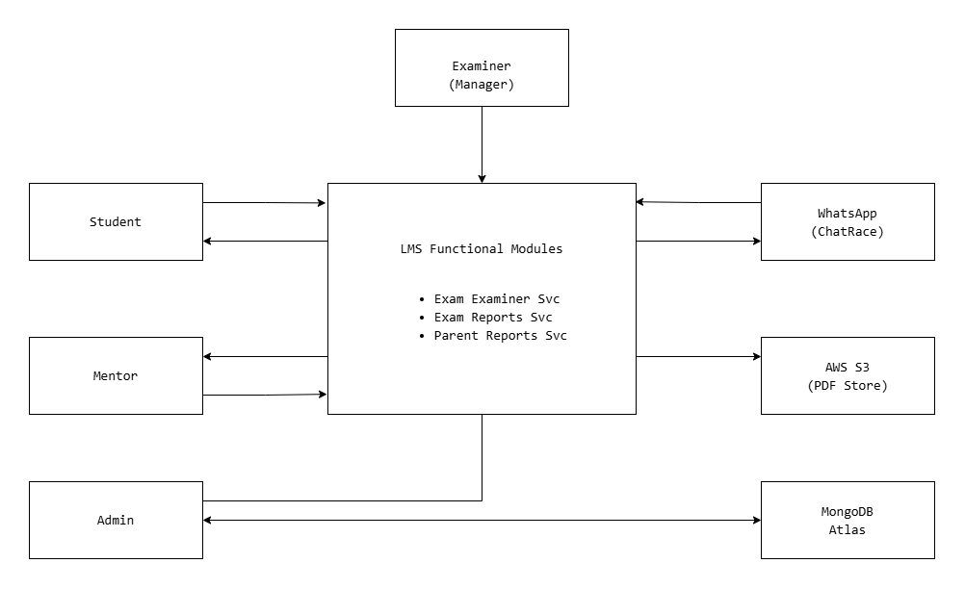
5.2 Context Diagram

5.3 Use Case Diagram

5.3.1 Exam Examiner Service — Use Cases
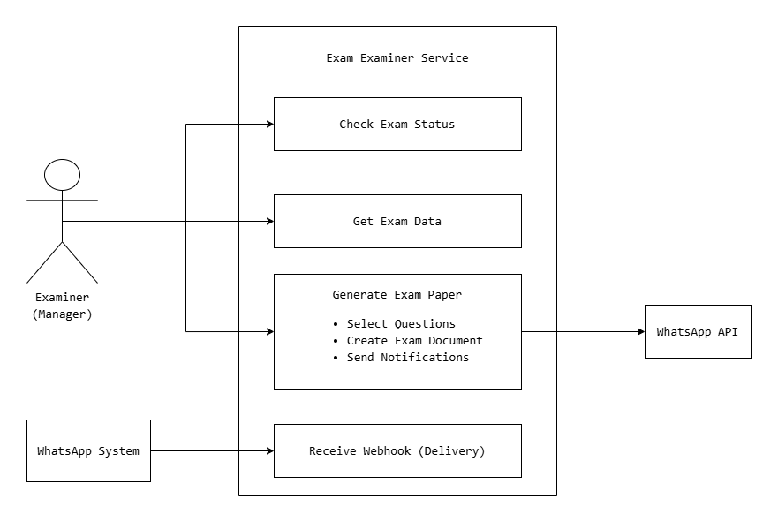

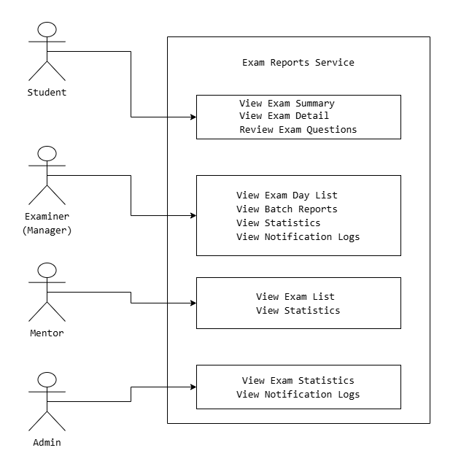
5.3.2 Exam Reports Service — Use Cases

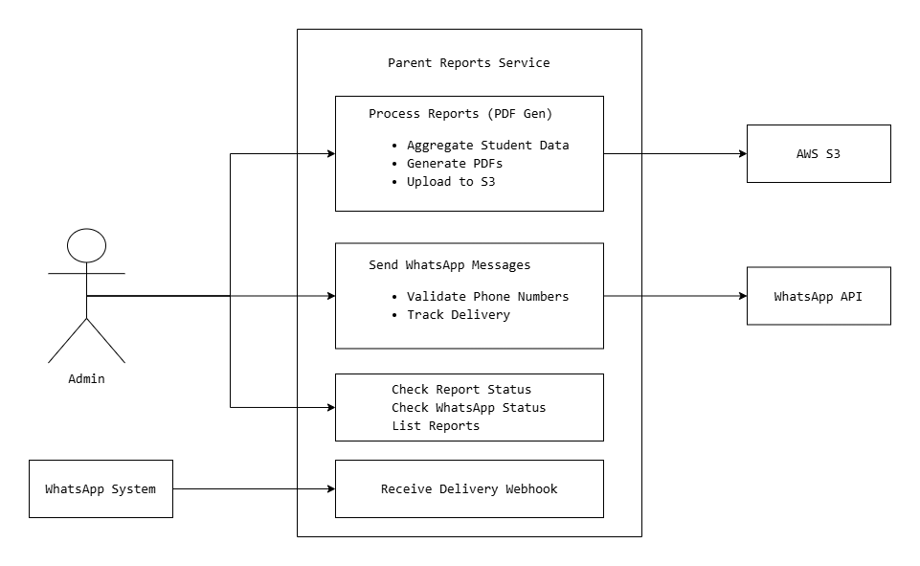
5.3.3 Parent Reports Service — Use Cases

5.4 Activity Diagram

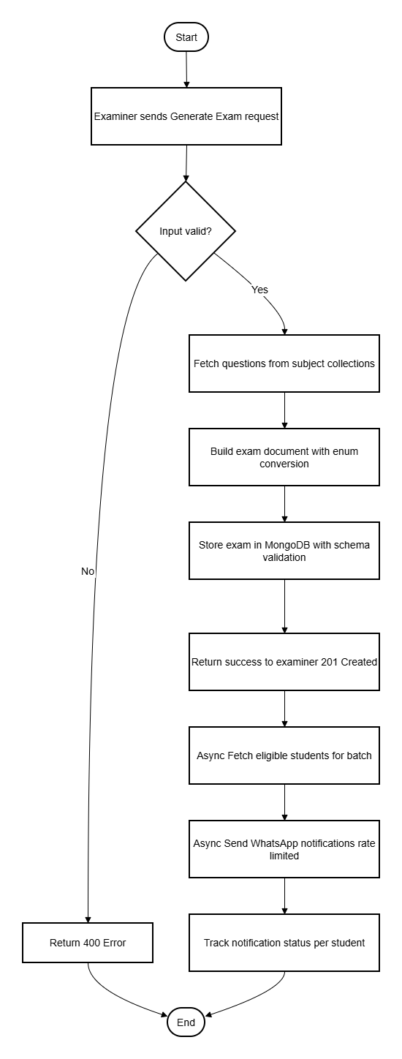
5.4.1 Exam Generation Flow

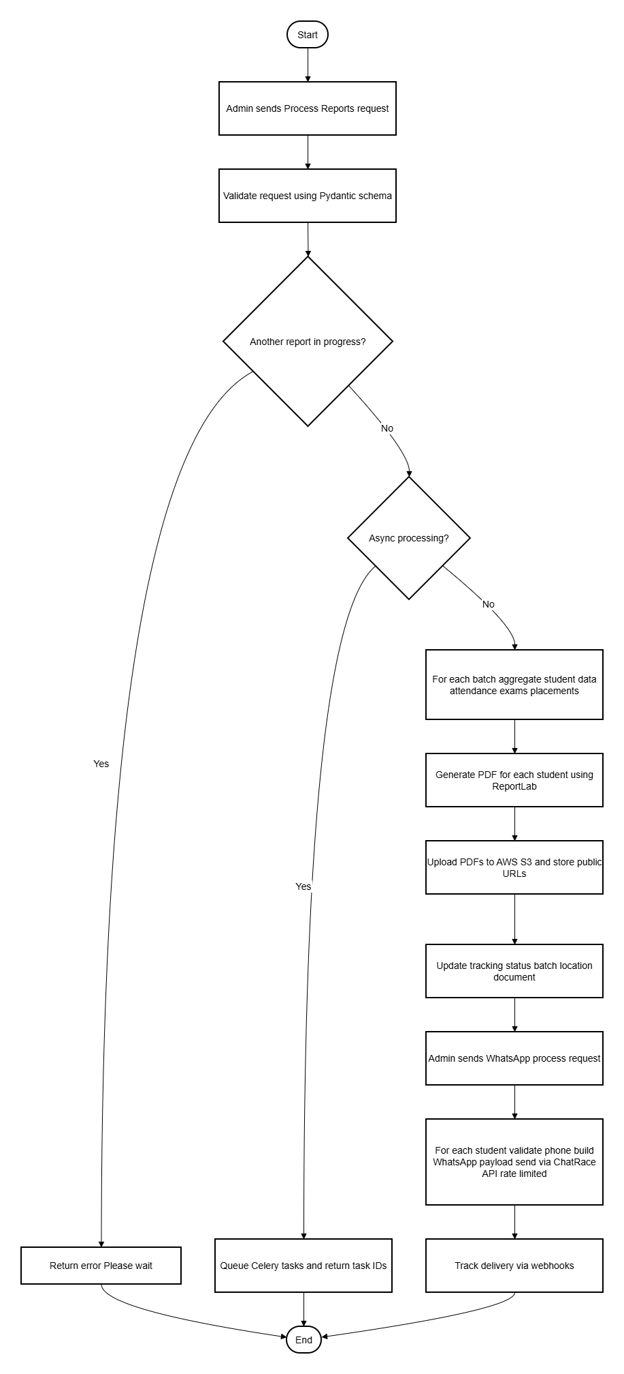
5.4.2 Parent Report Generation and Distribution Flow

5.5 Data Flow Diagram

5.5.1 Level 0 DFD — LMS Functional Modules

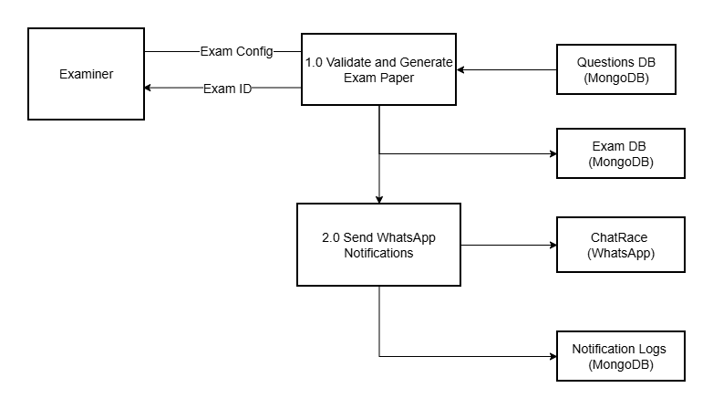
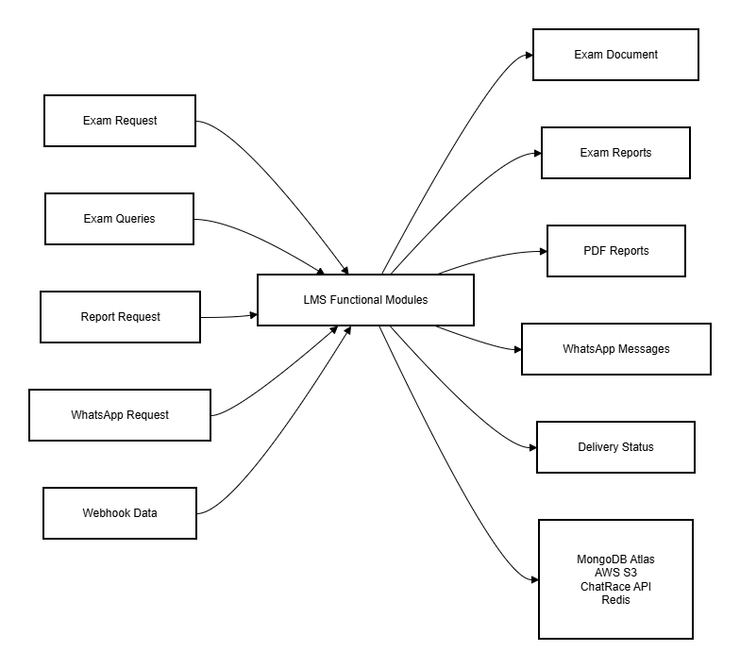
5.5.2 Level 1 DFD — Exam Examiner Service

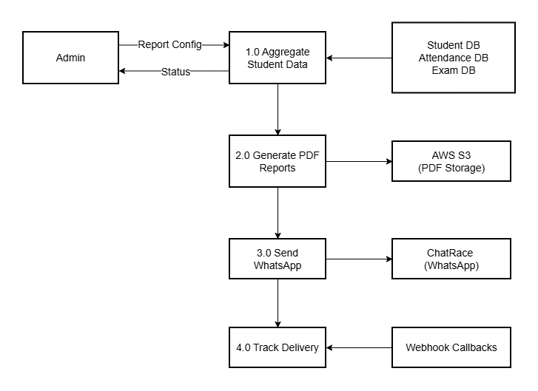
5.5.3 Level 1 DFD — Parent Reports Service

5.6 Database Design

5.6.1 MongoDB Collections — Exam Examiner Service
Table 5.1: MongoDB Collections — Exam Examiner Service
Collection | Purpose | Operations
Daily-Exam | Daily exam documents with nested students | Read / Write
Weekly-Exam | Weekly exam documents | Read / Write
notification_logs | Notification tracking with stats | Read / Write
enums | Enum mappings (subjects, locations, modes) | Read
student_login_details | Student info for notifications | Read
Batches | Active batch configurations | Read
window_configs | Exam window configurations | Read

Exam Document Schema:
{
"_id": ObjectId,
"examDate": "2025-01-15",
"examName": "Daily-Exam-78",
"location": 1,
"batch": "PFS-TD-888",
"mode": 1,
"windowStartTime": "10:00",
"windowEndTime": "10:30",
"windowDurationSeconds": 1800,
"totalExamTime": 10,
"subjects": [
{
"subject": 5,
"tags": ["Day-8:1", "Day-8:2"],
"selectedMCQs": {"1": 5},
"selectedCoding": {"1": 1},
"totalTime": 10
}
],
"students": [
{
"studentId": "STU001",
"paper": [...],
"score": 0,
"submitStatus": "not_attempted"
}
]
}

5.6.2 MongoDB Collections — Exam Reports Service
Table 5.2: MongoDB Collections — Exam Reports Service
Collection | Purpose | Operations
Daily-Exam | Daily exam documents | Read Only
Weekly-Exam | Weekly exam documents | Read Only
Monthly-Exam | Monthly exam documents | Read Only
enums | Enum mappings | Read Only
{subject}_mcq | Subject MCQ questions (e.g., python_mcq) | Read Only
{subject}_code | Subject code questions (e.g., python_code) | Read Only
{subject}_query | Subject query questions (e.g., mysql_query) | Read Only
notification_logs | Notification tracking | Read Only

5.6.3 MongoDB Collections — Parent Reports Service
Table 5.3: MongoDB Collections — Parent Reports Service
Collection | Purpose | Operations
parent_whatsapp_report | Report tracking document | Read / Write
student_login_details | Student data | Read
Batches | Batch information | Read
Attendance | Attendance records | Read
Daily-Exam-v3 | Exam scores | Read
jobs_listing | Placement data | Read
Manager | Manager contacts | Read

Parent Report Document Schema:
{
"_id": "weekly_2025-01-19_to_2025-01-24",
"report_type": "weekly",
"period_id": "2025-01-19_to_2025-01-24",
"status": "COMPLETED",
"global_stats": {
"total_students": 45,
"pdfs_generated": 45,
"whatsapp_sent": 43,
"whatsapp_delivered": 40,
"processing_time_seconds": 900
},
"locations": {
"Hyderabad": {
"status": "COMPLETED",
"batches": {
"DS-8": {
"status": "COMPLETED",
"total_students": 25,
"students": [
{
"student_id": "STU001",
"name": "Student Name",
"parent_phone": "919876543210",
"pdf_status": "SUCCESS",
"s3_url": "https://s3.amazonaws.com/...",
"whatsapp_status": "DELIVERED"
}
]
}
}
}
}
}

5.7 User Interface Design
Since the three modules are backend REST API services, the user interface is the API itself. The API endpoints are consumed by the LMS frontend application.

5.7.1 API Endpoints — Exam Examiner Service
Table 5.4: API Endpoints — Exam Examiner Service
Method | Endpoint | Auth | Purpose
GET | /api/v1.0/examiner/check-exam-status | Manager JWT | Check exam status with pagination
POST | /api/v1.0/examiner/exam-data | Manager JWT | Get exam data for batch/date/subjects
POST | /api/v1.0/examiner/generate-exam | Manager JWT | Generate exam paper + notify students
POST | /api/v1.0/examiner/webhook/whatsapp | Public | Receive WhatsApp delivery webhooks

5.7.2 API Endpoints — Exam Reports Service
Table 5.5: API Endpoints — Exam Reports Service
Method | Endpoint | Auth | Purpose
GET | /api/v1.0/reports/student-exam-summary | Student JWT | Paginated exam list
GET | /api/v1.0/reports/student-exam-detail | Student JWT | Detailed exam analysis
GET | /api/v1.0/reports/exam-questions-review | Student JWT | Question-by-question review
GET | /api/v1.0/reports/examiner/exam-day-list | Manager JWT | Exam schedule with stats
GET | /api/v1.0/reports/examiner/batch-reports | Manager JWT | Student-wise batch reports
GET | /api/v1.0/reports/examiner/stats | Manager JWT | Examiner statistics
GET | /api/v1.0/reports/mentor/exam-list | Mentor JWT | Cross-location exam list
GET | /api/v1.0/reports/mentor/stats | Mentor JWT | Mentor statistics
GET | /api/v1.0/reports/admin/stats/counts | Admin JWT | System-wide statistics
GET | /api/v1.0/reports/notification-logs | Multi-role | Unified notification logs

5.7.3 API Endpoints — Parent Reports Service
Table 5.6: API Endpoints — Parent Reports Service
Method | Endpoint | Auth | Purpose
POST | /api/reports/process | Admin JWT | Generate PDF reports
GET | /api/reports/status | Admin JWT | Query report status
GET | /api/reports/list | Admin JWT | List all reports
POST | /api/whatsapp/process | Admin JWT | Send WhatsApp messages
GET | /api/whatsapp/status | Admin JWT | Query WhatsApp delivery status
POST | /api/whatsapp/webhook | Public | Receive delivery webhooks

CHAPTER 6: SYSTEM IMPLEMENTATION

6.1 Modules Description

6.1.1 Module 1: Exam Examiner Service
The Exam Examiner Service is responsible for exam creation, paper generation, and automated student notifications. It runs as an independent Flask application on port 6003 (local) / 6003 (containerized).
Application Entry Point (app.py):
from flask import Flask, jsonify
from flask_restful import Api
from flask_jwt_extended import JWTManager
from flask_cors import CORS
from src.api.examiner_api import ExamStatusAPI, ExamDataAPI, ExamGenerationAPI
from src.api.webhook_api import WhatsAppWebhookAPI
from src.utils.queue.webhook_queue import webhook_queue
from src.services.webhook_processing_service import WebhookProcessingService
def create_app():
app = Flask(__name__)
app.config['JWT_SECRET_KEY'] = os.getenv('JWT_SECRET_KEY')
jwt = JWTManager(app)
CORS(app)
api = Api(app)
api.add_resource(ExamStatusAPI, '/api/v.1.0/examiner/check-exam-status')
api.add_resource(ExamDataAPI, '/api/v.1.0/examiner/exam-data')
api.add_resource(ExamGenerationAPI, '/api/v.1.0/examiner/generate-exam')
api.add_resource(WhatsAppWebhookAPI, '/api/v.1.0/examiner/webhook/whatsapp')
# Start webhook queue workers
service = WebhookProcessingService()
webhook_queue.start_workers(service.process_webhook, num_workers=50)
return app

Key Implementation Details:
Exam Generation Flow: 1. The examiner (manager) sends a POST request with exam configuration including batch, subjects, question counts, and time limits. 2. The 5-layer validation system validates the input — Pydantic schema validates field types and formats, middleware validates JSON structure, business logic validates exam rules (e.g., max 60 minutes for daily exams, Monday-Saturday only), MongoDB schema validates the document structure, and custom validators check enum values against the database. 3. The generation service fetches questions from subject-specific collections (e.g., python_mcq, python_code, mysql_query) based on the requested tags and difficulty levels. 4. The document factory builds the exam document with enum-converted values (subject names → IDs, location names → IDs) and stores it in the appropriate collection (Daily-Exam or Weekly-Exam). 5. After successful storage, the service asynchronously fetches all eligible students for the batch and sends WhatsApp notifications via the ChatRace API using ThreadPoolExecutor with rate limiting.
WhatsApp Notification System: - Uses ThreadPoolExecutor with configurable workers (default: 4) - Rate limiting with configurable delay between API calls (default: 0.7 seconds) - Per-student notification tracking in notification_logs collection - Webhook endpoint receives delivery confirmations from ChatRace - Queue-based webhook processing with 50 workers for high throughput.

Subject-Specific Question Types: - C, C++, Java, Python: MCQ + Code questions - MySQL: MCQ + Query questions - Advanced Java, Flask, Frontend, Aptitude, DataAnalytics, Statistics, ML, DL: MCQ only - Soft Skills: Excluded from exams
Scoring System: - MCQ: 1 point per question - Coding: Easy (5), Medium (10), Hard (15) points - Query: Easy (5), Medium (10), Hard (15) points.

6.1.2 Module 2: Exam Reports Service
The Exam Reports Service provides comprehensive exam analytics and reporting using the CQRS pattern. It runs on port 6005 and serves 10 API endpoints for 4 user roles.

Application Entry Point (app.py):

from flask import Flask, jsonify
from flask_restful import Api
from flask_jwt_extended import JWTManager
from flask_cors import CORS
from src.api.report_api import (
StudentExamSummary, StudentExamDetail, ExamQuestionReview,
ExaminerExamDayList, ExaminerBatchReports, MentorExamList
)
from src.api.stats_api_unified import ExaminerStats, MentorStats, AdminStats
from src.api.notification_logs_api_unified import NotificationLogs
from src.services.stats.stats_scheduler import start_stats_scheduler
def create_app():
app = Flask(__name__)
app.config['JWT_SECRET_KEY'] = os.getenv('JWT_SECRET_KEY')
jwt = JWTManager(app)
CORS(app)
api = Api(app)
# Student endpoints (3)
api.add_resource(StudentExamSummary, '/api/v.1.0/reports/student-exam-summary')
api.add_resource(StudentExamDetail, '/api/v.1.0/reports/student-exam-detail')
api.add_resource(ExamQuestionReview, '/api/v.1.0/reports/exam-questions-review')
# Examiner endpoints (3)
api.add_resource(ExaminerExamDayList, '/api/v.1.0/reports/examiner/exam-day-list')
api.add_resource(ExaminerBatchReports, '/api/v.1.0/reports/examiner/batch-reports')
api.add_resource(ExaminerStats, '/api/v.1.0/reports/examiner/stats')
# Mentor endpoints (2)
api.add_resource(MentorExamList, '/api/v.1.0/reports/mentor/exam-list')
api.add_resource(MentorStats, '/api/v.1.0/reports/mentor/stats')
# Admin endpoints (1) + Unified notification logs (1)
api.add_resource(AdminStats, '/api/v.1.0/reports/admin/stats/counts')
api.add_resource(NotificationLogs, '/api/v.1.0/reports/notification-logs')
start_stats_scheduler()
return app

Key Implementation Details:
CQRS Pattern: All operations in this service are read-only queries. The data flow follows:
API Request → Pydantic Validation → Service Layer → Query Repository → MongoDB → Formatter → Response
BaseExamService (DRY Principle): A base service class provides common exam-fetching logic shared across all student, examiner, and mentor services. This eliminates code duplication for exam document retrieval and validation.

Enum Conversion System: - Exam data is stored with integer IDs for efficiency (e.g., subject: 5 for Python, location: 1 for Hyderabad) - The enum converter translates IDs to readable names in API responses - Redis caching with 1-hour TTL stores enum mappings - Local in-memory cache serves as fallback when Redis is unavailable - Cache flow: Local Cache → Redis Cache → MongoDB → Store in both caches

Question Formatter: - Enriches question data with options, correct answers, and solutions from subject-specific collections - For incorrect code/query answers, includes correctSourceCode to help students learn - Handles three question types: MCQ (with options), Code (with test cases), Query (with expected output)

Batch Reports Features: - Search by student name, ID, or phone number - Filter by attempted status (attempted / not_attempted) - Sort by score (ascending / descending) - Exam states: Submitted, Auto Submitted, In Progress, Not Attempted - Student enrichment: UUID to readable studentId conversion with names

Automated Stats Scheduling: - APScheduler runs periodic statistics calculations - Aggregates exam attempt counts, notification delivery rates - Updates pre-computed statistics for fast API responses

6.1.3 Module 3: Parent Reports Service
The Parent Reports Service automates PDF report generation and WhatsApp distribution. It runs on port 6006 with optional Celery workers for async processing.

Application Entry Point (app.py):

from flask import Flask
from flask_restful import Api, Resource
from flask_cors import CORS
from src.api.reports.report_processor_resource import ReportProcessorResource
from src.api.reports.report_status_resource import ReportStatusResource
from src.api.reports.report_list_resource import ReportListResource
from src.api.whatsapp.whatsapp_status_resource import WhatsAppStatusResource
from src.api.whatsapp.whatsapp_processor_resource import WhatsAppProcessorResource
from src.api.whatsapp.whatsapp_webhook_resource import WhatsAppWebhookResource
def create_app():
app = Flask(__name__)
CORS(app)
api = Api(app)
# Reports endpoints
api.add_resource(ReportProcessorResource, '/api/reports/process')
api.add_resource(ReportStatusResource, '/api/reports/status')
api.add_resource(ReportListResource, '/api/reports/list')
# WhatsApp endpoints
api.add_resource(WhatsAppProcessorResource, '/api/whatsapp/process')
api.add_resource(WhatsAppWebhookResource, '/api/whatsapp/webhook')
api.add_resource(WhatsAppStatusResource, '/api/whatsapp/status')
return app

Key Implementation Details:
PDF Generation Pipeline: 1. Data Aggregation: MongoDB aggregation pipelines join student data with attendance records, exam scores, and placement information. 2. Data Processing: Specialized processors (AttendanceDataProcessor, ExamDataProcessor, PlacementDataProcessor, ManagerDataProcessor) transform raw data into report-ready formats. 3. PDF Components: ReportLab components build individual sections — header with logo, student info, attendance table, exam results table, placement statistics, and manager contacts. 4. PDF Assembly: The report builder assembles components into a complete PDF, merges multiple sections using PyPDF2, and generates the final document in memory. 5. S3 Upload: Generated PDFs are uploaded to AWS S3 with public read access, and the URL is stored in the tracking document.

Celery Async Processing: - Long-running operations (processing all batches across all locations) are queued as Celery tasks - Redis serves as both the message broker and result backend - Each batch is processed as an independent task, enabling parallel execution - Task workflow: Queue Task → Celery Worker → Process → Update Status → Check Completion

Status Tracking Hierarchy:
Document Level (overall)
├── Location Level (per city)
│ ├── Batch Level (per batch)
│ │ └── Student Level (per student)

Status propagates bottom-up: when all students in a batch complete, the batch status updates; when all batches in a location complete, the location status updates; when all locations complete, the document status updates.

WhatsApp Distribution: - Validates phone numbers using the phonenumbers library and converts to E164 format - Builds WhatsApp payloads with report links using a fluent builder interface - Sends messages via ChatRace API with configurable rate limiting (2-second delay) - Tracks delivery status: sent → delivered → failed - Webhook worker processes delivery confirmations with deduplication (Redis TTL: 3600s)

Three Processing Scenarios: 1. Specific Batch: location + batch — Processes a single batch 2. Location-wide: location only — Processes all active batches in a location 3. All Locations: No filters — Processes all active batches across all locations

6.2 Validation Checks

6.2.1 Exam Examiner Service — 5-Layer Validation
Table 6.1: Validation Layers — Exam Examiner Service
Layer | Location | Purpose | Example
Layer 1: Pydantic | src/schemas/exam_schemas.py | Field types, formats, business rules | examType must be “Daily-Exam” or “Weekly-Exam”
Layer 2: Middleware | src/middleware/validation_middleware.py | JSON structure, query params | POST requests must have valid JSON body
Layer 3: Business Logic | src/services/validation_service.py | Exam rules, window validation | Max 60 minutes, Monday–Saturday only
Layer 4: MongoDB Schema | src/schemas/mongodb_exam_schema.py | Database-level document validation | 11 required fields enforced at DB level
Layer 5: Custom Validators | Various | Enum validation, cross-field rules | Subject must exist in exam_subject_enums collection

6.2.2 Exam Reports Service — 2-Layer Validation
Layer 1 (Pydantic): 6 validation schemas for all endpoints — ExamSummaryQuerySchema, ExamDetailQuerySchema, ExamReviewQuerySchema, ExamDayListQuerySchema, BatchReportsQuerySchema, MentorExamListQuerySchema. Each schema validates field types, constraints, and whitespace prevention.

Layer 2 (Business Logic): Exam type validation (Daily-Exam, Weekly-Exam, Monthly-Exam), student ID extraction from JWT, required field validation, and data existence checks.

6.2.3 Parent Reports Service — 2-Layer Validation
Layer 1 (Pydantic): Request validation for report processing and WhatsApp distribution — report_type must be “weekly” or “monthly”, date formats validated, batch requires location to be specified.

Layer 2 (Business Logic): In-progress detection prevents duplicate processing (unless stale > 120 minutes), SKIPPED batches can be reprocessed without force flag, completed batches require force=true, phone number validation using phonenumbers library.

6.2.4 Common Validation Patterns
JWT Authentication: All services validate JWT tokens and extract user identity, roles, and claims (location, user ID). Role-specific decorators (@student_required, @manager_required, @mentor_required, @admin_required) enforce access control.
Error Response Format: All services return standardized error responses:
{
"success": false,
"error": {
"code": "VALIDATION_ERROR",
"message": "Descriptive error message"
}
}

HTTP Status Codes: - 200: Success - 201: Created (exam generation) - 400: Validation error - 401: Authentication failure - 403: Insufficient permissions - 404: Resource not found - 406: Invalid exam type - 500: Internal server error

CHAPTER 7: TESTING

7.1 Test Cases

7.1.1 Test Cases — Exam Examiner Service
Table 7.1: Test Cases — Exam Examiner Service
TC ID | Test Case | Input | Expected Output | Status
TC-EE-01 | Check exam status with valid params | examType=Daily-Exam, date=2025-01-15 | 200 with paginated exam list | Pass
TC-EE-02 | Check exam status without JWT | No Authorization header | 401 Missing Authorization Header | Pass
TC-EE-03 | Check exam status with invalid exam type | examType=Invalid | 406 Invalid exam type | Pass
TC-EE-04 | Generate exam with valid config | Valid batch, subjects, time | 201 with exam document ID | Pass
TC-EE-05 | Generate exam exceeding time limit | totalExamTime=120 | 400 Validation error (max 60 min) | Pass
TC-EE-06 | Generate exam on Sunday | startDate=Sunday | 400 Exams only Monday–Saturday | Pass
TC-EE-07 | Generate exam with invalid subject | subject=InvalidSubject | 400 Subject not in enum | Pass
TC-EE-08 | WhatsApp webhook with valid data | Valid webhook payload | 200 Status updated | Pass
TC-EE-09 | WhatsApp webhook with missing fields | Incomplete payload | 400 Validation error | Pass
TC-EE-10 | Get exam data for non-existent batch | batch=INVALID | 404 Not found | Pass

7.1.2 Test Cases — Exam Reports Service
Table 7.2: Test Cases — Exam Reports Service
TC ID | Test Case | Input | Expected Output | Status
TC-ER-01 | Student exam summary with pagination | page=1, limit=10 | 200 with paginated exams | Pass
TC-ER-02 | Student exam detail with valid ID | examDocId=valid, examType=Daily-Exam | 200 with detailed analysis | Pass
TC-ER-03 | Student exam detail with invalid ID | examDocId=invalid | 404 Not found | Pass
TC-ER-04 | Question review with subject filter | subject=python | 200 with filtered questions | Pass
TC-ER-05 | Examiner exam day list | batch=FSWD-01 | 200 with exam schedule | Pass
TC-ER-06 | Batch reports with search | search=StudentName | 200 with filtered results | Pass
TC-ER-07 | Batch reports sorted by score | sortBy=score, sortOrder=desc | 200 with sorted results | Pass
TC-ER-08 | Mentor exam list (cross-location) | batch=FSWD-01 | 200 with all-location exams | Pass
TC-ER-09 | Student accessing examiner endpoint | Student JWT on examiner endpoint | 403 Insufficient permissions | Pass
TC-ER-10 | Notification logs with role filter | Manager JWT with date | 200 with location-filtered logs | Pass

7.1.3 Test Cases — Parent Reports Service
Table 7.3: Test Cases — Parent Reports Service
TC ID | Test Case | Input | Expected Output | Status
TC-PR-01 | Process weekly report for batch | report_type=weekly, location, batch | 200 with processing result | Pass
TC-PR-02 | Process report without location for batch | Batch without location | 400 Cannot specify batch without location | Pass
TC-PR-03 | Process report while another in progress | Concurrent request | 400 Another report in progress | Pass
TC-PR-04 | Force reprocess completed report | force=true | 200 with reprocessed result | Pass
TC-PR-05 | Check report status (document level) | report_type, period_id | 200 with all locations | Pass
TC-PR-06 | Check report status (batch level) | location + batch | 200 with student details | Pass
TC-PR-07 | Send WhatsApp without PDFs generated | No prior PDF generation | 400 PDFs must be generated first | Pass
TC-PR-08 | Send WhatsApp for specific batch | location + batch + period_id | 200 with delivery tracking | Pass
TC-PR-09 | WhatsApp webhook delivery confirmation | Valid webhook payload | 200 Status updated | Pass
TC-PR-10 | List reports with pagination | limit=10, skip=0 | 200 with paginated report list | Pass

7.2 Unit Testing
Unit testing was performed for individual components across all three services:
Exam Examiner Service: - Validation schema tests: Verified all 6 Pydantic schemas reject invalid inputs and accept valid inputs - Enum conversion tests: Verified subject, location, and mode enum lookups and caching - Document factory tests: Verified exam document structure matches MongoDB schema - Notification tracking tests: Verified per-student status updates and statistics aggregation.

Exam Reports Service: - Formatter tests: Verified exam summary formatting, question enrichment, and report aggregation - Enum converter tests: Verified Redis cache hit/miss behavior and local fallback - Pagination tests: Verified page calculation, total count, and metadata generation - Statistics tests: Verified attempted/not-attempted calculations and percentage accuracy.
Parent Reports Service: - Phone validation tests: Verified E164 format conversion for various input formats - PDF generation tests: Verified component assembly and PDF output - Status propagation tests: Verified bottom-up status updates (student → batch → location → document) - Webhook deduplication tests: Verified Redis-based deduplication with TTL

7.3 Integration Testing
Integration testing verified the interaction between layers and external services:
Database Integration: - Verified MongoDB connection pooling and query execution across all services - Verified aggregation pipeline correctness for report data aggregation - Verified enum collection reads and caching behavior.

External Service Integration: - Verified WhatsApp API integration with ChatRace (both Examiner and Parent Reports services) - Verified AWS S3 upload and URL generation (Parent Reports Service) - Verified Redis connection for caching (Reports Service) and task queuing (Parent Reports Service).

API Integration: - Verified JWT authentication flow across all endpoints - Verified role-based access control (student cannot access examiner endpoints) - Verified error response format consistency across all services - Verified pagination behavior with various page sizes and data volumes.

End-to-End Flows: - Exam generation → WhatsApp notification → Webhook delivery confirmation - Report processing → PDF generation → S3 upload → WhatsApp distribution → Delivery tracking - Student exam summary → Exam detail → Question review (complete student flow).

CHAPTER 8: RESULT AND CONCLUSION

8.1 Results
The project successfully delivered three independent, production-grade microservices extracted from the monolithic LMS backend. The following results were achieved:

8.1.1 Exam Examiner Service — Results
- Successfully implemented exam paper generation with support for subject-specific question types (MCQ, Code, Query) across 14 subjects.
- Implemented a 5-layer validation system that catches invalid inputs at every level — from API request to database storage.
- Achieved automated WhatsApp notification delivery to 500+ students per exam with rate limiting and delivery tracking.
- Webhook integration provides real-time delivery status updates from the ChatRace API.
- Database-driven enum system reduces storage overhead by converting string values to integer IDs.
- The service runs independently on port 6003 with 4 API endpoints and its own health check.

8.1.2 Exam Reports Service — Results
- Successfully implemented 10 API endpoints serving 4 user roles (Student, Examiner, Mentor, Admin).
- CQRS pattern ensures all operations are read-only, enabling optimized query paths with MongoDB aggregation pipelines.
- Redis caching for enum mappings with 1-hour TTL and local fallback achieves sub-100ms API response times.
- Batch reports support search, filter (attempted/not_attempted), and sort (by score) capabilities.
- Question review endpoint provides correct source code for incorrect answers, aiding student learning.
- Automated stats scheduling via APScheduler keeps pre-computed statistics up to date.
- The service runs independently on port 6005 with its own health check and diagnostic endpoint.

8.1.3 Parent Reports Service — Results
- Successfully implemented automated PDF report generation for weekly and monthly periods.
- Data aggregation pipeline joins student data with attendance, exam scores, and placement information from multiple MongoDB collections.
- PDF reports include student info, attendance tables, exam results, and manager contacts using ReportLab.
- AWS S3 integration provides reliable PDF storage with public URL generation.
- Celery-based async processing enables parallel batch processing for large-scale report generation.
- WhatsApp distribution with phone validation, rate limiting, and delivery tracking via webhooks.
- Hierarchical status tracking (document → location → batch → student) provides real-time monitoring.
- The service runs independently on port 6006 with 6 API endpoints.

8.1.4 Overall Project Outcomes
Metric | Monolith | Microservices
Deployment Unit | 1 (entire app) | 3 independent services
Dependencies per Service | 90+ packages | 9–15 packages each
Fault Isolation | None (single process) | Complete (per service)
Scaling | Uniform (entire app) | Targeted (per service)
API Endpoints | 80+ in single app | 4 + 10 + 6 = 20 focused endpoints
Startup Time | All modules loaded | Only relevant modules

Limitations
- The three microservices share the same MongoDB Atlas cluster rather than having dedicated databases per service. This means a database-level issue could still affect all services.
- The migration covers only 3 of the 15+ modules in the monolith. The remaining modules (admin, attendance, BDE, certificates, code playground, etc.) still run as part of the monolith.
- No API Gateway was implemented. The frontend directly calls each service on its respective port.
- CI/CD pipeline automation was not implemented as part of this project.
- Load testing at production scale was not performed.

Lessons Learnt
- The Strangler Fig pattern proved effective for gradual migration — commenting out monolith routes after microservice deployment ensured zero-downtime transition.
- Clean layered architecture (API → Service → Repository) made the codebase significantly easier to understand and modify compared to the monolith’s flat structure.
- Pydantic validation at the API boundary catches most invalid inputs before they reach business logic, reducing debugging time.
- Redis caching for enum mappings dramatically improved response times for the Reports Service.
- Celery with Redis provided a robust async processing solution for the Parent Reports Service’s long-running PDF generation tasks.

8.2 Future Enhancements
- Extract Remaining Modules: Apply the same decomposition approach to extract the remaining monolith modules (attendance, certificates, code playground, BDE/jobs) into independent microservices.
- API Gateway: Implement an API Gateway (Kong or AWS API Gateway) to provide a single entry point for all microservices, handling routing, rate limiting, and authentication centrally.
- Database-per-Service: Migrate from shared MongoDB cluster to dedicated databases per service for complete data isolation and independent scaling.
- Container Orchestration: Migrate from AWS Elastic Beanstalk to Kubernetes for better container orchestration, auto-scaling, and service discovery.
- CI/CD Pipeline: Implement automated CI/CD pipelines using GitHub Actions or AWS CodePipeline for each microservice.
- Distributed Tracing: Implement OpenTelemetry for distributed tracing across services to monitor request flows and identify performance bottlenecks.
- Advanced Analytics Dashboard: Build a real-time analytics dashboard with Prometheus and Grafana for monitoring service health, API response times, and error rates.
- Export Capabilities: Add PDF and Excel export features to the Exam Reports Service for offline analysis.
- Event-Driven Architecture: Implement event sourcing with message queues (RabbitMQ or AWS SQS) for inter-service communication instead of direct API calls.
- Blue-Green Deployment: Implement blue-green deployment strategy for zero-downtime updates to production services.

CHAPTER 9: APPENDICES

Appendix-1: Plagiarism Certificate
(Attach the plagiarism report from the institution-approved detection tool)

Appendix-2: Screenshots

A2.1 Exam Examiner Service
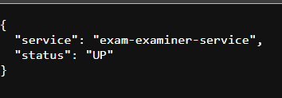
Screenshot 1: Health Check Response

Screenshot 1: Exam Examiner Service — Health Check

Screenshot 2: Check Exam Status API — Success Response

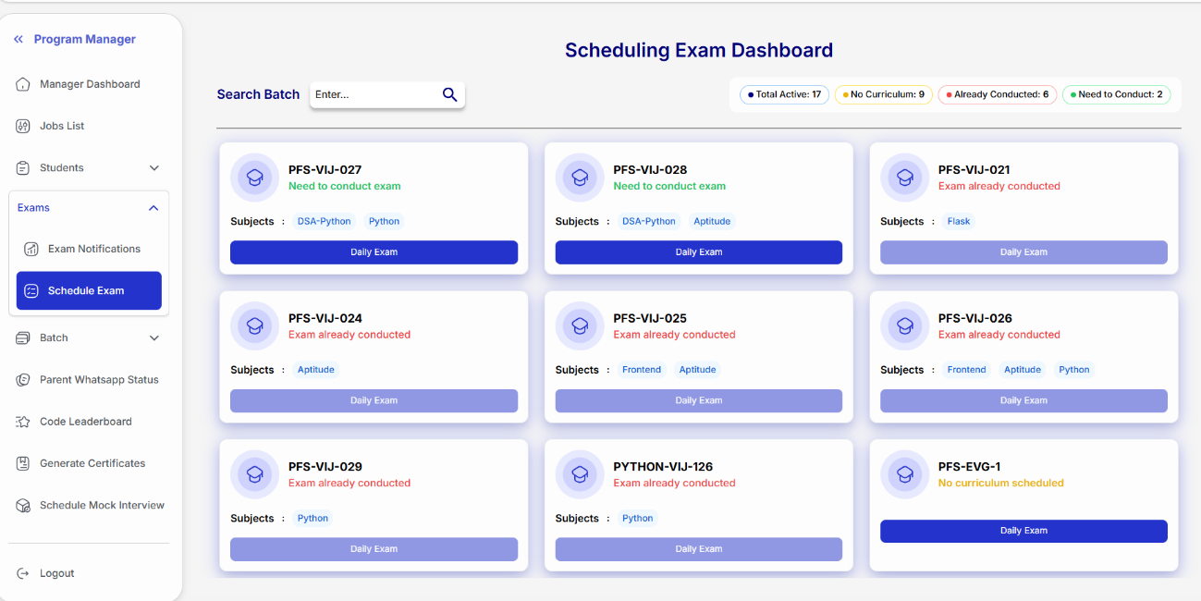
Screenshot 2: Check Exam Status

Screenshot 3: WhatsApp Webhook — Delivery Confirmation
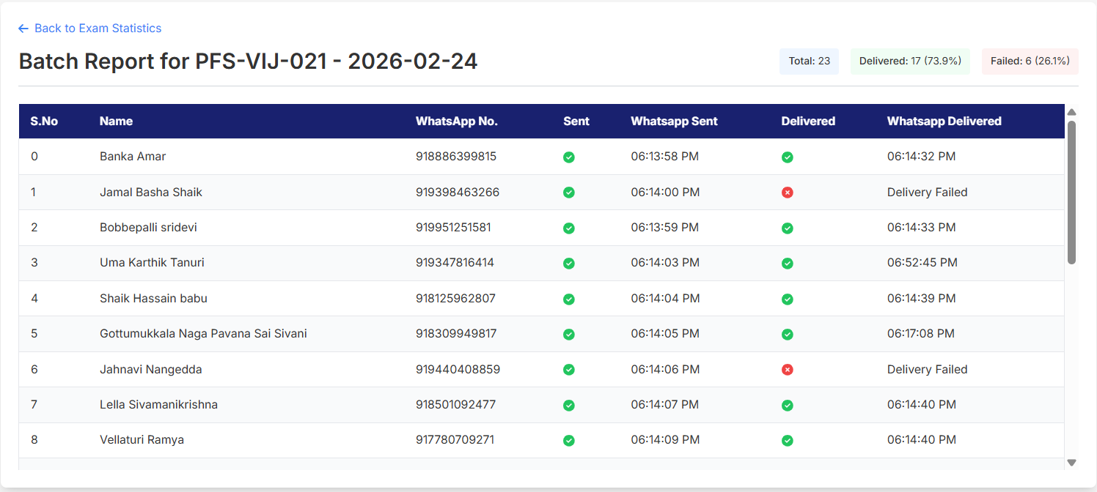
Screenshot 3: WhatsApp Webhook

A2.2 Exam Reports Service
Screenshot 4: Student Exam Summary
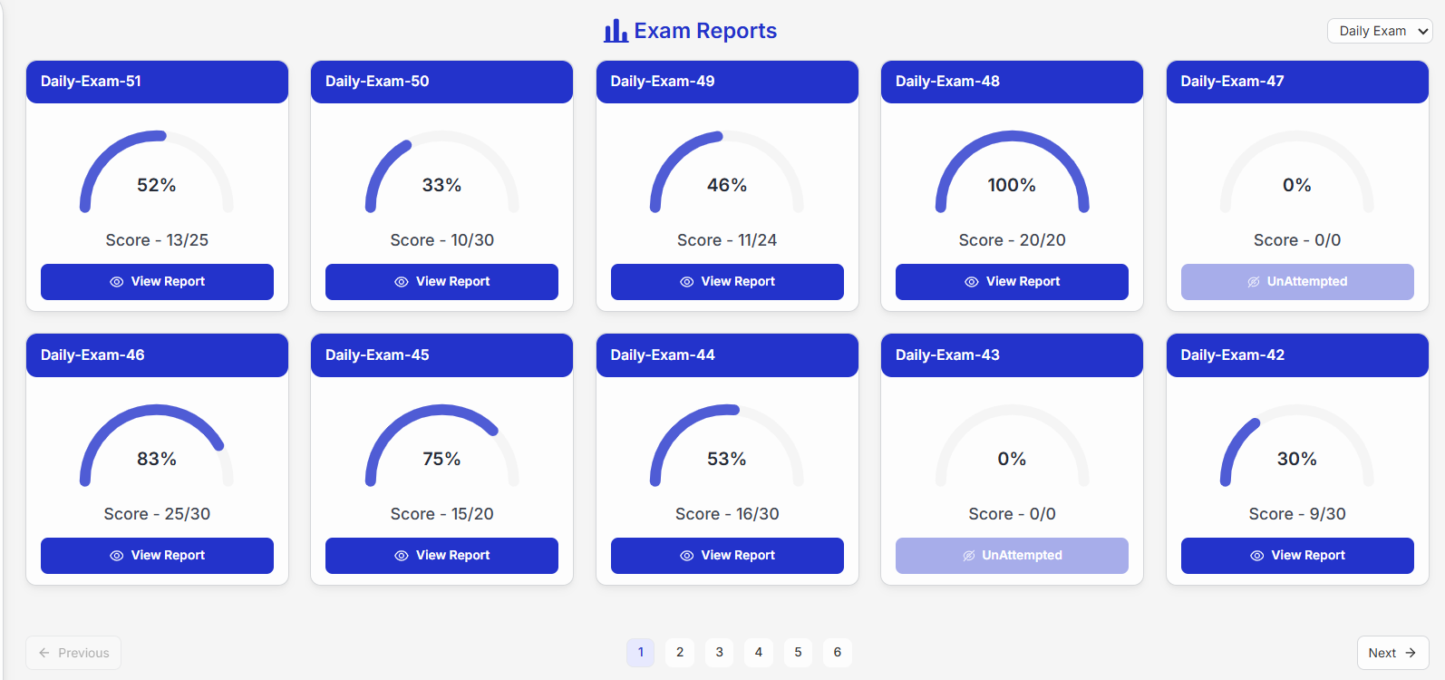
Screenshot 4: Student Exam Summary

Screenshot 5: Student Exam Detail
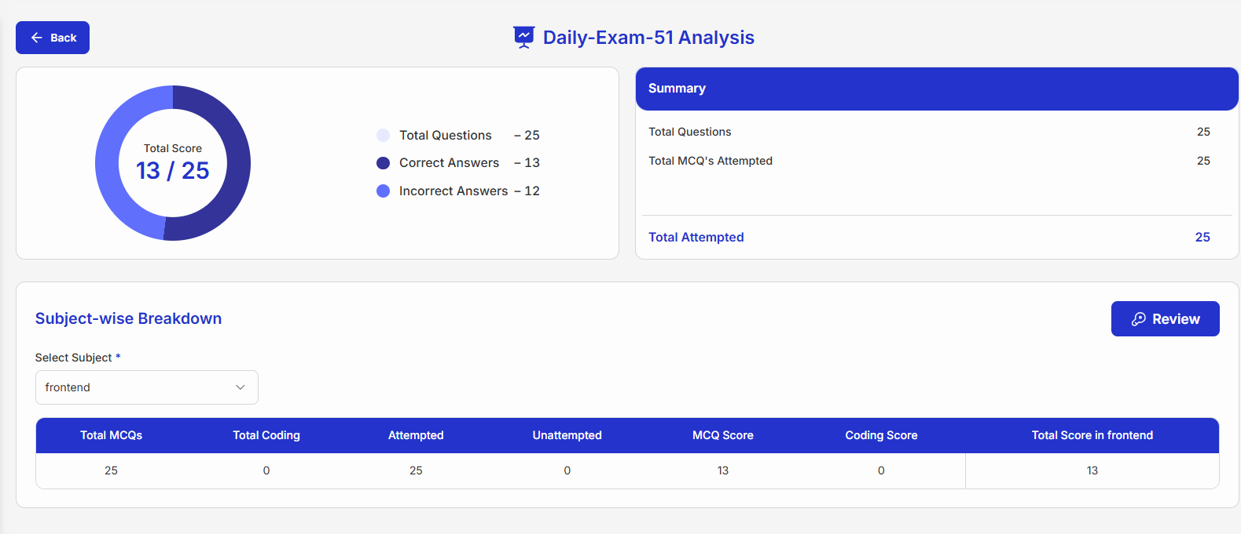
Screenshot 5: Student Exam Detail

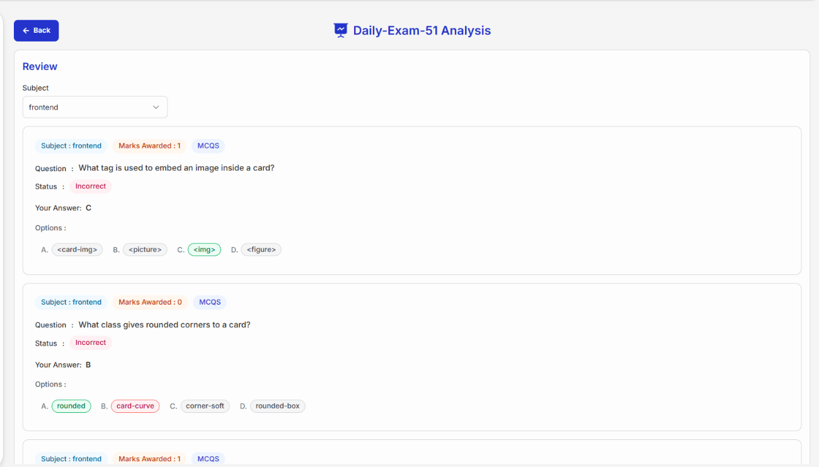
Screenshot 6: Question Review with Subject Filter

Screenshot 6: Question Review

Screenshot 7: Examiner Batch Reports with Search
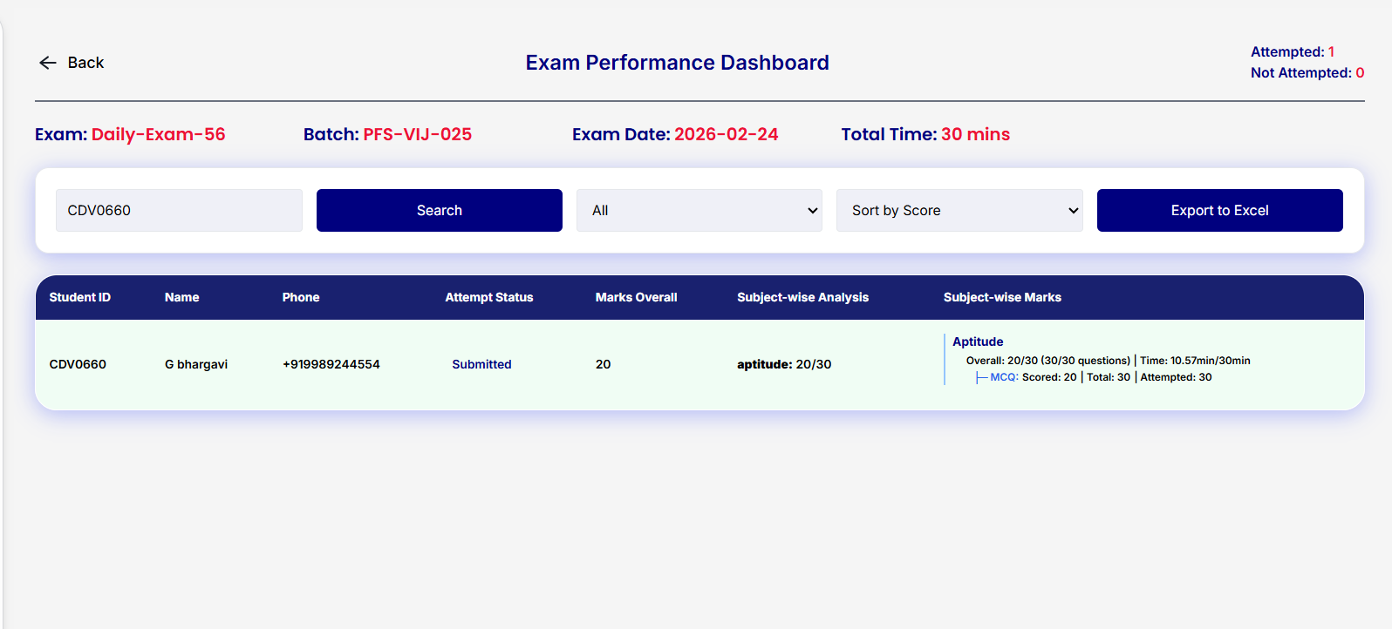
Screenshot 7: Examiner Batch Reports

Screenshot 8: Role-Based Access Denied
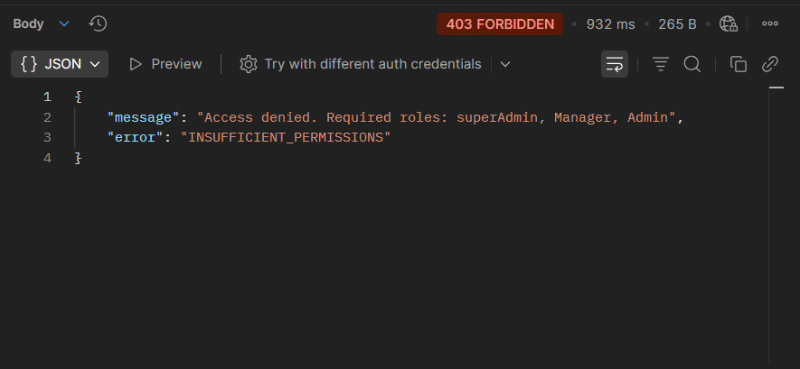
Screenshot 8: Access Denied

A2.3 Parent Reports Service
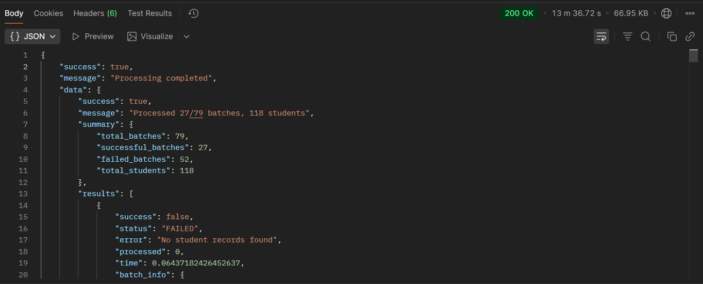
Screenshot 9: Process Reports — Sync Response
Screenshot 9: Process Reports Sync
Screenshot 10: Process Reports — Async Response
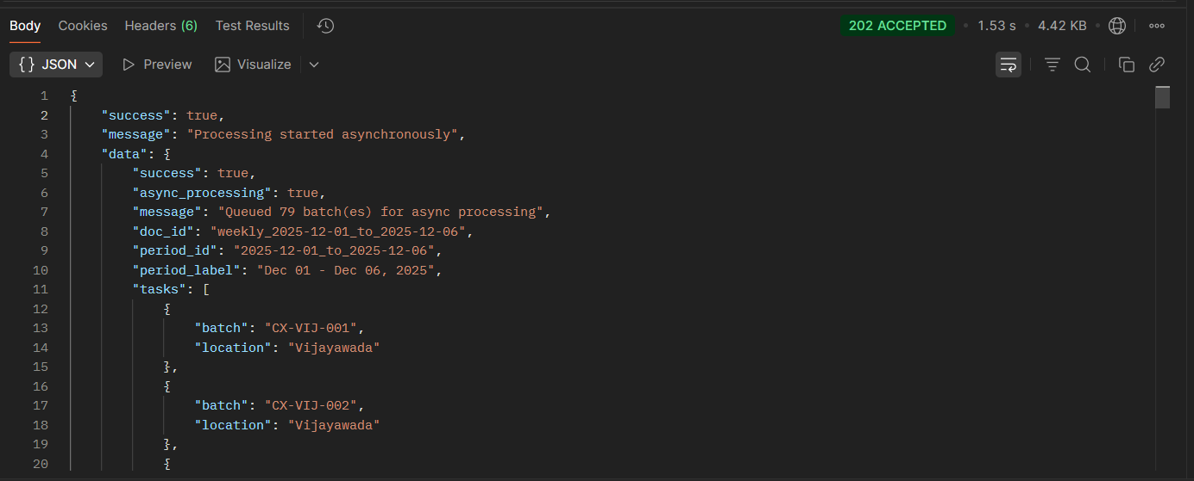
Screenshot 10: Process Reports Async
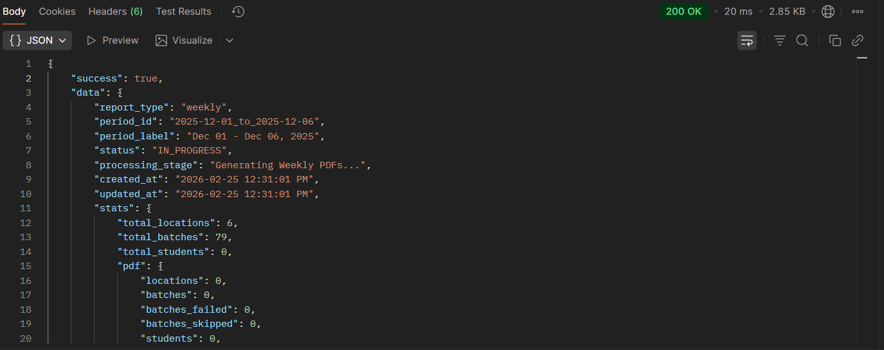
Screenshot 11: Report Status — Document Level
Screenshot 11: Report Status Document Level
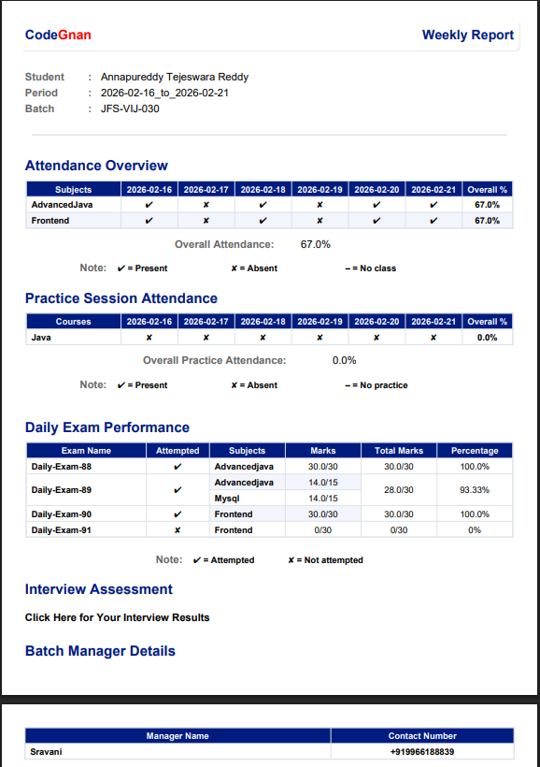
Screenshot 14: Generated PDF Report Sample
Screenshot 14: Sample PDF Report

Screenshot 15: MongoDB — Exam Document in Database
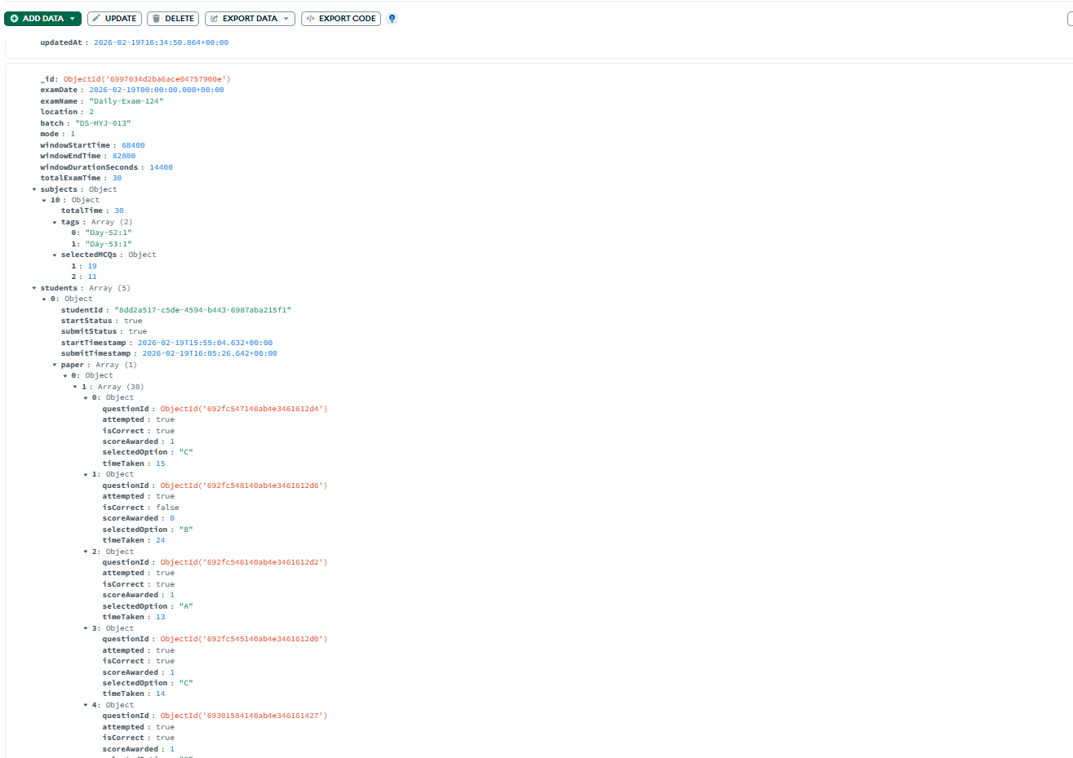
Screenshot 15: MongoDB Exam Document

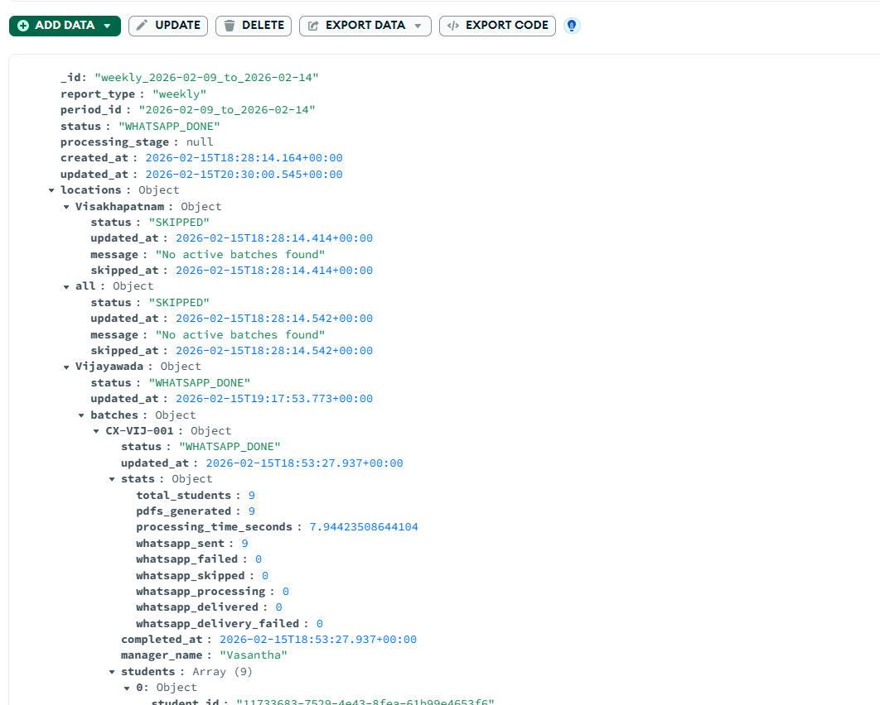
Screenshot 16: MongoDB — Parent Report Tracking Document

Screenshot 16: MongoDB Report Document

Appendix-3: Sample Coding

A3.1 Exam Generation Service (Exam Examiner Service)
class ExamGenerationAPI(Resource):
"""API endpoint for generating exam papers"""
@validate_json_schema(GenerateExamSchema)
def post(self):
try:
data = request.validated_data
claims = get_jwt()
manager_id = claims.get("id")
manager_location = claims.get("location")
result = self.generation_service.generate_exam(
exam_config=data,
manager_id=manager_id,
manager_location=manager_location
)
return success_response(result, "Exam generated successfully"), 201
except ValidationError as e:
return error_response(e.message, 400)
except NotFoundError as e:
return error_response(e.message, 404)

A3.2 CQRS Query Repository (Exam Reports Service)
class ExamQueryRepository:
"""Read-only repository for exam data access"""
def find_student_exams(self, student_id, exam_type, page, limit):
collection = get_exam_collection(exam_type)
pipeline = [
{"$match": {"students.studentId": student_id}},
{"$sort": {"examDate": -1}},
{"$skip": (page - 1) * limit},
{"$limit": limit},
{"$project": {
"examDate": 1, "examName": 1, "batch": 1,
"students": {"$filter": {
"input": "$students",
"cond": {"$eq": ["$$this.studentId", student_id]}
}}
}}
]
return list(collection.aggregate(pipeline))

A3.3 PDF Report Builder (Parent Reports Service)
class ReportBuilder:
"""Assembles PDF report from components"""
def build_report(self, student_data, attendance_data, exam_data):
buffer = BytesIO()
doc = SimpleDocTemplate(buffer, pagesize=A4)
elements = []
# Add components
elements.extend(HeaderComponent.build(student_data))
elements.extend(StudentInfoComponent.build(student_data))
elements.extend(AttendanceTableComponent.build(attendance_data))
elements.extend(ExamTableComponent.build(exam_data))
elements.extend(ManagerContactComponent.build(student_data))
doc.build(elements)
buffer.seek(0)
return buffer.getvalue()

A3.4 WhatsApp Async Sender (Exam Examiner Service)
class WhatsAppSender:
"""Async WhatsApp notification sender with rate limiting"""
def send_notifications(self, students, exam_data):
with ThreadPoolExecutor(max_workers=self.max_workers) as executor:
futures = {}
for student in students:
future = executor.submit(
self._send_single_notification,
student, exam_data
)
futures[future] = student
time.sleep(self.rate_limit_seconds)
results = {"sent": 0, "failed": 0}
for future in as_completed(futures):
if future.result():
results["sent"] += 1
else:
results["failed"] += 1
return results

Appendix-4: User Documentation

Installation Instructions
Prerequisites: - Python 3.11 or higher - MongoDB 5.0+ (or MongoDB Atlas account) - Redis 6.0+ (for Reports and Parent Reports services) - AWS account (for S3 — Parent Reports Service)

Step 1: Clone the repositories
git clone <exam-examiner-service-repo>
git clone <exam-reports-service-repo>
git clone <parent-reports-service-repo>

Step 2: Create virtual environments
cd lms-production-repo-exam-examiner-service
python -m venv venv
venv\Scripts\activate
pip install -r requirements.txt
(Repeat for each service)
Step 3: Configure environment variables Create .env file in each service directory with the required variables (DB_URL, DB_NAME, JWT_SECRET_KEY, etc.)

Step 4: Run services
# Exam Examiner Service
python app.py # Runs on port 6003
# Exam Reports Service
python app.py # Runs on port 6005
# Parent Reports Service
python app.py # Runs on port 6006
# (Optional) Start Celery worker for Parent Reports
celery -A src.common.tasks.celery_app worker --loglevel=info

README: How to Interact with the System
All three services expose REST APIs that can be tested using Postman or curl.
Authentication: Most endpoints require a JWT token in the Authorization header:
Authorization: Bearer <jwt_token>
Health Check: Each service has a health check endpoint at the root URL:
GET http://localhost:6003/ → Exam Examiner Service
GET http://localhost:6005/ → Exam Reports Service
GET http://localhost:6006/ → Parent Reports Service
Production Deployment:
# Using Gunicorn
gunicorn -w 4 -b 0.0.0.0:6003 app:app
# Using Docker
docker build -t exam-examiner-service .
docker run -p 6003:6003 --env-file .env exam-examiner-service

Appendix-5: Glossary
Term | Definition
API | Application Programming Interface — a set of protocols for building software
CQRS | Command Query Responsibility Segregation — pattern separating read and write operations
CRUD | Create, Read, Update, Delete — basic data operations
Celery | Distributed task queue for Python
ChatRace | WhatsApp Business API provider used for message delivery
DDD | Domain-Driven Design — approach to software design based on business domains
DFD | Data Flow Diagram — visual representation of data movement
E164 | International phone number format standard
Enum | Enumeration — a set of named constant values
Flask | Lightweight Python web framework
GridFS | MongoDB specification for storing large files
Gunicorn | Python WSGI HTTP server for production
JWT | JSON Web Token — compact token format for authentication
MCQ | Multiple Choice Question
MongoDB | Document-oriented NoSQL database
Pydantic | Python data validation library using type annotations
RBAC | Role-Based Access Control
Redis | In-memory data store used for caching and message brokering
ReportLab | Python library for PDF generation
REST | Representational State Transfer — architectural style for APIs
S3 | Amazon Simple Storage Service — cloud object storage
SES | Amazon Simple Email Service
Strangler Fig | Migration pattern for gradually replacing monolith with microservices
TTL | Time To Live — expiration time for cached data
UML | Unified Modeling Language — standardized modeling language
Webhook | HTTP callback for real-time event notifications
WSGI | Web Server Gateway Interface — Python web server standard

CHAPTER 10: BIBLIOGRAPHY

[1] Al-Debagy, O. and Martinek, P. (2018). “A Comparative Review of Microservices and Monolithic Architectures.” IEEE 18th International Symposium on Computational Intelligence and Informatics.
[2] AWS Documentation. (2025). Amazon S3 Developer Guide. docs.aws.amazon.com/s3.
[3] Balalaie, A., Heydarnoori, A., and Jamshidi, P. (2016). “Migrating to Cloud-Native Architectures Using Microservices.” IEEE Software, 33(5), pp. 36-45.
[4] Banker, K., Bakkum, P., Verch, S., Garrett, D., and Hawkins, T. (2016). MongoDB in Action. Manning Publications.
[5] Celery Documentation. (2025). Celery: Distributed Task Queue. docs.celeryq.dev.
[6] Dragoni, N., Giallorenzo, S., Lafuente, A.L., Mazzara, M., Montesi, F., Mustafin, R., and Safina, L. (2017). “Microservices: Yesterday, Today, and Tomorrow.” Present and Ulterior Software Engineering, Springer, pp. 195-216.
[7] Evans, E. (2003). Domain-Driven Design: Tackling Complexity in the Heart of Software. Addison-Wesley Professional.
[8] Flask Documentation. (2025). Flask Web Framework. flask.palletsprojects.com.
[9] Fowler, M. (2004). “Strangler Fig Application.” martinfowler.com.
[10] Fowler, M. and Lewis, J. (2014). “Microservices: A Definition of This New Architectural Term.” martinfowler.com.
[11] Grinberg, M. (2018). Flask Web Development: Developing Web Applications with Python. O’Reilly Media.
[12] MongoDB Documentation. (2025). MongoDB Manual. docs.mongodb.com.
[13] Newman, S. (2019). Monolith to Microservices: Evolutionary Patterns to Transform Your Monolith. O’Reilly Media.
[14] Pydantic Documentation. (2025). Pydantic v2. docs.pydantic.dev.
[15] Redis Documentation. (2025). Redis Documentation. redis.io/docs.
[16] Richardson, C. (2018). Microservices Patterns: With Examples in Java. Manning Publications.
[17] Villamizar, M., Garces, O., Castro, H., Verano, M., Salamanca, L., Casallas, R., and Gil, S. (2015). “Evaluating the Monolithic and the Microservice Architecture Pattern to Deploy Web Applications in the Cloud.” 10th Computing Colombian Conference (10CCC), IEEE.
[18] Young, G. (2010). “CQRS Documents.” cqrs.files.wordpress.com.

