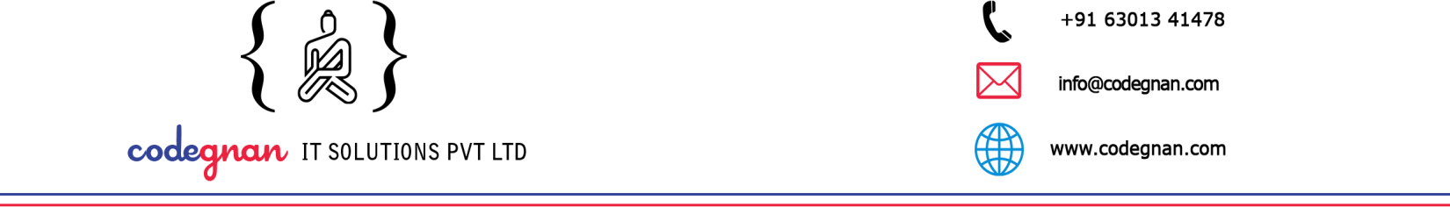


Date: 1st December 2025

To Whomsoever It May Concern

This is to certify that Mr. Jasti Kesava Datta, bearing Register Number: RA2432014010026, is a student of II Year, M.Sc. Applied Data Science, Faculty of Science and Humanities, SRM Institute of Science and Technology (SRMIST), Kattankulathur.
The student is currently working with our organization as a Software Developer (Project Trainee) and is involved in an in-house software development project titled:
“Design and Development of Functional Modules for a Learning Management System.”

As part of the Project Work prescribed by the university, the student is contributing to the design, development, and enhancement of functional LMS modules, following standard software development practices.
The project work is carried out during the period from December 2025 to March 2026, under the guidance of experienced professionals in the organization.
This confirmation is issued upon the request of the student for academic purposes, in accordance with the project requirements of SRM Institute of Science and Technology.
Yours sincerely,

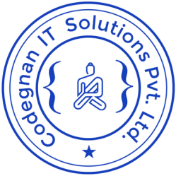
Authorized Signatory
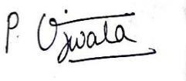
Ujwala Podisetti HR Executive
Codegnan IT Solution Pvt Ltd

