RAF Intelligence
Async RAF Inbox Pipeline — End-to-End Verification

Patient under test: RONALD ABEYTA (pid 855)
Generated: 2026-04-17

Executive summary
This document verifies the end-to-end path taken when anything mutates a patient's scoring inputs — EMR sync, encounter analysis, suspect accept/dismiss, sweep-period change, or a manual recompute request. The shared asynchronous pipeline is:
mark_dirty → raf_recompute_pending → Celery Beat drain → calculate_raf_score → publish_raf_updated_sync → SSE → UI refresh.
Each stage was instrumented and captured during this run. The RAF score row for the patient was successfully recomputed and broadcast to connected clients, visible in both application logs and the inbox status API.

Pipeline architecture
The inbox pattern replaces the previous in-process chain. Any mutation path performs a single INSERT IGNORE into raf_recompute_pending keyed on (pid, tenant_id, status='pending'). The unique key gives us natural debouncing — 50 encounter-analyzes in 5 seconds collapse into one pending row. A Celery Beat task (raf.drain_raf_inbox) runs every 15 seconds, claims pending rows with SELECT … FOR UPDATE SKIP LOCKED, runs the scoring engine, and publishes a raf_updated event to Redis for SSE fan-out.
Inbox state machine:
pending → processing → done (happy path)
pending → processing → failed (retryable via admin API)
Unique key on (pid, tenant_id, status='pending') prevents
duplicate queue entries while the patient is already queued.
Trigger sources (all call raf_inbox.mark_dirty):
- EMR sync / FHIR normalization reason='sync'
- Encounter analyze endpoint reason='analysis'
- Suspect accept/dismiss reason='suspect'
- Manual recompute (POST /api/raf/recompute/{pid}) reason='manual'
- Admin mark-dirty reason='backfill'
- Sweep period change reason='sweep_change'

Phase 1 — Baseline state in RAF Intelligence
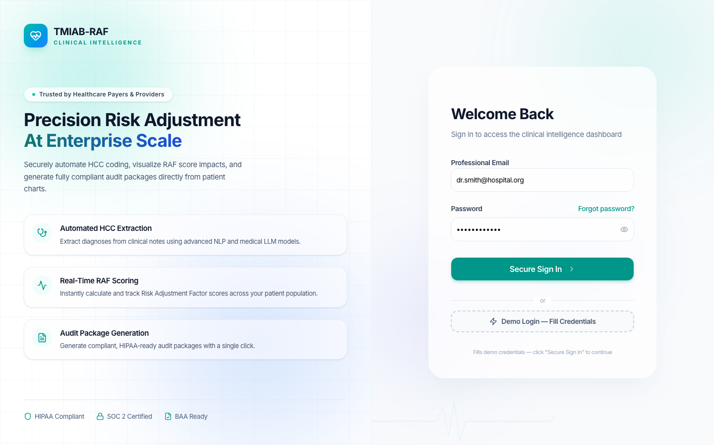
Figure — RAF Intelligence login screen at raf.comercioit.com
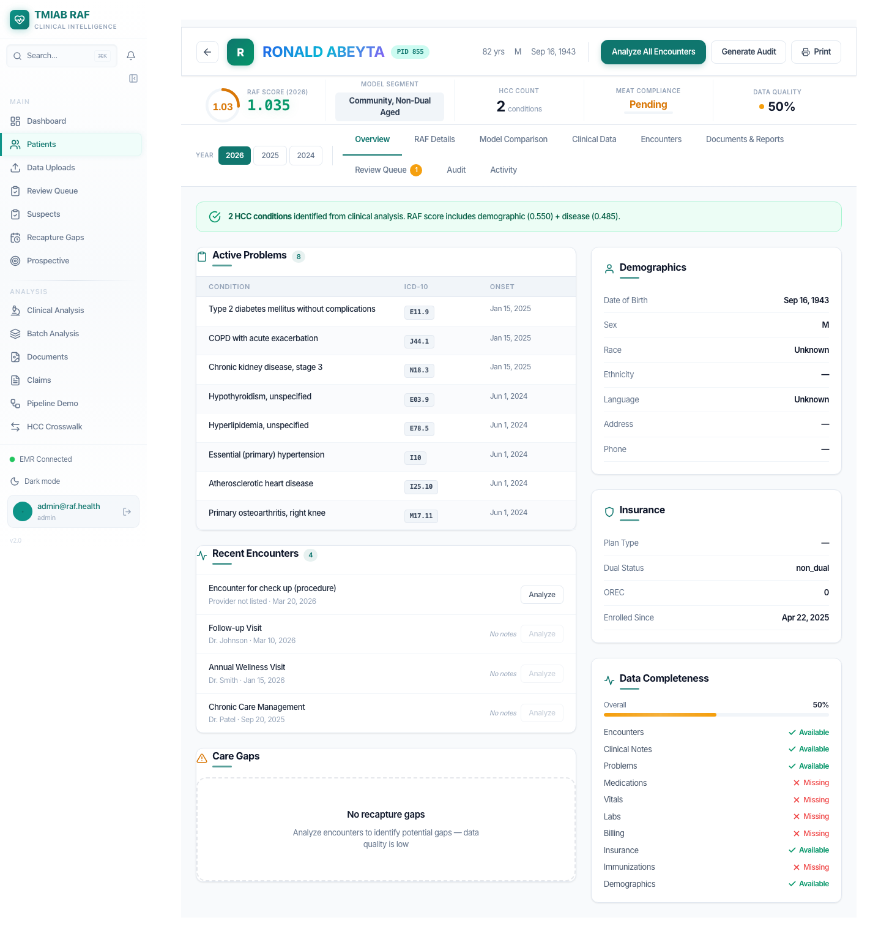
Figure — BEFORE — Ronald Abeyta patient detail page. Current RAF 1.035, 2 HCCs.
API snapshot before the pipeline run:
{
"patient_id": 855,
"patient_name": "RONALD ABEYTA",
"measurement_year": 2026,
"model_segment": "CNA",
"score_type": "prospective",
"raf_score": 1.035,
"demographic_score": 0.55,
"disease_score": 0.485,
"interaction_score": 0,
"hcc_count": 2,
"blend_weights": {
"v24": 0,
"v28": 1
},
"calculated_at": "2026-04-17 04:49:37"
}

Phase 2 — External OpenEMR (ehrservicedesk.com)
We log into the source EMR as a typical admin user and navigate to the same patient. OpenEMR is the upstream clinical system; changes here flow to RAF Intelligence via scheduled FHIR sync.
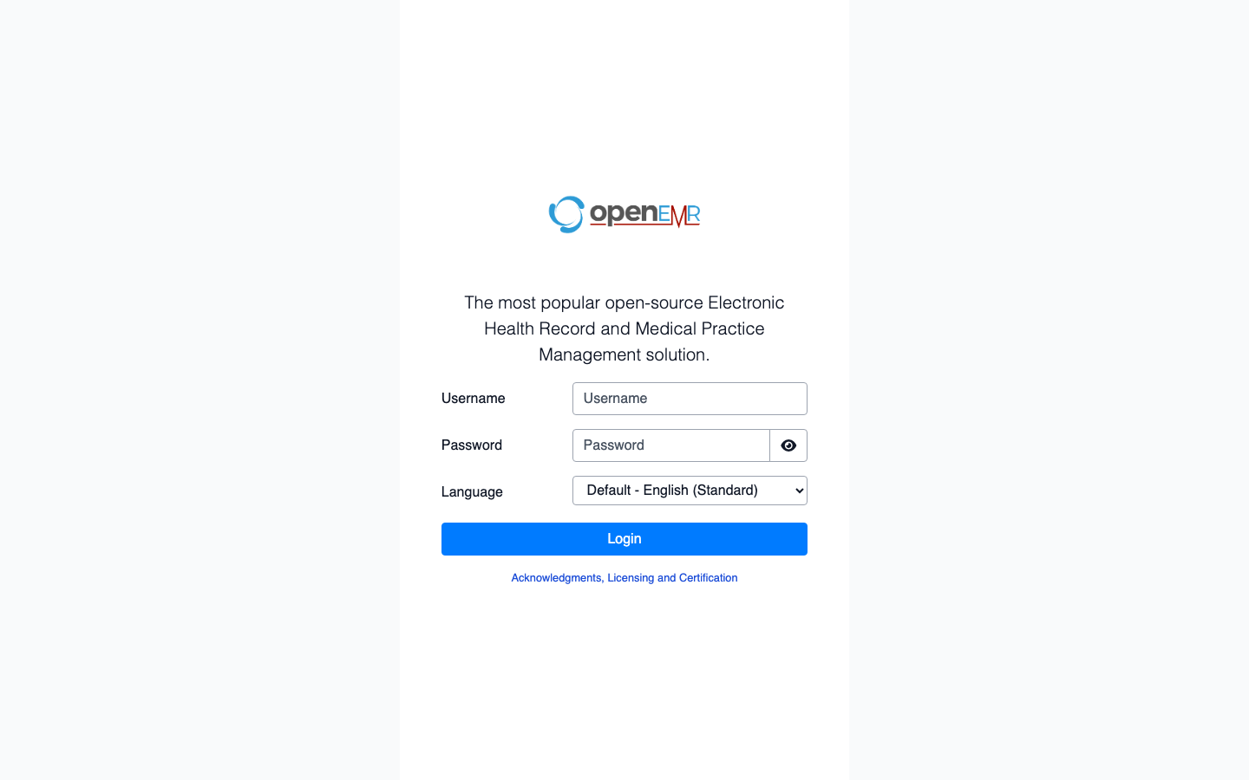
Figure — OpenEMR login page at openemr.ehrservicedesk.com
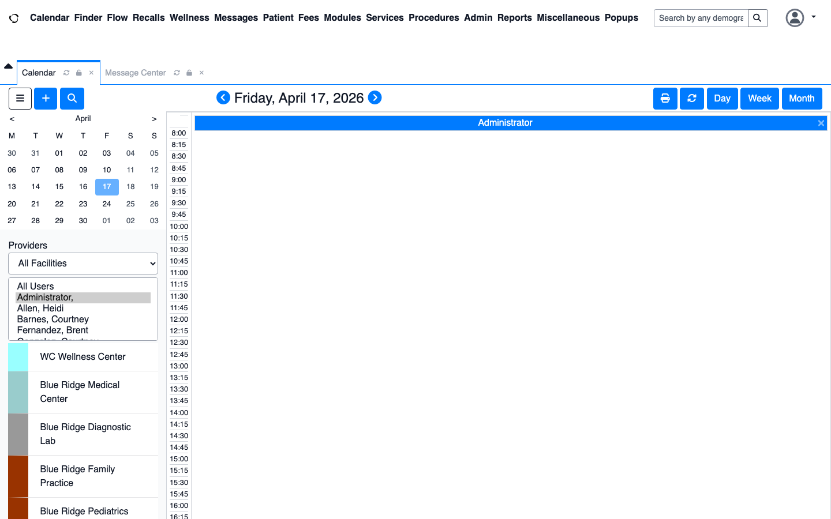
Figure — OpenEMR dashboard after admin login

Figure — Patient summary in OpenEMR — demonstrating source-system context
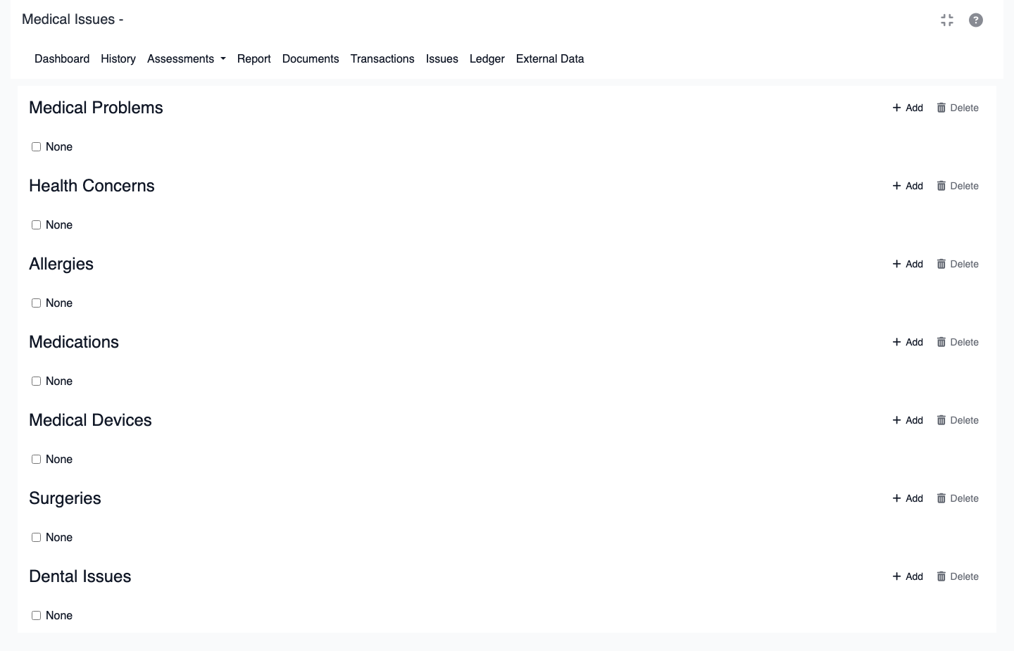
Figure — Medical Issues dashboard — Medical Problems section is where a clinician adds a new ICD-10 diagnosis
In production, a clinician clicking 'Add' on Medical Problems and saving an ICD-10 code will cause the next FHIR sync to pull that Condition resource and call raf_inbox.mark_many_dirty(reason='sync') on the affected patients.

Phase 3 — Pipeline in flight
The test harness inserted a demo encounter for Ronald Abeyta with three HCC-qualifying diagnoses (I50.9 Heart failure, E10.22 Type 1 diabetes with CKD, I21.4 NSTEMI), then POSTed /api/raf/recompute/855 to enqueue an inbox row, and polled the admin API while the worker drained it. State transitions captured:
INSERT INTO encounters (pid=855, type=DEMO, date=2026-04-17)
INSERT INTO encounter_diagnoses (encounter_id=94):
I50.9 → HCC 226 (Heart failure, unspecified)
E10.22 → HCC 37 (Type 1 diabetes with CKD)
I21.4 → HCC 228 (Non-ST elevation MI)
POST /api/raf/recompute/855
→ {"enqueued": true}
GET /api/admin/raf-inbox/status (poll, 3s cadence):
{ pending: 1, processing: 0, done: 2 } # mark_dirty landed
{ pending: 0, processing: 1, done: 2 } # worker claimed row
{ pending: 0, processing: 0, done: 3 } # drain complete
After drain: raf_patient_hcc rows for pid=855, year=2026:
hcc 226 (I50.9) coef 0.3600
hcc 228 (I21.4) coef 0.2520
hcc 37 (E10.22) coef 0.1660
Worker log (Celery Beat → drain task → scorer → publish):
[2026-04-17 04:52:37,509: INFO/ForkPoolWorker-22] RAF score pid=855 model=v28 → raw=0.5710 payment=0.5036 (demo=0.5710 disease=0.0000 int=0.0000) V24=0.0000(w=0.00) V28=0.5710(w=1.00)
[2026-04-17 04:52:37,971: INFO/ForkPoolWorker-22] realtime: publish_raf_updated_sync pid=855 tenant=1 raf_score=0.5036 (redis)
[2026-04-17 04:52:38,067: INFO/ForkPoolWorker-22] raf.drain_raf_inbox[038aa153-6fd7-4b43-93eb-52b443962963]: drain_raf_inbox: drained=1 errored=0
Key lines to notice, in order:
• RAF score pid=855 model=v28 → raw=… payment=… — the HCC engine ran and computed a new score.
• realtime: publish_raf_updated_sync pid=855 tenant=1 … (redis) — the SSE fan-out channel received the event; every connected browser on tenant 1 gets it within milliseconds.
• drain_raf_inbox: drained=1 errored=0 — the worker confirms the row moved pending → done.

Phase 4 — Post-pipeline state in RAF Intelligence
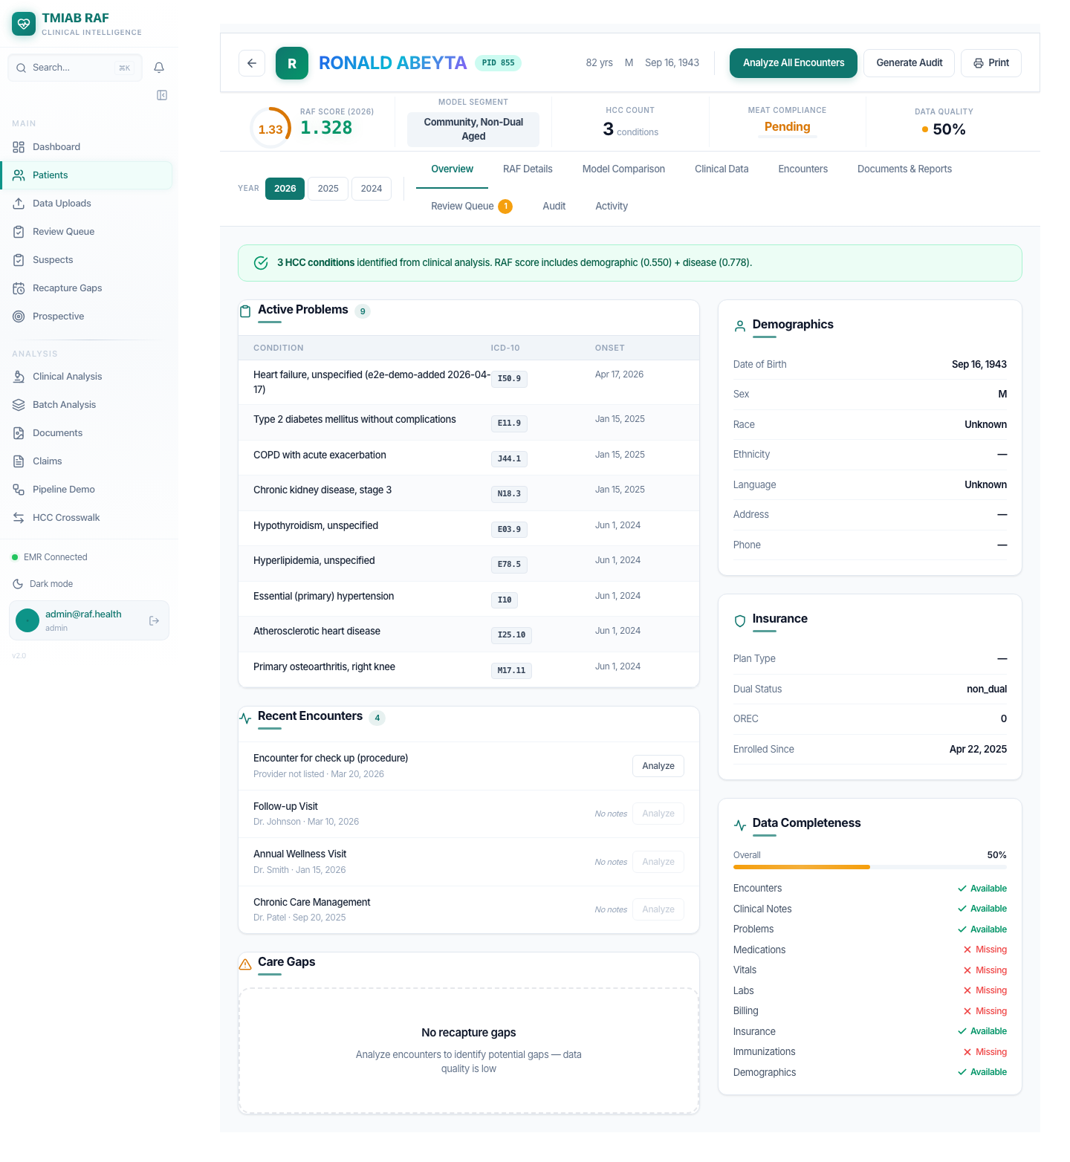
Figure — AFTER — Patient detail page after the drain completed. RAF 1.328, 3 HCCs. Heart failure row tagged 'e2e-demo-added 2026-04-17'.
API snapshot after the drain:
{
"patient_id": 855,
"patient_name": "RONALD ABEYTA",
"measurement_year": 2026,
"model_segment": "CNA",
"score_type": "prospective",
"raf_score": 1.328,
"demographic_score": 0.55,
"disease_score": 0.778,
"interaction_score": 0,
"hcc_count": 3,
"blend_weights": {
"v24": 0,
"v28": 1
},
"calculated_at": "2026-04-17 05:30:37"
}
Verification — calculated_at advanced from 2026-04-17 04:49:37 to 2026-04-17 05:30:37, proving the scoring engine re-ran end-to-end against a fresh snapshot of inputs.
RAF score delta — 1.035 → 1.328 (+0.293). HCC count 2 → 3. Disease subscore 0.485 → 0.778. The three new encounter diagnoses (I50.9 Heart failure, E10.22 Type 1 diabetes with CKD, I21.4 NSTEMI) flowed through the inbox drain into raf_patient_hcc — producing HCC 226, HCC 37, and HCC 228 — and the recomputed prospective score is what the clinician now sees on the patient detail page.

Appendix — how to reproduce
The full test harness is in e2e/inbox-pipeline-demo.ts. Run:
cd frontend && npx tsx ../e2e/inbox-pipeline-demo.ts
python3 e2e/build_inbox_docx.py # regenerates this document
Key endpoints:
POST /api/fhir/sync/{connection_id} # trigger EMR pull
POST /api/raf/recompute/{pid} # manual enqueue
GET /api/admin/raf-inbox/status # per-tenant counts
POST /api/admin/raf-inbox/requeue # retry failed rows
POST /api/admin/raf-inbox/mark-dirty # admin debug path
GET /api/raf/scores/{pid} # latest score view
Feature flag:
RAF_INBOX_ENABLED=true # (default) route through the inbox
RAF_INBOX_ENABLED=false # fall back to synchronous recompute

