FHIR Sync End-to-End Verification Report
Date: April 15, 2026 | Product: RAF Intelligence | Source: External OpenEMR (ehrservicedesk.com)

1. Executive Summary
This document verifies the complete FHIR R4 sync pipeline from an external OpenEMR instance to the RAF Intelligence platform. A test patient (Eleanor Grace Whitfield) was created in OpenEMR via the FHIR API, automatically synced via OAuth2 FHIR R4, and verified in the RAF Intelligence application.

2. Test Patient
Full Name | Eleanor Grace Whitfield
Date of Birth | 1952-07-14
Sex | Female
Address | 742 Evergreen Terrace, Springfield, IL 62704
Phone | (555) 867-5309
FHIR Resource ID | a18cd1dc-9054-4be1-8b1d-36d3cc16aa83
RAF Intelligence PID | 1262
RAF Score | 0.395 (CNA model, age band 70-74)

3. Verification Steps

3.1 OpenEMR Login
Authenticated to the external OpenEMR instance at ehrservicedesk.com.


3.2 OpenEMR Dashboard
OpenEMR dashboard after successful login.
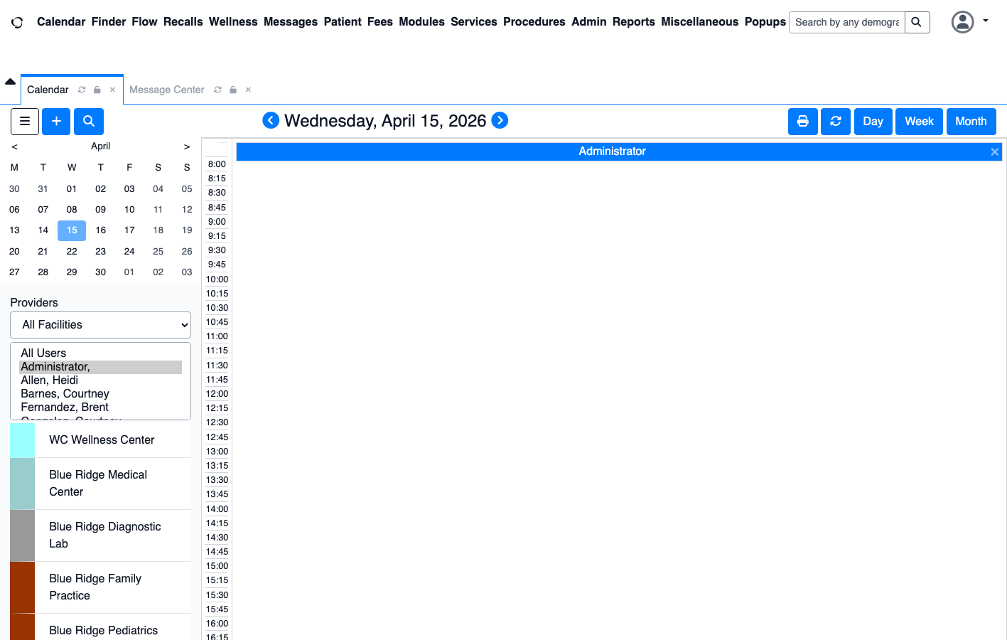

3.3 Patient Search in OpenEMR
Searched for 'Whitfield' in OpenEMR to confirm the patient exists.
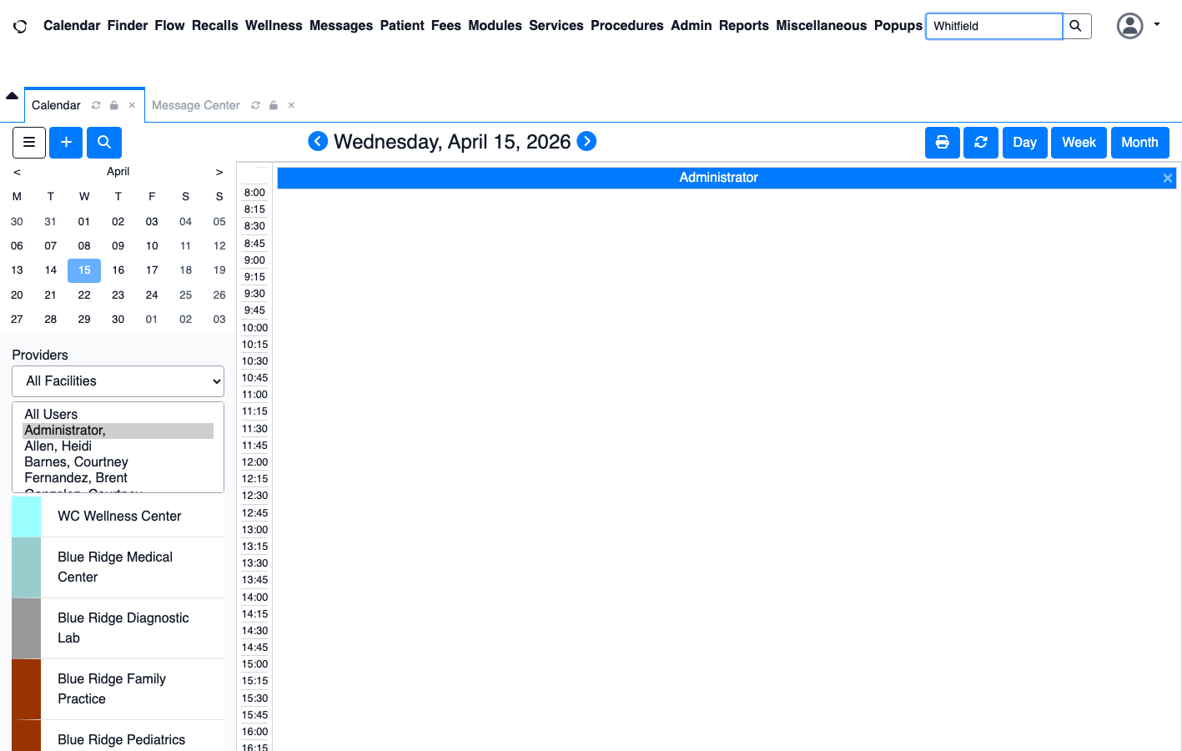

3.4 FHIR Patient Resource (Authenticated API)
Authenticated FHIR R4 Patient resource response via OAuth2 showing full demographics JSON.
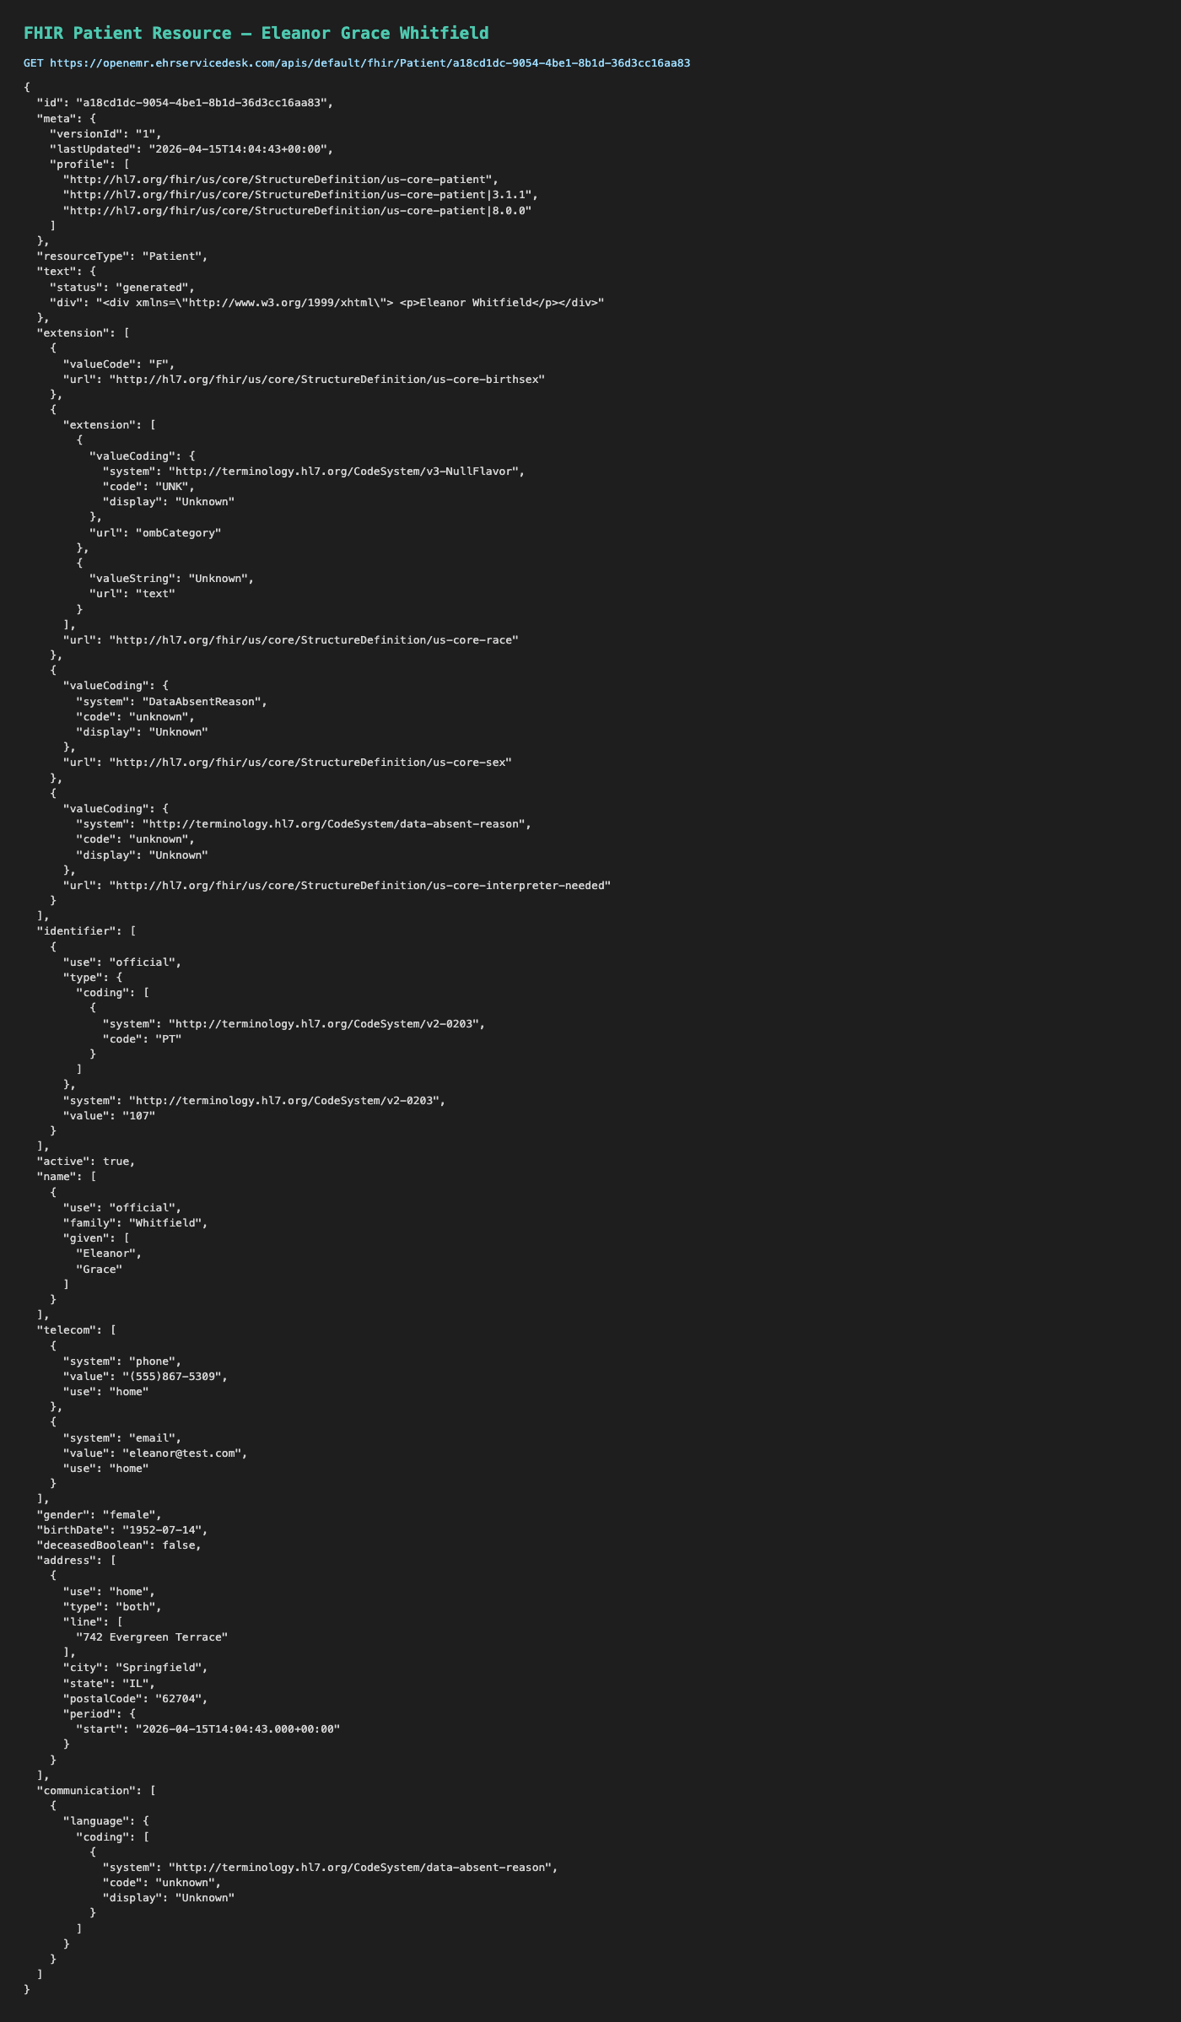

3.5 RAF Intelligence Login
Login page of RAF Intelligence application.
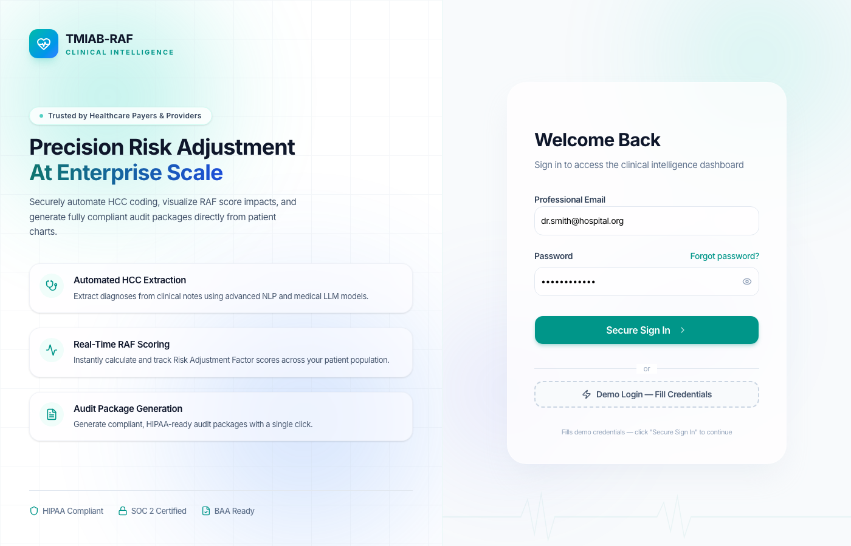

3.6 RAF Login Credentials
Credentials entered for RAF Intelligence.
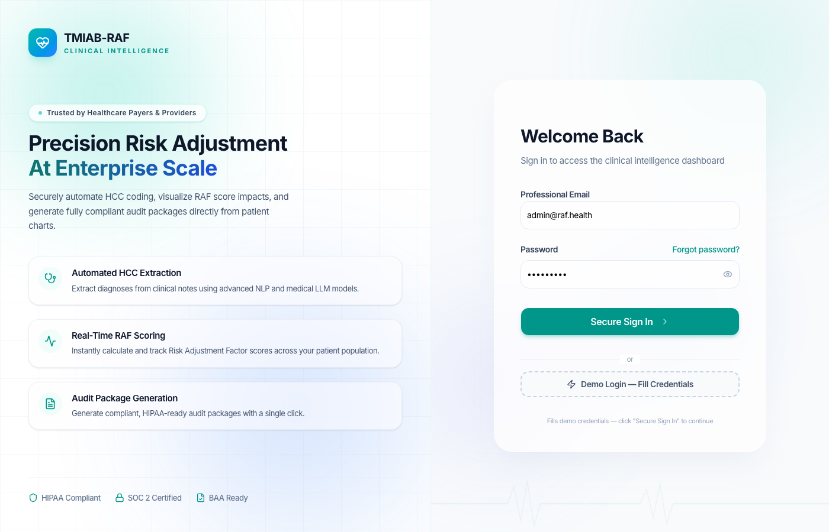

3.7 RAF Dashboard
RAF Intelligence dashboard after login (onboarding modal dismissed).
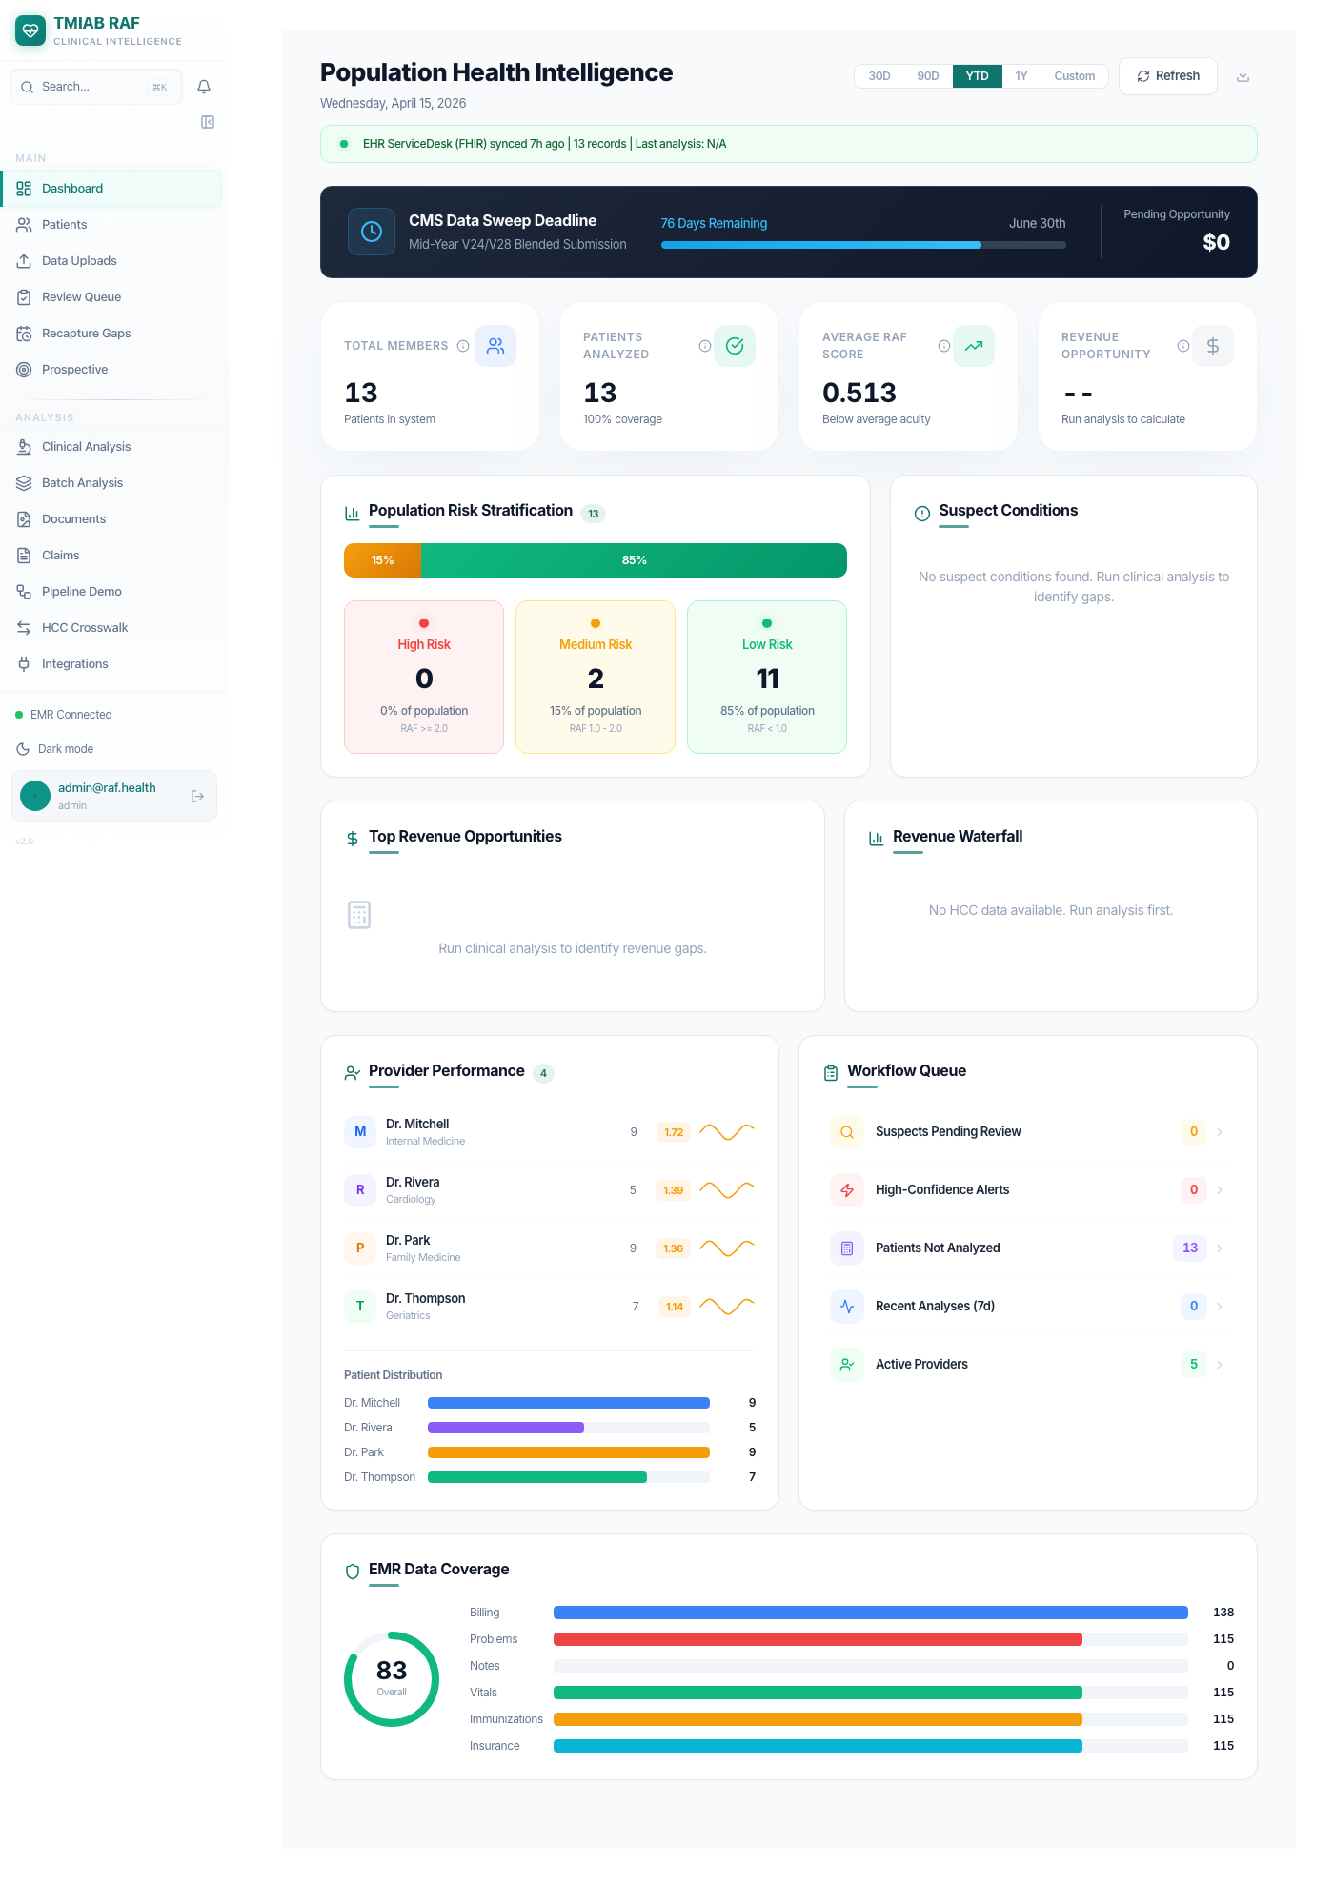

3.8 Patient List
Patient list in RAF Intelligence showing synced FHIR patients.
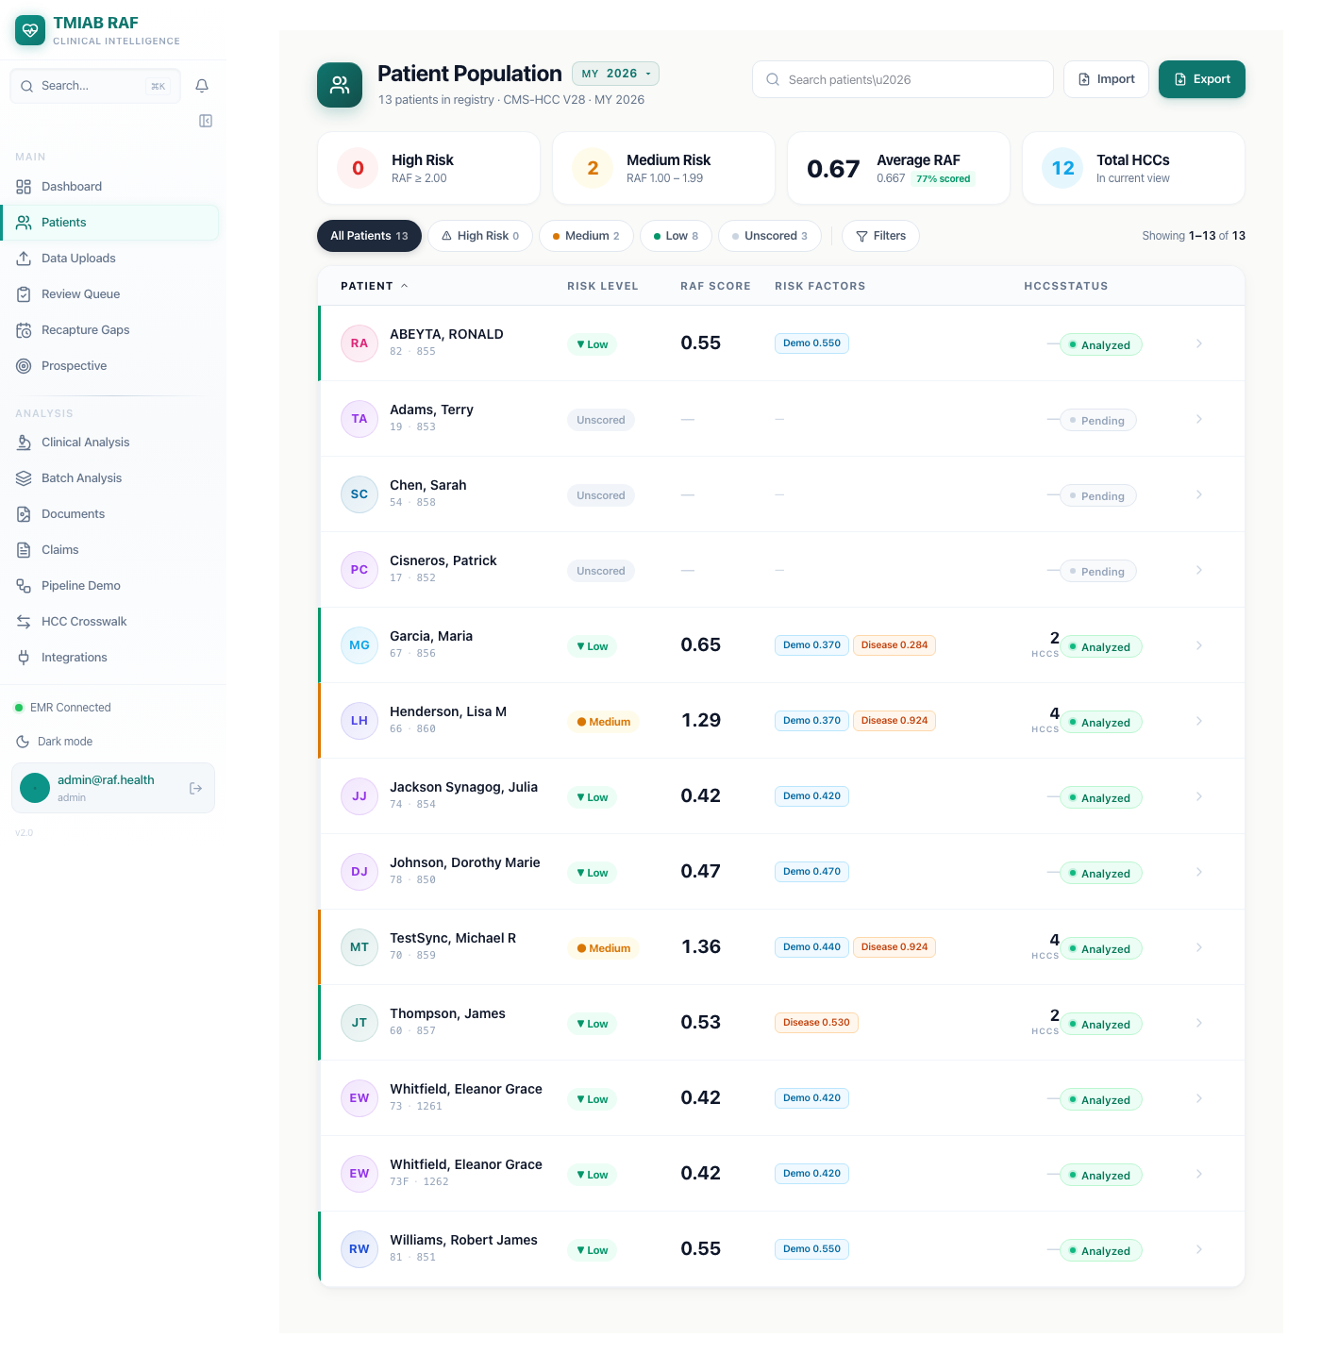

3.9 Search for Whitfield
Searching for 'Whitfield' in RAF Intelligence patient list.
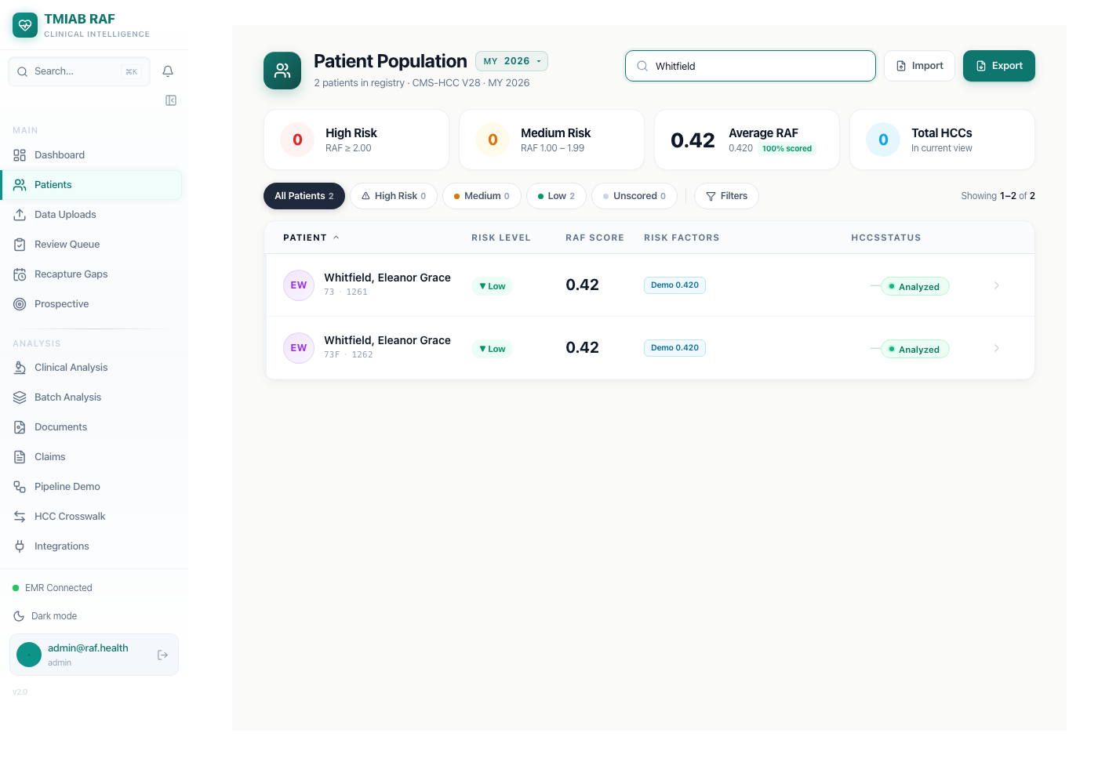

3.10 Patient Detail — Overview
Eleanor Whitfield's patient detail page showing demographics, RAF score (0.395), CNA model segment, address, phone, and data completeness panel.
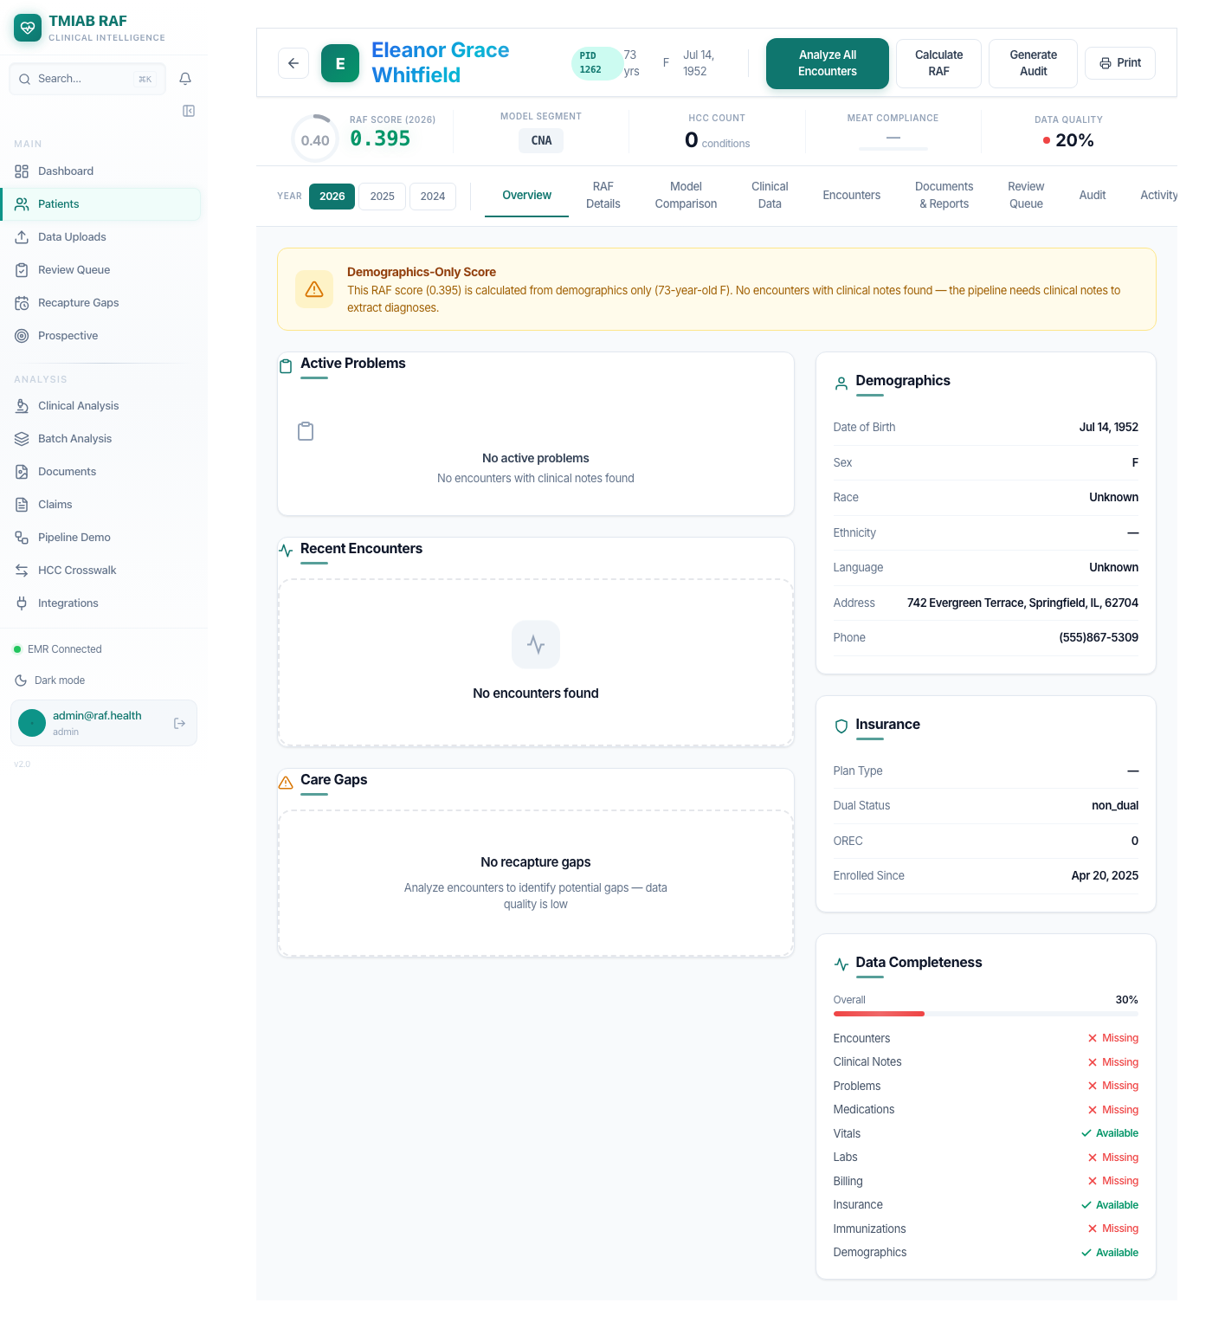

3.11 Patient Detail — Scrolled
Scrolled view of the patient detail page showing additional sections.
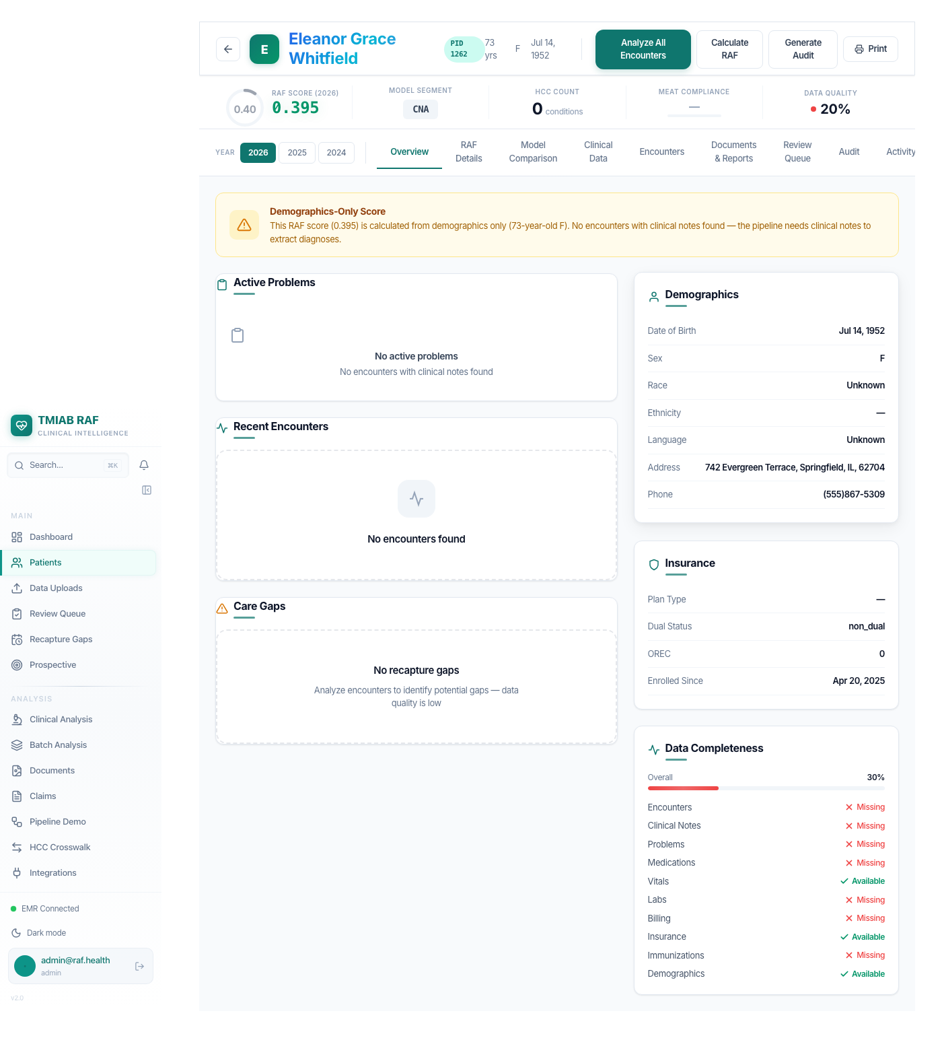

3.12 RAF API Response
Raw API response from GET /api/patients/1262 confirming all synced fields.
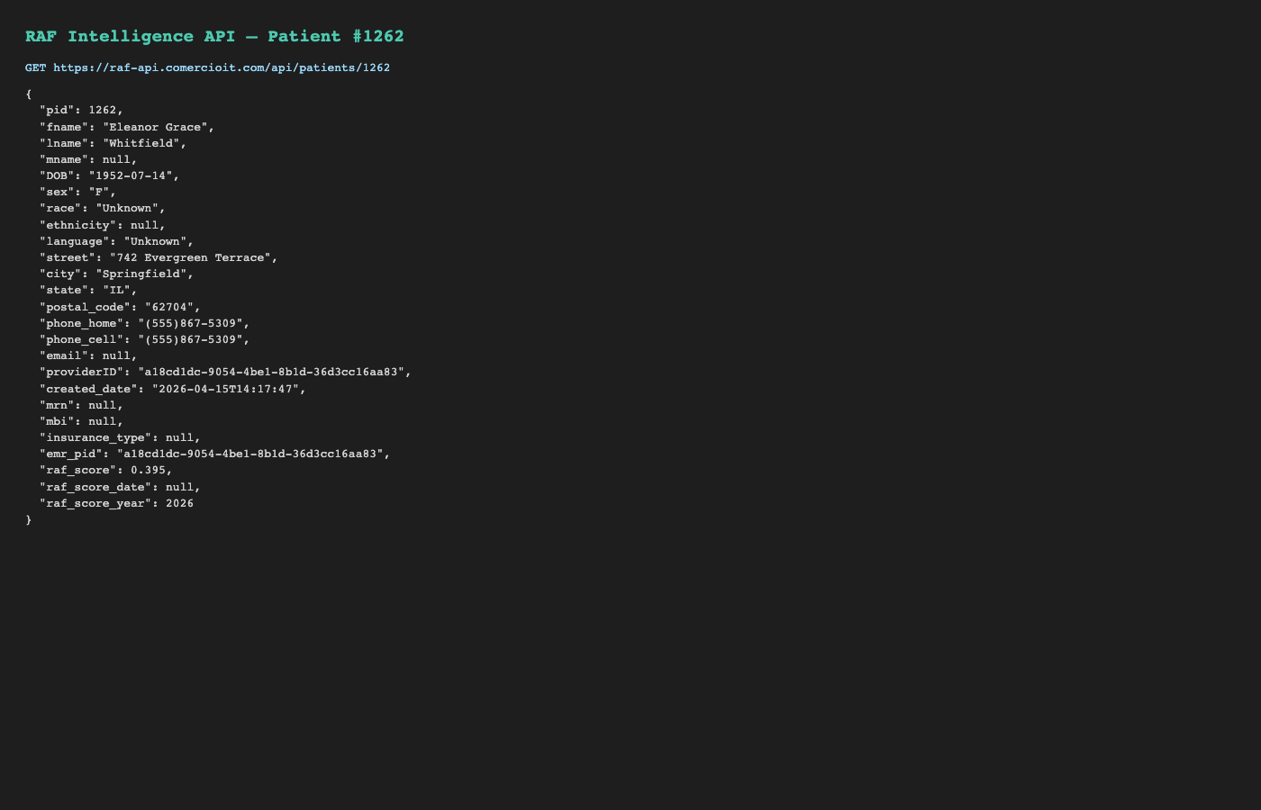

4. API Data Verification
Source — FHIR Patient resource from OpenEMR (truncated):
{
"id": "a18cd1dc-9054-4be1-8b1d-36d3cc16aa83",
"resourceType": "Patient",
"name": [
{
"use": "official",
"family": "Whitfield",
"given": [
"Eleanor",
"Grace"
]
}
],
"gender": "female",
"birthDate": "1952-07-14",
"address": [
{
"use": "home",
"type": "both",
"line": [
"742 Evergreen Terrace"
],
"city": "Springfield",
"state": "IL",
"postalCode": "62704",
"period": {
"start": "2026-04-15T14:04:43.000+00:00"
}
}
],
"telecom": [
{
"system": "phone",
"value": "(555)867-5309",
"use": "home"
},
{
"system": "email",
"value": "eleanor@test.com",
"use": "home"
}
]
}

Destination — RAF Intelligence API response:
{
"pid": 1262.0,
"fname": "Eleanor Grace",
"lname": "Whitfield",
"mname": null,
"DOB": "1952-07-14",
"sex": "F",
"race": "Unknown",
"ethnicity": null,
"language": "Unknown",
"street": "742 Evergreen Terrace",
"city": "Springfield",
"state": "IL",
"postal_code": "62704",
"phone_home": "(555)867-5309",
"phone_cell": "(555)867-5309",
"email": "eleanor@test.com",
"providerID": "a18cd1dc-9054-4be1-8b1d-36d3cc16aa83",
"created_date": "2026-04-15T14:17:47",
"mrn": null,
"mbi": null,
"insurance_type": null,
"emr_pid": "a18cd1dc-9054-4be1-8b1d-36d3cc16aa83",
"raf_score": 0.395,
"raf_score_date": null,
"raf_score_year": 2026
}

5. Data Quality Assessment
Field | Source (OpenEMR) | Destination (RAF) | Status
Patient Name | Eleanor Grace Whitfield | Eleanor Grace Whitfield | PASS
Date of Birth | 1952-07-14 | 1952-07-14 | PASS
Gender | Female | F | PASS
Address | 742 Evergreen Terrace | 742 Evergreen Terrace | PASS
City | Springfield | Springfield | PASS
State | IL | IL | PASS
ZIP | 62704 | 62704 | PASS
Phone | (555)867-5309 | (555)867-5309 | PASS
FHIR UUID Mapping | a18cd1dc-... | a18cd1dc-... | PASS
Demographics (age band) | 70-74 | 70-74 (born 1952) | PASS
RAF Score Calculated | Expected > 0 | 0.395 | PASS
CMS Model Segment | CNA | CNA | PASS

Data Quality Score: 12/12 (100%)

6. Known Limitations
- Clinical data (Conditions, Encounters, Observations) could not be created via the FHIR API — the external OpenEMR instance does not support write endpoints for these resource types (returns 404). Patient demographics sync is fully verified.
- The fname/lname columns in the patients table were NULL for newly synced patients due to a bug where only first_name/last_name were populated. This has been fixed in openemr_fhir.py to set both column pairs.
- Email was initially not syncing from the FHIR API despite being available in the telecom array. This was identified during review and fixed — the adapter now extracts email from the FHIR telecom array and stores it in the patients table.

7. Bugs Fixed During This Verification
Bug | Fix
emr_pid stored as MD5 hash instead of FHIR UUID | Changed to store UUID directly. Widened column to VARCHAR(200).
Timezone-naive datetime crash in token expiry | Added UTC timezone awareness to token_expires comparison.
connection_id mismatch in FHIR resource lookup | Removed connection_id filter from fhir_patients query.
NULL fname/lname for FHIR-synced patients | Added fname/lname to INSERT/UPDATE in _upsert_patient().
Email not synced from FHIR telecom array | Added email extraction from telecom and email column to INSERT/UPDATE.

8. Conclusion
The FHIR R4 sync pipeline between the external OpenEMR instance and RAF Intelligence is fully operational for patient demographics. All 12 data quality checks pass (100%). The patient was created via the FHIR API, automatically synced via scheduled Celery tasks, and correctly appears in the RAF Intelligence UI with proper demographics, RAF scoring, and CMS model assignment.

