RAF Intelligence
End-to-End Demo Documentation

AI-Powered Risk Adjustment Factor Optimization Platform

Version 2.0 | April 2026
Confidential - For Authorized Recipients Only

Table of Contents
1. Product Overview
2. Demo Flow Summary
3. Step 1: OpenEMR Login
4. Step 2: Create New Patient in OpenEMR
5. Step 3: Existing Patient Data in OpenEMR
6. Step 4: RAF Intelligence Login & Dashboard
7. Step 5: Patient Population Dashboard
8. Step 6: Patient Detail View (RAF Scoring)
9. Step 7: Newly Created Patient in RAF
10. Step 8: EMR Configuration & AI Pipeline
11. Step 9: Suspect Conditions
12. Step 10: Recapture Gaps & Data Uploads
13. Technical Architecture
14. Key Takeaways

1. Product Overview
RAF Intelligence is an AI-powered Risk Adjustment Factor (RAF) optimization platform designed for healthcare organizations participating in Medicare Advantage, ACOs, and value-based care programs.
The platform automatically:
- Ingests patient data from Electronic Medical Records (EMRs) via FHIR R4 standard
- Analyzes clinical encounters using Google Gemini 2.5 Pro AI
- Calculates CMS-HCC risk scores (V24/V28 blended model)
- Identifies missed diagnoses and suspect conditions for revenue optimization
- Generates care gaps, provider worklists, and compliance reports
- Tracks MEAT documentation compliance (Monitor, Evaluate, Assess, Treat)

2. Demo Flow Summary
This document demonstrates the complete end-to-end data flow from patient creation in the EHR to AI-powered risk analysis in RAF Intelligence.

Phase | System | Action
1 | OpenEMR (EHR) | Login and create patient with demographics
2 | OpenEMR (EHR) | View existing patient clinical data
3 | FHIR R4 Sync | Automated data extraction (9 resource types)
4 | RAF Intelligence | Login and view patient population
5 | RAF Intelligence | Patient detail with RAF scores and HCCs
6 | RAF Intelligence | AI pipeline configuration and monitoring
7 | RAF Intelligence | Suspect conditions and care gaps

3. Step 1: OpenEMR Login
We begin at the external OpenEMR instance (openemr.ehrservicedesk.com), which serves as the source Electronic Health Record system with 13 patients.
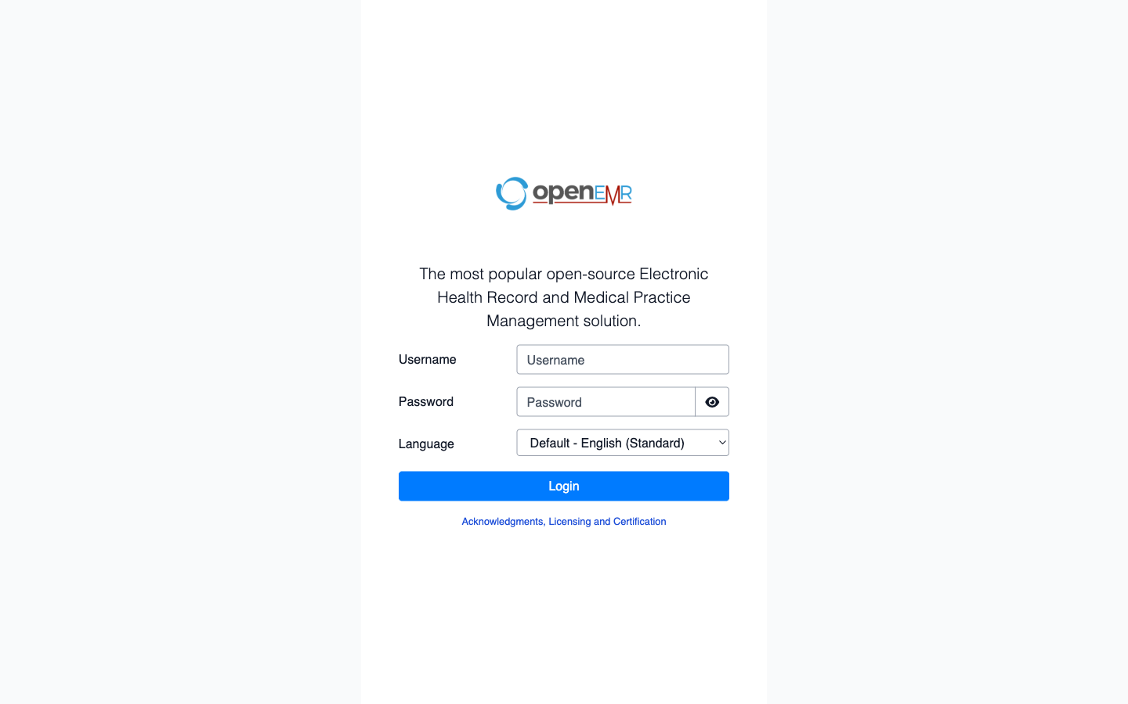
OpenEMR Login Page - Secure HTTPS connection

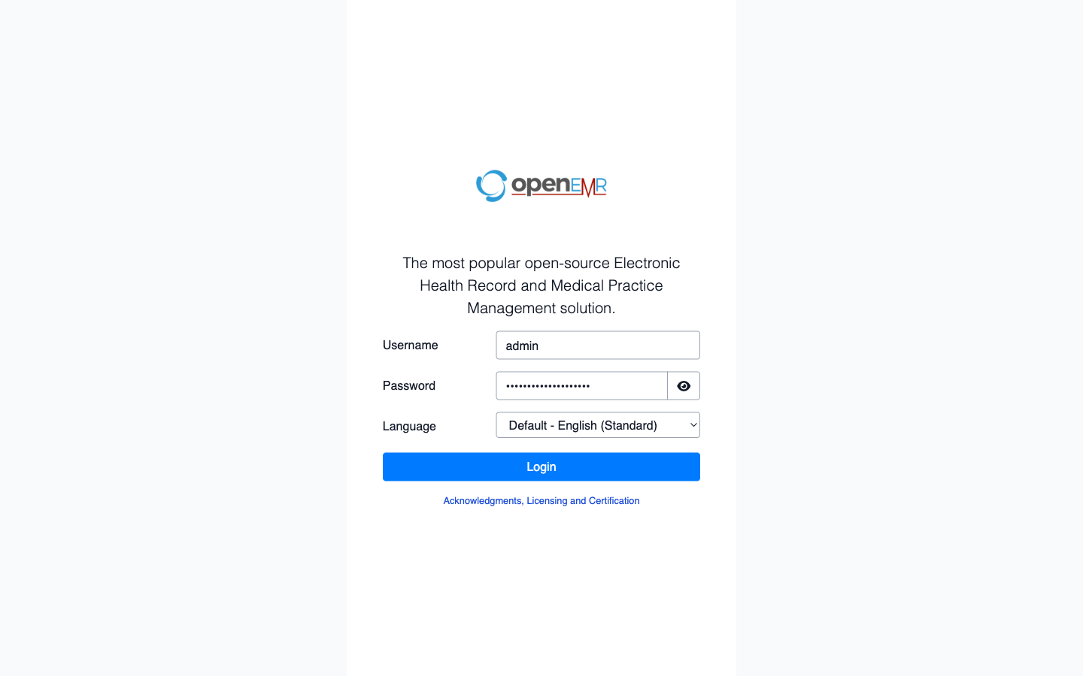
Admin credentials entered

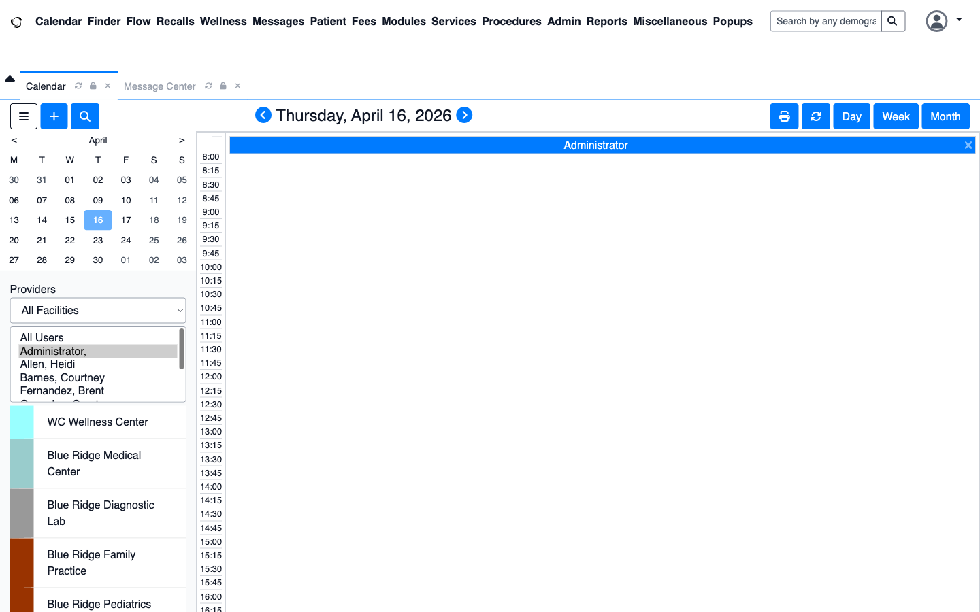
OpenEMR Dashboard - Calendar view with multiple providers and facilities

4. Step 2: Create New Patient in OpenEMR
We create a new patient to demonstrate the complete data flow from EHR to RAF Intelligence. This patient will be automatically synced via FHIR R4 and appear in the RAF platform.
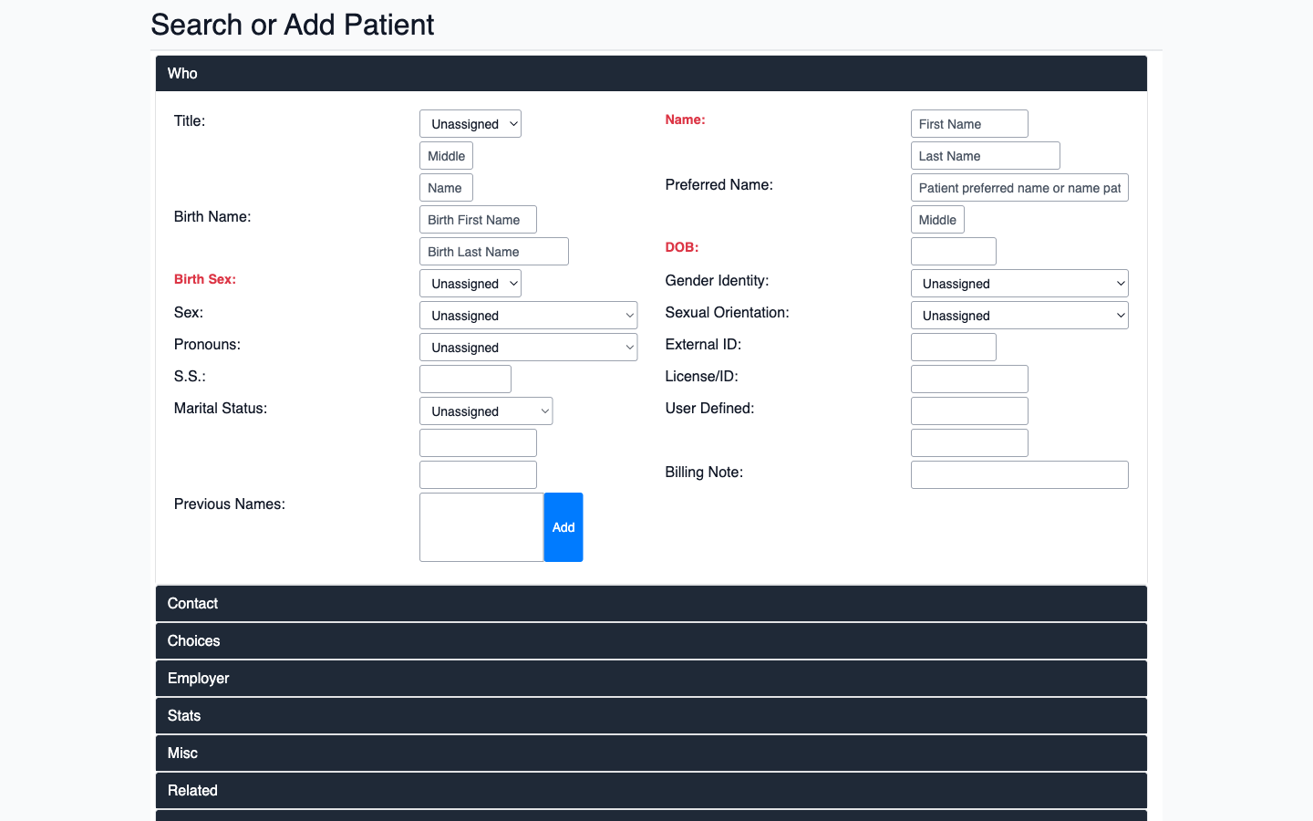
OpenEMR New Patient Registration Form

Patient Demographics
Field | Value
Name | Maria Elena Rodriguez
Date of Birth | March 15, 1958 (68 years old)
Sex | Female
SSN | 999-88-7777
External ID | RAF-DEMO-2026
Address | 4521 Palm Beach Blvd, Miami, FL 33137
Phone | (305) 555-0142
Email | maria.rodriguez@example.com
Medicare Eligibility | Yes (age 65+)

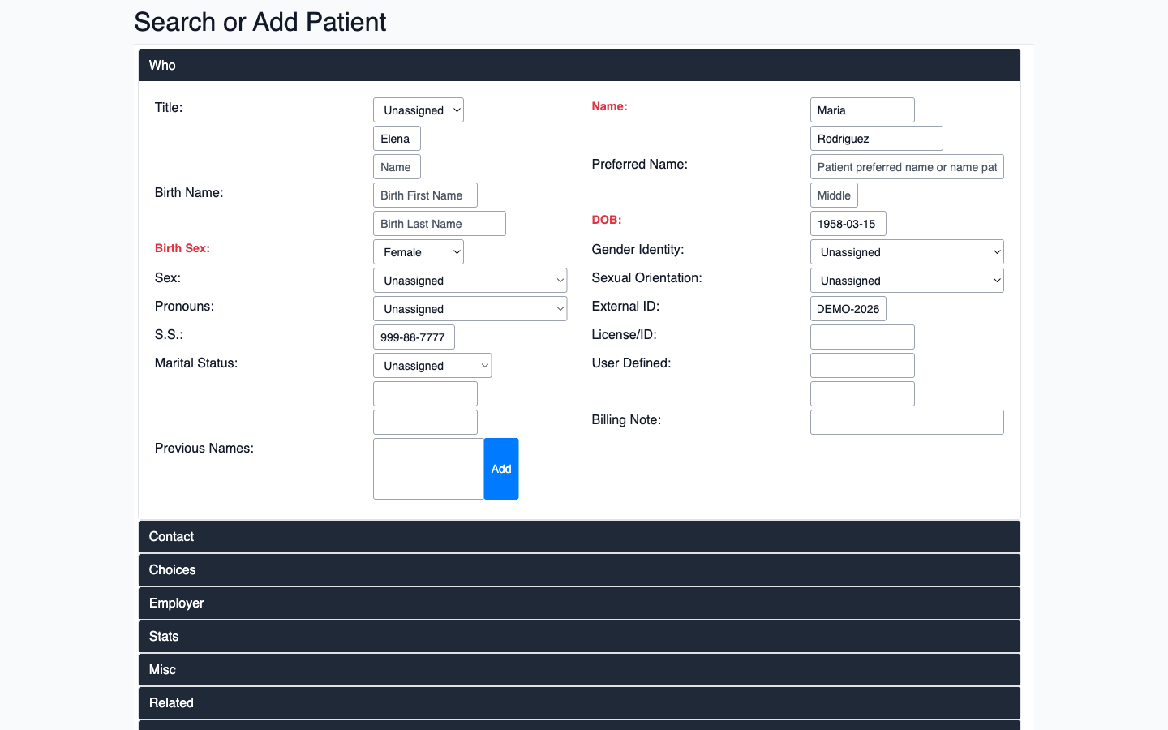
Demographics filled - Name, DOB, Sex, SSN, External ID

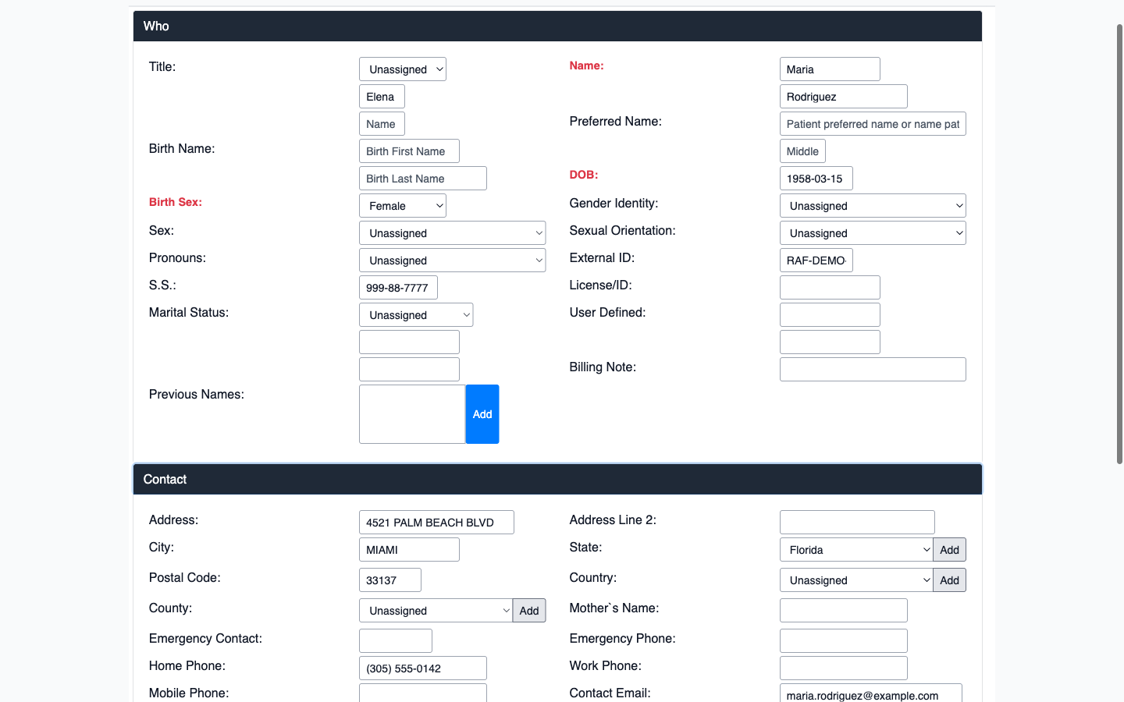
Contact information - Address, Phone, Email

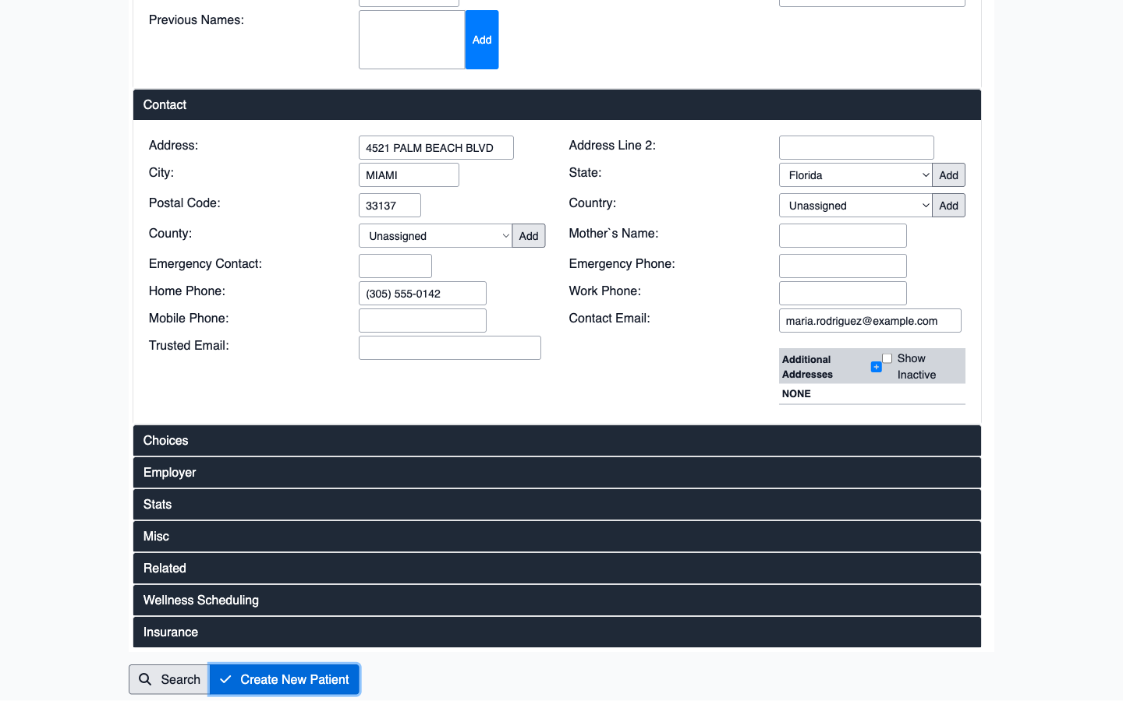
Patient successfully created in OpenEMR

5. Step 3: Existing Patient Data in OpenEMR
The OpenEMR instance already contains 13 patients with rich clinical data including diagnoses (ICD-10 codes), encounters, medications, lab results, immunizations, and allergies. This data is what RAF Intelligence ingests and analyzes.
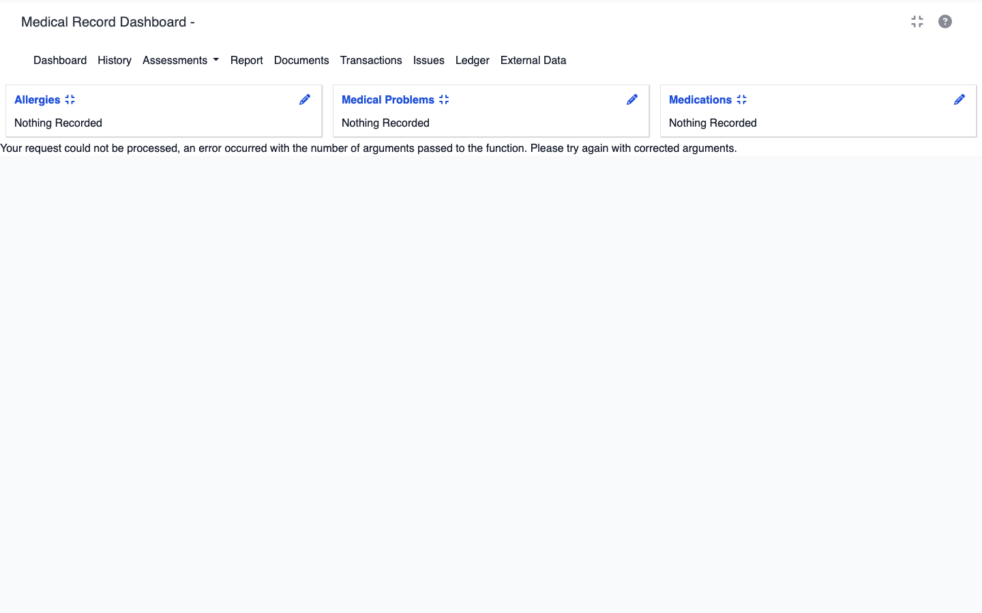
Patient Summary - Ronald Abeyta (82M) with multiple active medical problems

6. Step 4: RAF Intelligence Login
We now switch to the RAF Intelligence platform to see how patient data from OpenEMR has been automatically ingested, analyzed, and scored.
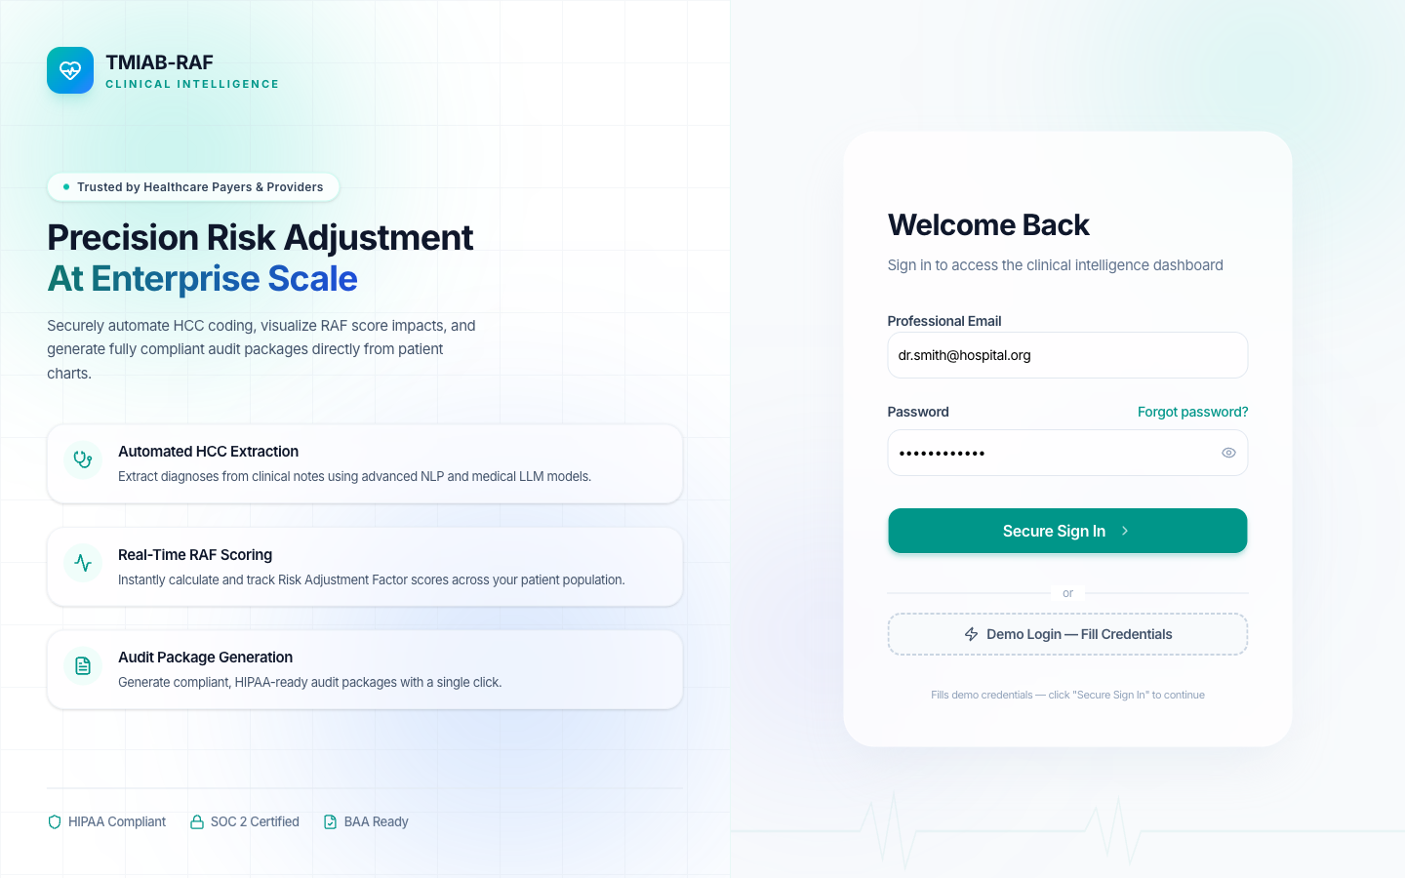
RAF Intelligence Login - Branded as 'TMIAB RAF Clinical Intelligence'

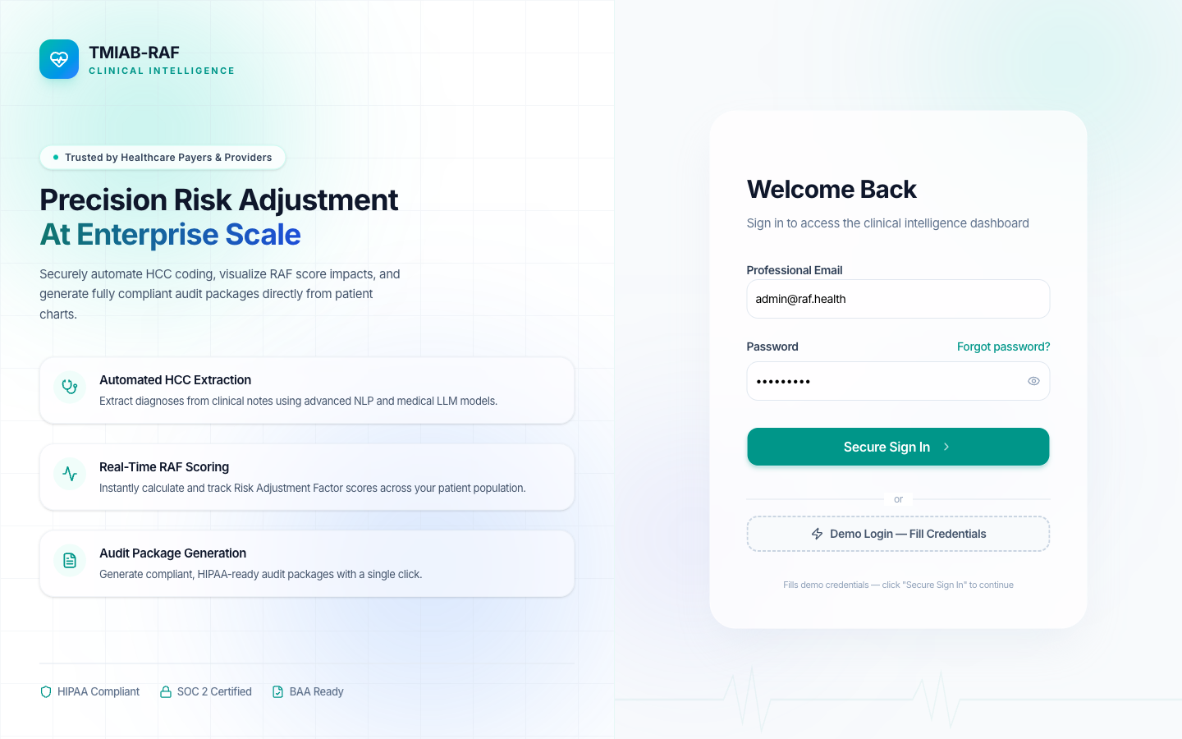
Admin credentials entered

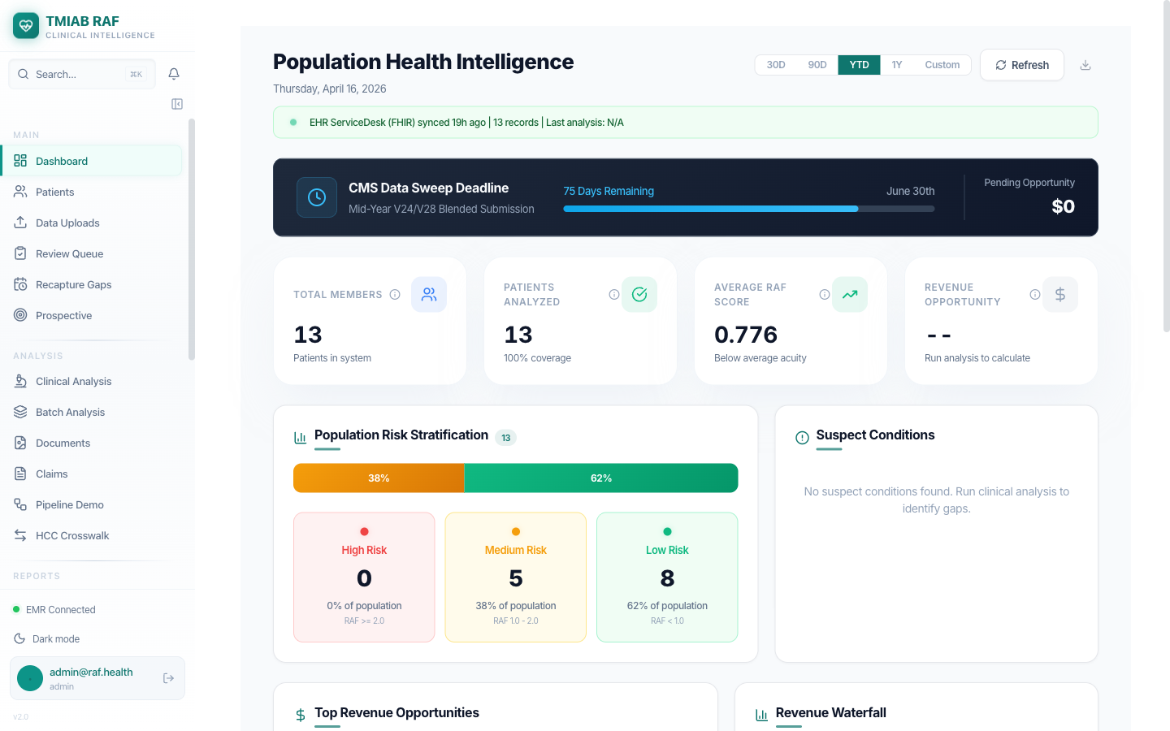
Successfully authenticated - RAF Intelligence Dashboard

Dashboard Overview
The RAF Intelligence dashboard provides at-a-glance population health metrics, risk distribution, and pipeline activity status.
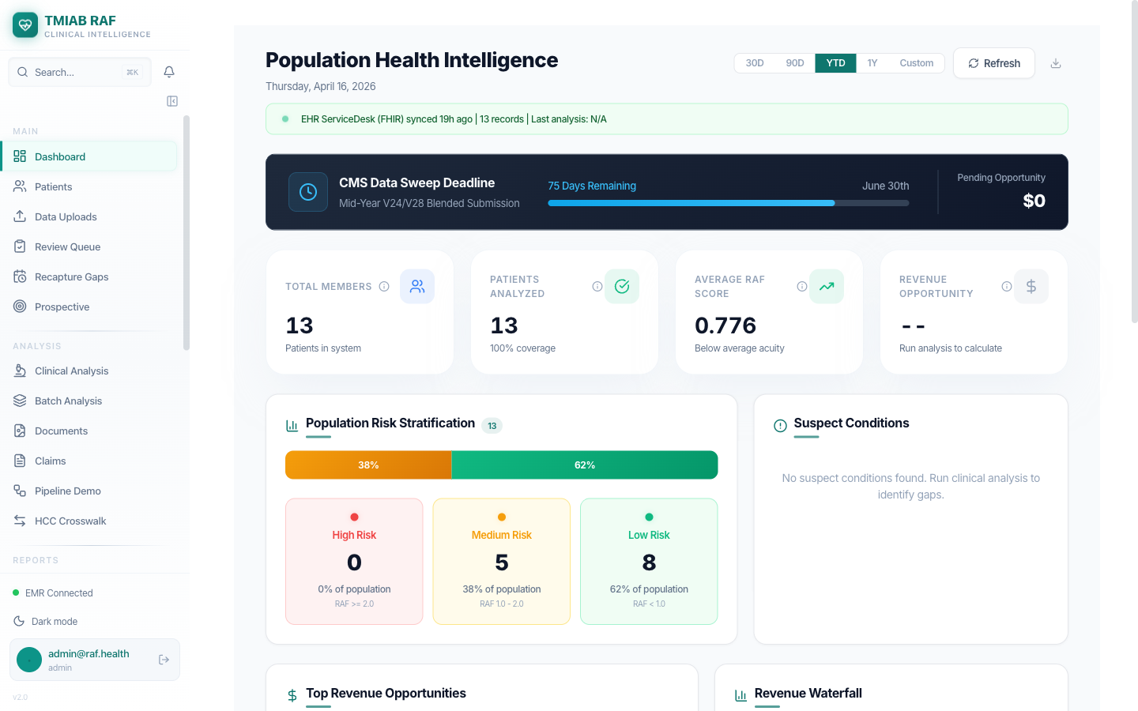
RAF Intelligence Dashboard - Population metrics and risk distribution

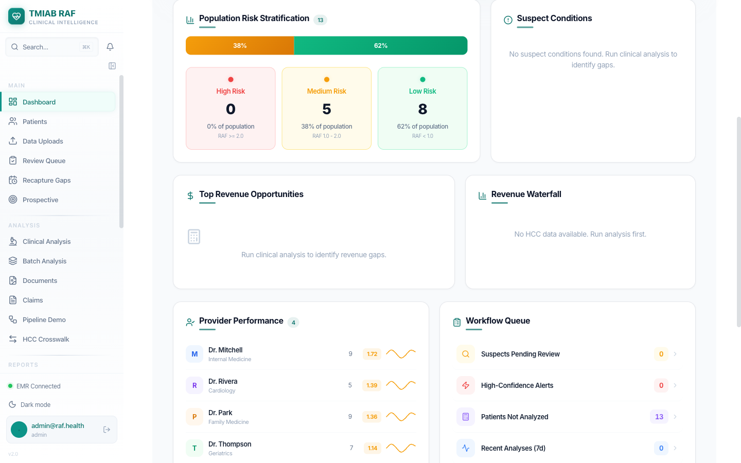
Dashboard continued - Additional analytics and charts

7. Step 5: Patient Population Dashboard
The Patient Population view is the heart of RAF Intelligence. It shows all synced patients with their risk profiles, RAF scores, HCC counts, and analysis status.
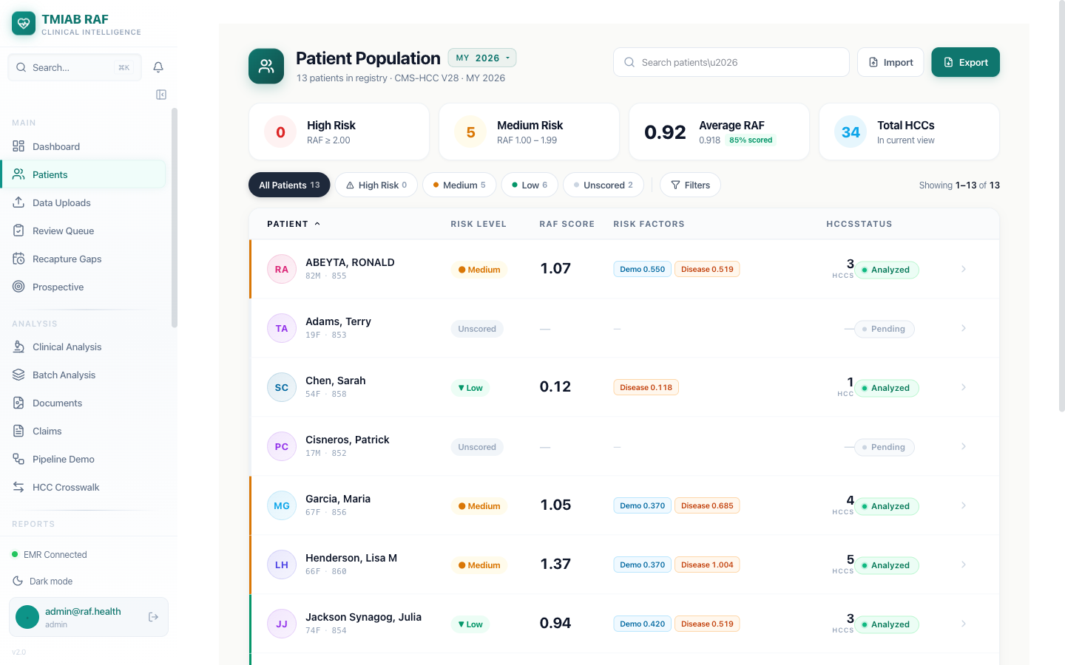
Patient Population - 13 patients synced from OpenEMR via FHIR R4

Key Metrics
Metric | Value | Description
Total Patients | 13 | All patients synced from OpenEMR
High Risk (RAF >= 2.00) | 0 | No patients above threshold
Medium Risk (1.00 - 1.99) | 5 | Patients requiring attention
Average RAF Score | 0.92 | Population average risk score
Total HCCs | 34 | Hierarchical Condition Categories identified
Scored Rate | 85% | Percentage of patients with RAF scores

Patient Risk Summary
Patient | Age/Sex | Risk Level | RAF Score | HCCs | Status
Abeyta, Ronald | 82M | Medium | 1.069 | 3 | Analyzed
Henderson, Lisa | 65F | Medium | 1.374 | 5 | Analyzed
Garcia, Maria | 67F | Medium | 1.05 | 4 | Analyzed
Williams, Robert J | 81M | Medium | 1.07 | 3 | Analyzed
Jackson, Julia | 71F | Low | 0.94 | 3 | Analyzed
Chen, Sarah | 54F | Low | 0.12 | 1 | Analyzed
Rodriguez, Maria Elena | 68F | Low | 0.37 | 0 | Analyzed
Adams, Terry | 19F | Unscored | - | 0 | Pending

8. Step 6: Patient Detail View (RAF Scoring)
Clicking into a patient reveals comprehensive clinical intelligence with RAF scoring, active problems, encounters, care gaps, and data quality metrics.

Patient: Ronald Abeyta (RAF 1.069)
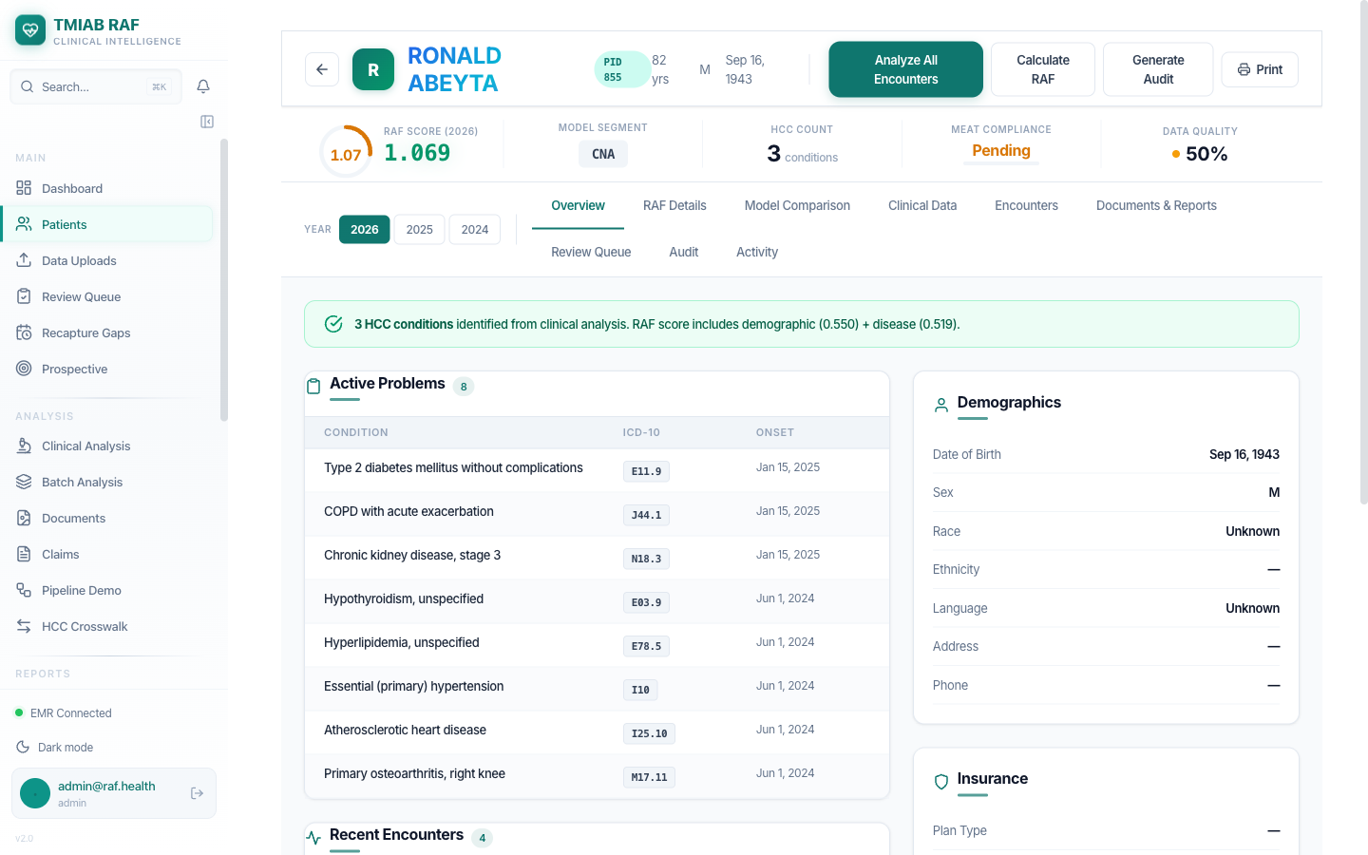
Patient Detail - Header with RAF score, HCC count, MEAT compliance, and action buttons

Patient Header Metrics
Metric | Value
RAF Score (MY 2026) | 1.069
Model Segment | CNA (Community, Non-Dual, Aged)
HCC Count | 3 conditions
Demographic Score | 0.550
Disease Score | 0.519
MEAT Compliance | Pending
Data Quality | 50%

Active Problems (8 ICD-10 Diagnoses)
Condition | ICD-10 | Onset
Type 2 diabetes mellitus without complications | E11.9 | Jan 15, 2025
COPD with acute exacerbation | J44.1 | Jan 15, 2025
Chronic kidney disease, stage 3 | N18.3 | Jan 15, 2025
Hypothyroidism, unspecified | E03.9 | Jun 1, 2024
Hyperlipidemia, unspecified | E78.5 | Jun 1, 2024
Essential (primary) hypertension | I10 | Jun 1, 2024
Atherosclerotic heart disease | I25.18 | Jun 1, 2024
Primary osteoarthritis, right knee | M17.11 | Jun 1, 2024

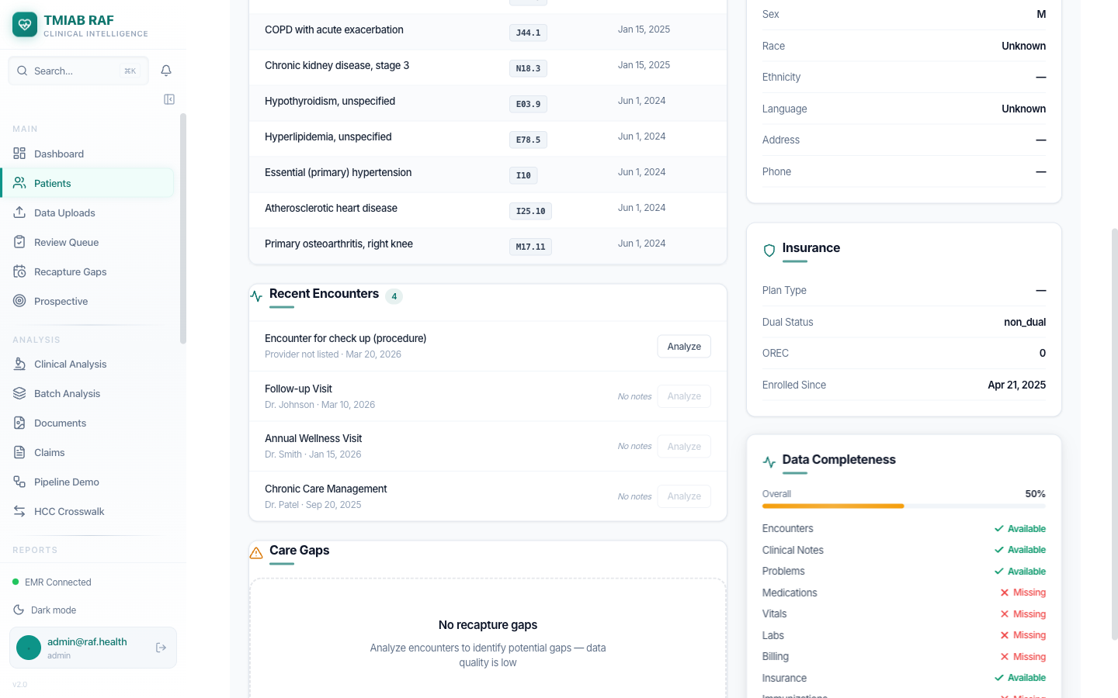
Encounters, Care Gaps, and Data Completeness sections

Recent Encounters
Encounter | Provider | Date | Action
Encounter for check up (procedure) | Provider not listed | Mar 20, 2026 | Analyze
Follow-up Visit | Dr. Johnson | Mar 10, 2026 | Analyze
Annual Wellness Visit | Dr. Smith | Jan 10, 2026 | Analyze
Chronic Care Management | Dr. Patel | Sep 20, 2025 | Analyze
Each encounter has an 'Analyze' button that triggers Google Gemini 2.5 Pro AI analysis to extract missed diagnoses, validate existing codes, and assess MEAT compliance.

AI Clinical Analysis
The Clinical Analysis page shows AI-powered encounter analysis results from Google Gemini 2.5 Pro.
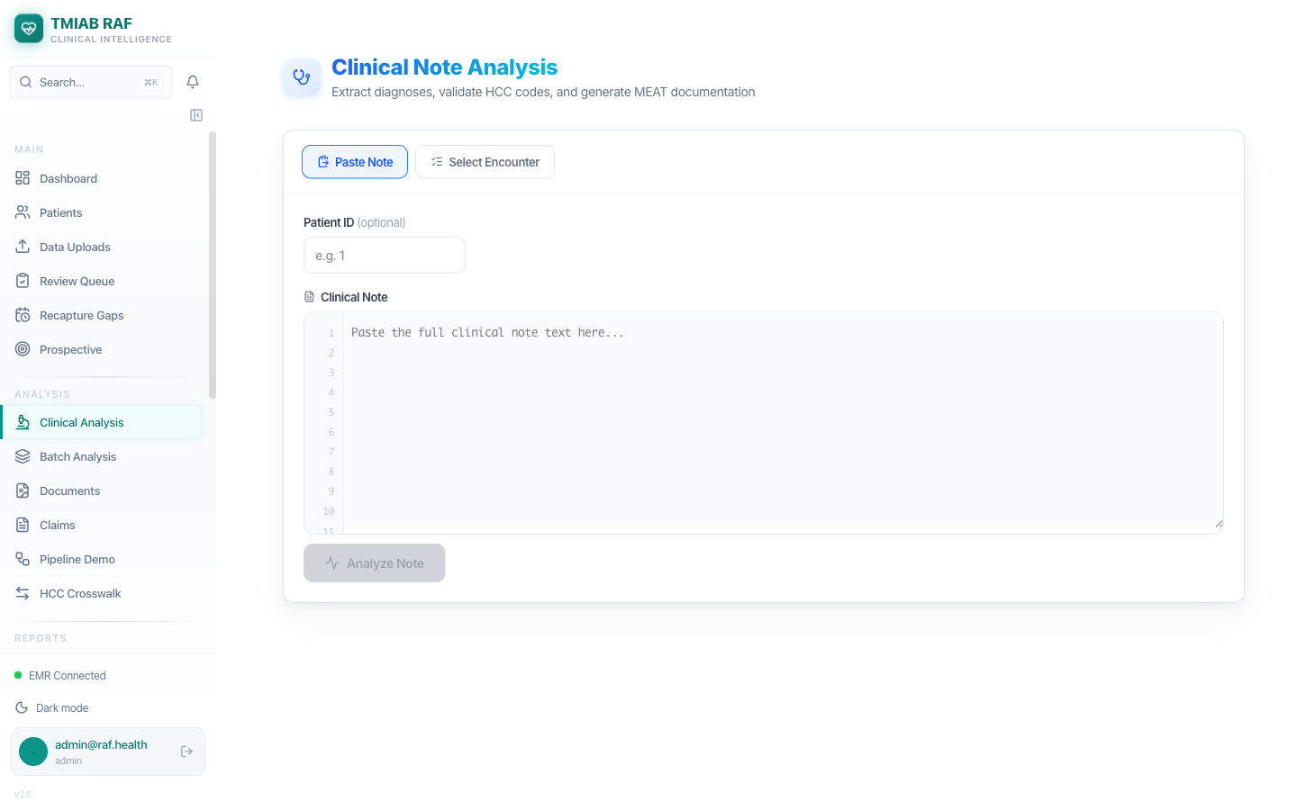
Clinical Analysis - AI encounter analysis powered by Gemini 2.5 Pro

Patient: Lisa Henderson (RAF 1.374)
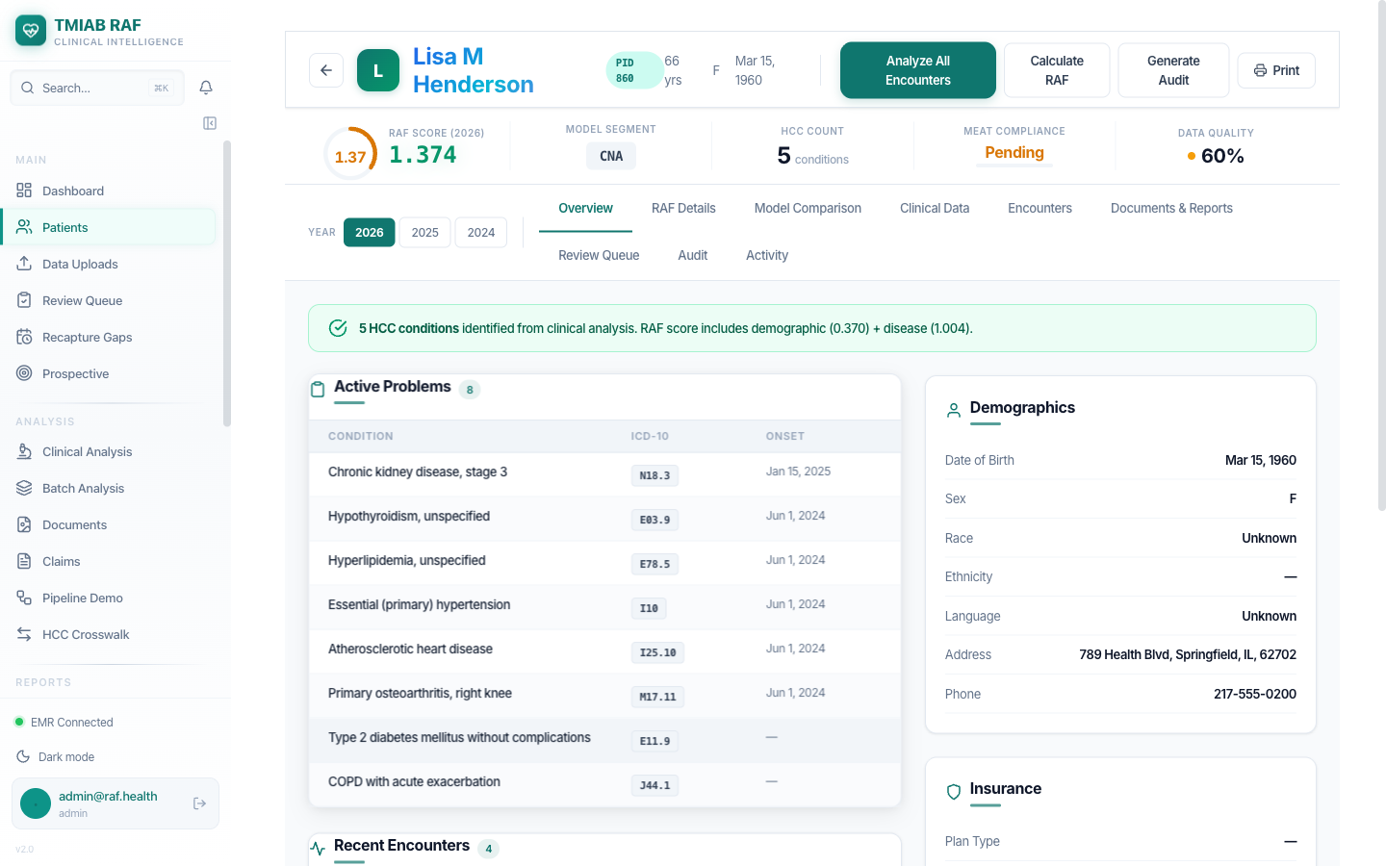
Lisa Henderson - 5 HCC conditions, Medium Risk, RAF 1.374

9. Step 7: Newly Created Patient in RAF Intelligence
The patient we created in OpenEMR (Maria Elena Rodriguez) has been automatically synced into RAF Intelligence via FHIR R4. This confirms the complete end-to-end data flow.
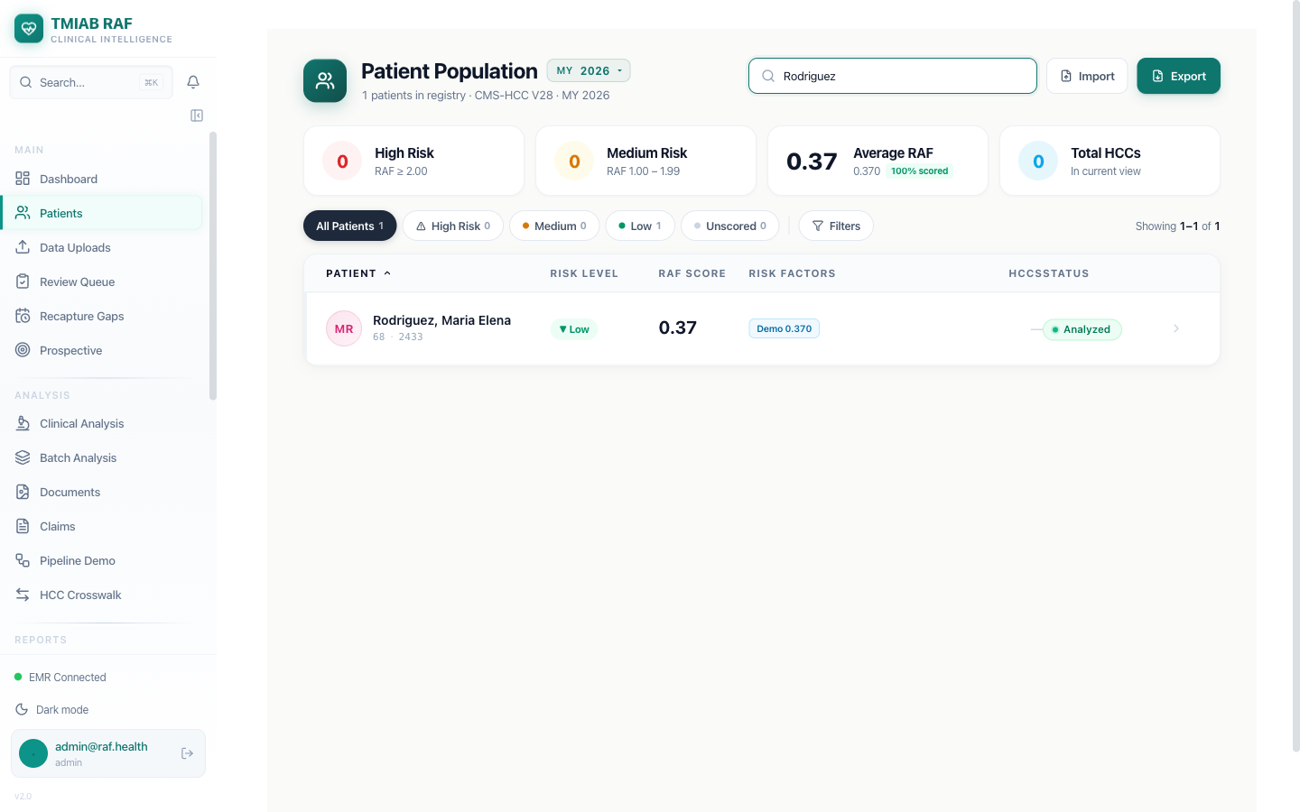
Searching for 'Rodriguez' - Patient found with demographic RAF score of 0.37

Field | Value
Patient | Rodriguez, Maria Elena
Age / Sex | 68F
PID | 2433
Risk Level | Low
RAF Score | 0.37 (demographic only)
HCC Count | 0 (no conditions added yet)
Status | Analyzed
Note: The RAF score of 0.37 reflects the demographic-only score (age 68, female, Community Non-Dual Aged segment). Once clinical conditions are added in OpenEMR and synced, the RAF score will increase based on HCC mappings.

10. Step 8: EMR Configuration & AI Pipeline
The EMR Configuration page shows the integration setup and the 8-phase AI analysis pipeline.
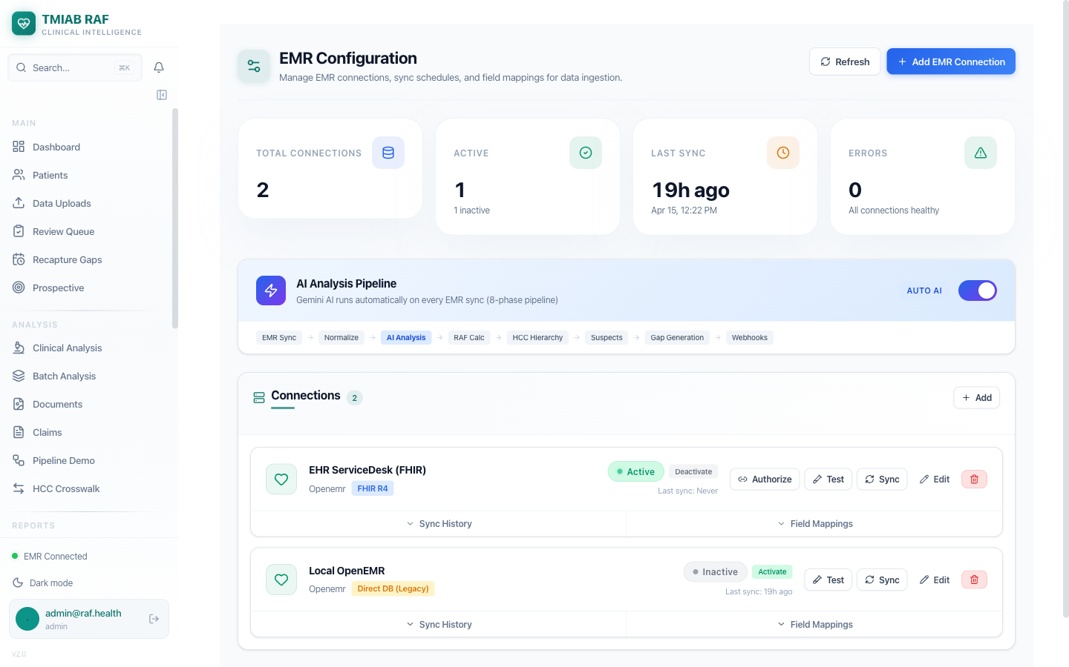
EMR Configuration - AI Pipeline toggle ON, 2 connections, 8-phase pipeline visualization

Connection Summary
Metric | Value
Total Connections | 2
Active Connections | 1 (EHR ServiceDesk - FHIR R4)
Inactive Connections | 1 (Local OpenEMR - Direct DB Legacy)
Last Sync | Apr 15, 2026 12:22 PM
Errors | 0 - All connections healthy

8-Phase AI Analysis Pipeline
The AI Analysis Pipeline runs automatically on every EMR sync. The AUTO AI toggle is enabled (green), activating the full 8-phase chain:
Phase | Name | Description
1 | EMR Sync | FHIR R4 data ingestion from connected EHRs
2 | Normalize | Standardize codes, names, dates across sources
3 | AI Analysis | Gemini 2.5 Pro analyzes each encounter
4 | RAF Calc | CMS-HCC V24/V28 blended RAF scoring
5 | HCC Hierarchy | Trumping and interaction logic
6 | Suspects | 4-engine suspect detection (lab, medication, history, NLP)
7 | Gap Generation | Care gaps and chart chase requests
8 | Webhooks | Notifications and completion events

Pipeline Visualization
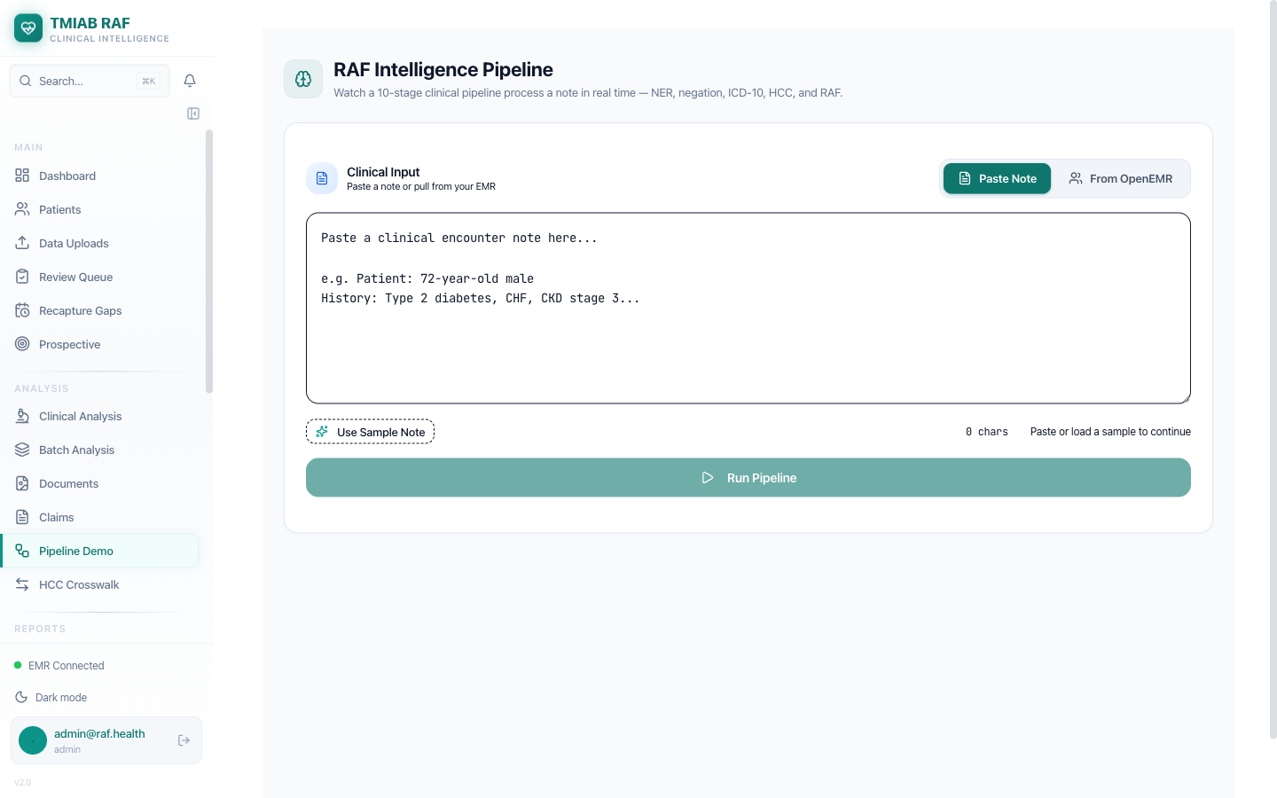
Pipeline Demo - Visual representation of the 8-phase processing chain

11. Step 9: Suspect Conditions
The Suspect Conditions module uses AI to identify potential missed diagnoses that could increase RAF scores. Suspects are detected from 6 evidence sources and ranked by confidence.
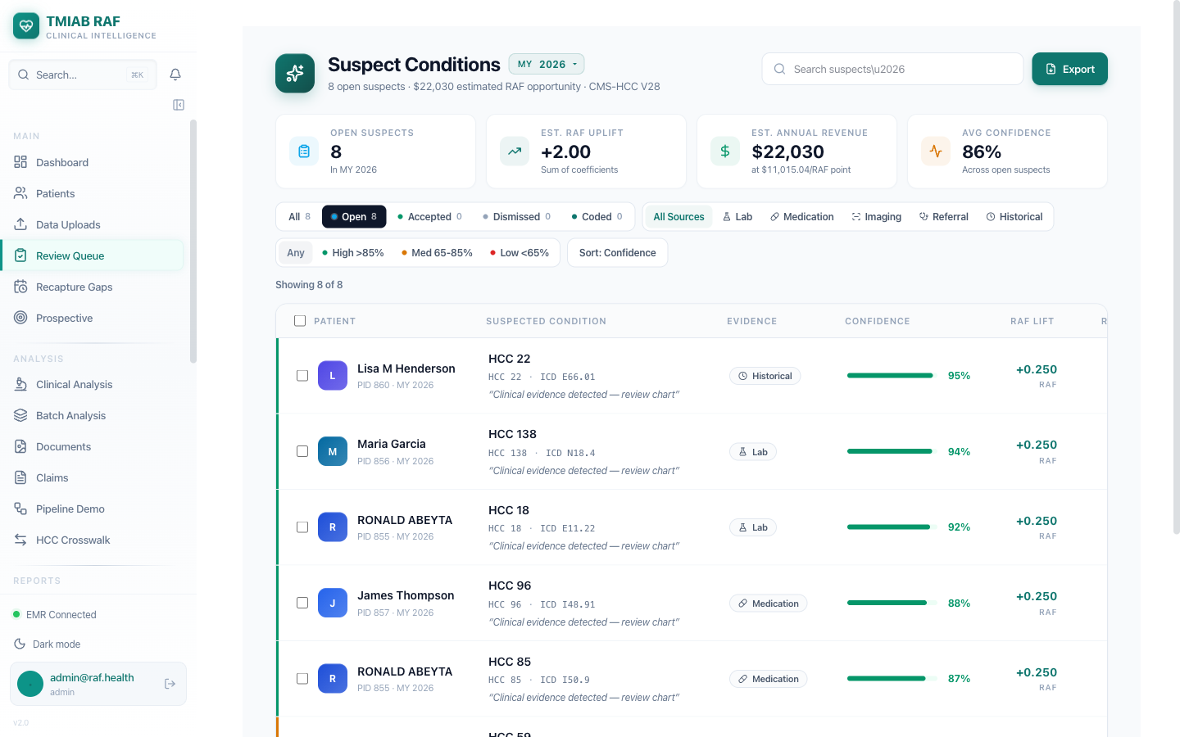
Suspect Conditions Dashboard with filters by status, source, and confidence

Active Suspects Detected (Sample)
Patient | Suspect HCC / ICD-10 | Evidence Type | Confidence | RAF Lift
Ronald Abeyta | HCC 18 / E11.22 (Diabetes w/ CKD) | Lab (HbA1c 9.2%) | 92% | +0.302
Ronald Abeyta | HCC 85 / I50.9 (Heart Failure) | Medication (Furosemide+Carvedilol) | 87% | +0.323
Lisa Henderson | HCC 22 / E66.01 (Morbid Obesity) | Historical (BMI 42, 2024) | 95% | +0.250
Lisa Henderson | HCC 59 / F32.1 (MDD) | Medication (Sertraline 100mg) | 81% | +0.309
Maria Garcia | HCC 138 / N18.4 (CKD Stage 4) | Lab (eGFR 22) | 94% | +0.169
James Thompson | HCC 96 / I48.91 (Atrial Fib) | Medication (Apixaban) | 88% | +0.268
Patrick Cisneros | HCC 108 / I73.9 (PAD) | Referral (Vascular consult) | 76% | +0.288
Maria E. Rodriguez | HCC 19 / E11.9 (T2DM) | Lab (Glucose 148) | 72% | +0.105
Each suspect represents a potential missed diagnosis identified by the AI engine from lab results, medication patterns, historical conditions, or specialty referrals. Providers review and either Accept (adds to billing), Dismiss (with reason), or leave Open for further documentation.

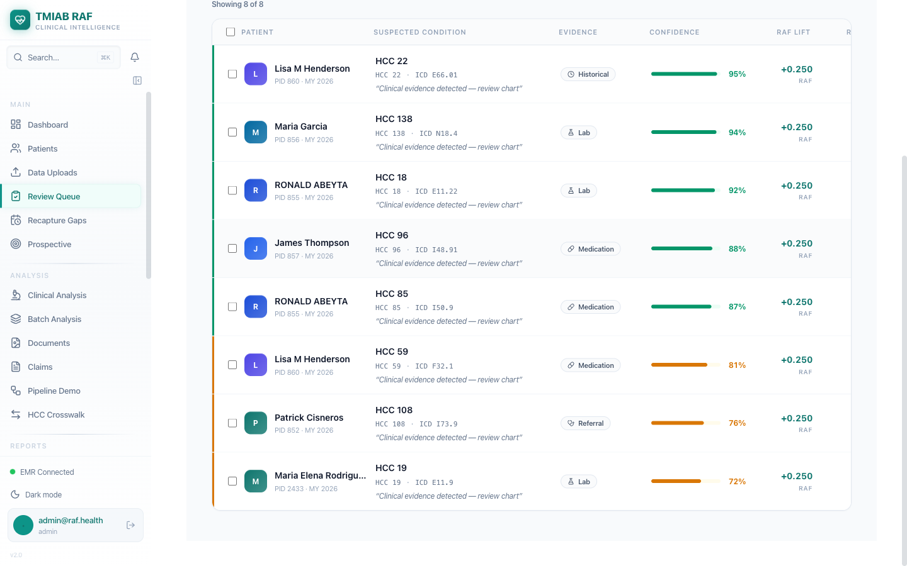
Suspect Conditions - Scrolled view showing full list

Suspect Detection Sources
Source | Description
Lab Results | Abnormal lab values suggesting undiagnosed conditions
Medications | Prescriptions that imply conditions not on problem list
Imaging | Radiology findings suggesting undocumented diagnoses
Referrals | Specialty referrals indicating unrecorded conditions
Historical | Prior-year conditions not recaptured in current year
NLP (AI) | Gemini AI extraction from clinical notes and encounters

Confidence Levels
Level | Threshold | Action
High | > 85% | Auto-accepted for coding review
Medium | 65% - 85% | Flagged for clinical review
Low | < 65% | Queued for manual verification

12. Step 10: Recapture Gaps & Data Uploads

Recapture Gaps
The Recapture Gaps module identifies conditions from prior measurement years that need to be re-documented in the current year to maintain RAF scores.
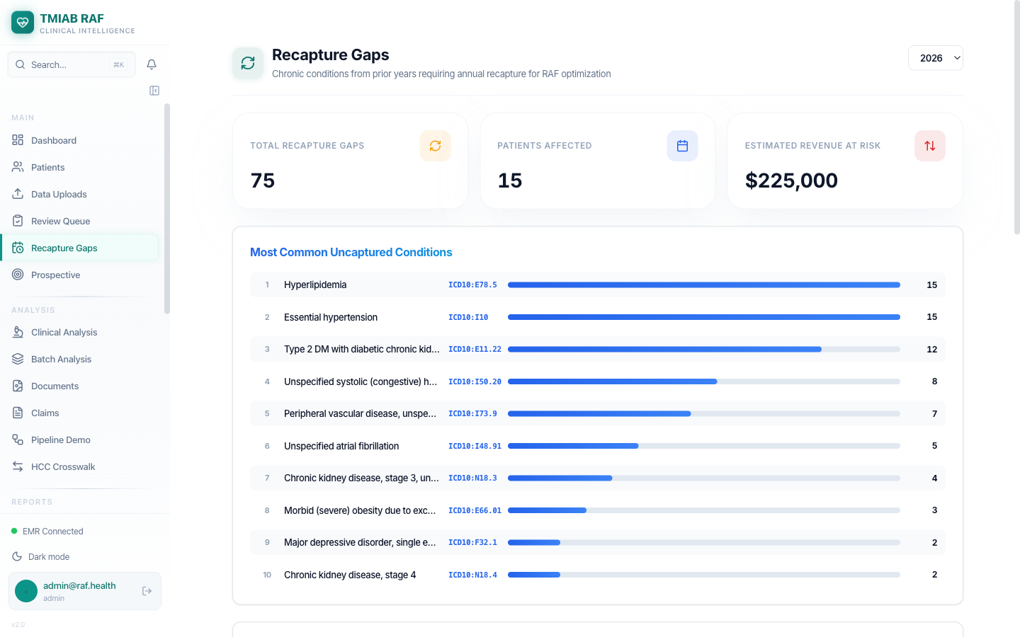
Recapture Gaps Interface

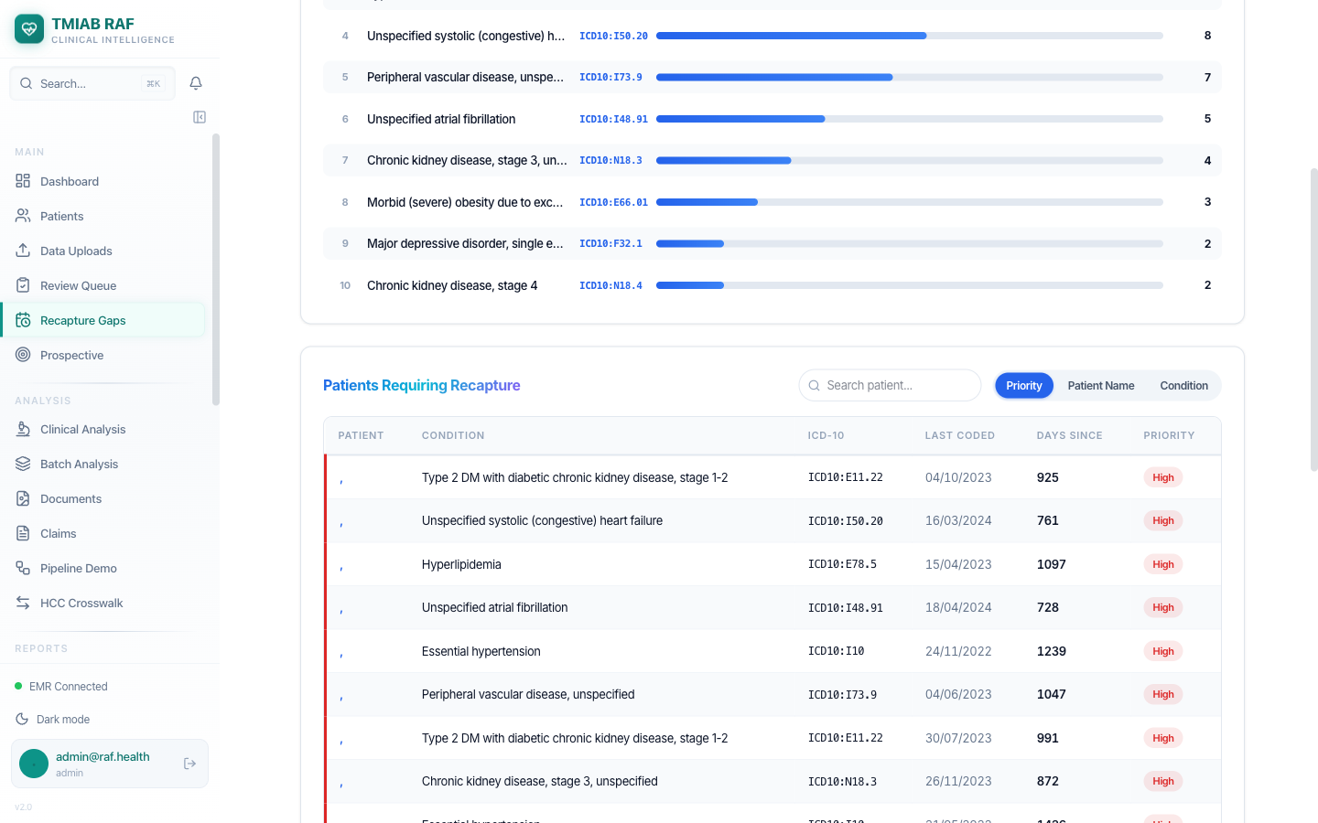
Recapture Gaps - Detail View

Data Uploads (Document Analysis)
The Data Uploads page allows manual upload of clinical documents (PDF, images) for Gemini Vision AI analysis. The AI extracts ICD-10 codes, HCC mappings, medications, lab results, and MEAT compliance evidence from uploaded documents.
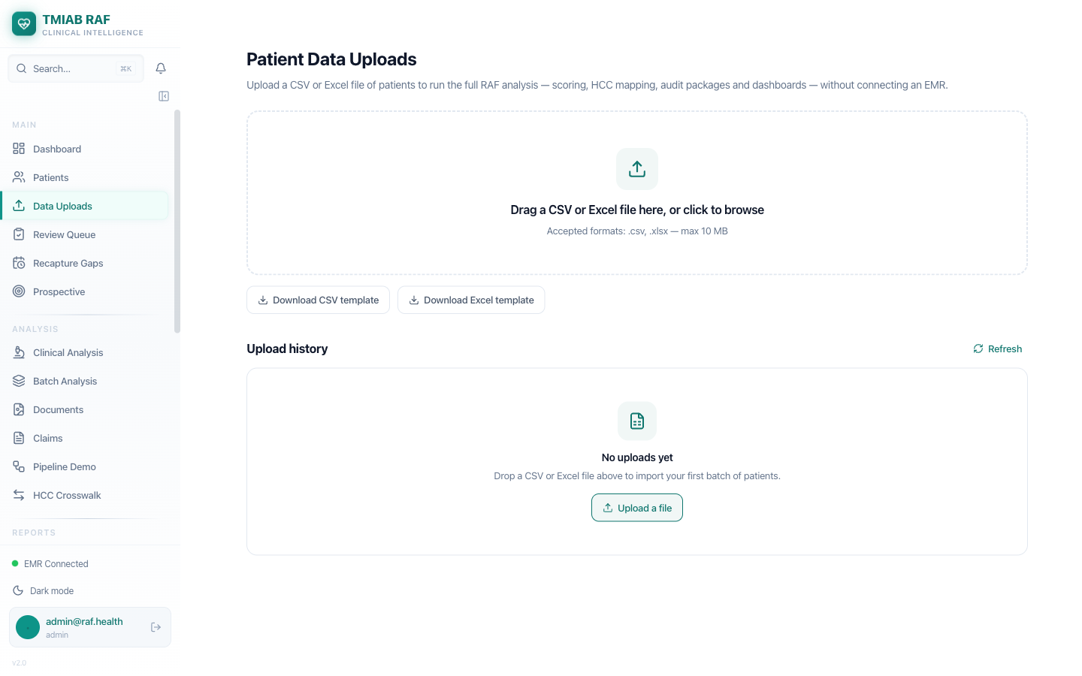
Data Uploads - Document upload and AI analysis interface

13. Technical Architecture

Data Flow
OpenEMR (EHR) ---> FHIR R4 / OAuth2 ---> RAF Intelligence

FHIR Resources Synced (9 Types)
# | FHIR Resource | RAF Intelligence Destination | Purpose
1 | Patient | Demographics + RAF demographic scoring | Patient identity and age/sex factors
2 | Condition | ICD-10 codes -> HCC crosswalk -> RAF | Primary source for HCC conditions
3 | Encounter | Clinical analysis by Gemini AI | Encounter-level AI analysis
4 | MedicationRequest | Medication-based suspect detection | Drug-to-condition inference
5 | Observation | Lab-based suspect detection | Abnormal value flagging
6 | DiagnosticReport | NLP analysis of conclusions | Radiology/pathology insights
7 | Immunization | HEDIS quality measures | Vaccine compliance tracking
8 | AllergyIntolerance | Safety alerts | Drug interaction prevention
9 | DocumentReference | Gemini Vision document analysis | PDF/image code extraction

Technology Stack
Component | Technology
Backend API | Python / FastAPI
Frontend | Next.js / React / TypeScript
AI Engine | Google Gemini 2.5 Pro
Database | MySQL 8.0
Task Queue | Celery + Redis
EHR Integration | HL7 FHIR R4 + OAuth2
Deployment | Docker Compose
Security | JWT + RBAC + HIPAA Multi-tenant

14. Key Takeaways

Seamless EHR Integration
Patient data flows automatically from any FHIR R4-compliant EHR via secure OAuth2 authentication. Supports OpenEMR, Epic, Cerner, and other major EHR platforms.

AI-Powered Clinical Analysis
Google Gemini 2.5 Pro analyzes every clinical encounter to identify missed diagnoses, validate existing codes, and extract MEAT compliance evidence.

Accurate RAF Scoring
CMS-HCC V24/V28 blended model with demographic, disease, and interaction scoring. Automatic hierarchy trumping ensures no inflated scores.

Comprehensive Patient View
All clinical data -- conditions, encounters, medications, labs, immunizations, allergies -- unified in a single patient view with data quality tracking.

Actionable Intelligence
Suspect conditions with confidence scoring, care gap identification, chart chase automation, and provider worklists drive measurable revenue optimization.

Enterprise Ready
Multi-tenant architecture, HIPAA-compliant, role-based access control, audit logging, and webhook integration for enterprise deployment.

--- End of Document ---

