Introduction
TPB_Spouge.docx establishes some notation.
Single Founder
In a standard notation, 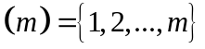. Fix an alphabet 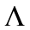, e.g., 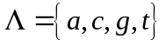. In practice, sequence analysis must invoke a strategy for handling anomalous characters in an alignment, e.g., ambiguous or gap characters. Sometimes, they are so infrequent that treating them as an ordinary character may provide acceptable approximations. Sometimes, the analysis omits columns containing them. The following assumes the adoption of some practical strategy for handling anomalous characters.
Consider a data set 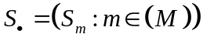 consisting of  sequences. The sequences are sampled simultaneously from the descendants of a single founder sequence . Align the sequences and 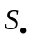 in an alignment matrix 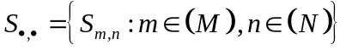 of  columns. The matrix column 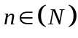 contains the letters 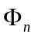 (from ), and 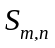 (from 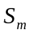).
In a notation like the Iverson bracket for indicator random variates, let 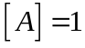 if the statement  holds, and 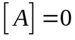 otherwise. (Context disambiguates indicators from events, thereby avoiding the ugly duplication of a square bracket in Iverson’s notation.) Let 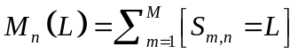 count the appearances of letter 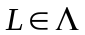 in column (), so 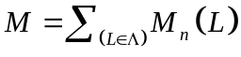.
A consensus letter 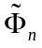 maximizes the consensus count 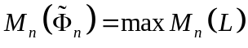 (a consensus letter is not necessarily unique, because two letters may have the consensus count). Consensus sequences 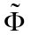, denoted by an over-tilde, figure prominently below. Let 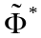 denote the set of consensus sequences; and , an arbitrary consensus sequence. Restrict attention to column until further notice, so 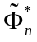 denotes the corresponding set of consensus letters; and 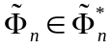, an arbitrary consensus letter. Let 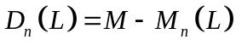 count letters differing from , with 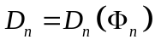 providing a default value (so the notation 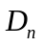 can leave its dependency on implicit) and 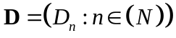. Let 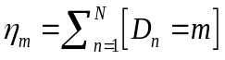 count the alignment columns where letters differ from the founder letter , with 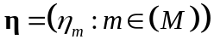. The founder sequence is unknown, so the SFS is not observable.
Consensus sequences are observable, however. Let 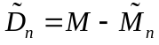 count minority letters, letter differing from an arbitrary consensus letter, so the observable 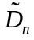 is not functionally dependent on the founder sequence . Let 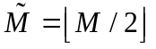. If 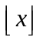 denotes the floor function, define the folded SFS 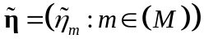 by the equation
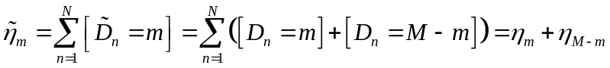
for 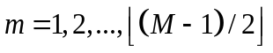). In addition if  is even, so 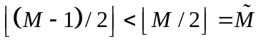, let 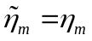 for 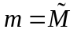, with 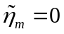 for 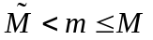.
The folded SFS 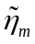 therefore counts the alignment columns where the number of minority letters is . If 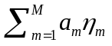 satisfies 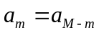 and 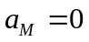, then 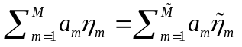 is observable, and it therefore can provide an estimator for inferring model quantities. To investigate, let 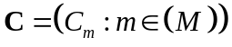 be the ancestral sample frequency spectrum (i.e., 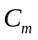 counts the ancestors with descendants in the sample).
Let 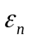 be the rate of mutation per base per generation in column of the alignment. Consider an infinite sites model (i.e., two or more mutations occur so rarely in the ancestry of a single letter that we neglect the possibility ), so every mutation occurs in a different column of the alignment. Let 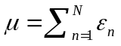 be the expected number of mutations per generation in the sequences. The novel mutation counts in every daughter of every mother are approximately independent Poisson variates with fixed mean 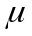 (e.g., as in the Gamma and Delta models defined in I).
Given 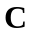, I showed that the coordinates of are independent Poisson variates, with 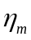 having mean 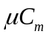. From Theorem 1 in TPB_Spouge.docx, given the ancestry (or even just the sample frequency spectrum 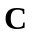) 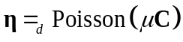, where the multivariate Poisson distribution has independent components.
Previous simulations showed that for 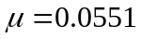 (HIV gp120), the usual magnitude of the ratio 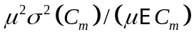 was at most about 18%, suggesting the deterministic approximation 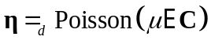. To approximate  in the Gamma model, define
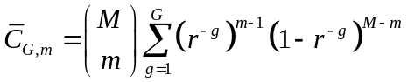
for 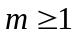, and let 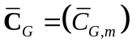.
I demonstrated that for HIV gp120, the approximation 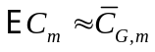 was useful. On one hand, define default values 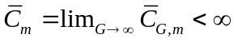 for 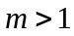. On the other hand, define for later brevity
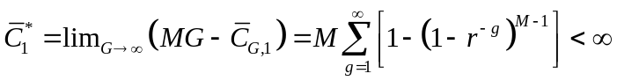.
We therefore examine the limit of the deterministic approximation as 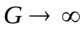:
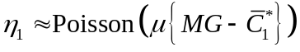
and 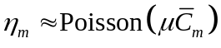, where all components 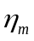 of are mutually independent.
Let 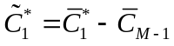. From Eq , the probability of the (observable) is
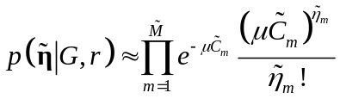,
where 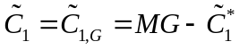 for 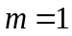, 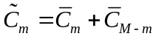 for 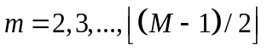, and in addition, 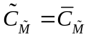 if is even. After dropping an irrelevant additive constant, the approximate log-likelihood is therefore
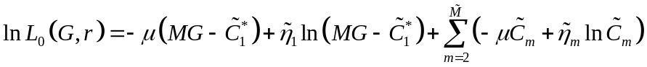.
Although Eq can be maximized directly as a function of both  and , 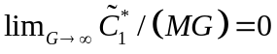. Thus, and are independent in another approximate log-likelihood,
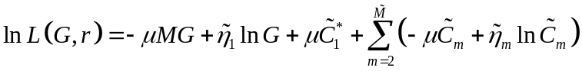,
because 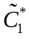 and 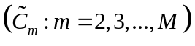 depend only on . On one hand, the resulting maximum likelihood estimate (MLE) 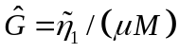 is biased and demonstrably inferior to other estimates of . On the other hand, a useful MLE derives from maximizing
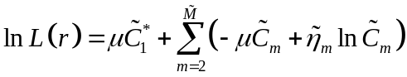.
With 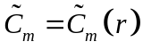, 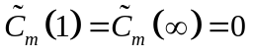 for 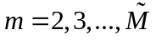. Because 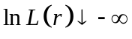 at the boundaries of 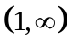, an MLE 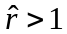 therefore exists. For HIV gp120, biological relevancy suggests that, say, 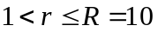, with an error no less than, say, 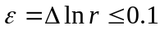. Brute-force search for the global maximum of 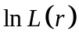 at resolution can therefore evaluate 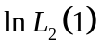 at 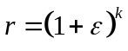 (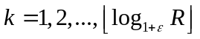). If desired, Golden-section_search can refine the maximum.
The (observed) Fisher information provides the approximate precision of :
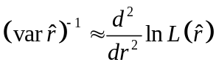.
We defer the actual calculation to consider some related estimators.
For comparison, the method of moments can also estimate . Consider 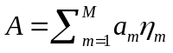 for general 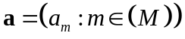 (and note that the likelihood has a related form). Then,
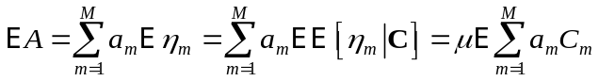,
and the law of total variance yields
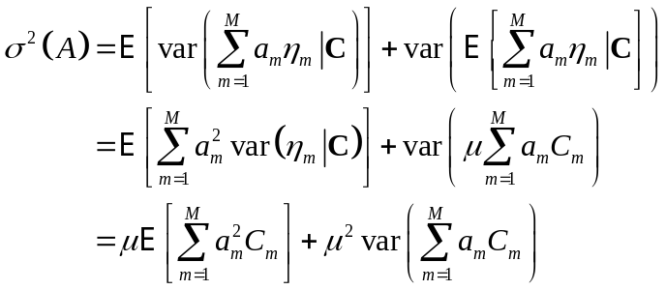,
where the second equality follows from the conditional independence of 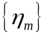 given and 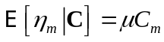; and the third equality follows from the fact that the variance of a Poisson variate equals its mean. Eq shows that simulations of 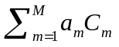 and 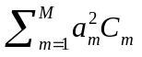 can estimate the first two moments of 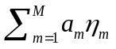. For HIV gp120, moreover, if 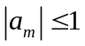 for 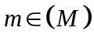, the small magnitude of suggests that the final variance term in Eq is small.
Let 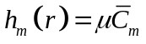 for 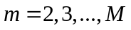. Unless mentioned otherwise, 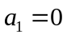 in the following, so 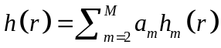 depends on but not . From Eq , 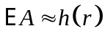 and
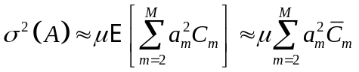.
In a standard notation, 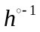 denotes the inverse of a function under functional composition (denoted by “”). The derivative of follows from the equation 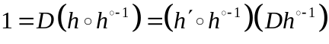.
In the method of moments, because 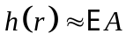, the reproductive number 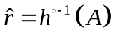 is estimated from the observed 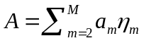 (therefore, usually 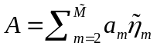). Because 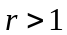, it is convenient to work in logarithms to approximate the variance in the estimate. Because,
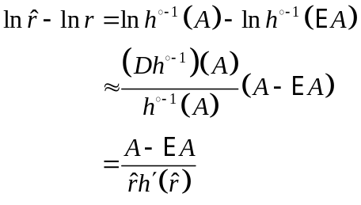,
Take variances and then square roots to derive the estimated standard deviation 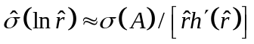 and to establish asymmetric error bars for :
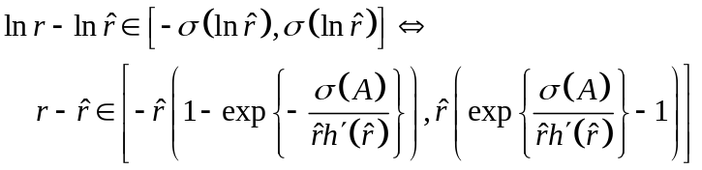
To calculate 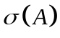,
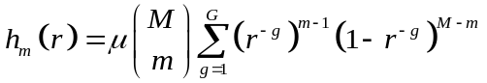,
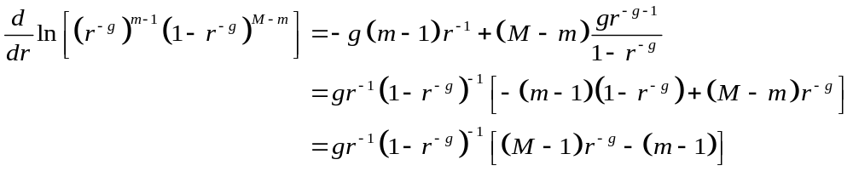,.
and
,.
yield 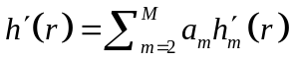 in Eq for the method of moments.
References
1. Arratia R, Goldstein L, Gordon L: Two moments suffice for Poisson approximations, the Chen-Stein method. Annals of Probability 1989, 17(1):9-25.
2. Efron B, Hinkley DV: ASSESSING ACCURACY OF MAXIMUM LIKELIHOOD ESTIMATOR - OBSERVED VERSUS EXPECTED FISHER INFORMATION. Biometrika 1978, 65(3):457-482.
3. Efron B, Hinkley DV: ASSESSING ACCURACY OF MAXIMUM LIKELIHOOD ESTIMATOR - OBSERVED VERSUS EXPECTED FISHER INFORMATION - REPLY. Biometrika 1978, 65(3):487-487.

