**­GLOBAL SHARK ATTACK PROJECT**

We chose the subject of our project to be global shark attacks from year 1868 to year 2018. Our data source was pulled from Kaggle. We have attached the CSV file along with our proposal. The CSV file excerpt looks like the following.

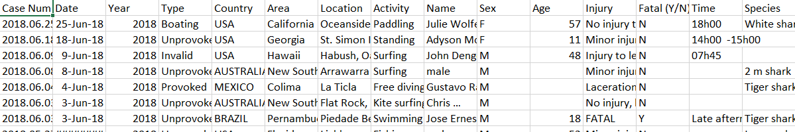

We want to show the distribution, frequency, types of shark attacks, and activities when attacked throughout the world.

Our page will have 3 visualizations.

1. An interactive map with multiple overlays showing the following
   1. 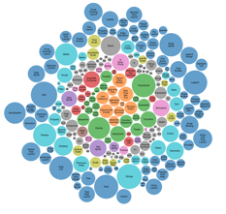Country
      1. When mouseover, show number of attacks and year(s)
   2. Specific Location
      1. Displayed has heatmap
   3. Markers
      1. Pop ups that include link to actual accident report
2. Bubble chart OR Word Cloud (whichever works easiest for us) ☺
   1. Victims activities when attack happened
   2. Frequency of the activities will result in larger bubble/word
3. D3 visualization that will show percent of attacks that are female/male.

Our page will ­­include a filter section to filter data based on input(s). Filters will include the following.

**Home Page – will include link to map page**

* 1. Year
  2. Reason of the attack (dropdown)
     1. 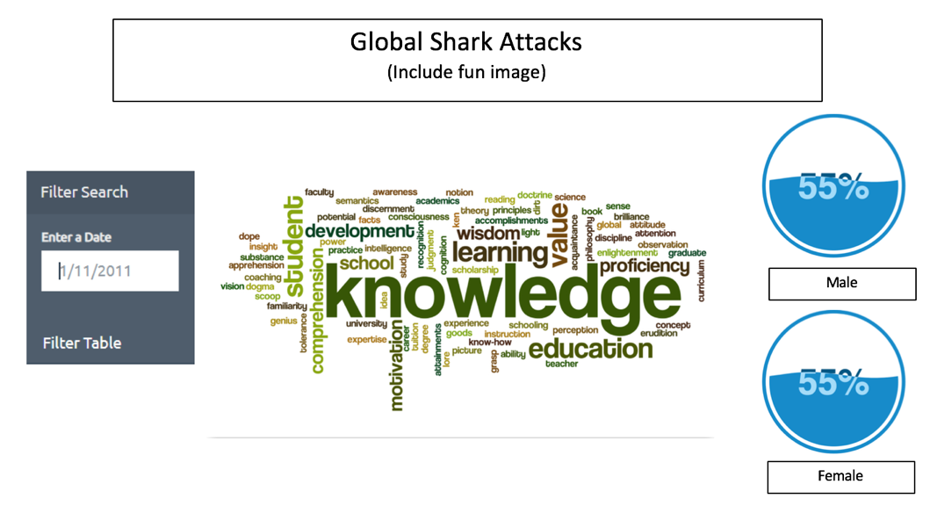Provoked
     2. Unprovoked
     3. Boating
     4. Unknown
  3. Type of incident (dropdown)

**Map Page – will include multiple overlays (see above)**

