L I V E C O F F E E M A K I N G P R O C E S S .



# We Telecast our Coffee Making Live

We are here to listen from you deliver exellence

Lorem ipsum dolor sit amet, consectetur

adipisicing elit, sed do eiusmod temp or incididunt ut labore et dolore magna aliqua. Ut enim ad

minim.



# What kind of Coffee we serve for you

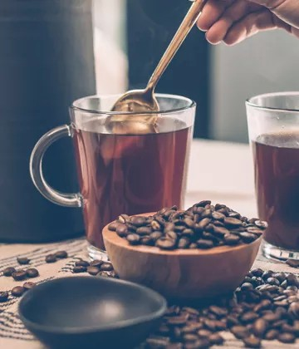Who are in extremely love with eco friendly system.

# What kind of Coffee we serve for you

Who are in extremely love with eco friendly system.



Travel Life St yle

Travel Life St yle

## Portable latest Fashion for young women



Mon-Fri: 8am to 2pm Sat-Sun: 11am to 4pm (012) 6985 236 7512

HOME ABOUT COFFEE REVIEW BLOG [PAGES ](https://preview.colorlib.com/theme/coffee/)

**NOW YOU CAN FEEL THE ENERGY**

**Start your day with a black Coffee**

BUY NOW



**What kind of Coffee we serve for you**

Who are in extremely love with eco friendly system.

**Cappuccino $49**

Usage of the Internet is

becoming more common due to rapid advance.

**Americano $49**

Usage of the Internet is

becoming more common due to rapid advance.

**Espresso $49**

Usage of the Internet is

becoming more common due to rapid advance.

**Macchiato $49**

Usage of the Internet is

becoming more common due to rapid advance.

**Mocha $49**

Usage of the Internet is

becoming more common due to rapid advance.

**Coffee Latte $49**

Usage of the Internet is

becoming more common due to rapid advance.

**Piccolo Latte $49**

Usage of the Internet is

**Ristretto $49**

Usage of the Internet is

**Affogato $49**

Usage of the Internet is

becoming more common due becoming more common due becoming more common due to rapid advance. to rapid advance. to rapid advance.



**What kind of Coffee we serve for you**

Who are in extremely love with eco friendly system.

**lorem ipusm**     

Accessories Here you can find the best computer accessory for your laptop, monitor, printer, scanner, speaker. Here you can find the best computer accessory for your laptop,

monitor, printer, scanner, speaker.

**lorem ipusm**     

Accessories Here you can find the best computer accessory for your laptop, monitor, printer, scanner, speaker. Here you can find the best computer accessory for your laptop,

monitor, printer, scanner, speaker.

2206

Happy Client

6578

Total Projects

1751

Cups Coffee

9060

Total Submitted

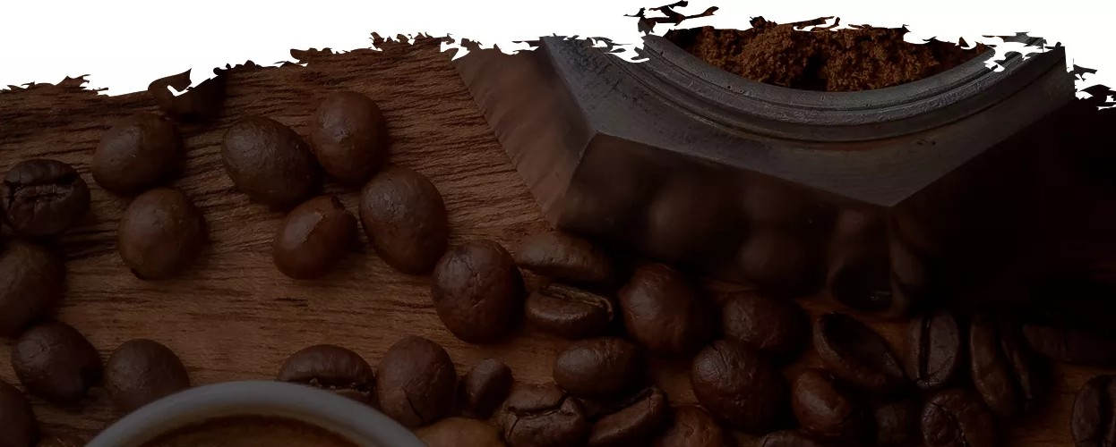

**About Us**

**Newsletter**

**Follow Us**

Lorem ipsum dolor sit amet, consectetur

adipisicing elit, sed do eiusmod tempor incididunt ut labore dolore magna aliqua.

Stay update with our latest

Let us be social

   

Copyright ©2021 All rights reserved | This template is made with  by [Colorlib](https://colorlib.com/)



Enter Email

Lorem ipsum dolor sit amet, consectetur adipisicing elit, sed do eiusmod tempor incididunt ut labore et dolore.

31st January, 2018

## Portable latest Fashion for young women

Lorem ipsum dolor sit amet, consectetur adipisicing elit, sed do eiusmod tempor incididunt ut labore et dolore.

31st January, 2018