**NEWSAPP**

In this project we started the creating comonents using class based components

Basic structure is like

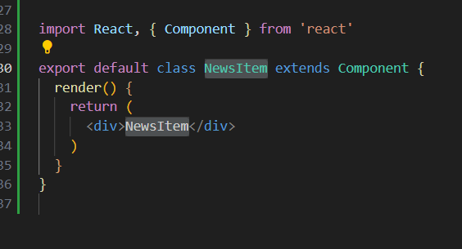

To pass props we need to declare variables and assign **this.props** which it got from the point where the component is called .

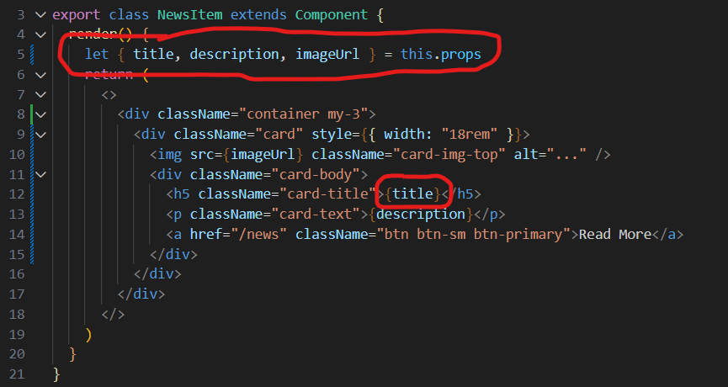

constructor jab run karta hai jab bhi kisi class ka object banta hai

for example jab hum ek component ko call krte hain dusre component k andar toh uss component k andar ka constructer run krta hai.

Hum state ka concept bhi issi se implement krte hain

***\*Yeh class based component main render k upar likha jata hai!!***

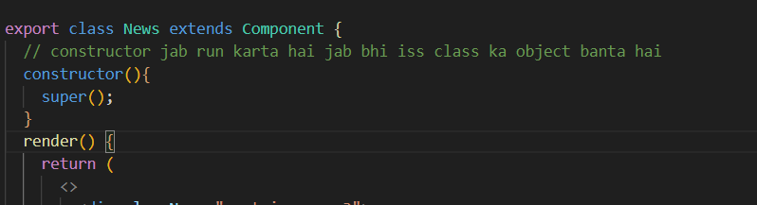

***So we’ve to decide to whether to use state or props?***

***Props are used to communicate between components. States can be used for rendering dynamic changes with the component.***

***Basically we use state when we want to change it dynamically without reloading the page. We cant’t change props again and again they’re like read-only***

**React Component Lifecycle** 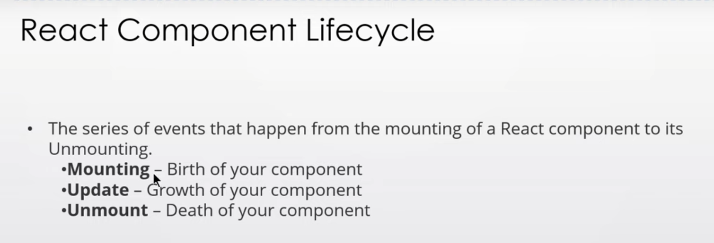

**Methods React Component Lifecycle** 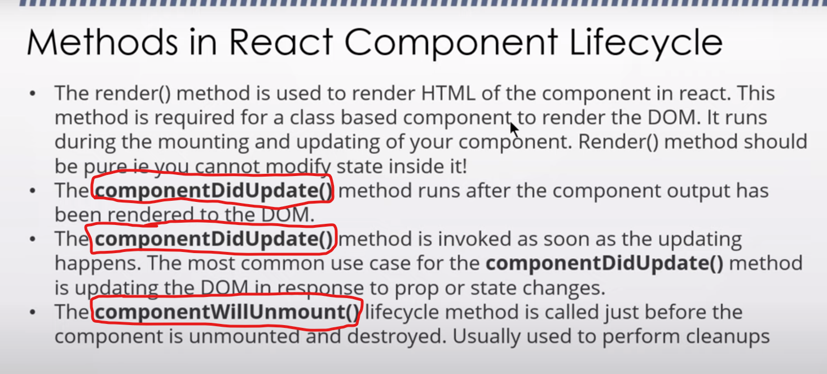

***\*We can’t update the state inside the render method***