**428. A New EJS Tool For Layouts**

layout(view):

When called anywhere inside a template, requests that the output of the current template be passed to the given view as the body local.

Inside views we created layout folder

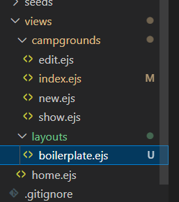

Boilerplate.ejs contains boilerplate for ejs

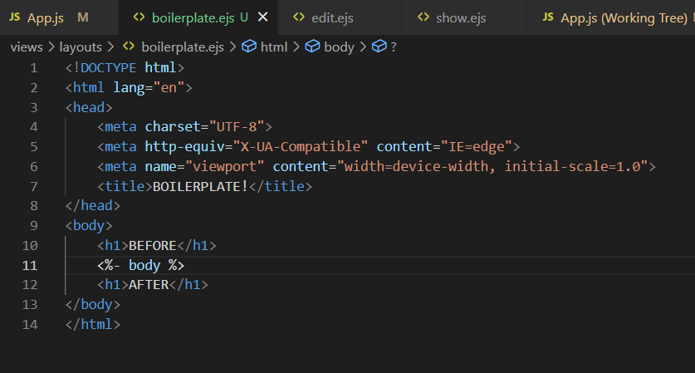

We just need to add ***“ <% layout ('layouts/boilerplate') %>”*** to access the boilerplate

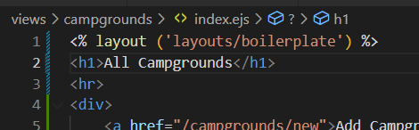

***429. Bootstrap5! Boilerplate***

Add link and script of bootstrap to the boilerplate.ejs file.

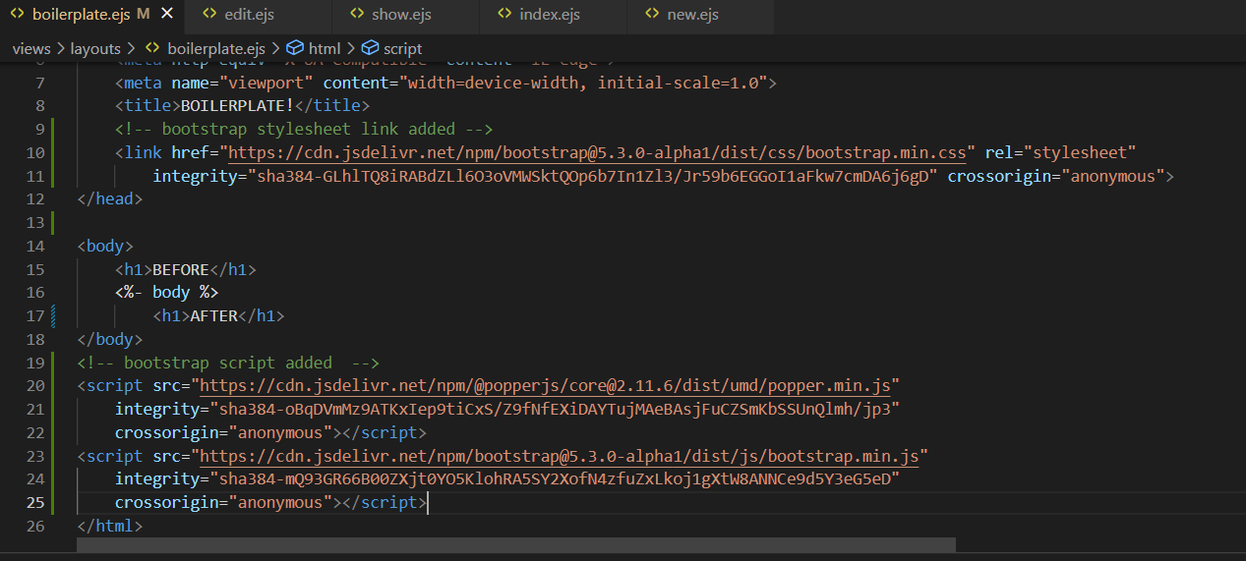

Added container class to the div enclosing the body tag of ejs mate

