**Project-3**

Material-UI is a popular React UI framework that provides a set of pre-built components for building web applications with a consistent look and feel.

Material-UI provides a wide range of customizable components, such as buttons, forms, cards, dialogs, menus, and more. It also includes a robust theming system that allows you to easily customize the appearance of your application, such as colors, typography, and spacing.

**Navbar Component**

In this component we used **stack** from **material-UI** and **link** from **react-router-dom**

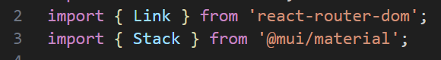

**Where stack is like a generic container, wrapping around the elements to be arranged.**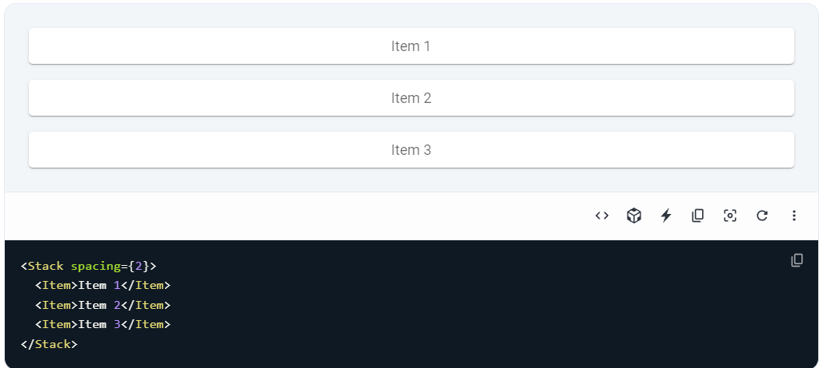

**\*Stack is a high-level component that is used for creating complex layouts and structures, such as forms, grids, or lists**

**Home Component**

Here we used **box** to wrap **heroBanner.js, SearchExercises.js** and **Exercises.js** components

* Box is a basic container that provides a set of props for customizing its appearance and behavior, such as width, height, padding, margin, and display. It is suitable for simple layouts and styling.

** Box is a basic container for simple layouts and styling, while Stack is a more advanced container for complex layouts and structures based on Flexbox and Grid.