2D Transformations

1. Affine Transformations  
     
   The most significant property of affine transformations is that a collection of parallel lines stays parallel after the transformation. Affine transformation is a linear mapping approach that maintains the integrity of planes, lines, and points.

The affine transformation method is commonly used to correct geometric deformations caused by non-ideal camera angles. In satellite photography, for example, affine transformations are used to address wide-angle lens distortion, panorama stitching, and image registration. It is desirable to convert and combine the pictures into a large, flat coordinate system to reduce distortion. As a consequence, because visual distortion is not considered, interactions and computations are simplified.

1. Projective Transformation  
     
   These are essentially transformations in which output images are formed by modifying the original image's point of view. When we applied this approach to an image in our experiment  
   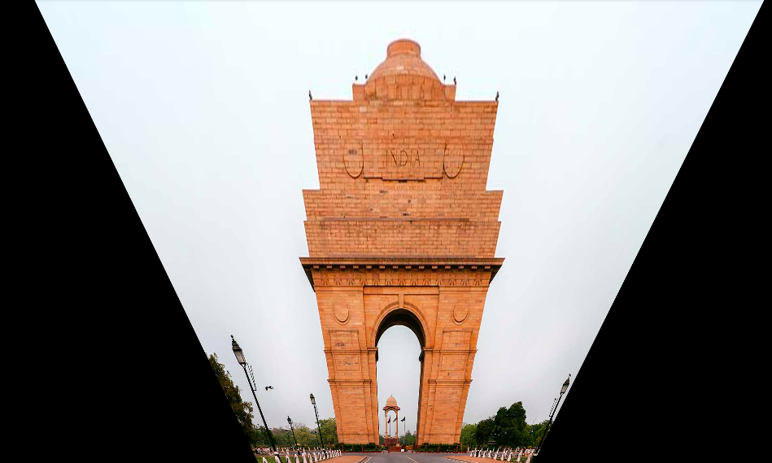
2. Similarity Transform  
   