CEIS

Somesh Srivastava

**Create New Company**

**Step 1:** Click on the ‘Company tab found in the navigation of the left side. Then click ‘Manage Company’ tab.

**Step 2:** Click on the Click on the  button. Then enter the company name, then click “Create Company” button to successfully create a company.

**Step 3:** Copy the database ID of your new company by clicking on the  icon found by DBID.

**Step 4:** Login to Pleask website, then click  tab found on the navigation.

**Step 5:** Click  button. Paste the copied database name in the field labeled Database Name.

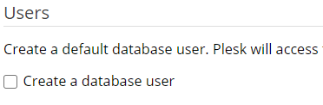**Step 6:** Uncheck the create database user checkbox. Then click ‘OK’ button.

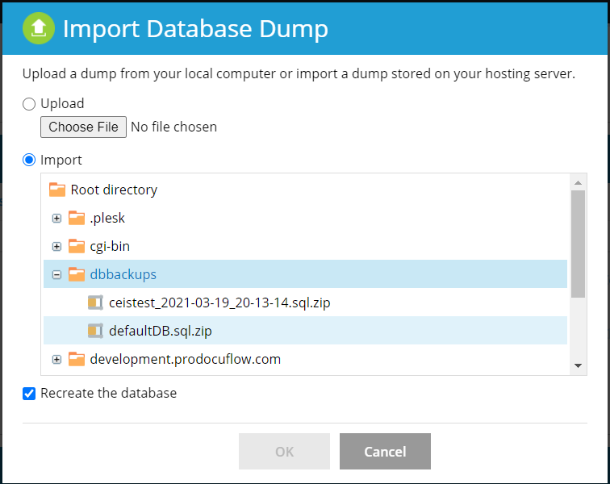**Step 7:** Navigate to your new database. Then click  button to initialize and load the database framework.

**Step 8:** Select ‘Import’ option. Then double click on the “dbbackups” folder. Then click on the “defaultsDB.sql.zip” file. Then click “OK” button.

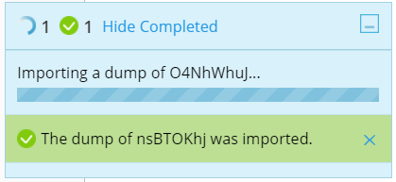**Step 9:** Wait for the loading to complete. Once the import has been successfully finished, you can then create admins.

***Login***

**Website Features**

Enter “admincontrol” as Company ID and click button labeled ‘Enter’.

Then click “Continue Login” Button to continue.

Enter your login credentials then click ‘Login’ button. 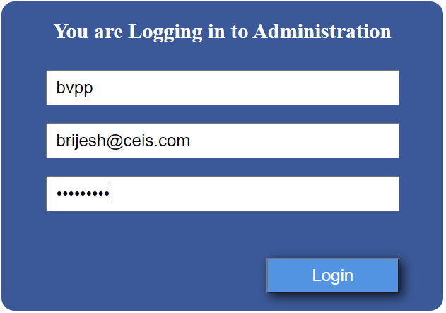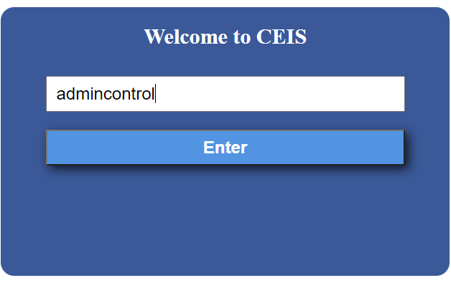

***Logout***

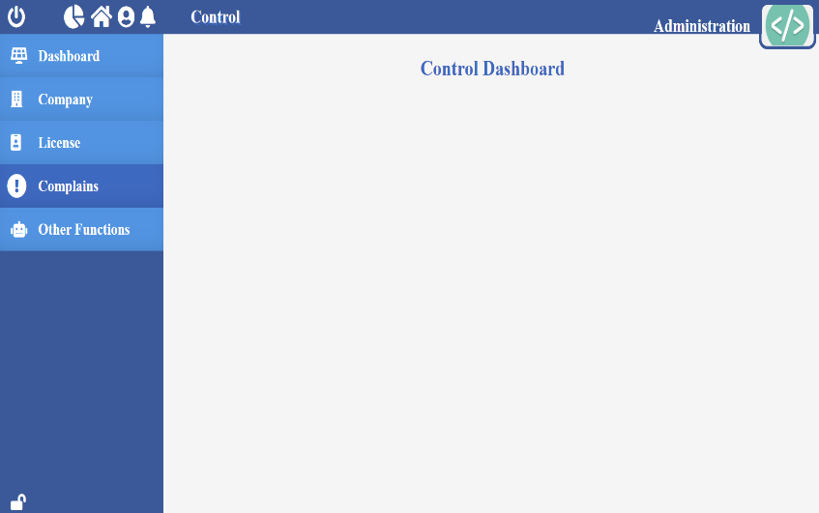Click on the  found in the top left corner to log out. You can also logout by clicking  icon located in the top left coner, then click “Logout” button.

***Navigation***

Click  icon to be redirected to the main home page.

Click  icon to prevent the navigation block found on the left side from expanding when you hover over it.

Click  icon to allow the navigation found on the left side to expand when you hover over it.

***Notification***

*View Notifications:* Click the  icon to view notifications.

***Company***

**Company**

Company tab is a control page where admins can access and manage companies, view and manage companies’ licenses, modules and create admins.

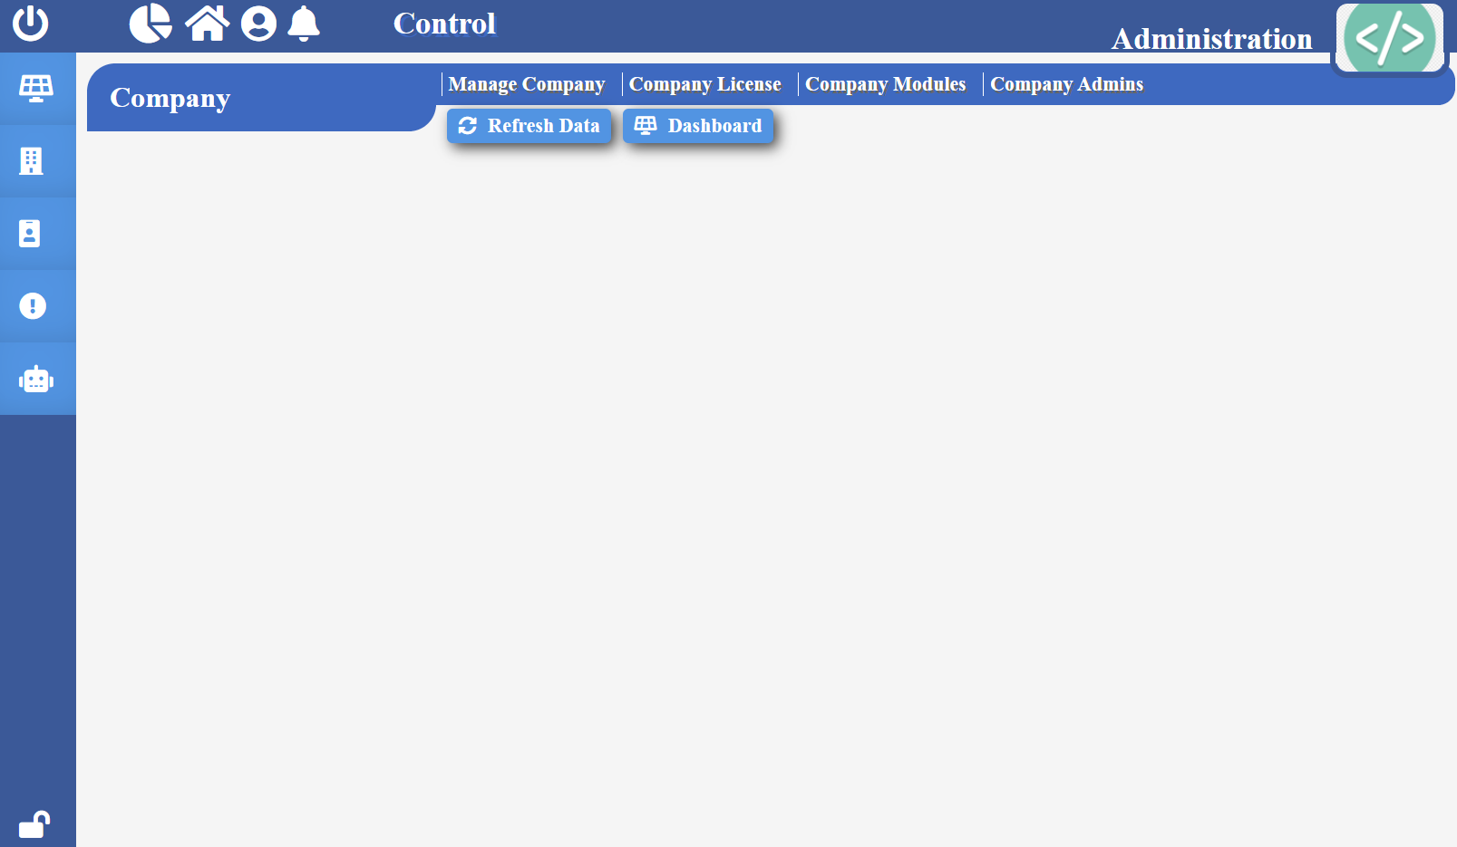

*Refresh Data:* Click “Refresh Data” to get new data without having to refresh the browser tab itself.

**Manage Company**

**Company**

Manage Company tab is where you can manage and create new companies. You will have access to the company ID and its database ID.

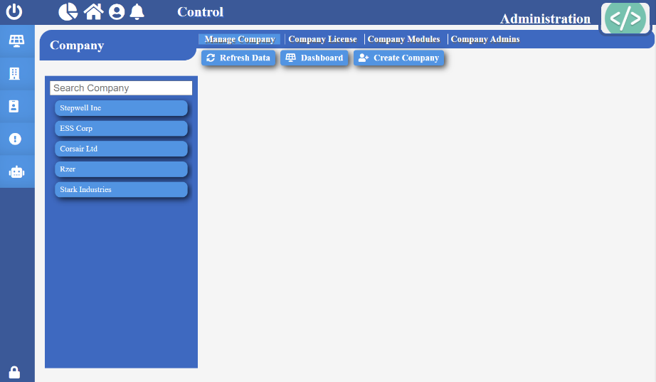To get to Manage Company tab, click on the ‘Company tab found in the navigation of the left side. Then click ‘Manage Company’ tab.

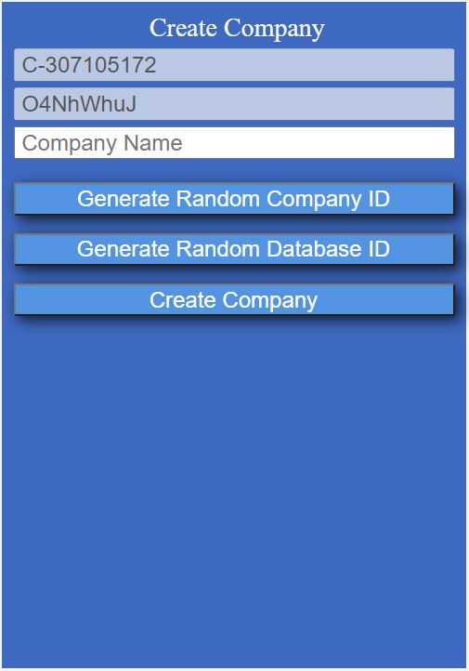

*Refresh Data:* Click “Refresh Data” to get new data without having to refresh the browser tab itself.

*View Company Details:* Click on the company you wish to see details of.

*Create New Company:* Click on the  button. Then enter the company name, then click “Create Company” button to successfully create a company.

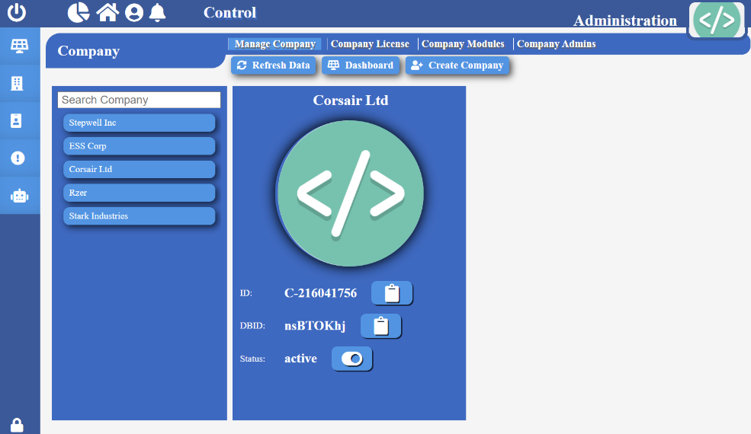*Change Company Status:* Click on the company name you want to change status of. Then click on the  icon to set the company to active status. Then Click “Yes” to confirm change.

**Company License**

**Company**

Company Licence tab is where you can manage and assign new licenses to each company. You will have access to a list of licenses each company contains.

To get to Company Licence tab, click on the ‘Company tab found in the navigation of the left side. Then click ‘Company Licence’ tab.

***Note:*** Only companies that are set to active will show here.

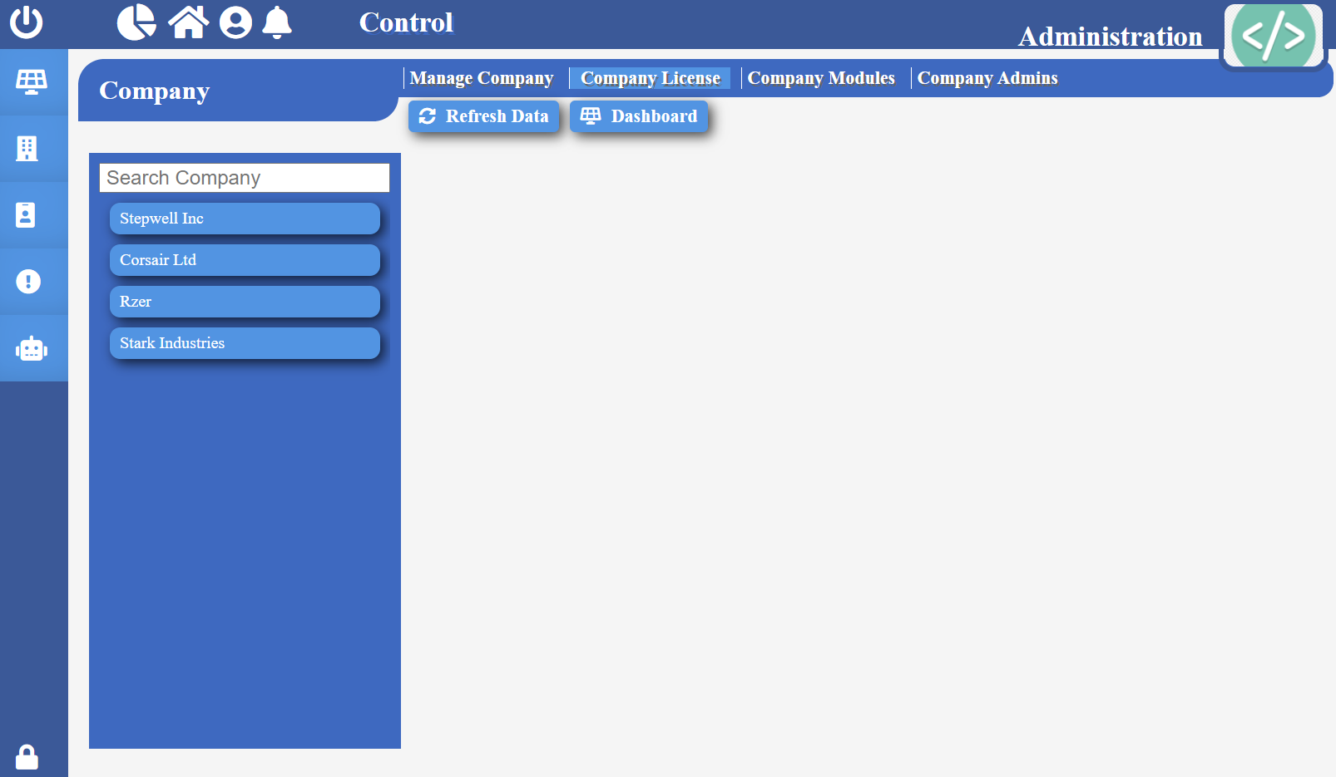

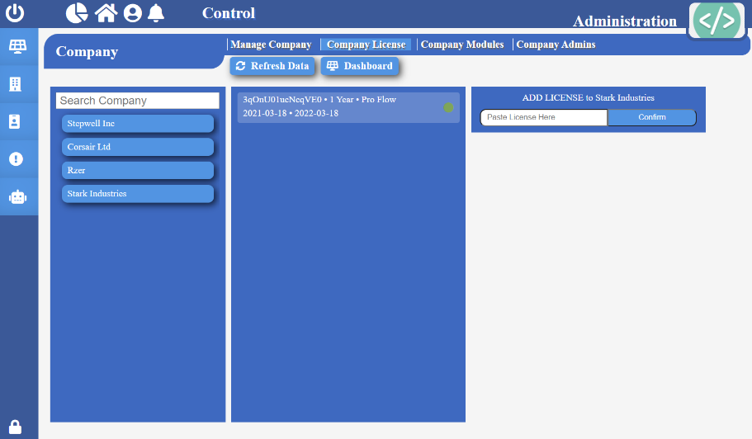*Refresh Data:* Click “Refresh Data” to get new data without having to refresh the browser tab itself.

*View Company Licenses:* Click on the company you wish to see License details of.

***Note:*** A green circle indicates the license is active, yellow circle indicate the license is ending within a week, and red circle indicates that the license has been archived.

*Add Licence:* Paste the license key in its designated field on the right-hand side, then click “Confirm” button to successfully add a license to the company.

***Note:*** An error will show if the licence key has already been used.

**Company Modules**

**Company**

Company Modules tab is where you can manually override and mange all companies’ access to modules.

To get to Company Modules tab, click on the ‘Company tab found in the navigation of the left side. Then click ‘Company Modules’ tab.



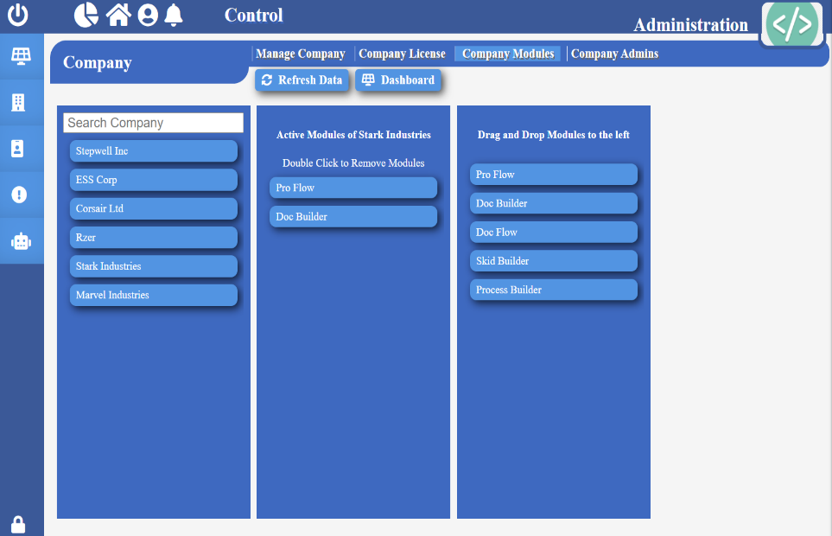*Refresh Data:* Click “Refresh Data” to get new data without having to refresh the browser tab itself.

*View Company Licenses:* Click on the company you wish to see module details of.

*Add Module:* Simply drag and drop a module from right column to the column in the middle.

*Remove Module:* Simply double click on the module you wish to remove in the middle column.

**Company Admins**

**Company**

Company Admin tab is where you can manage and create new admin for a company. You will have access to a list of company admins.

To get to Company Admin tab, click on the ‘Company tab found in the navigation of the left side. Then click ‘Company Admin’ tab.

***Note:*** Only companies that are set to active will show here.

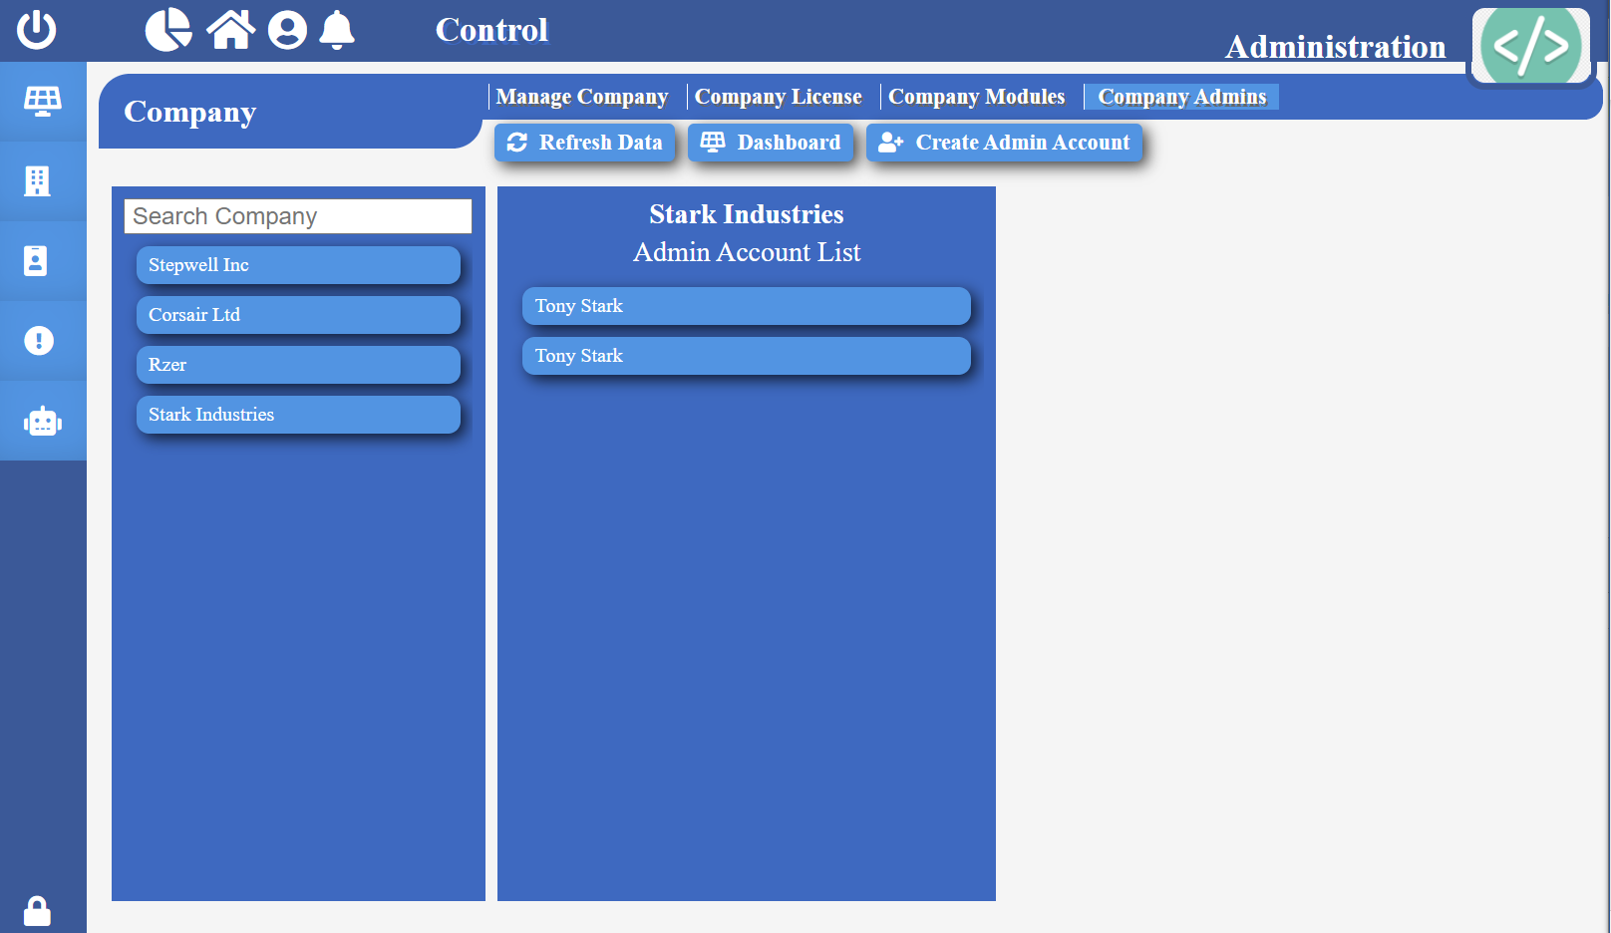

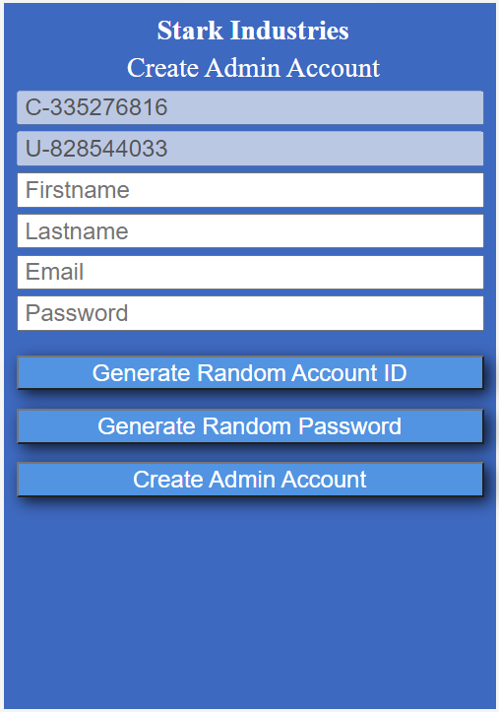

*Refresh Data:* Click “Refresh Data” to get new data without having to refresh the browser tab itself.

*View Admins:* Click on a company, you will see a list of admins already created for the company.

*Add Admin:* Click on  button, enter the required information, then click “Create Admin Account”.

**License**

**License**

License tab is where you can create new license keys for various modules. You will have access to a list of available modules.

To get to Licence tab, click on the ‘License’ tab found in the navigation of the left side.

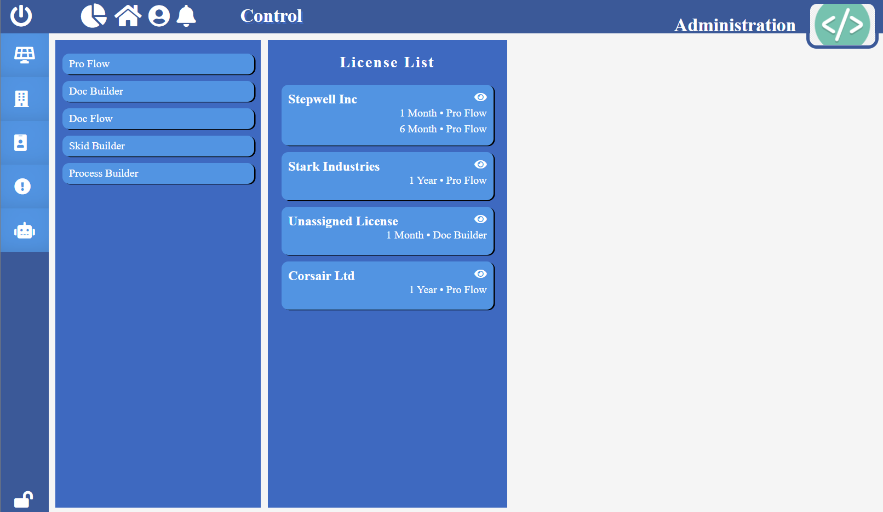



*View Company License:* Click  icon on the company to view all their licenses purchased.

*Create License Key:* Click on the module, then click the duration of the license, then click “Create License”.

***Note:*** You will have to copy the license key from ‘Unassigned License’ folder. To add license to a company, see ‘Add License’ instructions for Company License tab.

*View Unassigned Licenses:* Click  icon on the folder labeled “Unassigned License”.

*Copy License Key:* Click  icon found beside the license key to copy to a clipboard.

**Complains**

**Complains**

Complains tab is where you can manage complains from users. You will have access to a list of complains and its description.

To get to complains, click on the ‘Complains’ tab found in the navigation of the left side, Then click ‘Manage Complains’ tab.

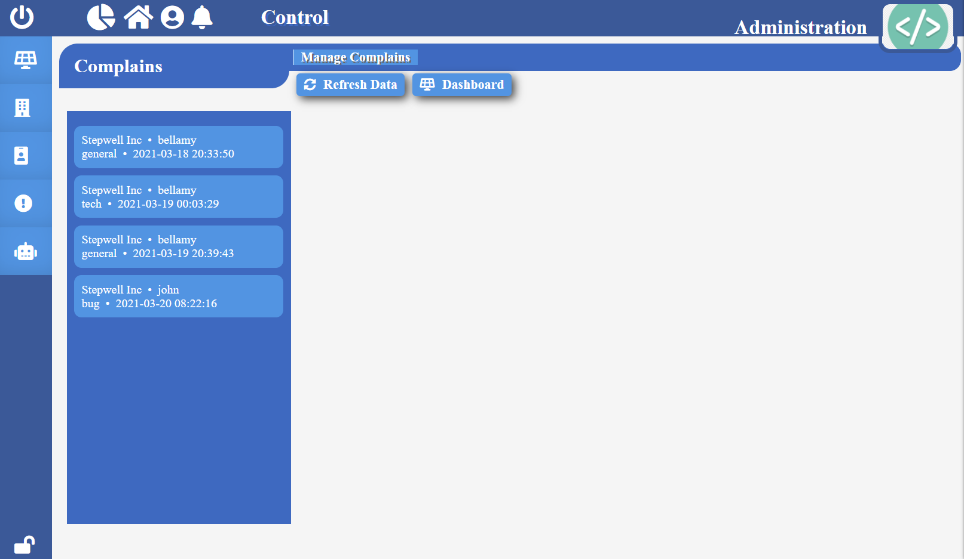

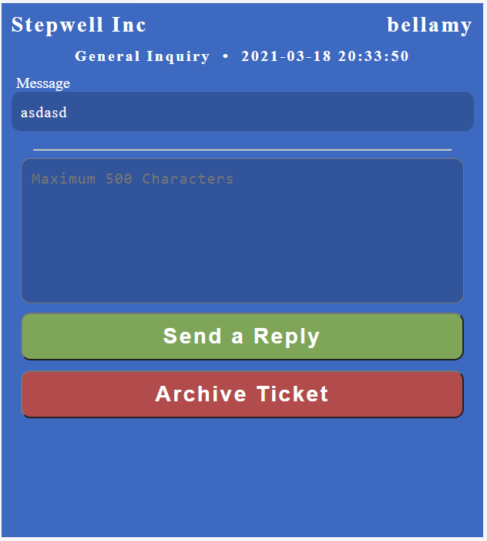

*Refresh Data:* Click “Refresh Data” to get new data without having to refresh the browser tab itself.

*View Complain:* Click on the complain you wish to detail of. You will see the complain type, date, and time it arrived.

*Send Reply:* Click on a complain, write your response in the text field, then click ‘Send a Reply’ button. Then click “yes” to confirm action.

*Archive Complain:* Click on a complain, then click ‘Archive Ticket’.