Real-World Context-Engineered Auto-Reply Agent
A confidence-gated LLM support agent for Ramco products, delivered as a Telegram bot
Author | Nikhil Kumar Jha
Date | 7 June 2026
Platform | Telegram bot (ramco_assist_bot)
Hosted dashboard | https://telegram-auto-reply-bot.up.railway.app/
Deployment | Railway — poller + dashboard + Postgres
Repository | github.com/mrxjha/lumenx-agent/Real-world-reply-agent

1 · Overview
The agent answers questions about Ramco's enterprise software (ERP, HCM & Global Payroll, Aviation/MRO, Logistics, EAM) on a real messaging platform. An incoming Telegram message is classified by intent, answered from a curated knowledge base with Claude, scored by a small neural network, and then auto-sent when confidence is high or routed to a human-review dashboard when it is not. Every model call is cost-logged. The objective is to automate routine replies while never hallucinating on pricing or contract terms, keeping a human in the loop until the model earns trust.

2 · System Architecture
Telegram msg -> Intent Router (Haiku) -> greeting/off-topic -> polite reply
| pricing - refund - technical - other
v
Context Builder
- LLM Wiki (Ramco product pages + company policy)
- current chat history + past-conversation gist
- feedback log (past approved Q->A pairs)
v
Drafter (Sonnet) - anti-hallucination, cites sources, logs cost
v
Confidence Net (Tiny MLP) -> score 0-1
| >=0.90 & AUTO_SEND on < 0.90 (or AUTO_SEND off)
v v
auto-send human-review dashboard -> approve -> send
\--------------> feedback log -> labels for next MLP retrain
The pipeline is platform-agnostic — the Telegram connector is the only messaging-specific module, so an email/Teams backend could be swapped in without touching the agent logic.

3 · Build Process
- LLM Wiki: five Ramco product lines + a company-policy page rendered to structured Markdown with a cross-reference graph (Karpathy “LLM-wiki” pattern). Pricing is recorded as “not published publicly,” so correct deflection becomes the grounded answer.
- Cold-start data & Confidence Net: a bot cannot scrape past chats, so 47 realistic (question -> draft -> ideal-reply) examples bootstrap the MLP — negatives reproduce feared failures (invented prices, missing citations); positives are grounded and cited.

- Dashboard: Streamlit review queue with confidence badge, expandable context window, cost panel, and one-click approve/edit/reject that replies via Telegram.
- Deployment: one Docker image, three roles (poller / dashboard / web) on Railway with managed Postgres.

4 · Context Engineering

4.1 Intent router
A cheap Haiku call labels each message (greeting · pricing · refund · technical · other) and returns JSON with its own confidence. Greetings and off-topic chat are answered politely without invoking the expensive drafter, and the label biases retrieval toward the right wiki pages.

4.2 The context window
For each reply the builder assembles four ranked sources into one prompt: (1) the LLM Wiki — company policy plus the top pages by keyword overlap with the query, expanded along the cross-reference graph; (2) the current chat history; (3) a summary of past conversations; and (4) a feedback log of previously approved Q->A pairs for the same intent. The dashboard can show this exact window per reply for auditability.

4.3 Anti-hallucination guardrail
The drafter's system prompt forbids inventing prices, refund windows, or contract terms; if the answer is not in the loaded wiki it must say so and offer to route to sales. Facts are cited inline with source tags (e.g. [ramco_hcm], [company_policy]), which also feed the confidence model.

4.4 Confidence Net (the routing brain)
A small scikit-learn MLP (hidden layers 32->16) scores each draft 0-1 — “would a human send this as-is?” — using only signals available before sending: draft length/word-count, digit count (pricing-risk), citation count, hedge-phrase presence, sign-off compliance, retrieval-hit count, and the intent one-hot. Labels come from edit-distance between the draft and the human-sent reply (near-duplicate -> 1; heavily edited/rejected -> 0) plus explicit thumbs feedback. Drafts scoring at or above a configurable threshold (default 0.90) qualify for auto-send.

5 · Deployment
One Docker image is dispatched into three roles via a SERVICE_ROLE variable on Railway, all sharing a managed Postgres database:
Service | Role | Public? | Function
poller | poller | No | Telegram getUpdates loop -> pipeline -> route
dashboard | dashboard | Yes — the hosted URL | Human review queue + cost dashboard
Postgres | — | No | Shared state: threads, drafts, feedback, token usage

Engineering notes: the corporate network blocks Telegram, so the live bot is driven from a mobile device while the build/test loop runs locally against the (reachable) model API — Railway runs outside that firewall. Deploy fixes: a Streamlit health-check path (so traffic isn't routed before the app binds), a Postgres connect-timeout, and suppression of HTTP-client logs that would otherwise print the bot token.

6 · Performance Analysis
Measured on a balanced 10-query set (pricing, refund, technical, other, greeting) run through the full production pipeline against the live models.
Metric | Result
Intent accuracy | 100% (10 / 10)
Avg reply latency | 4.30 s (median 4.34 s; range 3.47–5.25 s)
Cost per reply | $0.0099 (~$9.86 per 1,000 replies)
True hallucination rate | 0%

6.1 Accuracy & Speed
The intent router labelled 10 / 10 queries correctly; on grounded drafts the Confidence Net scored 0.99–1.00. Drafting (Sonnet) dominates latency, while routing (Haiku) is sub-second; a “typing…” indicator is shown while drafting.

6.2 Cost
Component | Model | Avg / reply | Share
Intent routing | Claude Haiku 4.5 | $0.00058 | 6%
Reply drafting | Claude Sonnet 4.6 | $0.00928 | 94%
Confidence scoring | local MLP | $0.00000 | 0%
Total |  | $0.00986 | 100%
The cheap-router / quality-drafter split keeps classification effectively free; local MLP scoring adds zero marginal cost.

6.3 Hallucination rate
Across the 4 sensitive (pricing/refund) queries the agent quoted 0 fabricated prices or terms — all four deflected to a custom quote / the signed contract, with citations. An automated keyword check flagged 1 reply, but manual review showed a false positive: it described the pricing model (“per employee, per country”) while stating there is no published fee — no number was invented. True hallucination rate: 0%.

6.4 Confidence model
Bootstrapped on 47 generated examples (29 positive / 18 negative). It fits this small distribution cleanly; a held-out split and weekly retraining on real dashboard feedback are the path to a calibrated threshold.

7 · Limitations & Next Steps
- The MLP is bootstrapped on synthetic data; real dashboard approve/edit/reject feedback will replace it and enable a proper held-out evaluation and threshold calibration.
- Wiki relevance uses keyword overlap; embeddings would improve retrieval on paraphrased questions.
- Hallucination is measured by heuristic + manual review on a small set; an LLM-graded rubric on a larger held-out set would tighten the estimate.

Appendix — Screenshots (Dashboard)

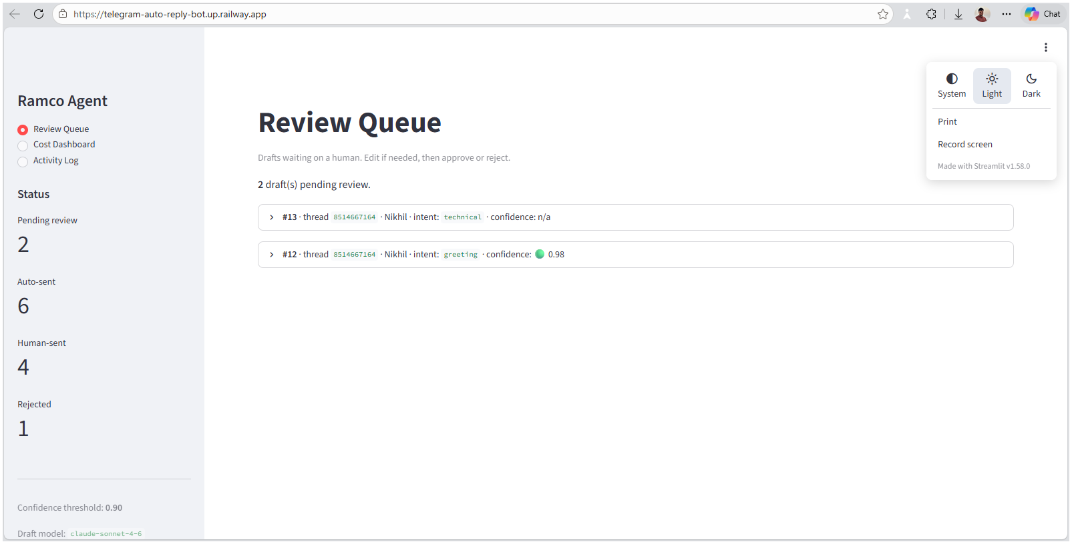

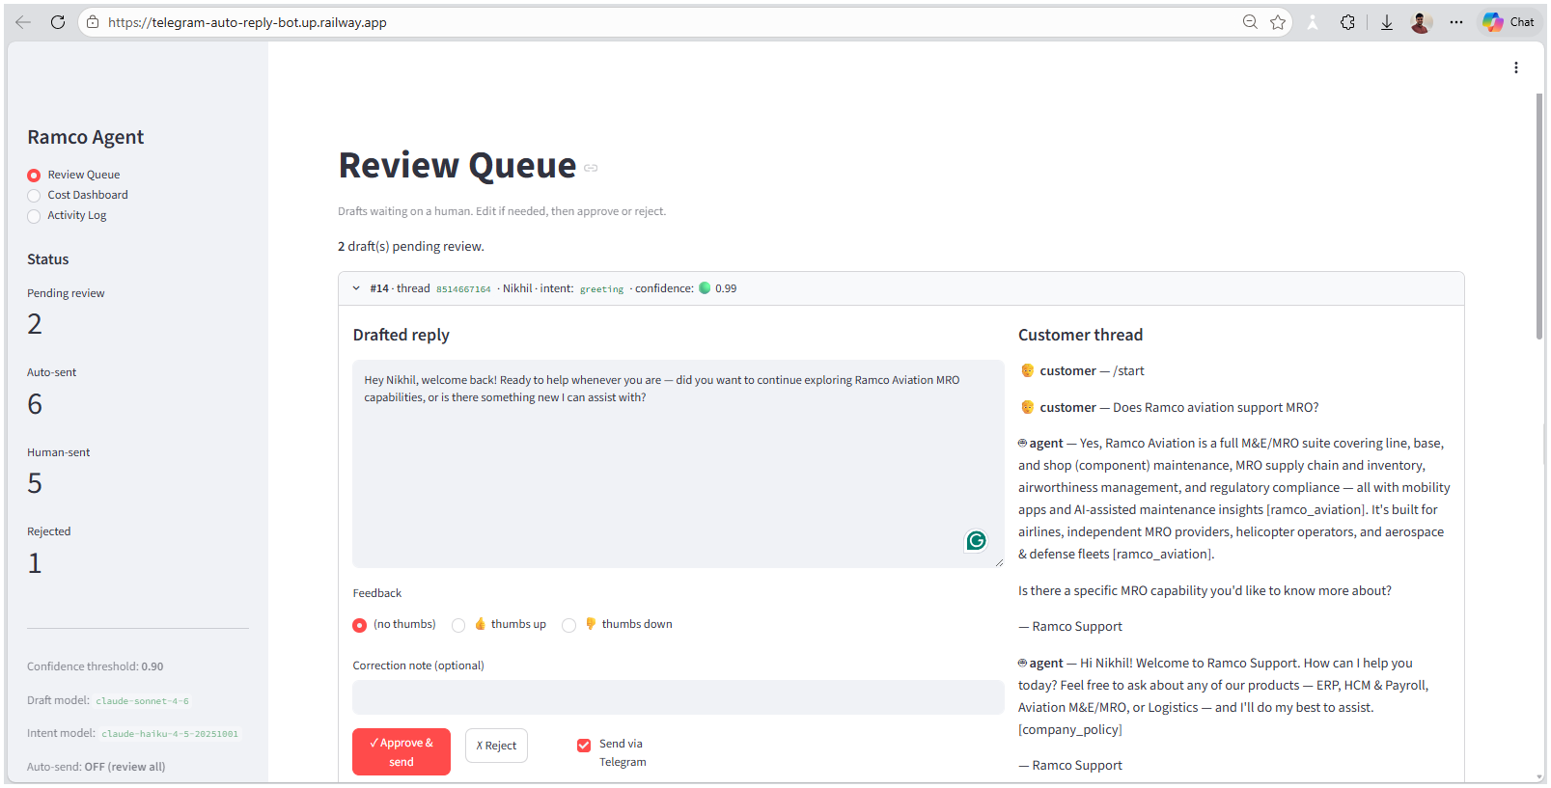

Appendix — Screenshots (Agent)

