WEEK 4
COMPREHENSIVE DATA SCIENCE REPORT
Customer churn prediction: insights, communication, and action plan

Item | Description
Project type | Hypothetical supervised learning and business insight project
Audience | Executive and operational stakeholders
Planned effort | 33 hours
Deliverable | Report with mock visualizations and presentation plan

1. Executive Summary
This report consolidates a hypothetical customer churn project into an executive-ready set of findings and recommendations. The project objective is to identify customers who are most likely to discontinue a subscription and translate that information into practical retention actions. The analysis suggests that churn risk is concentrated in a relatively small high-risk segment. In the mock results, 15% of customers are classified as high risk and show an illustrative churn rate of 42%, compared with 4% for the low-risk group. The implication is that a targeted intervention program is more efficient than contacting every customer.
The recommended decision is to combine risk scores with customer context, such as contract status, recent service issues, usage decline, and payment behavior. The model should support prioritization, not replace human judgment. Success should be measured through retention lift, contact effectiveness, customer experience, and financial value. The visuals in this report are mock-ups designed to demonstrate how the final findings would be communicated once real data and validated model results are available.

2. Methodology Review
The proposed methodology follows a reproducible data science lifecycle. Historical customer, usage, billing, contract, and support information would be combined using documented definitions and a consistent observation window. Data quality checks would assess missing values, duplicates, invalid categories, unusual values, and target-label consistency. Exploratory analysis would then examine distributions, group differences, time patterns, and relationships with churn.
- Define churn, the prediction horizon, the observation period, and the business cost of false positives and false negatives.
- Separate training, validation, and final test data before fitting transformations or selecting features.
- Use a preprocessing pipeline for missing-value handling, categorical encoding, scaling where required, and feature creation.
- Compare an interpretable baseline with more flexible candidate classifiers and tune only with validation data.
- Evaluate recall, precision, F1 score, ROC-AUC, PR-AUC, calibration, lift, and business value rather than accuracy alone.
- Document assumptions, leakage checks, limitations, versioned outputs, and a monitoring plan before deployment.

3. Findings and Analysis
The mock analysis produces three central findings. First, risk is concentrated: the high-risk segment is smaller than the full customer base but accounts for a disproportionate share of expected churn. Second, risk should be interpreted alongside drivers. A recent decline in usage, short tenure, month-to-month contracts, payment friction, and unresolved support issues are plausible signals that can guide an intervention. Third, a model is useful only when its predictions lead to measurable action. A score without a response protocol would create reporting activity without business impact.
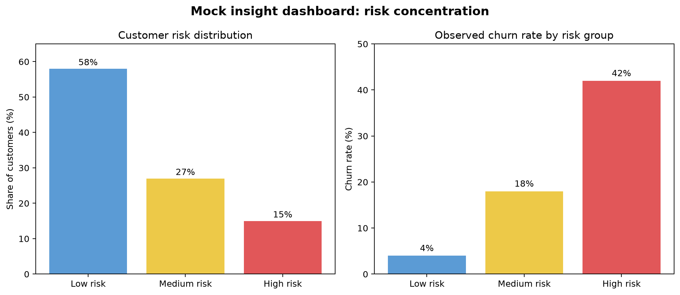
Figure 1. Mock risk distribution and churn concentration.
The first visual is deliberately split into two panels. The left panel answers how customers are distributed across risk groups; the right panel answers whether those groups differ meaningfully in observed churn. This pairing prevents stakeholders from mistaking a large low-risk population for the main intervention opportunity.

4. Planned Visualizations and Rationale
Visualization | Question answered | Reason for inclusion
Risk distribution bar chart | How many customers are in each risk group? | Shows operational workload and segment size.
Churn-rate comparison | Does risk separate outcomes? | Makes model usefulness visible through group-level lift.
Monthly trend line | Is churn changing over time? | Reveals seasonality, intervention timing, and drift.
Driver comparison plots | Which behaviors differ by outcome? | Connects predictions to understandable customer behaviors.
Recommendation impact chart | Where should effort start? | Ranks actions by expected practical value.
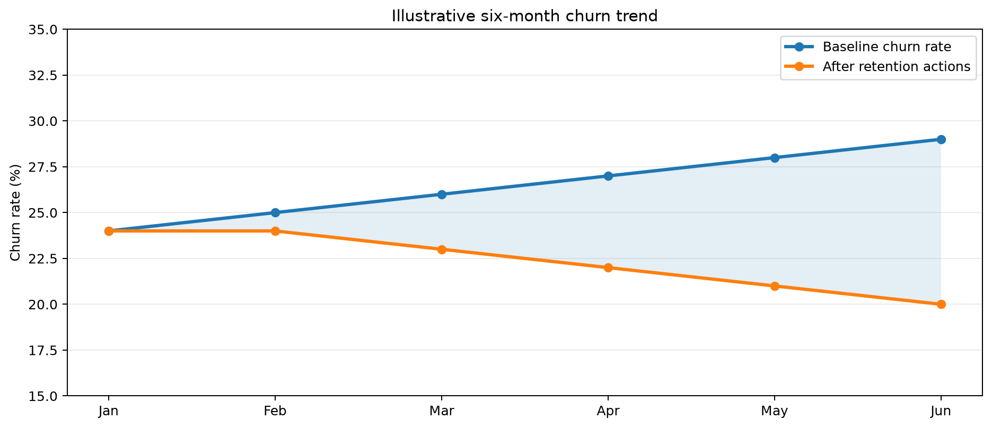
Figure 2. Mock baseline and post-intervention trend.
The trend chart would be used after launch to distinguish model performance from business impact. A declining churn rate is not automatically caused by the model, so results should be compared with a control group or a clearly defined baseline.

5. Actionable Insights
Insight | Business meaning | Proposed action
Risk is concentrated in a small segment | Broad campaigns may waste budget and attention. | Prioritize high-risk customers and set contact capacity limits.
Usage decline is an early warning | Customers may disengage before cancellation. | Trigger education, onboarding, or success outreach after a sustained decline.
Contract and payment context matter | Commercial friction can increase preventable churn. | Offer plan review, payment support, or suitable alternatives.
Service issues can create immediate risk | Unresolved problems weaken trust. | Route high-risk support cases to a recovery workflow with ownership and deadlines.
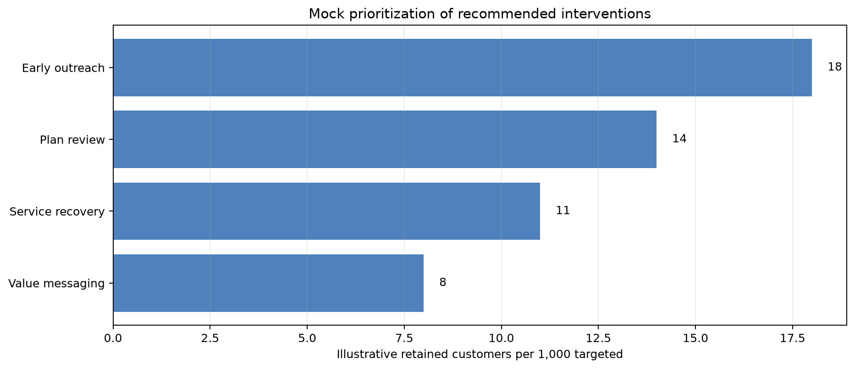
Figure 3. Mock prioritization of retention interventions.

6. Presentation Strategy for a Non-Technical Audience
The presentation should use a decision-first story rather than beginning with algorithms. Open with the business question: which customers need attention now, and what action is likely to help? Next, establish the scale of the problem with one simple trend and explain the high-risk segment in plain language. Introduce the model as a prioritization tool, not as an oracle. Show one visual at a time, label the conclusion directly, and avoid technical terms unless they change the decision.
- Start with the customer and financial consequence, then move to the evidence.
- Use a three-part narrative: what is happening, why it matters, and what we should do next.
- Explain precision and recall through business examples such as unnecessary outreach and missed at-risk customers.
- State uncertainty and limitations openly, including that mock results are not production evidence.
- End each section with a decision, owner, timing, and success measure.

7. Recommendations and Future Work
- Validate the target definition, prediction horizon, and cost assumptions with business owners.
- Run a controlled pilot in which targeted outreach is compared with a control group.
- Build a dashboard showing risk volume, segment lift, contact outcomes, retention, and fairness checks.
- Calibrate thresholds to available service capacity instead of selecting a cutoff only from a statistical metric.
- Monitor data drift, model performance, intervention response, and customer experience after deployment.
- Extend the analysis with survival methods, uplift modeling, or treatment-effect analysis when sufficient outcome data exists.

8. Evaluation and Delivery Plan
Workstream | Hours | Output
Synthesize methodology and assumptions | 4 | Consistent end-to-end project narrative
Validate mock findings and insight logic | 5 | Evidence-to-decision mapping
Design and refine visualizations | 7 | Three presentation-ready figures
Write executive and stakeholder narrative | 6 | Plain-language communication plan
Develop recommendations and future work | 4 | Prioritized action roadmap
Format, review, and quality-check DOCX | 7 | Polished final report
Total planned effort: 33 hours. Quality review will check clarity, consistency between text and visuals, readable labels, explicit assumptions, and whether every recommendation is linked to an insight and measurable outcome.

9. Conclusion
A strong final data science deliverable does more than report model scores. It connects a defensible analytical process to specific decisions, communicates uncertainty responsibly, and gives stakeholders a practical path from insight to action. This Week 4 plan presents customer churn findings as a coherent story: risk is concentrated, customer context explains where to intervene, targeted action is preferable to broad outreach, and controlled measurement is required to prove impact.

