WEEK 3
Python-Based Machine Learning Model
Development and Evaluation Plan
Hypothetical Project: Customer Churn Prediction

Week | 3
Project Type | Supervised Machine Learning – Binary Classification
Programming Language | Python
Planned Effort | 35 Hours

Strategic planning document — no code execution or real dataset required

1. Project Introduction
This Week 3 plan defines a complete strategy for developing and evaluating a Python-based machine learning model. The hypothetical use case is Customer Churn Prediction, where the model estimates whether a customer is likely to discontinue a service. The exercise focuses on conceptual implementation rather than executing code, while following a realistic machine learning lifecycle.
Project Goal: Build a reproducible classification workflow that transforms prepared customer data into validated churn predictions and provides a clear path toward deployment.

2. Problem Definition and Relevance
Customer churn prediction is suitable for this exercise because it represents a practical binary classification problem. Historical customer information can be used to identify patterns associated with churn. A prediction system could help an organization prioritize customers for retention analysis and targeted interventions.

Objectives
- Define churn as the target variable with two classes: churn and non-churn.
- Prepare reliable features while preventing data leakage.
- Compare multiple classification algorithms using consistent validation procedures.
- Tune the selected model and evaluate it on unseen test data.
- Document a deployment and monitoring strategy for future implementation.

3. End-to-End Machine Learning Workflow
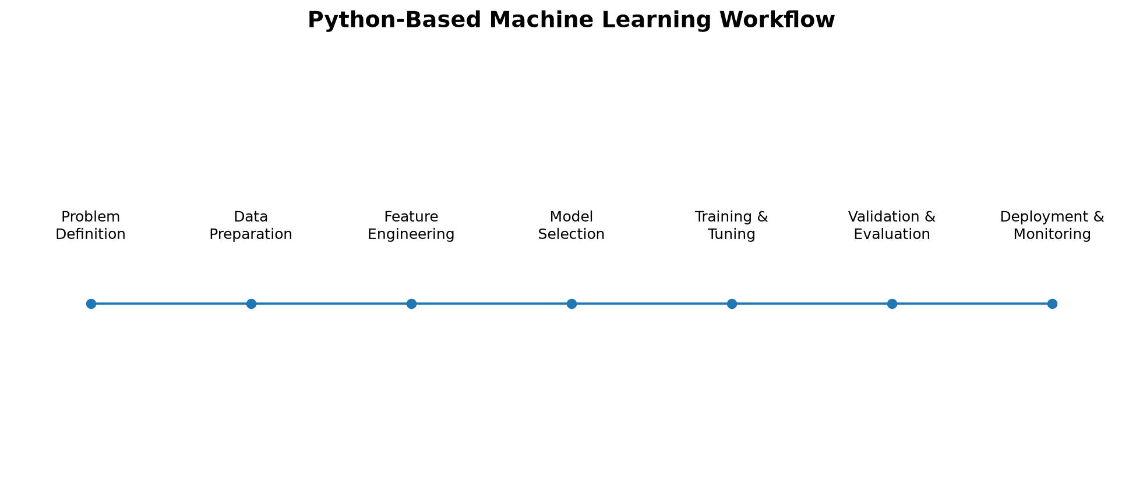
The workflow separates data preparation, model development, validation, and deployment to reduce leakage and make the process reproducible.

4. Data Preprocessing Plan
Stage | Planned Activity
Data Understanding | Inspect columns, data types, target distribution, duplicates, ranges, and unique values.
Data Cleaning | Handle missing values, duplicates, invalid records, inconsistent categories, and obvious data-entry errors.
Target Preparation | Encode churn as a binary target and verify that target labels are valid and consistently defined.
Categorical Encoding | Use suitable encoding such as one-hot encoding for nominal variables.
Numerical Scaling | Apply standardization or other appropriate scaling when required by the algorithm.
Feature Engineering | Create meaningful variables such as tenure bands, usage ratios, service counts, or recent activity indicators.
Feature Selection | Remove identifiers, leakage-prone variables, redundant features, and features with weak analytical value.
Data Split | Create training, validation/cross-validation, and final test partitions before fitting transformations on training data.

5. Feature Engineering and Selection Strategy
Feature engineering will convert raw fields into variables that are more informative for classification. Candidate features may include tenure, monthly charges, service usage, contract type, payment behavior, support interactions, and recent account activity. Features will be reviewed for business meaning, missingness, redundancy, and possible data leakage before they are used for model training. Selection may combine domain knowledge, correlation analysis, model-based importance, and validation performance.

